Digital Surveying and Highway Design ACBA4017:
Surveying the Dylan Thomas Centre using Digital Tools

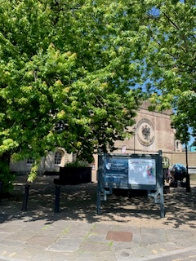

Contents
Introduction 2
a. Importance of Building Surveys 2
b. Role of Digital Technology in Modern Building Surveys 3
c. Purpose of the Assignment 3
2. Survey Objectives and Scope 4
a. Objectives of the Building Survey 4
b. Scope of the Survey 4
3. Selection of Digital Tools and Technologies 6
a. Selected Technologies 6
b. Justification of Tools 7
4.Survey Planning 8
a. Phased Survey Plan 8
b. Methodology and Data Outputs 9
5. Challenges and Solutions 10
a. Identified Challenges 10
b. Mitigation Strategies 10
6. Conclusion and Recommendations 11
a. Summary 11
b. Recommendations 11
7. References 13
8 Appendices 15

Introduction

a. Importance of Building Surveys
Building surveys are used to evaluate the structural condition and long term performance of buildings. For public and heritage buildings, these surveys are vital to maintaining safety, preserving architectural value, and complying with legal obligations (RICS, 2021). In the case of historic structures, understanding their current condition allows for appropriate conservation and restoration while respecting their original materials and design intent.
The Dylan Thomas Centre in Swansea was constructed in 1825 and later adapted, it now functions as a cultural centre dedicated to the Welsh poet Dylan Thomas as well as part of the University Trinity Saint David (UWTSD) Campus. As a Grade II* listed neoclassical building it holds historical significance and requires careful management to ensure that alterations or repairs are sensitive to its heritage status (Swansea Council, 2022).

b. Role of Digital Technology in Modern Building Surveys
The introduction of digital surveying technologies has revolutionised how construction and conservation professionals assess and manage built assets. Traditional tools like tape measures and theodolites are increasingly being replaced or supplemented by technologies such as Terrestrial Laser Scanning (TLS), drones, and Building Information Modelling (BIM). These tools improve data precision, reduce human error, and speed up survey timelines (CIOB, 2021) as well as giving the client a visual model of the building.
Digital tools ensure non-intrusive surveying which is crucial for listed buildings where invasive investigation methods may not be allowed or can become costly. Digital models generated through these technologies can be archived and reused or turned into a digital twin, offering long-term benefits for asset management and conservation planning (Historic England, 2018).

c. Purpose of the Assignment
This report will discuss and outline a detailed, realistic plan for conducting a digital building survey of the Dylan Thomas Centre. The aim is to identify the tools required, establish the scope of the work, propose a structured survey methodology, and analyse potential challenges that it may face. This will hopefully give a clear overview of the uses of digital technology in surveying and how they help to aid and improve it.

2. Survey Objectives and Scope

a. Objectives of the Building Survey
When conducting a digital survey for a building like the Dylan Thomas Centre, there are 4 main points to consider. A Condition Assessment of the building, this would normally be undertaking in a methodical way working from the top down to accurately assess the physical condition of the building's structural elements and fabric. Digital Archiving could be incorporated with the aim being to produce and collate all data for long-term record keeping and heritage planning, this will give a detailed overview of all the information held for the building to be used for future projects. Maintenance Planning to support future repairs, conservation, or adaptive reuse projects like change of use of the building. The last being Data Integration, this will enable for the future integration with facilities management platforms via BIM .
These objectives ensure that the survey serves both immediate operational needs and long-term conservation efforts, depending on the needs of the client all four areas can be completed or only one or two. For example, a condition assessment may be all that is required for the client to understand if there are any areas that require immediate attention.

b. Scope of the Survey
The scope should indicate the main areas that will be looked at and identified in the survey to give a clear overview of how it can be conducted. This gives futures readers of the survey a clear overview.
Building Type should be identified: The Dylan Thomas Centre is a Grade II* listed neoclassical building constructed of sandstone, its known for cultural, architectural, and literary significance and was originally built in 1825 as the Swansea Guildhall. Its current use is now a public museum and event venue dedicated to the life and works of Dylan Thomas (VisitWales, n.d.) but is also used by UWTSD as part of their campus.
Location and address should be noted: Dylan Thomas Centre, Somerset Place, Maritime Quarter, Swansea, SA1 1RR.
What is the function and occupancy: The Centre is jointly operated by Swansea Council and the UWTSD. As part of a 25-year lease and the 2021 Dylan Thomas House Scheme, parts of the building are being adapted into creative studios and academic facilities to support SMEs and education in the cultural industries (Swansea Council, 2021). It remains open to the public Wednesday to Sunday (10:00 am – 4:30 pm) and houses interactive exhibits such as “Love the Words” and family-friendly learning spaces including Swansea Space (VisitWales, n.d.; Swansea Council, 2025).
From this information Focus areas can be established. For the Daylan Thomas centre the external façades are of Sandstone masonry with architectural detailing as well as roofline cornices, windows, and drainage systems (See Appendix B,C,I Picture 2,4,10) are of clear importance as they are part of its listed status. These will be captured using terrestrial laser scanning (TLS) and UAV imagery.
Key internal areas should also be given extra attention, there are exhibition rooms, public corridors, gallery space, staircases, ceiling features, lecture rooms and the foyer, all of which are in regular public and educational use. Inaccessible or hard to reach zones like, roof valleys, parapets, and attic spaces, could be surveyed using drones or telescopic scanners to minimise danger to surveyors.
Environmental Factors looks at areas with a higher potential for damp ingress, thermal bridging, or poor insulation in a building, in a building as old as this one this will be specially around ground level if there is no DPC around window reveals, and floor and wall junctions and roofing junctions. These will be examined using thermal imaging and damp meters. Future use spaces can also be looked at, if there are areas earmarked for UWTSD’s refurbishment under the Dylan Thomas House Scheme (Swansea Council, 2021), then this can be surveyed in detail to support renovation planning and compliance if needed.
The scope above should aim to layout a comprehensive and non-disruptive digital record of the Dylan Thomas Centre. It is good to note that the work must all surveying follows guidelines that are set out by Cadw, as there will most likely be conservation requirements applicable to Grade II* listed buildings (Historic England, 2018). As the building is used by the public it will be best to do the survey operations around public opening hours. This will make the use of TLS easier ensuring minimal disruption to the Centre’s educational and cultural programmes.

3. Selection of Digital Tools and Technologies

a. Selected Technologies
Surveying historic and complex buildings such as the Dylan Thomas Centre, careful consideration of digital technologies is important to achieving accurate, efficient, and non-invasive data collection. Advanced tools are available to gain high-resolution mapping and diagnostic assessments, this is very handy in heritage sites where intrusive methods may not be allowed.
One of the most common tools used in building surveying is Terrestrial Laser Scanning (TLS). TLS can be stationary tripod-mounted laser scanner to emit thousands of laser pulses per second, capturing the time it takes for the laser to return from surfaces around the room, or a hand held device that is quicker but less detailed. This produces a dense three-dimensional "point cloud" that accurately represents the physical geometry of the structure (Boon, Prasanna and Mowforth, 2020). These point clouds can then be used to create digital models, floor plans, or elevation drawings with a high degree of precision. This is very useful on a building where detailed architectural features must be recorded without causing any physical disruption (see Appendix E, H,J. Pictures 5, 8,10)
Unmanned Aerial Vehicles (UAVs) commonly known as drones using high-resolution cameras or LiDAR sensors allow for safe and efficient data collection from elevated, hard-to-reach or potentially dangerous locations like rooflines, parapets, and valleys. This is especially useful for the Dylan Thomas Centre, where fragile roofing and high-level architectural features must be inspected while minimising risks to the surveyor and avoiding costly scaffolding or lifting equipment.
While less commonly used in structural mapping, thermal imaging is a great diagnostic tool. Older buildings are generally prone to energy inefficiency. A thermal camera can identify areas of heat loss, damp ingress, leaks or failed insulation, issues often hidden within wall cavities or under roof membranes (Pavlou and Tsiourva, 2021). This could also be used to try and find areas that can be easily targeted to reduce heating and energy bills.
An integral part of modern building surveying is the use of Building Information Modelling (BIM). BIM provides a digital environment that integrates spatial data, construction materials, services and maintenance information within a coordinated 3D model. This is great for enhanced collaboration between stakeholders including architects, engineers, and conservation officers (Eastman et al., 2018) as it offers the possibility to change key components within the 3d model and see how they would behave. For heritage properties, BIM can also be used to develop a ‘digital twin’ a dynamic, real time simulation of the physical structure that supports conservation planning, facilities management, and future interventions. This could be useful for a building that has a multi-functional use.
Although the above are seen as the best tools, there are other tools that can be used depending on the specific needs of the survey. Photogrammetry, for instance, uses multiple photographs taken from different angles to construct 3D models through image-matching algorithms. 360-degree cameras are also increasingly popular for documenting internal spaces in an immersive, navigable format, particularly useful for remote access or archival records. Total stations, which combine laser distance measurement with angular measurement remain a reliable tool for precise geospatial control in larger or multi-structure sites.
When used together all these technologies enable a surveyors to complete a clear and concise map. It is conservation sensitive in its approach and by integrating TLS, drone imaging, BIM, and thermal diagnostics, the survey can provide high-quality data for immediate decision making while contributing to the Centre’s long-term asset management and heritage strategy.

b. Justification of Tools
Table 1: Summary of advantages and disadvantages of key digital survey tools, (Adapted from Historic England, 2017).
Tool | Advantages | Disadvantages
Terrestrial Laser Scanning (TLS) | Provides millimetre accuracy its suited surveying complex geometries and as mentioned before is not invasive and relatively fast. | High equipment purchase cost. limited effectiveness in direct sunlight and requires processing expertise.
Drone Surveying | Accesses hard to reach or dangerous areas and speeds up data capture. | Weather dependent and must have a licence to fly large drones. Its subject to limited indoor use.
Thermal Imaging | Reveals hidden issues like heat loss, moisture ingress, or air leakage non-invasively. | Requires controlled environmental conditions; limited structural analysis; can mislead without context.
Building Information Modelling (BIM) | Enables data integration for planning, maintenance, adaption and heritage documentation. Supports collaboration. | Can be time consuming to set up as well as requires trained personnel.to easily transferred to other software.

4.Survey Planning

a. Phased Survey Plan
To make sure that the digital survey is undertaken in a structured approach the layout below is a good way to give an overview in five clear phases, this has been adapted using information on surveying and surveying of historical building plus personal knowledge (Historic England, 2017; Watt, 2011).
Planning Phase
Conduct desktop study looking at architectural drawings, previous condition reports.
Obtain consent from Cadw and owner of the building
Risk assessments and Method statements (CDM 2015).
- External Survey
Use UAVs to photograph roof areas and capture data.
Conduct TLS around the perimeter
Capture key elevation features: window heads, parapets, signage.
- Internal Survey
Use TLS to scan rooms, corridors, and ceilings.
Make thermal scans of suspect areas (areas at risk of high heat loss, walls floors, roof)
Map any areas the client has extra interest in or are of extra relevance.
- Data Processing and Modelling
Make sure all point clouds are aligned to floor plans.
Clean and export data into BIM software for example Autodesk Revit
- Output and Handover
Produce:
Interactive BIM model.
Written condition report with annotated visuals.
Maintenance priority list and potential areas to make more cost effective.

b. Methodology and Data Outputs
Modern surveying methodologies depend on digital technologies for their ability to capture, store, and present spatial and environmental data. This is due to their speed, accuracy, and light disruption. According to Smith and Gorse (2021), the integration of tools such as TLS, UAVs, thermal imaging and BIM ensures that condition assessments and conservation strategies are based on reliable, layered information sets. Table 2 describes the outputs of selected technologies and how these contribute to effective building management.
Table 2: Showing tools and outputs (Adapted from Smith and Gorse, 2021)
Tool | Primary Outputs
Terrestrial Laser Scanning (TLS) | Clear High resolution 3D point clouds representing precise geometric dimensions of the structure and façade.
Unmanned Aerial Vehicles (UAVs) | Aerial imagery, photogrammetry based 3D elevation models and access planning for hard-to-reach areas.
Thermal Imaging | Thermal gradient maps used for diagnosing insulation deficiencies, moisture ingress, water leaks and heat loss.
Building Information Modelling (BIM) | Multi layered 3D model integrating material data, construction phases, and maintenance schedules.

It is also important to mention that this data needs to be stored security for data protection and for the ability to link it into management platforms when all the data is collect.

5. Challenges and Solutions

a. Identified Challenges
Restricted Access will be an issues giving limited operational hours to conduct the survey. The weather can make it difficult for UAV operations and laser scanning may be disrupted by rain or high winds as well. The sheer data volume and interpretation process of high-resolution scans can easily exceed 20GB per project, requiring skilled processing. The cost of equipment, licensing, and software can be a barrier for smaller teams or single surveyors as well as higher cost for clients. Lastly complying with heritage organisations can give delays in approvals from Cadw or council officers can impact scheduling (RICS, 2021).

b. Mitigation Strategies
Risk mitigation strategies are critical in ensuring the smooth execution of digital building surveys particularly for complex buildings. Survey access should be carefully planned around public opening hours, ideally taking place during closure days or off-peak periods. Temporary signage and physical barriers should also be used to maintain health and safety for visitors and staff. In terms of weather challenges, observing local forecasts will allow plan external and internal scanning activities. For smaller teams or single surveyors, sharing high cost resources such as laser scanners and drones through partnerships with local universities or digital heritage centres may reduce financial barriers. Early engagement with stakeholders including Cadw representatives and local authority officers is critical to securing the project runs smoothly and on time. By planning for these risks proactively, the survey can remain both on schedule and sensitive to the needs of the client (Smith and Gorse, 2021).

6. Conclusion and Recommendations

a. Summary
This report outlines a detailed plan ton how to conduct a digital survey of the Dylan Thomas Centre. The integration of TLS, drones, BIM, and optional thermal imaging technologies will allow a non-intrusive, accurate and holistic understanding of the building’s condition. The survey methodology is designed to minimise risks, enhance long term usability and support heritage management through digital archiving keeping the client at its core.

b. Recommendations
Below are four recommendations to allow for the continued preservation of the building.
- Regular Digital Surveys, perform follow up surveys every 5 years to monitor changes and deterioration.
- Data Archiving and Sharing, maintain digital models in open access formats for community and educational use.
- Training in Digital Tools, provide staff at Swansea Council/UWTD with CPD opportunities in TLS and BIM.
- Integrate BIM with Maintenance Planning, use BIM models to streamline conservation tasks and funding applications.
By adopting these practices, it can ensure the continued preservation and responsible stewardship of the Dylan Thomas Centre.

7. References
Boon, J., Prasanna, N. and Mowforth, R. (2020) Measured surveying for architects. 3rd edn. London: RIBA Publishing. Available at: https://www.ribabooks.com/Measured-Surveying-for-Architects_9781859469059 (Accessed: 17 July 2025).
British Standards Institution (2017) PAS 1192-2:2013 Specification for information management for the capital/delivery phase of construction projects using building information modelling (BIM). London: BSI. Available at: https://shop.bsigroup.com/products/pas-1192-2-2013 (Accessed: 17 July 2025).
Chartered Institute of Building (2021) Digital construction: From digital surveying to smart buildings. Available at: https://www.ciob.org/knowledge/digital-construction-report-2021 (Accessed: 17 July 2025).
Eastman, C., Teicholz, P., Sacks, R. and Liston, K. (2018) BIM handbook: A guide to building information modeling for owners, designers, engineers, contractors, and facility managers. 3rd edn. Hoboken: Wiley.
Historic England (2017) 3D laser scanning for heritage: Advice and guidance to users on laser scanning in archaeology and architecture. Available at: https://historicengland.org.uk/images-books/publications/3d-laser-scanning-heritage/ (Accessed: 17 July 2025).
Historic England (2018) 3D laser scanning for heritage. Available at: https://historicengland.org.uk/images-books/publications/3d-laser-scanning-heritage/ (Accessed: 17 July 2025).
Health and Safety Executive (2015) Managing health and safety in construction: Construction (Design and Management) Regulations 2015 (L153). Sudbury: HSE Books. https://www.hse.gov.uk/pubns/books/l153.htm (Accessed: 21 July 2025).
Pavlou, K. and Tsiourva, E. (2021) ‘Assessment of moisture in historic buildings using non-destructive techniques’, International Journal of Architectural Heritage, 15(3), pp. 310–326. DOI: 10.1080/15583058.2019.1656130.
Pavlou, K. and Tsiourva, T. (2021) ‘Application of thermal imaging in building diagnostics’, International Journal of Architectural Heritage, 15(2), pp. 135–151. DOI: 10.1080/15583058.2020.1722312.
Royal Institution of Chartered Surveyors (2021) Building surveys and technical due diligence of commercial property. Available at: https://www.rics.org/uk/upholding-professional-standards/sector-standards/building-surveying/ (Accessed: 17 July 2025).
Smith, M. and Gorse, C. (2021) Building surveyor’s pocket book. 3rd edn. London: Routledge. Available at: https://cis.ihs.com/CIS/search?f=All&t=Smith%2C+M.+and+Gorse%2C+C.+(2021)+Building+Surveyor%E2%80%99s+Pocket+Book%2C+3rd+ed.+London%3A+Routledge.&sqm=AllTerms (Accessed: 18 July 2025).
Swansea Council (2021) Dylan Thomas House Scheme Report, Cabinet – 15 April 2021. Available at: https://democracy.swansea.gov.uk/documents/s72223/11%201%20of%203%20FPR7%20-%20Dylan%20Thomas%20House%20Scheme%20Report%20FINAL.pdf (Accessed: 16 July 2025).
Swansea Council (2022) Conservation area appraisal – Maritime Quarter. Available at: https://www.swansea.gov.uk/conservationareas (Accessed: 16 July 2025).
Swansea Council (2025) Dylan Thomas Centre. Available at: https://www.swansea.gov.uk/article/9142/Dylan-Thomas-Centre (Accessed: 16 July 2025).
VisitWales (no date) Dylan Thomas Centre. Available at: https://www.visitwales.com/attraction/museum/dylan-thomas-centre-518079 (Accessed: 16 July 2025).
Watt, D. (2011) Surveying historic buildings. 2nd edn. London: Routledge. Available at: https://www.google.co.uk/books/edition/Surveying_Historic_Buildings/QQEwCgAAQBAJ?hl=en&gbpv=1 (Accessed: 17 July 2025).

8 Appendices
Picture 1 Appendix A Front Elevation Dylan Thomas Centre taken by author 19th June
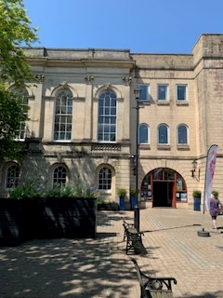
Picture 2 Appendix B Front Elevation Dylan Thomas Centre taken by author 19th June

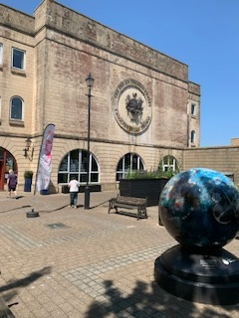
Picture 3 Appendix C Front Elevation Dylan Thomas Centre taken by author 19th June

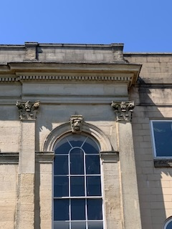
Picture 4 Appendix D Front Elevation Details Dylan Thomas Centre taken by author 19th june

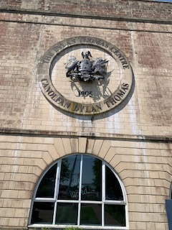
Picture 5 Appendix E Front Elevation Dylan Thomas Centre taken by author 19th June

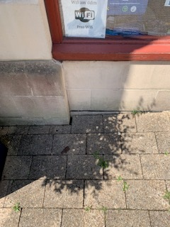
Picture 6 Appendix F Front Elevation floor detail Dylan Thomas Centre taken by author 19th June

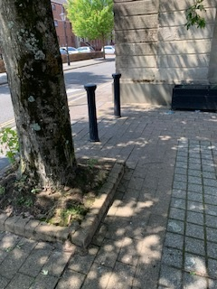
Picture 7 Appendix G close proximity of trees Front Elevation Dylan Thomas Centre taken by author 19th June

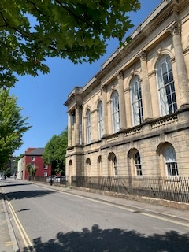
Picture 8 Appendix H Side Elevation Dylan Thomas Centre taken by author 19th June

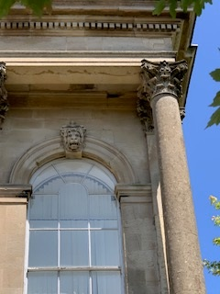
Picture 9 Appendix I Side Elevation Dylan Thomas Centre taken by author 19th June

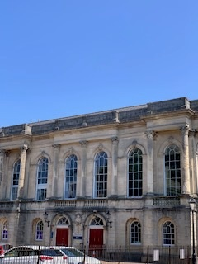
Picture 10 Appendix J Rear Elevation Dylan Thomas Centre taken by author 19th June

