Janet Thorndycraft
2316471

Write ONE commentary of 1500 words on a visual source. You may select your own image on which to comment but you should ensure that you do not repeat material you may use in your essay. You may wish to choose a manuscript depiction (such as one of the manuscripts from early Cîteaux), or a building or architectural feature from a Cistercian abbey, or a ground plan.

Hailes Abbey in Gloucestershire was founded in 1246 as a Cistercian monastery by one of the wealthiest men in Europe at that time, Richard, Earl of Cornwall, the second son of King John. Richard survived a dangerous sea crossing and vowed to founder a monastery as thanks to God, his brother granted him the manor of Hailes. Three years later he was able to fulfil his vow and became the patron of Hailes Abbey. With a prior and small retinue of monks and lay brothers they journeyed to Hailes from Beaulieu. With the help and huge financial assistance from Richard, within five years the site held a church, dormitory, refectory, cloister and adjoining buildings. In contrast with Hailes the very first Cistercian abbey in Britain was in Waverley in Surrey built in 1128. Timber built and accommodating basic rooms it was meant to be temporary while the monks established themselves and achieved stability. Once established these buildings were demolished and stone buildings erected in the early 1130’s. This consisted of the addition of a chapter house, parlour, kitchen and latrine. The church was plain with a short, square presbytery, small eastern chapel, long nave and simple stone detailing. Even at this early stage of development the abbeys in the twelfth century were conforming to a typical format of the cloister lying to the south of the church while monks ate and slept on the east range and lay monks to the west.

By the time that Hailes was consecrated over 100 years later in 1251 the Cistercians were well established in Britain with many monasteries with a recognized format and design for the building of its abbeys. The architects and masons worked to an established layout, the founder had ample money to pay for the works and Beaulieu provided the initial colony under Prior Jordan. Below is the ground plan showing in pink the original building with a large church, altar to the east, porch to the west, cloister and buildings on the south side. The church was by far the most important building with the eastern end of the church for the exclusive use of the monks and the western end for the lay brothers, each having their own entranceway into the church, choir stalls and altars. The monks had their own doorway leading to the cloisters, the heart of every monastery, an area surrounded by the buildings essential for their everyday life meaning that they had no reason to depart this space. The monks’ saw the cloister as a symbol of heavenly paradise, facing southwards to make the most of warmth and light from the sun, it was used for contemplation, spiritual reading, washing, shaving and mending of clothes, all in silence.
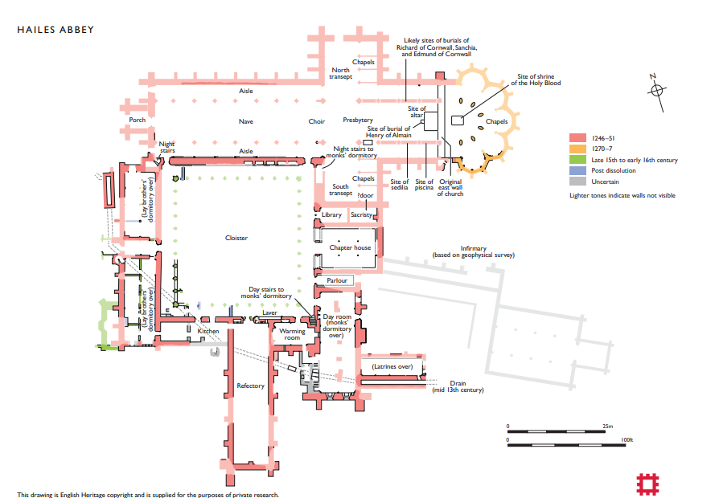
Figure 1: Ground plan of Hailes Abbey, English Heritage Website
To the east of the cloisters are the doorways to the library, sacristy, chapter house, parlour, day room and latrines. The library was the first doorway off the cloisters on the east side with the sacristy beyond that. The sacristy was the room which housed vestments and articles for worship and where the priest prepared for the service. The chapter house at Hailes was one of the first buildings to be completed, highlighting its importance within the community as a meeting room, for the reception of novices into the brotherhood, where monks listened to a reading from a chapter of the Rule of St Benedict, where practical issues were discussed, where monks confessed their sins and were punished, the dead brethren and benefactors were commemorated, distinguished guests were received and sermons given by the abbot on special feast days. At the time that Hailes abbey was founded the simplicity and sparseness off earlier abbeys was being replaced with more adornment, coloured glass windows, decorated tiles and colour. The chapter house would have been resplendent with stone vaulting, carved bosses and decoration that was brightly painted and gilded.
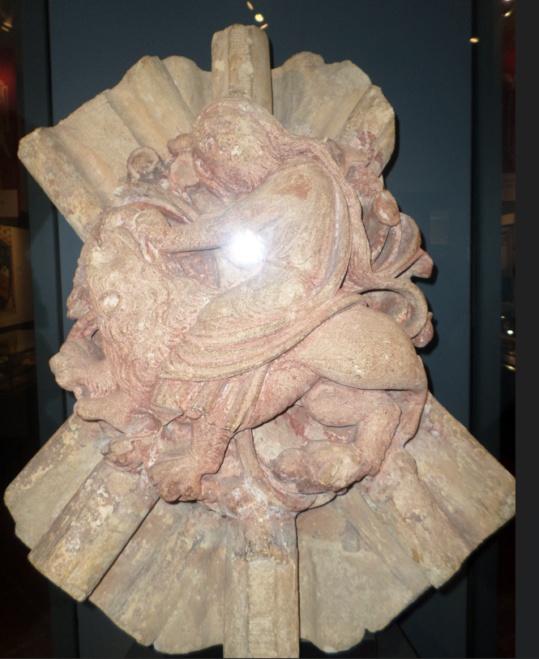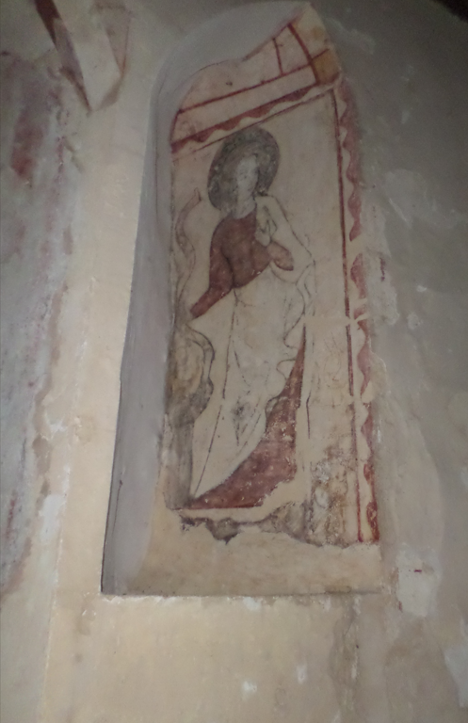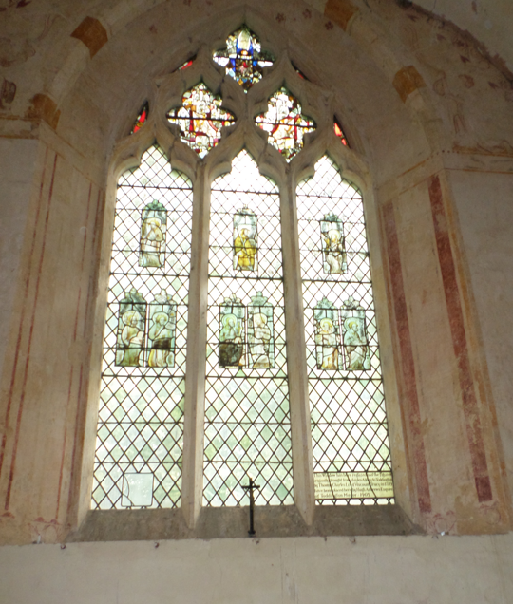
Figure 2: 13th Century ceiling boss depicting Samson and the Lion
Figure 3: Painted altar piece now at St Michael’s Church, Buckland
Figure 4: Stained-glass window now in Hailes Church
Photographs taken by D.C Thorndycraft 23.9.23.
Beside the chapter house was the parlour, a room in the monastery where monks were allowed to speak with one another, albeit restricted to conversation around the everyday lives of those within the abbey. To dissuade the monks from remaining too long the room had access and exit at either end acting as a corridor to the infirmary. To the right of the parlour was the day room, exclusively for the monks use where the activities of manuscript copying, metalworking, needlecraft and the repair and binding of books occurred. Above the day room was the monks dormitory and latrines. The dormitory was originally designed as one large space for communal sleeping, it was only later in the 14th century that cubicles were created to give the monks privacy. The southern range of the monastery followed the pattern of many other Cistercian abbeys with day stairs for the monks to reach their dormitory. Over the winter months a fire was allowed in the warming room which was also used to wash and dry the laundry, where the monks experience bloodletting or seyney, and had their heads shaven. A later addition to the complex was the laver, where hands were washed before eating and the weekly mandatum occurred, the ceremony of the abbot ritually washing the feet of the monks.
The refectory was for the monks only. They ate once a day in the late morning in wintertime, with a second meal allowed in the summer months. The remains of storage cupboards can be seen in the northern wall of the refectory as well as either side of the entranceway. Although conversation at mealtimes was forbidden, a raised pulpit would accommodate one of the monks who read passages from the Bible or other divine works to spiritually enrich the monks as they ate. Continuing along the western side of the cloisters would have been the kitchen, serving both monks and conversus. The lay brothers occupied the west range with a day room and refectory on the lower ground and dormitories above. Hailes did not have as many conversus as other abbeys and by the following century the community was so small that the abbot claimed the building as his own lodgings turning it into an impressive accommodation befitting his status as head of a wealthy and significant monastery. Away from the cloister and living accommodation would have been the infirmary to the south-east. Not thought to have been built until the end of the thirteenth century surveys reveal that it was a large building with its own chapel, latrine and kitchen. Later in the fifteenth century it had been adapted to house corrodians who, as lay folk, paid to live and eat inside the monastery precinct. In 1270 Edmund, the son of Richard and Sanchia, gifted a relic of blood thought to be blood shed by Christ on the Cross. The relic was of such importance to Hailes that it necessitated the rebuilding of the eastern end of the church. What had been a traditional square end to the presbytery now had an extension of an elaborate chevet, beyond the altar the shrine of the Holy Blood was placed on a platform and encircled by five chapels. The shape of the new chevet was influenced by the newly completed church at Westminster and was an exciting and dynamic addition to Cistercian architecture.
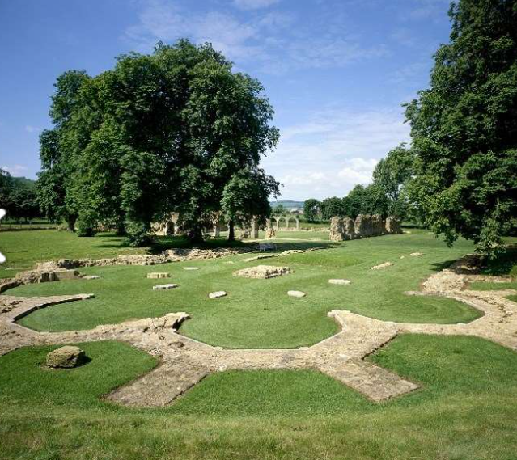
Figure 5: Present day remains of the chevet and high altar, English Heritage Website
This period of the late thirteenth century was the beginning of a shift in the lives of the Cistercians as they accepted lay folk into their previously quiet and isolated world, at Hailes this also coincided in the acceptance of lay burials within the building. For their financial generosity and support patrons required more than just the prayers of the monks for the salvation of their souls. Richard, Earl of Cornwall, died in 1272, just five years before the completion of the addition of the chevet to the church. His wife, Sanchia, had preceded him in 1261. They were royalty and their patronage of Hailes ensured that their bodies, and those of their children, would be entombed close to the high altar where their souls would benefit from the prayers of the monks and pilgrims. By 1412 the abbey had increased debt and the buildings needed repair, with the decree from the pope the situation improved and repairs and renovations to the monastery began in 1458. The abbot moved into his private accommodation which included a chapel, decorated tiles were laid in the church while art and architecture became part of the monastery. Books were added to the library and bosses of coats-of-arms were sculpted, stained glass windows, gold and silver plate, vestments and furnishings were provided by benefactors.
The end for Hailes abbey came firstly with the denunciation of the Holy Blood and then the suppression of the monastery in 1539 by Henry VIII. Later excavations have revealed what remains still exist and finds are displayed in the museum on site. Today what is left shows the ground plan of an abbey which was built in the mid thirteenth century with the benefit of more than a hundred years of experience in constructing Cistercian abbeys. The size of the dormitories, refectory and church reveal a large occupation and expansion over its three hundred years. The high standing of its patrons with tombs close to the altar, the addition of the chevet to house the gifted relic and architectural remains reveal how Hailes abbey had developed considerably from the stark origins of other Cistercian buildings. Hailes depicts the progression made in design and embellishment, the permittance of tombs within the presbytery and expansion of the Cistercian monastery. While the daily ritual of the monks would have altered little, their surroundings had reflected the changing times and the need to progress to remain relevant and appealing to patrons and new novitiates.

Bibliography
Burton, Janet., Monastic and Religious Orders in Britain, 1000-1300 (Cambridge University Press, 1994).
Carter, Michael., English Heritage Guidebooks (Park Communications Ltd, 2017).
Coppack, Glyn., The White Monks – The Cistercians in Britain 1128-1540 (Tempus Publishing Ltd, 2005).
Jamroziak, Emilia., The Cistercian Order in Medieval Europe 1090-1500 (Routledge, 2013). Kerr, Julie., Life in the Medieval Cloister (Continuum UK, 2009).

