
Ian Lewis
pEMBROKESHIRE COLLEGE
Design and Implementation of a Relational Database System
Introduction to Web and Database Concepts Sam Flory (175864)

Contents
Title: Design and Implementation of a Relational Database System 2
Introduction: 2
Requirements: 3
Relational Integrity: 3
Third Normal Form (3NF): 3
Target Audience: 3
Implementation: 5
Screen grabs: 5
Home Page & Header navigation – 5
References 5
Appendices 6

Title: Database Design Documentation

Introduction:
This document covers the design documentation part of this assignment where the Entity Relationship Diagrams, Data dictionary and Form and Query designs will be demonstrated.

Entity Relationship Diagram:
Here can be seen the Entity Relationship Diagram for the Craft Gem database system. As illustrated below in Figure 1 the database is comprised of one-to-many relationships between each table in the database. Starting at the Customer table, the one-to-many relationships illustrates the cardinality of that a single customer can place multiple orders which can all be traced back to that single individual. This relationship is brought upon using the Customer foreign key in the order table allowing for a relationship to be created. Further down the diagram we can see that another one-to-many relationship is started since there is an OrderID foreign key within the orderLine table. This depicts that a singular order can be made up of multiple items instead of a singular item. A third one-to-many relationship is seen tjrough the foreign key of productID also being in the order Line table, allowing for a product to be included in more than one order and not just one order line. The final relationship is away from the main backbone of the database and in relation to the user roles and responsibilities part of the database which allows for certain people to have access to the system depending on what role they offer the organisation. Each table has a primary key which can be seen via the key symbol identifying a unique record in that table which has no duplicate record ie all the primary keys are ID numbers a unique record. The foreign keys are used to relate information from one table back into another to help build a robust and efficient database.

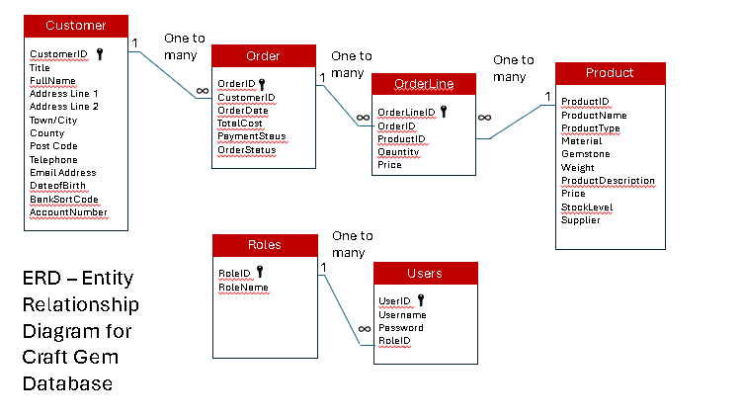
Figure 1 - Entity Relationship Diagram for Craft Gem Database

Data Dictionary:
Here the data dictionary can be viewed demonstrating the detail of each and every record that is present in the database system for Craft Gem. Every Attribute, Field name, Primary/Foreign key, Data type, Validation rule and text is defined here. This helps ensure the database is consistent and that it aligns with Third Normal Form. Third Normal Form (3NF) is a way of making sure that no redundant data is present in the database meaning that data only appears once and is not repeated through multiple tables. This offers the benefit of more space, increased accuracy and allows for more informed and accurate queries which can be used for pulling data out the tables and into easier to view forms and reports offering greater detail in how the company is performing for example.

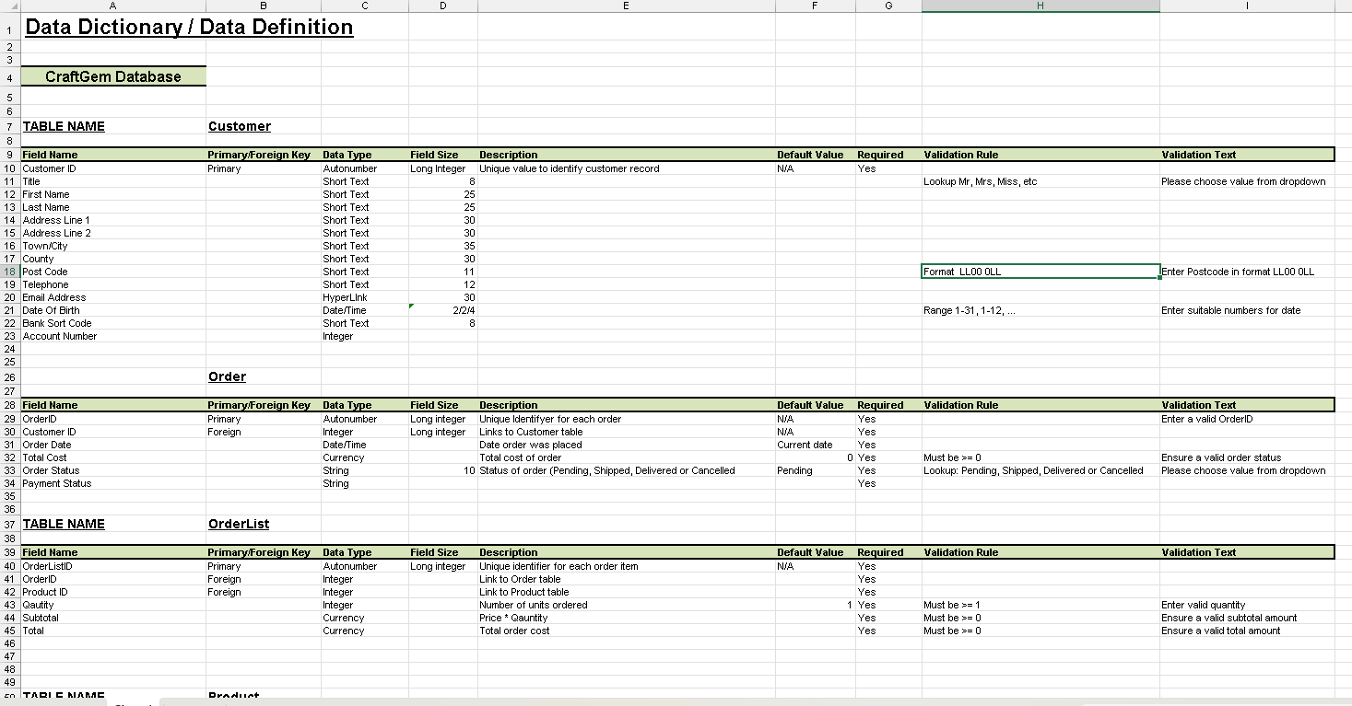
Figure 2 - Data Dictionary for Craft Gem Database pt1
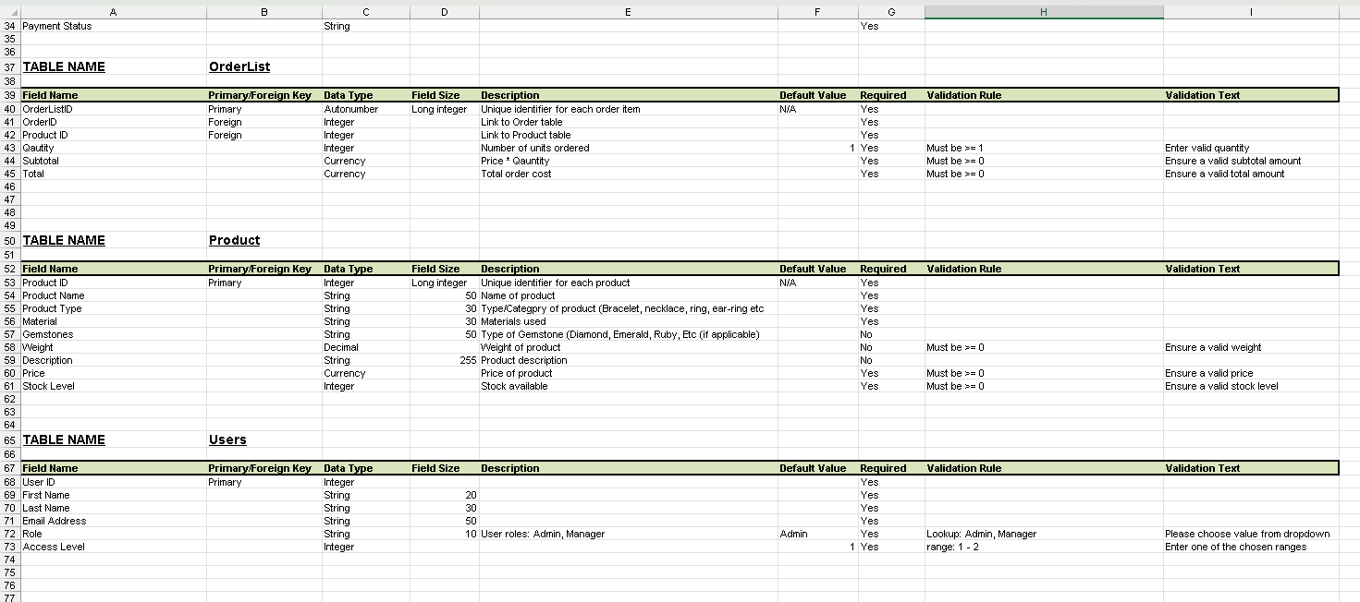
Figure 3 - Pt2 - Data Dictionary for Craft Gem Database

Form and report Designs:
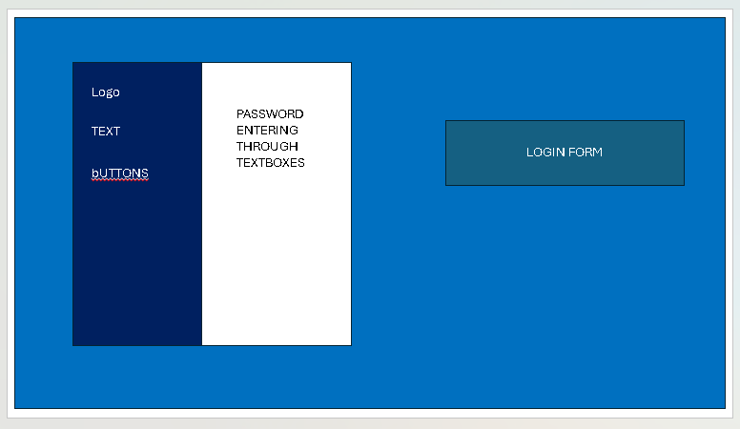
Figure 4 – Login form design
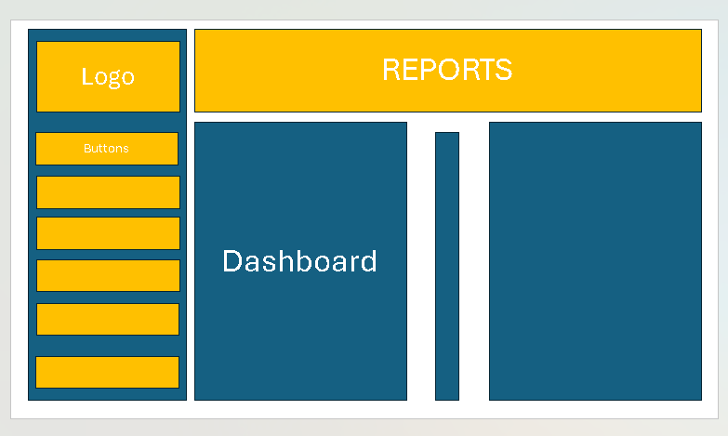
Figure 5 - dashboard design

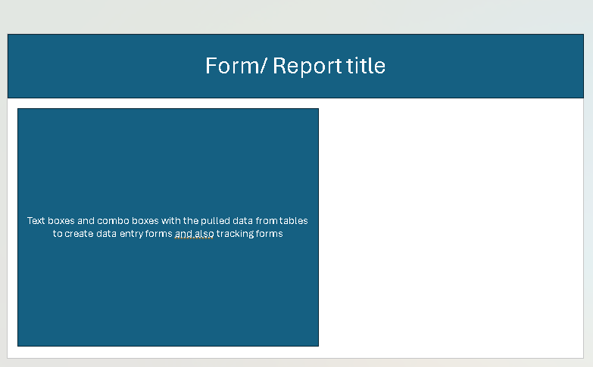
Figure 6 - form/report designs'

