Module code and name: ECAD7003 – Learners, Schools & Communities: Where am I teaching?

Module lead: David Stacey

Assignment title: How a school develops one aspect of its SDP: a report that critically reflects on the actions, impact and evidence and evidence base

Permitted word count: 2500 (+/-10% 2250-2750)

Due date: 17/04/2023

Student number: 1800054

Word count: 2749

Submission date: 17/04/2023

 | Targed/Target | Yr hyn yr wyf wedi’i wneud yn yr aseiniad hwn….  What I have done in this assignment….
Targed/Target 1 | Take care when referencing. | Referred to the UWTSD Harvard referencing document when referencing.
Targed/Target 2 | Ensure I use a wide range of literature. | I used a variety of literature throughout my essay.

Introduction
A school development plan (SDP) outlines the targets set out by the school and its stakeholders. An English-medium school located in South Wales will develop its approaches to teaching and learning pedagogy in line with the Curriculum for Wales (CFW) (2022). In reference to BERA 2018, the school's information will be kept anonymous and referred to as ‘School X’ within the essay. School X has 411 full-time pupils from nursery to year 6, and the focus of the school's last Estyn report (2019) was on the standards the school provides for its learners, which has driven this specific target identified in the SDP.
I will be exploring how the school's development plan is implemented within the school and how the school focuses on the improvement of a specific target that they have set out. This essay will outline how the school specifies its targets for improvement and the impact that improvement provides for the school and its learners through its action plan. Additionally, the essay will analyse the strategies and resources used by School X to achieve their improvement targets and how they monitor and evaluate progress towards achieving these targets.
Literature review
To attain high standards and aspirations for everyone, the main goal of school improvement is to assist students in having the best learning experiences and outcomes, regardless of their circumstances or backgrounds (Welsh government, 2022). Self-evaluation is key to successfulness according to Demetrious (2012), it provides the school with a clear purpose, evaluating the behaviour and relationships and classroom performance. It allows the school and its stakeholders to analyse and judge the quality of education and to provide recommendations for improvement (Devos, 1998).

The school identifies their current progress and strengths by outlining their attributes and achievements, using this to plan future development by identifying goals and the school’s need for progress. In reference to the Bristol Skills Framework (2020) (appendix 3), in order to set out an effective improvement plan, the school should set targets that reflect the school’s effectiveness, specifying targets that are self-motivated and reflective of the school’s need for improvement (Chang, 2008). Referring to the school’s previous Estyn report (2019), the SDP reflects the desire for academic improvement with the new curriculum coming into force and showcases the need to implement the new skills and pedagogical principles within teaching and learning. Education policies represent the national pivotal of education reform which the SDP should foster (Chang, 2008). Ensuring the SDP subsists an integral part of the school’s purpose (Bristol Skills Framework, 2020; Chang, 2008), the SDP provides the CFW as the driving force for the school’s improvement. Given the standard of academic ability within CFW as a policy for education reform, the SDP outlines how they plan to go about improving the pupils independence and pupil voice within learning. The school’s self-evaluation for self-improvement is the internal part of the SDP, providing critical reflection on the outcomes it delivers for its pupils and clearly identifying the school’s priorities (Department of Education, 2015). The SDP adapts the national policies and school vision to ensure that their focus is intrinsic to the school and its pupils development.

According to the Department of Education (2015), an effective school development plan outlines the actions to achieve their target through strategic planning outlines the action plan for how they will measure the impact. Through doing this, the SDP specifies the objectives the school needs to focus on, identifies the means of measuring the impact, creates a clear structure, and provides collective and clear whole-school expectations, bringing clarity to the roles and responsibilities of all staff assisting in the improvement of the school (Welsh Government, 2022).

It is the Board of Governors duty as stakeholders to revise and prepare the SDP according to Article 13 (Education Order, 1998). The stakeholders help the school identify the areas for improvement that need to be implemented in the SDP. In order to create a SDP that is motivated by the school’s need for improvement, it is important that all members of the school are able to reflect on the SDP (Education Order, 1998). The stakeholders involvement is essential to creating an effective SDP (Freiburg, 1999), providing quality progress within the school, and are central to the decision-making process (Hoy and Miskel, 2001), as they are responsible for both internal and external change (Fullan, 1991). The stakeholders are key to the SDP as they provide decisions about how improvements are measured (Goldstein, 1995). The staff’s involvement in the SDP has been successful, according to an Estyn’s (2019) report of a SDP, through developing new initiatives, reflecting on certain areas to which the staff has been assigned, creating a collaborative approach, monitoring progress and identifying areas for improvement, and increasing the staff’s attitude towards evaluation (Fullan, 2001). This process exercises the teacher’s leadership responsibility to support the development of all staff, creating a whole school ethos (Estyn, 2019). Staff’s involvement aids school in identifying the improvements needed and the action plans, as well as other priorities, including the cost and the deadline, to ensure a cohesive approach (Fullan, 2001; Rosenholtz, 1991).

The school’s parental involvement in developing the SDP collaboration and removes barriers which separates the schools and family life (Lewis, 2018). According to Harris and Goodall (2007) “parental engagement in children’s learning makes a difference” because by engaging parents with how the school evaluates its need for improvement, it improves pupil engagement and communication between teachers and parents, as parental engagement “is the most powerful school improvement lever we have”. This suggests that having parents involved in the self-evaluation process could offer new insights to the school coming from a parental perspective which will affect pupil behaviour according to the Welsh government (2018) and Neehyba (1999) shaping educational outcomes (Appendix 3). Parental engagement in pupil learning and school community is beneficial according to Rewriting the future (2014), however, this isn’t always the case according to Crawford (2021), parental engagement in a child’s learning can cause disturbing behaviours including difficulties with self-regulation as research suggests also impacting academic achievement associated with control and critical thinking.

Demonstrating appropriate time scales within the SDP provide a clear structure for priorities that will raise the standards for the school, they allow the school to monitor the progress through termly review meetings. Outlying timescales, cost and the people responsible for the action plan objectives provide an effective SDP, it provides a constant reflected self-evaluation through performance management (Chang, 2008). An affective SDP outlines the cost needed within the SDP, providing more detailed strategic planning also identifying cost for staff training or supply days which further implies the action plan (Welsh Government 2022).

Developing an action point
The schools self-evaluation has been driven by their previous Estyn report (2019) to identify the focus on the areas of improvement drawing from the need to improve teaching and learning pedagogies to ensure teachers are encouraging pupil independence throughout the learning, suggesting the need for a continuous whole school approach to independent learning, ensuring all staff are taking every opportunity to encourage the pupils to learn independently. Drawing from the schools Estyn report (2019) ensures that schools are effective in their self-evaluation process, as inspections can have a significant role when identifying improvement (Estyn, 2016). School X has identified this target through observing good progress prior to covid, this target was implemented through schools need to revise and continue to embed the pedagogical principles within the school encouraging learners to take responsibility for their own learning and promote problem solving and critical thinking within their learning (impact.wales, 2018). This ensures that the schools direction is monitored through the need to improve its learners standards.

The School’s vision ‘work and preserver to succeed’ has been used to motivate their SDP, ensuring their targets are central to the school and continuing to raise the standards for student outcomes (School X, 2022). Being an intrinsic part of the schools self-evaluation process, the school vision ensures that they are providing the best possible outcomes for the learners, however the school vision might not mirror the school’s identification for improvement (Berwick) but the target will still be an intrinsic part of the school’s improvement to create improvement for its learners.

The school analyses the data collected continuously within the monitor, evaluate and review (MER) processes which are carried out by the school staff, allowing the school to identify possible needs for improvement. Through learning walks, MER book reviews and pupil voice, they can see that independent learning had developed well prior to COVID-19 but has been impacted by seeing less independent learning and pupil voice within the learning. Continuous MER meetings allows the school to evaluate their approaches to teaching and learning through continuous self-evaluation and reflection.
Planning strategically
The SDP has clearly outlined the expected outcomes that they intend to have at the end of the academic year aiming for independent learning and pupil voice being of good quality and there should be consistency and progression across the school. The school has broken down the main aim to review elements of teaching and leading pedagogy in line with CFW 2022 into three smaller, more specific targets; one of the smaller objectives outlines the need “to review provision for independent learning and pupil voice across the school” (Appendix 1).

Through wider research the school can develop approaches to pedagogical thinking in relation to feedback to ensure that learners are progressing in their learning and are still promoting independent learning, through analysing information through hwb (Welsh Government site which supports teaching and learning) to identify good practice and evaluating against the school’s current provision. This allows the school to continue their professional learning and ensure their pupils are attaining high standards as part of the school vision (Berwick). The SDP outlines the timescale in which the school aims to achieve these objectives, aiming to achieve the objectives every end of term, this timescale gives the school and the stakeholders a realistic approach to attain achievable targets (Welsh Government, 2021).

Data analysis
The staff input on the SDP is evaluated from MER meetings conducted by different members of staff who are responsible for certain aspects of the school, review different books and planning from all classes within the school, as well as conducting meetings with the pupils in order to identify strengths and ways to move forward. This is then monitored and reviewed by the head teacher who conducts the schools areas of improvements. This allows the school to monitor the improvement through reviewing at a later date through feeding back to the other staff in a staff meeting.

Through staff meetings it ensures a whole school approach and all staff understand the pedagogical approaches to feedback, ensures that the stakeholders are part of the cohesive approach (Brighouse, 1995). Providing an effective way to ensure all staff are demonstrating a collective approach across the school providing high suitable standards for the pupils (Estyn, 2016) through leading a whole staff discussion of the current position and updates, it allows all staff to know where the school is in their action plan.

Measuring the impact
The SDP lays out the impact that these action points have on the school achievable collaborative and sustainable approach. The school outlines the baseline in which the school is currently at from the last set of results “Independent learning had developed well prior to COVID-19 but was impacted during lockdown and students independence in their learning has been affected as well as the use of pupil voice” (Appendix 1). The school outlines their targets and expected outcomes by the end of the academic year, where independent learning and pupil voice should be of good quality across the school, observing consistency and progression across the school, the school measures the impact of the success that they have achieved through evaluating whether they have reached the overall outcome.
The school will continue to conduct MER meetings to evaluate the progress the school has made and can evaluate whether there is more to be done to attain the objectives.

Reflection and evaluation
On the SDP feedback has provided that the objective to review provision for independent learning and pupil voice across the school is still ongoing and INSET days and staff meetings have been used for research of the current pedagogical thinking in relation to feedback for pupils to develop a new way forward. From this, the school has implemented learning powers which encourage the learning to adapt positive learning habits to encourage independent learning and building initiative and determination to learn (Claxton, 2018). The school adapting different animal characters to encourage essential tools for adaptive learning, these learning powers have been adapted from research within the growth mindset and developing resilient and enthusiastic learners (Dweck, 2006). The school implements these particular skills across the school, which have been revised and evaluated by the SLT and all staff to ensure a collective approach.
From research the school is encouraging its learners to structure their own success criteria, developing independent thinking, working out how to get to the end goal before setting off on the task without the teacher demonstrating the steps to success. This has come from research by McGonagill (1992) and Stigler (1999) states that providing self-advocacy enhances student independence and academic success and promotes resilience to learning.
By using INSET days and staff meetings to conduct research and feedback to the staff about how to improve pedagogical feedback given what they have done well to identify evidence of good practice and a next step to improve to motivate learners to continue independently (Juwah, 2004). This objective focuses on how the school has provided research to improve independent learning but they fail to state how they will improve pupil voice or any direction on how pupil voice has been improved, therefore the school can continue to break down the aims into smaller objectives and focus on how to ensure all the objectives of the SDP are met and continue to improve.

The SLT’s learning walks conduct informal observations to observe the specific area of education in order to conduct a review of the independent learning. Learning walks provide an element of realistic observation of how teachers conduct independent learning, providing critical feedback to continue to improve learning (Malone, 2022; Estyn 2021), however, this alone doesn’t provide an overview of the independent learning (Griffin, 2022) along with the MER meetings, it provides a more in-depth realistic overview of how the staff provide independent learning, through pupil interviews, book reviews.

Involving stakeholders within the school’s self-evaluation process impacts the students achievement, a study conducted by Demetriou (2012) identifies an effective and wholesome approach. Within the SDP, there is a lack of parental involvement directing the self-evaluation process. The involvement of students, parents and the wider community is a critical factor to determine the success of the evaluation process (McTaggert 1997; Coleman 1998; Hopkins 2001), as it encourages active participation of pupil engagement in learning. Even though the school has its own responsibility for quality (Hofmann et al, 2010), parental involvement benefit the pupil’s learning, identifying areas of improvement from a parental perspective. School X could provide parental participation through letters home and contact through social media, however, there are limitations to receiving parental engagement such as time, ability and access.

Conclusion
This research into the SDP aimed to explore the impact school improvements can have on the holistic approach to the school and its learners. While an in-depth exploration into the SDP enabled me to uphold a deeper analysis, there are limitations of evaluating the impact of the SDP without seeing the whole progress the school is able to make, knowing the improvements can be ongoing further to the SDP, which potentially hinders the evaluation.
To further enhance the exploration of the SDP, pupil and staff interviews could be a way forward to claim the perceptions of the first-hand experience the school has developing their SDP.

This has proven to be beneficial for my future practise by influencing my leadership aiding me with recommendations for my future practise through research identifying the priorities of the school in line with the Welsh priorities in policies and guidance. This research of the objectives within the SDP has influenced my practise with how the school staff measure pupil voice, independent learning and parental involvement in learning outlying the benefits parental involvement within the SDP can have on learners outcomes encouraging good wellbeing and progression aligning with Bronfenbrenner’s Ecological systems theory (1979) (Appendix 4) attaining the pedagogical learning standards (Welsh Government, 2019).

Appendices

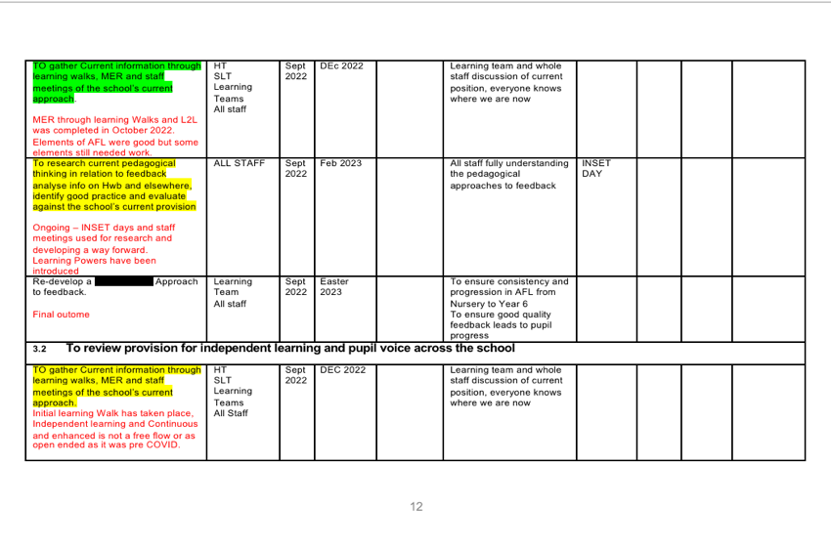
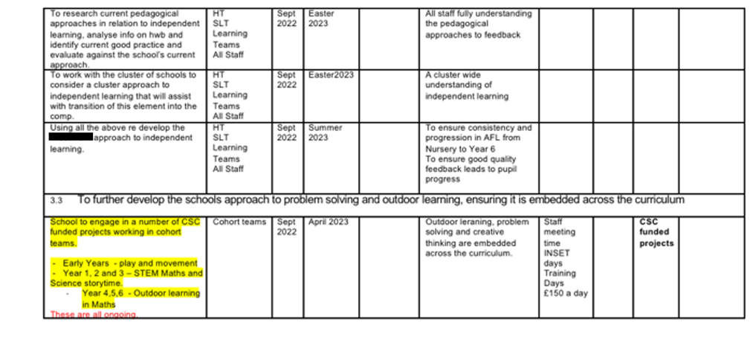
Appendix 1- School X’s School Development Plan.
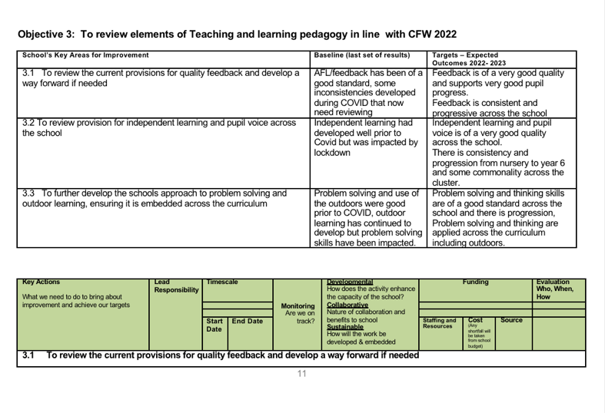
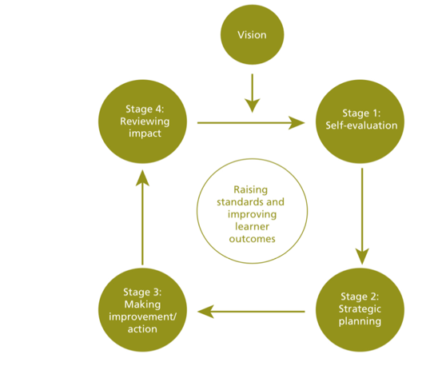
Appendix 2- School Development Planning Cycle.

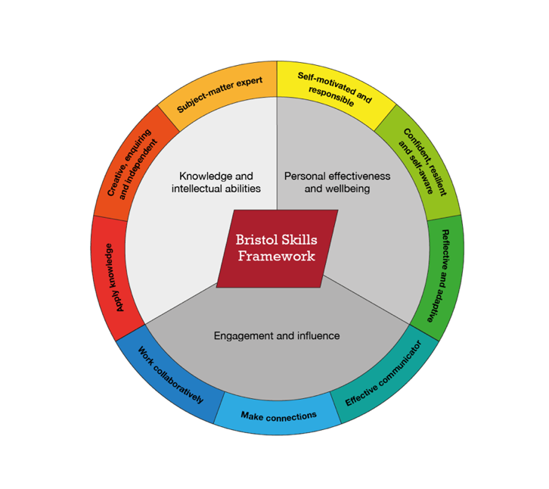
Appendix 3- Bristol Skills Framework (2020)

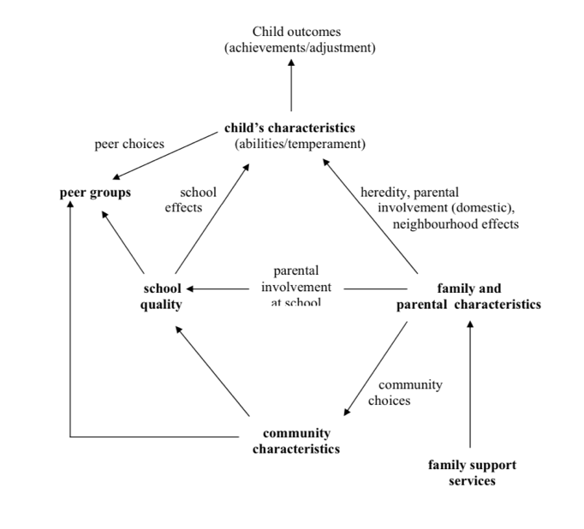
Appendix 4- Forces shaping educational outcomes (achievement and adjustment) Adapted from Neehyba et al (1999). (Desforges, C at al. 2003)
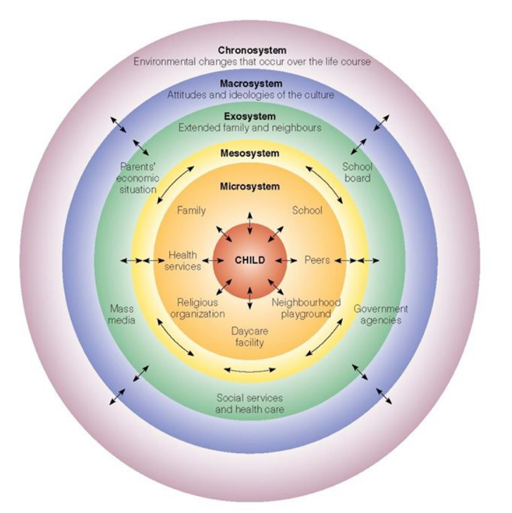
Appendix 5- Bronfenbrenner’s Ecological system (1979). (Teach First, 2022)

References

Ager, A. Et al. (2023) What are the 12 pedagogical principles & how to use them, Impact Wales. Available at: https://www.impact.wales/new/12-pedagogical-principles/ (Accessed: 3 April, 2023)

Berwick, S. (No date) Vision and School Improvement Priorities, Bromley Educational Trust. Available at: https://bromleybeaconacademy-Bromley.org.uk/about-us/vision-and-school-improvement-priorities (Accessed 5 April, 2023)

British Educational Research Association (BERA). (2018). Ethical Guidelines for Educational Research. 4th edn. London: BERA

Bristols skills framework. (No date). Available at: https://www.ole.bris.ac.uk/bbcswebdav/courses/Study_Skills_2016/PDP/Skills%20framework/index.html#/id/5f3d46bd02b59503800af557 (Accessed on: 27 March, 2023)

Chang, G.C (2008) Direction in Educational Planning: Symposium to Honour the Work of Francoise Caillods.

Claxton, G. (2018) The Learning Power Approach: Teaching Learners to teach themselves. Thousand
Oaks, CA: Corwin, a SAGE Company.

Coleman, P. (1998) Parent, student and teacher collaboration: the power of three (Thousand Oaks, CA, Corwin Press)

Crawford 2021) Study reveals impact of Too Much Parental Involvement, Standford News. University of Stanford. Available at:https://news.Stanford.edu/2021/02/11/study-reveals-impact-much-parental-involvement/ (Accessed: 6 April, 2023).

Demtrious, D. Kyriakides, L (2012). The impact of school self-evaluation upon student achievement: a group randomization study, Oxford Review of Education, 38:2, 149-170, DOI: 10.1080/03054985.2012.666032

Department of Education Strategic Planning (2015) Education. Available at: https;//www.education-ni.gov.uk/department-education-strategic-planning (Accessed 24 March, 2023).

Desforges, C. (2003). The impact of parental involvement, Parentalsupport and family Education on Pupil Achievements and Adjustment: A literature Review. Available at: https://dera.ioe.ac.uk/6305/1/rr433.pdf (Accessed on: 6 April, 2023)

Devos, G. (1998) Conditions and caveats for self-evaluation: the case of secondary schools, Paper presented at the Annual Meetings of the American Educational Research Asociation, San Diego: (ERIC Document Reproduction Service No. ED421493).

Donalson, G. (2015). Successful Futures: Independent Review of Curriculum and Assessment Arrangemeents in Wales. Available at: https://gov.wales/sites/default/files/publication/2018-03/successful-futures.pdf (Accessed 7 April 2023).

Dweck, C.S. (2006) Mindset: The New Psychology of Success. London: Robinson.

Education (Northern Ireland) order 1998 (1998) Legislation.gov.uk. Government Printer for Northern Ireland. Available at: https://www.legislation.gov.uk/nisi/1998/1759/content/made (Accessed 3 April, 2023)

Estyn. (2016) Leadership and primary school improvement. Available at: https://estyn.gov.wales/system/files/2020-07/Leadership-and-primary-school-improvement- new-links_0.pdf. (Accessed on 6 April, 2023)§

Estyn (2019). A report on School X primary school. Available at: https://www.Estyn.gov.wales/systems/files/2019/SchoolX%20Primary%20School.pdf (accessed 25 March 2023).

Estyn. (2021). Supplementary guidance: Lesson observations and learning walks. Available at: https://www.estyn.gov.wales/book/print/pdf/20555 (Accessed: 6 April, 2023)

FaCE the challenge together: Family and community engagement toolkit for schools in Wales: Main Guidence. (2015). Available at: https://www.gov.wales/sites/default/files/publications/2018-12/face-the-challenge-together-family-and-community-engagement-toolkit-for-schools-in-wales-main-guidance.pdf (Accessed on: 1 April 2023)

Freiburg, H. J. (Ed.) (1999) School climate: measuring, improving and sustaining healthy learning environments (London, Falmer Press).

Fullan, M. (2001) The new meaning of education change (3rd edn) (New York, Teachers College Press)

Fullun, M., & Stiegelbauer, S. (1991). The new meaning of educational change. New York: Teachers College Press.

Griffin, B. (2022) The what, why, and how of Learning Walks, Learner. Available at: https://learnercentered.org.learning-walks-what-why-how/ (Accessed: 6 April, 2023)

Goldstein, H. (1995) Multrilevel statistical models (2nd win) (London, Edward Arnold).

Harris and Goodall (2007) Engaging parents in raising achievement- Do They Know They Matter? Taylor & Francis. Pg.70 DOI:10.1080/00131880802309424

Hofman, R. H. Hofman, W. H & Gray, J. M. (2010) Instiutional context and international performances in schooling: comparing patterns and trends over time in international surveys, European Journal of Education, 1, 153-173ching standards

Hopkins, D. (2001) School improvements for real (London, RoutledgeFalmer).

Hoy, W. K & Miskel, C.G. (2001) Educational administration: theory, research and practice (Singapore, McGraw-Hill)

Juwah, C., et al (2004). Enhancing student learning through effective formative feedback. Pp. 45-65. Availave at: https://doi.org.10.4325/9780203934333-11

Malone, E. (2022) “Why a learning walk is a must for all governors after the pandemic”. Tes Magazine. Available at: https://www.tes.com/magazine/leadership/compliance/why-learning-walk-must-all-governors-after-pandemic.

McGonagill, G. (1992). Overcoming barriers to educational restructuring: A call for “system literacy”. ERIC, ED 357-512.

McTarggert, R. (1997) Participatory action research (New York, Albany).

Rewriting the future: Raising ambition and attainment in Welsh schools (2014). www.gov.wales/topics/educationandskills/schoolshome/deprivation/rewriting-the-future- schools/?lang=en (Accessed on: 1 April 2023)

Rosenholtz, S.J. (1991) Teacher’s workplace: The Social Organization of Schools, Semantic Scholar. Available at: https://www.semanticscholar.org/paper/Teacher’s-workplace-%3A- the-social-organisation-of-Rosenholtz/e1d691dc557021350c40bfcdb7dda4a77a (Accessed on: 6 April, 2023)

School X (2022). School X Primary School. Available at: https://www.XXXXprimary.org.uk (Accessed on:3 April, 2023)

Stigler, J.W., & Hiebert, J. (1999). The teaching gap: Best ideas from the world’s teachers for improving education in the classroom. New York: Free Press.

Teach First research roundup (2022) TeachFirst. Available at: https://www.teach first.org.uk/blog/research-roundup-may-2022 (Accessed on: 6 April, 2023)

Welsh Government (2019) Professional standards. Hwb. Available at: https;//hwb.gov.wales/professional-teaching-standards/ (Accessed: 8 April, 2023)

Welsh Government. (2021). School improvement guidance: framework for evaluation, improvement and accountability. Available at: https://www.gov.wales/sites/default/files/consultations /2021-01/210126-school-improvement-guidance-consultation-document.pdf (Accessed on: 6 April, 2023)

Welsh Government. (2022). Introduction to the Curriculum for Wales Guidance. Available at: https://hwb.gov.wales/curriculum-for-wales/introduction (Accessed on: 17 March, 2023)

