
Assignment 1 – ACCA5012
Alan Hather - 1903410

Contents
Task 1 – Application Development Concepts 2
Task 3 – Report 3
Introduction and Requirements 3
Design and Implementation 4
Screenshots 5
Evaluation – Browser & Mobile Compatibility 7
Test Case Summary/Description 7
Preconditions or Prerequisites 7
Test Steps & Data 7
Expected Result 7
Actual Result 7
Status (Pass/Fail) 8
Evaluation – Google Map API 8
Test Case Summary/Description 8
Preconditions or Prerequisites 8
Test Steps & Data 8
Expected Result 8
Actual Result 8
Status (Pass/Fail) 8
Overall Evaluation of Site 8

Task 1 – Application Development Concepts

There are multiple web application trends that are currently being used in a variety of ways. Below are a few examples of the trends currently being used in 2019:
- AI & Bots
- JavaScript
- Progressive Web Apps
- Single Page Applications
- Mobile-Friendly Websites
- Motion UI
- Blockchain Technology
- Cybersecurity
For my research, I decided to look into Blockchain Technology. Blockchain Technology is a new trend that has been highlighted in the media due to its technology being used in crypto currencies.
Blockchain was first established in 1991 by research scientists Stuart Haber and W. Scott Stornetta. It was introduced as a solution to time stamp digital documents, so that they could not be backdated or tampered with. The name “Blockchain” comes from the process of storing information in blocks and linking them together, in this case to store the digital stamped documents. This technology, however, went unused and the patent lapsed in 2004. [1]
In 2008, Satoshi Nakamoto issued a white paper to propose Bitcoin as an electronic payment system based on a decentralised peer-to-peer network, without the need for a third party. [2]
Delving deeper into research on Blockchain Technology, I found an interesting article written by Hannah Halaburda. Her article explains how the suggested benefits of Blockchain does not come uniquely from Blockchain Technology itself. The article explains that the technology may benefit companies by enabling cost savings due to transactions being quicker, safer and decentralised. Although there is confusion around what Blockchain is and that the proposed benefits of encryption and automated transactions do not actually need Blockchain.
The confusion comes from the media branding the technology against the bitcoin system and its properties being “distributed, secure, public, permissionless, and will operate without the need for a trusted third party.” [3]
The writer then discusses the ideas of encryption, automated transactions and distributed ledgers, which are conceptually separate and that Blockchain, as a term, has aggregated these. She considers it important that the concepts are kept separate due to the estimation of costs, benefits or until a prediction of the best use of Blockchain Technology is found.
Within the journal the writer engages in the benefits of using this technology and considers its main benefit as being used as a distributed ledger. This allows multiple parties to add transactions to a shared ledger, which is the concept of a shared database that is synced across multiple sites, allowing a public witness. However, it’s stated that it has been difficult to create a decentralised, permissionless and safe Blockchain to transfer assets other than the native crypto- currency. [3]
The writer reflects on the future of what Blockchain will be and the impact on other industries other than its limited use in finance. She envisions Blockchain has given industries tools to change, but “since the benefits of encryption and smart contracts can be realised without a distributed ledger, the world after the Blockchain revolution may well be a world without the Blockchain”. [3]
This was an interesting article and I agree with the writer’s views. Although there are now known crypto companies such as Ripple working with centralised banks to improve asset flow and the speed of transfers using its XRP platform. This also strengthens her case that Blockchain would be difficult to become a decentralised and permissionless platform.

Task 3 – Report

Introduction and Requirements
For the application software task, I decided to recreate my own work’s website, which aims to inform parents and families of the Maternity and Neonatal services that are provided in Wales. I wanted to design a more modern, mobile friendly site to bring it up to date with current technology, as well as adding in more interactive features to also improve the user experience.
The site contains 6 pages which include a home page, a footer with additional contact information, an overview of the Network, upcoming events with links to the agendas, an interactive map of the locations of the Health boards across Wales, as well as a contact form that end users can use.
Having used one HTML page for the whole site, I have sped up the user experience as there is now no loading or waiting times for individual pages.
One requirement for the application was to be browser independent. In order to accomplish this I have kept the website quite simple to allow for cross browser compatibility. I have also tested in multiple browsers, iteratively enhancing the code to remove bugs.
To ensure a mobile first strategy I used Bootstrap 4 which makes the containers fluid, meaning that columns will restructure across all platforms. Media Queries is another way I was able to ensure mobile compatibility. This is a type of CSS style used to change the content and design of the site dependant on the characteristics of the device being used. For example, it is used to fix the headings and buttons on the page to resize when using a mobile device.
Another requirement was to have some form of interactive functionality. I have implemented this throughout the website in various ways to make the user experience as simple and effective as possible:
- To start I used a navigation bar to move freely throughout the site, which is explained in more depth below.
- Another example is the use of buttons in multiple formats to allow the user to navigate, send or view information as required.
- An interactive map has also been used, where users are able to view information on their selected Healthboard location. To create this, I used Google maps with two layers of data. The first layer being the Healthboards and the second being the Units associated to these. This was then embedded into HTML with CSS styling to ensure the map is responsive.
- A contact form was added on the Contact Us page to allow users to send comments/questions into the Network. For this I used the ‘form’ class within Bootstrap for the input fields.
The final requirement was for a Web API. Using JavaScript, I was able to use this API to display a Google map which shows users the location and building name of our offices.

Design and Implementation
The overall theme of the website uses the Welsh Maternity and Neonatal Network colour scheme, which keeps it on brand as well as giving the site a professional appearance.
A navigation bar flows across the top of all the pages for consistency as well as provide easy access for the user across pages. I have used CSS hover important functionality so that when the user hovers over the various page names they change colour, which again helps make the navigation easier for the user.
Users are also able to navigate to other pages by simply scrolling up/down through the website. To make the change in pages clearly visible to the user as they scroll through, I used a Jumbotron in Bootstrap so that the containers alternate background colour, which makes each distinctive against each other.
This scrolling functionality is also linked to the Navigation Bar as the page names will change colour to highlight which page the User is currently on. In order to do this, I used navbar links to the pages and CSS with the ‘active’ and ’hover’ action.
Keeping within the mobile first strategy the display of the Navigation Bar would have to change depending on the device. For browsers the page names being displayed across the top works as intended, however for mobile devices this wouldn’t be visually pleasing to the user or fit across the screen appropriately. In Bootstrap there is a class called ‘toggler’ that allows the navbar to collapse into a drop-down menu.
To add extra design to the website and enhance the user experience I added icons from a ‘font awesome JavaScript’ source and styled within CSS to change the colours of the icons.

Screenshots

Home Page
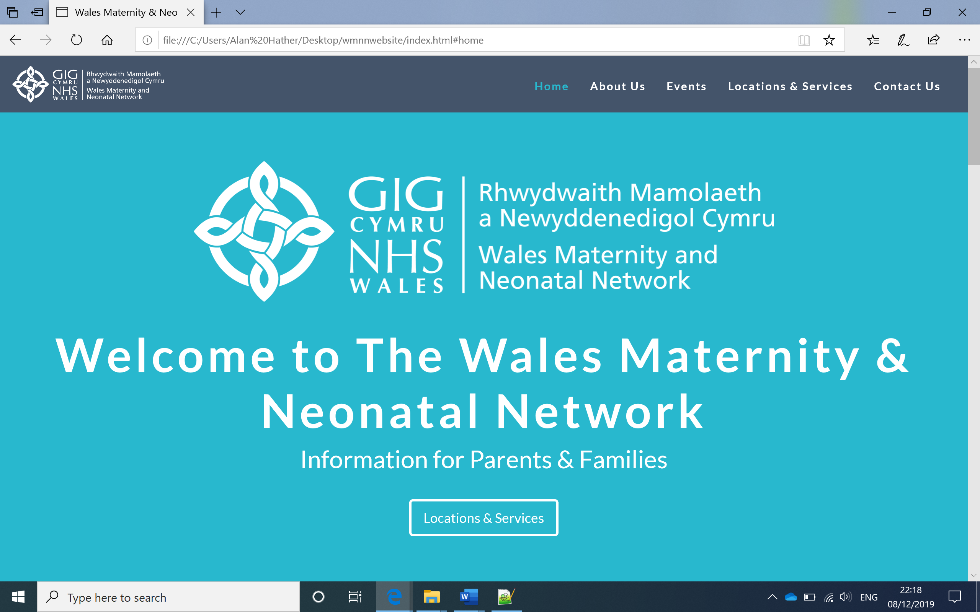

About Us & Events Pages
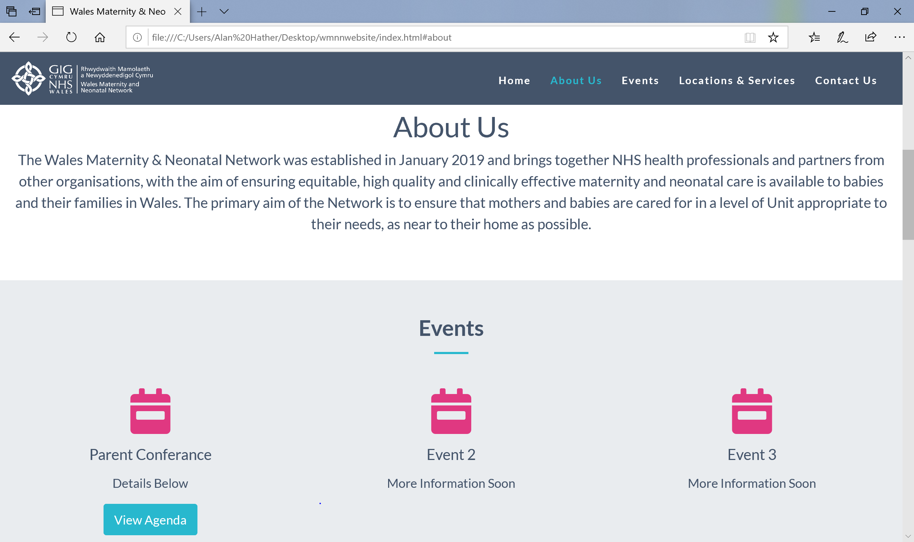

Locations & Services Page
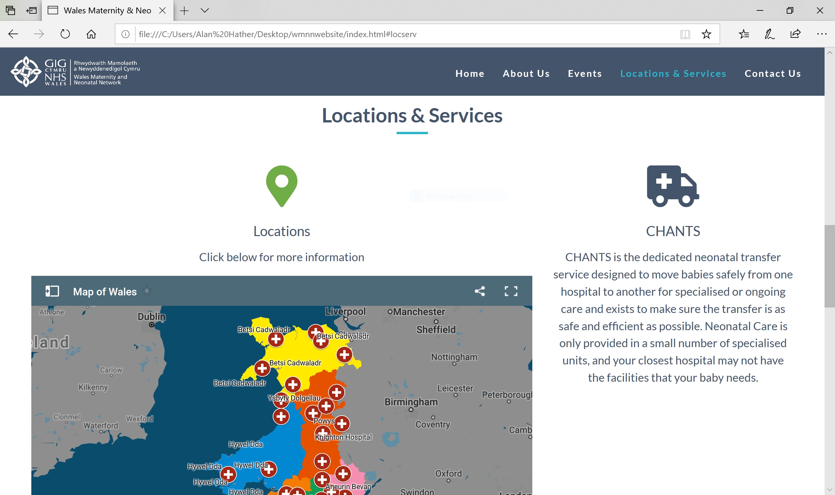

Contact Us Page
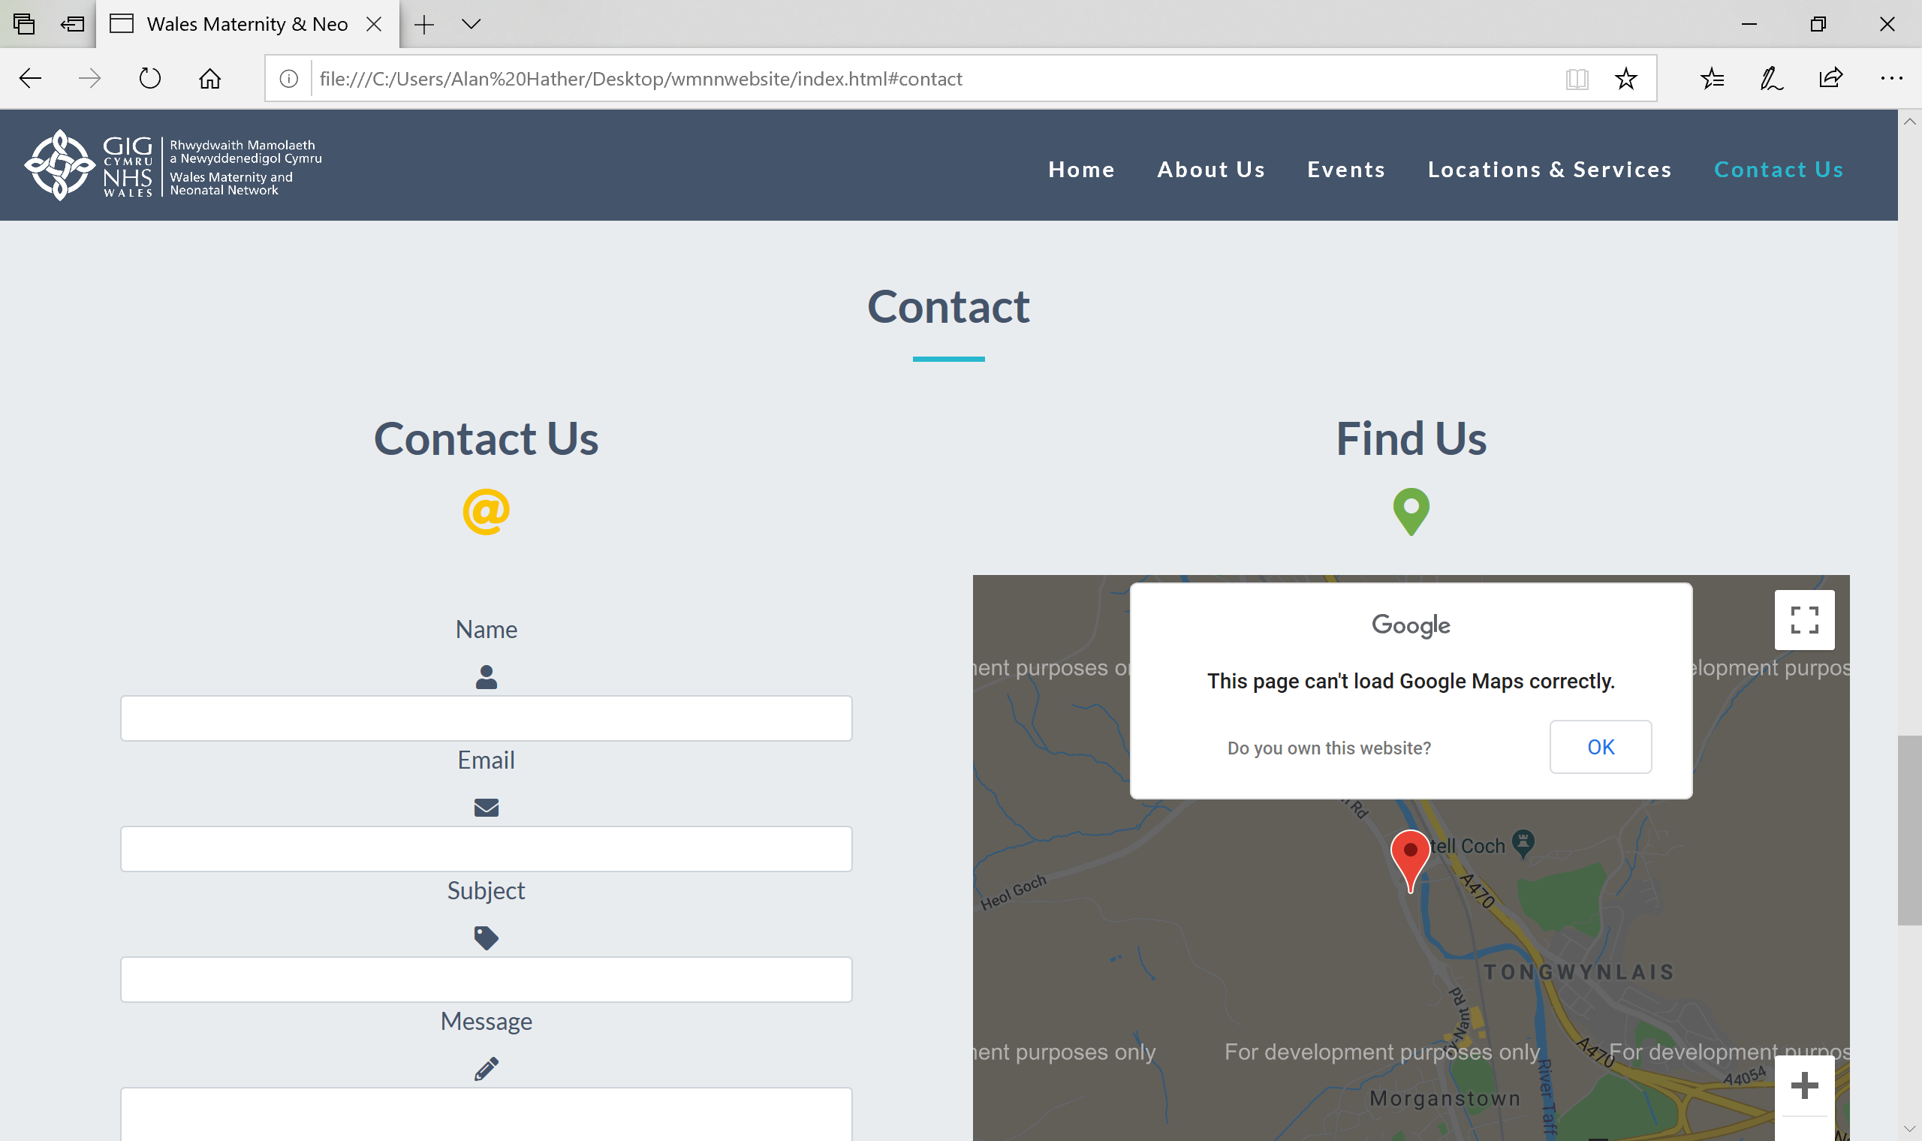

Footer
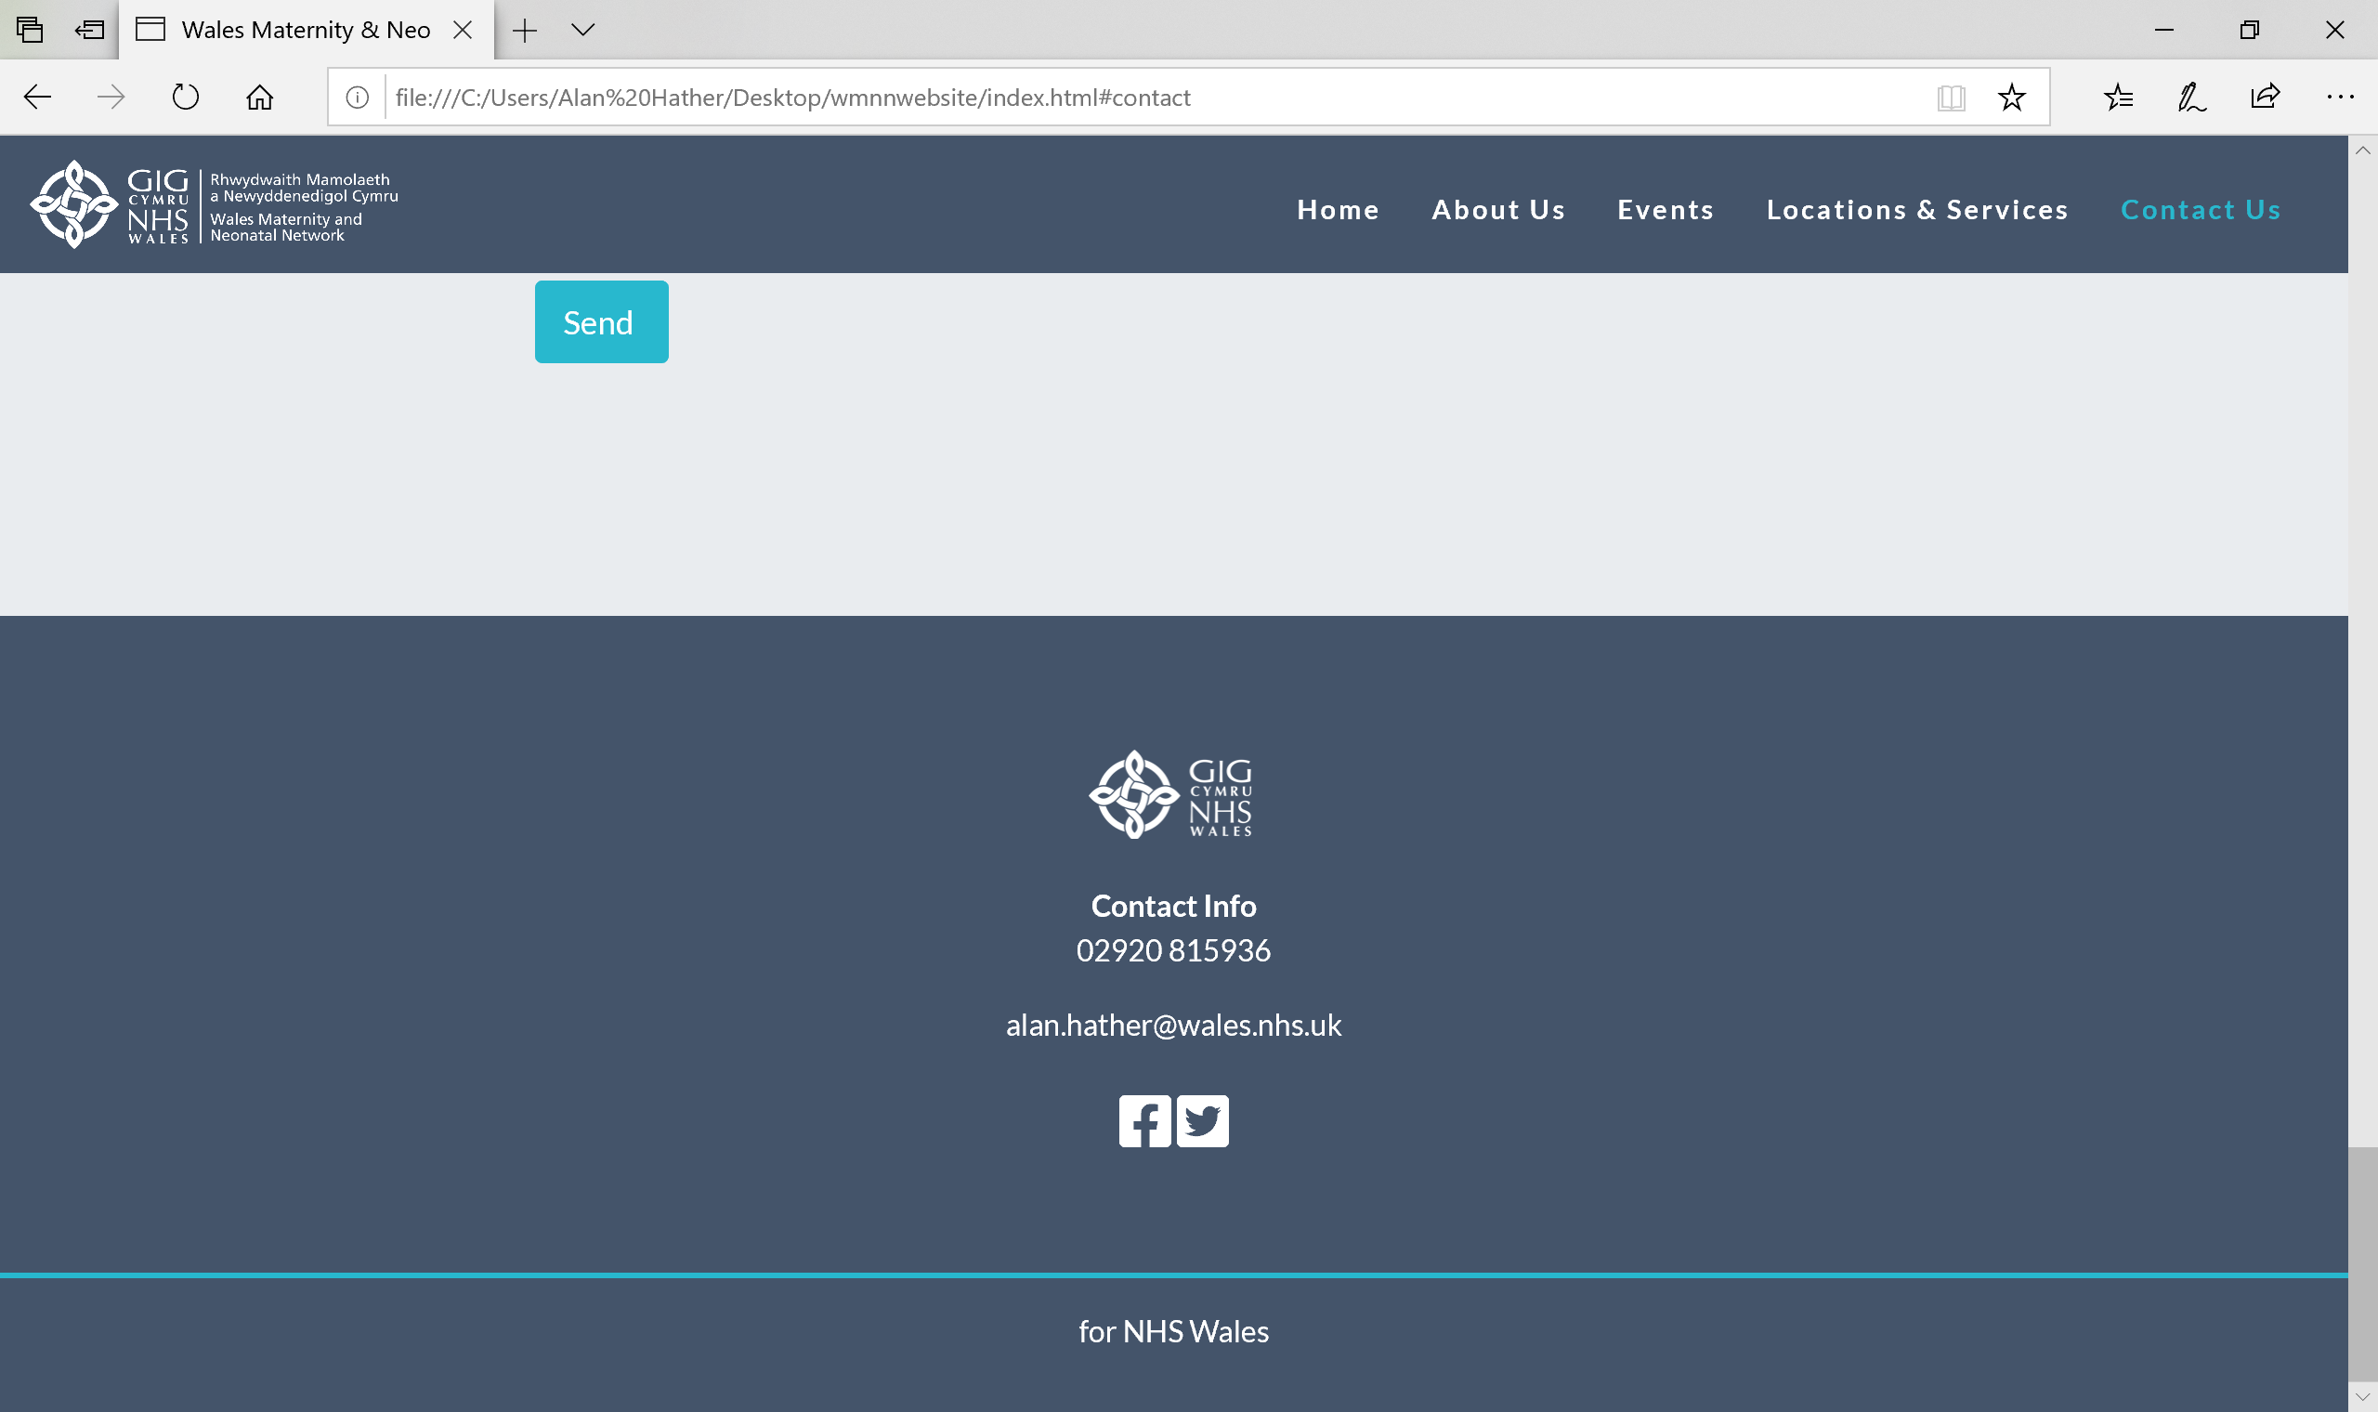

Evaluation – Browser & Mobile Compatibility

Test Case Summary/Description
One of the requirements was for the Website to be Browser and Mobile Compatible. To ensure that this was the case I had to test this functionality across multiple browsers and mobile, making sure that the website looks and performs as expected.

Preconditions or Prerequisites
Access to multiple browsers on my laptop to test this functionality.

Test Steps & Data
- Opened the code in various browsers e.g. Google Chrome, Microsoft Edge
- Resized the page and scrolled through the website
- Test all functionality, links, interactive experiences etc. work as intended

Expected Result
When using different browsers and resizing the page we would expect the content to resize appropriately to the screen, the navbar to collapse to a drop-down menu, columns to realign underneath each other and scrolling up/down through the pages to flow smoothly with no changes. I would also expect all buttons and links to work across browsers.

Actual Result
- All results when resizing the page were as expected.
- All buttons/links worked correctly.
- Images in Google Chrome did not appear throughout the site whereas for other browsers this was fine. This is due to images being used as a PNG file rather than JPG and so does not display properly.
- In Microsoft Edge when scrolling back up to the Home page this appears blank, again in other browsers this was not an issue.

Status (Pass/Fail)
Fail due to inconsistencies across browsers.

Evaluation – Google Map API

Test Case Summary/Description
The JavaScript API on load of website should show the location and building name of our offices on a Google Map. I tested this functionality to ensure that this displayed accurately on the Website.

Preconditions or Prerequisites
None for this test case.

Test Steps & Data
- Load the Website
- Ensure the map shows the location and name of building correctly
- Test against the location in Google Maps also, to validate the accurateness

Expected Result
We would expect the maps to show the location of the offices and name of the building once the Website is loaded

Actual Result
The map loads as expected and displays the correct location and name but shows as ‘development purposes only’. This is due to a billing account not being attached to the API key, which you can view as an error in the console in Google Chrome inspect page.

Status (Pass/Fail)
Pass as the maps works as intended for the task requirement.

Overall Evaluation of Site
Overall the design of the website is a lot more visually pleasing and professional looking than the current Network Website, with the additional features such as the icons and changing colours for navigation making the website more user friendly. The site has the ability to be used across multiple browsers/devices and also provides forms of interaction for the end user.
There are some further developments that could be made to the site. For example, the contact form can be filled in by the user but currently only takes them back to the Home Page. I recognise that PHP is needed to store and send the data but is outside the requirements for this task.
Another development that could be made would be to enhance the interactive functionality of the Google Maps. An enhancement on this API would be to enable the user to get directions from the location on the map.
To make the website more accessible for the end user we could build in a translator so that the pages could be shown in either English or Welsh, to be in line with new Welsh Language standards from the NHS. Also, a text sizer could be added to increase or decrease the size of the text on the Website.

References

[1] | Binance, "Binance Acadamy," 11 11 2019. [Online]. Available: https://www.binance.vision/blockchain/history-of-blockchain. [Accessed 16 11 2019].
[2] | M. Atzori, "Blockchain Technology and Decentralized Governance: Is the State Still Necessary?," University of Nicosia, Cyprus, 2015.
[3] | H. Halaburda, " Blockchain revolution without the blockchain?," Communications of the ACM, vol. 61, no. 7, pp. 27-29, 2018.

