
Student name: Marie Jandova
Student number: 2020984
Programme: CertHE Skills for the Workplace
Module: Effective Team Work and Communication
Module code: BMSW4002
Assignment Title: Effective Team Work and Communication Assessment 1

Lecture: Timothy Hopkins

Contents
1…………………….Acknowledgements, Abstract, 1 Introduction
2…………………….2 Literature Review, 3 Methodology
3…………………….4 Results, Case of study 4.1
4…………………….Case of study 4.1
5…………………….Case of study 4.2
6…………………….Case of study 4.2, 4.3
7…………………….Case of study 4.3
8…………………….References
Acknowledgements
I would like to thank to all my lectures for the support in developing and proof-reading this report. I would also acknowledge my funding that I was able to use to study at this university, as well the input of my Agent which provided me all the assistance to get to this university. This report is written in purpose to show what I have learn in this semester as well as prove my understanding and knowledge about Communication to the audience – the assignment team at the Trinity Saint University. For this written report I used Gibb’s ‘Reflective Cycle’ (1988) Method.
Abstract
This article is about the importance and use of Communication Skills. I will explain what is communication to the detail and what is the difference between Verbal and non verbal communication. I will demonstrate the three models of a communications that exist and we learned them in my second school term.
1 Introduction
This report provides an example structure of Communication models. In this report we will be able to have a deeper understanding of what means the different models of communication. Shannon and Weaver Model, Schramm Model and Berlo Model. We are going to explain each of them with examples applied in case study we have done in the classes in the past. I will then discuss their meanings and study outcomes, my view of point. I’m going to explain how these model can be useful in our future, how we can prevent miss understanding or missing message. I will do conclusion at the end and see how those different communication models can be helpful in the future. And what would I recommend.
2 Literature review
Communication skills are the most important
Communication - sharing information, understanding of the feelings behind this information. Developing communication skills can help us avoid conflicts, compromise and help in better decision making. By improving communication skills, we can improve TEAM WORK. Communication is simply the act of transferring information from one place, person or group to another. We can exchange these information by speaking, writing, or using some other medium. Every communication involves at least one sender (information source), a massage ( and recipient (destination). The transmission of the message from sender to recipient can be affected by so many things. From Emotions through the cultural situation, different language too different location. We have two categories of communication and that is spoken Verbal communication or Non-Verbal Communication. Spoken communication includes face-to-face, mobile phone, television and other media. On the other side, Non-Verbal communication includes body language , how we act and dress, gestures, the way we stand, or move our hands, our face expression. There is many subtle ways that we can use to communicate with others without actually saying anything, perhaps even unintentionally. Most of the time the tone of voice can give us little clue of a mood state, whilst body language - hand signals can add to a spoken message. We also have a written communication which includes letters, e-mails, social media, books, magazines, the Internet and other media and Visualizations which can be maps, logos, graphs. But these all weren’t popular as much until recent times when we have daily access to internet from our phones and laptops from anywhere. Today can basically anyone publish their ideas, books, experiences, information online which was not possible until 2008-2010 because of the internet in the palm of your hand. These days the Non- Verbal communication we have online is on of the most popular and most used.

3 Methodology

To this report I used mixed methods using Qualitative and also Quantitative researching. When I begin my research I used secondary date collected from articles, studies and from university resources, communication skill is long known skill that been discussed and defined in 1948 when the first model of communication was created. Claude Elwood Shannon wrote an article “A Mathematical Theory of Communication” in Bell System Technical Journal with Warren Weave - Shannon Weaver model. Later on Berslo’s and Schramm 1954 models of communication. Analysing the date I have collected people do often communication mistakes, and losing than the information. On these models we will be able to see how the information supposed to be passed from sender to receiver and where some mistakes has happen. When the receiver could not receive the whole message or when he could not understand. Lost message.

4 Results
The transmission error is the NOISE in this case. The feedback will let me know that the message reached incomplete (my Co-Worker asks questions) The receiver gets the chance to get the full message only after my feedback which comes after her feedback when not hearing my message fully. Due to data loss during passing some sort of information from one place to another, people should pay attention to communication more. We have three levels of Communication problems – Technical problems, Semantic problems, Effectiveness problems. Most of these problems that causes data loss in the message are easy to prevent. Both sides Sender and Receiver are very important and both have to consider the “noise” part of the communication to be successful.
4.1 Case Study One – The professor and The village people – Berlo’s Model
LIoyd b. 7//19
A Professor of English at a well-known Welsh University lived in a large house not far from a little village. He never went into the village, but shopped in the town near the University because he had nothing in common with the village people, who were mostly not educated, but did manual jobs.

One night, the professor fell asleep while smoking his pipe and the pipe fell onto the carpet and started a fire.

When the professor awoke and saw the house on fire, he rushed into the village, screaming:

‘The edifice is being consumed by a great conflagration!’

‘The edifice is being consumed by a great conflagration!’

The village people looked at him and continued doing what they were doing

‘Don’t you understand?’ He said . ‘‘The edifice is being consumed by a great conflagration!’

They ignored him.

When the Professor returned home, he saw that his house had been completely destroyed. He sat down on the ground and wept.

The next day, he went into the village crying. ‘Why, oh why didn’t you help me ? My home has been destroyed by the fire. I came and begged you las t night.’ He wept.

‘Bu t Professor, why didn’t you say that your house was on fire? We would have helped.

Description:
Professor’s house was in fire, when he went to the village to ask the village people for help, no one would go and help him. His house was gone the next morning and he went back to than found out why they didn’t want help him.

Feelings:
I feel like the whole situation didn’t have to end up this way, there were some communication mistakes made, that why nobody helped him. Village people would willing to help if they knew what is exactly going on.

Evaluation:
Is good that he tried to talk to them, repeated what is happening ‘The edifice is being consumed by a great conflagration!’ ‘The edifice is being consumed by a great conflagration! and asked ‘Don’t you understand?’ but he never received any positive feedback, they heard him loud and clear, the knew what he was saying, but they didn’t understand him. When he came next morning to ask them why they didn’t help, they said ‘why you didn’t say your house was on fire’ Here we can determinate the error. They didn’t know him, didn’t understand the language he used. If he knew right away he could change his language and approach to the village people.

Source – Professor
Message – ‘The edifice is being consumed by a great conflagration’
Channel – Hearing, seeing
Receiver – Village people

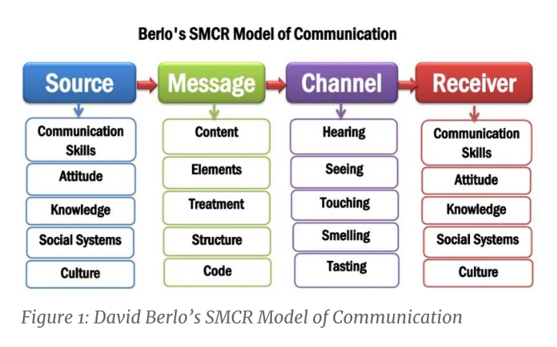

Analysis:
As we can see, these people were the same culture and used the same language with the only difference and that was that village people was less educated and the English he used was too far away from the English they use. In my personal life experience this happen many times. When I came to this country I could not speak English. I used to work in café and this lady asked me plain tap water, we only had tap water with lemon prepared and she repeated ‘pain tap water’ and I again offered her tap water with lemon, she got really upset with me. If she only used simple language with me things could have gone better. She could say ‘can I have water without the lemon in it’ even ‘no lemon please’ and I would understand.
Conclusion:
I have learned that not everyone have the same language, not everyone have the same education, people want to help in many cases but the don’t understand, they don’t know how if we won’t help them to understand, we can use simple language, we can also use body language.
Action plan: Try to be more careful who you talking and what words you chose. How you approach to people.
4.2 Case Study Two – Maria and Pedro
Pedro works on a building site and Maria is his wife.
One day Maria phoned Pedro.
‘Hello, Pedro, when you’re coming home, see if you can get me a chicken.’
‘Okay,’ replied Pedro.
When he got home, Pedro took off his boots and coat and went into the kitchen.
‘Maria, where are you?’ He said.
‘Here –in the sitting room,’ she said.
When Pedro went into the sitting room, Maria said, ‘Where is the chicken?’
‘What Chicken?’ Asked Pedro.
The one I asked you to get on your way home.
’Oh, no! I thought you said when I come home I will see you in the kitchen

Description:
Marie called to Pedro to ask him to buy her something from the shop, Pedro is working on very loud constructions. When Pedro came back home, he found out that Maria wanted him to buy something and he heard completely different message.

Feelings:
Again, situation that they could have prevent by paying more attention and considering the working environment.

Evaluation:
When Marie called to her husband Pedro, she didn’t considered any of the errors such a loud working environment that Pedro was in. It Is good hat he gave her feedback by saying ‘ Okay’ when he thought that he got the message. Wrong that He said ‘okay’ without confirming what she really needed.

Encoder – Maria
Message – ‘when you are coming home, can you see if you can get mem a chicken’
Decoder – Pedro
Feedback – ‘Okay’

Analysis:
She could have simply send him a text message. I don’t think that he paid much attention, he didn’t even ask if he heard correctly. Sometimes I ask people at work to do something when I’m on the first floor and they are on the second, not every time they hear me correctly and I hear ‘yes yes’ very often, than coming back and work is not done.

Conclusion:
We should always make sure that we got the message right, we understood correctly before giving positive feedback. We should also always ask if the other side understood what we requesting from them.
Action plan:
Going to get back upstairs when talk to my colleague to make sure they can hear me okay, I will ask them to repeat maybe to confirm.

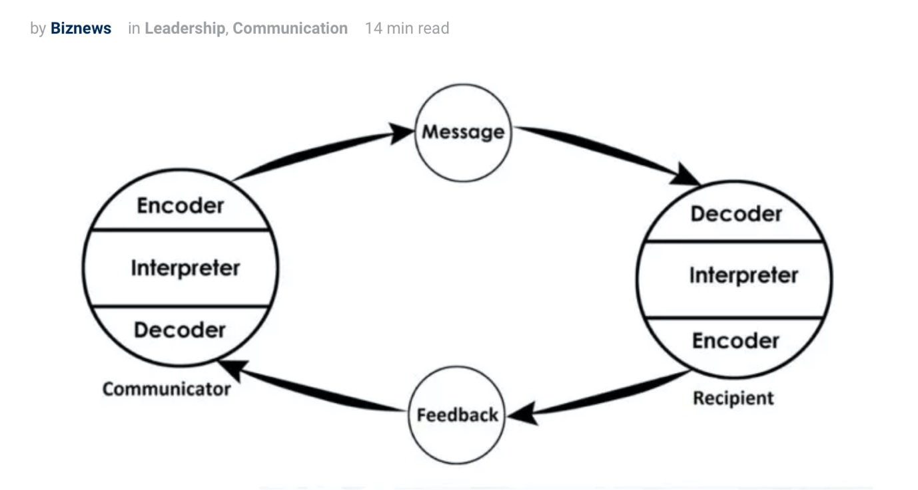

4.3 Case Study Three – Magazine
Shannon and Weaver
An Editor made call to one of the reporter about a meeting happening for important news coverage at 5pm but during his call, noise appeared (transmission error) and reporter received ‘we have a meeting about the important news coverage’ (‘’at 5pm goes missing due to phone network disruption or noise) ‘At what time?’ reporter asked. ‘5pm’ editor said.
Description:
Editor made a call, but unfortunately the reporter didn’t receive the whole message due to transmission error. Likely Reporter asked back ‘what time’ to confirm the time.
Feelings:
Conversation went well, information was passed, received, confirmed.
Evaluation:
Both sides did well, asking the time and repeating the time, Editor could also send text message and maybe add it in calendar.
Analysis:
Sometimes we are really busy at work, so we have to make sure everything goes how is it planned, no mistakes no delayes, we have lots of clients coming in having different requests. In order to stay organised we put everything in diary, repeat to each other, ask each other is we understand the task, if this is what they meant, send text messages.
Conclusion:
Feedback is very, very important to keep teamwork professional without any miss understanding or missing on messages. Message on electronic device can be easily overheard or When there s not feedback you can never be sure that the other half understood. You can hope and that is not enough.
Action:
I will always ask to repeat and give feedback.

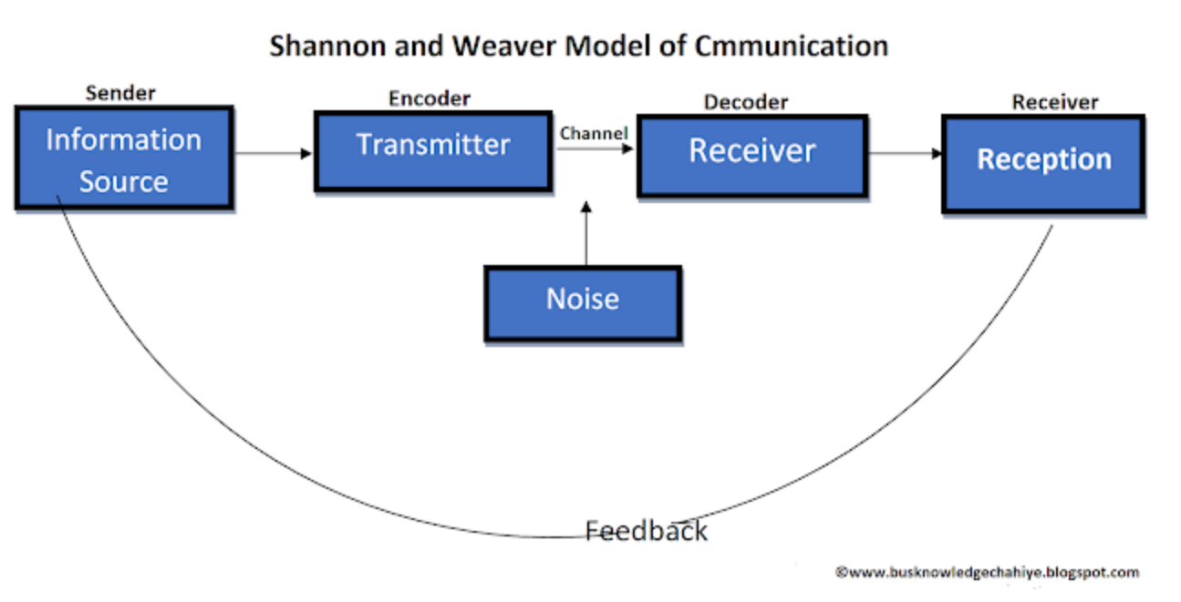

Sender (Information source) – Sender is the person who makes the message, chooses the channel and sends the message.

Encoder (Transmitter) –Encoder is the sender who uses machine, which converts message into signals or binary data.

Channel –Channel is the medium used to send the message.

Decoder (Receiver) – Decoder is the machine used to convert signals and any data into message or the receiver who translates the message from signals.

Receiver (Destination) –Receiver is the person who gets the message or the place where the message must reach. The receiver provides feedback according to the
message.

Sender: Editor
Encoder: Telephone network company
Channel: Mobile network
Noise: Missing time due to disruption
Decoder: Mobile phone
Receiver: Reporter Here again reporter asked (feedback) – At what time?

Conclusion general:
As a team we need to make sure we communicate, we communicate well, communication skill is important acheving goals easily, faster, effectively. It can happen that message we send might get lost, but we can try to prevent it, we can ask questions, communicate, to make sure we understand to each other. We have so many options where to get better, we just have to be more careful.

References
Maund, A. Schriek, M. and Tinkler, P. (2017). Certificate in Higher Education: Skills for the Workplace Student Yearbook. Sage Publications
Morgan, P. (2016). The Business Student’s Guide to Study and Employability. Sage Publications
Belbin, R.M. (2010) Teamroles at Work. Butterworth-Heinemann Title; 2 edition
Magin, M. (2004) Making teams Work: 24 Lessons for working together successfully. McGraw-Hill Pub.
Jouany V., Martic K., (2020) Top 5 Communication Skills and How to Improve Them [online] Available at: https://blog.smarp.com/top-5-communication-skills-and-how-to-improve-them (Accessed 17 August 2021).
Mattson D., (2017) 6 Benefits of Teamwork in the Workplace [online] Available at: https://www.sandler.com/blog/6-benefits-of-teamwork-in-the-workplace/ (Accessed 17 August 2021)
Royle C., (2020) 7 Advantages of Teamwork [online] Available at: https://www.intheloop.io/blog/advantages- of-teamwork/#Why_Were_Better_Together (Accessed 18 August 2021)
Maund, A. Shriek, M. and Tinkler, P.K (2017) Certificate in Higher Education: Skills for the Workplace Student Yearbook. Sage. London.

