Paula Smith 1903588 Module HPHI6020. Due 13th October 2024.

The Anglo-Irish Treaty of 1921 marked a defeat for Irish Republicanism. Discuss with particular attention given to the relationships between the main protagonists involved in negotiations.

The Anglo-Irish Treaty of 1921 marked a defeat for unity within the new government of Free State Ireland. The hard-won compromise between intractable forces initially seemed a successful answer to the Irish Question, an issue that had dogged both countries for generations, but its reception in the Dail Eireann quickly dismantled that hope for peace.
Republicanism as a functioning reality was broken in the aftermath. Comrade turned against comrade in a bitter civil war, stalling the development of the new Free State. Destruction of infrastructure as well as loss of life left deep scars throughout the country.
People lost their lives, becoming heroes in folklore from each side of the divide. A President who resigned and led resistance to the Free State, survived to oversee the final separation of Eire from its domineering neighbour many decades later. Those who were unable or unwilling to manoeuvre so well chose to face their deaths head on, in the hope their sacrifice would bring reconciliation.
Irish Republicanism itself, the desire for self-government, never went away.

The 1918 General Election had given Sinn Fein an overwhelming majority in Ireland , but those elected abstained from Westminster, instead establishing self-government in Dublin- the Dail Eireann. Sinn Fein were a coalition united by a common enemy and desire for freedom from British rule .
The first meeting of the Dail in January 1921 held only 30 elected members, the rest being in jail. Cathal Brugha was elected as speaker, and with Eamon de Valera- President of Sinn Fein- being in jail, Brugha became acting-President . The British declared the Dail illegal on the first day it convened. The same day gelignite was commandeered in Tipperary, with 2 Royal Irish Constabulary killed in the process- the War of Independence had begun . In April, de Valera escaped jail and took his place in the Dail, Brugha becoming Minister for Defence.
In Westminster, Lloyd George (Liberal)- managing a coalition government with Bonar Law (Conservative) - saw a more general acceptance of national self-determination since the end of WW1. With the Unionists in the North of Ireland maintaining their position of armed opposition to government from Dublin, and the limits of devolution not answering Irish nationalism in the South - there was need for a new solution.
Lloyd George’s answer was to establish separate Parliaments in the North and South - The Government of Ireland Act 1920. A Council of Ireland would be a link, ultimately leading to one Irish Parliament . The North accepted separation, creating Northern Ireland- but the South did not, and the fighting continued. In 1921 Lloyd George reversed the policy of repression in the South and began formal negotiations with the Dail for an Anglo-Irish Treaty .
In June, talks commenced between de Valera, Lloyd George, Sir James Craig- Prime Minister for Northern Ireland- with the South African Prime Minister Jan Smuts advising . Smuts believed the South African experience gave understanding of the difficulties with Ulster . In an incognito meeting in Dublin Smuts was unable to convince de Valera to relinquish the idea of a Republic at this stage.
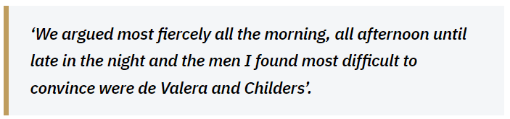
Image 1. Smuts. The Truce Talks.
De Valera had a talent for uniting disparate parts of Sinn Fein . Although he was known for concealing his motives , he was respected. He was charismatic and Collins found him to be ‘disarming’ . While de Valera was away in America, Collins helped feed his family at personal risk . John Bowman says Smuts viewed de Valera as “a ‘visionary’ who lived in ‘a world of dreams, visions and shadows”. A man hard to pin down, he was a political player of skill. He became President of Sinn Fein by persuading Arthur Griffith, the founder, to not seek it himself. Griffith did trust him, seeing him as “a man of cool judgement” .

A truce in the War of Independence was agreed in July 1921, and in October the negotiations began- de Valera did not attend himself, instead sending plenipotentiaries, thereby distancing himself from negotiations in London.
Lloyd George had to bring disparate forces together in the same way as de Valera did in Ireland. He faced a vote of censure himself in October 1921, from die-hard Conservatives opposed to any coercion of the North. Craig was intractable in his refusal to have anything to do with an all-Ireland Parliament. Lloyd George suggested that 26 counties of the South should have a Dominion Parliament, and if Northern Ireland chose not to join, a Boundary Commission would determine a partition border .
To face down the ‘die-hards’, Lloyd George needed a commitment from the Irish delegates, to agree a document accepting the Crown in return for the UK recognising “the essential unity of Ireland”. In November Arthur Griffith- Minister for Foreign Affairs and leader of the Irish delegation- agreed. With the threat of Lloyd George resigning resulting in hard-line Bonar Law taking over, Griffith agreed not obstruct the Boundary Commission proposal. These agreements were enough to prevent the vote of censure succeeding.
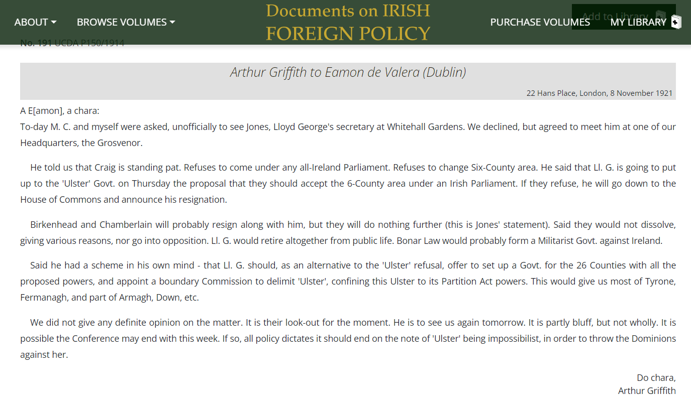
Image 2. Griffith to de Valera. 8th Nov. 2021
The delegation maintained contact with Dublin, although communication was time consuming and difficult. Not trusting the British postal system, information was carried by couriers, a journey taking many hours and done in secrecy . This isolated the delegation in London, and although they wanted de Valera there, he did not go.
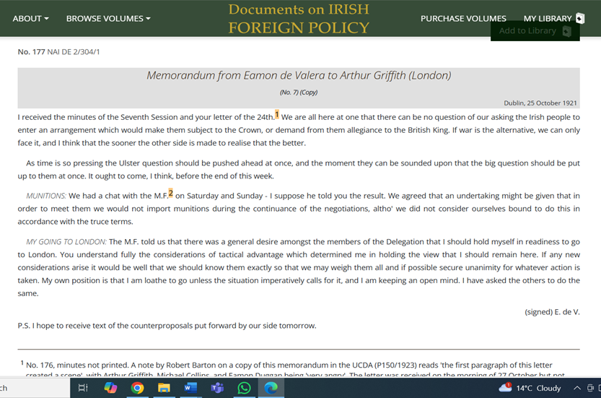
Image 3. Memorandum. Eamon de Valera to Arthur Griffith (London) Dublin, 25th Oct 1921.
With the threat of renewed war with Britain , both sides finally came to terms and signed on the 8th of December 1921. Griffith hopped for “a foundation of peace and friendship….the end of the conflict of centuries is at hand” (Image 4 ). The Treaty was presented to the Dail, and a month of debate followed. The contentious issues remained- Dominion status, the Oath, British use of some ports, and Partition. This was not the free Ireland declared in the 1916 Proclamation, but a compromise many thought of as a stepping-stone to full independence, and the best that could be done at that moment . Others felt was not enough.
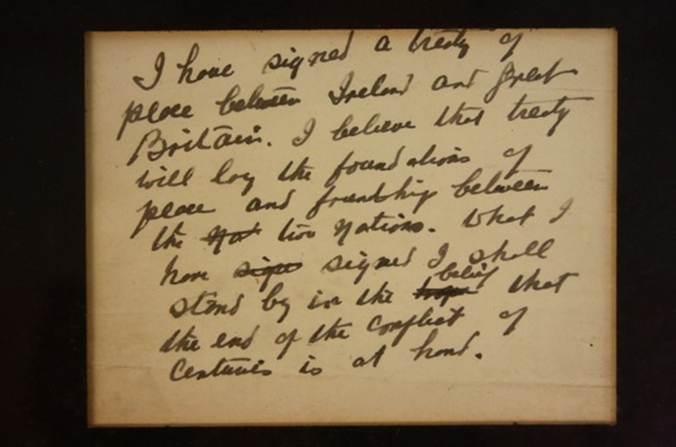
Image 4. Griffith- Announcing the signing of the Treaty statement.
To keep Sinn Fein together, de Valera had proposed an ‘external association’ with the Empire. This was the minimum the more radical members such as Brugha, would accept in place of the Oath to the Crown . The Treaty that came back with the London delegation was a compromise too far, and Sinn Fein became divided. The Irish stage was now set, with pro and anti-Treaty arguments raging. The debates become personal, personality clashes blending with political difference. Brugha and Collins particularly did not get on.
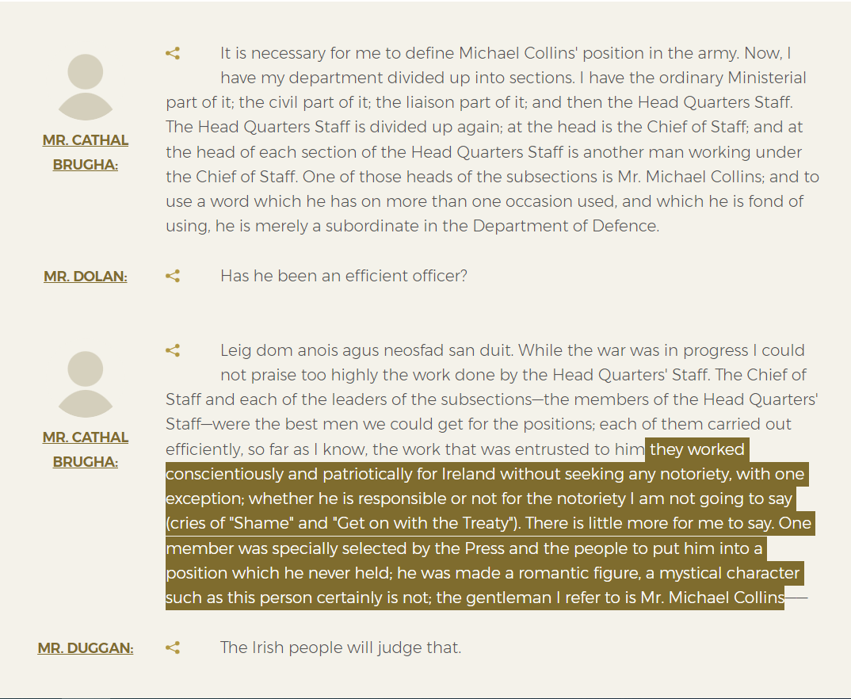
Image 5. Brugha speaking. Dail Eireann debate- Saturday, 7 Jan 1922.
Brugha was a determined, single-minded to a fault, ruthless and courageous man . He held himself and others to a high standard even in the midst of war, insisting all violence have a political end. He came in conflict with colleagues, including Michael Collins- Minister of Finance, leader of the IRB, member of the London delegation- over finances, being a stickler for accountability. He resented the influence of the IRB, thinking they should be disbanded ,and for all Dail deputies and Irish Volunteers take an oath to “support and defend the Irish Republic and the Government…which is the Dail Eireann”- the Volunteers never formally accepted this; it being left to the discretion of local commanders . He could not accept the Treaty and resigned in response.
In contrast, Collins was a pragmatist, arguing for the Treaty to be a stepping-stone (Image 6). He had an ability to combine ruthlessness with courage and charisma. Seen as uproarious, friendly, noisy and playful, he was a larger-than-life character, known as the Big Fella . He specialised in guerrilla tactics, which were later studied worldwide- the Prime minister of Israel used the codename ‘Micail’ during their War of Independence . His large physique and loud personality conflicted with Brugha, who was a devout reserved man, their animosity so well established as to be accepted as normal .
As the arguments raged, pragmatists battled with idealists, Collins and Brugha represented two ends of the debate. It was known the London delegates were never going to bring back a free Republic, and despite de Valera’s awareness of the artifice of the Empire, and the need for unwavering faith in his plenipotentiaries, he found himself unable to agree with what had been signed.

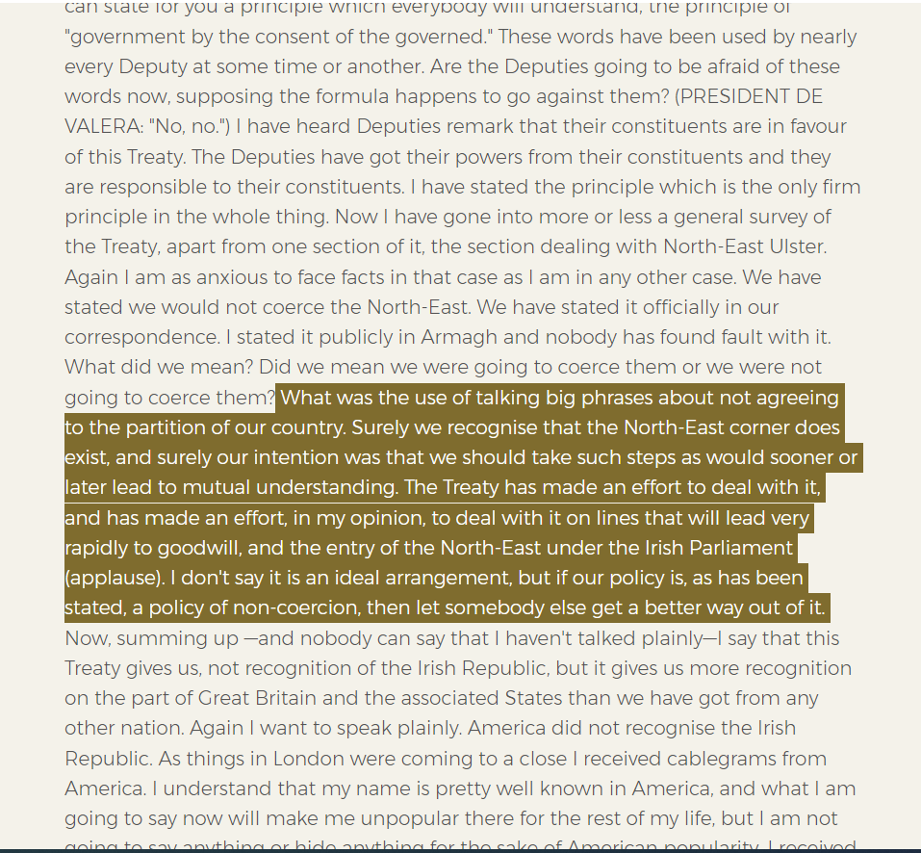
Image 6. Collins addressing the Dail. 19th Dec 2021. House of the Oireachtas.
De Valera pressed for his ‘external association’ and presented an alternative ‘Document No.2’ to restart negotiations . A vote was held - the Treaty was accepted by seven votes. Losing the vote, de Valera resigned as President, and alongside Brugha and others, walked out. He soon organised the anti-Treaty ministers into Cumann na Poblachta. On St Patricks day, ‘The Chief’ as he was known, declared Republicans would have to “march over the dead bodies of their own brothers” and “wade through Irish blood” . Viewed as incitement to violence- although he said it was a warning- it showed he no longer saw a political path to a free Ireland. Military action would be required, to overthrow the Free State government .
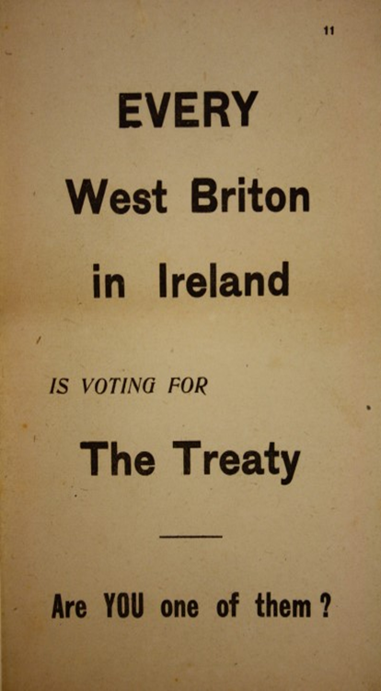 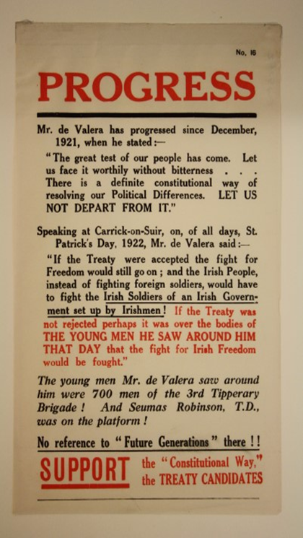 Image 7. Anti-Treaty propaganda leaflet Pro-Treaty propaganda leaflet

With Arthur Griffith as President Collins as became Commander-in-Chief of the first Irish National Army, travelling the country with armed guards. He was up against de Valera and the anti-Treaty IRA who tried to prevent him speaking on the grounds of “the Free State Army is entering this county in a provocative manner” . Rallies were well attended, with a backdrop of simmering violence. In a country saturated with guns it was a threat to individuals and the establishment of the new Free State. The anti-Treaty I.R.A. entrenched in the Four Courts in Dublin, set up a Council of War. The British pointed out to Collins their occupation was contrary to the Treaty, and on the 27th of June 1922, the Free State Army started firing on the Four Courts, and the Civil War began .
The suppression of the anti-Treaty resistance was bitter and violent. The Ballyseedy massacre in Kerry in 1923 became a ‘catchcry’ of the politics at that time, representing the extremes of inhumanity. Irishmen chained Irishmen to a bomb set on a timer and watched them pray before their death . The civil war hardened the attitude of Sir James Craig in Ulster , and the stage was set for a divided Ireland, both North and South, and pro against anti-Treaty.

Conclusion.
Republicanism was deeply challenged by the division of the new Free State government. However, the desire for a Republic never went away.
The personalities involved on centre stage were representatives of threads in the whole. De Valera was a charismatic and unifying leader. Without this ability, Sinn Fein would not have won the votes, to set up the Dail, and to bring the British government to the table.
Other personalities represented elements of the fight. From Collins the pragmatist, to Brugha the idealist, they all were figureheads in the story. The dynamic combination of competing personalities, entrenched visions and conflicting roles fuelled the Republican discourse. Many died, becoming heroes in folklore, sacrificing themselves in the hope for peace. Both Collins and Brugha knew of their probable deaths and faced it anyway. Collins wrote on signing the Treaty “I tell you this -early this morning I signed my own death warrant. I thought at the time how odd, how ridiculous -a bullet might just as well have done the job 5 years ago”. And Brugha deliberately walked into the guns of the Free State Army, after dismissing de Valera brokering a ceasefire saying ‘These fellows have gone over to the British. We’re going to fight back’ . Meanwhile, the President who resigned, prejudicing that chance of unity , returned, and went on to preside over the free Republic eventually established decades later .
While the Anglo-Irish Treaty wreaked havoc on the Free State government, its acceptance was the start of constitutional pathway to a Republic- it did not defeat it.

2619.

Images.
Image 1. Smuts. The Truce Talks. .Available at: https://www.rte.ie/history/truce/2020/0824/1160994-i-have-brought-both-mules-to-the-water-jan-smuts-and-the-truce/ Accessed on:13-10-24.
Image 2. Griffith to de Valera. 8th Nov. 2021. Available at: https://www.difp.ie/volume-1/1921/arthur-griffith-to-eamon-de-valera-dublin/191/#section-documentpage Accessed on 13-10-24.
Image 3. Memorandum from Eamon de Valera to Arthur Griffith (London) Dublin, 25th Oct 1921. Available at: https://www.difp.ie/volume-1/1921/memorandum-from-eamon-de-valera-to-arthur-griffith-london/177/#section-documentpage Accessed on 10-10-24.
Image 4. Brugha speaking. Dail Eireann debate- Saturday, 7 Jan 1922.Available at: https://www.oireachtas.ie/en/debates/debate/dail/1922-01-07/2/ Accessed on 12-10-24.
Image 5. Griffith- Announcing the signing of the Treaty statement. Available at: https://www.museum.ie/en-IE/Collections-Research/Collection/Documentation-Discoveries/Artefact/The-Signing-of-the-Anglo-Irish-Treaty,-1921/7a49e7e5-7cf7-4218-b3b4-c974d4adafa6#:~:text=Written%20for%20issue%20to%20the,friendship%20between%20the%20two%20Nations. Accessed on 13-10-24.
Image 6. Collins addressing the Dail. 19th Dec 2021. House of the Oireachtas. Available at: https://www.oireachtas.ie/en/debates/debate/dail/1921-12-19/2/ Accessed on: 11-10-24.
Image 7. Anti-Treaty propaganda leaflet /Pro-Treaty propaganda leaflet. The Signing of the Anglo-Irish Treaty, 1921 National Museum of Ireland .Available at: https://www.museum.ie/en-IE/Collections-Research/Collection/Documentation-Discoveries/Artefact/The-Signing-of-the-Anglo-Irish-Treaty,-1921/7a49e7e5-7cf7-4218-b3b4-c974d4adafa6#:~:text=Written%20for%20issue%20to%20the,friendship%20between%20the%20two%20Nations.

Bibliography.
Aiken, Síobhra, ‘Cathal Brugha. By Fergus O’Farrell. Dublin: University College Dublin Press. 2018. €17 Paperback’, Irish Historical Studies (Cambridge, UK: Cambridge University Press, 2019), 153–54. Available at: https://librarysearch.uwtsd.ac.uk/permalink/44WHELF_UWTSD/1ir6fgh/cdi_crossref_primary_10_1017_ihs_2019_29 Accessed on 7-10-24.
BBC Home. Wars & Conflict. The Irish Volunteer Force/Irish Republican Army (IRA). 24 Sept. 2014. Available at: https://www.bbc.co.uk/history/british/easterrising/profiles/po16.shtml#:~:text=The%20Irish%20Volunteer%20Force%20(IVF,paper%20'An%20Claidheamh%20Soluis'. Accessed on: 6-10-24.
Blake, R.N.W, Blake, B. Britannica. David Lloyd George. 22 Aug 2024. Available at: https://www.britannica.com/biography/David-Lloyd-George Accessed on: 6-10-24.
Bowman, John, De Valera and the Ulster Question, 1917-1973 (Oxford: Clarendon, 1982). Available at: https://librarysearch.uwtsd.ac.uk/permalink/44WHELF_UWTSD/11c0l68/alma9916914102421 Accessed on 6-10-24.
Britannica. Arthur Griffith. 8 Aug 2024. Available at: https://www.britannica.com/biography/Arthur-Griffith Accessed on: 6-10-24.
Cillin, Micheal O. "Cathal Brugha 1874-1922." Dublin Historical Record 38.4 (1985): 141-149. Available at: https://www.jstor.org/stable/30100671?seq=7 Accessed on 7-10-24.
Collins, Michael. Letter to John O’Kane after the Treaty. Collins Quotes. Collins 22 Society. Available at: http://www.generalmichaelcollins.com/life-times/the-struggle/collins-quotes/#:~:text=%E2%80%9CTo%20go%20for%20a%20drink,have%20I%20got%20for%20Ireland%3F Accessed on: 11-10-24.
Coogan, Tim Pat. Michael Collins: The Man Who Made Ireland. Palgrave Macmillan, 2002. Available at: https://books.google.co.uk/books?hl=en&lr=&id=xscRAhBt2JgC&oi=fnd&pg=PR7&dq=Coogan,+Tim+Pat.+Michael+Collins:+The+Man+Who+Made+Ireland.+Palgrave+Macmillan,+2002.&ots=8u15o8mM4M&sig=Gk_Mdl5DGywe6zt69fNbYX4eqy8&redir_esc=y#v=onepage&q=Coogan%2C%20Tim%20Pat.%20Michael%20Collins%3A%20The%20Man%20Who%20Made%20Ireland.%20Palgrave%20Macmillan%2C%202002.&f=false Accessed on: 9-10-24.
Dail Eireann debate- Tuesday,10 Jan 1922. Vol.T No 17. Houses of Oireachtas. 10 Jan 1922. Available at: https://www.oireachtas.ie/en/debates/debate/dail/1922-01-10/2/ Accessed on: 13-10-24.
De Valera. First President of the Republic addressing the nation on the eve of the London Negotiations on October 7, 1921. Collins 22 Society. 10th Oct. 2024. Available at: http://www.generalmichaelcollins.com/life-times/rebellion/treaty-plenipotentiaries/ Accessed on: 10-10-24.
De Valera. Proposed Treaty of Association between Ireland and the British Commonwealth presented by Eamon de Valera to Dail Eireann¹ Dublin, January 1922. Documents on Irish Foreign Policy. 10th Oct. 2024. Available at: https://www.difp.ie/volume-1/1921/anglo-irish-treaty/218/#section-documentpage Accessed on: 10-10-24.
Final text of the Articles of Agreement for a Treaty between Great Britain and Ireland as signed. Documents on Irish Foreign Policy. London, Dec. 6 1921. Available at: https://www.difp.ie/volume-1/1921/final-text-of-the-articles-of-agreement-for-a-treaty-between-great-britain-and-ireland-as-signed/214/#section-documentpage Accessed on 10-10-24.
Government of Ireland Act 1920. Legislation.gov.uk. 1920. Available at: https://www.legislation.gov.uk/ukpga/1920/67/pdfs/ukpga_19200067_en.pdf Accessed on 6-10-24.
GPO Museum. July7, 2022. Available at: https://www.facebook.com/GPOWH/posts/otd-cathal-brugha-died-of-a-bullet-wound-to-the-leg-received-on-the-5th-of-july-/6619122631490883/ Accessed on:13-10-24.
Griffith, Arthur .T.D. Chairman of the Irish Plenipotentiaries. Collins 22 Society. 10th Oct. 2024. Available at: http://www.generalmichaelcollins.com/life-times/rebellion/treaty-plenipotentiaries/ Accessed on: 10-10-24.
Hart, Peter. Mick: The Real Michael Collins. Pan Macmillan, 2006. Available at: https://books.google.co.uk/books?hl=en&lr=&id=DhF0K3kpulcC&oi=fnd&pg=PR11&dq=Hart,Peter.+1963.+Mick:+The+Real+Michael+Collins.&ots=ZBNudhXsfP&sig=OYvL4-_1-RNyG3WS1JJOuNgEOSo&redir_esc=y#v=onepage&q=Hart%2CPeter.%201963.%20Mick%3A%20The%20Real%20Michael%20Collins.&f=false Accessed on 6-10-24.
Irish War of Independence. National Army Museum. 2024. Available at: https://www.nam.ac.uk/explore/irish-war-independence#:~:text=O'Shea%2C%201921-,Ulster,had%20returned%20in%20the%20south. Accessed on 6-10-24.
Keith Middlemass (ed), Thomas Jones: Whitehall Diary Volume III – Ireland 1918-1925, London: Oxford University Press, 1971,pp79-85. Available at: https://librarysearch.uwtsd.ac.uk/permalink/44WHELF_UWTSD/11c0l68/alma99117287902421 Accessed on 6-10-24.
Lynch, John M. "The Anglo-Irish Problem." Foreign Affairs 50.4 (1972): 601-617. Available at: https://librarysearch.uwtsd.ac.uk/permalink/44WHELF_UWTSD/1ir6fgh/cdi_proquest_miscellaneous_60331541 Accessed on: 6-10-24.
McCullagh, David, ‘“It Is Only by Political Means That We Can Hope for ... Success”: Éamon de Valera’s Long Climb Back to Power, 1922-32’, Irish Political Studies, 39.2 (2024), 298–319 . Available at: https://librarysearch.uwtsd.ac.uk/permalink/44WHELF_UWTSD/1ir6fgh/cdi_proquest_journals_3091090176 Accessed on: 9-10-24.
Murray, F. The people behind the 1921 Treaty. Law Society Gazette. 1 April 2022. Available at: People of the 1921 Treaty (lawsociety.ie) Accessed on: 9-10-24.
Ó Corráin, Daithí, and Gerard Hanley. Prologue to, Cathal Brugha:'An Indomitable Spirit'. Four Courts Press, 2022. Available at: https://doras.dcu.ie/27851/9/Pages%20from%20Cathal%20Brugha%20Author%20Approved%20Prologue.pdf Accessed on: 10-10-24.
O'Shea, Owen. No Middle Path: The Civil War in Kerry. Merrion Press, 2022. Available at: https://books.google.co.uk/books?hl=en&lr=&id=ks-dEAAAQBAJ&oi=fnd&pg=PT7&dq=ballyseedy+massacre&ots=bhrYjO5VpQ&sig=8iesWhyj__VKjJRvrJSedEVngxk&redir_esc=y#v=onepage&q=ballyseedy%20massacre&f=false Accessed on 6-10-24.
Reilly, Ciaran. 'I have brought both mules to the water': Jan Smuts and the Truce talks. RTE. History. 7 July 2021. Available at: Reilly, Ciaran. 'I have brought both mules to the water': Jan Smuts and the Truce talks. RTE. History. 7 July 2021. Accessed on: 13-10-24.
The Anglo-Irish Treaty,1921. House of Commons Library. Available at: https://commonslibrary.parliament.uk/research-briefings/cbp-9260/ Accessed on 6-10-24.
Torrance, D. House of Commons Library. The Anglo-Irish Treaty, 1921.5 Dec 2022. Available at: https://researchbriefings.files.parliament.uk/documents/CBP-9260/CBP-9260.pdf Accessed on: 6-10-24.
The Irish Revolution Project. University College Cork. 2 June 2024. Available at: https://www.ucc.ie/en/theirishrevolution/collections/mapping-the-irish-ffrevolution/the-victory-of-sinn-fein-the-1920-local-elections/ Accessed on: 6-10-24.
Walsh F. Daithí Ó Corráin and Gerard Hanley. Cathal Brugha: “An Indomitable Spirit.” Dublin: Four Courts Press, 2022. Pp. 222. Journal of British Studies. 2023;62(3):842-843. Available at: https://www-cambridge-org.ezproxy.uwtsd.ac.uk/core/services/aop-cambridge-core/content/view/FC519B6B2C81E33AEBEDBFD264B9B228/S0021937123001314a.pdf/daithi-o-corrain-and-gerard-hanley-cathal-brugha-an-indomitable-spirit-dublin-four-courts-press-2022-pp-222-euro2495-paper.pdf Accessed on: 10-10-24.

Lynch, John M. "The Anglo-Irish Problem." Foreign Affairs 50.4 (1972): 601-617.p606
McCullagh, David, ‘“It Is Only by Political Means That We Can Hope for ... Success”: Éamon de Valera’s Long Climb Back to Power, 1922-32’, Irish Political Studies, 39.2 (2024), 298–319
Cillin, Micheal O. "Cathal Brugha 1874-1922." Dublin Historical Record 38.4 (1985): 141-149.p146.
Cillin,.p146.
Blake, R.N.W, Blake, B. Britannica. David Lloyd George. 22 Aug 2024.
Lynch, John M. "The Anglo-Irish Problem." Foreign Affairs 50.4 (1972): 601-617.p 607.
Government of Ireland Act 1920. Legislation.gov.uk. 1920.
Lynch, John M. "The Anglo-Irish Problem." Foreign Affairs 50.4 (1972): 601-617.p607.
Bowman, John, De Valera and the Ulster Question, 1917-1973.p49
Bowman.p49
Reilly, Ciaran. 'I have brought both mules to the water': Jan Smuts and the Truce talks. RTE. History. 7 July 2021.
McCullagh, David, ‘“It Is Only by Political Means That We Can Hope for ... Success”: Éamon de Valera’s Long Climb Back to Power, 1922-32’, Irish Political Studies, 39.2 (2024), 298–319
Coogan, Tim Pat. Michael Collins: The Man Who Made Ireland. Palgrave Macmillan, 2002.p.250.
Coogan, p.191.
Coogan, p.250.
Coogan, Preface.
Bowman, John, De Valera and the Ulster Question, 1917-1973. P50.
McCullagh, David, ‘“It Is Only by Political Means That We Can Hope for ... Success”: Éamon de Valera’s Long Climb Back to Power, 1922-32’, Irish Political Studies, 39.2 (2024), 298–319. P300.
Torrance, D. House of Commons Library. The Anglo-Irish Treaty, 1921.5 Dec 2022.p13.
Torrance.p13.
Murray, F. The people behind the 1921 Treaty. Law Society Gazette. 1 April 2022.
Griffith, Arthur.T.D. Chairman of the Irish Plenipotentiaries. Collins 22 Society. 10th Oct. 2024.
Coogan, Tim Pat. Michael Collins: The Man Who Made Ireland. Palgrave Macmillan, 2002.Preface.
Torrance, D. House of Commons Library. The Anglo-Irish Treaty, 1921.5 Dec 2022.p14.
Ó Corráin, Daithí, and Gerard Hanley. Prologue to, Cathal Brugha:'An Indomitable Spirit'. Four Courts Press, 2022. P842.
Ó Corráin, p843.
Cillin, Micheal O. "Cathal Brugha 1874-1922." Dublin Historical Record 38.4 (1985): 141-149.p146.
Coogan, Tim Pat. Michael Collins: The Man Who Made Ireland. Palgrave Macmillan, 2002 p20.
Coogan,Preface.
Coogan, p.250.
De Valera. First President of the Republic addressing the nation on the eve of the London Negotiations on October 7, 1921. Collins 22 Society. 10th Oct. 2024.
Cillin, Micheal O. "Cathal Brugha 1874-1922." Dublin Historical Record 38.4 (1985): 141-149.p148.
McCullagh, David, ‘“It Is Only by Political Means That We Can Hope for ... Success”: Éamon de Valera’s Long Climb Back to Power, 1922-32’, Irish Political Studies, 39.2 (2024), 298–319
O'Shea, Owen. No Middle Path: The Civil War in Kerry. Merrion Press, 2022.
McCullagh, David, ‘“It Is Only by Political Means That We Can Hope for ... Success”: Éamon de Valera’s Long Climb Back to Power, 1922-32’, Irish Political Studies, 39.2 (2024), 298–319
Dail Eireann debate- Tuesday,10 Jan 1922. Vol.T No 17. Houses of Oireachtas. 10 Jan 1922.
O'Shea, Owen. No Middle Path: The Civil War in Kerry. Merrion Press, 2022.
Cillin, Micheal O. "Cathal Brugha 1874-1922." Dublin Historical Record 38.4 (1985): 141-149.p148.
O'Shea, Owen. No Middle Path: The Civil War in Kerry. Merrion Press, 2022.f
Hart, Peter. Mick: The Real Michael Collins. Pan Macmillan, 2006.
Collins, Michael. Letter to John O’Kane after the Treaty. Collins Quotes. Collins 22 Society.
McCullagh, David, ‘“It Is Only by Political Means That We Can Hope for ... Success”: Éamon de Valera’s Long Climb Back to Power, 1922-32’, Irish Political Studies, 39.2 (2024), 298–319
Hart, Peter. Mick: The Real Michael Collins. Pan Macmillan, 2006.
McCullagh, David, ‘“It Is Only by Political Means That We Can Hope for ... Success”: Éamon de Valera’s Long Climb Back to Power, 1922-32’, Irish Political Studies, 39.2 (2024), 298–319

