Digital Skills and Research Methods

Student Name: BADMUS OMOTOSHO
Student Number1914925:
Module Number: BMSW4003
Module Name: DIGITAL SKILLS AND RESEARCH METHODS
Supervisor: DR TERRY WALCOTT

Abstract
Virtual learning is a system of a web-based platform for the digital aspects of courses of study, usually within educational institutions (Lau, 2015). This research is conducted within the students learning experience at the University of Wales Trinity Saint David London Campus. For the research, we have collected both primary and secondary data. The primary data is collected from the students of the campus. Total of 50 samples is collected by a random sampling system. We provide a Google form including some specific questionnaire and collect the norms and response of the students. Also, we have collected secondary data from some recent journals and books. We found both the positive and negative aspects regarding virtual learning environment from the primary and secondary data. We also provide the statistical tools and results of the response in this research report.

Table of Contents
Abstract ii
Introduction 1
Research Objectives 1
Questionnaire 1
Research Rationales 2
Research Scope 2
Literature Review 3
Research Design 5
Methodology 5
Data Analysis 5
Ethical facts 5
Data Analysis 6
Impact of Moodle 6
Questionnaire analysis 7
Conclusion 11
References 12
Appendix 13

Introduction
Virtual Learning Environment is a modern way of teaching where the technical tools are used. VLE accomplishes all the management and activity of an institution. It is just same as the manual system. Here the curriculum syllabus, student guidance, necessity, homework, communication to the students and all other things that are necessary for education (Foss, 2013). But these things are done by technology with virtual tools. Many PhD program, internship, and other courses are done by VLE and now this has become a necessary part of the higher studies. VLE contains some certain aspects. These are the planning and management of the courses and subjects, provide PowerPoint or videos of learning the course items and their solution, online assignments and reports, submission through the digital media, online feedback of learning and many other aspects.

Research Objectives
The main objective of this research is to find out the positive and negative impact of VLE. Also, the VLE system is new to the students so far and one of the basic objectives of this research is to find out the experiences acquired by the students from this system of learning. Objective contains how the students manage to use the different virtual tools that use in VLE. Also how they prepare their leaning items, curriculum factors, assignments by virtually is the basic objective of this research (Ewais and De Troyer, 2014). Also, we want to figure out the different good tools of e-learning and how those can be used efficiently.

Questionnaire
Some specific questions are resolved in this research. We want to figure out the necessity and impact of the VLE in the University of Wales Trinity Saint David London Campus. So here is the questionnaire is given below:
- Whether the learning system has a positive impact on the university and will it be applicable further.
- Whether the learning process is done efficiently and without any constraints.
- What is the feedback of the students regarding VLE in the university?
- How can the authority of the university establish the e-learning system and make it more effective to the students?

Research Rationales
Virtual Learning Environment platform has a great impact nowadays to the social and educational institutions. It is connected to every field of studies including higher studies (Secker, 2016). As this is now connected to every field, so it is obvious to know that whether this system provides quality education or not. We are here to research the University of Wales Trinity Saint David London Campus that whether the students of this institutions get quality education from the system of VLE and how can they improve their learning aspects along with this system. As this coronavirus pandemic has created a major constraint for the education system, so it is must know to the authorities that the system of VLE contains uninterrupted education system.

Research Scope
The research is conducted within a random sampling of 50 students of the University of Wales Trinity Saint David London Campus. This research is particularly based on Moodle, the impact of the VLE platform to the students of this university campus. This research has not a long-range of scope but has accountability to find out the impact of the VLE system (Thomas, 2012). This research is also encouraged to fill up the limited range of literature as the sample size is very small. This is qualitative research and only works for the betterment of the university.

Literature Review
Through this learning, the system is quite new to the environment and there is a limited level of research occurred regarding this issue. But we have collected some literature review of VLE platform as the research is conducting with both primary and secondary data. Different journals and authors of books have submitted their quote and opinion regarding VLE.
According to K. Lau (2015), “Virtual learning system is the new ideas of education where the education platform is created by virtually and the students can get to know the modern system of education through this.” This implies that the idea of VLE is very modern to the generation and very much effective. As this is the twenty-first century and the technical tools are very much established. So this VLE platform creates a modern system of education.
S. Chou & C. Liu (2012) defined VLE as “This is a quite designed and decorated system of learning where both the instructor and users are preplanned their duties and explore their learning by modern technologies.” By the authors, this is clear that for VLE both the teachers and students have to make themselves ready and prepared for the online learning also they have to know the uses of the tools of the online learning system.
J. Foss (2013) stated that “VLE learning is very much efficient than a manual system. Because this system offers the students a large number of options and supports. Also, this is very much comfortable for them.” As per J. Foss, students feel more comforts by VLE rather than go to the institutions. Also, they can get enough time to make themselves prepared for the lessons. They get much comfortable to study the lessons and understand.
A. Ewais, O Pe Troyer (2014) conducted research regarding VLE and they found many positive aspects of this system. As per their research portion, about 78% of students are very much comfortable with VLE learning platforms. They get enough flexibility and other benefits because 39% of them are foreigners and they have part-time jobs. And as long as they use a VLE system they got no hamper both in their studies and jobs.
Along with the positive vibes, many researcher find different types of negative aspects of the VLE platform. J. pellet & B. Lecat (2012) performed research together and found that one-third of their sampling that means students are very much eager to find out any unethical way to solve their problems of learning. For this, the real learning progress gets affected and this is a very crucial fact that is connected to VLE.
Also J. Hu, C. Feng, Y. Liu and R. Zhu (2014) found that several participants are not aware of the uses of this system. Also, they have a lack of face to face engagement and they have to face a lot to understand the learning topics. The assessment system of this learning platform is not that much effective for the behaviour of students. Many students do not get their desired grade just because they do not understand the way of using the assessment tools.

Research Design
The research has been designed by two different segments. Both the primary data and the secondary data is being used to the research. The secondary data is collected from the different researchers report, journals and other online papers. And the primary data is collected from the 50 students of the University of Wales Trinity Saint David London Campus.

Methodology
We have created a Google form writing our research questions and provide them to the emails of the 50 random students of the campus. We assure them not to reveal any sample identity along with their email information. Also, we collect their feedback through the same process.

Data Analysis
We genuinely made some column charts and pie charts that symbolizes the results of the participants. Also, the form was created by rating different aspects of Moodle and how they can manage to use it.

Ethical facts
This research maintains the ethical behaviour of every fact that is used in the research. The first thing, there is no biasness made onto the research sample collection. The samples are collected on a random basis. Also, we have assured the relative members not to disclose their identity and other things. No falsification information and any other fake contents are not subject to this research report. The secondary data that is used is mentioned by reference.

Data Analysis
We have provided the column chart, line chart and pie chart of the collected results. We have divided two parts of data analysis. Firstly, the Positive and negative impact of the Moodle Virtual Learning Environment at the University of Wales Trinity Saint David London Campus. And secondly, the analysis of the questionnaire.

Impact of Moodle
There are some certain thing of the positive impact of VLE which are flexibility, affordability, accessibility, opportunity and efficiency. About 39% of respondents think this is very much flexible, 27% thinks this is efficiently accessible, 24% have the affordability, 5% is on the opportunity and 5% is on efficiency.
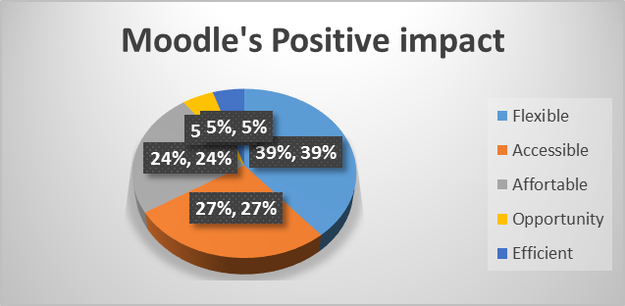
Along with the positive impact, there is also some negative impact that arises on the uses of Moodle on the campus. The factors we have used for the negative impact are learning limitations, communication gap, resources suitability, Discipline. 60% students think that there will be very much lack of discipline in this type of learning, 27% have faced the learning limitations, 5% have the resource problem and rests have the communication gap problem.
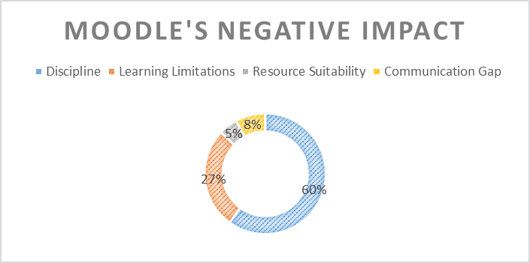

Questionnaire analysis
We have provided some certain questions to the students which are
- Moodle is a flexible and time-saving system.
- Moodle have digital resources that help to establish the course.
- Moodle has more accessibility.
- Moodle has more access to unfair means like cheating.
- The chances of teamwork have been decreased in Moodle.
We provide the Google form to rate the above questions to the respondents. They have provided the multiple-choice question basis to the respondents. All the questions have such options as Strongly Agree, Agree, Neutral, Disagree, Strongly Disagree. And the respondents only could answer one answer for each question.
Moodle is flexible and time-saving system
The research was conducted with 50 samples. About 33 students strongly agree with this question.
12 agrees, 3 is neutral, 1answered disagree and strongly disagree. And as per research, we can say this feature is more flexible than others.
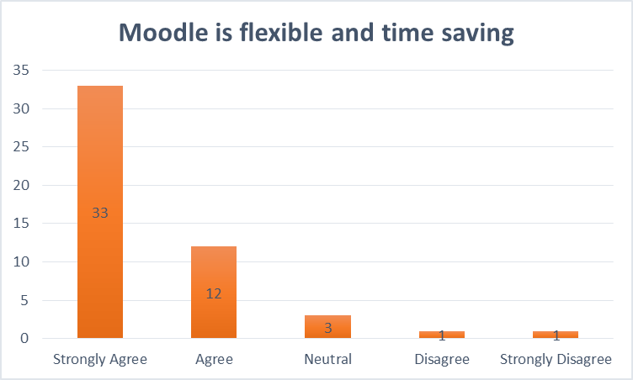

Moodle have digital resources that help to establish the course
Among 50 students 23 students strongly agreed with this opinion, 13 was agreed, 7 was neutral, 4 disagreed and 3 strongly disagreed. This report supports this statement that this feature has more digital resources.
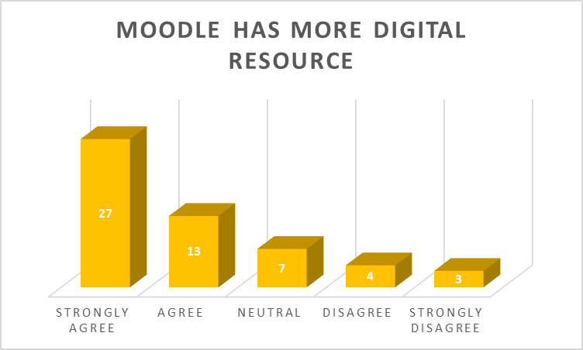
Moodle has more accessibility
About 34 students were very much happy with Moodle’s accessibility. 7 was agreed, 2 was neutral, 4 disagreed and 3 was not at good for its accessibility. We can find out that this system is quite accessible than other feature.
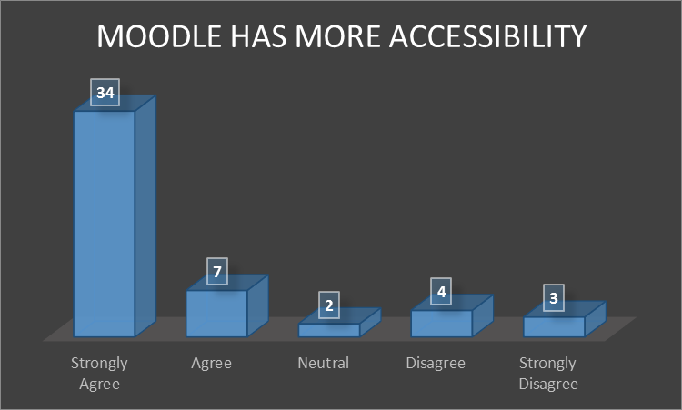
Moodle has more access to unfair means like cheating
21 students find that this system can be used in unfair means and it is possible. Among them, 13 strongly agreed. 5 student was neutral in this statement and the remaining were not agree at all. 7 rated strong disagree with this system.
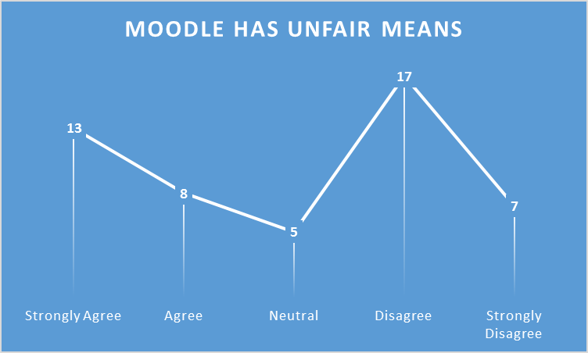
The chances of teamwork have been decreased in Moodle
Among 50 students 30 students strongly agreed that there is no chance of teamwork in Moodle. 12 was agreed, 6 disagreed and remaining were strongly disagree. No students were found neutral in this segment. It is quite obvious that the chances of teamwork are very difficult in Moodle.
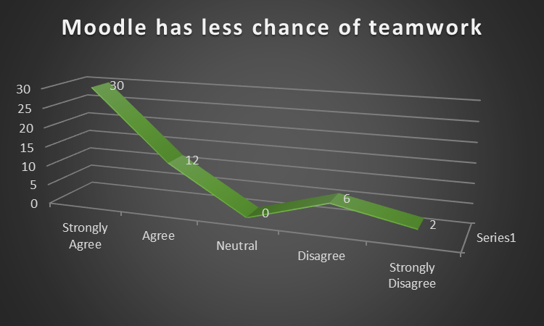
These were the results of our questionnaire. The response was quite good from the students. We create a table where we can produce the results by percentage ratio. This is much more fruitful regarding this issue.
Questions | Strongly Agree | Agree | Neutral | Disagree | Strongly Disagree
Moodle is flexible and time-saving system | 66% | 24% | 6% | 2% | 2%
Moodle have digital resources that help to establish the course | 54% | 26% | 14% | 8% | 6%
Moodle has more accessibility | 68% | 14% | 4% | 8% | 6%
Moodle has more access to unfair means like cheating | 26% | 16% | 10% | 34% | 14%
The chances of teamwork have been decreased in Moodle | 60% | 24% | 0% | 12% | 4%

In the evaluation of the table, we can say that there is both a positive and negative impact of Moodle on the London campus of the University of Wales Trinity Saint David.

Conclusion
The research has established the idea of VLE and its uses on the campus. We have found both positive and negative outcome from the questionnaire we provide and also have supportive information. Here the students have the flexibility, accessibility and affordability of Moodle uses in VLE. Though a limited number of students also oppose the system of this uses. There are also a certain number of the negative feature of Moodle in VLE. About 42% of students think that unfair means can easily access in this type of system. Also, teamwork cannot be performed accurately in Moodle. So, if the university authority wants to adopt Moodle in University, they have to prevent such type of negative feature. Also, they should make assurance to the students to provide the resources of Moodle. In this coronavirus pandemic, such thought of using the VLE platform in the education system as well as the higher studies is very much appreciable.

References
Chou, S. and Liu, C., 2012. Learning effectiveness in a Web-based virtual learning environment: a learner control perspective. Journal of Computer Assisted Learning, 21(1), pp.65-76.
Ewais, A. and De Troyer, O., 2014. Authoring Adaptive 3D Virtual Learning Environments. International Journal of Virtual and Personal Learning Environments, 5(1), pp.1-19.
Foss, J., 2013. Lessons from learning in virtual environments. British Journal of Educational Technology, 40(3), pp.556-560.
Hu, J., Feng, C., Liu, Y. and Zhu, R., 2014. UTSE: A Game Engine-Based Simulation Environemnt for Agent. Applied Mechanics and Materials, 496-500, pp.2142-2145.
Lau, K., 2015. Organizational learning goes virtual?. The Learning Organization, 22(5), pp.289-303.
Pelet, J. and Lecat, B., 2012. Virtual Worlds as the Next Asset of Virtual Learning Environments for Students in Business?. International Journal of Virtual and Personal Learning Environments, 3(2), pp.59-76.
Secker, J., 2016. Electronic Resources In The Virtual Learning Environment. Oxford: Chandos.
Thomas, M., 2012. Design, Implementation, And Evaluation Of Virtual Learning Environments. Hershey, PA: Information Science Reference.

Appendix
Here is Google form that is used in the search survey. Google form link: https://docs.google.com/forms/d/e/1FAIpQLSclwrz97Z0k5KDYsQ4Sayz-VD7SP7Dge3VPhAkDKoEu48U5YQ/viewform?fbclid=IwAR3X3NhH1ZSfBxfK5VGRd2uOj4vlhrjuXsdIHajDeBsSKPmmiVgKR6s-BNE


