Assignment 2
By Huzaira Shafqat-(2128180)

Module Title: Sustainable Hospitality & Tourism Management
Module Code: BMIH5006
Lecturer’s name: Kathryn Roberts
Deadline:01/03/2024

Table of Contents:
Introduction: 3
Sustainability: 4
Green washing: 6
Self -Evaluation Practices: 7
Use of Green Technology: 9
Alternatives to Self-Evaluation: 10
Adopting the Alternatives at the Grand York: 11
Conclusion: 11
References: 13

Introduction:
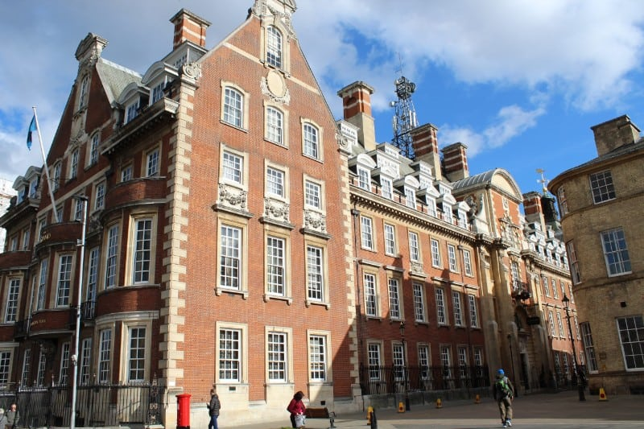
Figure 1: The Grand York, UK
In the vibrant world of hospitality, one establishment stands out not just for its luxury and comfort, but for its commitment to sustainability and innovation: The Grand York, UK, this hotel is like a beacon, it defines the traffic towards the environmentally friendly practices in the hospitality industry.
Sustainability, which is usually perceived as a synonym of conservation, has, however, a broader scope in the context of tourism and hospitality. It is beyond merely environmental balance, but also social responsibility and economic profitability. It is about bringing together the different elements for the benefit not only of the environment, but also the social and economic spheres (The Grand, York (n.d.).
This report aims to critically assess the sustainability projects of The Grand, York by exploring the objectives of the program and the challenges associated with them. We should investigate their green certifications, also, ‘green washing’ appears to be an eye-catching matter, and as well we will investigate how the hotel judge itself, and their use of green technology.
While our focus rests on The Grand, York which has spearheaded sustainability in its operation, we focus on The Grand, York which has been the front runner in sustainability. We will review how the owner of the hotel has made it possible to combine luxury and sustainability without compromising the level of comfort, inspiring others with their successful example in the industry (Rogers, et al, 2012).
In our discussion, one of the topics we will tackle is the issue of ‘green washing’, which is a marketing technique that makes it seem like a company is clean and green. We will check that The Grand has been accused of same usage and whether they reacted to the accusations.
The aim of this report is to provide a clear picture of sustainability in the hospitality industry where The Grand, York is taken for example and the areas of challenge and opportunity will be analysed. And we are confident that, as we begin this exploration, we will find approaches that will direct the shaping of sustainable growth in the tourism and hospitality sector. It’s such a grand scale of work.

Sustainability:

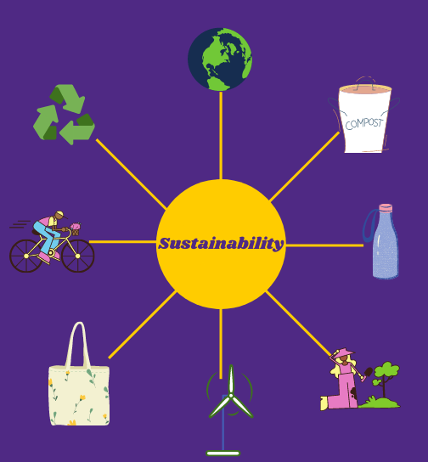
Figure 2: Sustainability (Caradonna, 2022).
The Grand, York is a jewel of luxury and comfort and surfaces the philosophy of sustainability. They have implemented several eco-friendly practices. They have implemented several eco-friendly practices:
- Energy-efficient lighting.
- Waste reduction programs.
- Water conservation measures.
Their commitment to locally sourced food and their commitment to locally sourced food are:
- Reduces carbon footprint.
- Supports local businesses.
- Allows the restaurant to consistently provide customers with fresh and good quality food.
Their practices align well with the concept of sustainability in the tourism and hospitality sector, which includes:
- Their practices align well with the concept of sustainability in the tourism and hospitality sector, which includes (Mihalič, et al, 2012).
- Reducing environmental impact
The involvement in positive local communities is one of the most significant contributions.
- Ensuring economic viability.
Local sourcing in their approach promotes reduction of transportation emissions and provides the local farmers and suppliers with needed support for their work contributing to the local economy.
Besides, the green energy and water saving techniques help reduce the environmental impacts while also cutting the operational costs, ensuring the economic sustainability of the hotel. The Grand, York serves as an inspiring example, demonstrating to the hospitality sector how hotels can integrate sustainability in their operations, acting for the benefit of both the environment and local community and aiding their own bottom line as well. Their commitment is proof that sustainability and luxury can walk together. It is a real trophy for the seller (Brown, et al, 2017).

Green washing:


Figure 3: Green washing in Hospitality (Harshajit Sarmah, 2022).
Green washing is a misleading or deceitful act, which a company or organisation performs to convey the impression that they are environmentally friendly. It is the slang that stands for occasions when a company is spending more energy in promotion and advertisement representing itself as an eco-friendly company rather than enforcing the activities that minimise the environment’s impact.
In the case of The Grand, York, green washing is not mentioned from initial information provided, which indicates that there are no specific allegations against this hotel. Such a gesture shows that the hotel has consistently worked towards sustainable goals. It implies that out of the many factors of their success in this venture, “going green” is not simply for marketing or show but is woven into their operations and business model.
The lack of green washing criticisms levelled at The Grand, York emphasises the significance of environment sustainability authenticity. Today, the consumer is aware and attentive to ecology problems. These include transparency and honesty, and they can arrive at the truth when confronted with hollow sustainability claims. Thus, the companies need to secure the credibility of their green initiatives by making them substantial and having verifiable evidences (Pizzetti, et al, 2021).
In a time without green washes, The Grand, York might turn into a leader that can be considered as a model of real sustainability in the hospitality market. The behaviour of their practices goes beyond that of mere compliance with environmental rules and adopts a more sustainable way of operation. This is a symbol of good practice.
Transparency is one of the most critical aspects in sustainability practices. It empowers consumers to make educated decisions and encourages adherence to the standards on the part of firms. Being thoroughly open about sustainability in their operations has greatly helped Grand, York’s credibility and reputation in the business community (De Vries,et al, 2015).

Self -Evaluation Practices:
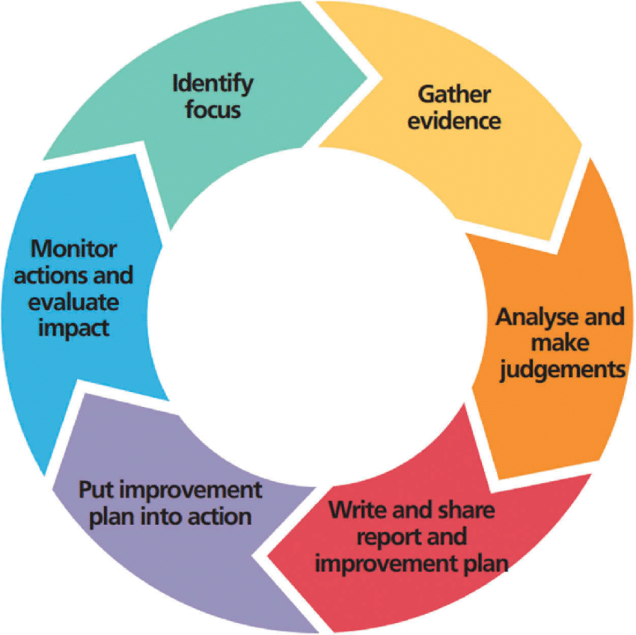
Figure 4: Self-evaluation practices (Pace, 2010).
The Grand, York, which is recognised as a leader in the field of hospitality, is implementing the self-evaluation practice as a core component of its sustainability strategy. The defining feature of self-evaluation is that organisations assess their internal performance and evaluate progress towards sustainability goals by using multiple tools such as internal audits, employee surveys, and internal performance metrics. It means they can have a clear realisation of the positions they are occupying in terms of the sustainable goals and what they need to do so that they can achieve them.
Self-evaluation offers numerous benefits. It offers a platform for inward looking, which entails its ability to enable identification of strong points and areas of weaknesses. These anticipatory ways of thinking not only allows them to make the essential tweaks but also refine and enhance their sustainability projects. Through constant monitoring of their practices, they can be confident that they are doing well in their endeavours to reach their sustainability goals (Pace, 2010).
Companies like The Grand, York, which consider self-evaluation as a useful tool for numerous reasons have made it their custom. It gives them an opportunity to keep the evaluation process under their control, and the process of adjustment of the evaluation to their objectives and particular goals. That way, it creates a culture of accountability and mindset of continuous improvement within the organisation. Through self-assessment they can keep their practices of sustainability always consistent with their aims and ideals.
Self-assessment allows for the acquisition of information that could be utilised in management and weighing of strategic options. The Grand being able to gauge where it stands at present will help in choosing the way forward in its sustainability initiatives. This can also make them to discover new potential improvement and to focus by putting priority to their task.
The over commitment of the Grand, York's review of themselves shows the scale of their purpose is sustainability. While many hospitality businesses are willing to be accountable to, they and continuously aim higher, sustainable leadership makes them stand out. Their self-evaluation practices represent a good model for other firms in the industry and prove that luxury and responsibility do not contradict.
The Grand in York has become the biggest example in the hospitality industry, you can see this in the way they evaluate themselves. Their ability to be constantly improving and accountable is just exceptional and the fact that sustainable luxury is an option is definitely remarkable. Through this process they are not only developing their own successful practices, but also setting the right example for the industry. To sum up, it's an outstanding feat (Schulte, & Hallstedt, 2018).

Use of Green Technology:
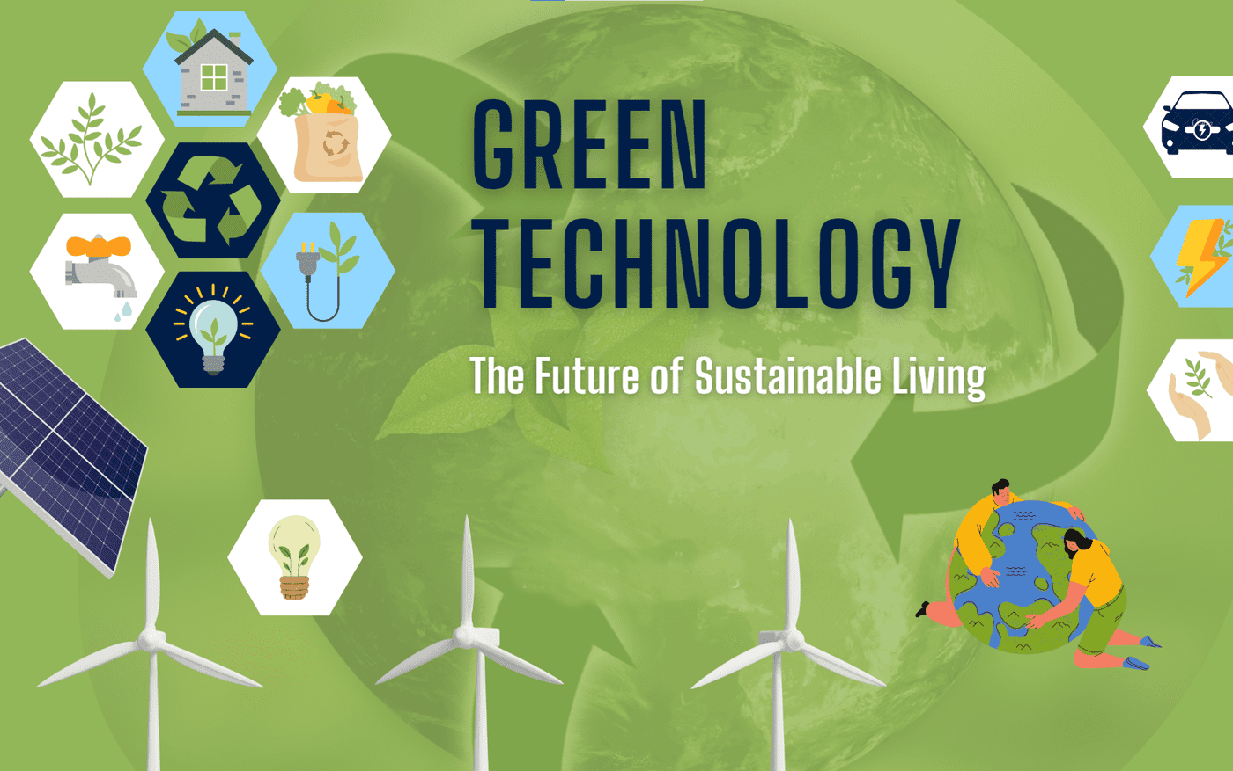
Figure 5: Green Technology (Bukchin & Kerret, 2018)
The Grand-York, the luxury hotel famous for its sustainability endeavours, has incorporated green technology in its operations. Many hotels that are oriented at sustainability use specialists such as energy-efficient lighting, smart thermostats and water-saving techniques.
Energy efficiency technologies such as low wattage bulbs and heat and pressure-controlled showers are able to reduce the hotel’s environmental impact or lessen its energy consumption. Example is LED lighting which uses less energy and last for longer periods compared to traditional lighting. Smart thermostats can provide optimisation of the heating/cooling processes upon occupancy and hence help reduce energy usage (Dao, et al, 2011).
Use of water-saving technologies, like low-flow showerheads and dual-flush toilets, helps save a lot of water. This does not only make a resource that is crucial to survive scarce but also decreases the energy that is used in water heating (Fernando, et al, 2019).

Alternatives to Self-Evaluation:
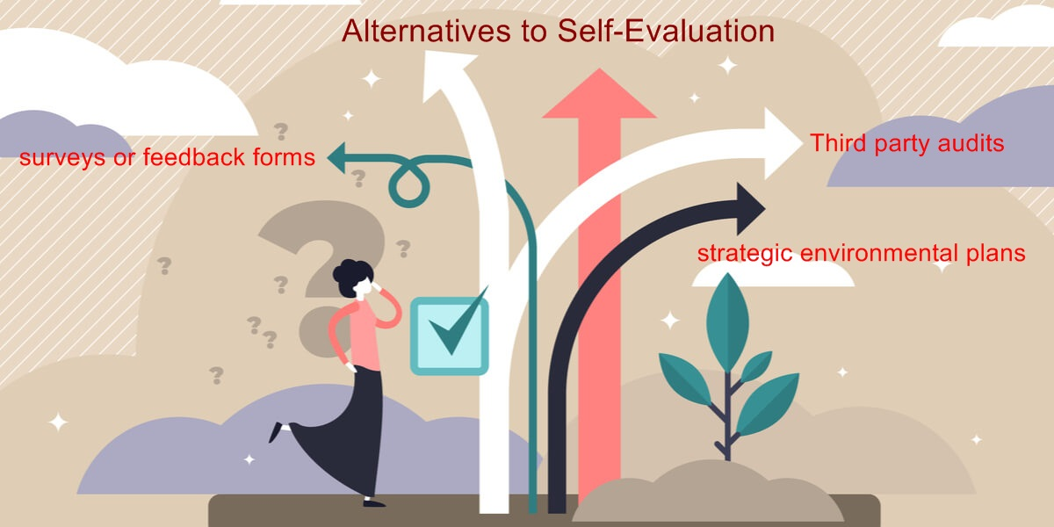
Figure 6: Alternatives to self-Evaluation (Chang, et al, 2012).
Self-evaluation is a useful instrument to help such organisations like The Grand, York to determine the amount of sustainability they are embracing. But it’s not the only way, though. Let us look at some alternatives that cover our criteria more completely and objectively.
Second to self-evaluation, there are third party audits as an alternative. Among others, these are what the independent organisations whose area of expertise revolves around the evaluation of sustainability practices conduct. They can give an objective point of view to the nature of the green initiatives of a hotel and provide with areas for improvements. The Grand, York may be well-advised to take this kind of approach to confirm their sustainability commitment.
One of these options is customer feedback. Guests of the Grand York may not be aware of these strategic environmental plans; therefore, their assessments of these plans can be crucial for the company. In addition, surveys or feedback forms could serve as methods for monitoring how customers view the hotel’s green projects (Kara, 2012).
Another handy source of information is the employee feedback. Since those who are the one who carry out the sustainability practices are the employees, they can give you the first-hand information on what’s working and what’s not. The Grand, York can conduct feedback sessions albeit monthly or simply use the suggestion boxes to get such insights.
Benchmarking is the process of comparing one’s existing practices against others’ best practices or leaders in the industry. The Grand, York could pick out those hotels, which are already famous for their green practices and compare their practices with the ones of the grand hotel.
Finally, as an alternative to self-evaluation, obtaining sustainability certifications from well-known organisations can provide you with one. These certificates, which are very often about serious assessments, can be a kind of seal of a hotel’s sustainable approach. The Grand, York could also go ahead and aim at gaining such certifications (Gao & Mattila, 2016).

Adopting the Alternatives at the Grand York:
Adopting these alternatives at The Grand, York will need meticulous planning and should be worked out with dedication. Every option has its own group of needs and advantages, and the hotel would need to determine which one is suitable in the preparation of sustainable goal alignment. Through a search for alternatives to self-evaluation, The Grand in York UK will guarantee their leadership in sustainable hospitality. It is a pinnacle of indeed (Abdou, et al, 2012).

Conclusion:
The investigation we have conducted has led us through an exciting journey into the sustainable operations of The Grand, York, an authorised centre of quality and convenience in the hotel business. Along the way, we have touched on their ecofriendly practices, the application of green technologies, and their method of self-evaluation. We similarly ventured into green washing content and found nothing that could really bar the name of The Grand against York, a clear indication of the genuinely held sustainability values of York (Mihalič, et al, 2012).
The Grand, revealed York’s strategy of local sourcing not only support them to cut down their carbon-footprint but also contribute to the local economy, local businesses, and the local area. The application of energy and water-saving strategies also confirm that they seek to minimise the environmental influence and at the same time improve on their economic stability. Consequently, we suggest some broad-brush strategies to be followed in future by the hospitality industry in sustainability. The York Hotel is a brilliant demonstration of how classic and environmentally friendly can work in the same way. This framework of their actual implementation of meaningful sustainability practices makes them stand out among other hotels and enables them to be the leading inspiration for other hotels.
The process of sustainability The Grand demonstrates that it’s not just about “being green” on paper. It is about fitting the sustainability into the different functionalities of the operation using energy, waste management and physical materials. It is about taking responsibility and being on the improvement path at all times (Jones, et al, 2014).

References:
Abdou, A.H., Hassan, T.H. and El Dief, M.M., (2020). A description of green hotel practices and their role in achieving sustainable development. Sustainability, 12(22), p.9624.
Brown, N.A., Rovins, J.E., Feldmann-Jensen, S., Orchiston, C. and Johnston, D., (2017). Exploring disaster resilience within the hotel sector: A systematic review of literature. International Journal of Disaster Risk Reduction, 22, pp.362-370.
The Grand, York. (n.d.). Luxury Hotel in York City Centre. Retrieved from https://www.thegrandyork.co.uk/
Dao, V., Langella, I. and Carbo, J., (2011). From green to sustainability: Information Technology and an integrated sustainability framework. The Journal of Strategic Information Systems, 20(1), pp.63-79.
De Vries, G., Terwel, B.W., Ellemers, N. and Daamen, D.D., (2015). Sustainability or profitability? How communicated motives for environmental policy affect public perceptions of corporate greenwashing. Corporate Social Responsibility and Environmental Management, 22(3), pp.142-154.
Fernando, Y., Jabbour, C.J.C. and Wah, W.X., (2019). Pursuing green growth in technology firms through the connections between environmental innovation and sustainable business performance: does service capability matter?. Resources, conservation and recycling, 141, pp.8-20.
Gao, Y.L. and Mattila, A.S., (2016). The impact of option popularity, social inclusion/exclusion, and self-affirmation on consumers’ propensity to choose green hotels. Journal of Business Ethics, 136, pp.575-585.
Jones, P., Hillier, D. and Comfort, D., (2014). Sustainability in the global hotel industry. International Journal of Contemporary Hospitality Management, 26(1), pp.5-17.
Kara, D., (2012). Gender differences of middle-level hotel managers self-evaluation ratings in Turkey. Journal of Human Resources in Hospitality & Tourism, 11(1), pp.1-15.
Mihalič, T., Žabkar, V. and Cvelbar, L.K., (2012). A hotel sustainability business model: evidence from Slovenia. Journal of Sustainable Tourism, 20(5), pp.701-719.
Mihalič, T., Žabkar, V. and Cvelbar, L.K., (2012). A hotel sustain.
Pace, P., (2010). Self-evaluation as a tool in developing environmental responsibility. Journal of Teacher Education for Sustainability, 12(1), pp.5-26.
Pizzetti, M., Gatti, L. and Seele, P., (2021). Firms talk, suppliers walk: Analyzing the locus of greenwashing in the blame game and introducing ‘vicarious greenwashing’. Journal of Business Ethics, 170, pp.21-38.
Rogers, P.P., Jalal, K.F. and Boyd, J.A., (2012). An introduction to sustainable development. Earthscan.
Schulte, J. and Hallstedt, S.I., (2018). Self-assessment method for sustainability implementation in product innovation. Sustainability, 10(12), p.4336.
Caradonna, J.L., (2022). Sustainability: A history. Oxford University Press.
Harshajit Sarmah, (2022). Greenwashing in hospitality.
Pace, P., (2010). Self-evaluation as a tool in developing environmental responsibility. Journal of Teacher Education for Sustainability, 12(1), pp.5-26.
Bukchin, S. and Kerret, D. (2018). Food for hope: The role of personal resources in farmers’ adoption of green technology. Sustainability, 10(5), p.1615.
Chang, C.H., Ferris, D.L., Johnson, R.E., Rosen, C.C. and Tan, J.A., (2012). Core self-evaluations: A review and evaluation of the literature. Journal of management, 38(1), pp.81-128.

