Anthony Jacques 1806571
BMSW5104
Dr Kenny Tang

MANAGING PROJECTS IN THE ORGANISATION

Table of Contents
Introduction 4
Project Definition 4
Problem Statement 6
Project Strategy 6
Project Objectives 6
Performance, Cost, and Time Objectives 7
Deliverables 7
Project Scope Statement 9
Quality management 9
Risks 10
Resources 10
Success Criteria 10
Project Assumptions 10
IMPLEMENTATION PLAN 11
Work Breakdown Structure 11
Schedule: Gantt chart 13
Project Processes 13
Communication plan 14
Small scale research 16
Data Analysis 17
Evaluation of personal ability to manage a project. 22
Recommendation 23
Conclusion 23
References 24
Appendices 25

Introduction
The project is based on the case of Asos PLC that is willing to open in new “Point of Sale System” (POSS)or checkout system in Malaysia. The expansion project of Asos PLC must be conducted in a number of phases and it is necessary that the project is administered in a systematic way so success of the project can be guaranteed. Asos PLC was established in the year 2000 in the UK. The organisation mainly targets young people. The organisation offers a number of products to the customers in clothing and fashion sector like accessories, clothes, shoes, and beauty. The headquarters of the organisation is based in Camden Town London.

Project Definition
Project can be termed to be a task series that must be accomplished so that estimated results can be obtained. Project is something in which a particular set of output is required against a particular set of inputs so the goal set in relation with the project is achieved (Kerzner, 2017). Project can either be simple or complicated that can administered by a particular person or more than hundred people. The project of Asos PLC is based on the establishment of checkout system or POSS in Malaysia by researching the Malaysian market properly.
“Provide a critical assessment of the usefulness of project management tools and techniques.”
Tools & techniques of project management
For managing a project, varying tools are required. For administering a project tools like waterfall technique, agile project administering tool, classic technique, and several others. The techniques that are required for managing a project are “Work Breakdown Structure”, Gantt Chart, PERT, Critical Path Method, and Kanban. In classic technique, plans are devised regarding deadline, quality management, distributing resources, and others. Waterfall technique is based on creating a sequence of the tasks iscreated so that steps in relation with the progress made in the project can be monitored (Meredith et al., 2017). “Agile project management” is based on principles with respect to value-centered approach that in turn segregating tasks of the project in a way so that the value of project can be maximised. To do the project on Asos PLC, with respect to opening its new checkout system in Malaysia waterfall and agile project tool has been used.
Project communication methods
In a project, various communication methods are used as listed below:
- Interactive Communication:In this form of communication, stakeholders of a project are allowed to interact with each other live.
- Push Communication:In this form of communication, data is conveyed to recipients in cases when reviews are not required on an immediate basis (Heagney, 2016).
- Pull Communication:The communication method is convenient for audience in large scale having the urge of accessing data as per their convenience.
Benefits of project management
The advantages that project management has been listed below:
- Project management is helpful in terms of putting in effort so that desired results can be attained.
- Project administration is helpful in gaining a new perspective on a particular project so that it can be a for business plan (Walker, 2015).
- Project administration aides to set priorities with respect to resources available for a business so that the resources are used efficiently.
- It is crucial in terms of setting budget, schedule, as well as scope of an organisation in relation with its project.
Characteristics of project managers
The characteristics of project manager are as follows:
- A project manager must have excellent communication skills
- It is required for a project manager to have strong leadership skill
- It is necessary for a project manager to have good decision making skill
- Project manager are required to have skills pertaining to team-building
- A manager must act in a cool way even under pressure
“Prepare a plan for the implementation of the project and specify the relevant steps that must be followed and how the plan is going to be implemented. Communicate the project plans with appropriate colleagues and stakeholders.”

Problem Statement
Asos Plc has a strategy of expansion so that it can increase its customer base. Asos PLC does not have its operation or stores in Malaysia. The organisation is facing tough rivalry from other companies in the fashion industry like Booho, House of Fraser, Gucci, Zara, H&M, and others. It is important to note that its rivals like Zara has its extension in the country however Asos Plc does not have it. Therefore, Asos Plc is lagging behind its rivals in the market in terms of its customer base and profitability. Therefore, it is necessary for the organisation to focus on its expansion in Malaysia by opening its checkout system or PSOS there. Thus, the project is based on creating a plan for taking measures one by one so that the company can be successful in terms of opening its new PSOS in Malaysia.

Project Strategy
The strategy of the project outlines the survey that will be conducted in order to gain information regarding the demands of people in Malaysia so that Asos can offer its products accordingly. The survey will emphasise on assessing the market of Malaysia with respect to fashion and beauty products so that Asos Plc can operate accordingly in the market of Malaysia. The results and its analysis will enable the organisation to gain success in the Malaysian market. The project will cover each aspect of retail organisations in the fashion and beauty sector that will affect the operation of the organisation Asos Plc in the Malaysian market.

Project Objectives
Aim: The project is aimed at identifying the needs of people in Malaysia in relation with the expansion of Asos Plc in the country
Objective:
- To assess the market of Malaysia in relation with fashion and beauty sector
- To determine the products that Asos Plc must offer to the Malaysian customers in fashion as well as beauty sector so that it can be successful
- To identify the issues that Asos Plc might face while expanding in Malaysian market
- To provide recommendations so that Asos Plc can conquer the hurdles that it might encounter in the Malaysian market

Performance, Cost, and Time Objectives
The project has been organised in accordance with the measures that Asos Plc must take in order to become successful in Malaysian market. The performance objective of the project is to make an estimation regarding the success that Asos can have in the Malaysian market in accordance with the products the organisation offers (Joslin and Müller, 2015). While doing a project, it is required thatthe factors that can affect the project are identified so that a plan can be created to ensure successful completion of the project talking into account the resources required, cost, and timeline within which the project can be accomplished.
For completing the project a budget of 1700 GBP has been fixed to ensure that the project can be successfully completed. The cost of stationeries and electricity has been considered while setting a budget for the project. A timeline of 2 months has been estimated for the project by taking into account the factors that might affect the project. The objective with respect to the time that has been set for the project is two months from 17th May 2020 to 17th July, 2020 so that the forces affecting the project can be analysed to ensure its effective completion.

Deliverables
The deliverables of a project refers to its outcome. The project will enable to assess the demands of the customers in Malaysia in relation with the type of products they prefer in beauty and fashion sector. The kind of materials people in Malaysia prefer will be identified through the survey so that Asos Plc can enter the Malaysian market as per the demands of people in the country. In relation with Ansoff Matrix, it can be stated that Asos Plc has focussed on the strategy of market development so that it can enter new markets with its existing products. However, the organisation might change few of its products on the basis of the result that will be obtained by doing the survey of the customers in the country (Tsatsoula, 2018). The project is mainly based on assessing the outcome that will be obtained by doing the survey so that a strategy can be formulated for Asos Plc to expand in the Malaysian market.

Project sponsor
The project will be sponsored by the Board of Directors of the organisation since the expansion strategy of Asos Plc is connected with the activities of promotion that involves market research as well.
Stakeholder matrix of the project
“High importance & low influence (Keep Satisfied)”
- Malaysian Government

“High importance & high influence (Manage closely)”
- Managers
- Project members
- People in Malysia

“Low importance & low influence (Monitor)”
- Customers

“Low importance & high influence (Keep Informed)”
- Board of Directors

Figure 1: Stakeholder Matrix of the project
(Source: Created by the learner)
In the project, it can be stated that its stakeholders are important to be identified so that their interests can be known and they can be prioritised as per their importance and their needs can be addressed accordingly (Van Niekerk, 2016). The project of conducting the survey will emphasise on ensuring that the project sponsor and government is satisfied. Customers in the Malaysian market as well as the project manager will be focussed as well so that their interests can be kept in mind while doing the project. Measures pertaining to satisfy interests of the customers will be focussed in the project so that the measures pertaining to the expansion of Asos Plc can be carried out smoothly in Malaysia. The Board of Directors of the organisation will be prioritised since they are the sponsors of the project. Customers of Asos Plc in the UK are not of much importance in the project since the project is based on the expansion of the organisation in Malaysia therefore people in Malaysia is of high importance in the project so that it can be accomplished successfully. It is necessary that the project’s important aspect that is survey is organised in a way so that the norms of Malaysian government are followed strictly. If it is not done then the project might fail in terms of achieving its objectives.

Project Scope Statement
The project will emphasise on various aspects like cost, time, and resources so that the objectives of the project can be met. The scope of the project is to estimate the market in Malaysia so that the expansion strategy of Asos Plc can be successful.
Included scope:
- To determine the demands and needs of customers in the Malaysian market
- To determine the needs of consumers in Malaysia pertaining to clothing and beauty products
- The project is based on the illustration of research, cost, time, and objectives with respect to the objective to be attained.
Excluded Scope:
- The aspects of other items like food will not be covered in the project and the analysis conducted in relation with the project
- The data obtained and analysed in the project is applicable for the chosen organisation Asos Plc and cannot be used for other organisations.
Quality management
Quality administration with respect to the project can be termed to the procedure that ensures that the tasks are done as per standard attributes. However, the research and the project done are on a small scale (Verzuh, 2015). The project manager will be liable for formulating quality questions to ensure that the data obtained ids effective in terms of creating a strategy so that Asos Plc can be successful in terms of having expansion in Malaysia. The activities done by the project members will be reviewed by the project manager so that it can be ensured that the standards pertaining to quality of the project are met effectively.

Risks
Risk management is necessary so that the dangers that might affect the efficiency of the project adversely can be mitigated (Kinyua et al., 2015).The risk pertaining to the project was with respect to communication and coordination among the team members so that the project is completed effectively within the deadline set. The other risk was with respect to the absence of participants from the survey. Proper plans were created so that the risks identified can be mitigated. The risks were required to be administered through risk register that included risk mitigation, risk ranking, risk control, and risk assessment.
Resources
The materials that were considered to be important for the project to be conducted are stationeries like pen and paper (Marchewka, 2016). The other resources that were considered to be important for the project to be accomplished are phone bill and internet along with laptops and printers. The requirements pertaining to the resources were documented so that so that it can be ensured that they are available to ensure that the project is completed within the timeframe. The resources were documented in a way so that expenditure on the project does not exceed the planned budget.

Success Criteria
The project will be successful if it is successful in meeting the project objectives properly that is identifying the needs of customers properly. If proper data is obtained regarding the needs of people in Malaysia based on which Asos can take proper steps and emerge to be successful in the Malaysian market then the project will be successful.

Project Assumptions
The assumption that has been considered for accomplishing the project is that market research is extremely helpful for an organisation to flourish in a new market. It has been considered that the Malaysian market can be effectively surveyed by organising survey and its results will be helpful for Asos Plc to emerge successful in Malaysian market.

IMPLEMENTATION PLAN
A proper strategy will be executed so that the outcome of the project is reliable so that the project objectives can be met. The plan will be implemented in such a way so that the deadline and the budget set for the project is not exceeded.

Work Breakdown Structure
In relation to project management, the ideology of Work Breakdown Structure (WBS) can be defined as a “deliverable-oriented hierarchical decomposition of the work”, which is executed by the project team under the guidance of the project manager to achieve a specific set of project goals. It can be stated that the concept of WBS is the foundation of operative planning associated with the project, execution of the project plan, controlling and monitoring, and finally reporting of the deliverables (Buchtik, 2013).
In this project, the project manager needs to design a proper WBS structure keeping in mind the deliverables of the project. The WBS diagram of the project is given below

Figure: Gantt chart for the Project
(Source: Created by Author)

Schedule: Gantt chart
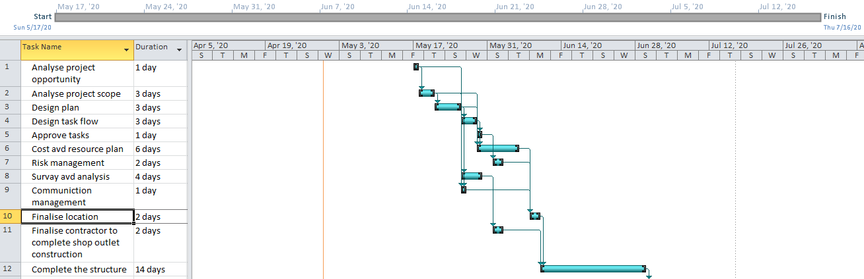
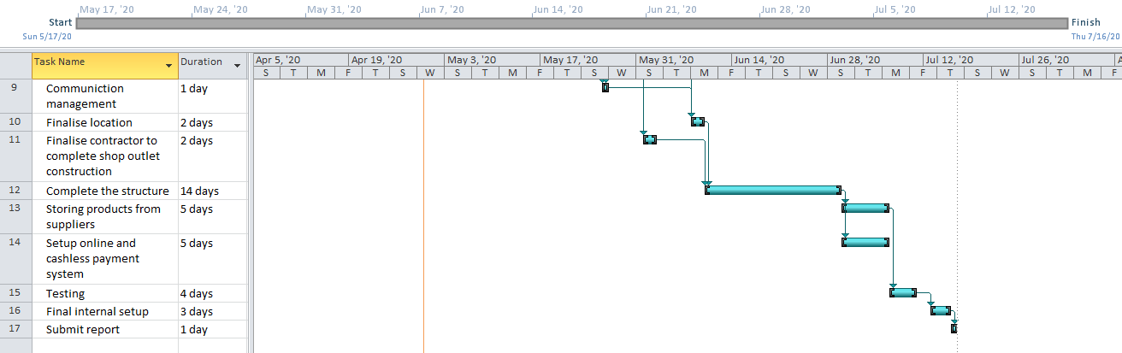
Figure 1: Gantt chart
Source: Created by Author

Project Processes
Project process is a completely planned approach of the project manager to achieve the desired project goals or objective. In every project, the process has been designed by the project manager in the beginning and after getting approval of the same from the management and sponsors, the tasks starts. According to Karten (2016), the 5 key phases associated with a project management are initiation, planning, execution, control and finally closure.
The project of expansion of Asos is scheduled to be start from 17th May, 2020 and it is a 2 months (8 weeks) project. The end date will be 17th July, 2020.

Communication plan
In every project, the project manager requires to design a proper communication plan to ensure that there are proper coordination with all the stakeholders of the project. The process of project communication plan can be defined as a systematic process which helps all the stakeholders to get a regular update about the status of the project as well as its present scenario in terms of completion of tasks, risks, challenges, cost management and other key areas.
In this project, the project manager will design following communication plan to complete the project appropriately:
What | Target | Purpose | Frequency | Method
Project aim, objective and deliverables | All stakeholders | Share key information regarding project and ensure all stakeholder are agreed on tot | 15th May, 2020. | Presentation and hardcopy of report in a meeting
Project plan | All stakeholders, especially the employees in the project | Discuss and communicate about the task flow, time and budget management, resource allocation and risk management plan | 17th May, 2020, the start date of the project. | Meeting
Project Status report | Top management and sponsors, the employees working on the project. | Inform on the present status of the project as well as task flow.  Update about the cost and time management.  Update about completed task, tasks which are in live or behind or ahead of schedule | Once a month, Monthly | E-mail to sponsors, top management.  Meeting with employees.
Team Conference | Employees working on the project | Task allocation, discuss about the ongoing tasks, status of different issues | Fourth nightly | Group meeting
EmployeeTraining Meeting | Employees | Discuss about necessary training to complete the task timely. | Every week | Group meeting
Final Report Meeting | All the stakeholders | Communicate the overall status of the project, list of successful deliverables, any specific points which needs to be mentioned regarding project, budget details and project audit report. | After completion of the project. | Meeting with all the stakeholders. The report needs to submit as a hard copy.

Table 2: Communication Plan
(Source: Created by Learner)

Small scale research
Before working on the project the organisation dove a small scale market survey to understand the demand as well as success potential in the target area, A market survey has been dove among 50 participants and based on their responses the organisation finalise its plan to open a store as well as what are the key areas to focus in terms of product mix as well as promotion strategy and so on. Analytical methodology that has been chosen for examining data that has been obtained through survey were analysed through graphs. The graphs have been assessed so that proper conclusions can be reached in relation with the project objective set.

Data Analysis
In order to analyse the overall market it is important to identify effective data related to the topic of research. Quantitative research helps to identify the opinion of a market whereas qualitative research helps in the identification of details information related to the area where the research is being conducted. In order to expand the market of Asos Plc in the Malaysian market, the situation of the market and the buying behaviour of the consumers need to be identified so that proper business development strategies can be made. In order to attain that process a primary quantitative research with a survey among 50 people from a shopping mall of the Malaysia has been done by using random sampling technique. The overall findings and analysis is being stated there.
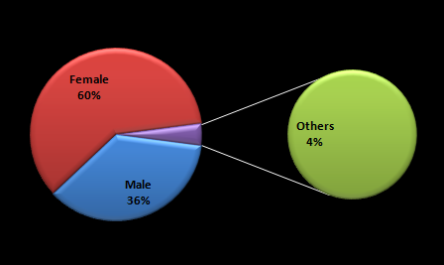
Figure 1: Gender of the respondents
The very first question of the survey is about the gender of the respondents so that the overall segmentation of the organization can be identified. From the responses it has been identified that 60% of the respondents are female, 4% of them belong to the other gender and 36% of the total responses are from male respondents. This survey has been conducted based on the random data sampling technique and the result shows that the major shoppers in the shopping malls are female.
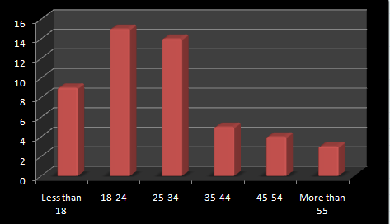
Figure 2: Age group of the respondents
The second question has been highlighting the age group of the respondents so that Asos Plc can easily understand the primary focus for the product development process. 18% of the respondents have said that they are under the age of 18 years, 30% belongs to the age group between 18 years to 24 years. Apart from that 28% of the respondents belong to the age group of 25 years to 34 years, 10% are 35 years to 44 years, 8% are within 45 years to 54 years and 6% are more than 55 years of age.
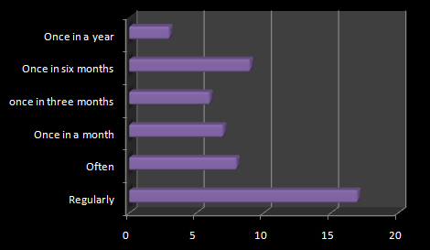
Figure 3: Frequency of shopping
On the topic of the frequency of their shopping, 34% have said that they shop on regular basis, 16% shop often, 14% shop once in a month, 12% once in three months, 18% once in six months and 6% have stated that they shop once in a year. From the context it is clear that the people of Malaysia likes to shop often as most of the respondents have replies that they are shopping on regular basis.

Figure 4: Fashion retailers in Malaysia
Figure 4 signifies that Zara is highly popular in Malaysia that is followed by Malaysia online fashion, and Brands Outlet. Therefore, it is required that Asos takes into competition seriously so that it can adopt proper strategies to deal with the issues effectively.

Figure 5: Clothes fabrics in Malaysia
Figure 5 indicates that people in Malaysia generally prefer clothes made of cotton. It is so because most of the votes were in favour of cotton therefore it is necessary that Asos Plc focuses on clothes made of cotton. However, the issue is that Asos Plc emphasises on designer clothes that are usually made of polyester. Therefore, the organisation needs to make large investment on its products as well to make an entry into the Malaysian market.

Figure 6: Beauty products in Malaysia
With respect to the question asked and the responses against it, it can be stated that people in Malaysia generally prefer organic beauty products rather than chemical beauty products. It is necessary that Asos Plc offers organic beauty products to the customers in Malaysia majorly otherwise the organisation will fail to make profit.

Evaluation of personal ability to manage a project.
As a project manager, I have assessed my experience with respect to the expectations that the project had in relation with the methods that were adopted for execution of the project. The project was successful in meeting its objectives however if certain improvements had been made then its results could have been better. The project took 10 days more to be completed over the two months that was set for the project to be accomplished.

COMPETENCY | HOW I HAVE DEVELOPED IN THIS AREA | WHAT I NEED TO DO TO DEVELOP FURTHER IN THIS AREA
Analytical Skills | I have enhanced my analytical skills by collecting data through survey and assessing the same by using graphs. | I need to gain knowledge regarding analytical procedures as well as methods.
Research Skills | I have been able to develop the skill by using methods of quantitative research. | I need to learn about qualitative research method as well.
Strategic Thinking | I have enhanced my ability to think strategically by demonstrating objectivesof the project. | I need to handle bigger projects so that I can enhance my skill further.
Project Planning | I was able to create a plan for the project efficiently before it started | I was not able to execute the plan as per the plan in several aspects
Communication Skills | I have been successful in communicating effectively with the stakeholders of the project | I need to enhance my communication skill further by handling a bigger group
Risk Assessment | I tried to recognise the risk of the project | I need to be trained further to improve
Progress monitoring | I have not been able to improve since I failed to notice the conflicts emerging | I need to monitor a project in a better way and make sure the project is completed on time
Table 3: Reflection (Performance Review Template)
(Source: Created by the learner)

Recommendation
With respect to the project it can be stated that the organisation Asos Plc has to diversify its operations in various aspects. It is necessary that the organisation increases its investment on the production of cotton clothes so that the needs of people in Malaysia can be improved. The organisation needs to offer organic beauty products so that it can increase its customers in Malaysia. Moreover, it is necessary for Asos Plc to adopt proper marketing strategies so that it can compete with the leading fashion retailers in Malaysia like Zara.

Conclusion
The project is on assessing the expectations of customers in Malaysia with respect to fashion products so that the fashion retailers based in the UK that is Asos Plc can expand and open its POSS in Malaysia. From the project done it can be stated that it is necessary that a number of aspects of the way a project is executed is changed in order to get better results. For the project to be completed a survey was organised so that needs of people in Malaysia can be known and decisions related with the expansion of Asos Plc can be taken.

References
Buchtik, L. 2013. Secret to mastering WBS. London: Project management Institute
Heagney, J., 2016. Fundamentals of project management. Amacom.
Joslin, R. and Müller, R., 2015. Relationships between a project management methodology and project success in different project governance contexts. International journal of project management, 33(6), pp.1377-1392.
Karten, B. 2016. Project management simplified: A step by step process. London: CRC press
Kerzner, H., 2017. Project management: a systems approach to planning, scheduling, and controlling. John Wiley & Sons.
Kinyua, E., Ogollah, K. and Mburu, D.K., 2015. Effect of risk management strategies on project performance of small and medium information communication technology enterprises in Nairobi, Kenya. International Journal of Economics, Commerce and Management, 3(2), pp.1-30.
Marchewka, J.T., 2016. Information technology project management: Providing measurable organizational value. John Wiley & Sons.
Meredith, J.R., Mantel Jr, S.J. and Shafer, S.M., 2017. Project management: a managerial approach. John Wiley & Sons.
Tsatsoula, E., 2018. Application of Ansoff's Matrix-Methodology: Marketing Growth Strategies For Products.
Van Niekerk, M., 2016. The applicability and usefulness of the stakeholder strategy matrix for festival management. Event Management, 20(2), pp.165-179.
Verzuh, E., 2015. The fast forward MBA in project management. John Wiley & Sons.
Walker, A., 2015. Project management in construction. John Wiley & Sons.

Appendices

Appendix 1: Survey
Q1: What is your gender?
Options | Number of Responses | Total Respondents | Percentage of Respondents
Female | 30 | 50 | 60
Male | 18 | 50 | 36
Others | 2 | 50 | 4

Q2: You belong to the age group of
Options | Number of Responses | Total Respondents | Percentage of Respondents
Less than 18 years | 9 | 50 | 18
18-24 | 15 | 50 | 30
25-34 | 14 | 50 | 28
35-45 | 5 | 50 | 10
45-54 | 4 | 50 | 8
More than 55 | 3 | 50 | 6

Q3: How frequent you prefer to shop
Options | Number of Responses | Total Respondents | Percentage of Respondents
Regular | 17 | 50 | 34
Often | 8 | 50 | 16
Once in a month | 7 | 50 | 14
Once in three months | 6 | 50 | 12
Once in six months | 9 | 50 | 18
Once in a year | 3 | 50 | 6

Q4. From which of the organisations do you buy fashion products?
Options | Number of Responses | Total Respondents | Percentage of Respondents
Zara | 30 | 50 | 60
Malaysia online fashion | 10 | 50 | 20
Dorothy Perkins IOI City Mall | 2 | 50 | 4
Brands Outlet | 8 | 50 | 16

Q5. Which kind of materials do you prefer the most for you clothing?
Options | Number of Responses | Total Respondents | Percentage of Respondents
Cotton | 30 | 50 | 60
Linen | 7 | 50 | 14
Polyester | 3 | 50 | 6
Silk | 6 | 50 | 12
Rayon | 4 | 50 | 8

Q6. What do you prefer in terms of beauty products?
Options | Number of Responses | Total Respondents | Percentage of Respondents
Organic | 40 | 80 | 60
Chemical | 10 | 20 | 20

