Student name: Melania Nicoleta Chelu
Student ID: 2025193
Module Code: BMSW6103
Lecturer’s Name: Prof Dennis Pepple

Leading and implementing workplace change

Assignment Title:
Change management portfolio

Table of Contents
Introduction 3
Discussion 4
1. Discussing the ways culture influences communication, negotiation and feedback practices between the 2 nations through Lewis model 4
2. Discussing the Ethnocentric and polycentric model and identifying people management areas in which it would be relevant during the takeover process 8
3. Interviewing someone from a different culture to determine the validity of the Lewis model 15
Conclusion 16
Recommendations 17
References 18
Appendix 21
Appendix 1: Interview Transcript 21

Introduction
Cultural diversity acts as an important factor in shaping the practices of communication, mechanisms of feedback, and strategies of negotiations across the globe. Catering to the nuances of cultures are crucial within the context of business operations on a global scale could be fostered through the enhancement of communication networks within varied cultural landscapes. Moreover, the use of the Lewis Model within the report would provide a framework for the categorization of cultures within multi-active, reactive, and linear-active scales, based upon the behavioural and cultural preferences. Considering this, the report will aim to analyse the impact of negotiations, feedback, and communication between two countries considering UK and the UAE during the period of acquisition of Universal Elect Plc by Energy Power. The report would also analyse some challenges or opportunities that both the employees of the UK and UAE might face due to such wide cultural differences. Under this premise, this report would shed light on proposing some viable strategies which would be quite effective in not only mitigating communication gaps or misinterpretation among the teams but also help them promote collective steps to embrace transparent communication lines.

Discussion

Ways that influence communication, negotiation and feedback practices between the 2 nations and its culture with the aid of Lewis model

The Lewis Model has been introduced by the famous British linguist, Richard Lewis. He has also been a reputed cross-cultural consultant which has probably steered him to introduce this effective model. This model has categorised culture into three types namely linear-active, multi-active and reactive, based on their respective behaviour and communication preferences. According to Lewis (2021), linear active cultures always tend to be more task oriented, direct and logical. On the contrary, multi-active cultures are expressive, emotional and focused more on people-oriented culture while reactive cultures have emerged as respectful, indirect and relationship-oriented. Every culture has their distinct negotiation, communication or feedback practices. All of which has a huge role to play in influencing cross-cultural communications, particularly in this context of the acquisition of Universal Elect Plc By Energy Power in the UK in UAE. Under this premise, it has to be mentioned that culture plays a profound role in influencing communication practices and shaping the ways people express their feelings, interpret messages or interact with each other. Cultural norms are a significant aspect which dictate the methods by which verbal language or nonverbal cues pave the way to variations in communication methods. This would be analysed with the application of Lewis Model so that the culture's impact on communication practices can be analysed properly so as to mitigate any unforeseen challenges.
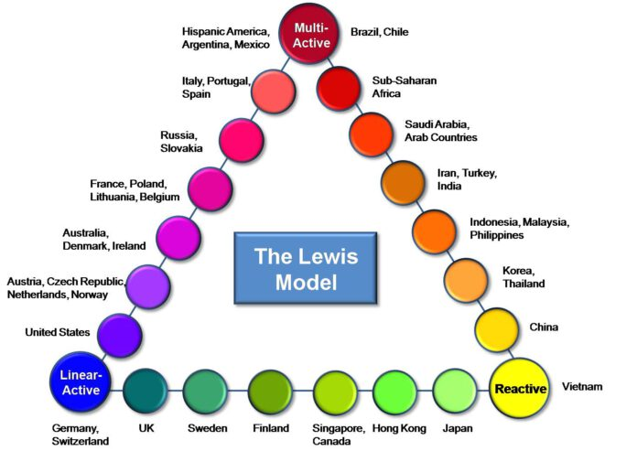
Figure 1: The Lewis Model- Culture Triangle
(Source: Society, 2015)

Firstly, it has to be said that in terms of communication, the UK is one such country that tends to use more direct communication practices while interacting and is much more task oriented and explicit. People of the UK mostly prefer to say what they think and by doing it, they foster more emphasis on transparency and not on feelings or relationships. Even though there are some people in the UK who use indirect communication practices putting more emphasis on feelings and relationships, the majority of the people tends to interact directly while communicating information (Commisceo Global, 2021). This makes the UK come within the ‘Linear Active Culture’ for people who value efficiency and clarity while interacting and focuses more on logical arguments and facts. Considering the case study, the British Communication practices would shape the ways employees would communicate with the other employees in the UAE. It is highly expected of the British managers to expect the employees to provide concise updates on their integration process and adopt clear discussions regarding timeliness and objectives. On the contrary, UAE can be sent to follow a multi-active culture due to its communication style focusing more on flexibility and relationship building. The individuals at UAE value polite and respectful interactions with usage of formal titles or greetings. People of this country emphasise more on personal connections as they express themselves in an indirect manner, avoiding confrontation and maintaining harmony (Commisceo Global, 2021).
Active listening and patience during conversations has a huge role to play and so, UAE can be included under multi-active culture in terms of communication practices. While the takeover process took place, an issue might arise when the UAE employees of Universal Elect PLC would implement multi-active interaction practices with the UK-based employees. This might lead to communication gap between the two sets of employees wherein the UAE one desires for a harmonious and positive communication exchange while the UK workforce demands short and concise visual reminders. Reactive culture can be exhibited for the UAE but not for the UK employees as they are less indirect. The UAE has emerged as one of the most diverse nations, having around 10-20% of their population as native Emiratis (LinkedIn, 2024). This diversity holds the notion that while working in the UAE, employees would have to come across varied people belonging from diverse cultures. Shedding light on this, the UAE uses non verbal cues such as body language or facial expressions as well in order to assess varied scenarios before responding to it. Nonverbal cues like body language or facial expressions play a profound role in communication of the UAE people. On the other hand, the UK cannot be placed under the realm of ‘reactive culture’ for they tend to be reserved while communicating with others. Their gestures are often quite polite, reserved and less demonstrative. The UK employees (or British) are mostly direct communicators and they remain polite throughout the conversation while reacting (Cultural Atlas, 2016). Therefore, it can be ascribed from the given information that even though the UAE staff might give into subtle cues like body language, tone of voice during discussions or negotiations but the UK employees would not facilitate this kind of communication and try to be self-deprecating during conversation. This would be with an intention to be known as being honest, relaxed and humble about themselves. These differing styles of communication would lead to manifold challenges and few opportunities for both of these sets of employees belonging from two distinct cultures. Cross-cultural interaction practices has to be implemented thereafter to resolve such conflicts of miscommunication and building trust or attaining mutual goals in terms of international business domain.
Negotiation is the strategic discussion that occurs between two parties in order to resolve a problem in such a way that it is acceptable in both ways (Korobkin, 2024). Under this light, cultural values also cast their principles in the negotiation strategies that shape the ways individuals resolve issues, approach bargaining and foster trust. Starting with the UK, the employees follow a formal approach of negotiation that is often set with logical arguments and clear objectives. It results in contractual and explicit exchanges in this case. This aids in setting the goal clear and limpid to both the parties so that no doubt coerces out of the negotiation. This can be related with the clarity and precise negotiation approach implemented by the Energy Power to Universal Elect PLC. The British negotiators of the former company based in the UK would prioritise transparent and clear negotiations which are outlined on the specified terms and conditions of their takeover agreement. They would also detail the outline of their tasks at the end of the formal negotiation taking place and outline the duties and responsibilities that each member would shoulder, time duration and procedures of during tasks in written format (LinkedIn, 2016). On the contrary, as the UAE has already been marked as relationship-oriented and flexible, it comes under the multi-active culture of Lewis Model. According to Miller and Verhoeven (2020), Emirati negotiators are the ones who always avoid adversarial techniques or openly aggressive tones but prefer more subtle versions. Relation-building is one of the foremost strategies that these negotiators employ and shows interest in the wellbeing of their partners involved in this process. They are often of the belief that forming a direct opening offer stands as a standard practice to start into a bargaining process (Dubai FreeZone, 2024). This resonates well with the takeover negotiations provided in the case study. The Emirati counterparts would emphasise more on relationship-building negotiations with that of the team of Energy Power which signifies openness and flexibility. As per Chukwu et al. (2023), openness in terms of negotiation is a significant aspect which not only fosters collaboration or trust but encourages problem solving in an efficient manner with beneficial solutions. Thus, this can be one of the potential reasons for delving into relationship-based approaches as that forms the groundwork of transparency and reduced misunderstandings. Thus, the aspect of reactive culture of Lewis Model can be related to UAE employees and not to the UK workforce for they are rigid in terms of negotiation as compared to the Emirati counterparts. There can be many potential challenges that both of these companies and their set of workforce would have to face due to such distinct negotiation styles. One of the primary barriers is that the British negotiators would find building rapport and trust a very time consuming activity whereas the Emirati colleagues would prioritise on making a good rapport first followed by the result. This would outrageously result in a cultural gap for the British colleagues would be overly focused on the outcome and efficiency of the negotiation of takeover in the UK. Therefore, it can be noted that both parties have to adjust to each of their negotiation approaches and culture in order to reach a common ground.
Lastly, feedback forms the crux of any business organisation for it is by this process one can get a succinct awareness of the work procedure (Delshammar and Artman, 2020). Shedding light on this, as mentioned before, the UK follows a linear-active culture for it is specific and focused towards their only objective of attaining performance improvement. Under this juncture, it can be reflected that 94% of the UK customers prefer companies that practise transparency (Slack, 2019). It resonates with the British professionals who put more focus on value transparency, clear communication lines and transparency in attaining measurable goals. This goes well with the approach that the British professionals of the Energy Power company might implement and that is to give direct, constructive feedback in order to enhance their performance after the smooth takeover in the UK. Change management across varied cultures is constant and so, one must be able to adjust to the new culture in order to work effectively. This would be the same for the Emirati employees of UAE who would have to adapt to this direct feedback, even if those are offending and negative. Furthermore, measuring an employee's performance (or feedback) can be best levied with the aid of construction and reliable feedback which improves employee performance (McKinsey & Company, 2023).
Therefore, the managers at Energy Power would frequently want feedback from the employees as that has a direct cause-and-effect relationship with improving an employee's performance. Clarity or accountability in terms of feedback forms the foundation of their practices. Conversely, in the case of the UK, feedback is often delivered in such a manner that it does not make the listener feel bad. Indirect manner with a lot of sensitivity and softness in order to retain the relationships is focused more in the UAE. Emirati professionals often value harmony and so soften criticisms pace the way quite often in the form of praise or delivering feedback to respective people in private. It is also a noted fact that the managers of UAE typically consult their stakeholders, including their employees in their decision-making process (Commisceo Global, 2024). It is only after consulting with their stakeholders, the managers implement the decision by passing it to their subordinate team members. This teamwork often delineates the way towards a friendly and not-so-rigid atmosphere which reflects respect, social harmony and hospitality. It might be during this phase the managers can provide feedback to their employees in a soft-spoken manner. Thus, during the process of takeover, Emirati workforce might prefer subtle feedback which would consider their social status and feelings. Therefore, a non-confrontational and supportive manner can be the best way for delivering feedback to these sets of employees which would not only help them to improve better but also reinforce the significance of empathy and cultural sensitivity throughout this feedback mechanism. Reactive culture can be observed for the UK while the UAE workforce cannot be placed under this category due to their assertion on avoiding conflicts and retaining harmony. This proves the importance of cross-cultural communication practices which must be practised at large so as to mitigate any cultural nuances, even while adapting to the feedback delivery.
Therefore, it can be mentioned that culture varies across different countries and so, it proves influential in impacting communication, negotiation and feedback practices. Considering this case study, it has come to the forefront that UAE and UK have distinct culture and behavioural norms which might make it difficult for both of these workforces to adapt accordingly. It has been found out that while the UK is one such nation that believes in direct communication style, the UAE focuses on indirect communication. Besides this, the UK has a very rigid or formalised negotiation practice while THE UAE emphasises on relationship-oriented and flexible negotiation processes which resonates with the multi-active culture of Lewis Model. Considering the feedback practices, frequent and constructive feedback is what the British professionals place emphasis on while the UAE professionals make it a point to follow subtle manners. They prioritise harmony, thus paving the way for praise or delivering feedback in private. These findings place the fact that the UK belongs to the linear-active category of the Lewis Model while the UAE belongs to the multi-active premise of the model. Reactive variations vary between these two countries but the UK cannot be termed as ‘reactive culture’ unlike UAE.
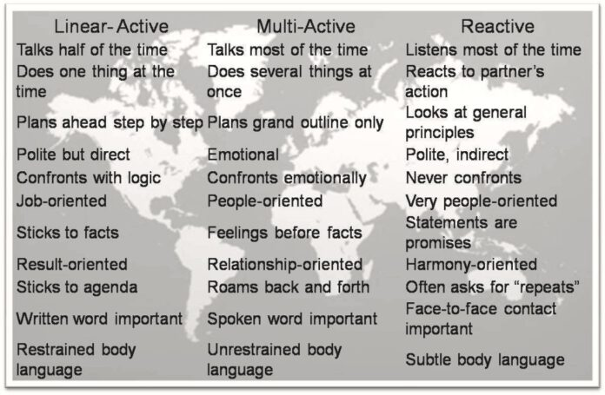
Figure 2: Characteristics of these three categories of The Lewis Model
(Source: Society, 2015)

2. Discussing the Ethnocentric and polycentric model and identifying people management areas in which it would be relevant during the takeover process

The Ethnocentric Model:
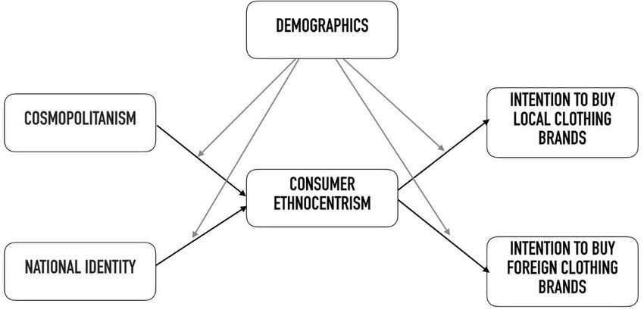
Figure 3: The Ethnocentric Model
(Source: Lemos et al. 2020)

The ethnocentric model within people management could be referred to the approaches in which the prominent panel from a parent organisation are placed in positions within their subsidiaries abroad. This model further caters to the approach, practices, and values of the parent organisations and replicated within their operations across global levels (Lemos et al. 2020). Within the context of the takeover, the implementation of ethnocentric models fosters efficient strategies to manage people effectively. Henceforth, the identified areas in which the people management could be levied by the organisation are:

Factors | Area | Discussion
Leadership Alignment | Centralised Decision Making | The Ethnocentric Model states that the decision-making process should be centralised within an organisation and align it with the roles of leadership of an individual from the country they are operating globally (Bizumic et al. 2021). Within the case of acquisition of Energy Power, the prominent positions of leadership should be filled by the employees that are familiar with the practices and culture of the parent company. This would foster a sense of stability and continuity during the phase of transition.
Integration of Corporate culture | Imposition of corporate values | The ethnocentric model further caters to the imposition levied by the core values of the organisation across the globe. This approach could be fostered during the takeover process by the Energy Power, by implementing their corporate culture, norms, and values to Universal Elect Plc. The establishment of a unified corporate culture would help in catering to a harmonious and cohesive environment for work and productivity.
Training and Development | Standardised Programs for Trainings | The Ethnocentric Model focuses on a standardised program and process for training within the home country (Miguel et al. 2023). Hence, Energy Power could implement a unified initiative for training for ensuring that the employees within UAE and the UK receive guidance on the policy of the company aligned with the expectations and procedures. This process could help in minimising the confusion and help the employees to adapt to their organisational structure.
Communication Strategies | Unified Channels for Communication measures | The Ethnocentric Model further states that maintaining a unified communication strategy is important for an organisation. Following this, Energy Power should establish a centralised communication network considering their parent company and the subsidiaries across a global scale to pass down information accurately to all their employees. This would ensure that the employees in the UAE and the UK could receive the updates and foster a sense of belonging.
Talent Management | Mobility in Global Talent | The Ethnocentric Model involves the movement of talent from the operational base to the subsidiaries (Ramadania et al. 2023). Within the context of acquisition, Energy Power could send their staff working in the UK to the UAE for facilitating mentorship, transfer knowledge, and ensuring effective transition. This would promote the integration and understanding of cross-cultures.
HR Policies and Practices | Standardised HR Policies | Through the adherence of an effective HR Policy and practice levied by the home country of an organisation, their subsidiaries could also help in gaining significant advantage of talent retention and management. Hence, Energy Power should ensure that their HR policies have been implemented and amended across their global chain successfully considering the cultural and legal differences. This would promote equality and fairness in alignment to the acquisition of the organisation’s standards.
Table 1: The Ethnocentric Model
(Source: Self-Developed)

However, considering the areas identified, there are certain limitations to this model which can be discussed as,
- Cultural Sensitivity: The fostering of unified corporate culture could disregard a diverse context of culture for the UK and UAE. Hence it is crucial to balance among respecting the local nuance and organisational coherence for avoiding resistance to employees.
- Employee Engagement and Morale: The overemphasis on a centralised leadership and decision-making process could lead to a decline in employee engagement and morale within the workforce of the companies acquired (Biriowu and Ofurum, 2020). Hence valuing and recognition of the local talent is crucial to foster a productive and motivated workforce.
- Adapting to the dynamics of the local market: The Ethnocentric Model is not flexible for adapting to their marketing dynamics within UAE and the UK. Hence, the expertise of local communities is crucial to foster regulatory frameworks and the emerging trends of markets effectively.
- Communication Barriers: Fostering a centralised strategy for communication could cater to challenges for addressing the communication and language preferences within the UK and the UAE. Hence, fostering effective strategies for communication within the context of local communities is essential to foster their communication abilities.
Hence, the Ethnocentric Model could be considered as an effective tool for change management across varied regions and cultures. Through the careful adoption of this model across various phases of people management, an organisation could adopt a nuanced approach for the values of cultural sensitivity across global networks.

The Polycentric Model:
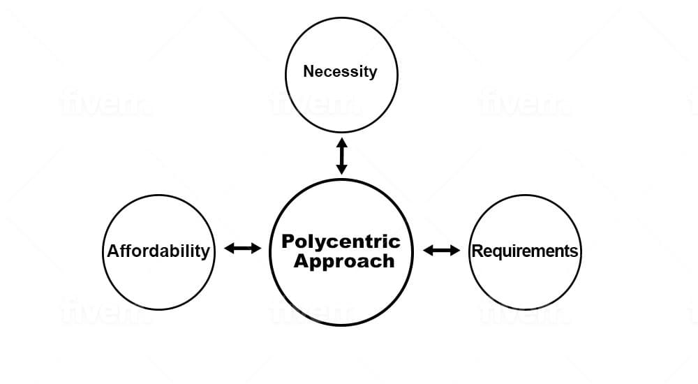
Figure 4:The Polycentric Model
(Source: Humer et al. 2022)
The Polycentric Model could be stated as an approach to management that emphasises on the adaptation of an emphasis on the local autonomy, that plays a crucial role within the field of cross-cultural management of change (Gatto, 2022). The acquisition of Universal Elect Plc by Energy Power in the UAE aligns with the Polycentric Model for ensuring an effective transition and collaborative measures. Moreover, this Model encourages the organisation in decentralising their process of decision-making by allowing their subsidiaries to operate within a certain measure of autonomy. Henceforth, the identified areas in which the people management could be levied by the organisation are:
Factors | Area | Discussion
Leadership and Decision Making | Empowerment of Local Leadership | This model of change management caters to the empowerment of local leaders for making informed decisions that are based on their understanding of the local contexts (Lanfredi et al. 2022). Within the stature of Energy Power, the organisation could appoint local workforce equipped with prominent leadership skills for the process of decision-making. Hence, this approach would enhance the adaptability and acceptance of the organisational workforce in alignment to providing respect to the local talent.
Adoption of Corporate Culture | Flexible corporate culture | The Polycentric Model fosters flexibility to adaptation to the local norms and culture within the corporate realm (Humer et al. 2022). Considering this, Energy Power could encourage collaborative measures to cater to the best practices from the organisation and its subsidiaries for creation of a unified corporate culture subjecting to the strengths of the organisations.
Training and Developmental Programs | Tailored Programs for Training | This model helps in supporting tailored programs for training that could be customised as per the requirement of an organisation to address the needs specified by the organisation. Considering this, Energy Power should cater to training initiatives that considers the cultural differences, regulatory frameworks, and local dynamics of the market. This initiative could accelerate the integration and enhance the effectiveness of the structured programs for training between the two organisations.
Talent Management | Development of Local Talents | The Polycentric Model promotes the recognition and development of local communities (Zhou et al. 2022). Hence, Energy Power could invest in the programs for talent management programs that could nurture and identify the potential leaders within their subsidiary alliance. Hence this approach could help in fostering prominent leaderships from the local communities and foster a sense of commitment and ownership.
HR Practices and Policies | Adaptation of HR Policies | The Polycentric Model fosters the adoption of HR policies that align with the local norms of culture and their regulations. Hence, Energy Power in collaboration with the local teams of their subsidiary organisation should ensure that the policies are aligned with the legal framework of the country. This approach would promote employee satisfaction and comply with the local laws of employment.
Communication Strategies | Localised Channels of communication | The Polycentric Model fosters the use of local communication modes with the recognition of the importance of effective communication among the team members (Sun et ak. 2020). Considering this, Energy Power should cater to communication strategies considering the local culture, communication style, and linguistic preferences. This would ensure that the information could be transferred effectively across all their organisational locations.
Table 2: The Polycentric Model
(Source: Self-Developed)

However, considering the areas identified, there are certain limitations to this model which can be discussed as,
- Standardisation: The decentralisation on the process of decision-making could lead to the potential challenge considering the efforts of coordination and maintaining a sustained practice across varied locations of operations considering an organisation. Hence Energy Power should cater to the balance between obtaining a core process and autonomy.
- Corporate identity: The Polycentric Model could foster prominent challenges for the establishment of a corporate identity that is unified (Turner and Wills, 2022). Hence, Energy Power should ensure that there should be a recognisable and coherent identity for organisations with the values and missions, in spite of their adaptations locally.
- Transfer of Knowledge: The local autonomy within an organisation could affect the effective knowledge transformation and the profound practices among varied subsidiaries on a global scale. Hence to mitigate this risk, the organisation should be implementing strategies considering the aspects of knowledge sharing programs and mentorship sessions for facilitating collaborative responses and cross cultural learning.
Therefore, this model helps in providing a strategic framework in navigation through the complexities for people management during the acquisition of Universal Elect Plc by Energy Power.

3. Interviewing someone from a different culture to determine the validity of the Lewis model

The Lewis model has been identified as one of the important frameworks which offers multifarious insights into the culture of different countries. Culture impacts communication, behaviour, negotiation and feedback methods. Under this premise, the interview of Ela Kander would be highlighted that would help in understanding the diverse complexities concerning cultural dynamics and the ways it intersects her professional as well as personal experience.
In the interview, Ela says that “I am originally from Poland, a country that belongs to a multi-active category based on the Lewis Cultural Model” [Refer to Appendix]. From her answer, it is quite evident of the fact that Poland is one such country that belongs to the multi-active category of the Lewin model. Multi-active category emphasises mostly on being expressive, emotional and focused (Ogiermann and Bella, 2021). As Ela belongs from Poland, it is much evident that she also prioritises generosity and relation building activities. She also mentioned in the interview that “It is common in my culture to make guests feel welcome and comfortable”. This resonates properly with the multi-active domain of this model as valuing interpersonal connections along with emotional expressiveness comes before fostering direct and formal relationships. Poles, people of Poland, like building personal relationships in terms of business and this is what signifies the people's personality over there (Cultural Atlas, 2017).
There is always a ‘professional closeness’ that resides in the people of Poland and this has been ongoing since the communist times. Since time immemorial, Poles have been heavily relying on making personal contacts with their connections and that helped them obtain valuable information regarding the authority figures. This tendency is still being practised at large and that is why Poland belongs to the multi-active category due to its emphasising more on making relationships and personal contacts. Preserving and celebrating the cultural heritage stands integral to Poland's culture and the same is for Ela in this interview. However, Ela has had some experiences while working in Germany and the UK which has impacted on her approach to deal with time management and task prioritisation activities. This adaptation speaks of her adaptability to adapt to Germany's task-focused background and the target-oriented approach of the UK. Later in this interview, she goes on to add “At work in the UK, there is only one priority: target” [Refer to Appendix]. This reflects the idea that adaptability and flexibility are two such aspects which vary across varied cultural environments. It is also understood of the significance of the Lewis Model in validating that Germany belongs to the ‘linear-active’ category of culture. It is indicated from the dialogue by Ela that “Germans tend to be very task-oriented and value productivity and time management”. It can be understood from the above statement that Germany has a linear-active culture where punctuality and efficiency are heavily valued. Communication lines are explicit along with focusing more on logic and facts. It is also known from the research by LinkedIn (2023), that Germans prioritise tasks and are widely known for their planning and precision of tasks.
It has been understood from the communication style of Ela that she really belongs to a multi-active culture where interactions often happen face-to-face along with valuing emotional responsiveness more. It is evident from the line, “In a professional environment, I prefer face-to-face communication over written, .........showing emotions is perceived as passion and honesty” [Refer to Appendix]. This highlights that communication preferences within the multi-active culture often places emphasis on building trust and rapport via expressive communication. Expressive interaction happens in an effective manner when two people indulge in one-on-one or direct communication with each other, expressing emotions and feelings simultaneously (Mesquita, 2022).
Besides this, her approach in conflict resolution and negotiation has emphasised the significance of fairness and trust-building practices. She says that, “I approach negotiation and conflicts based on relationships and trust in general, I believe,…In this context, fairness and ethics are the core elements for me”. This statement is indicative of the focus of the multi-active cultures in maintaining relationships and trust. This practice aligns with the key components of a multi-active criteria placed in the Lewis Model which embraces interpersonal relationships and trust as the key components of conflict resolution and successful negotiation. It has always been the notion followed by the countries coming under multi-active culture to focus on building relationships and rapport and depend on situational aspects of the other parties. It is also evident from her interview regarding the adaptations of cultural dynamics over time. She has mentioned that “The change I have noticed is in the importance of hierarchy and authority. In my culture, respect for authority figures is vital, and people often defer to those in positions of power.” This brings us to the differences between Poland, which is her native place along with the other countries such as the UK and Germany. Even if Poland emphasises more on hierarchy, Germany or the UK puts less stress on hierarchy and it has often been seen that they challenge the authority or raise voices for themselves against any injustice. Germans are generally known for their innate power to be honest and discreet while speaking about what seems important to them (Cultural Atlas, 2017). Even though this excerpt taken from the interview above speaks of the adaptation of diverse cultural behaviour, it brings to the forefront that culture holds a profound role in shaping a person's experiences. However, one thing that is quite relatable from the overall interview is that even if Lewis Model helps in understanding the diverse cultural differences, it acts as the foundation for oversimplifying cultural diversity.

Conclusion
In a nutshell, this report employed the Lewis model which helped in fostering the dynamic interplay between negotiation, culture and communication in alignment to the strategies of conflict resolution. Moreover, the report underscored the multi-active approach to the cultural context for undermining the significance of emotional expressiveness, fostering trust, and interpersonal relationship within the professional interactions. This report further discussed the intricacies of cultural dynamics of the UK and UAE for emphasising the differences of communication abilities, authoritative approaches, and hierarchical structures. This report further provided a foundation in understanding the nuances of cultures by categorising them into reactive, liner-active, and multi-active types, based upon the behavioural and preference norms of an individual. This report signified the importance of adoption of a diverse cultural environment for enhancing the productivity and operational measures within an organisation through the orientation of a task-based approach. Moreover, this report fostered a target-based mindset of the UK while valuing the rational aspects of communication within the UAE. This report further emphasised on the limitations of communication barriers in catering to the complexities of cultural diversity. The report fosters insights to the tendencies that had outlined the diversification of cultures by emphasising on the individual variations. It was observed in the report that the cultural adaptation could be signified as a dynamic process that required empathy and open-mindedness for catering to the communication barriers. Hence, within the global business realm, the cross-cultural communication approaches fostered by an organisation helps in creating awareness and operational efficiency by fostering trust and mutual respect within the work environment.

Recommendations
Based on the analysis of cultural dynamics, there are several recommendations that could be fostered to address the challenges and optimise the opportunities presented within the context of acquisition. The implementation of a comprehensive training program for cultural sensitivity for all the employees could be involved during the process of acquisition. The training programs would focus on emphasising the need and awareness on communication styles, negotiation strategies, and cultural differences in alignment to the approaches to conflict resolution. Through the enhancement of cultural understanding, the employees within the work environment could foster adaptability and empathetic behaviour, which could lead to a smooth collaboration and communication with individuals with a diverse cultural background. The development of personalised strategies of communication aligning with the accommodation to varied communication preferences for employees would leverage the opportunity for Energy Power for a smooth process of acquisition and operational measure. Within an organisation, some of the employees prefer direct mode of communication while the others preferably value contextual and indirect mode of communication (Einwiller et al. 2021). Hence, integrating the opportunity for written, verbal, and virtual mode of communication training to the employees, the organisation could mitigate the communicational barriers and ensure enhanced collaboration and smooth operational functionality within the work environment. Investments made for training and development of cross-cultural leadership could further leverage the leaders with the knowledge and skills for navigating through the cultural landscape. Within an organisation, the leaders could be trained in recognising the cultural nuances and adapt considerably with the preferences of employees from a diverse cultural background.
Engaging flexibly within the diversified negotiation style of the employees with an organisation considering their cultural background could stand as a crucial recommendation for Energy Power. Within an organisation some of the employees prioritise consensus-building and relationship-building strategy for the approaches to negotiation, while others could prefer the emphasis on efficiency and transparency (Maurer et al. 2023). Therefore, adaptation to an integrative and collaborative approach could help to cater to the cultural nuances and help the organisation to achieve the outcome beneficial for them. Moreover, the establishment of sensitive mechanisms for feedback considering the sensitivities and preferences of employees could help the organisation to enhance their productivity and mitigate the cultural barriers. Integrating group feedback sessions, anonymous feedback assistance, and one on one discussions could help the employees enhance their comfort levels. Emphasising on the importance of feedback could help in delivering a sense of empathy and cater to a culture of mutual support and continued improvement.

References
Biriowu, C.S. and Ofurum, U.A., 2020. Employee engagement and organizational survival. World Journal of Innovative Research, 9(5), pp.79-92.
Bizumic, B., Monaghan, C. and Priest, D., 2021. The return of ethnocentrism. Political Psychology, 42, pp.29-73.
Chukwu, E., Adu-Baah, A., Niaz, M., Nwagwu, U. and Chukwu, M.U., 2023. Navigating ethical supply chains: the intersection of diplomatic management and theological ethics. International Journal of Multidisciplinary Sciences and Arts, 2(1), pp.127-139.
Commisceo Global, 2021. Cross Cultural Management Guide for the UAE. Available at: https://www.commisceo-global.com/resources/management-guides/uae-management-guide (Accessed on: 12 March, 2024).
Commisceo Global, 2021. What’s the British Communication Style? Available at: https://www.commisceo-global.com/what-is-the-british-communication-style%3Fformat%3Damp&ved=2ahUKEwia5f2Nku6EAxW9bmwGHS-fAeQQFnoECCEQAQ&usg=AOvVaw1kNlg3tt-Cbz9bpDqVC26m (Accessed on: 12 March, 2024).
Commisceo Global, 2024. UAE - Language, Culture, Etiquette and Business Practices. Available at: https://www.commisceo-global.com/resources/country-guides/uae-guide (Accessed on: 12 March, 2024).
Cultural Atlas, 2016. Communication of British Culture. Available at: https://culturalatlas.sbs.com.au/british-culture/british-culture-communication (Accessed on: 12 March, 2024).
Cultural Atlas, 2017. Business Culture. Available at: https://culturalatlas.sbs.com.au/polish-culture/polish-culture-business-culture (Accessed on: 12 March, 2024).
Cultural Atlas, 2017. German Culture of Communication. Available at: https://culturalatlas.sbs.com.au/german-culture/german-culture-communication (Accessed on: 12 March, 2024).
Delshammar, J. and Artman, J., 2020. The Crux of Virtual Leadership-Understanding how Virtual Leadership is Exercised in Practice by Examining a Case Study in a Global Organizational Context.
Dubai FreeZone, 2024. 5 Golden Rules for Negotiating in the UAE. Available at: https://en.dubai-freezone.ae/articles-about-bussines-in-uae/5-golden-rules-for-negotiating-in-the-uae.html (Accessed on: 12 March, 2024).
Einwiller, S., Ruppel, C. and Stranzl, J., 2021. Achieving employee support during the COVID-19 pandemic–the role of relational and informational crisis communication in Austrian organizations. Journal of Communication Management, 25(3), pp.233-255.
Gatto, A., 2022. Polycentric and resilient perspectives for governing the commons: Strategic and law and economics insights for sustainable development. Ambio, 51(9), pp.1921-1932.
Humer, A., Cardoso, R.V. and Meijers, E., 2022. Breaking with the spatial-cycle model: the shift towards ‘syncurbanization’in polycentric urban regions. Regional Studies, 56(1), pp.21-35.
Korobkin, R., 2024. Negotiation theory and strategy. Aspen Publishing.
Lanfredi, M., Egidi, G., Bianchini, L. and Salvati, L., 2022. One size does not fit all: A tale of polycentric development and land degradation in Italy. Ecological Economics, 192, p.107256.
Lemos, C.M., Gore, R.J., Lessard-Phillips, L. and Shults, F.L., 2020. A network agent-based model of ethnocentrism and intergroup cooperation. Quality & Quantity, 54, pp.463-489.
Lewis, R.D., 2021. Organisational culture-a fallacy?. TLC Journal, 5(1).
LinkedIn, 2016. Leadership IMHO #5: Informal versus Formal Approach in Negotiating. Available at: https://www.linkedin.com/pulse/leadership-imho-5-informal-versus-formal-approach-don-varela&ved=2ahUKEwjd_ofap-6EAxVPRmwGHQaFCvcQjjh6BAg3EAE&usg=AOvVaw0jWV4yK2rkPpoEDQ3F6Aiu (Accessed on: 12 March, 2024).
LinkedIn, 2023. Navigating Cultural Differences: India and Germany Through the Lens of the Lewis Model. Available at: https://www.linkedin.com/pulse/navigating-cultural-differences-india-germany-through-moutushi-k%C3%BCnne (Accessed on: 12 March, 2024).
LinkedIn, 2024. UAE Business Culture. Available at: https://www.linkedin.com/pulse/uae-business-culture-emma-jordaan-assoc-cipd&ved=2ahUKEwiW-sjumO6EAxW1T2wGHRvkDPAQjjh6BAgWEAE&usg=AOvVaw0uChlTLMx3Vbhe8rrWyGe0 (Accessed on: 12 March, 2024).
Maurer, M.E., Hilliard‐Boone, T., Frazier, K., Forsythe, L., Mosbacher, R. and Carman, K.L., 2023. Examining how study teams manage different viewpoints and priorities in patient‐centered outcomes research: Results of an embedded multiple case study. Health Expectations, 26(4), pp.1606-1617.
McKinsey & Company, 2023. Performance through people. Available at: https://www.mckinsey.com/~/media/mckinsey/mckinsey%2520global%2520institute/our%2520research/performance%2520through%2520people%2520transforming%2520human%2520capital%2520into%2520competitive%2520advantage/mgi-performance-through-people-full-report-vf.pdf&ved=2ahUKEwjQgLOmye6EAxWbs1YBHc-JBOo4ChAWegQIAhAB&usg=AOvVaw2bXfLU1APjOgOxUUQDjIww (Accessed on: 12 March, 2024).
Mesquita, B., 2022. Between us: How cultures create emotions. WW Norton & Company.
Miguel, L.P., Marques, S.H. and Duarte, A.P., 2023. Characterising the fruit and vegetables consumer ethnocentrism in a southern European Country: An assessment of the reliability and validity of the “CETSCALE” in Portugal. Food Quality and Preference, 105, p.104770.
Miller, R. and Verhoeven, H., 2020. Overcoming smallness: Qatar, the United Arab Emirates and strategic realignment in the Gulf. International Politics, 57(1), pp.1-20.
Ogiermann, E. and Bella, S., 2021. On the dual role of expressive speech acts: Relational work on signs announcing closures during the Covid-19 pandemic. Journal of Pragmatics, 184, pp.1-17.
Ramadania, R., Suh, J., Rosyadi, R., Purmono, B.B. and Rahmawati, R., 2023. Consumer ethnocentrism, cultural sensitivity, brand credibility on purchase intentions of domestic cosmetics. Cogent Business & Management, 10(2), p.2229551.
Slack, 2019. Transparency in business: the next wave in company evolution. Available at: https://slack.com/intl/en-in/collaboration/transparency-in-business-company-evolution (Accessed on: 12 March, 2024).
Society, 2015. The Lewis Model: How To Understand Every Culture In The World. Available at: https://society30.com/lewis-model-understand-every-culture-world/ (Accessed on: 12 March, 2024).
Sun, B., Han, S. and Li, W., 2020. Effects of the polycentric spatial structures of Chinese city regions on CO2 concentrations. Transportation Research Part D: Transport and Environment, 82, p.102333.
Turner, R.A. and Wills, J., 2022. Downscaling doughnut economics for sustainability governance. Current Opinion in Environmental Sustainability, 56, p.101180.
Zhou, Y., Tian, Y., Jim, C.Y., Liu, X., Luan, J. and Yan, M., 2022. Effects of public transport accessibility and property attributes on housing prices in Polycentric Beijing. Sustainability, 14(22), p.14743.

Appendix

Appendix 1: Interview Transcript



