

Managing Enterprise in the 21st Century

EcoWash London Ltd

Business Description:
Sustainable Laundry Collection and Delivery Service in London
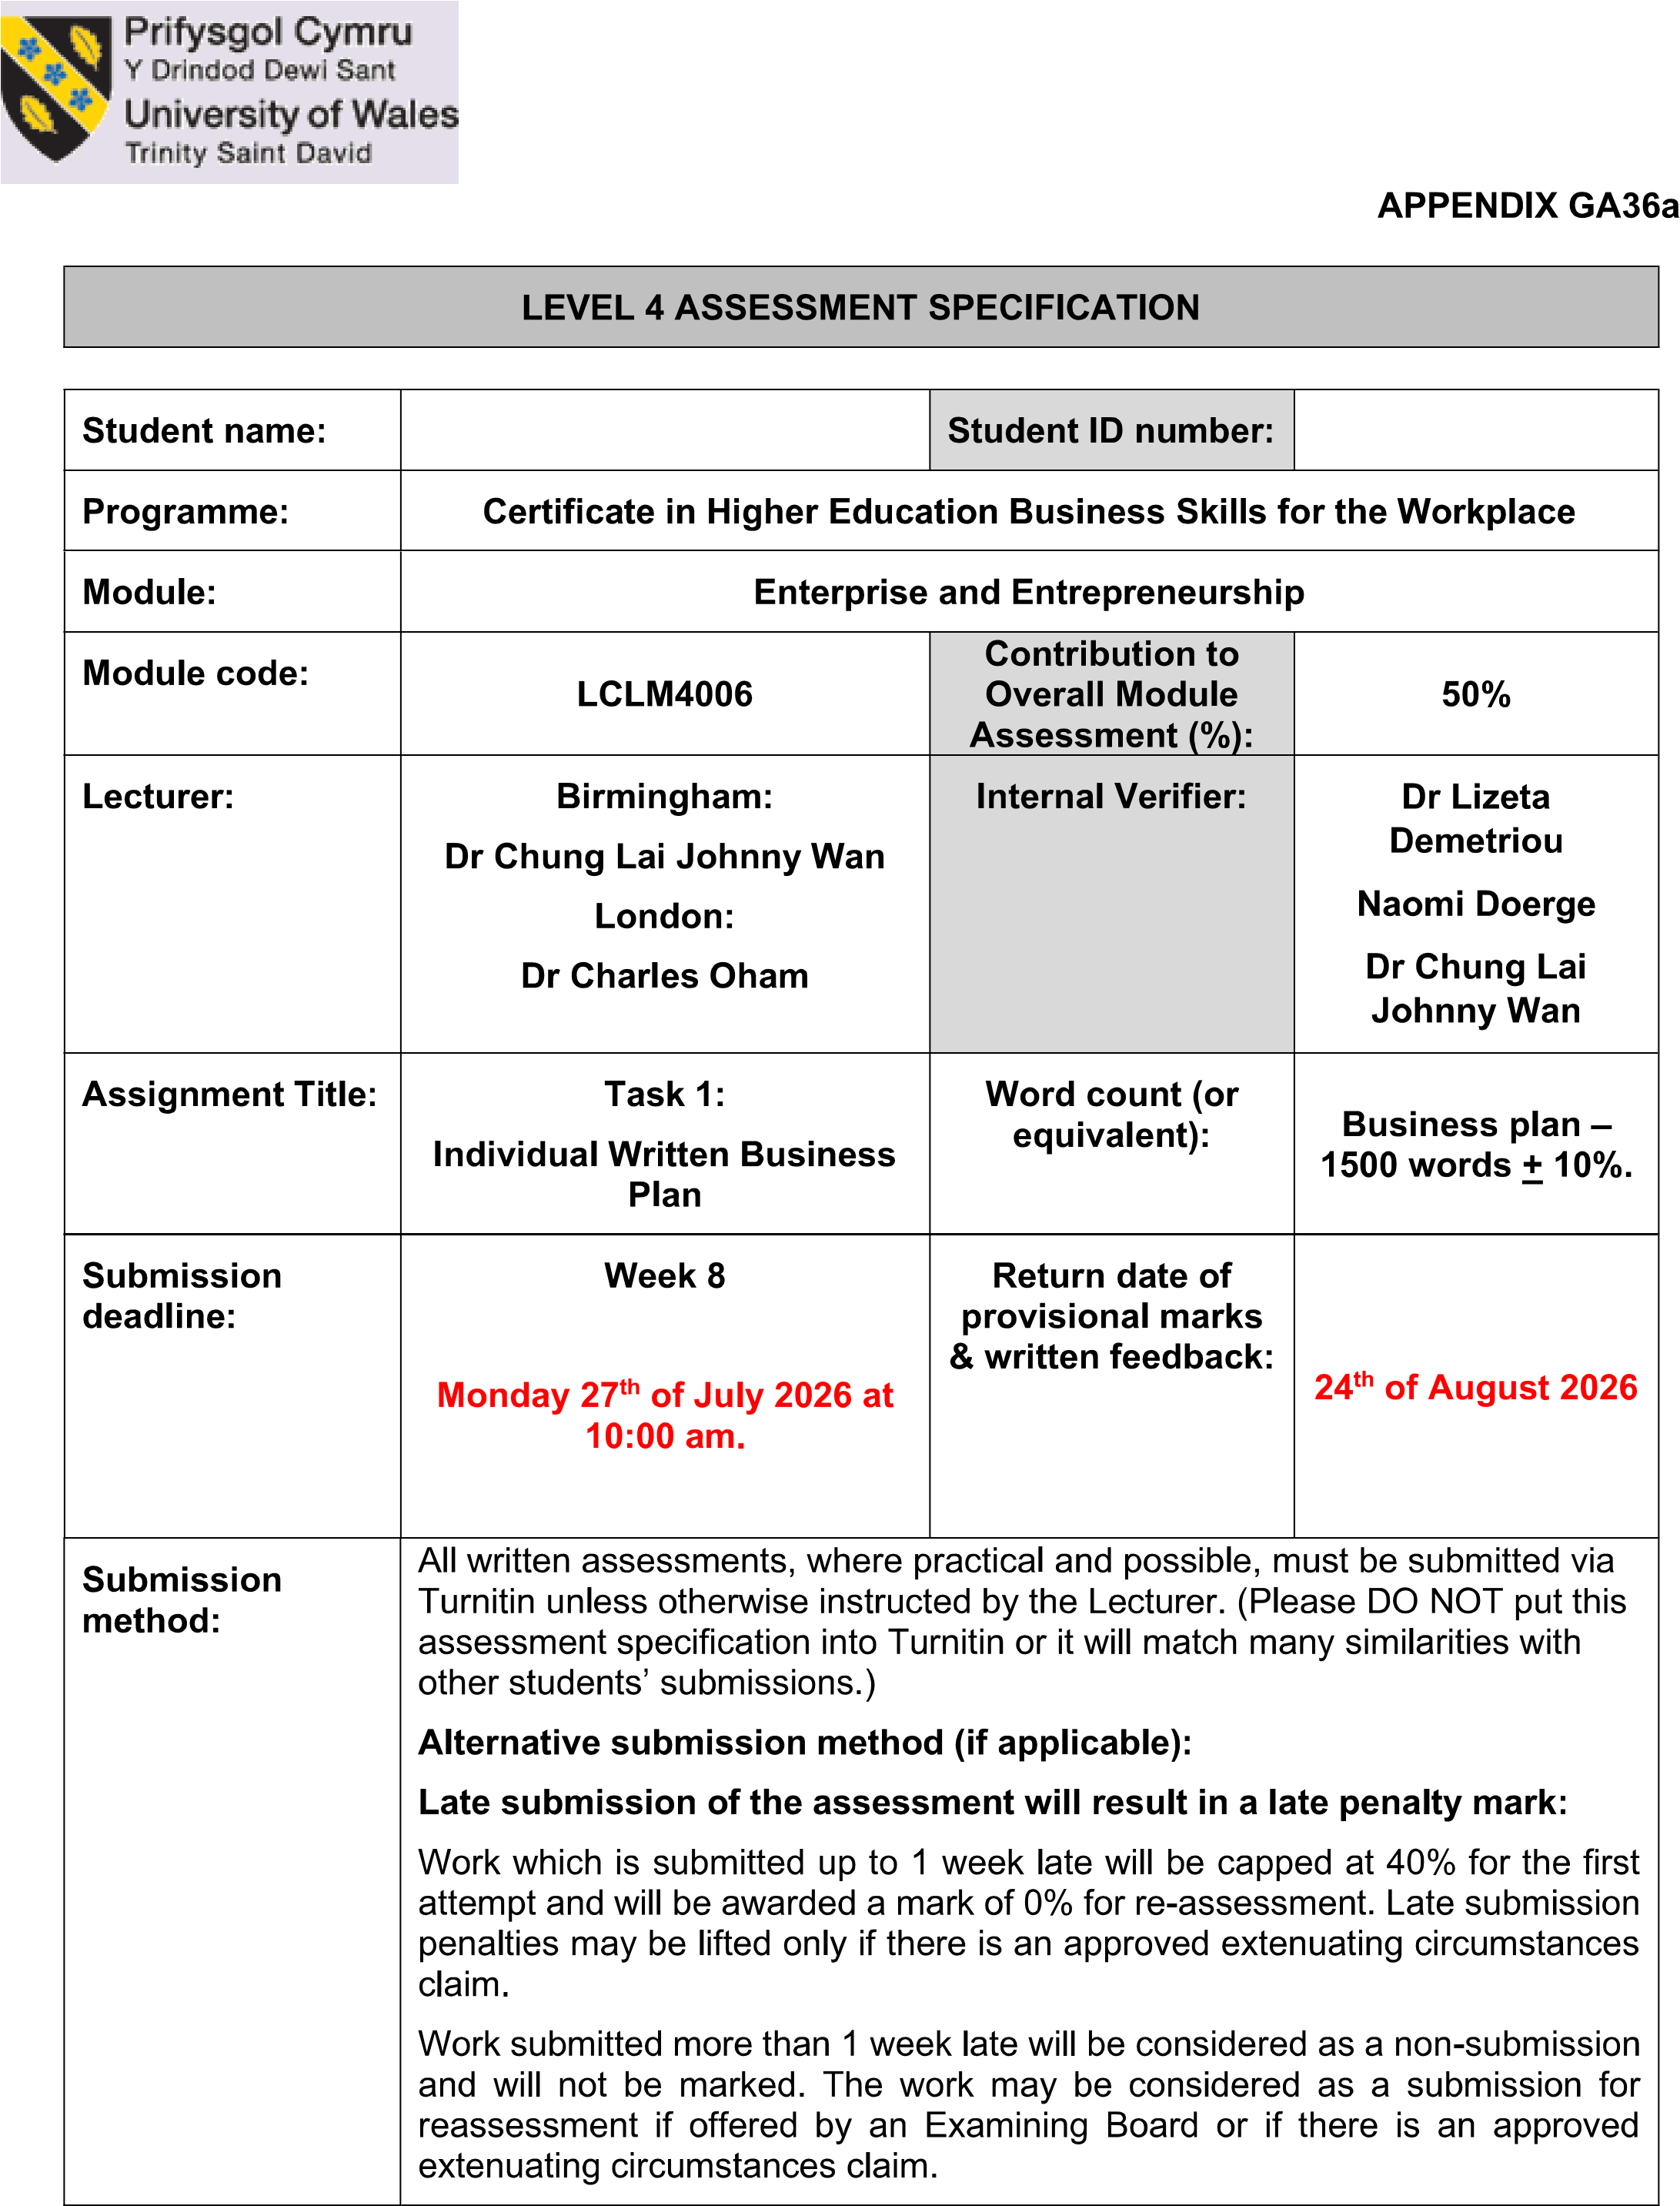
2513589
Songul Kisa

Submission Date: 24/07/2026
Lecturer: Mustakkima Afrin

Table of Contents
Executive Summary 5
Business Concept Summary 5
Business Description Summary 5
Product Description 6
Business Objectives (SMART Objectives) 6
Short-Term Objectives (less than a year) 7
Long-Term Objectives (More than a year) 7
Market Analysis and Marketing Plan 8
Market Analysis 8
PESTEL Analysis 9
SWOT Analysis 9
Marketing Mix (4Ps) 10
Management Team 10
Management Team and Their Background 11
Organisational Chart 11
Key Milestones 12
Financial Plan (One Year) 12
Sources of Finance 13
Cash Flow Forecast 13
Sales Forecast 13
Cost of Production Forecast 14
Break Even Analysis 14
Operations and Management Plan 15
Production of Good and Service 15
Technology Plan 15
Human Resource Plan 15
Expansion Plan 16
Conclusion 16
Reference List 16
Appendices: 17

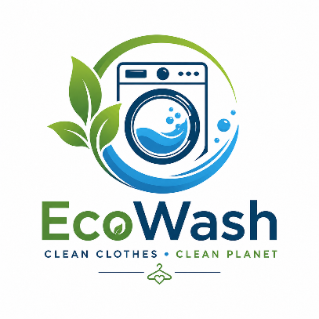

Executive Summary

EcoWash London Ltd is a sustainable laundry collection and delivery service designed for busy families, students, Airbnb hosts, and small businesses in London. To keep startup costs low and minimize environmental impact, the business will partner with existing local laundrettes instead of buying expensive new machinery.

The company uses eco-friendly products and smart delivery routes to reduce pollution while creating local jobs. They need £10,000 in initial funding for marketing, transport, and website development, with the long-term goal of opening an independent eco-laundrette within two years.

Business Concept Summary

EcoWash London Ltd is a sustainable laundry collection and delivery business that provides washing, drying, ironing, folding, and doorstep delivery services for busy families, students, Airbnb hosts, and small businesses across London. Customers can easily book online, and the company manages the entire laundry process from collection to delivery. To keep start-up costs low, EcoWash will partner with existing local laundrettes instead of purchasing expensive equipment or opening a physical shop. Operating as a Private Limited Company (Ltd) provides limited liability protection while allowing the business to test market demand and build a loyal customer base before expanding into its own eco-friendly laundrette.

Business Description Summary

EcoWash London Ltd provides a reliable and environmentally friendly laundry collection and delivery service throughout London. The business targets working families, university students, Airbnb hosts, and small businesses that require convenient laundry solutions. By offering flexible booking, professional cleaning, and doorstep delivery, EcoWash saves customers time while maintaining high service quality. During the start-up phase, the company will collaborate with existing laundrette partners to reduce investment costs and operate efficiently. Eco-friendly detergents and planned delivery routes will help minimise environmental impact. As the business grows, EcoWash aims to establish its own energy-efficient laundrette, expand across London, and create local employment opportunities.

Product Description
EcoWash London Ltd provides a comprehensive, door-to-door laundry collection and delivery service for busy families, students, Airbnb hosts, and small local businesses. Customers can easily book services online or via direct channels to have their clothes or linens picked up from home or work. The company offers tailored, flexible options including standard washing and folding, professional ironing, specialized business laundry support for linens and uniforms, and convenient contact-free doorstep return.

To minimize initial infrastructure costs, the service utilizes existing local laundrette partnerships during its startup phase to manage processing. This asset-light model prioritizes strict quality control, reliable turnaround times, and customer satisfaction to build a loyal local clientele. The company's ultimate growth plan involves transitioning to its own independent, energy-efficient facility utilizing sustainable products to deepen its environmental and community commitment.

Business Objectives (SMART Objectives)

EcoWash London Ltd has established clear SMART objectives to support sustainable growth and measure business performance. These objectives focus on building a strong customer base, achieving financial stability, and developing a sustainable laundry service.
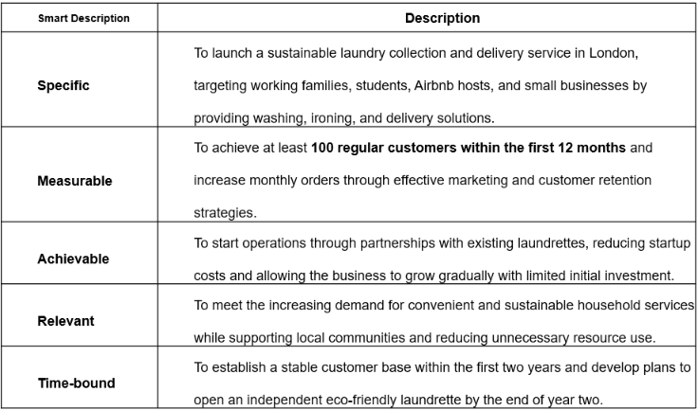
Additional objectives include achieving high customer satisfaction by providing reliable service, maintaining environmentally responsible practices through efficient delivery planning and eco-friendly products, and creating local employment opportunities as the business expands.
These SMART objectives will help EcoWash London monitor progress, evaluate performance, and ensure that the business develops in a structured and sustainable way.

Short-Term Objectives (less than a year)

During the first year of operation, EcoWash London Ltd will focus on establishing the business, attracting customers, and creating a strong foundation for future growth. The main short-term objectives are:
- Launch the laundry collection and delivery service within the first three months by creating partnerships with local laundrettes and establishing reliable washing and delivery processes.
- Gain at least 100 regular customers within the first year by targeting working families, students, Airbnb hosts, and small businesses through effective marketing and customer referral strategies.
- Develop an online presence within the first six months by launching a simple website, online booking system, and social media platforms to improve customer access and brand awareness.
- Achieve high customer satisfaction by providing reliable collection times, quality laundry services, and responding to customer feedback to build trust and loyalty.
- Create sustainable business practices from the beginning by using existing laundrette facilities, promoting eco-friendly products, and planning efficient delivery routes to reduce environmental impact.

Long-Term Objectives (More than a year)
EcoWash London Ltd’s long-term objectives focus on business expansion, financial sustainability, and establishing a strong position within London’s laundry service market.
- Open an independent eco-friendly laundrette within two years by using profits generated from the collection and delivery service. The new facility will include energy-efficient equipment and sustainable practices to reduce environmental impact.
- Expand the customer base and increase market presence by developing long-term relationships with working families, students, Airbnb hosts, and local businesses across different areas of London.
- Create employment opportunities within the local community by recruiting delivery drivers, laundry assistants, and customer service staff as the business grows.
- Develop partnerships with more local businesses such as accommodation providers, property management companies, and small businesses to create regular income streams and increase service demand.
- Build a recognised sustainable laundry brand in London within five years by maintaining high service quality, improving customer experience, and continuing to introduce environmentally responsible solutions.

Market Analysis and Marketing Plan

Market Analysis

EcoWash London Ltd will operate in London's growing convenience service market, where busy lifestyles have increased demand for time-saving services (Office for National Statistics (ONS), 2024). The target customers include working families, university students, Airbnb hosts, and small businesses that require regular laundry services.
London's large student and professional population, together with the growth of short-term rental accommodation, has created demand for reliable collection and delivery laundry services (AirDNA, 2024). This provides EcoWash London Ltd with an opportunity to offer a convenient and affordable solution.
The business will compete with traditional laundrettes and larger online laundry providers. While larger companies often have wider coverage, EcoWash London Ltd will differentiate itself through competitive pricing, flexible collection and delivery, and personalised customer service (Kotler and Keller, 2022).
Growing environmental awareness also supports the business opportunity. EcoWash London Ltd will work with existing laundrette facilities during the start-up stage and promote eco-friendly detergents and efficient delivery routes to reduce environmental impact (Department for Environment, Food and Rural Affairs (DEFRA), 2023).
References (Harvard Style)
AirDNA (2024) London Short-Term Rental Market Review. Available at: https://www.airdna.co (Accessed: 25 July 2026).
Department for Environment, Food and Rural Affairs (DEFRA) (2023) Resources and Waste Strategy for England. Available at: https://www.gov.uk/government/organisations/department-for-environment-food-rural-affairs (Accessed: 25 July 2026).
Kotler, P. and Keller, K.L. (2022) Marketing Management. 16th edn. Harlow: Pearson.
Office for National Statistics (ONS) (2024) Population and Household Estimates, England and Wales. Available at: https://www.ons.gov.uk (Accessed: 25 July 2026).

PESTEL Analysis

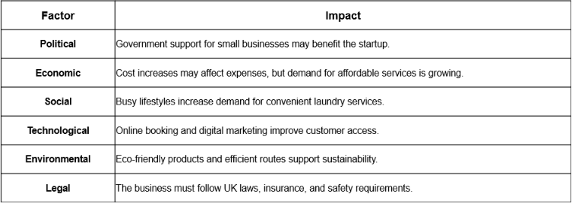

SWOT Analysis

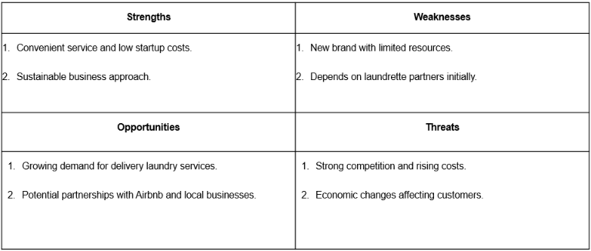

Marketing Mix (4Ps)

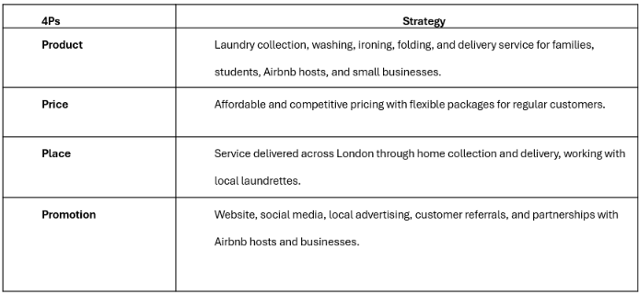

Management Team

EcoWash London Ltd will initially have a simple management structure to keep costs low and operations efficient.
Founder / Managing Director – Songül Kısa
Responsible for overall business management, finance, marketing, customer relationships, and partnerships with laundrette providers.
Operations Assistant (Future Role)
Responsible for managing customer orders, coordinating laundry processes, and supporting daily operations.
Delivery Staff (Future Role)
Responsible for laundry collection and delivery, ensuring reliable and timely service for customers.
As the business grows, more employees will be recruited to support operations and help EcoWash London expand its services.

Management Team and Their Background

EcoWash London Ltd will initially be managed by the founder, Songül Kısa. She has over 12 years of experience in retail management, customer service, administration, bookkeeping, and business operations.
Since 2019, she has managed Southgate Food Centre, where she has gained experience in team supervision, stock control, purchasing, financial records, and customer relationship management. She is also studying Business Management at the University of Wales Trinity Saint David, developing further knowledge in leadership and business strategy.

Organisational Chart

Managing Director / Founder
Songül Kısa
- Overall business management
- Finance and administration
- Marketing and partnerships
Operations & Customer Service Assistant
- Manage customer orders
- Coordinate laundry processes
- Handle customer enquiries
Delivery Staff
- Collect and deliver laundry
- Maintain delivery schedules
- Support customer satisfaction
Laundrette Partners
- Provide washing and drying facilities
- Support service operations
Future Growth: Additional employees will be recruited as the business expands and opens its own eco-friendly laundrette.

Key Milestones

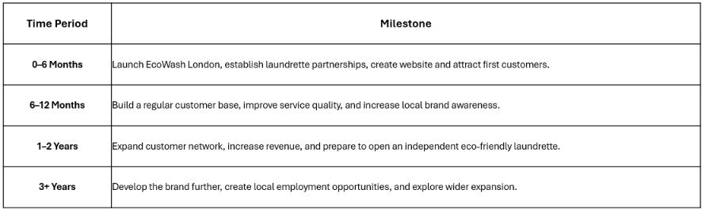

Financial Plan (One Year)
EcoWash London Ltd will follow a low-cost startup model by working with existing laundrette partners during the first year. This approach reduces the need for high initial investment while allowing the business to develop a customer base.
Estimated Funding Requirement: £10,000
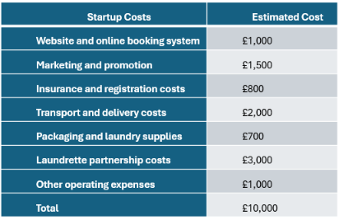

Sources of Finance

EcoWash London Ltd will require £10,000 initial funding to start operations. The main sources of finance will be:
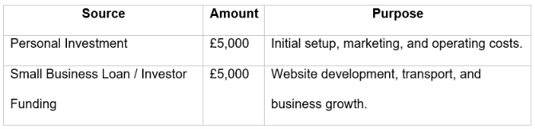

Cash Flow Forecast

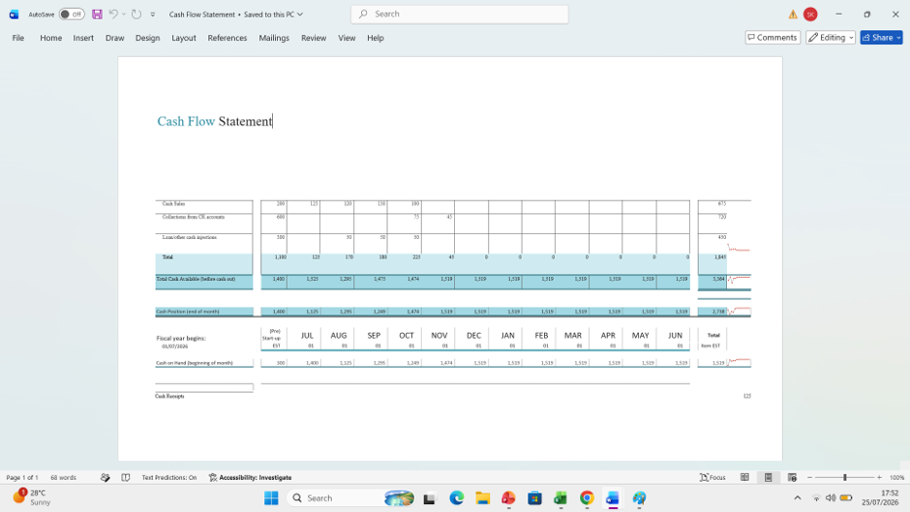

Sales Forecast
EcoWash London Ltd expects sales to grow gradually by building a local customer base and developing partnerships with families, students, Airbnb hosts, and small businesses.
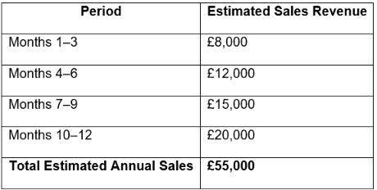
The forecast is based on an average order value of £20–£25 and increasing customer demand throughout the first year. The business aims to increase sales through repeat customers, online marketing, and local partnerships.

Cost of Production Forecast

EcoWash London Ltd will control production costs by working with existing laundrette partners instead of purchasing expensive laundry equipment. The main costs include laundry processing, delivery, supplies, and daily operations.
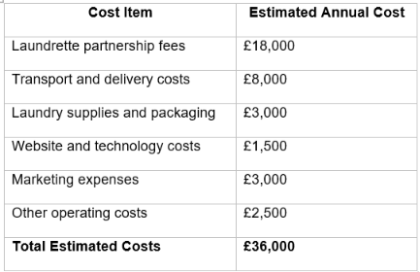

Break Even Analysis

EcoWash London Ltd aims to reach the break-even point when monthly revenue covers all fixed and variable costs
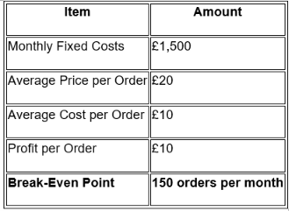

Operations and Management Plan

EcoWash London Ltd will operate by partnering with local laundrettes during the start-up stage. Laundry will be collected from customers, professionally cleaned, checked, packaged, and delivered back. The founder will manage daily operations, customer service, finance, and business partnerships. This low-cost model enables the business to build a strong customer base before investing in its own eco-friendly laundrette.

Production of Good and Service

EcoWash London Ltd provides a door-to-door laundry collection and delivery service. Laundry is collected from homes or businesses, washed, dried, ironed, and folded by partner laundrettes before being quality checked, packaged, and returned. Eco-friendly detergents and efficient delivery routes will help reduce environmental impact while maintaining high service standards.

Technology Plan

Technology will improve efficiency and customer experience. Customers will be able to book services and make payments through the company website. Social media will support marketing, while a customer management system will track bookings, deliveries, and customer information, ensuring smooth daily operations and supporting future growth.

Human Resource Plan

EcoWash London Ltd will begin with a small team to minimise costs. The founder will oversee operations, finance, marketing, and customer relationships. As demand grows, delivery staff and an operations assistant will be recruited. Staff will receive training in customer service, delivery procedures, and quality standards to ensure reliable and professional service.

Expansion Plan
The business will initially focus on increasing its customer base and developing partnerships with laundrettes, Airbnb hosts, and local businesses. Within two to three years, EcoWash London Ltd plans to open its own eco-friendly laundrette, increase service capacity, expand across London, and create local employment opportunities.

Conclusion
EcoWash London Ltd provides a convenient and sustainable laundry collection and delivery service for busy customers in London. Its low-cost business model, customer-focused approach, and commitment to environmentally friendly practices create a strong foundation for growth. With effective marketing, careful financial planning, and clear business objectives, EcoWash London Ltd has the potential to become a successful and trusted laundry service while contributing positively to the local community.

Reference List

AirDNA (2024) London Short-Term Rental Market Review. Available at: https://www.airdna.co (Accessed: 25 July 2026).
Department for Environment, Food and Rural Affairs (DEFRA) (2023) Resources and Waste Strategy for England. Available at: https://www.gov.uk/government/organisations/department-for-environment-food-rural-affairs (Accessed: 25 July 2026).
Kotler, P. and Keller, K.L. (2022) Marketing Management. 16th edn. Harlow: Pearson.
Office for National Statistics (ONS) (2024) Population and Household Estimates, England and Wales. Available at: https://www.ons.gov.uk (Accessed: 25 July 2026).

Appendices:

The appendices contain supporting information that is referred to in the report but is not included in the main body.
You can include items such as:
- Appendix A: EcoWash London Ltd Logo
- Appendix B: Organisational Chart
- Appendix C: Cash Flow Forecast
- Appendix D: Sales Forecast
- Appendix E: Break-even Analysis
- Appendix F: Market Research or Competitor Information (if applicable)

