1/26/2020
Steven Wilkinson (P149872)

ACM Motion Simulation
M6X00408


University of Wales Trinity Saint David
School of Engineering

ACM Motion Simulation
MX600408

Steven Wilkinson
P149872

Contents
1 Introduction 4
1.1 Aims 4
1.2 Outcomes 5
2 Finite element analysis 5
2.1 FEA in the Design process. 5
2.2 Von Mises Stress 5
2.3 Meshing 6
3 Components 8
4 Methodology 12
4.1 Components construction 12
4.2 Motion loading 13
5 Motion loading 15
6 FEA 1 Initial designed component. 16
6.1 Initial Mesh study 17
6.2 Second refined mesh. 20
6.3 FEA Study of the second iteration of the Mesh. 21
7 FEA 2 23
7.1 Changes to the components. 23
7.2 Altered component Meshing. 23
7.3 FEA Study 24
8 Impacts on surrounding component. 25
9 Comparisons. 26
10 Conclusion 27
11 Bibliography 28

Figure 1:Von Mesis Graph 6
Figure 2:Component Double eye. 8
Figure 3 Taper pin. 9
Figure 4:Split pin. 10
Figure 5: Single Eye. 11
Figure 6: Collar. 11
Figure 7: Forces acting on the components. 13
Figure 8: Forces using data points 13
Figure 9: Initial component mass. 16
Figure 10:Initial mesh of component. 17
Figure 11: Geometry Analysis 18
Figure 12: Initial Von Mises stress plot. 19
Figure 13: Mesh of double eye 20
Figure 14: Von Mises stress plot of initial component design. 21
Figure 15:Progression of Von Mesis 22
Figure 16: Altered component. 23
Figure 17: Altered component FEA. 24
Figure 18:Stress Analysis on the centre pin. 25

Introduction

Finite Element Analysis (FEA) is an increasingly powerful tool for an engineering to use as more and more projects require tighter more stricter regulations governing the thought process behind them.
FEA can aid this by providing a visual and mathematical approach to how a component will behave under set conditions.
This report will focus on how following the engineering design process in an FEA study will identify imperfections to a component within an assembly and making alterations to it to improve its characteristic within the overall assembly.
Only Solidworks 2019 will be used to Construct the assembly and a motion simulation will be carried out which its which motion loads of the simulation imported to individual parts for analysis. This will then allow the FEA process also on Solidworks 2019 to take place and evaluations of the results drawn afterwards.

Aims

- To build and assemble real life components modelled in Solidworks.
- To run a Motion analysis and import its Motion loads ready for FEA study.

- To evaluate and assess the FEA results and apply appropriate alterations to the components as necessary to benefit the user.

Outcomes

- Increase knowledge of Solidworks and its FEA package within the software.

- Critically analysis the results made and the application of FEA as an engineering tool.

- Draw conclusions on the changes of the components made.

Finite element analysis

FEA in the Design process.

Incorporating FEA into the design process of a new product or engineering project can lead to benefits in the reduction of total cost and the time scale the development is.
This is due to when an FEA processes is used to analysis the component during the design process. Any problems or errors that develop can be quickly identified and rectified with a simple alteration and then a rerun of the FEA can be. (Khandani, 2005)
This means issues are not carried over into the validation or the manufacturing of prototypes, wasting resources and time. This allows a design loop to be created between designing and Computational testing, repeating these two steps as needed to maximise the quality of the designed product.

Von Mises Stress
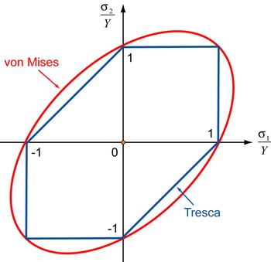
Von Mises stress is a fatigue study commonly used to observe stresses of ductile metals and a stress study within Solidworks.
It works beyond using Sigma Yield to monitor stresses as it uses other failure theories to look at the micro atom level of the material.
When graphically plotting Von Mises its calculated by the position of the first principle stress in relation to the second principle stress in the X/Z planes. (Onwubeck, 2013)

Figure 1:Von Mesis Graph

When a material undergoes an increasing stress force it will eventually reach Sigma yield this is the point where the material enters plastic deformation and will not return back to its original shape. Until then it is in elastic limit as the forces applied are small enough to allow it to return to its intended or original shape.
Upper and lower yield – When a material reaches plastic range at a critical point is the upper yield and suddenly drops to lower yield when deformation starts to happen.
Rupture stress – Separation of material from stress with large plastic deformation the material gets thinner as more pressure is applied until it suddenly breaks.

Meshing

To produce an FEA study firstly the component will need to be meshed. This uses triangular shaped elements with a node on each point and joined by another element, across the surface of the component this forms a mesh in which stress calculations can be undertaken.
Degrees of freedom
These are the directions that each node can move to when applied with pressure during a simulation run. It can use either linear elements or parabolic elements. When generating a basic mesh a linear element is preferred as it uses a low computational power however when undertaking an FEA study on a curved surface it is worth using a parabolic element as its shape can reduce the inaccuracy of meshing, the trade of is a larger computational resources and increase in solving times. (Akin 2010)

Mesh Types
Solidworks uses two types of meshing techniques for example a shell mesh for thin parts such as sheet metals. This has 6 degrees of freedom in total, 3 translation and 3 rotational. Another form of Mesh is a solid mesh for complex shapes this has only 3 translation degrees of freedom (Solidworks, 2019)

Iterations and evolution of meshing.
When first starting an FEA study it is worth beginning with a very coarse mesh to begin with, this is because it allows the user to check the component and its fixtures and constraints before adding in complex levels of elements. The result will be highly in accurate, but it gives a starting point in which to refine the mesh adding in more elements into particular areas of interest rather than others.
Once a mesh has been initially solved it is good practise to use a tool in Solidworks ‘Geometric analysis feature’ this will check the components for the quality of the mesh and flag up any issues such as too smaller faces, sharp edges or discontinued lines which will lead to in accuracy and errors when running the FEA. (Solidworks, 2019)

Components

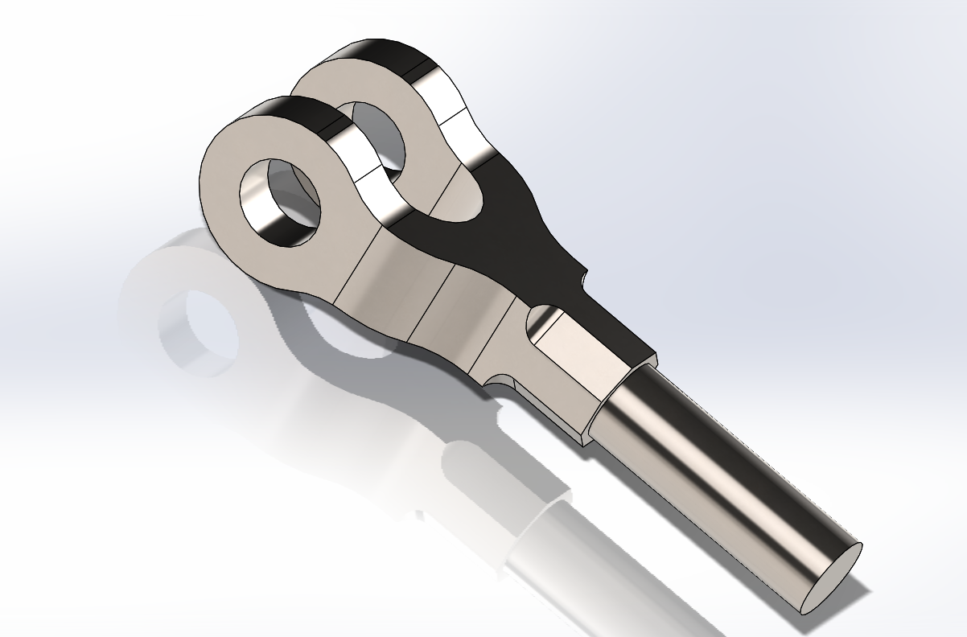
Figure 2:Component Double eye.

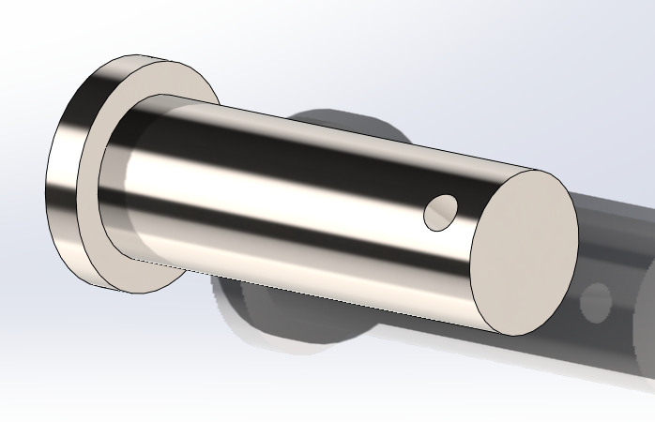
Figure 3 Taper pin.

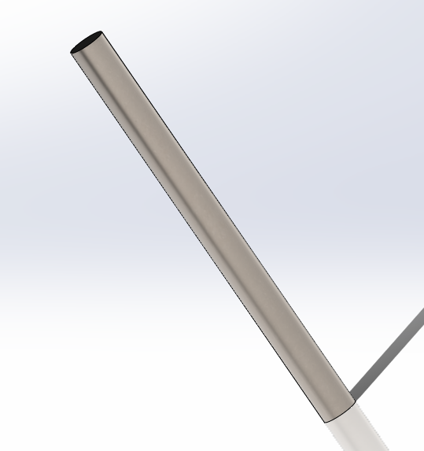
Figure 4:Split pin.

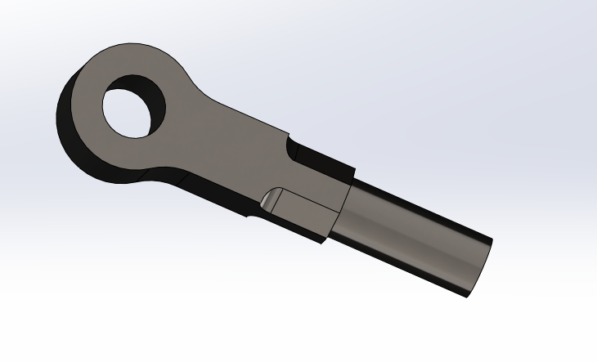
Figure 5: Single Eye.

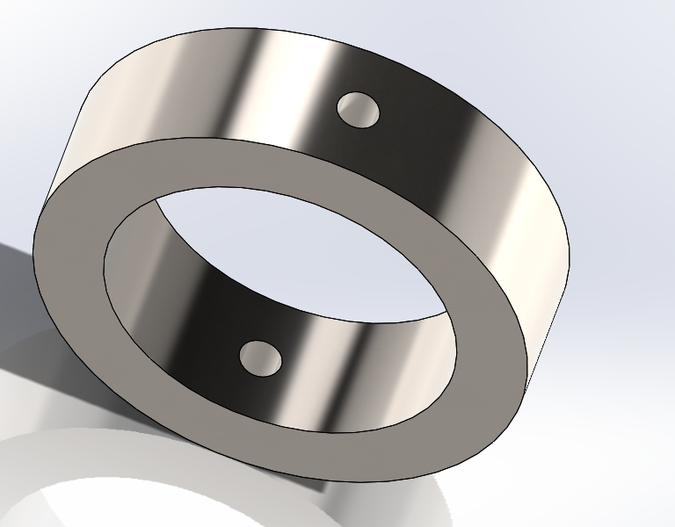
Figure 6: Collar.

Methodology

Components construction

The components to construct the complete knuckle joint were made using a range of parts then assembled together using basic mates such as concentric and tangent to mate components to a single face of another component together mechanical mates such as hinges were used to mate the double eye piece to the centre pin this reduced any extra mates which would further become redundant when the motion simulation was commenced.
An angle mate was used to space the two ends of the eye pieces 90 degrees apart this was to simulate the complete part fixed at both ends.

Motion loading
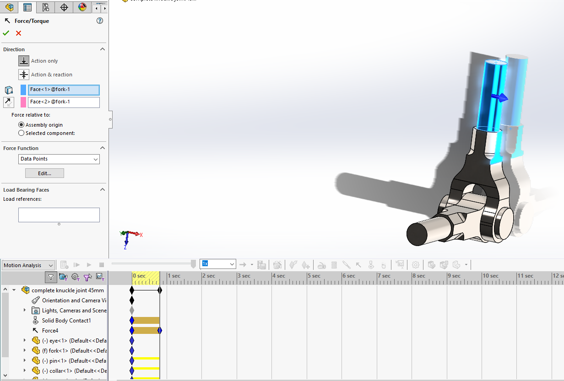
Figure 7: Forces acting on the components.
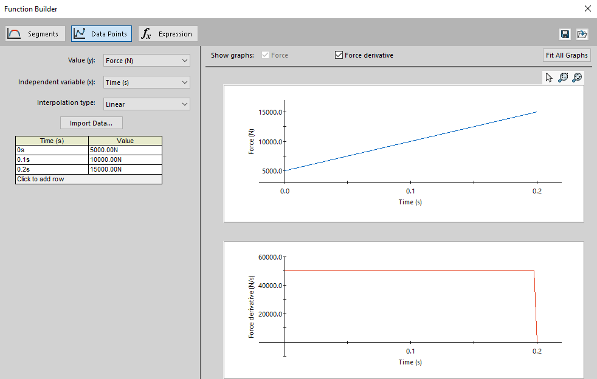
Figure 8: Forces using data poin
The motion analysis was achieved by applying a force (N) using data points (Figure 7) through one side of the component. It would be unable to move during the simulation due to an angle mate implemented, this would simulate the component being forced in a direction beyond its ideal operating angle and causing more pressure onto the eyelets rather than transferred along to taper pin or single eye.
The three different forces were chosen 5000N, 10000N and 15000N as this assembly is often used as a linkage between agricultural vehicles and trailers. The part was designed and tested to replicate the similar loadings as expected in this application.
The study is being carried out using this type of joint as it would be interesting to apply different amounts of loading onto the parts and observe the difference in pressure.

Motion loading

To allow for a FEA study to be carried out the Motion loads would need to be imported and transferred from the motion analysis through to the components study.
This was achieved by carrying over individual parts that were to be studied and for this study clicking the multiple frames to be observed. The motion study would use 19 scenarios at 0.04s intervals to capture the complete analysis.
In doing so, allows for a number of scenarios to be calculated within a specific time frame, for this motion loading it was scaled to how long the assembly’s analysis length was. This reduced unneeded frames and further reduced the time needed to run the FEA study.

FEA 1 Initial designed component.

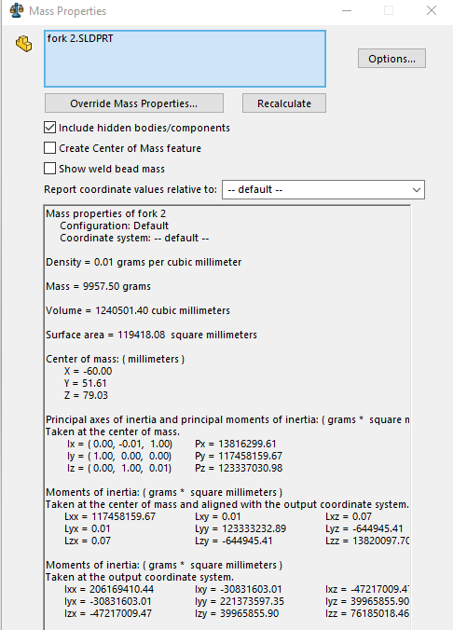
Figure 9: Initial component mass.

The initial component has a mass of 9.96kg which will be observed throughout the FEA process when developing and improving the component later on in the study.

Initial Mesh study

Initial mesh
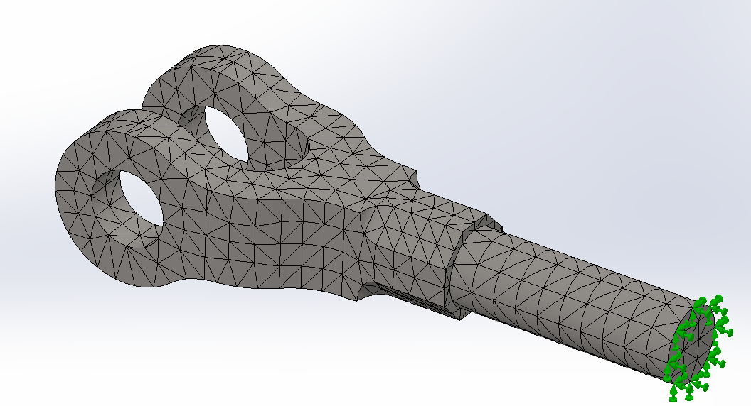
Figure 10:Initial mesh of component.
First mesh was generated using a coarse mesh with no smaller sized elements used in any areas of the component this was done to achieve a basic FEA stress analysis to get an idea of the locations and the magnitude of stress concentrations situated on the surface. The mesh was created initially using a constant average sized mesh of 21mm.
When ran, this led to a basic and not detailed stress colouration on the component to observe the forces acting onto it.
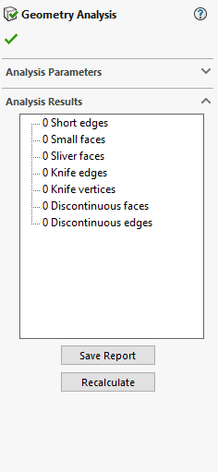
Figure 11: Geometry Analysis

The basic mesh was used to also check the quality of the components construction to find out if any design errors were found. This was achieved by running a geometry analysis, it has shown that the initial mesh produced zero issues thrown up by the components design so no redesigning of parts was needed.

First FEA study
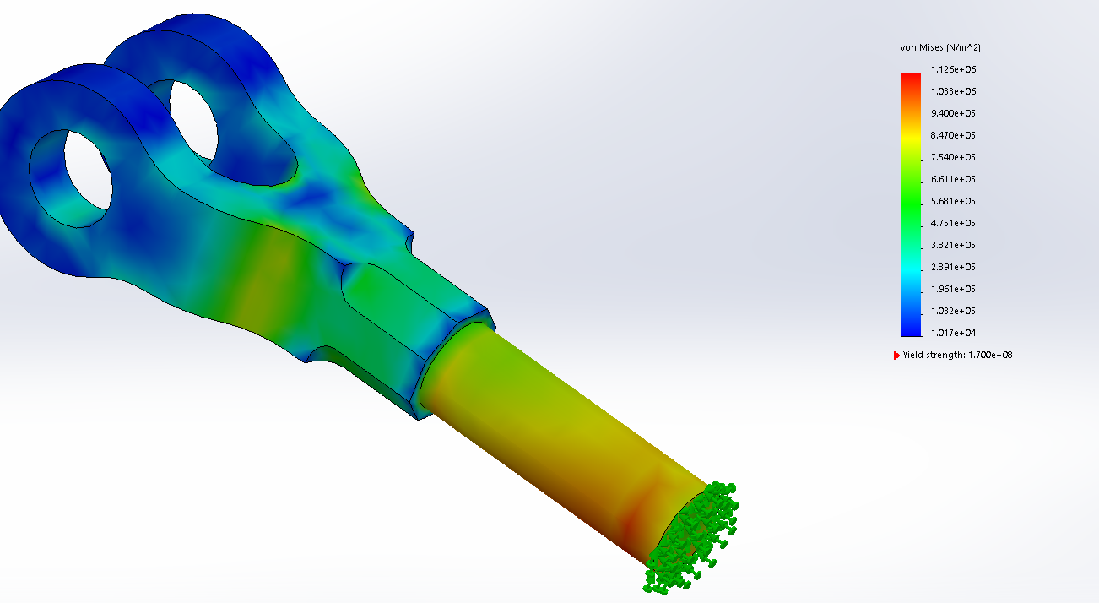
Figure 12: Initial Von Mises stress plot.

The figure above shows higher stress concentrations in extrusions leading towards the eyelets. It is below the Sigma Yield point of the material so is not a concern.

Second refined mesh.
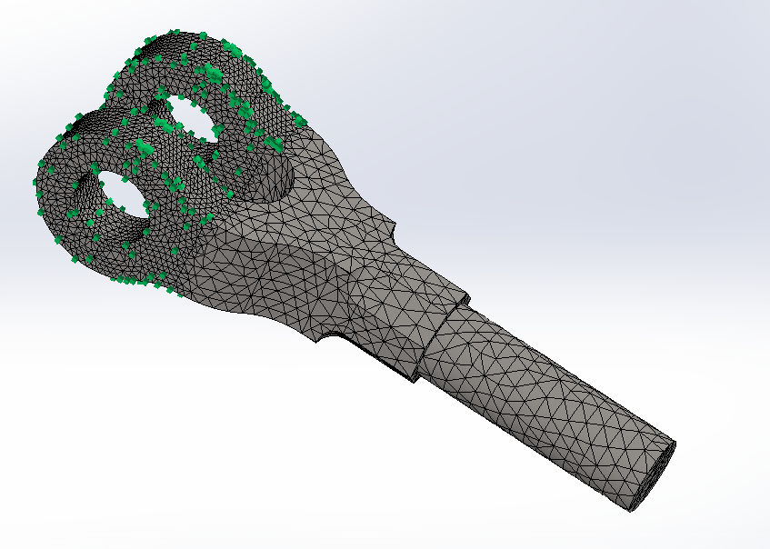
Figure 13: Mesh of double eye

When ran again (Figure 9) a more detailed and finer mesh was used on the eyelets as this was where the load was going to transferred between it and the taper pin which was positions through it. Having a finer mesh on particular parts on individual areas and not all of the component allowed for calculation time to be reduced but accuracy still remained on the areas that would be of interest.
Even though the force from the motion simulation was being applied through the fixed edge of the extruded cylinder down towards the eyelets a finer mesh was chosen not to be used in favour of the standard mesh as it was not an area of interest and knowing it was below yield point.

FEA Study of the second iteration of the Mesh.

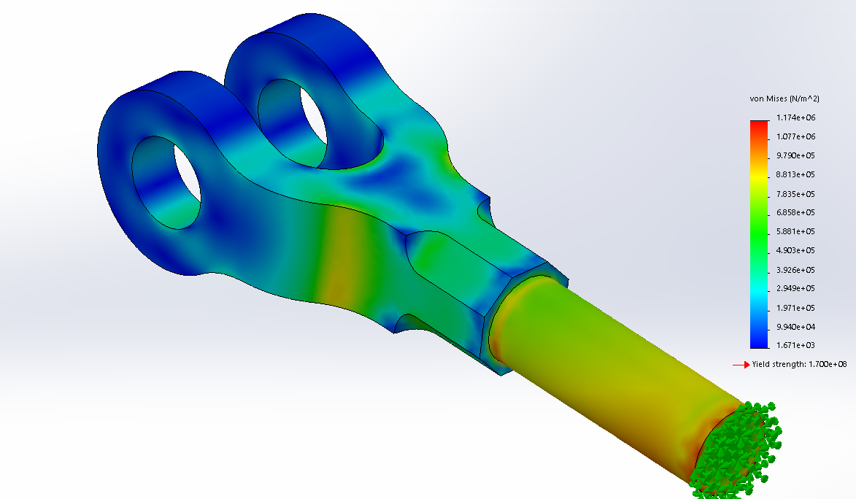
Figure 14: Von Mises stress plot of initial component design.

Comparing the two iterations of mesh sizes can show that the overall Von Mises stresses were increased with a more accurate mesh applied. The pressure the material was put under was still under yield stress level.
Visually between the two mesh sizes you can see that the plot is more defined with denoting the differences and progressive stress colouration.
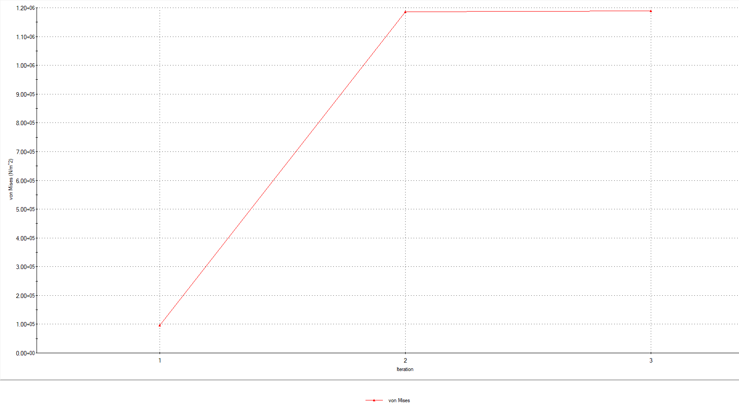
Figure 15:Progression of Von Mesis

The figure above shows how the increase in number of elements and the reduction of the size. Reflects on the Von Mesis calculations however this increases up to a point where the more elements used does not influence or benefit the study this is called convergence.
Any more detail is not captured by the increase of elements and only takes more time to calculate the simulation.
Iteration three used a very fine mesh of 1 mm on the eyelets and 1 mm on the rest of the component, which has not benefited the study.

FEA 2

Changes to the components.

With an aim to reduce overall mass the component, the radius of the eyelets was reduced from 50mm in diameter to 45mm this was undertaken to reduce the component’s overall mass but still maintain a high enough strength in the material so it was not taken into yield from the forces acting onto it.
The motion analysis was also changed for the second study by reducing its overall length but still maintained the same data points.
This in turn allowed the number of frames to be reduced from 20 to 6. This vastly reduced the calculating time of the FEA.

Altered component Meshing.

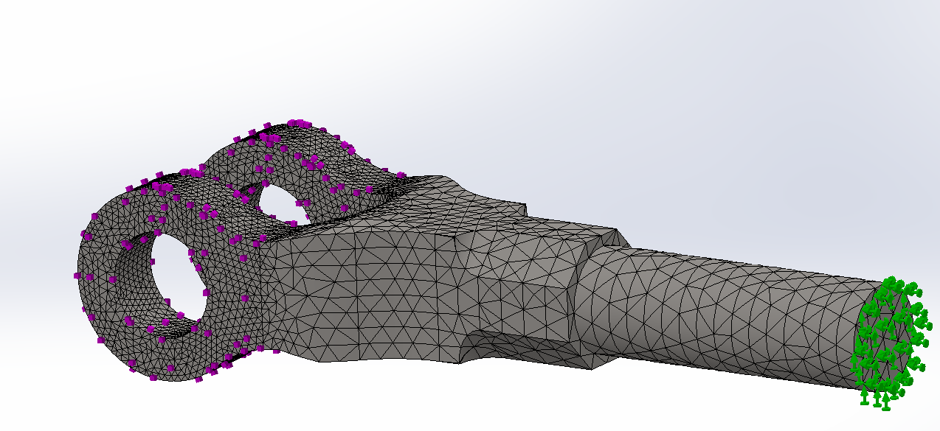
Figure 16: Altered component.

FEA Study

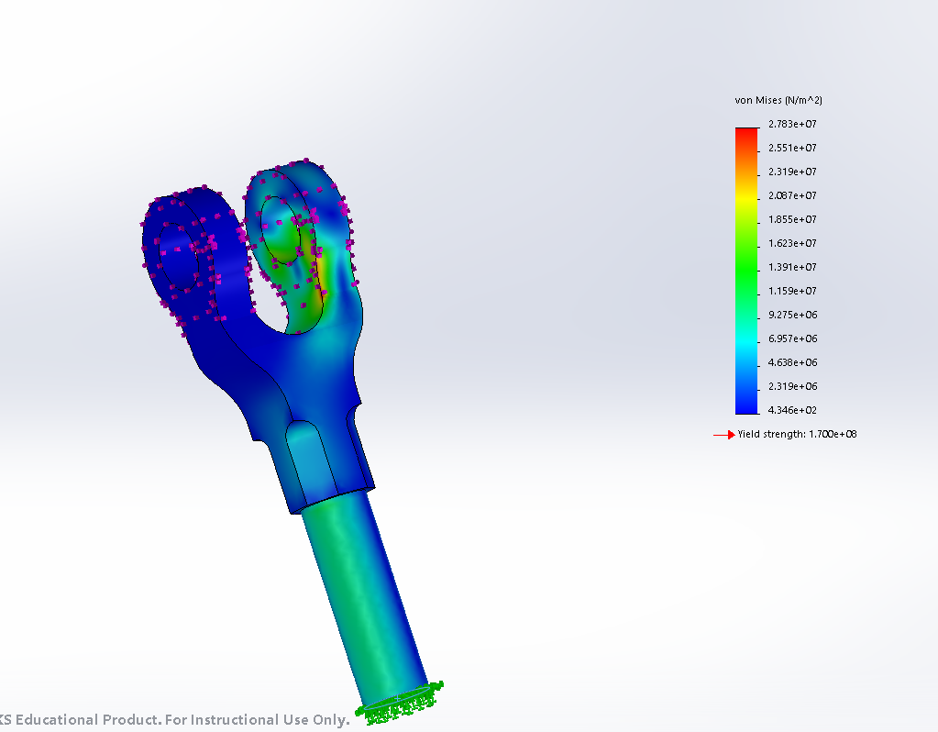
Figure 17: Altered component FEA.

By reducing the eyelet by a diameter of 5mm has increased the pressure onto the component however a small stress concentration has been created on the top of the eyelet the Von mises stress is not above the materials yield value so it has not affected the components structural integrity.

Impacts on surrounding component.

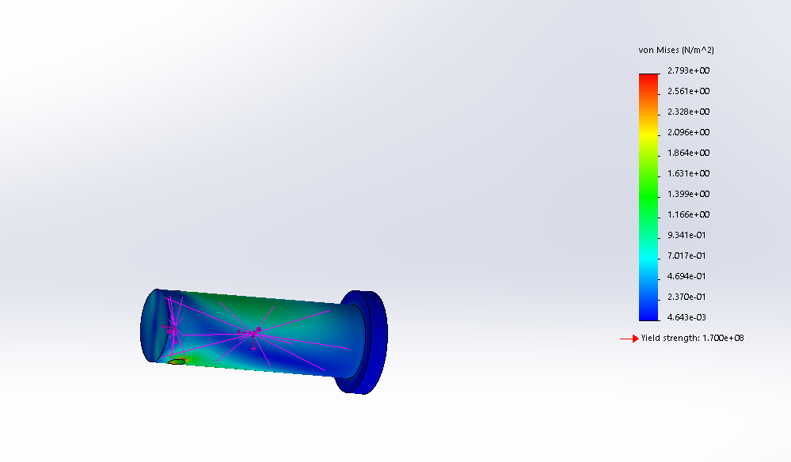
Figure 18:Stress Analysis on the centre pin.

One area that could easily be overlooked when redesigning an existing part for an assembly is how it has impacted the other surrounding parts.
With less material to withstand against the pressure applied on the double eye component it will allow for more forces to bend the centre pin.

Comparisons.

When comparing the two iterations of the double eyelet component the stresses between the two are within yield point of the material and this means they are not in plastic deformation, meaning would return back to their original shape when put under the applied pressures.
By changing the radius of the eyelet by 5mm reduced its mass from 9.6kg down to 9.2kg. A further mass reduction could have been achieved by removing material from the middle of the part as there is no stress concentration at all recorded in these regions this would reduce the mass drastically. This was not done as the study was to focus on the eyelets and how the forces impact these areas.
The alterations that have been made are practical and viable in a real-world application to achieve the same performance as no lasting deformation has occurred.

Conclusion

In undertaking this report, it is clear to see the importance of FEA in the engineering design industry and how much of a valuable tool it has to engineers. When incorporating it within the design process and creating a feedback loop, this drastically reduces the time in developing a design and how easy it is to make changes through the uses of equations built into Solidworks software.
When utilising FEA it is worth paying a lot of attention to the computational resources that you have available to you and plan your mesh structure accordingly.
If this is not appropriately done this would lead to long calculation times which would cost the user or company in vast amounts wasted waiting times.
When a reduction in initial meshing would subsequently lead to results very close to the outcome and speed up the process, it’s very important to find a level ground between detail and time.

Link: https://uowtsd-my.sharepoint.com/:f:/g/personal/swilkinson_149872_student_uwtsd_ac_uk/EsZTuWWR5cRGqlye18SZe7kBVyJiy-E-npwgZRatV7KTJw?e=MPMWxs

Bibliography
akin, J., 2009. Concept of Stress analysis. 1st ed. s.l.:s.n.
Akin, J., 2010. Finite Element Analysis concepts via Solidworks. 1st ed. s.l.:world scientific publishing.
D.LO, 2015. Finite Element Mesh Generation. 1st ed. s.l.:CRC Works .
Khandani, S., 2005. Engineering Design Process. s.l.:s.n.
Komzsik, L., 2009. Computational Techniques of Finite element analysis. 2nd ed. s.l.:CRC Press.
Kuroski, P., 2014. Engineering Analysis with solidworks 2014. 1st ed. s.l.:SBC Publication .
Onwubeck, G., 2013. Computer aided engineering Design with Solidworks. s.l.:Imperial college press.
Quck, S., 2003. The Finite Element Method A practical Course. 1st ed. s.l.:British Libray .
Shih, R., 2013. Introduction to Finite element Analysis using Solidworks 2013. Oragon : Oragon insitute .
Shih, R., 2017. Introduction to Finite element Analysis using Solidworks. 1st ed. Oragon: Oragon insitute of technology .
Shinde, D., 2015. FE ANALYSIS OF KNUCKLE JOINT PIN USEDIN TRACTOR TRAILER. s.l.:Asian Research Publishing.
Solidworks, 2019. Meshing Options. s.l.:Solidworks .
Solidworks, 2019. Meshing tips. s.l.:Solidworks.
Vikas, S., 2019. Meshing Techniques in FEA for complex shape and model optermization. s.l.:s.n.

