Module Name: Networks and Cyber Security Essentials
Module Code: ACCA4024
Student Name: Tatiana Zaneva
Student ID: 2436814
Group:2
Lecturer’s Name: Amit Naik

Cybersecurity Framework for HealthPlus Analytics (HPA)

Contents
Abstract 2
1. Introduction 3
2. Identification of Threats 3
2.1 External Threats 3 [1] [2]
2.2 Internal Threats 4
3. Security Policies 5
3.1 Access Control and Zero Trust 5
3.2 Data Protection and Encryption 5
3.3 The 3-2-1 Backup Strategy 5
4. Mitigation Measures 6
5. Monitoring and Incident Response 7
5.1 The 6-Step Incident Response Plan 7
6. Staff Training and Awareness 9
7. Summary and Recommendations 9
8. Conclusion 10
References 11
Bibliography 11

Abstract
HealthPlus Analytics (HPA) is a UK-based organization that handles highly sensitive medical data. In the current digital landscape, healthcare data has become a primary target for cybercriminals due to its high value on the black market. Recently, HPA suffered significant security failures, including unauthorized access to cloud systems and a damaging ransomware attack. These events proved that the existing security infrastructure was not adequate. This report provides a detailed cybersecurity framework to fix these gaps. It covers threat identification, mandatory security policies, technical mitigation measures, and a proactive incident response plan. The final goal is to protect patient privacy, comply with the UK GDPR, and ensure that the company can recover quickly from any future attacks.

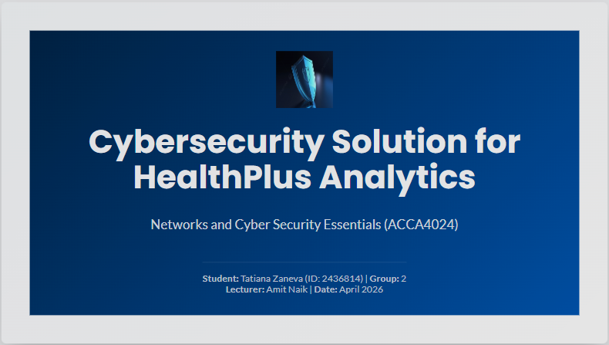
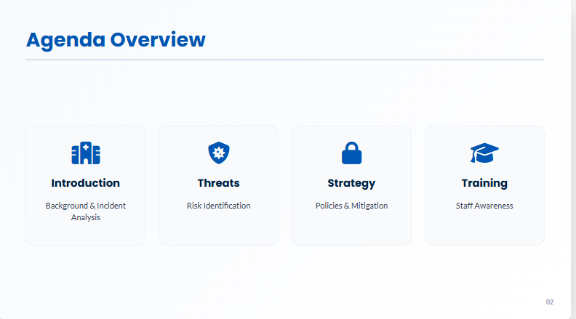

1. Introduction
The healthcare sector is increasingly dependent on technology to manage patient records, blood tests, and surgical schedules. HealthPlus Analytics (HPA) provides these vital analytics services to hospitals and clinics. However, with the benefits of technology come significant risks. Cybersecurity is no longer just an IT issue; it is a fundamental part of patient safety. If a hospital cannot access its data because of an attack on HPA, lives could be put at risk.
The recent breaches at HPA showed that the company’s "perimeter" was weak. Specifically, the unauthorized access to cloud storage suggested that access controls and encryption were not used correctly. Furthermore, the ransomware attack indicated that the backup systems were either not offline or not updated frequently enough to prevent total data loss [3]. This report will move through a logical path to solve these problems. It starts by looking at who is attacking the company and ends with a plan to train the people inside the company to be the first line of defense.

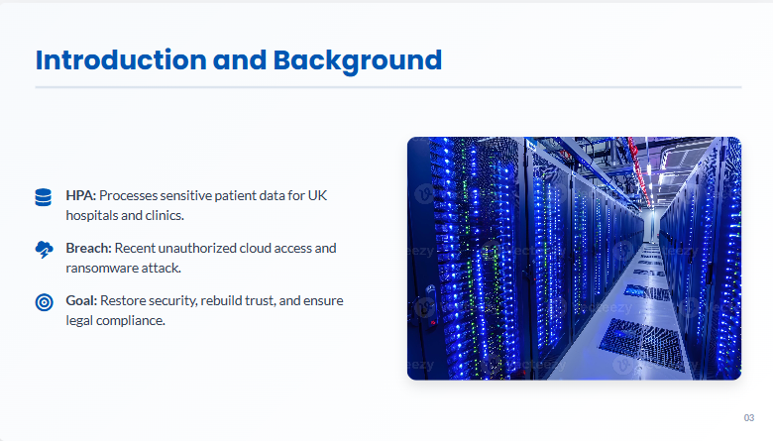
The slide above outlines the primary goals of this framework, focusing on data integrity and legal compliance.

2. Identification of Threats
To defend a network, a company must first understand who is attacking it and how. Threats are usually divided into external actors (outside the company) and internal factors (inside the company)

2.1 External Threats
External threats often come from organized crime groups or independent hackers. The most significant threat identified for HPA is ransomware [3]. This is a type of malware that encrypts all files on a network, making them impossible to read without a digital key. Hackers then demand a payment (usually in cryptocurrency) to release the key. Even if the money is paid, there is no guarantee that the data will be returned.
Phishing is the most common way ransomware enters a system. Hackers send emails that look like they come from a trusted source, such as a bank or a senior manager. If a staff member clicks a link or opens an attachment, the virus is released into the HPA network. This entry point is critical because once the ransomware is executed, it can propagate laterally through the server infrastructure, making recovery nearly impossible without a robust, off-site backup solution [3]. The financial burden of such an incident often includes not just the ransom, but also legal fees and loss of business continuity [2].

2.2 Internal Threats
Internal threats are often more dangerous because they come from inside the "trusted" zone. Human error is the leading cause of security breaches at HPA. This includes accidentally sharing a private file, using weak passwords that are easy to guess, or losing a physical laptop that contains patient data.
Weak passwords like "Admin123" allow hackers to use "Brute Force" attacks to guess the credentials and enter the system. Additionally, as staff members work from home, they often use unsecure Wi-Fi networks, which allows hackers to intercept the data while it is traveling through the air. To combat these internal vulnerabilities, HealthPlus Analytics must enforce strict 'Bring Your Own Device' (BYOD) policies that require mandatory encryption on all hardware used for processing patient information [4]. Furthermore, implementing automated session timeouts can prevent unauthorized access if a laptop is left unattended in a public space

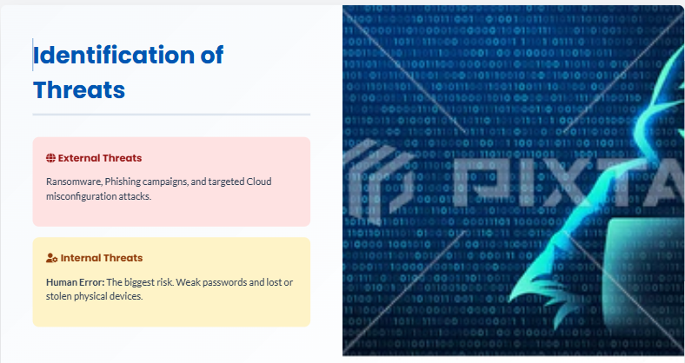
This visual representation shows the balance between external attacks and internal risks, highlighting why human error is a major concern.

3. Security Policies
A policy is a set of rules that everyone in the company must follow. Without clear policies, technical tools like firewalls are not very useful.
HealthPlus Analytics operates within the United Kingdom, meaning it is legally bound by the Data Protection Act 2018 and the UK GDPR [4]. Under these regulations, medical data is classified as 'special category data,' requiring the highest level of protection. A failure to secure this data does not only lead to operational downtime but also carries massive financial risks. The Information Commissioner’s Office (ICO) has the authority to issue fines up to £17.5 million or 4% of the total annual worldwide turnover, whichever is higher [2]. Furthermore, Article 33 of the GDPR mandates that any personal data breach must be reported to the ICO within 72 hours of discovery [4]. The implementation of the proposed strategic framework is, therefore, not just a security preference but a legal necessity to ensure the organization remains compliant and avoids devastating litigation from affected patients.

3.1 Access Control and Zero Trust
HPA will move to a "Zero Trust" model. This means the system assumes every user and device is a potential threat until proven otherwise. Every login attempt must be verified, no matter where it comes from. Access is granted based on the "Principle of Least Privilege," meaning workers only see the data they need for their specific job [5].

3.2 Data Protection and Encryption
Encryption is the process of turning data into a secret code. HPA must encrypt data in two states: "at rest" (stored on hard drives) and "in transit" (being sent via email or the cloud). If a hacker steals an encrypted file, they cannot read it without the decryption key, making the stolen data useless [5].

3.3 The 3-2-1 Backup Strategy
To survive a ransomware attack, HPA must have perfect backups. The 3-2-1 rule is the industry standard [5]:
- 3 copies of data: The original and two backups.
- 2 different media types: For example, one on a local server and one in the cloud.
- 1 copy kept off-site: This copy must be "air-gapped" (disconnected from the internet) so the ransomware cannot reach it.

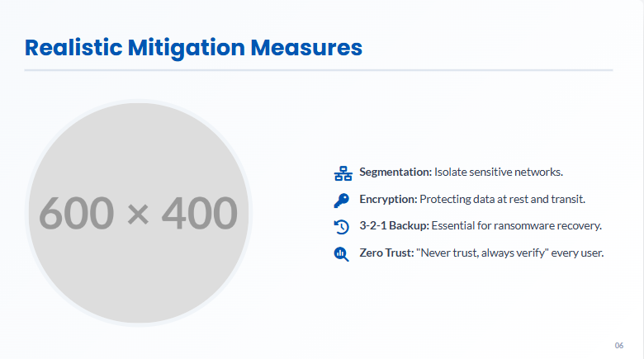
The slide outlines the core policies of encryption and the 3-2-1 backup rule that HPA will now use as its primary defense.

4. Mitigation Measures

While policies provide the rules, technical measures provide the actual protection.
- Network Segmentation: This involves splitting the HPA network into smaller, isolated sections. If a hacker gets into the "reception" part of the network, they cannot reach the "patient data" section because there is a wall between them [5].
- Multi-Factor Authentication (MFA): This requires two types of identification (like a password and a code sent to a phone). MFA stops 99% of account takeover attacks [5].
- Endpoint Detection and Response (EDR): This is advanced antivirus software that monitors every laptop and phone in the company. It uses artificial intelligence to spot strange behavior, like a computer trying to encrypt 1,000 files in one minute [5].
To achieve robust data security, HPA must employ Advanced Encryption Standard (AES) 256-bit for data at rest. This is considered military-grade encryption and would take billions of years to crack using current technology. For data in transit, the organization must enforce Transport Layer Security (TLS) 1.3 protocols [5]. This ensures that even if a cybercriminal intercepts the communication between an HPA analyst and a hospital database, the information remains unreadable. Additionally, the use of hashing algorithms like SHA-256 should be implemented for password storage. Unlike encryption, hashing is a one-way function, meaning that even if the password database is stolen, the actual plain-text passwords are never exposed, providing an extra layer of defense against credential harvesting [5].

5. Monitoring and Incident Response
HPA must be ready for the moment a breach happens. Detection must be fast to stop the damage.

5.1 The 6-Step Incident Response Plan
- Preparation: Writing the plan and training the IT team [3].
- Detection: Using monitoring tools to find the virus or the hacker [3].
- Containment: Unplugging infected computers to stop the spread [3].
- Eradication: Deleting the virus and fixing the security hole [3].
- Recovery: Bringing the systems back online using the safe 3-2-1 backups [3].
- Lessons Learned: Meeting after the event to make sure it never happens again [3].
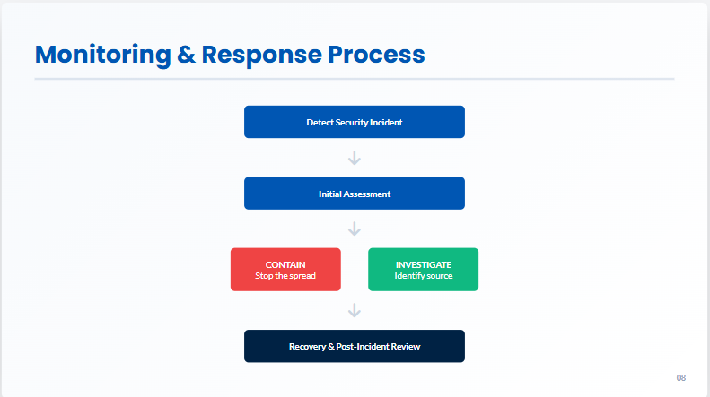

This timeline slide shows the logical flow of actions required to manage a crisis effectively.

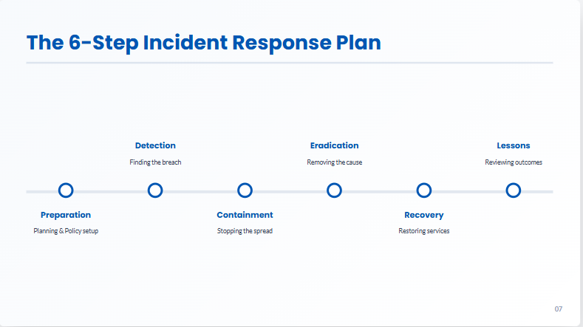
The flowchart provides a technical view of how the system decides whether to contain or monitor a potential threat.

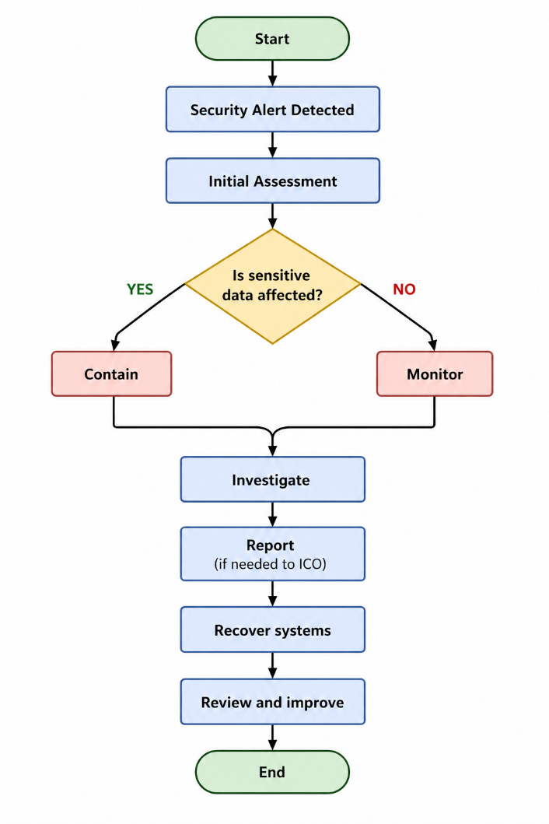
As illustrated in Figure 1, the incident response process at HealthPlus Analytics follows a strict logical flow to ensure that sensitive patient data is prioritized during a crisis. The process begins with the detection of a security alert, followed immediately by an Initial Assessment to determine the scale of the threat [3].
A critical decision point in this framework is the question: 'Is sensitive data affected?'. If the answer is YES, the protocol dictates an immediate Containment phase to stop the spread of the breach. If the answer is NO, the system continues to Monitor the activity without disrupting normal operations. This automated and human-led decision tree ensures that the company complies with the UK GDPR requirement to report significant breaches to the ICO within 72 hours after an investigation has been conducted [4].

6. Staff Training and Awareness
Since human error is the biggest threat, the staff must be trained to recognize danger.
- Phishing Simulations: The IT department will send "fake" phishing emails. If a staff member clicks, they are not punished but are given a short, 5-minute training video on what they missed.
- Password Hygiene: Teaching staff to use "passphrases" (long sentences) instead of simple passwords.
- Reporting Culture: Making sure staff know that if they make a mistake, they should report it immediately. Early reporting can save the company millions of pounds.

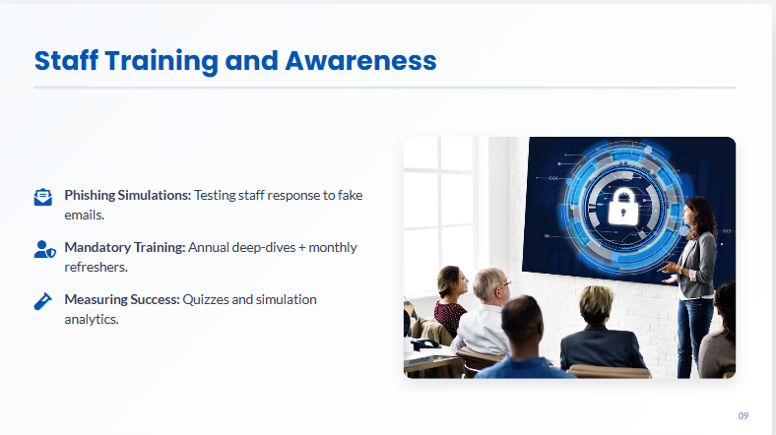
This slide explains the different methods used to educate the workforce, from simulations to mandatory annual classes.

7. Summary and Recommendations

To move forward, HealthPlus Analytics must focus on four key areas:
- Immediate MFA Adoption: No account should be accessible with just a password [5].
- Encryption First: All patient data must be hidden behind strong encryption [5].
- Better Backups: The 3-2-1 rule must be tested every month to ensure it works [3].
- Legal Compliance: All actions must be documented to prove to the ICO that HPA is following the UK GDPR [4].

8. Conclusion
Cybersecurity is not a project with a fixed end date; it is a continuous and evolving process. For HealthPlus Analytics, the recent incidents have highlighted the importance of strengthening both technical and organisational security measures. By combining advanced technologies such as encryption and network segmentation with a well-trained workforce, the organisation can significantly reduce its exposure to cyber threats [5].
Protecting patient data is not only a legal obligation under UK GDPR but also essential for maintaining trust between healthcare providers and patient [4]. A strong cybersecurity framework ensures long-term resilience, regulatory compliance, and the continued safe operation of healthcare services.
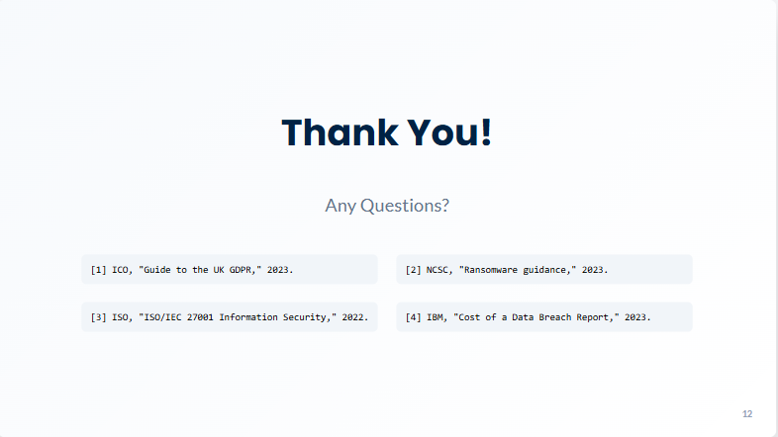
The conclusion slide reminds us that security is a balance of technology and people working together.

References

[1] | I. Security, „Cost of a Data Breach Report 2023,“ 2023.
[2] | N. Digital, „Data Security and Protection Toolkit,“ NHS Digital, 2024.
[3] | N. C. S. Centre, „Ransomware advice and guidance,“ 2023. [Онлайн]. Available: https://www.ncsc.gov.uk/ransomware/home.
[4] | U. Government, „Guide to the UK General Data Protection Regulation,“ GOV.UK, 2023.
[5] | I. O. f. Standardization, „ISO/IEC 27001 Information Security Management,“ ISO, 2022.
[6] | N. I. o. S. a. Technology, „Cybersecurity Framework,“ NIST, 2024.

