Module : BMSS5007
Developing your Professional Profile

Modiwl : BMSS5007C
Datblygu eich Proffil Proffesiynol

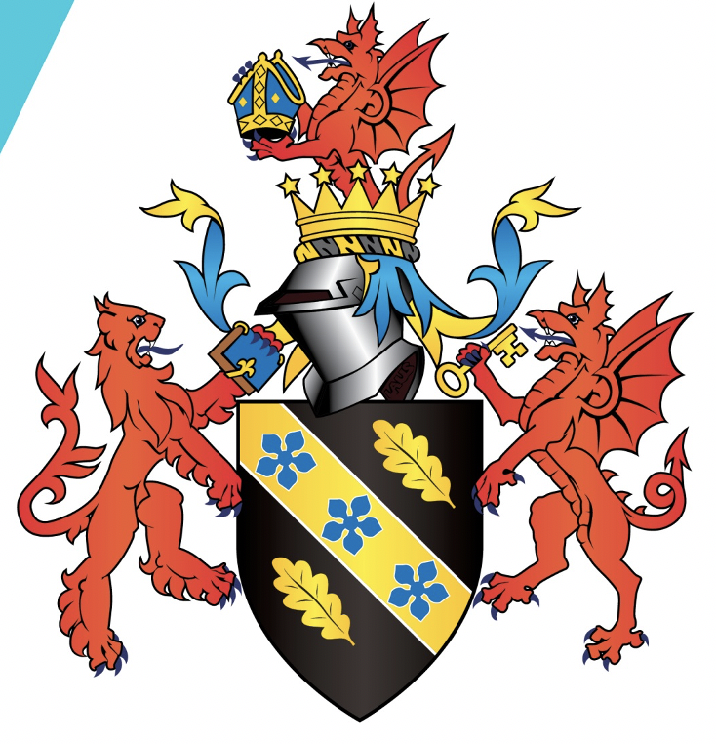

Asesiad / Assessment :
E-portfolio prep for CPD / Work

Gan / By: Rachel Wassermann
Student number : 2217472

Arweinydd Modiwl / Module lead : Heddwen Davies

CV
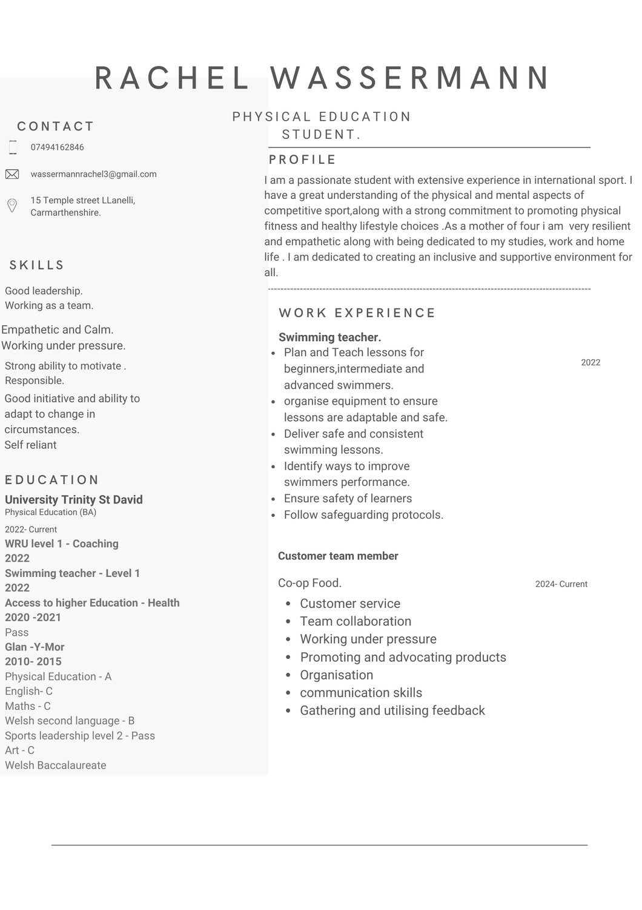

Personal statement

My passion for physical activity started at a young age which was largely influenced by my school teachers and the opportunities they provided me . Their influence and encouragement was fundamental in assisting me in reaching high levels in a variety of sports such as football, athletics, netball, cricket and rugby also, giving me the confidence to compete on the international stage. One of my proudest sporting moments was playing in the Touch rugby world cup in Australia 2015, this would not be possible without their support. My ambition has always been to become a Physical education teacher as I want to share my joy and fulfilment that sport gives me and give other students the opportunities and engagement I encountered whilst at school.

Over the last two years, the university has provided me with qualifications and teaching experience including swimming teaching, creative movement and WRU level one coaching. These qualifications allowed me to achieve a role as a swimming instructor in the local leisure centre, teaching students of different abilities. This has enabled me to gain confidence in my ability to deliver clear instructions, adapt my teaching methods to individual needs, and maintain a calm and supportive environment, particularly when students are facing challenges. As a swimming instructor I take great pride in being an empathetic and guiding participants to overcome challenges while promoting their desire and enthusiasm for sport and physical fitness. Being previously appointed as vice captain of the welsh team in touch rugby, I believe that the leadership role gave me the ability to motivate and encourage individuals to work hard to achieve the best outcome, work well as a part of a team while ensuring a fun and safe environment.

Outside of university my hobbies are rugby and football. These sports have been really fun for me as they challenge me both mentally and physically. My latest sporting accomplishment was scoring a try in the principality stadium which is an experience I will never forget with my team. In addition to my sporting and academic achievements, I am a mother to four children while working part time at a local supermarket. Although balancing a busy schedule and employment with my education is difficult, it has been highly beneficial for me to be focused, work well as part of a team, be empathetic, remain calm under pressure and adapt quickly to changing situations.

In conclusion, I am eager to share my knowledge with future learners and assist them in every element of physical education, as well as to encourage them to be physically active throughout their lives. I believe my elite sporting background enables me to provide opportunities and encourage the next generation. I am passionate about promoting physical activity , health and wellbeing and also being an inclusive teacher. I Hope I achieve my goal of inspiring children to be committed to physical activity and giving them the opportunity to attain their full potential. I believe I am the ideal candidate for providing future pupils with the confidence and skill set that they can not only implement in Physical education but in everyday life.

Focus statement

I am a highly motivated and organised individual with a strong passion for physical education, built on both my international sporting experience and qualifications. As a former international athlete and vice captain for my country at major tournaments like European championships and playing in the World Cup (Australia 2015) I developed leadership skills,resilience and the ability to remain calm under pressure. My broad experience in sport has equipped me with a unique ability to empathise with people helping them develop both physically and mentally.

In addition to my sporting career, I have pursued professional development , earning qualifications such as the WRU level one coaching certificate and a swimming teacher level one qualification. These qualifications, together with my undergraduate teaching experience working with children of different ages and abilities, has expanded my teaching and problem-solving abilities. My practical experience teaching swimming has taught me the value of adapting lessons to each student's unique requirements, resulting in an inclusive, safe, and effective learning environment . Balancing work and family commitments has been difficult throughout my degree but it has taught me to be very self-sufficient, motivated, and focused on my final goal .

After completing my Physical education degree, my aim is to secure a place on a PGCE secondary teacher training course to fulfil my goal of becoming a secondary school physical education teacher. In preparation for this,I'm aware of a few matters that need to be improved. One is interview skills. To increase my confidence. I aim to attend sessions with student support to obtain some assistance and guidance on strengthening my interview responses with confidence. I intend to gain additional practical experience by working as a teaching assistant and volunteering at my children's school for after-school sports. I believe that these teaching opportunities will be beneficial in expanding my knowledge and gaining confidence in my teaching methods and facilitate my future career.

Another area I am going to work on is to improve my knowledge on new technology to incorporate in my teaching pedagogies. To achieve this I am going to further my research on new technology and if achievable attend courses and lessons to expand my knowledge.
I am committed to giving children the support and encouragement they need to feel confident in their physical education journey, and I am convinced that my strong work ethic and expanding skill set will benefit future learners.

Appendices.

Training development plan.

What do I want to learn? | What do I have to do? | What support and resources will I need? | How will I measure my success? | Target date for review.
Interview skills | Practise answering interview questions required for a specific job role. | Lecturers  Attended meetings with student support. | Feedback from lecturers or student support team. | 4 months
Public speaking  (presenting). | In group scenarios offer to be the leader | Speak to tutors to find out when events are happening to get involved | Complete public speaking and get feedback from the audience. | 3 months.

SWOT Analysis .

Strengths (Internal)  Strong communication skills  Passion for physical education/activity  Knowledge of physical education  Adaptability  Motivation skills  Empathetic  Organising  Planning | Weaknesses (Internal)  Use of new technology.  Public speaking (Presentations)
Opportunities (External)  Take part in presentations  Attended it courses  Teaching assistant job role.  Volunteer in local schools. | Threats (External)  Family commitments.

Reference list

Guidance in writing letters of applications
Guidance in writing goal setting targets

