

Student Name: GOWRI PAMARTHI
Student Number: 2206771
Module Name: Database systems (ACCA7002)
Assignment Title: Data storage investigation

Contents
Abstract: 3
1 Different types of NoSQL databases 3
1.1 Column Orientated: 3
1.2 Document oriented: 4
1.3 Key-value Orientated: 4
1.4 Graph Orientated: 5
2. Architectures: 6
2.1 MongoDB: 6
2.2 DyanmoDB Architecture: 6
2.3 Neo4J: 7
2.4 Architecture of Cassandra: 7
Summary: 7
3.NoSQL database vs relational database 8
3.1 Scalability: 8
3.2 RDBMS vs NoSQL: 9
3.3 RDBMS's primary focus is on ACID properties: 10
3.4 Different Query formats 10
4 Conclusion and Limitations 11
SQL Code Implementation 12
Creating Tables: 12
Check Constraints: 13
Creating Index: 13
Inserting Data: 14
Fetching Data from Tables: 16
References 18

Abstract:
This paper examines the detailed work of different types of NoSQL databases and the Architecture of Mongo DB, a comparison between different types of NoSQL and relational databases, and the implementation of NoSQL and relational databases.

1 Different types of NoSQL databases

NoSQL Database Types

- Column Orientated
- Document Orientated
- Key-value Orientated
- Graph Orientated

1.1 Column Orientated:
A multi-dimensional, sparse, distributed map is used by column-oriented databases to store data. These databases are sometimes referred to as wide column stores or column family stores. A record could include one, several, or even super columns that are nested inside other columns. One-column families or several-column families can be used to group columns together. With each column family, a main key is used to retrieve data. Column-oriented databases store data in columns instead of relational databases, which store specific data in a table's rows (s). Column-oriented databases could initially resemble relational databases, however, they vary since they don't have any prestructured tables to handle the data. Large volumes of a given attribute can be retrieved more quickly because of this feature of column-oriented databases. In essence, column-oriented databases are two-dimensional arrays with one or more key/value pairs associated with each key, record, or row.
Fig 1: Column-oriented and row-oriented comparison

1.2 Document oriented:
The necessity to create a database system without reliance on schemas led to the creation of document databases. In order to query data using SQL and rely on schemas where objects are thought of as collections of relationships, relational databases were established. Cloud computing, the need to store unstructured data, and the demand for agile development methodologies have led to the rise of novel databases, among which document databases are one. Each record and the data it contains are considered documents in document-oriented databases, also referred to as databases with semi-structured data. A document database gives database objects agility and less dependency by encapsulating everything relevant to them. JSON XML and BSON are two examples of the file formats that the documents used to encapsulate and encode data. Although they function similarly to column-oriented databases, document-oriented databases offer deeper nesting and more complicated structures that are documented within documents, etc. [1]. Several well-known document-oriented databases include Couchbase, MongoDB, and CouchDB.
Fig 2: Document database compare to relational database

1.3 Key-value Orientated:
The simplest and most fundamental NoSQL database solution uses key-value-oriented databases, where keys are matched to values in a manner akin to a dictionary or hash. In computing jargon, dictionaries refer to a group of objects or records that may include numerous fields with data. Key-value-oriented databases lack structure and relationships. Key-value databases keep a pair of keys and values that can be used to get the value when a key is known. Relational databases have a pre-defined data structure as tables with fields with specific data types, whereas key-value stores operate differently. Key-value stores, on the other hand, handle data as a single opaque collection that could contain various fields for every record. . One of the primary benefits of key-value stores is their scalability because they typically don't need to be redesigned and can operate quickly [2]. DynamoDB, Riak, and Redis are a few of the well-known Key-value databases.

1.4 Graph Orientated:
The three NoSQL database types before it is completely distinct from graph databases.
In explicit graph structures, nodes and edges are connected to one another by relations, forming a tree-like structure. These explicit graph structures are the foundation of graph-oriented databases. Each node is aware of its surrounding nodes, and a searchable index is available. Nodes in a database store information about each object, relationships explain connections between nodes, and properties are just the node on the other side of a relationship [3]. Orient DB, Mark Logic, and Neo4j are a few of the well-known graph-oriented databases.
Fig 3: Graph-oriented database

2. Architectures:

2.1 MongoDB:
MongoDB stores data as BSON (Binary JSON) documents, where each field in a BSON document includes a value of a particular form of data, such as an array, binary data, or a subdocument. Collections of documents with nearly identical structures are arranged. Multiple comments, tags, and categories may be expressed as embedded arrays in a collection. In contrast to traditional databases, where the data for a given record is dispersed across numerous tables, documents in MongoDB deliver all the data in a single document. Because the concept of schema in MongoDB is dynamic, each document may have a distinct set of fields. This allows for modeling unstructured and polymorphic data with greater flexibility.
Fig 4: MongoDB data model

2.2 DyanmoDB Architecture:
Tables, items, and attributes make up the main parts of the DynamoDB data model, which is actually a collection of tables. An item is a group of attributes, while a table is a group of things. In contrast to relational databases, DynamoDB has no predetermined schema, including table names, column names, and data types, with the exception of the primary key. The maximum size of a DynamoDB item is 400 KB, despite the fact that an item can have any amount of characteristics. The size of an item is determined by adding the names and values of its attributes, where names might be binary or UTF-8 lengths [4]. A name-value pair with either a single value or a multi-valued group of values serves as an attribute for an item.

2.3 Neo4J:
Neo4j primarily relies on nodes and relationships, but there are many more concepts that are important to comprehend in order to fully grasp the Neo4j graph database's design.
Nodes - In graph databases, nodes are frequently used to represent entities, but depending on the domain, they may also be used for other things. Properties may be found in nodes. When a node contains zero or more named values, a property is said to be defined. Nodes can have labels in addition to properties and relationships.

2.4 Architecture of Cassandra:
With no single point of failure and the ability to handle massive data distributed over several nodes, Cassandra is designed to handle it. System and hardware failures are inevitable and will occur when there is a single point of failure. Since failure is impossible, availability is crucial. By installing peer-to-peer nodes in homogenous nodes, where data is dispersed among all nodes in the cluster, Cassandra solves this issue [5]. A commit log is systematically written on each node throughout each information exchange to confirm the longevity of the data. Into the in-memory structure memorable, data is indexed. When this memory structure is full, it is sent to a disc in an SSTable data file, where the writes are automatically spread across the cluster and partitioned. A sorted String Table is known as SSTable. Periodically consolidating SSTables removes outdated data. An authorized user can access any node in any cluster using Cassandra and run queries using the CQL language, which is similar to SQL. Each application has its own keyspace within a cluster. Any node in the cluster where the node client joins to serve as a coordinator can receive client read-write requests

Summary:
The four database types covered above demonstrated how one might be both quite similar to and very different from one another. One database system is more widely used than the other.
Cassandra: In content management, where contents are saved with tags, categories, etc., Cassandra and related column family stores are frequently employed. It is utilized when creating video, desktop, and mobile games, which are situations where the expiry column functionality may be useful. Among the numerous well-known companies in the sector using Cassandra are Accenture, eBay, Coursera, Comcast, and Hulu.
DynamoDB: Fast in-memory access cases, compact read/write cases, and easier upgradeability scenarios are where key-value stores like DynamoDB, Amazon, and others are most commonly employed. Another advantage of DynamoDB is that it has programming flexibility comparable to MongoDB, which is utilized to create APIs in several languages. EA Sports, Nordstorm, Shazam, and the New York Times are a few of the industry pioneers who use DynamoDB.
MongoDB: When tiny, continuous reads and writes are required, MongoDB and other document store databases are frequently employed. These are also well-liked in environments with a wide range of data kinds and access patterns. Because of its sharding feature, MongoDB is well-known for its scalability. Among others, The Weather Channel, MetLife, Bosch, and Expedia employ MongoDB in the business world.
Neo4j: Neo4j and other comparable graph-oriented databases are utilized in social networking platforms and in situations where quick navigation between entities is necessary.
They are also utilized while developing partnerships or other circumstances that call for dynamic features. Neo4j is used by Walmart and eBay for consumer recommendations. Other Neo4j users in the market include Cisco, Lufthansa, and TomTom, to name a few.

3.NoSQL database vs relational database
The idea of NoSQL databases gained traction among Internet behemoths like Google, Facebook, Amazon, and others who work with massive amounts of data. When you utilize RDBMS for enormous volumes of data, the system's response time slows down. We could "scale up" our systems by updating our current hardware to overcome this issue. This procedure is pricey. NoSQL databases have recently been created as a result of the massive data expansion, particularly in web and mobile applications. If social networking websites like Facebook, LinkedIn, and Twitter are to be taken into account, it must be noted that in addition to managing massive amounts of data, those systems still need to maintain latency.
The most common differences and key features of No-SQL and traditional RDBS
- Scalability
- Non-Relational
- Schema-Free
- Simple-API
- Distributed

3.1 Scalability:

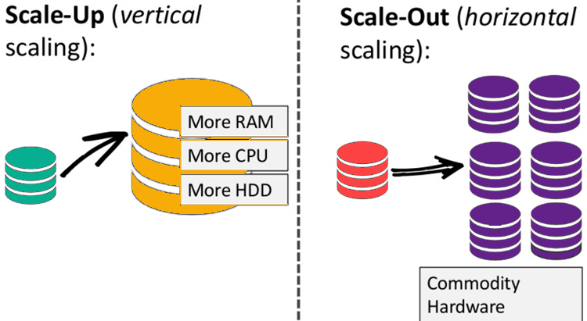
Fig 5: Scalability feature (Accessed from: https://www.guru99.com/nosql-tutorial.html)

Database administrators have depended on scaling up for years rather than scaling out, which involves dividing the database across different hosts as load increases. The cost benefits of scaling out on commodity hardware, however, become indisputable as transaction rates and availability needs rise and databases migrate to the cloud or virtualized settings. The new breed of NoSQL databases is built to expand transparently to take advantage of new nodes, and they're typically designed with low-cost commodity hardware in mind. RDBMS may not scale out readily on commodity clusters.
The relational model has traditionally been the most popular method of managing data, and many of the most well-liked database management systems still utilize it today. For instance, scaling a relational database horizontally might be challenging. The process of adding more machines to an existing stack is known as horizontal scaling, or scaling out, and it aims to spread out the load so that more traffic and faster processing are possible. Because the relational model was created to guarantee consistency, scaling a relational database horizontally is challenging.

3.2 RDBMS vs NoSQL:
RDBMS | NoSQL
When the data is large, RDBMS performance and scalability have several problems. With the current load, servers might not function properly, which causes performance problems. | It performs admirably under heavy loads. In NoSQL, scalability is excellent. This improves the database's performance in comparison to RDBMS. Users are able to manage a large volume of data with ease.
In RDBMS, joining multiple tables is simple and has no impact on the database's performance. In this instance, the main key is useful. | NoSQL prohibits the joining of several tables since it is difficult for the database to handle and has negative effects on the data's performance.
The database is typically available whenever it is opened and is dependent on the server's performance. Users won't be misled by the data because it is consistent and clear. | Although the databases are easily accessible, some of them offer less consistency than others. Users should frequently check the availability because this affects the database's performance.
Even if the queries are sophisticated, data analysis and querying are simple using RDBMS. To properly analyze the provided data, slicing and dicing can be done using the data at hand | Although NoSQL may also be used for data analysis, real-time data analytics is where it really shines. Reports are not created in databases, but if an application must be created, NoSQL is a viable option.
Because the database's data needs to be structured and in the right format to establish identifiers, documents cannot be stored in RDBMS. | The NoSQL database can be used to store documents because it is unstructured and does not include rows and columns.
In the database, partitions cannot be formed. To describe the data in a specific format specified in the schema databases, key-value pairs are required. | Key-value pairs are not required to identify the data in the source, and partitions can be simply generated in the database. NoSQL can be coupled with software as a service.
The market offers user interface tools for data access so that consumers can experiment with the entire RDBMS infrastructure's schema. Users will be able to interact with the material more effectively and comprehend it better as a result. | Users have few options for interacting with data because there aren't many user interface tools available in NoSQL to access and change data.

3.3 RDBMS's primary focus is on ACID properties:
Each transaction is atomic, which is a feature. The entire transaction fails if even one component of it fails (and is rolled back)
• Consistency - A uniform set of rules applies to every transaction (constraints, triggers, cascades)
No transaction should interfere with another transaction, which is known as isolation.
• Stability - A transaction is stable once it is committed.
ACID is crucial, but only in systems like banking, finance, and safety systems, which can be burdensome for systems like Google, Amazon, and other systems that must communicate a lot of data.

3.4 Different Query formats
Schema Statement
SQL | NoSQL
CREATE TABLE employee (emp id NOT NULL, emp name Varchar (200), age integer, status boolean | db. Create collection ("employee") or db.emp.insert( { emp_id: "nosq145", age: 27, status: "A" } )

Insert Statement
SQL | NoSQL
INSERT INTO employee (empid, age, status) VALUES ("ace123", 27, "A") | db.employee.insert( { emp_id: "nosql145", age: 27, status: "A" } )

Select Statement
SQL | NoSQL
Select * from emp; | db.employee.find()

SQL Schema Statements MongoDB Schema Statements CREATE TABLE users (id MEDIUMINT NOT NULL AUTO_INCREMENT, user_id Varchar (30), age Number, status char (1), db. Create a collection ("users") or db. users.insert( { user_id: "abc123", age: 55, status: "A" } ) DROP TABLE users db. users.drop()

4 Conclusion and Limitations
Scalability: Users must scale relational databases on strong servers, which are costly and challenging to manage. A relational database needs to be distributed across several servers in order to scale. It is a mess to manage tables across multiple servers.
Complexity: Data on the SQL server must fit into tables regardless. If your data doesn't fit into tables, you'll need to develop a complex, once more challenging to manage database structure.
When supporting dynamic queries and data validity is essential, RDBMS are excellent tools for handling ACID challenges.
When having rapid data is more crucial than having just-updated, up-to-date data is more critical, and NoSQL is an excellent option for resolving data availability issues.
RDBMS traditionally rely on pricey proprietary servers and storage solutions, while NoSQL databases typically use clusters of inexpensive commodity servers to manage the explosion in data and transaction volumes. As a result, NoSQL can be far more affordable per gigabyte or transaction/second than RDBMS, enabling you to store and process more data at a much lower cost.

SQL Code Implementation

Creating Tables:
Here I used MS SQL to create the tables.
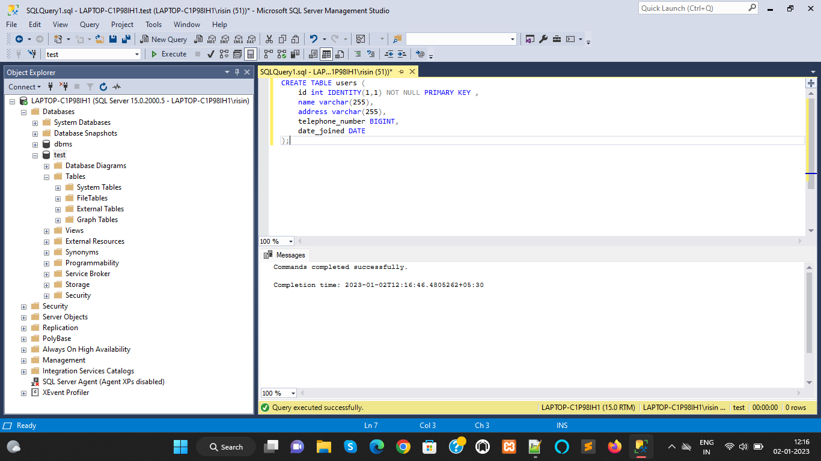

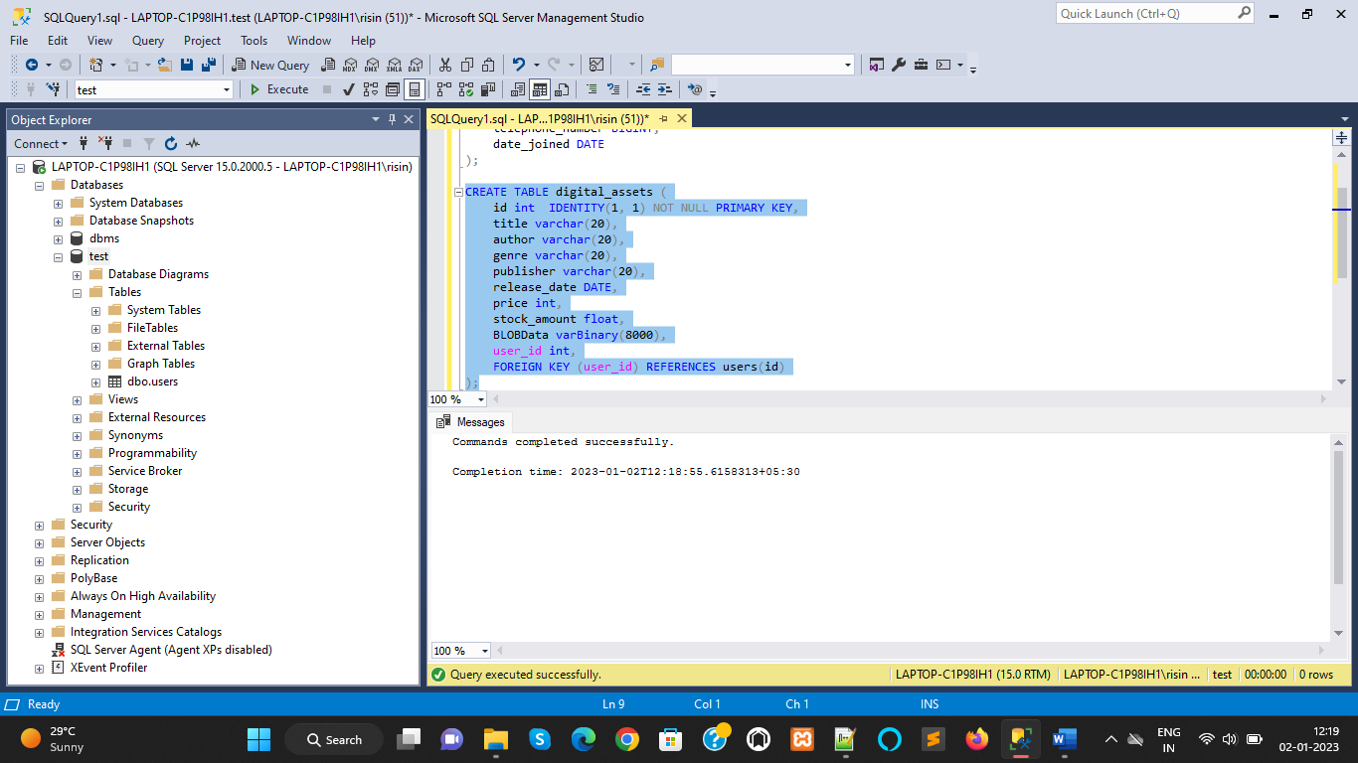

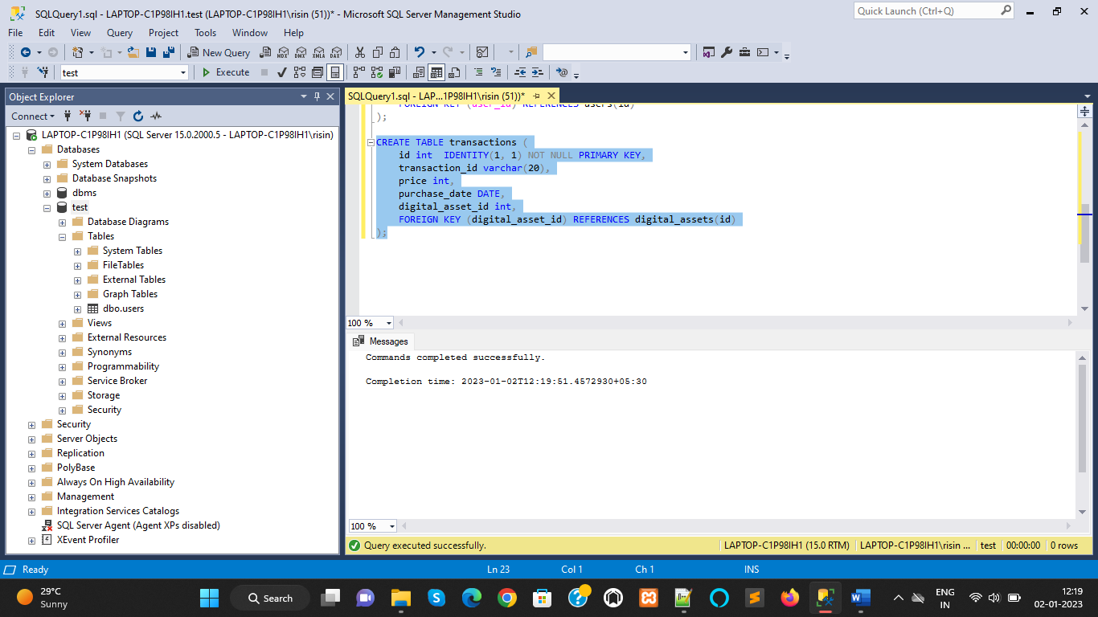

Check Constraints:
Here, I created check constraints
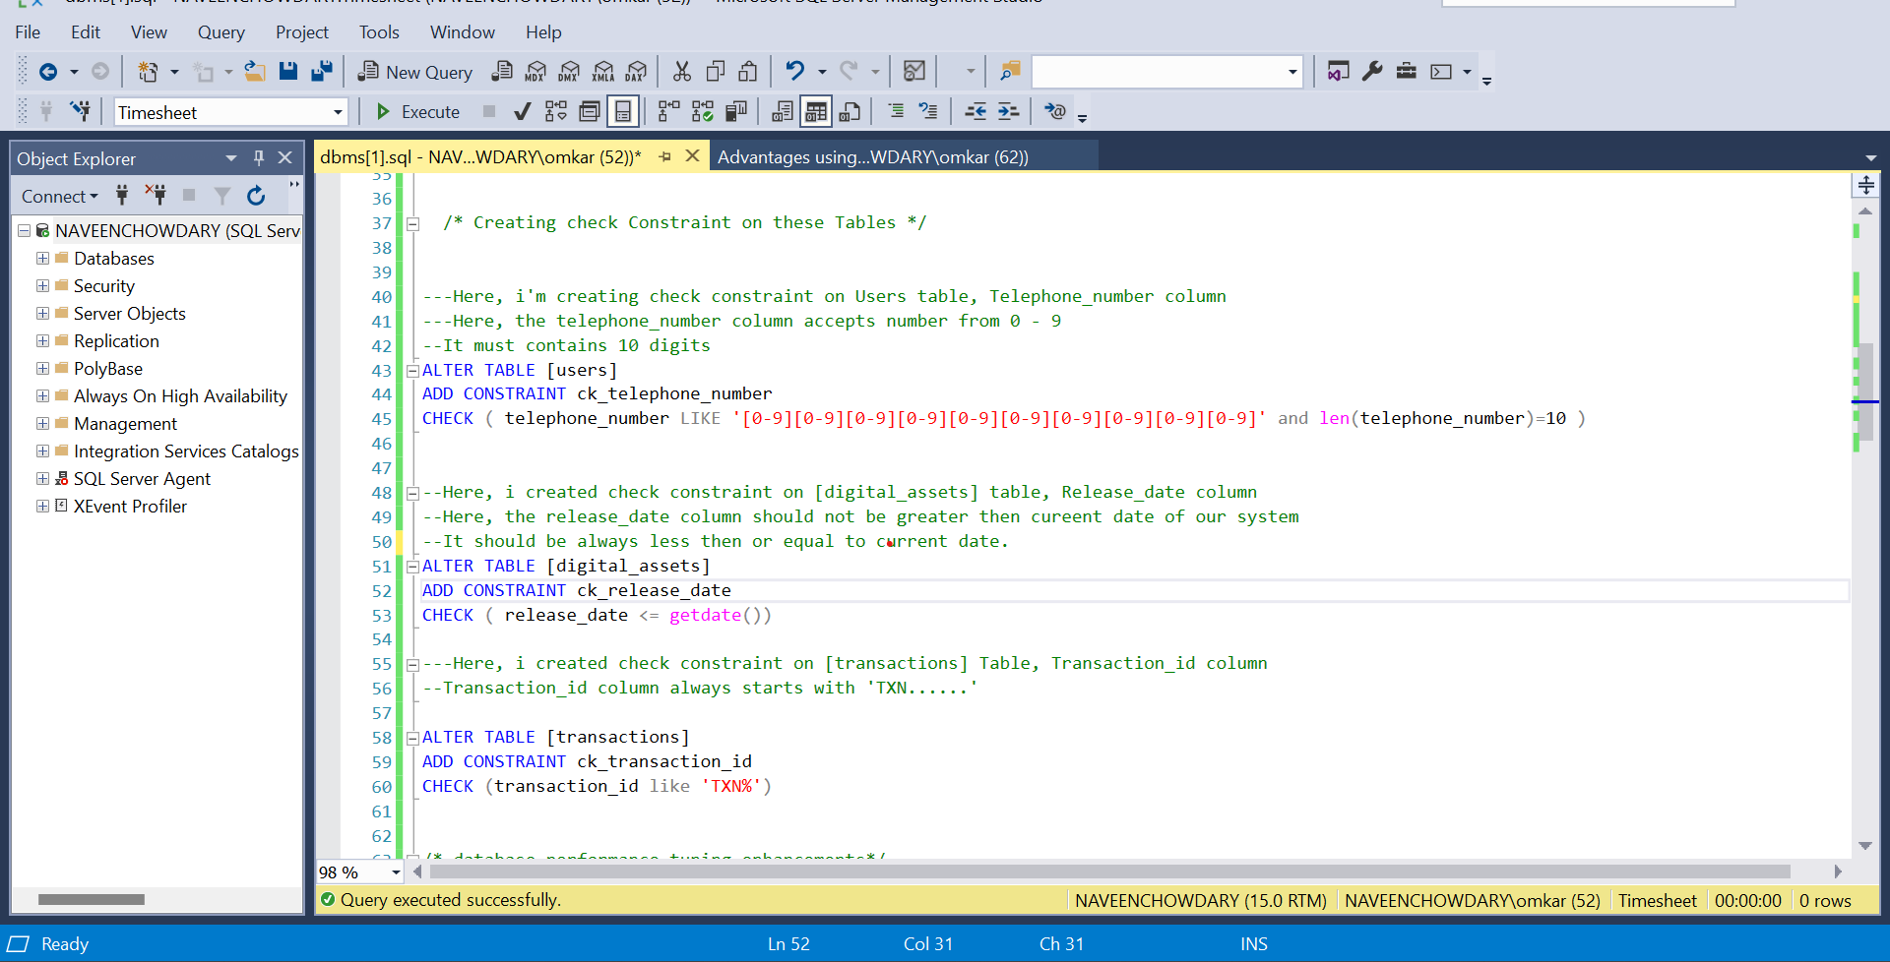

Creating Index:
Here, I created a NON-CLUSTERED INDEX for the following tables. why I created non clustered index means, for example, when we create any table with the primary key, then the default clustered index will be created on the table, and data will be sorted.
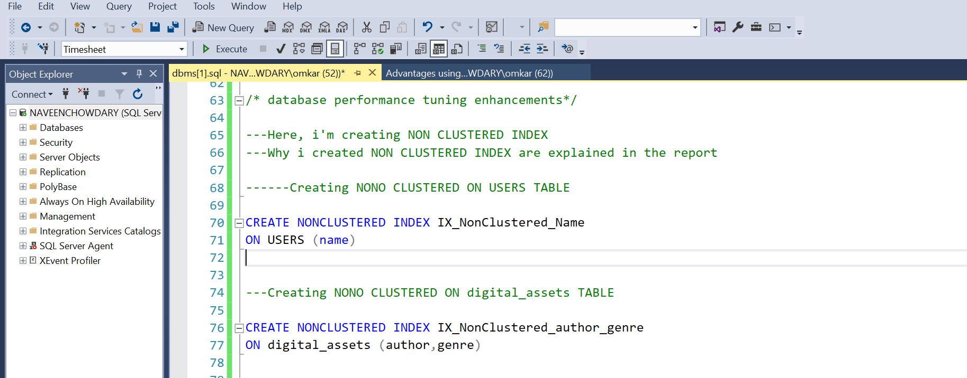

Inserting Data:
Here I inserted the data into the tables.
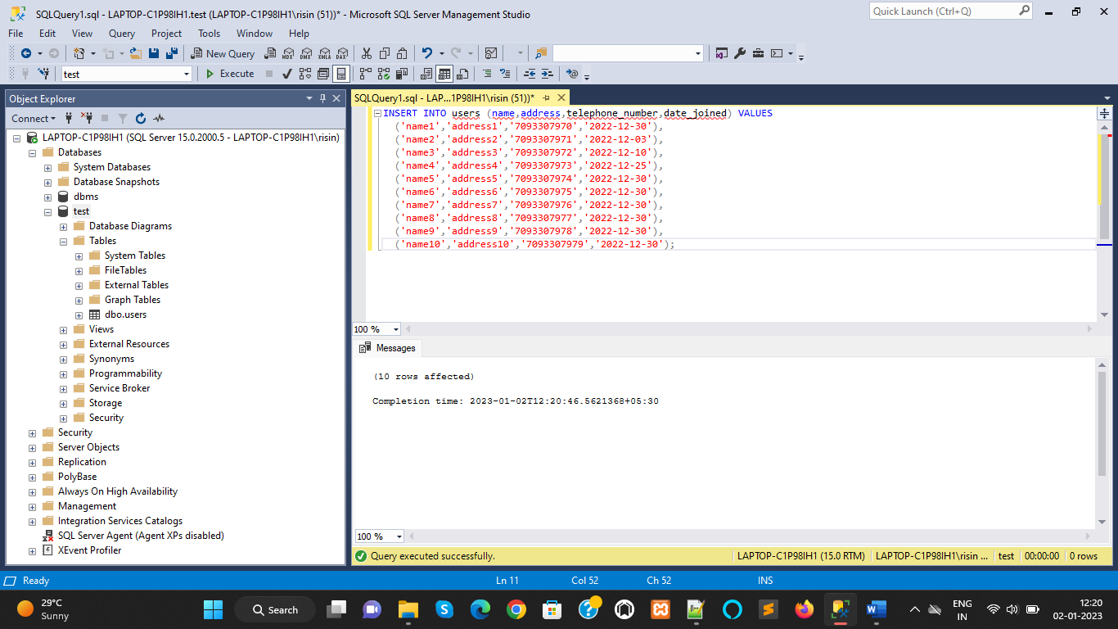

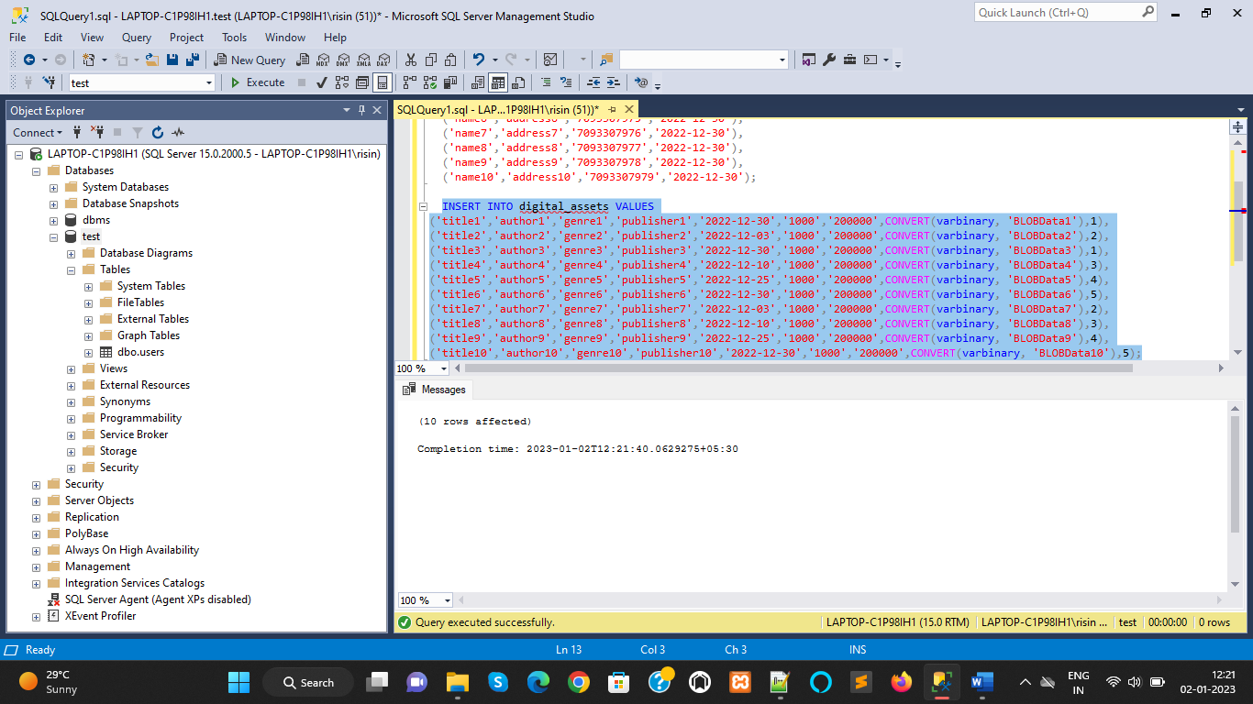

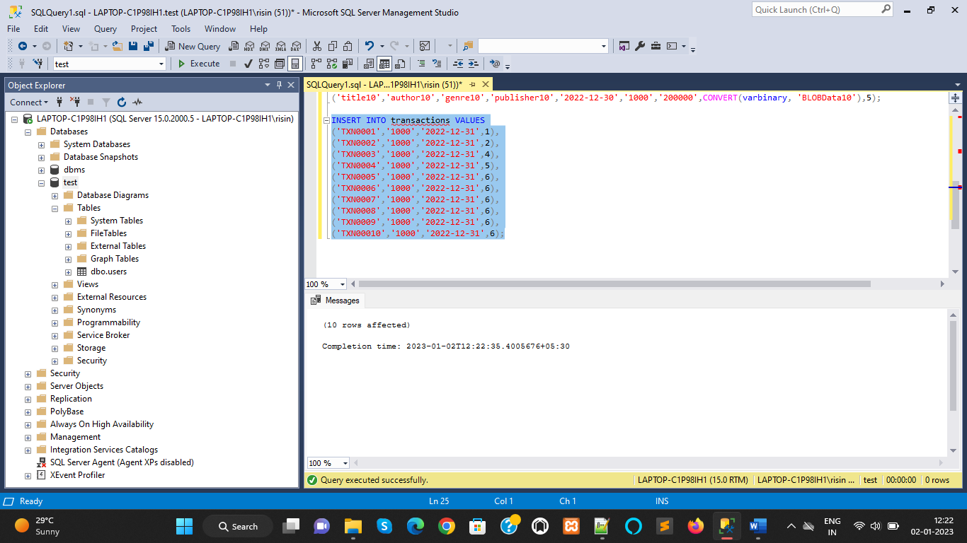

Fetching Data from Tables:
Here I fetched the data from the tables. In SQL, to retrieve data stored in our tables, we need to use the SELECT statement.

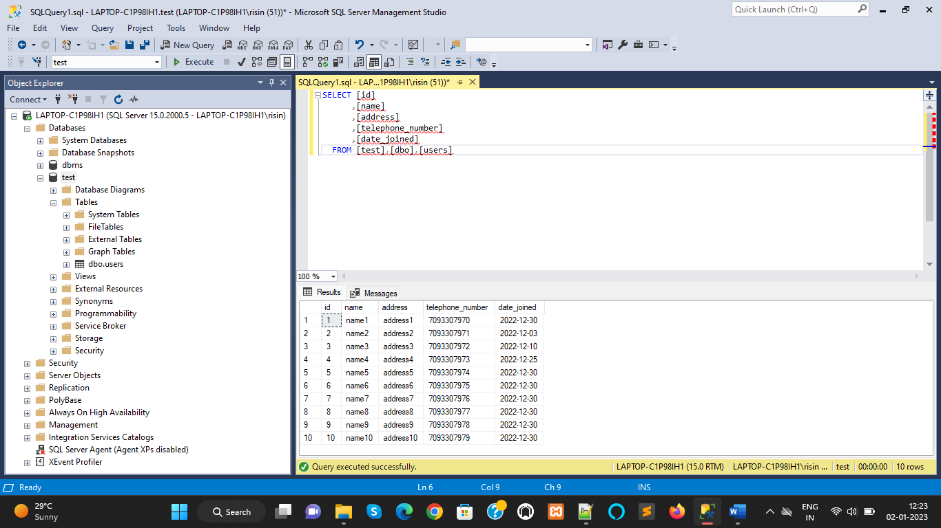

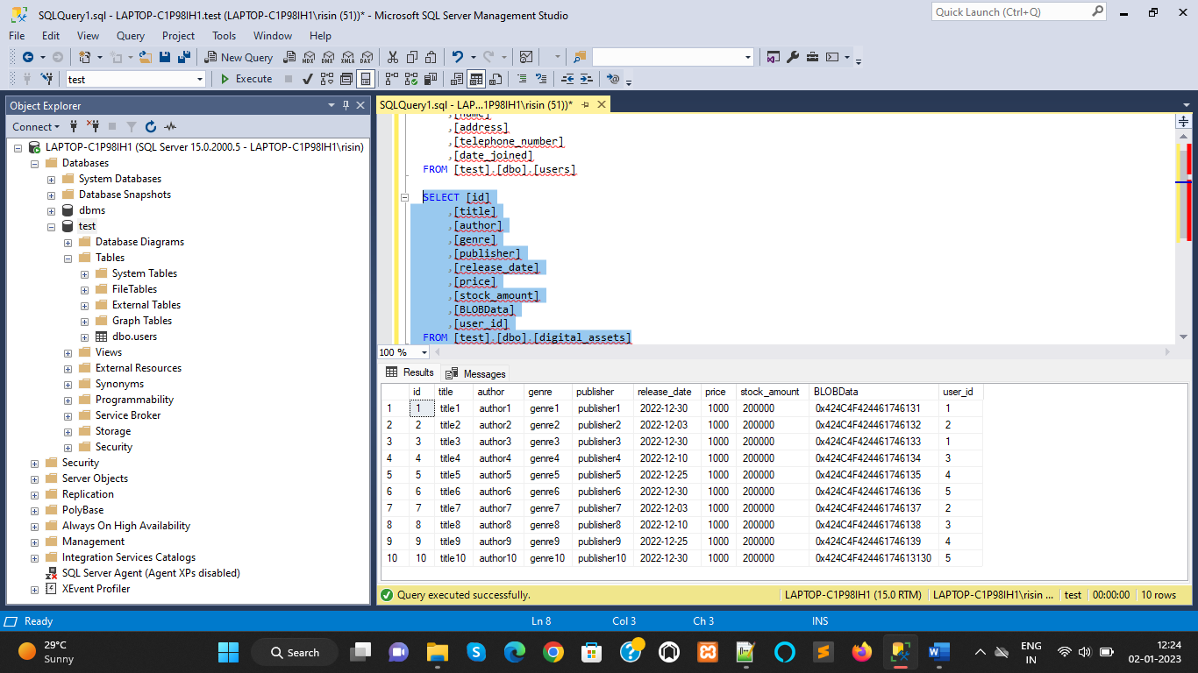

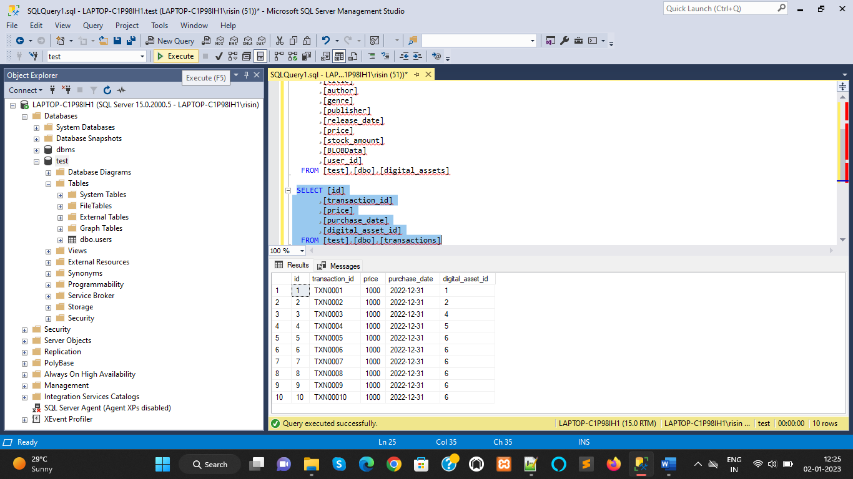

References
[1] A Comparison of NoSQL Database Management Systems and Models. (2014, February 21). Retrieved from Digital Ocean: http://www.webcitation.org/6hACY1MFW
[2] Reeve, A. (2013, November 25). Big Data Architectures - NoSQL Use Cases for Key-Value Databases. Retrieved from EMC2 InFocus: http://www.webcitation.org/6hADVIDWr
[3] Olson, K. (n.d.). What are the main differences between the four types of NoSQL databases? Retrieved from Quora: http://www.webcitation.org/6hAEOkiBj
[4] Amazon DynamoDB - Developer Guide. (2012, August 10). Retrieved from Amazon Web Services Docs: http://www.webcitation.org/6hAH31OjL
[5] Apache Cassandra™ 2.0. (2015, August 13). Retrieved from http://www.webcitation.org/6hAEi0UxB
[6] https://www.educba.com/rdbms-vs-nosql/
[7] Nayak, A. & Poriya, A. & Poojary, Dikshay. (2013). Article: Type of NoSQL databases and its comparison with relational databases. International Journal of Applied Information Systems. 5. 16-19.
[8] Al-Sakran, Aya & Aqel, Musbah. (2017). A Comparative Study of NoSQL Databases.

