

Postgraduate/Distance Learning
Assignment coversheet & feedback form

THIS SHEET MUST BE THE FIRST PAGE OF THE ASSIGNMENT YOU ARE SUBMITTING (DO NOT SEND AS A SEPARATE FILE)

For completion by the student:
Student Name: Joseph Green

Student University Email: 2413950@student.uwtsd.ac.uk
Module code: HPCA7028  Module title: Sacred Skies | Student ID number:  2413950 |  |  | Educational support needs:  Yes/No
Assignment title: The Sky, Space, and Space Travel in 2001: A Space Odyssey and Interstellar

Assignment due date: May 1, 2025
This assignment is for the 1st 2nd 3rd 4th 5th 6th module of the degree
I confirm that this is my original work and that I have adhered to the University policy on plagiarism.
Signed Joseph Green April 30, 2025
Email submission:if you are submitting this form via email, please tick this box □
(as a substitute for your signature) to confirm that you agree to the above declaration.
Assignment Mark
1st Marker’s Provisional mark
2nd Marker’s/Moderator’s provisional mark
External Examiner’s mark (if relevant)
Final Mark

NB. All marks are provisional until confirmed by the Final Examination Board.

For completion by Marker 1 :
Comments:

Marker’s signature: |  |  | Date:
For completion by Marker 2/Moderator:

Comments:

Marker’s Signature: |  | Date:
External Examiner’s comments (if relevant)

External Examiner’s Signature: |  | Date:

The Sky, Space, and Space Travel in 2001: A Space Odyssey and Interstellar
Introduction:
The aim of this essay is to compare and contrast the visual representation of the sky, space, and space travel in the films 2001: A Space Odyssey and Interstellar. Both are American science fiction films that feature space and space travel as driving themes to their stories. The context in which these films were made had a deep influence on how their creators decided to visually represent the sky, space, and space travel.
The essay will briefly discuss the important link between culture, science, technology, and film. Comparing the two films, the essay will first look at conflicts presented in the films, and how both films use the sky to represent those conflicts. The essay will look at these conflicts in the context of the culture the films were created in. Next, the essay will explore the visual representation of objects throughout the film and how the cultural knowledge of the time, including scientific understanding and technological ability, affected the representation of the sky, space, and space travel in the film.
Culture, Science, and Film:
Culture can be a difficult word to define, but in the context of this essay it can be understood as Edward Burnett Taylor defined it in Primitive Culture:
“Culture, or Civilization, taken in its wide ethnographic sense, is that complex whole which includes knowledge, belief, art, morals, law, custom, and any other capabilities and habits acquitted by man as a member of society”
The definition provided offers a broad idea of what aspects of our lives are included under the term “culture.” It includes not only beliefs and art, but also knowledge. This more general knowledge can be thought to include scientific and technological knowledge. In their article titled Science and Culture author Alan Gross argues that science, technology, and culture have become closely linked. He makes the claim that for much of human history science specifically was not an established part of our culture.
There have been periods of time where science has thrived, the examples provided by Gross including ancient Greece and late Middle Ages Western Europe. Science was explored during these distinct and separate periods of time but could not cement itself as a cultural practice. According to Gross, a third scientific revolution was needed for that to occur. 16th century Western Europe was the home to this third revolution. As of this third revolution, individuals who researched the natural world began to be referred to as “scientists”.
Gross went on to discuss the importance that World War II and the invention of the atomic bomb to the connection of technology and science in American culture. Regarding the atomic bomb, Gross wrote “Virtually for the first time science and technology were partners: physics made the atomic bomb possible; technology made it actual”. This quote displays the perceived cultural link between science and technology. Science can envision new possibilities, and technology can make those possible. In a culture that treats scientific discovery as a core cultural component, as the modern western outlook does, the ability to create new things and improve upon the existing bleeds into many aspects of that culture.
A portion of the essay is spent exploring the link between science and literature, and how they sometimes seem to mingle. Gross wrote about a journal called American Literature and Science which included essays exploring the scientific impact on multiple works of literature. The essay helps present the idea that literature and science can meld into one cultural practice.
Film has also become a very important part of American culture. Vivian Sobchack’s essay Beyond Visual Aids: American Film as American Culture explores this idea. Sobchack wrote about how film is often disregarded in regard to criticism, as it was seen as something meant for adaptation of literature. Sobchack argued that film is a form of literature though. They wrote “American film as the popular literature of a nation and culture is equal to any form of written literature in its ability to animate American mythology or to express overtly or symbolically the preoccupations of American experience.” They went on to write about how western films have contributed to the myth of the American West as much as literature has, cementing its place in American culture.
Science and technology are driving cultural themes for the two films this essay sets out to compare. Both films represent the cultural knowledge under which they were created. Film is used to visually express those cultural values and ideas.
2001: A Space Odyssey and Interstellar:
2001: A Space Odyssey was released in 1968 and directed by Stanley Kubrick. Kubrick wrote the film alongside science fiction author Arthur C. Clarke. The majority of 2001: A Space Odyssey that this essay discusses takes place across the second and third parts of the film, which is broken up into three total acts. The first part followed primitive humans as they encounter a mysterious monolith and war amongst themselves.
Part two took place 6 million years later and followed the character Heywood Floyde as he traveled to a lunar base where another mysterious monolith had been discovered. Upon further investigation a loud radio signal was emitted from the monolith. The third part of the film followed astronauts Dave Bowman and Frank Poole as they traveled to Jupiter. They traveled on the spacecraft Discovery One, which was piloted by a supercomputer called HAL. As they approached Jupiter, Hal malfunctioned. This resulted in the death of most of the crew, and the reveal that the true goal of this journey to Jupiter was to investigate another monolith orbiting Jupiter, which was where the radio signal from the moon was directed.
Interstellar was directed by Christopher Nolan and released in 2014. The film was written by Christopher and his brother Jonathan. The project also included executive producer Kip Thorne. Interstellar followed Joseph Cooper, a former test pilot for the National Aeronautics and Space Administration, NASA. The beginning of the film took place on an Earth suffering from blight, dust storms, and a climate crisis. Cooper was recruited by his former employer to pilot a mission through a worm hole in search of a planet that may be habitable for future humans. This took cooper and his team to planets that orbited a massive black hole called Gargantua.
There are many visuals that are very comparable between 2001: A Space Odyssey and Interstellar. Nolan has many positive things to say in regard to the film during an interview he did with the official Stanley Kubrick YouTube channel. In both this video and an interview, that he did with YouTube channel HeyUGuys, he discussed the importance of 2001: A Space Odyssey in his development as a director. He said he looks to that film as inspiration for his work. This has resulted in two films that have moments that look strikingly similar and offer unique opportunities to compare the works.
Threats from the Sky:
Both films depicted human societies that were vastly different than our own. Both societies faced struggles, struggles that were influenced by the culture the works were created in. The sky played a part in this struggle for both films, being the point of origin for parts of the conflict. The beginning of part two of 2001: A Space Odyssey opened with a view of a spacecraft orbiting the Earth (Fig. 1).
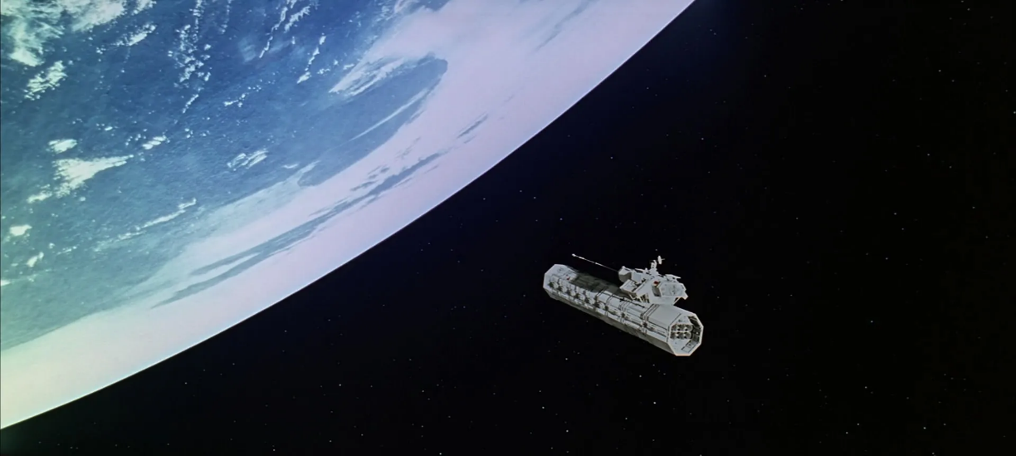
Figure 1. Stanley Kubrick (1928-1999), 2001: A Space Odyssey, 1968, film, United States, Stanley Kubrick Productions. Image: https://movie-screencaps.com/2001-space-odyssey-1968/
While viewers of the movie were left to wonder what this object is, the original screenplay gives a glimpse into the true motivations behind this spacecraft. The screenplay included the following quote, explaining the significance of this object:
“By the year 2001, overpopulation has replaced the problem of starvation, but this was ominously offset by the absolute and utter perfection of the weapon. Hundreds of giant bombs had been placed in perpetual orbit above the Earth. They were capable of incinerating the entire Earth’s surface from an altitude of 100 miles. Matters were further complicated by the presence of twenty-seven nations in the nuclear club. There had been no deliberate or accidental use of nuclear weapons since World War II and some people felt secure in this knowledge. But to others, the situation seemed comparable to an airline with a perfect safety record; in showed admirable care and skill but no one expected it to last forever”.
The threat of total annihilation sat in the sky above everyone on the surface of the Earth. This depicted threat, the nuclear bomb dropping from the sky, can be found rooted in the culture of the American 1950s and 60s. The first nuclear bomb used in warfare was detonated in August of 1945. The invention and use of the nuclear bomb, as well as the Cold War, had profound impacts on culture.
In their article From Trauma to Paranoia: Nuclear Weapons, Science Fiction, and History author Cyndy Hendershot wrote about the impacts the nuclear bomb and the atomic age had on film making, specifically in the realm of science fiction. On page 77, they commented that science fiction is one of the most well-equipped literary modes to handle the representation of the nuclear bomb. 2001: A Space Odyssey does this in a very indirect way, hardly even mentioning to the viewers that the thing depicted on screen could bring about the annihilation of the planet below but still uses the moment to represent a fear of what atomic technology can do.
Interstellar also utilized a threat from the sky, but in a very different way. The first act of the film took place on Earth. Much of that time was spent exploring a blight that threatened the crops that humans used to survive on, with few crops left able to grow. The threat from the sky is a result of this blight, intense dust storms (Fig. 2).
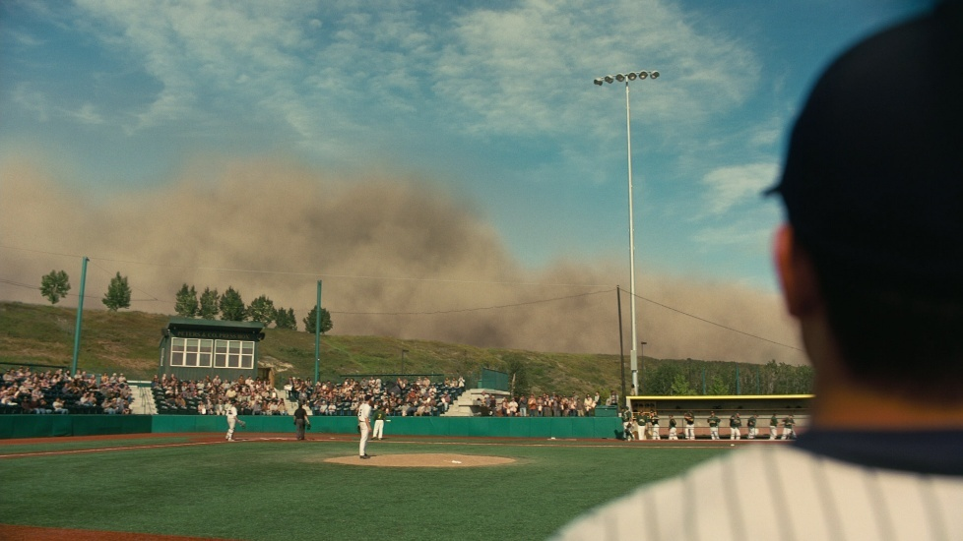
Figure 2. Christopher Nolan (1970-current), Interstellar, 2014, film, United States, Paramount Pictures. Image: https://screenmusings.org/movie/blu-ray/Interstellar/pages/Interstellar-023.htm
The threat the sky took is much more direct in Interstellar than in 2001: A Space Odyssey. Later in the film, the dust storms had a direct effect on the health of the characters on the Earth. In Symposium on Science Fiction and the Climate Crisis the author claimed on pages 426 and 427 that science fiction stories most often take place in the future, whether it be in the distant future, the near future, or somewhere in between. The paper, published in 2018, went on to argue that, because a period of climate change has already begun, science fiction stories that take place in the near future will include climate change as a driving force. They write “all near-future sf now has to include climate change or it becomes some kind of alternative history…”.
In The Science of Interstellar Kip Thorne discussed the importance of creating an Earth that was approaching uninhabitability. In working with biological researchers, they were able to come up with a planet stricken with blight and ravaged by dust to be the most plausible option for a motivator to leave the planet. Thorne and Nolan wanted to depict a possibility for the future of the Earth, and in keeping to the ideas presented in the Symposium on Science Fiction and the Climate Crisis, climate change had to be included in the film for it to be considered an accurate possibility.
Both films represented some sort of threat to humanity that originates from the sky but represent the different fears that influence the cultures of the times. 2001: A Space Odyssey depicted the nuclear bomb as a threat lingering from above, ready to strike at any moment. Interstellar chose to represent the climate crisis as the threat from the sky and did so in a much more direct way, impacting the characters throughout the film.
Spacecraft and the Earth:
Space travel played a big role in both films. In part two of 2001: A Space Odyssey, there were glimpses of the Earth from orbit. One shot included a spacecraft called Space Station Five (Fig. 3). Space Station Five sat in the center of the frame while a portion of a pale blue Earth lingered in the corner of the shot.
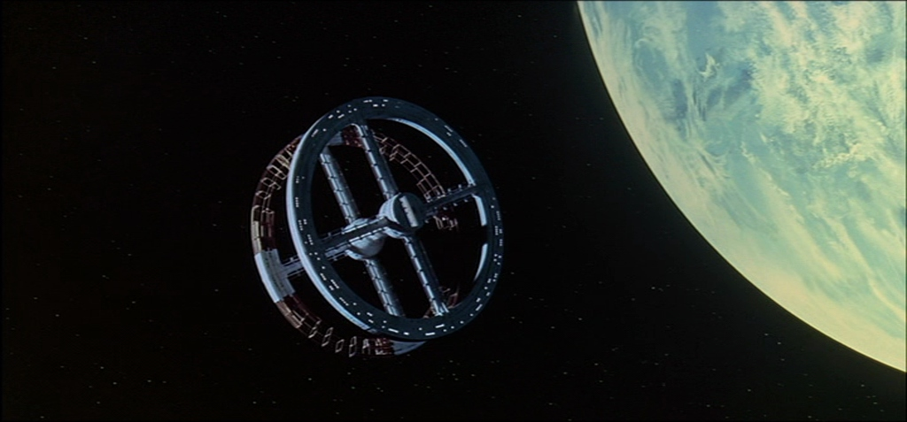
Figure 3. Stanley Kubrick (1928-1999), 2001: A Space Odyssey, 1968, film, United States, Stanley Kubrick Productions. Image: https://film-grab.com/2010/07/06/2001-a-space-odyssey/
Interstellar’s first view of the Earth from space was similar to figure three (Fig. 4). The shot included Endurance, the ship that took the crew to Saturn. Endurance glided away from the Earth in this shot, taking its passengers on a journey far from their familiar home. The Earth took up a large portion of the frame.
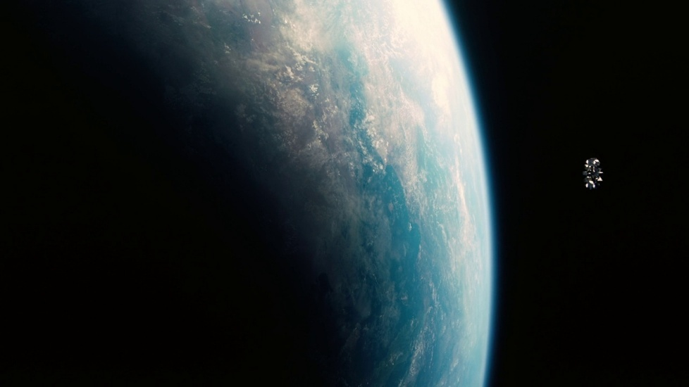
Figure 4. Christopher Nolan (1970-current), Interstellar, 2014, film, United States, Paramount Pictures. Image: https://film-grab.com/2015/04/17/interstellar/
The selected stills are similar in what they represent. They depict similar objects, the Earth and a spacecraft. While the spacecraft are the focus of these scenes, both containing our characters, the Earth is included in both stills. Though they represent similar things, they differ in many ways. 2001: A Space Odyssey places Space Station Five in the center of the frame, while Interstellar gives the Earth much more space in the shot.
The spacecraft the characters traveled in are examples of the culture impacting the design of the film. They took on similar structures, having a circular design with a central body. They both spun to create artificial gravity. In Vision of a Future Passed: The Prophecy of 2001 Arther C. Clarke commented on how NASA helped him and Kubrick come up with designs for the spacecraft in the film. In the same documentary, others commented on how they were surprised no space station has been designed to spin and create artificial gravity. They said that many people used to believe that space stations would be designed like that. This assumption, along with input from a trusted entity like NASA, likely informed Kubrick’s and Clarke’s decisions to go with a spacecraft that created artificial gravity as a thing the future would hold.
In the case of Interstellar, a very similar spacecraft was utilized. While it was smaller, it still spun to create artificial gravity. In the interview with HeyUGuys, Nolan was asked how they approached designing the advanced technology in the film. Nolan explained that the functionality of the equipment was the most important aspect of design. He made the comment that all the technology, including the design of the ship, was based on how to deal with living in space in a contemporary reality. The design of the ship was meant to represent the contemporary understanding of survival in long term space travel.
The interior design of each spacecraft also gave a glimpse into the influence the film was under. The interior of Space Station Five was a sleek white with flashy furniture (Fig. 5).
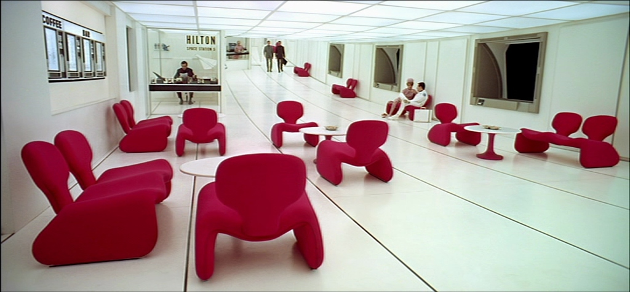
Figure 5. Stanley Kubrick (1928-1999), 2001: A Space Odyssey, 1968, film, United States, Stanley Kubrick Productions. Image: https://film-grab.com/2010/07/06/2001-a-space-odyssey/
In Vision of a Future Passed: The Prophecy of 2001, science writer Bettyann Holtzmann Kevles said “They have done the world of the 1960s, which is a little bit prettier. The furniture is a bit more molded and what we used to call futuristic.” This spacecraft was influenced by the culture of the 1960s, with popular brands of the day such as Hilton making appearances throughout the film. The ideas of the future were rooted in the context of the contemporary.
Interstellar took a different approach to the design of its spacecraft. It was much more cluttered with screens, buttons, and storage covering the interior of the spacecraft (Fig. 6).
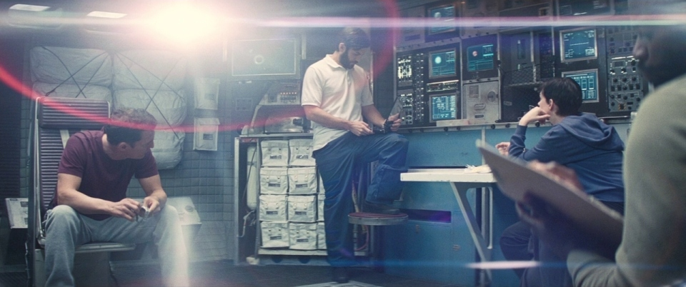
Figure 6. Christopher Nolan (1970-current), Interstellar, 2014, film, United States, Paramount Pictures. Image: https://film-grab.com/2015/04/17/interstellar/
In Vision of a Future Passed: The Prophecy of 2001 many people, including the author of Kubrick’s biography John Baxter, discussed how this set gives a glimpse into the world of the 1960s. In Nolan’s interview with HeyUGuys, he explained that the design of the spaceship was meant to stay away from a futurist look. He looked to history for reference of what has already been used in space travel to influence the design of Endurance, while Kubrick had to predict what the future could hold.
The largest object in figure three and four is the Earth. Both films depicted the same planet yet did so in different ways. 2001: A Space Odyssey’s Earth was a much paler blue than Interstellar’s. There was a reason for this difference, and it comes down to the understanding of space at the time these films were created. 2001: A Space Odyssey was in production as early as 1965 and was released in 1968. This was very early on in America’s space program, with NASA only officially forming in 1958. In Vision of a Future Passed: The Prophecy of 2001, a documentary on 2001: A Space Odyssey, science fiction screenwriter Dan O’Bannon discussed how the Earth in the film can be considered inaccurate, and that all that Kubrick had to work with was high atmosphere photography. In the same documentary, Rob Coleman regarded that today, people have access to images and films depicting the Earth accurately. He claimed that if Kubrick had access to those images at the time of the creation of the film, he would have included it in the film. This demonstrates the limitations placed on the film by the culture of the American 1960s, and how the technical limitations influenced the imagery in the film.
Interstellar, on the other hand, had the context of colored photography of the Earth. As such, the Earth in Interstellar resembled something more comparable to images that accurately depict the Earth from space (Fig. 7).
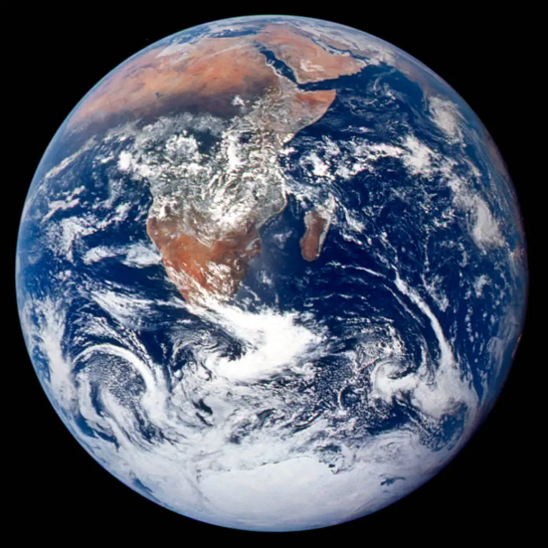
Figure 7. National Aeronautics and Space Administration, The Blue Marble, 1970, United States. Image: https://www.nasa.gov/image-article/blue-marble-view-from-apollo-17/
Figure five is an example of one such image. The Blue Marble, an image taken by the Apollo 17 crew in 1970. In this image there are deep blues and browns, both of which are visible in the still from Interstellar. In the HeyUGuys interview, Christopher Nolan discussed the importance of the contributions of executive producer and theoretical physicist Kip Thorne in keeping the story plausible. He claimed to have created a story that does not stray too far from what physics and astronomy can understand, and that motivation bleeds into the representation of the Earth in his film. It is depicted as it would appear to someone taking a picture of it from a spacecraft.
The scientific knowledge of the time allowed Christopher Nolan to depict the Earth as someone would see it from space. Stanley Kubrick attempted to do the same thing but was limited in his ability to do so. While the imagery achieved was a spectacular experience for viewers, the Earth depicted in 2001: A Space Odyssey is nothing more than a guess at what it might actually look like. The scientific knowledge of 1960s America, a culture that had only just begun to journey off the Earth, limited Kubrick to what him and his team were able to achieve and depict.
Planetary Bodies:
The surfaces of significant astronomical objects were also put on display throughout both films. In part two of 2001: A Space Odyssey, the characters spend a portion of their screentime on the surface of the moon (Fig. 8).
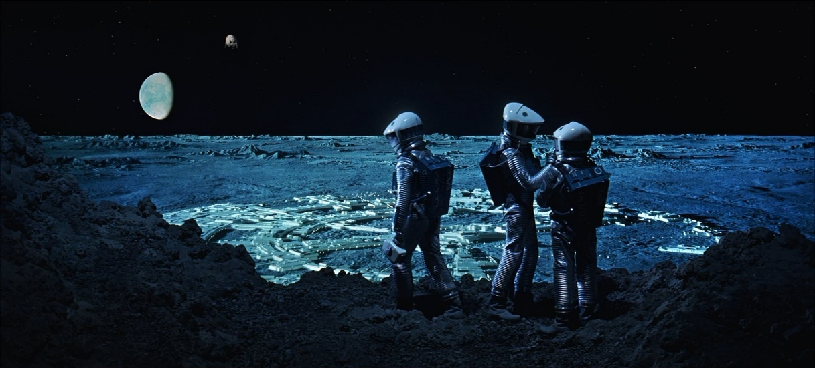
Figure 8. Stanley Kubrick (1928-1999), 2001: A Space Odyssey, 1968, film, United States, Stanley Kubrick Productions. Image: https://shot.cafe/movie/2001-a-space-odyssey-1968/exterior
The film, being released in 1968, came out a year before the first man walked on the moon in 1969. Because of this, similar to the Earth in the film, Kubrick had no way to tell what the moon might look like from the surface. In Vision of a Future Passed: The Prophecy of 2001, multiple people talked about how Kubrick had to be creative when depicting the surface of the moon. Douglas Trumbell commented that there was a debate about if the moon was just dust and if a person would just sink into it. John Baxter says that this lack of knowledge about the surface of the moon gave Kubrick much more creative freedom. He can be quoted saying they could “show a moon that was their idea of what the moon was like, in fact it was a much more glamorous moon than the real moon”. Kubrick had to construct a lunar surface without any preexisting knowledge of what that might be like.
Interstellar represents planetary bodies much different than anything in the Solar System. One such planetary body the characters of Interstellar venture to was referred to as Miller’s Planet. Miller’s Planet is a watery planet that orbited very close to the black hole Gargantua (fig. 9).
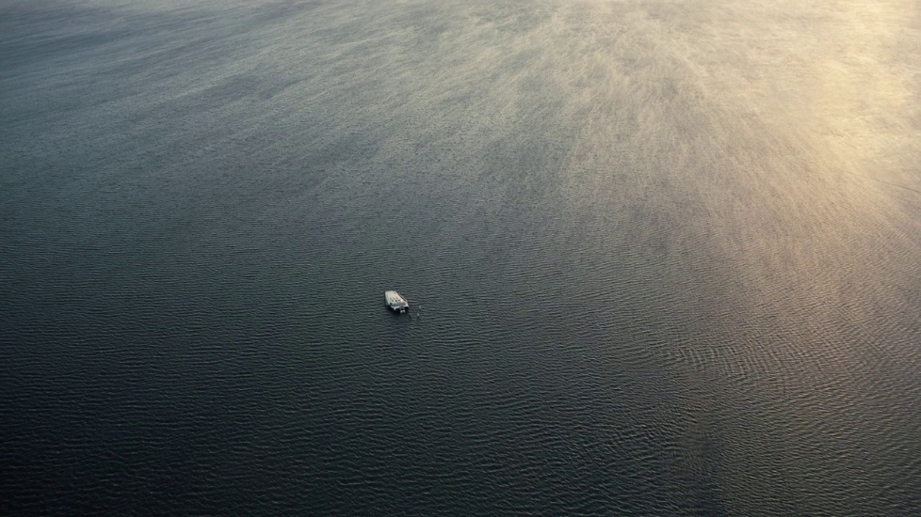
Figure 9. Christopher Nolan (1970-current), Interstellar, 2014, film, United States, Paramount Pictures. Image: https://film-grab.com/2015/04/17/interstellar/
NASA and many other space agencies have identified thousands of exoplanets. Because of the nature of exoplanets, they are very far away, and researchers are unable to tell much about their surfaces. This allows for some creative liberties to come into play when designing exoplanetary bodies like Miller’s Planet. In an interview with Niel DeGrasse Tyson on his podcast StarTalk, Kip Throne discussed this planet and how realistic it was. Because of its close orbit, it experienced time at a different rate than those on Earth do, one hour on Miller’s Planet was seven years on Earth. One other effect that the characters had to deal with on this planet was giant waves thousands of feet tall. Kip talks about how this is one example of the science behind the film being exaggerated but still stays true to scientific theory.
The surfaces of the bodies differ greatly; the moon being a rocky grey surface while Miller’s Planet is covered in a vast ocean. In a case similar to the Earth, Kubrick mostly had to guess what the surface of the moon might be like. While visual observations were able to be made at the time, there had been no way to know what the surface was like to walk on until a person was able to do so a year after the release of Kubrick’s film. Nolan, similarly, was able to depict a planetary surface as he wished it to be to suit the needs of the story.
Black Hole and Jupiter:
Some of the most spectacular depictions of objects in the sky in these films include great celestial bodies. In part three of 2001: A Space Odyssey, a third monolith was found orbiting the planet Jupiter. As Bowman approached Jupiter, imagery of the planet played on the screen. The monolith, the main object of interest, sat suspended among Jupiter and its moons (Fig. 10).
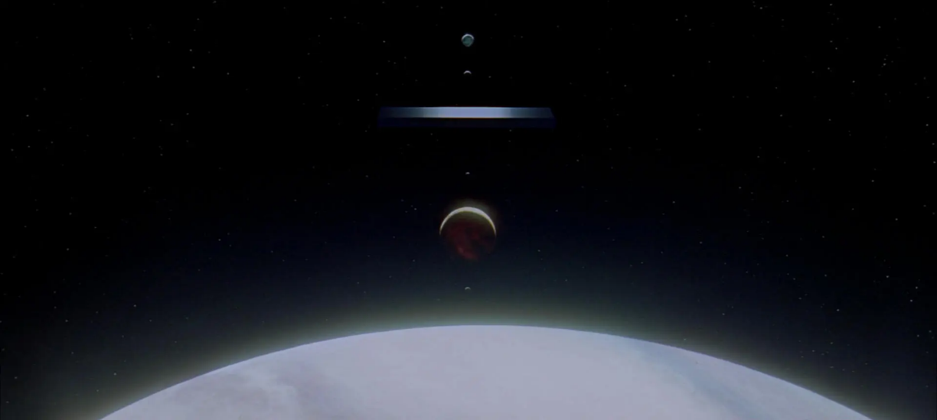
Figure 10. Stanley Kubrick (1928-1999), 2001: A Space Odyssey, 1968, film, United States, Stanley Kubrick Productions. Image: https://movie-screencaps.com/2001-space-odyssey-1968/
Interstellar utilized a celestial object much larger than a planet like Jupiter. One of the most important objects to the plot of Interstellar was the massive black hole Gargantua. In the still below (Fig. 11), Gargantua sits in the background with a planet placed between the black hole and the viewer. The planet, Miller’s Planet, is the object of interest in this situation.
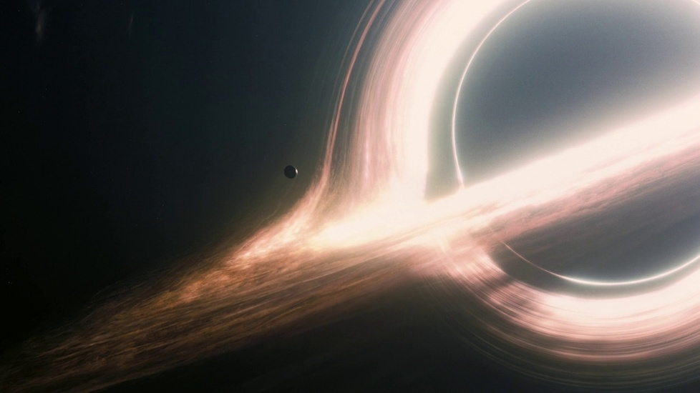
Figure 11. Christopher Nolan (1970-current), Interstellar, 2014, film, United States, Paramount Pictures. Image: https://film-grab.com/2015/04/17/interstellar/
These shots represent some of the most important objects in the films. In 2001: A Space Odyssey the monolith, a mysterious alien technology, was the main reason the characters have ventured so far from the Earth. The planet that Interstellar depicted is one of the possible habitable planets that were so important to humanities survival, a savior from the crisis that ravages the Earth.
The technology available also influenced what celestial objects were used in the film. According to The Making of Kubrick’s 2001, Jupiter was originally going to be Saturn. Members of the special effects teams discussed the difficulty they experienced trying to represent Saturn accurately. Con Pederson comments that “Jupiter was selected over Saturn, because to do Saturn meant, in effect, getting a convincing Jupiter first… and then finding a way to put a ring around it.” To depict Jupiter alone, they had to invent the so called “Jupiter Machine.” The Jupiter Machine consisted of “an optical scanning technique that transformed flat painted artwork into a perfectly accurate sphere”. Even though the crew was limited by their technology, they were still able to push the limits of what they did have available to depict Jupiter.
The technology available for Interstellar also had an impact on what objects are depicted in the film. The black hole, as depicted in the film, was only possible through computer generated imagery (CGI). The task was so complex that the studio responsible for it, Double Negative Visual Effects, wrote and published a research paper covering the techniques and equations used in the rendering. This article discussed the code required for the process, including more than 40,000 lines of code, based off equations Kip Thorne wrote himself about how light would look from an observer approaching a black hole. The article stated that each image generated took anywhere between “30 minutes to several hours”. Despite this, it went on to say that “render times were never a serious enough issue to influence shot composition or action”. While the process was intensive, the technology used was still capable of completing the task. It did not force the director or producers to change any of the shots that include the black hole, unlike 2001: A Space Odyssey.
Available technology and scientific knowledge had a great impact on the objects depicted and explored. 2001: A Space Odyssey was limited by the technology of the time and was thus forced to make changes to the screenplay. Interstellar, coming almost five decades later, had the technology to explore more of the shots that Kubrick may have originally hoped to depict.
Conclusion:
This essay aimed to explore how the films 2001: A Space Odyssey and Interstellar depicted the sky, space, and space travel. Both films explored space travel extensively, and this lead to many different representations of the sky, and different objects in space. Some objects explored include planetary bodies, moon, and black holes.
46 years separate the release of the films, which means two distinct cultures created these two works of fiction. The social problems of the times influenced the conflicts on display throughout the films. 2001: A Space Odyssey depicted new and potentially dangerous technologies like the nuclear bomb, while Interstellar depicted the climate crisis overtaking the sky. Both cultures influenced the conflicts of the films. Hendershot argued the atomic age influenced early science fiction making itself evident in the spacecraft depicted through the film. The author of the Symposium on Science Fiction and the Climate Crisis argued that contemporary science fiction stories set in the near future will have to include climate change as a factor of the story, and Interstellar is evidence of this.
The scientific technological knowledge of the times also influenced the films, going as far as to dictate what objects were included in the films in some cases. The stills explored in the essays that depict the Earth displayed how this knowledge heavily influenced the depiction of the Earth. As discussed in the documentary Vision of a Future Passed: The Prophecy of 2001, the production team working on 2001: A Space Odyssey had no knowledge of what the Earth looked like from orbit. They had to essentially guess what it might look like, resulting in a lighter blue color compared to figure seven. Interstellar did have the context of imaging of the Earth from space, and as such the Earth depicted in that film took on a much more realistic appearance. Cultural knowledge had a direct impact on the depiction of the Earth, as well as the depiction of the surface of other planetary bodies in the films.
The technological capabilities of the period also influenced the films, both in what was represented and how they were represented. The team working on 2001: A Space Odyssey were forced to pick Jupiter over Saturn due to technical limitations, while Interstellar was able to render a black hole accurately. Interstellar was able to bring technology to a further limit than 2001: A Space Odyssey, yet with less advanced equipment Kubrick was still able to create miraculous imagery of the planet.
Both films were products of their time. The science, technology, and culture of their times have a great impact on the imagery put on display throughout both films. Despite originating in different cultures with different technical and scientific capabilities, both films effectively depicted celestial objects in ways that represent the cultural knowledge of the time. They both also represented social issues of the times through the depiction of the sky, space, and space travel.
Sources
‘Symposium on Science Fiction and the Climate Crisis’, Science Fiction Studies, 45.3 (2018), 420–432. https://doi.org/10.5621/sciefictstud.45.3.0420
Agel, Jerome, The Making of Kubrick’s 2001, (New York: New American Library, 1970)
FILMGRAB, 2001: A Space Odyssey [still]. https://film-grab.com/2010/07/06/2001-a-space-odyssey/ [accessed 10 March 2025]
FILMGRAB, Interstellar [still]. https://film-grab.com/2015/04/17/interstellar/ [accessed 10 March 2025]
Gross, Alan, ‘Science and Culture’, American Literary History, 7.1 (1995), 169-186 <http://www.jstor.org/stable/489804>
Hendershot, Cyndy, ‘From Trauma to Paranoia: Nuclear Weapons, Science Fiction, and
History’, Mosaic: An Interdisciplinary Critical Journal, 32.4 (1999), 73-90 <http://www.jstor.org/stable/44029850>
HeyUGuys, Christopher Nolan Interview – Interstellar [video]. 2014 https://www.youtube.com/watch?v=IlTfLREt9ko [accessed 5 April 2025]
James, Oliver and others, ‘Gravitational lensing by spinning black holes in astrophysics, and in the movie Interstellar’, Classical and Quantum Gravity, 32.6 (2015) <https://iopscience.iop.org/article/10.1088/0264-9381/32/6/065001>
Kubrick, Stanley (dir.) 2001: A Space Odyssey [Film], (United States: Stanley Kubrick productions: 1968)
Movie Screencaps, 2001: A Space Odyssey [still]. https://movie-screencaps.com/2001-space-odyssey-1968/page/75#foobox-1/79/2001-space-movie-screencaps.com-13400.jpg?ssl=1 [accessed 17 March, 2025]
National Aeronautics and Space Administration, Exoplanets https://science.nasa.gov/exoplanets/ [accessed April 19 2025]
National Aeronautics and Space Administration, NASA History https://www.nasa.gov/history/ [accessed 19 April 2025]
National Aeronautics and Space Administration, The Blue Marble: The View From Apollo 17 (2020) https://www.nasa.gov/image-article/blue-marble-view-from-apollo-17/ [accessed 17 April 2025]
Nolan, Christopher (dir.) Interstellar [Film], (United States: Paramount Pictures, 2014)
Script Slug, 2001: A Space Odyssey [script]. https://www.scriptslug.com/script/2001-a-space-odyssey-1968 [accessed 10 March 2025]
Script Slug, Interstellar [script]. https://www.scriptslug.com/script/interstellar-2014 [accessed 10 March 2025]
Shot Cafe, 2001: A Space Odyssey [still] https://shot.cafe/movie/2001-a-space-odyssey-1968 [accessed 5 April 2025]
Sobchack, Vivian, ‘Beyond Visual Aids: American Film as American Culture’, American Quarterly, 32.3 (1980) < https://www.jstor.org/stable/2712451>
Stanley Kubrick, Chris Nolan on 2001: A Space Odyssey and Stanley Kubrick [video]. 2024 <https://www.youtube.com/watch?v=XtjBtOyYEs8> [accessed 18 April 2025]
StarTalk, The Science of Interstellar with Science Advisor, Kip Thorne [video]. 2024 < https://www.youtube.com/watch?v=4f9V-8BHONo&t=1534s> [accessed 20 April 2025]
Taylor, Edward B., Primitive Culture, 4th edn. (London: Murray 1920) <https://archive.org/details/in.ernet.dli.2015.42334/page/n5/mode/2up>
Thorne, Kip, The Science of Interstellar, (New York: W.W. Norton & Company, 2014)
TIME, Christopher Nolan & Kip Thorne Break Down The Physics of Interstellar | TIME [video]. 2014 < https://www.youtube.com/watch?v=z9tUFJG0lWA> [accessed 7 April 2025]
Warner Bros. Entertainment, 2001: A Space Odyssey | Vision of a Future Passed: The Prophecy of 2001 | Warner Bros. Entertainment [video]. 2013 https://www.youtube.com/watch?v=XpnMf7Bvpj0&t=826s [accessed 5 April 2025]

Taylor, Edward B., Primitive Culture, 4th edn. (London: Murray 1920) p. 1 <https://archive.org/details/in.ernet.dli.2015.42334/page/n5/mode/2up>
Alan Gross, ‘Science and Culture’, American Literary History, 7.1 (1995), 169-186 (p. 169-170) <http://www.jstor.org/stable/489804>
Gross, ‘Science and Culture’, p. 170.
Gross, ‘Science and Culture’, p. 170.
Gross, ‘Science and Culture’, p. 172-176
Vivian Sobchack, ‘Beyond Visual Aids: American Film as American Culture’, American Quarterly, 32.3 (1980), 280-300 (p. 290) < https://www.jstor.org/stable/2712451>
Stanley Kubrick (dir.) 2001: A Space Odyssey [Film], (United States: Stanley Kubrick productions: 1968)
Christopher Nolan (dir.), Interstellar [Film], (United States: Paramount Pictures, 2014)
HeyUGuys, Christopher Nolan Interview – Interstellar [video]. 2014 https://www.youtube.com/watch?v=IlTfLREt9ko [accessed 5 April 2025]
Script Slug, 2001: A Space Odyssey [script]. https://www.scriptslug.com/script/2001-a-space-odyssey-1968 [accessed 10 March, 2025]
Cyndy Hendershot, ‘From Trauma to Paranoia: Nuclear Weapons, Science Fiction, and History’, Mosaic: An Interdisciplinary Critical Journal, 32.4 (1999), 73-90 (p. 77) <http://www.jstor.org/stable/44029850>
Nolan, Interstellar, 2014.
‘Symposium on Science Fiction and the Climate Crisis’, Science Fiction Studies, 45.3 (2018), 420–432 (p. 427) https://doi.org/10.5621/sciefictstud.45.3.0420
Kip Thorne, The Science of Interstellar, p. 122-127 (New York: W.W. Norton & Company, 2014)
Kubrick, 2001: A Space Odyssey, 1968.
Nolan, Interstellar, 2014.
Warner Bros. Entertainment, 2013.
HeyUGuys, 2014.
Warner Bros. Entertainment, 2013.
Warner Bros. Entertainment, 2013.
HeyUGuys, 2014.
Jerome Agel, The Making of Kubrick’s 2001, (New York: New American Library, 1970), p. 2.
National Aeronautics and Space Administration, NASA History https://www.nasa.gov/history/ [accessed 20 April 2025].
Warner Bros. Entertainment, 2013.
HeyUGuys, 2014.
Warner Bros. Entertainment, 2013.
National Aeronautics and Space Administration, Exoplanets https://science.nasa.gov/exoplanets/ [accessed 19 April 2025]
StarTalk, The Science of Interstellar with Science Advisor, Kip Thorne [video]. 2024 <https://www.youtube.com/watch?v=4f9V-8BHONo&t=1534s> [accessed 14 April 2025]
Agel, The Making of Kubrick’s 2001, p. 138-140.
Oliver James and others, ‘Gravitational lensing by spinning black holes in astrophysics, and in the movie Interstellar’, Classical and Quantum Gravity, 32.6 (2015) p. 37 <https://iopscience.iop.org/article/10.1088/0264-9381/32/6/065001>

