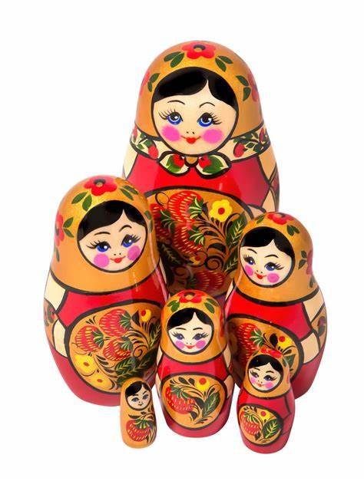  Understanding Cultural Dynamics: Navigating Business in Russia  A Comprehensive Exploration of Communication Styles, Skills, and Cultural Dimensions | Abstract  With an emphasis on conducting business in Russia, this extensive document delves into the subtleties of international business communication. With a focus on cultural aspects, communication techniques, and effective communication strategies, the analysis offers British professionals insightful information. People can improve their cross-cultural competency and facilitate successful business interactions in the Russian market by learning the necessary skills and comprehending the cultural context.  Junyi He  International Business Communication

Executive Summary
This paper offers a thorough analysis of business communications worldwide, with a particular emphasis on dealings with Russia. It emphasises how crucial it is to navigate the Russian business environment with proficiency in communication, cultural awareness, and understanding. The analysis sheds light on important cultural dimensions and offers insights into the complexities of Russian society by referencing Hofstede's Cultural Dimensions Theory. British nationals conducting business in Russia will find a comprehensive guide that emphasises practical skills and strategies for effective communication and relationship building.

Content Page

Introduction
Russia, or the Russian Federation as it is officially called, is the world's largest country, encompassing both Northern Asia and Eastern Europe. Russia is a country rich in history, culture, and global influence, and it plays a major role in geopolitics and international affairs. This investigation explores the intricacies of global business communication, highlighting the special abilities needed for business endeavours to succeed in Russia. This paper examines the various obstacles that British professionals encounter when attempting to establish business ties with Russia. The inquiry explores linguistic obstacles, negotiation techniques, trust-building, and cultural differences. It also describes the tactics and fundamental abilities needed for successful cross-border business communication, with an emphasis on the UK-Russian context.

2.0 Main Findings
Here are the main challenges I found for British people develop business in Russia:
Cultural differences: Misunderstandings and misinterpretations may arise from the UK and Russia's differing cultural norms and communication styles.
Language Barrier: Even though business settings frequently use English, subtle linguistic differences can still make communication difficult.
Building Trust: For British professionals, building trust in the Russian business culture is important, but it can take some time.
Negotiation Styles: Russians are known for their direct and assertive negotiating style, which can make it difficult to reach agreements.

2.1 – International Business Communication
Except for cross-cultural exchanges, regular business communication and international business communication are identical. This can be difficult, though, as cultural expectations and norms differ widely between nations. The use of technology, varying business practices, and language barriers can all make international communication more difficult. However, you can overcome these difficulties and carry out cross-cultural business transactions successfully if you prepare carefully, have professional training, and have a basic understanding of cross-cultural communication principles. (SIMON & SIMON, 2022)
The sharing of data and messages between people, businesses, or other entities operating internationally while conducting business is referred to as international business communication. In the global business environment, effective communication is essential because it promotes relationship building, information flow, and the success of cross-border transactions.

2.2 – Skills Requirements
Beyond ordinary business acumen, there are several skills needed to do business in Russia. It is essential to navigate the business environment, comprehend local culture, and cultivate relationships. When starting a business in Russia, British nationals may find the following essential competencies useful:
Cultural Intelligence:
Trust and personal relationships are highly valued in Russia. It is essential to comprehend Russian culture, traditions, and manners in order to establish fruitful business partnerships. This entails being aware of business protocol, communication styles, and social norms.
Language Ability:
Even though English is widely spoken by business professionals in Russia, particularly in larger cities, knowing the basics of the language can be quite helpful. It promotes improved communication and demonstrates respect for the local way of life.
Flexibility:
There may be major differences between the business environment in Russia and the UK. It's crucial to be flexible and receptive to new business models. Being adaptable in the face of unforeseen difficulties and changes is a useful ability.

Negotiation Skills:
In Russia, negotiating is an essential part of doing business. It is essential to comprehend Russian negotiation techniques, which can be more direct and assertive, and to be able to negotiate successfully while upholding positive relationships.
Relationship Building:
In Russian business culture, developing strong personal ties and gaining trust are essential. To establish rapport, making the effort to mingle, attend business dinners, and strike up conversations can be very beneficial.
Legal and Regulation Expertise:
It is essential to comprehend Russian business laws, rules, and compliance specifications. To navigate the legal system and make sure that business operations comply with local laws, seek legal counsel.
Intercultural Communication Proficiency:
Cross-cultural communication that works is essential. British businesspeople should communicate clearly and succinctly and be aware of cultural differences in communication styles. Written correspondence in emails and other business documents falls under this category.

2.3 – Methods of Communication
Different communication styles and cultural orientations are referred to as high-context and low-context cultures. Anthropologist Edward T. Hall popularised these ideas, which are now widely applied in intercultural communication. They speak about how much nonverbal clues and context matter in each culture when it comes to communication. (Group, 2023)
High-Context Cultures:
High-context cultures rely largely on context, non-verbal clues, and shared cultural knowledge for much of their implicit communication. In high-context cultures, people frequently communicate indirectly and presume that other members of their own group are aware of the unspoken details of a message.
High-context cultures place a high value on relationships and trust, and they frequently foster a strong feeling of community. These cultures prioritise group cohesion and harmony and are typically more collectivist.
Low-Context Cultures:
Low-context cultures rely more on verbal expression that is clear and explicit in communication. Individuals from low-context cultures typically speak more directly and don't rely as much on implicit understanding or shared context. Written or spoken words are used to communicate ideas, and context is frequently less important for comprehension.
Low-context cultures frequently place a high importance on individualism, self-actualization, and communication clarity. People may feel more at ease interacting with people outside of their immediate social circles and relationships may be more task-oriented.

Comprehending the cultural context of a given situation is essential for proficient cross-cultural communication. When people from various cultural backgrounds and communication styles interact, miscommunication can occur; however, awareness of these differences can help close gaps and promote better understanding.

2.4 – Effective Communication
Develop Relationships:
Personal connections and trust are important to Russians. Prior to starting a business conversation, spend some time getting to know each other. Making small talk, sharing meals, and interacting socially can all aid in building a connection.
Non-Verbal Communication:
Russian communication heavily relies on non-verbal clues, so be aware of them. Make sure to give a firm handshake, keep eye contact, and pay attention to your body language. In Russian culture, nonverbal cues can reveal a great deal.
Respect Hierarchy:
Authority and hierarchy are highly valued in Russian society. In business meetings, treat senior members with deference by using their proper titles and last names until they are asked to use their first names.
Use Formal Language:
Until a more casual relationship is established, use formal language and titles in your initial communications, especially in written correspondence. This demonstrates deference to professional limits.

Acquire Basic Russian Phrases:
Although many Russian professionals may speak English, it can be helpful to try to learn some basic Russian phrases. It demonstrates regard for the native tongue and customs.
Cultural Sensitivity:
Recognise the subtleties and sensitivity of other cultures. Steer clear of touchy subjects like politics unless your Russian counterparts initiate the conversation. You might get respect from Russians for their historical and cultural background.

2.5 – International Culture
The Cultural Dimensions Theory by Hofstede provides a framework for comprehending cultural variations among various societies. This theory, which was developed by Dutch social psychologist Geert Hofstede, identifies six cultural dimensions that are useful for contrasting and comparing different cultures. (Nickerson, 2023) 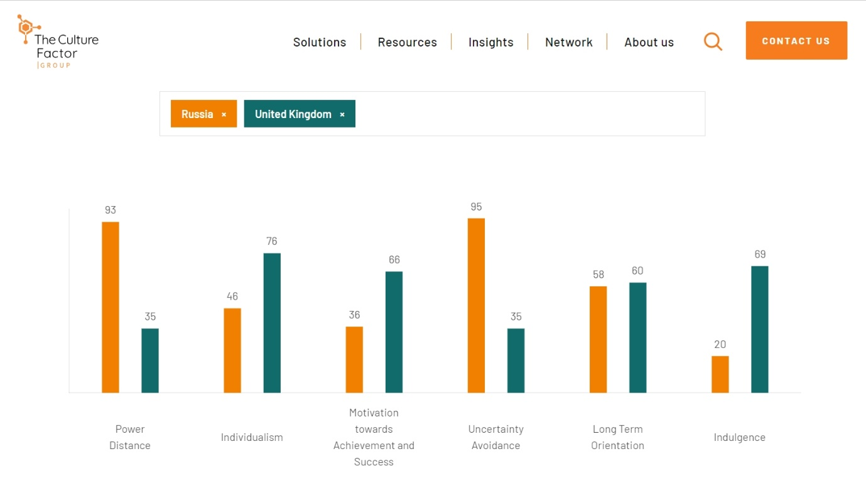
Power Distance
Russia scored 93, a country where the ruling class is extremely aloof from the rest of society. The largest nation on earth is highly centralised, as evidenced by the fact that two thirds of all foreign investments go to Moscow, the location of 80% of the world's financial potential. Status symbols are very important because of the stark differences in power between the less and more powerful individuals. In all business interactions, whether they involve visits, negotiations, or collaboration, behaviour must reflect and represent the status roles. A top-down approach with explicit instructions for each task is required.
At 35 Britain sits in the lower rankings of PDI – i.e. a society that believes that inequalities amongst people should be minimized. It's interesting to note that research indicates that the British upper class has a lower PD index than the working class. The PDI score initially appears to be at odds with the long-standing and well-established British class system. It also highlights a tension that exists within British culture between the value placed on birth rank and the deeply held conviction that one's place of birth shouldn't restrict one's opportunities in life. People who think that everyone should be treated equally are motivated by a sense of fair play.
Motivation Towards Achievement And Success
Regarding its inclination for status symbols, Russia's comparatively low score of 36 on Motivation towards Achievement and Success may come as a surprise, but this is because of the country's high Power Distance. Upon closer inspection, it becomes evident that Russians tend to downplay their individual accomplishments, contributions, and abilities, both in professional settings and when interacting with new people. Scientists, researchers, and doctors are generally expected to lead very modest lives, and they speak modestly about themselves. Although it may be tolerated when it comes from superiors, peers do not value domineering behaviour.
Britain is a Decisive society at 66; people there are very driven and focused on success. The apparent conflict between the British culture's emphasis on modesty and understatement and its success-driven value system is a major source of confusion for foreign visitors. The ability to "read between the lines" is essential to comprehending the British. Not everything that is said is always intended. When compared to Consensus cultures—like those of the Scandinavian countries—people in the UK live with a clear performance goal in mind and live for work.
Uncertainty Avoidance Index
95 points The Russians have developed one of the world's most intricate bureaucracies, and they also perceive uncertainty as a great threat. Presentations can be incredibly detailed and well-prepared, or they can be ill-prepared, as in the case of negotiations where the emphasis is on developing relationships. Moreover, thorough planning and briefing are frequently used. Background knowledge and context are preferred by Russians. Russians come across as extremely formal and aloof when they engage with those who are regarded as strangers. Formality is also regarded as a mark of deference.
With a low score of 35 on the uncertainty avoidance scale, the UK is a nation content to "make it up as they go along," adjusting plans in response to new information, and wake up not knowing what the day will bring. The British, being a low UAI nation, are accustomed to vague circumstances; the phrase "muddling through" is a quintessential British way of putting it. British society is known for having few rules, but the ones that exist are strictly followed.
Long-Term Orientation vs. Short-Term Normative Orientation
Russia scored 58, indicating that it is a pragmatic nation. People who live in pragmatic societies tend to think that circumstances, context, and timing all play a significant role in determining the truth. They exhibit a strong inclination to save and invest, as well as the capacity to readily modify customs to suit shifting circumstances. thrift and tenacity in getting things done.
Britain has a pragmatic culture, scoring a 60 in this area. People who live in pragmatic societies tend to think that circumstances, context, and timing all play a significant role in determining the truth. They exhibit a strong inclination to save and invest, as well as the capacity to readily modify customs to suit shifting circumstances. thrift and tenacity in getting things done.

3.0 Conclusions
In conclusion, developing specialised skills and having a nuanced understanding of cultural dimensions are necessary for effective communication in the Russian business environment. The importance of developing relationships, being flexible, speaking fluent Russian, having strong negotiating skills, and having legal knowledge have all been discussed in this document when navigating the complexities of the Russian business environment. British professionals can successfully navigate obstacles, build strong relationships, and conduct business in Russia by adopting these insights.
A strategic approach that considers and tackles linguistic variances, cultural diversity, and negotiation discrepancies is necessary when conducting business in Russia. The issues raised highlight how important it is for British workers to develop their language skills, cultural intelligence, and adaptability. The implementation of efficacious communication tactics, derived from the examination of cultures with and without context, augments the likelihood of prosperous commercial exchanges between the United Kingdom and Russia.

4.0 Recommendations
Silence in a meeting could be seen as disagreement or lack of engagement in the UK, but it could also be seen as agreement or careful consideration in Russia. At the outset of a collaboration, be sure to clarify expectations regarding communication styles. Promote candid dialogue and give people a chance to express how they prefer to be communicated with.
Because of minute linguistic variations, using English could result in misunderstandings. It's possible for idioms or ambiguities to be misinterpreted. Promote communication that is clear. When communicating, speak simply and directly. Encourage people to ask clarifying questions, and for important conversations, think about utilising bilingual professionals or interpreters.
While British professionals might prefer to get right to the point in business meetings, Russians might place more value on developing personal relationships before discussing business matters. Make time for social events that foster relationships, like casual get-togethers or business dinners. Acknowledge and honour one another's preferred methods for fostering trust while striking a balance between intimate conversations and professional ones.
Russian negotiators might be more direct and forceful in their approach, which could come across as confrontational to British counterparts who usually prefer a more diplomatic one. Both parties should receive negotiation training that emphasises the cultural variations in negotiating approaches. Encourage honest dialogue about expectations and identify a common ground for a negotiation strategy that will work for both parties.

When it comes to significant matters, Russians might prefer in-person communication, whereas British professionals might rely more on online platforms. Give precise instructions on the recommended channels of communication for different kinds of communication. To satisfy both preferences, combine virtual and in-person communication channels.

References
SIMON & SIMON (2022). The Complete Guide To International Business Communication | SIMON & SIMON. [online] www.simonandsimon.co.uk. Available at: https://www.simonandsimon.co.uk/blog/the-complete-guide-to-international-business-communication.
www.hofstede-insights.com. (n.d.). Country comparison tool. [online] Available at: https://www.hofstede-insights.com/country-comparison-tool?countries=russia%2Cunited+kingdom.

Group, U.L. (2023). Communicating in High Context vs. Low Context Cultures. [online] www.unitedlanguagegroup.com. Available at: https://www.unitedlanguagegroup.com/learn/communicating-high-context-vs-low-context-cultures.

Nickerson, C. (2023). Hofstede’s Cultural Dimensions Theory & Examples. [online] Simply Psychology. Available at: https://www.simplypsychology.org/hofstedes-cultural-dimensions-theory.html.

