

Professional Career Development
BMSW 4005

Ana-Maria Racu
1913741
Lecturer: Lloyd Beharry

Table of content

1.Introduction ………………………………………………………...2
2. The employment Relationship……………………………………. 2
2.1 The Recruitment Process ………………………………………… .3
2.2 The Interview – reflection on role play ……………………………. 5
3.Career Development ……………………………………………….6
4.Conclusion …………………………………………………………7
Appendix 1 …………………………………………………………..9
Appendix 2 ………………………………………………………… 10

1.Introduction
This report aims to discuss the employment relationship and how it is regulated by legislation. Furthermore, will be addressed the recruitment and selection process with a reflection on the interview role play exercise done in week 9. Lastly, will be discussed my own Career Development.

2. The Employment Relationship
The Employment Law is the relationship bound between employers and employees which ensures that every right is protected on both sides. It is constituted of guidelines that an employer and employee must honor in order to provide a safe, fair and equal workplace environment. Furthermore, the breach of employer responsibilities or employee duties may lead to Employment Tribunal.
The primary legislation that implements the laws in the UK are Acts of Parliament. “An Act of Parliament creates a new law or changes an existing law” (Legislation.gov.uk. 2020). “An Act is a Bill that has been approved by both the House of Commons and the House of Lords and been given Royal Assent by the Monarch. Taken together, Acts of Parliament make up what is known as Statute Law in the UK” (Legislation.gov.uk. 2020).
The secondary legislation that dictates the legal standards are UK Statutory Instruments (Legislation.gov.uk. 2020). Furthermore, legislation originating from the European Union influenced employment law in the UK by incorporating the European Convention on Human Rights 1950 and creating the Human Rights Act 1998 (Legislation.gov.uk. 2020).
The Employment Law governs the following sections of an employment: recruitment, employment contract, pay and holiday entitlement, health and safety at work, discrimination, working hours, dismissal and redundancies (Legislation.gov.uk. 2020). The main employer’s responsibility is to obey the law and follow the legal regulations in order to provide a safe and equal working environment for its employees. In addition, the employer’s responsibilities can vary in accordance with the type of the employment contract.
The employee’s responsibilities are to honor the employment contract and fulfill their duties as it says. Moreover, to behave respectfully to other employees and be aware of their rights.
2.1 The Recruitment Process
“Recruitment refers to the process of identifying, attracting, interviewing, selecting, hiring and onboarding employees” (Smartrecruiters.com. 2020). In other words, is to find the right person for the role. Firstly, the recruitment process should be efficient in using adequately the financial resource on its methods and sources. Secondly, it should be effective in identifying the right fit for the open position and filling the vacancies in a timely manner. Lastly it should be fair which means that the selection process is based on the merit alone and the applicants are not discriminated in any way (ACAS, 2019).
The recruitment process can vary from one organization to another but there are essentially 15 steps which are taken in hiring process according to Smart Recruiters.com: “Identify the hiring need, devise a recruitment plan, write a job description, advertise the position, recruit the position, review applications, phone interview/initial screening, interviews, applicant assessment, background check, decision, reference check, job offer, hiring, onboarding” (smartrecruiters.com, 2020).
Once the vacant position is identified and strategy in publishing the position is agreed the next step is writing a job description. It is an important step because the job description makes clear understanding of the main purpose and the scope of the open position and what are the key tasks. It is prioritizing the list of job requirements and responsibilities. For instance, the qualification, special characteristics, experience in the field. In addition, a job specification includes basic information as working timeframe, location, salary, benefits.
Important to note that person specification is crucial when making the job description because it is a succinct profile of skills, knowledge, experience, personal qualities and aptitudes of the person who will match the job. The specification will help job applicants understand if they possess the necessary characteristics for applying for the position. Furthermore, ensures employers with a benchmark in assessing and shortlisting appropriate candidates (ACAS, 2019).
Advertising the open job position is the next step in the recruitment process. Employers should consider applying more than one channel for advertisement as to widen the findings and not discriminate other applicants. In accordance with their budget and personal preferences, employers can utilize different sources of advertising. For instance, company’s website, social media platforms, local newspapers, job posting sites like LinkedIn, industry publication and events, recruitment agencies, job centers or even the word-of-mouth (smartrecruiters.com, 2020).
When CV’s or application forms are received begins the next step of recruitment which is reviewing candidates and shortlisting. Due to a high number of candidates applying for roles, the applications will receive a short period of consideration: those which have gaps in relevant qualification, competences, background or which contain gaffs and error will be shortlisted (Neugebauer, J. and Evans-Brain, J. in Maund, A. et al, 2017).
Once the selection process is done begins the next step which are telephone interviews. Some of the organization will use initial phone screening to verify if the selected applicants are worth bringing further to the interview. Sometimes, organizations will give short notice about the interview call. In order to pass, is important to be prepared and demonstrate it by having the application form and personal information accessible at any time. Furthermore, it will be shown that the applicant can handle unexpected calls (Neugebauer, J. and Evans-Brain, J. in Maund, A. et al, 2017).
The interviews or face-to-face meetings are the final assessment of the applicants. The candidates can experience two types of interviews: structured and unstructured. Structured interviews consist of similar and typical questions like “Tell me a bit of yourself” or “How your competence meets the job requirements”.
Questions that are available online and can be practiced. On the other hand, unstructured interviews are unpredictable, and the range of questions asked can be unordinary. Nevertheless, the interviews can be different, and it is important that candidates stay true to themselves and state points clearly.
2.2 The interview- reflection on the role play
In the week 9 I had to perform an interview role play in Microsoft Teams as part of my assignment where I played in the role of interviewer and interviewee. In the week 6 I teamed up with a student from my class and during those 3 weeks we practiced the role play. I prepared 5 questions mimicking a structured type of interview which were chosen from a list shared by my lecturer Mr. Lloyd.
Beforehand, I completed a job application form which served as guidance in choosing the questions for my role play. Therefore, helped me to understand what questions to expect in a real interview. On the day of the role play I felt excited and enthusiastic because I prepared for this day for couple of weeks and I was eager to see how I will perform.
During the interview I was feeling confident and positive in the way how I was carrying myself. However, I can recall that I felt slightly nervous as well only because I have limited experience in doing interviews. Nevertheless, I enjoyed the interview and alongside made me feel mixed feelings.
I consider the role play has passed well and I managed to present it neatly. I was on time to the role play and I had a presentable appearance. Furthermore, during the interview, I kept my posture straight and opened to the interviewer and my facial and hand movements were natural. I had a good eye contact with the interviewer and that helped me to be seen as a confident and relaxed interviewee.
My presentation skills and delivery of my answers were good. I acted politely and have answered all 5 questions in full and timely manner. Furthermore, I displayed enthusiasm and I have limited the use of filler words. In addition, I spoke clearly, and the volume of my voice was reasonable and pleasant.
On the other hand, the interview was structured with general questions and I did not mention anything about my qualifications. During the interview I did not mention or reference items from my CV in order to enforce my statements and I did not prepare incoming questions for the interviewer. Although my answers aligned with the needs of the company, I failed to demonstrate enough knowledge about the actual company.
Taking in consideration all said above I realized that I need to be more prepared for the job interview if I want to obtain the desired vacancy. Taking a glance back to the period when I started to rehearse for the roleplay, I can affirm that my level of confidence grew day by day and kept me motivated and persuasive to my goal. Further, I am more comprehensive of my interview skills than I was before the roleplay.
Reflecting upon my interview roleplay, I am overall satisfied with my performance, but I could have done it better if asked questions that were more to my expertise and my answers would be enforced with evidence. Further, the roleplay made me realize that real interviews are unpredictable. Plus, if I want to be prepared for the job interview, I need to rehearse in advance and consider a variety of possible questions.
The knowledge I gained from this roleplay I will consider as a pilot run for every interview I will have in the near future. I will assure that I am fully documented about the company before going to the interview, my appearance looks professional, my speech is to the point and my body language is appropriate.

3.Career Development
This module made me review my priorities and objectives about my career direction. I decided to pursue further in my existing career which is hairdressing but to develop more my styling skills. I do not want to be the “red boat” anymore and I made an action plan how to develop my career further.
My short-term goal for the next 6 months is to enroll in “The Professional Photo, Film, TV and Personal Stylist” course at British College of Professional Styling and obtain the Diploma of Professional Styling. This course will give me necessary knowledge about specific aspects of styling and how to go about creating functional and appealing style concepts. This course will enable me to work as a stylist in areas such as fashion houses, fashion boutiques, photographic studios, fashion magazines, film houses and television networks.
My mid-term goal is to obtain the NVQ level 2 and 3 Qualification in Hairdressing. I will apply my document to the London Hairdressing Apprenticeship Academy and enroll in one-year course to obtain both certificates in one go. These qualifications will make me more employable and further will contribute to my CV appearance and depth.
My long-term goal is to move to Amsterdam and work part-time as a stylist in a Hair Salon and part time freelancer stylist in fashion and film industry. Qualification plays a major part in my further career development but alongside is important to develop my self-awareness in order to succeed and grow as a professional. I will continue my ongoing education therefore I need to understand my learning style in order to be efficient in achieving my goals.
VARK Questionnaire was a great use for me in identifying my learning style. I can firmly say, that knowing I am visual and kinesthetic learner helped me to review my methods on further education. Furthermore, I developed my self-awareness by using the Johari Window diagram which is a technique aiming to help knowing yourself.

Conclusion
The knowledge I gained during this course opened my eyes upon many things and made me reconsider my career goals. Knowing how legislation and the employment law works made me aware of my rights as employee. Further, learning about recruitment process made me consider each step of recruitment and provide equal attention to every step as slowly to move forward. The interview roleplay was the necessary pilot run in preparing myself for the real life. Finally, my career development plan is the action plan which will shift forward my career.

References
Archive.acas.org.uk. 2019. [Online] Available from: <https://archive.acas.org.uk/media/268/Recruiting-staff-guide/pdf/Recruiting_staff_guide.pdf> (Accessed :24 December 2020).
Legislation.gov.uk. 2020. Understanding Legislation. [Online] Available from: <https://www.legislation.gov.uk/understanding-legislation#Howlegislationcomesintoforceandisamended> (Accessed: 20 December 2020).
Mound, A. Schriek, M. and Tinkler, P. (2017). Certificate in Higher Education: Skills for the Workplace Student Yearbook. Sage Publications | Chapter 13: Finding Work.

Smartrecruiters.com.2020. [Online] Available from: <https://www.smartrecruiters.com/resources/glossary/recruitment/#:~:text=Recruitment%20refers%20to%20the%20process,of%20a%20range%20of%20workers.> (Accessed: 23 December 2020).

Appendix 1
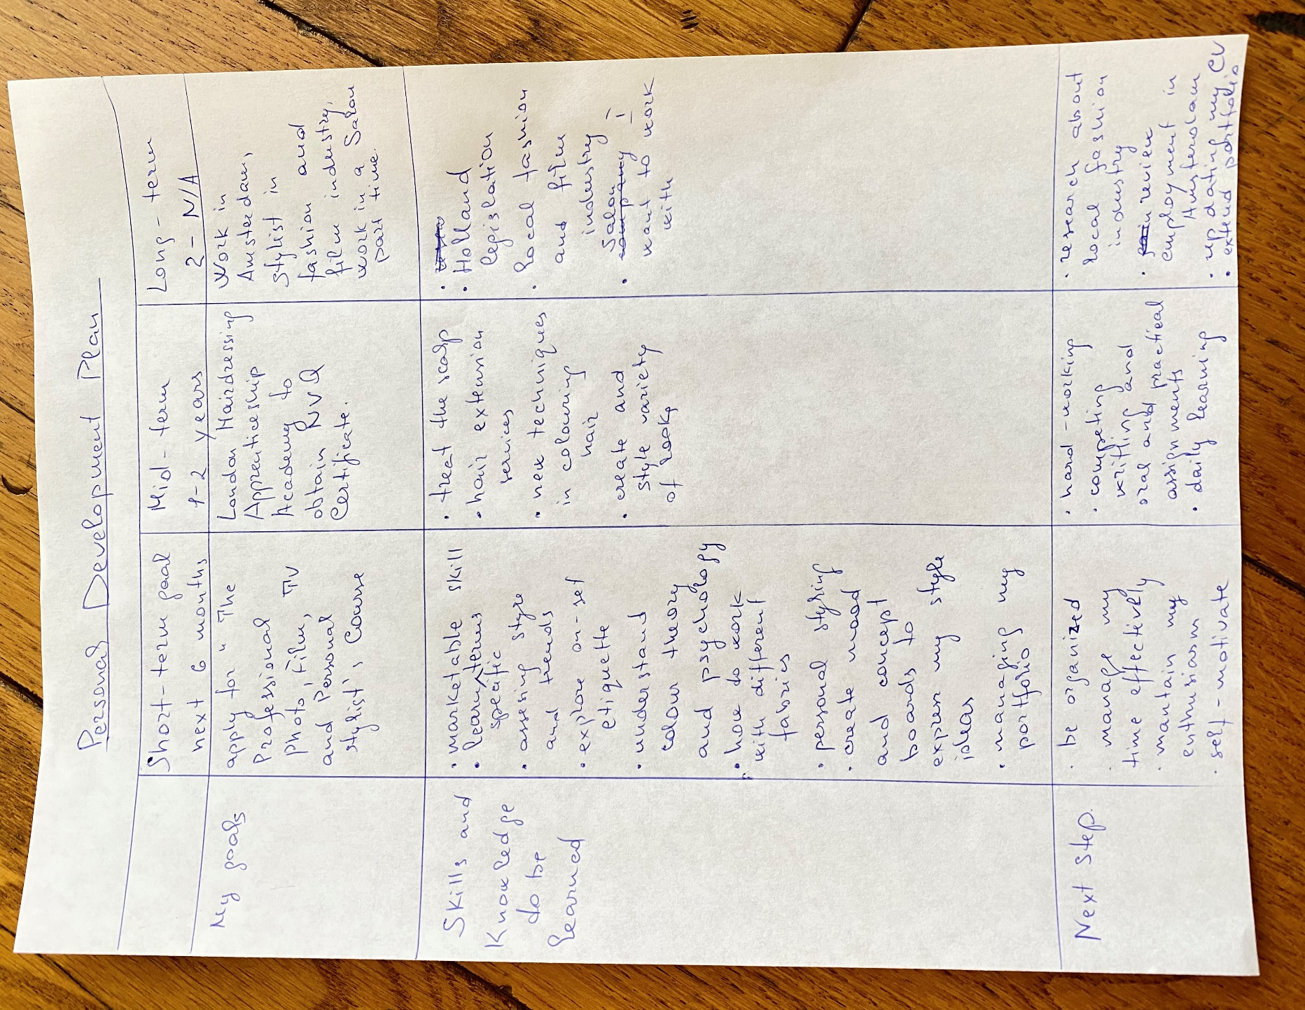
Appendix 2


