

MODULE CODE: ECPT6006

ASSESSMENT COMPONENT: A Critical Evaluation of the Role of Digital Innovation in Professional Practice

STUDENT NAME: Jessica Newport

STUDENT NUMBER: 2327495

Use of Generative AI in Assessment

(Lecturer to indicate Yes or No against each element)

RESEARCH | For this assessment, you can use Generative AI to support you in research, including searching for bibliography, using tools to summarise, compare and interrogate materials. | Yes ☒  No ☐
STRUCTURE | For this assessment, you can use Generative AI to support you in structuring your submission, including creating a draft argument structure, identifying parts and headings, etc. | Yes ☒  No ☐
PROOFREADING | For this assessment, you can use Generative AI to check your own text/creation for grammatical and syntactical mistakes, including rephrasing of your own work within specific standards. | Yes ☒  No ☐
WRITING | For this assessment, you can use Generative AI to create text for submission. | Yes ☐  No ☒
CREATIVE | For this assessment, you can use Generative AI to create creative materials, such as images. | Yes ☒  No ☐
PROGRAMING | For this assessment, you can use Generative AI to create and check code. | Yes ☐  No ☒
NONE | For this assessment, you are not allowed to use any type of Generative AI support. This includes research support, structure support, writing/proofreading support and creative support. | Yes ☐  No ☒

AI Acknowledgement
I confirm that I have not used any AI tools in the research and creation of this assignment.
I confirm that I have not presented any AI generated materials as my own work.
I confirm that I have copies of my drafts, notes, and other resources I used, which I may be asked to provide in evidence.

Table of Contents
Introduction 4
Creativity and Digital Innovation 5
What is digital learning? 5
How can technology enhance rather than replace? 6
Ethical implications 7
Future digital tool usage 8
The link to professional standards 8
Conclusion 9
Selection and Justification of the chosen digital tool 10
Application of the chosen learning tool 13
Collaborative learning with an experienced colleague 13
Design 14
Digital tool usage 18
Lesson Plan 24
Evaluation and Reflection 33
Description 33
Feelings 33
Evaluation 34
Analysis 35
Conclusion 36
Action Plan 37
Reference List 40

Introduction
This assignment will critically evaluate digital innovation in professional practice, through analysis of current literature coupled with the design and use of a digital tool in the classroom.
The chosen tool was Vevox, and it was utilised in a Level 4 International Gastronomy Management class at UWTSD. Vevox was chosen because it was anticipated that it would satisfy the needs and preferences of less confident students through anonymous answering. The aim was to gain an understanding of whether this would increase learner confidence, leading to elevated engagement and participation.
Learning theories and digital pedagogy reinforce the criticality of ensuring technology enhances learning, with a clear caution for strategic use. Digital tools are becoming more commonplace in the classroom, but pedagogy remains the priority (Daniela, 2020). Therefore, the utilisation of digital tools must align with theoretical research. This assignment will ensure that the points raised align with professional standards to bridge the gap between theory and practice, and to appreciate appropriate technology use in the classroom.
There are four sections: a discussion of the role that creativity and digital innovation play in professional practice, the selection and justification of the tool, evidence in practice including the design, creation and delivery, and lastly an evaluation and reflection that includes peer and student feedback.

Creativity and Digital Innovation
Digital capabilities are continuously evolving, with regularly emerging technologies joining existing options. These technologies can provide innovative approaches to delivering education and can contribute to changes in how learners absorb information and the role the teacher performs (Daniela, 2020). However, it is crucial that pedagogy remains the priority, avoiding digital platform use just because it is available (Guppy et al., 2022). It is also important that careful consideration is paid to legal and ethical implications of utilising digital tools in learning. The following literature review will outline existing understanding and identify how technology could be used moving forward.

What is digital learning?
Digital learning encompasses learning and understanding with a digital tool as a vehicle, or the learning and understanding of digital tools themselves. Irrelevant of purpose, they must be supported by the teacher through “interaction, dialogue and reflection” (Forbes, 2019, p.1). Digital learning can provide greater flexibility and increased learning potential (Alenezi, 2023); however, it has been highlighted that in higher education there has been some resistance. Clearer appreciation of how effective and ethical use can be achieved will help alleviate concerns.
The use of digital tools is increasing, particularly after the COVID-19 pandemic which required an immediate response to education delivery (Keengwe, 2023). As argued by Daniela (2020), digital tools are essential for interactive and collaborative learning and can increase personalised learning experiences. These tools are seen as innovative as they enable students to engage in a manner that promotes creativity and collaboration between themselves, the teacher, and their fellow learners. However, research has indicated that particularly within post-16 learning there is an anomaly where digital tools are overlooked entirely or utilised without thought and planning. This lack of balance could disrupt the innovative potential and therefore requires attention (Blair, 2020).
Digital learning is often noted as originating with teaching machines that generated immediate feedback for learners, although accuracy errors impacted utilisation and the concept was deemed a failure by the 1960s (Benjamin, 1988; Beetham and Sharpe, 2019). However, digital tools in learning have continued to evolve and whilst the original concepts are still apparent, the capabilities have vastly increased (Daniela, 2020). In its arguably most simple form, digital tools in education can be found in lecture PowerPoint presentations, but current capabilities include a range of options. There are gamification platforms such as Kahoot, and online learner paced platforms such as Nearpod. Digital learning is even utilised through Virtual Reality (VR) which is currently transforming practical training options within fields such as biology and engineering (Eutsler and Long, 2024).
It has been argued that perhaps the greatest popularity surge came because of the COVID-19 pandemic and the need for immediate online learning. Many of these practices have continued, resulting in an increasing delivery of blended or hybrid learning (Guppy et al., 2022). This has helped ensure that individual needs are met, however, there are concerns that practices have not been perfected following the pandemic, which raises questions regarding effectiveness. Critics argue that the rush to react to the pandemic and the lack of change since could mean substandard teaching practices are in place (Guppy et al., 2022). Responses to this include the importance of teacher interaction and the avoidance of asynchronous only learning (Graham et al., 2023). Teacher participation remains a concern, as does the need for sufficient digital training for educators (Graham et al., 2023).
One of the most discussed emerging digital tools is artificial intelligence (AI). For instance, online digital platforms such as Nearpod can be used to create interactive lectures through available AI suggested prompts and content. Similarly, digital assessment tools such as Kahoot and Vevox also provide the option for AI generated quiz content and questions. A recent survey conducted by Forbes confirmed that 60% of educators are already using AI in their lesson designs, with this total expected to increase (Hamilton and Swanston, 2024). There are benefits in terms of saving time and enabling the teacher to focus on other aspects of learning, however, the question of ethics, particularly regarding assessment is an ongoing concern (Bearman et al., 2020).

How can technology enhance rather than replace?
A key area of focus is that technology enhances learning rather than replacing it, with the competence and confidence of the teacher a primary component. Antonietti, Cattaneo and Amenduni (2022) discovered a higher likelihood of success if the educator was confident in their abilities. This would aid learner engagement and heighten the success of delivery.
Fundamental to this is the understanding of the differing learner needs that evolve over time. As mentioned by Daniela (2020), many educators use technology only because they feel obliged to. As a result, often the tool is chosen first and then the teacher aims to satisfy pedagogical needs. This is the wrong order and raises the risk of less effective learning. Research suggests that a scaffolding approach may effectively address these concerns, as it enables the teacher to remain in a heavily supporting role as the learner navigates the tool (Daniela, 2020). It also ensures the teacher remains aware of the success of the tool compared to non-digital options (Daniela, 2020; Beetham and Sharpe, 2019). This awareness is crucial to satisfy learner needs and professional development of the teacher.
Another important consideration is the role of the educator, with research indicating there is an increasing need for teacher flexibility and clear understanding of how digital learning environments can enhance learning outcomes (Blair, 2020). Guppy et al., (2022) suggest increased dedication to training to remove stigmas and drive capability. Alenezi (2023) supports this but does highlight that it is key that pedagogical requirements are honoured ahead of any technological implementation.

Ethical implications
Using digital tools in professional practice requires careful navigation of legal and ethical implications. As cautioned by Marin and Tur (2024), this is often overlooked with focus remaining on positive aspects only, such as how the increased fun can result in amplified learning and enhanced skills. However, technology usage brings risks that require careful navigation, including learner privacy and the handling of sensitive data (Efthymious et al., 2023; Hamer and Smith, 2021).
Another concern is the risk of a digital divide. Issues regarding accessibility remain prevalent and demonstrate the importance of ensuring equitable access for all learners to avoid unnecessary disadvantages (Marin and Tur, 2024). Research outlines that educators and institutions must ensure they shoulder the responsibility of learner access by providing appropriate guidance and support (Blair, 2020).
Benefits of digital learning and blended or hybrid learning environments include economic advantages that remove commuting, and asynchronous learning that can help with inflexible classroom schedules (Guppy et al., 2022). This demonstrates the relevance of the advice that mindful incorporation can achieve a balance that assists learners whilst mitigating ethical implications. This will enable educators to promote the innovative capabilities of digital tools whilst advocating safety and accessibility (Efthymious et al., 2023).

Future digital tool usage
The Digital 2030 initiative (Jisc, 2019) was created as a response to the need for ethical technology use and digital tools for enhanced learning. It highlights areas of potential use including how to successfully utilise tools such as AI and VR to enhance learning potential. For example, VR can enable the safe and immediate transportation of a hospitality student to a cafe in another country. This helps to ensure equal learning opportunities which may have previously been determined according to socio-economic backgrounds and financial circumstances (Guppy et al., 2022). This demonstrates how access can be widened and how the innovative capabilities of digital tools can enhance the learning experience (Jisc, 2019). However, this success is dependent on teacher capability and confidence in utilising the benefits of these tools. A breakdown could see a negative impact on learning potential (Daniela, 2020). Another key area of concern is the accessibility disparities, including the potential that institutions in more rural locations may experience challenges in ease of access and offsite technical support (Jisc, 2019). These concerns highlight the need for suitable contingency plans to ensure that learning exposure is as fair as possible.

The link to professional standards
The literature discussed above can be linked to the Professional Standards framework, as the effects of utilising digital tools within pedagogical practices aligns with many aspects. These standards are a crucial support to ensure effective teaching and so linking the use of digital tools to this framework is a valuable exercise.
Specific alignment can be found to “demonstrate commitment to learners, their learning, safety and well-being” (Educators Wales, n.d.) as the anonymity of many digital tools could increase comfort and participation of less confident learners. This literature review has also addressed that using “evidence and research to improve” (Educators Wales, n.d) is key as technology continues evolving and so ongoing professional development is crucial. Furthermore, this review has discussed aspects that link to the importance of ensuring the “delivery of effective learning, teaching and assessment” (Educators Wales, n.d.) by ensuring that digital tools are used to enhance learning, thus protecting and promoting pedagogy. The importance of ensuring that learners feel confident and capable links to the standard of building “positive and collaborative relationships” (Educators Wales, n.d.), a key aspect of effective teaching practices. Lastly, utilising digital tools can assist in the “commitment to sustainability” (Educators Wales, n.d.) through digital assessment rather than paper-based testing, or through an increase of hybrid learning reducing frequency of commuting. Consideration of the literature review in line with relevant professional standards allows for a clear landscape of how pedagogy and technology can be used in tandem to promote agile teaching in the ever-evolving digital age.

Conclusion
Digital learning is constantly developing and becoming more commonly used. There are many benefits including the promotion of a more inclusive classroom and heightened engagement due to anonymous answering. However, the danger of incorporating digital tools simply because they are available is a risk that must be mitigated. Careful planning will help to ensure that pedagogy, professional standards and ethical responsibilities are maintained. This planning must be ever-present as further technologies emerge.

Selection and Justification of the chosen digital tool
To select the appropriate tool, I needed to determine which aspect of learning could be enhanced through a technological approach. I realised that as a lecturer on a degree programme that promotes widening access, my class mainly consists of mature students that have been out of education for quite some time. The outcome is a marked reduction in confidence, particularly when answering questions in a group setting. This realisation confirmed that my classes required a scaffolding technique, like that of Jermone Bruner. As discussed by Ritter (2025), Bruner acknowledged that students thrive when supported to empower themselves. I realised the students in my classroom would benefit from this support to build confidence and increase participation. Therefore, a digital tool that could enable students to answer questions anonymously would help to achieve this. It would present the opportunity to share thoughts and ideas without the fear of getting the answer wrong preventing contributions. As they would see that they perhaps had more knowledge than they realised, this would hopefully encourage them to speak more freely, meaning that the support of the anonymous tool as a scaffold could be removed.
Accessibility was another concern, as I was conscious of the potential that more mature students would find digital tools more challenging, and there may be increased resistance (Daniela, 2020). It was important therefore that the tool was user-friendly.
When considering these concerns, I selected Vevox as the appropriate digital tool. Vevox offers anonymity, which is a key requirement, but it is also user-friendly and suitable for those less confident with technology. It is accessed via a QR code or online and this flexibility suited the student demographics of my class. I did consider using Kahoot, but I felt my students would have struggled with some aspects such as timed answers, leaderboards and the bright colours which can be distracting. Vevox aligned with the needs of the students and the learning outcomes of the lesson.
It was crucial that the digital tool enhanced the pedagogical requirements of the lesson, meaning the support of a digital framework was needed. The SAMR model was selected to help direct focus on where and how Vevox could be integrated effectively. As outlined by Blundell, Mukherjee and Nykvist (2022) this framework allows for digital tool usage through enhancement (substitution or augmentation) or transformation (modification or redefinition). I decided that Vevox would be utilised as a formative assessment tool. Through the combination of anonymous Word clouds and Multichoice quiz questions, it was possible to ensure interactive participation in real time whilst maintaining anonymity. This would mean limited delays or disruption to the lesson, meaning the tool would not only enhance but transform the lesson through a completely different approach to assessment. It was therefore established that Vevox could satisfy the requirements of modification within the SAMR framework. It would also satisfy the professional standards of “the delivery of effective learning, teaching and assessment” and “working collaboratively with others to reduce and remove barriers to learning” (Educators Wales, n.d.).
Further steps taken during the selection process included design analysis. Vevox is visually appealing, with a colour palette that is neither overwhelming nor tedious. Whilst Mentimeter was considered, its lack of colour was a factor in declining to proceed as I realised that Vevox most effectively mitigated the risk of distraction or losing student engagement. Achieving a balance was crucial as the demographics of my students required visually comfortable designs to aid understanding and effective use. Ensuring this would also mean that my teaching was meeting the requirements of the professional standard to “promote diversity, equality of opportunity and inclusion” (Educators Wales, n.d.).
During the selection process, my research led me to the benefits of gamification within formative assessment. As outlined by Gini et al. (2025) gamification can increase engagement through competition and motivation to win. This is supported by Christopoulos and Mystakidis (2023) who discussed how gamification can provide a valuable learning experience, as humans react well to elements of competition that often result in increased retainment of learning. However, it was determined that my students would not engage with the heightened gamification style typical of platforms such as Kahoot and the increased competitive nature could risk further negative impacts on confidence levels. As cautioned by Almeida et al. (2023) there is a risk that gamification can cause disruption, particularly elements such as leaderboards which can result in a lack of motivation for those who do not win. Therefore, whilst Vevox does not offer all the benefits of gamification that can be found in other digital platforms, it does provide the safety of ease of accessibility and anonymous answering that was most appropriate for my classroom. It removes direct competition that could provide unnecessary pressure for underconfident learners which makes it more appropriate.
Guidance from the scaffolding techniques of Bruner and the SAMR model enables a clear appreciation for how using Vevox for formative assessment in a widening access setting can enhance learning by encouraging participation and increasing learner confidence. The opportunity for students to recognise strengths without the pressure of verbally contributing will enable a clearer understanding of capabilities in terms of academics and critical thinking (Umarova et al., 2025). Real-time answering and immediate feedback that maintains anonymity whilst inviting contributions sees Vevox satisfy the modification element of the SAMR model as it moves past substitution and augmentation, into the transformative stages. The result is something that could not have been achieved otherwise. This is clear through the maintenance of privacy that the platform can provide.

Application of the chosen learning tool
To successfully implement Vevox, careful planning and design was required. The below screenshots outline this process, including the implementation and results. This section also includes the lesson plan that supported the successful usage of the digital tool.

Collaborative learning with an experienced colleague
I began by obtaining the guidance of a peer (Daniel) that I knew had utilised Vevox in his teaching already. Daniel’s assistance was crucial to my success, as his careful explanations and approachability ensured I felt comfortable to ask questions. Daniel’s positive reinforcement and familiarity with my students helped to tailor his guidance to my specific needs.
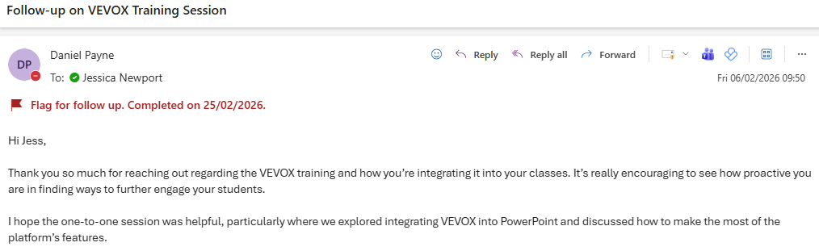

Design
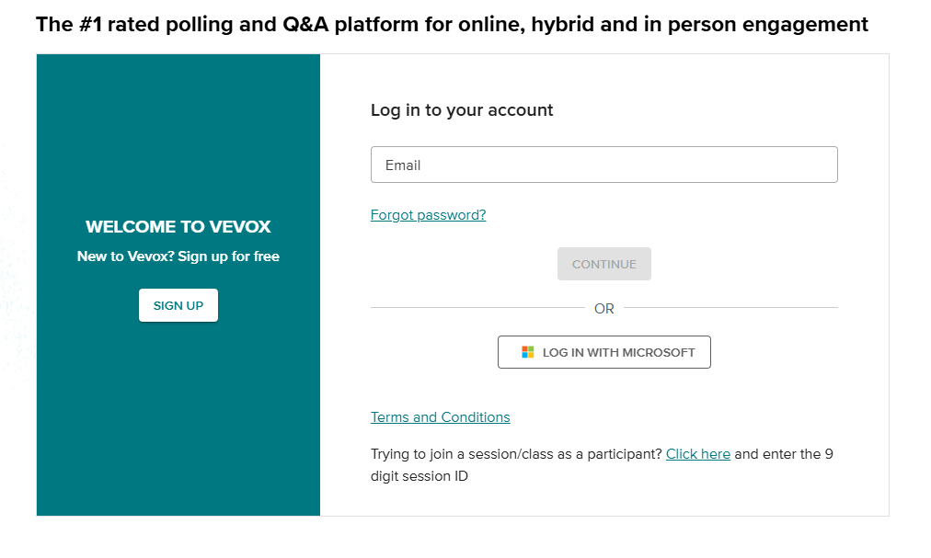
My first step was to create a free account by clicking the sign-up button as shown above. This was a straightforward process that was completed quickly using my UWTSD staff credentials. I could now log into my free account as depicted in the image above.
The next steps were to create a session and give that session a name as shown in the below images. This is for clarity and to enable the creator to have multiple sessions stored that they can easily identify.

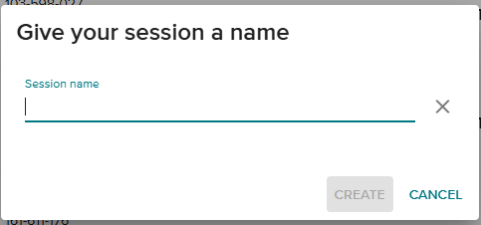
It was now possible to begin creating content as shown in the screenshot below. There are two options available: add content or utilise sample options from the Vevox library.
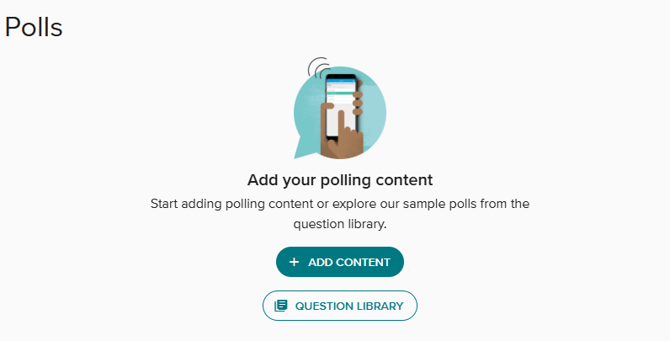
The library is a great resource to guide and inspire, particularly for those that haven’t used Vevox polls previously. A screenshot of the question library homepage is shown below.
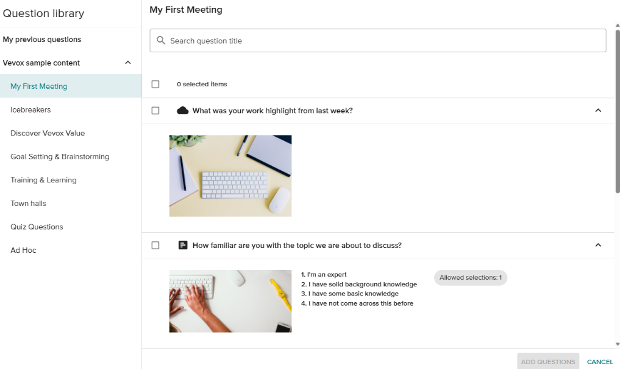
I selected the add content option so I could design my own questions as I already had specific ideas. The image below depicts the available options when choosing this route. The range of options demonstrates the diversity of the platform. I selected Word cloud for anonymous thought sharing and Multichoice questions for added insight in terms of responses to a differing assessment type.
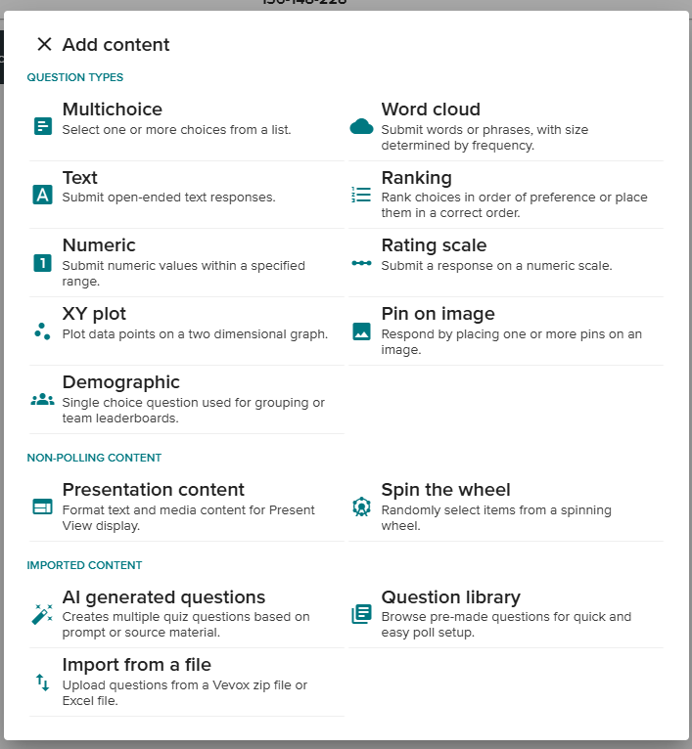
Once the content is created, the poll can then be presented as depicted below.
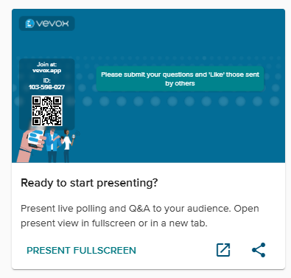
Daniel’s guidance led me to realise that the most effective presentation option for me would be through the integration of Vevox directly into my PowerPoint presentation. The below screenshots show how this was achieved.
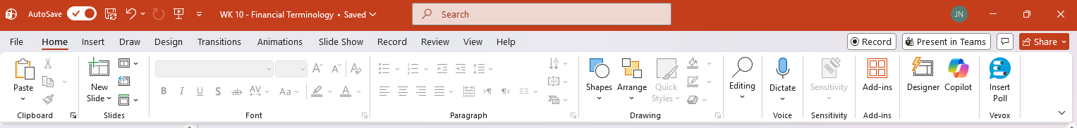

All UWTSD staff members have the option to directly insert a Vevox poll into a PowerPoint presentation as shown in the above images. This was an attractive option for me as it prevented the need to switch between screens and windows. This was beneficial as this class is hyflex, meaning I am already navigating multiple screens and the Microsoft Teams platform for distance attendees.

Additional options available include the capability to add a leaderboard as shown in the above image. This was not appropriate for my lesson but does demonstrate the flexibility of the platform and the option to increase the competitive gamification if required. I did utilise the add joining instructions option for ease, however. To create the poll through PowerPoint it is a very similar process, with the add content button shown in the above screenshot. This produces a drop-down list of options as depicted below. From here I was able to select the Multichoice and Word cloud options for my lesson.
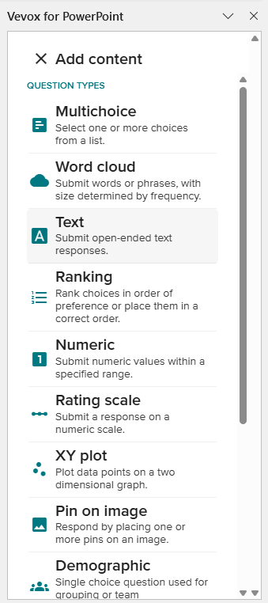

Digital tool usage
The first image below shows the joining instruction slide, with two different access options (QR code and via vevox.app). My class chose to access via the QR code for speed and ease. It is possible to also add the joining instructions ahead of subsequent polls within the class which is a great capability as it enables quick access for any learners that may accidentally leave the session.
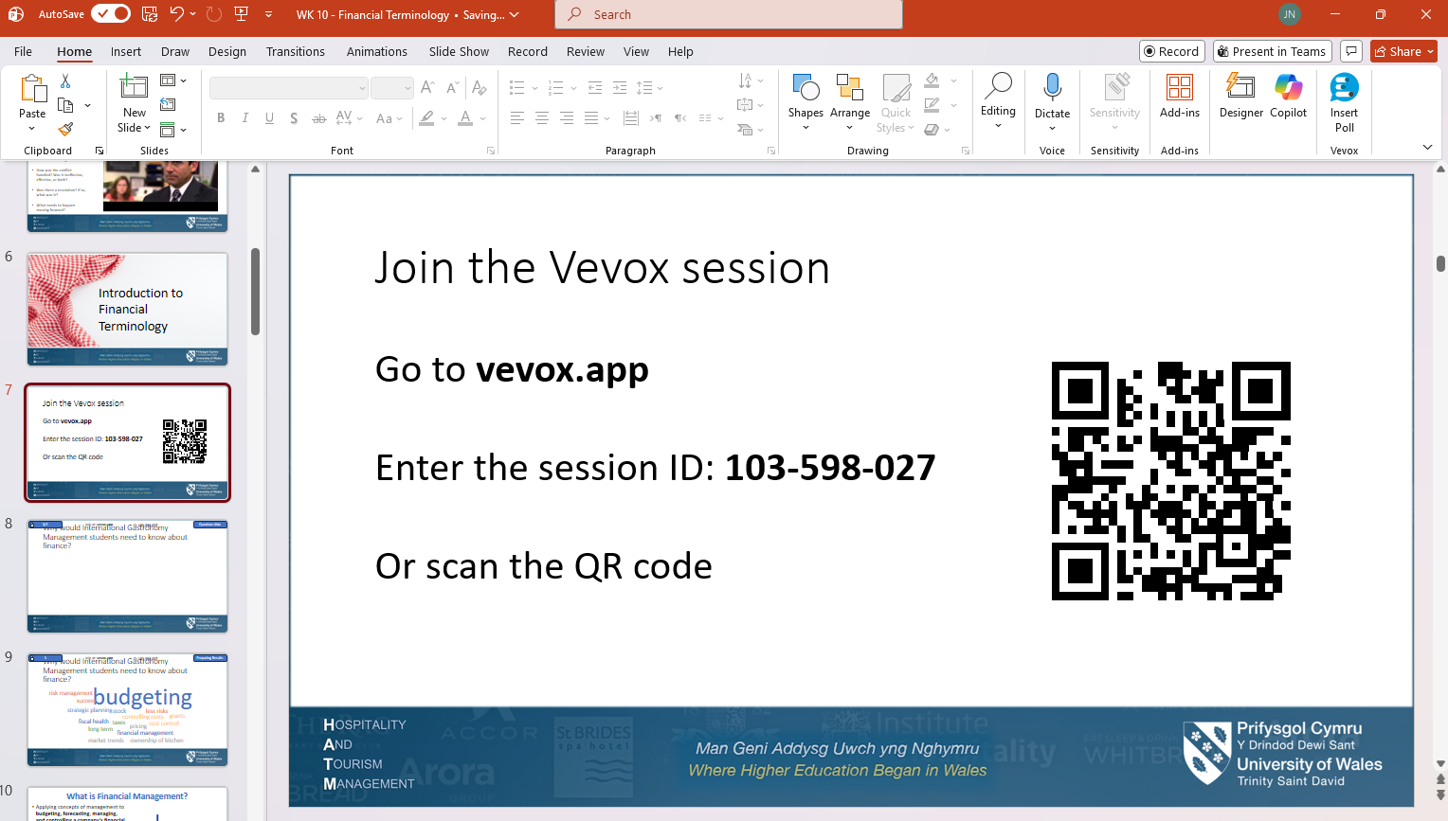
The image below outlines how the question slide appears. The blue button depicts how many students have joined the poll and how many have currently answered. This is a great supporting resource as it allows for effective tracking of engagement and participation and for knowledge of when all responses are received.
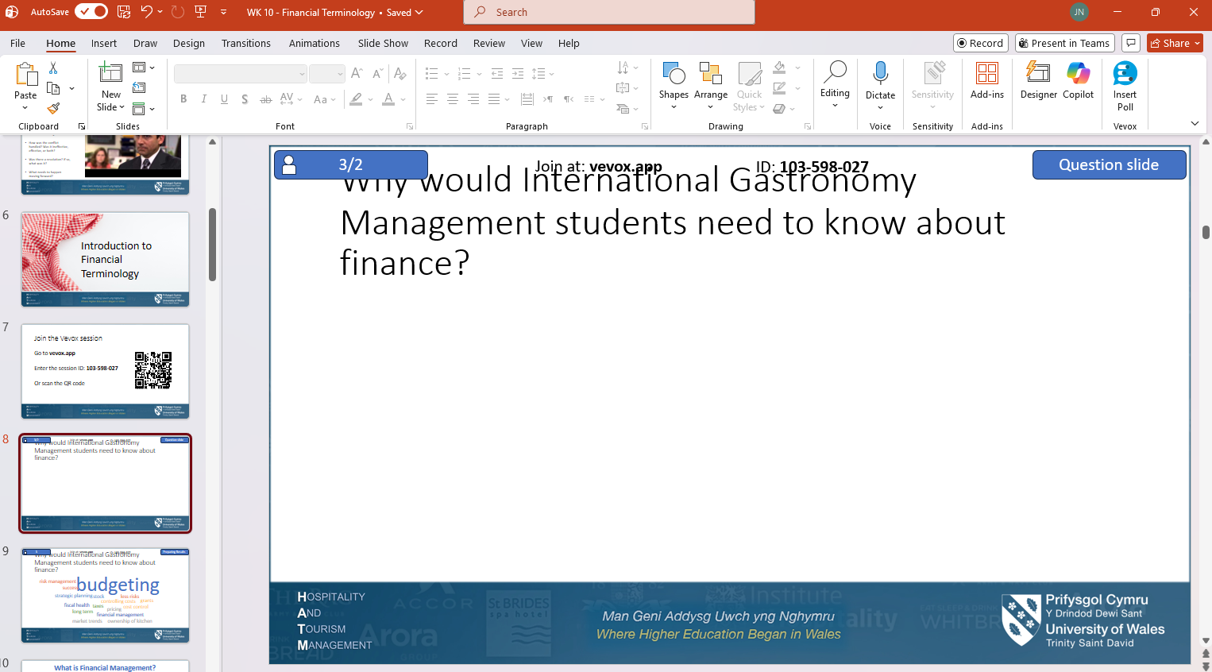
The images below show how the cover page and first Word cloud poll appears on a mobile device, and therefore how it appeared to the students using it for this class. As the screenshot shows, it is clear and user-friendly with ease of accessibility evident. An additional positive is that no account is required. When students access via either of the accessibility options they are directed straight to the poll without any need to sign in or create an account. Again, for a class that is likely to have confidence concerns with digital tools this is a useful attribute.


The screenshot below shows the results slide and how the answers appeared. The varying colours help to separate and identify answers and are a welcome feature. The sizing of the results is another positive attribute, as it directly relates to how many people have typed that word or phrase. The larger the word the more answers overall. This aids collaborative working as it demonstrates common ground between learners and a matching of knowledge.
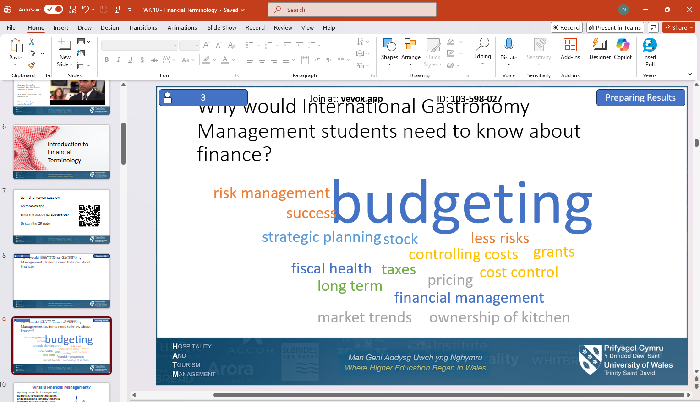
In the screenshot below there is an example of one of the multiple-choice questions that I included, with the first image depicting how it appeared within the presentation, and the second representing how it looked for the students on their devices.
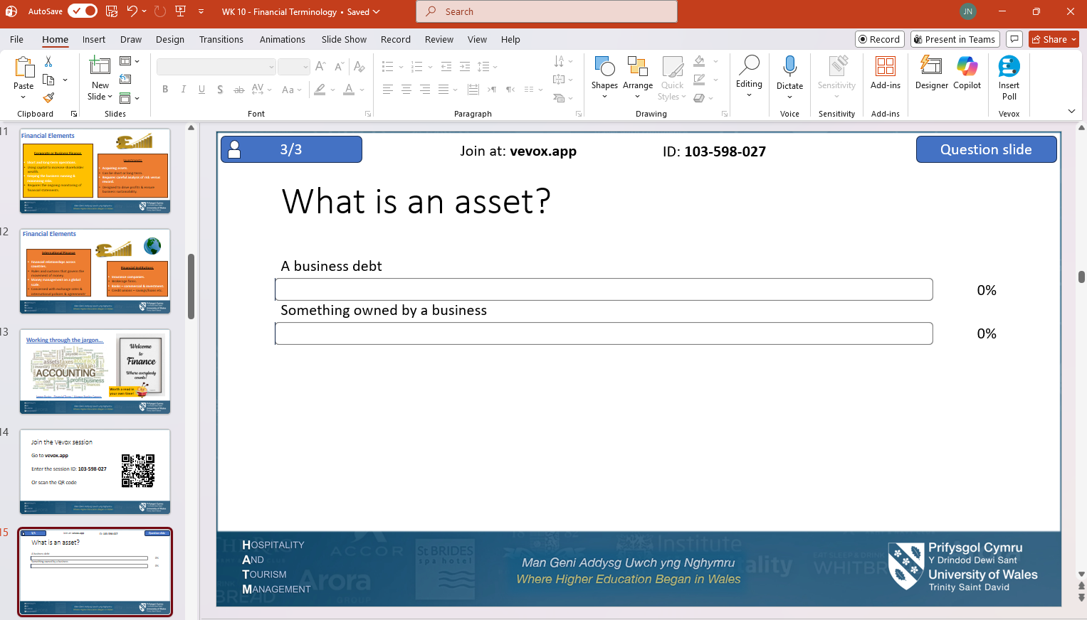
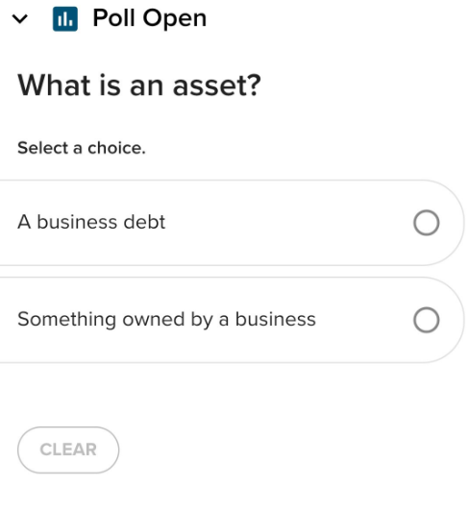
The images above demonstrate that the accessibility of the platform is maintained across polling types. Again, there are clear instructions and easy to navigate buttons. For this question I decided to include only two different answers to avoid overwhelming new users, however, it is possible to increase past this total if desired. As shown in the image below, the included tick outlines which of the options is the correct answer. The sizing of this tick helps to avoid unnecessary disappointment or embarrassment for incorrect answers as it is subtle in design, a feature that suited my students and their needs.
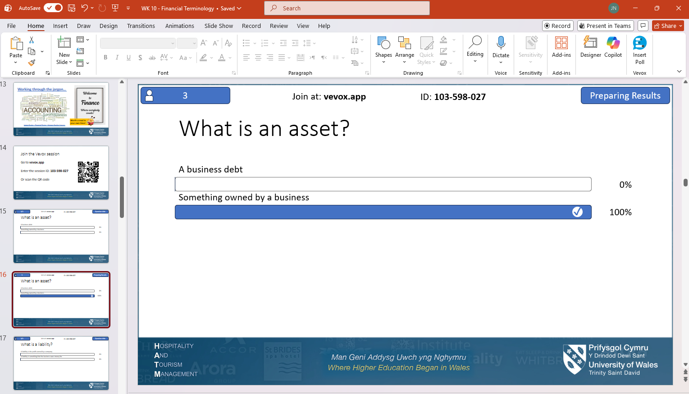The screenshot below provides an example of what the results slide looks like if there are incorrect answers. Again, the subtle design avoids unnecessary embarrassment that could have a negative impact on learner confidence. I made sure that I reiterated the definition as I was aware that if students are unsure then they will guess the answer, and therefore some may get the correct answer through luck rather than knowledge. This demonstrates the need for recaps to instil effective learning.
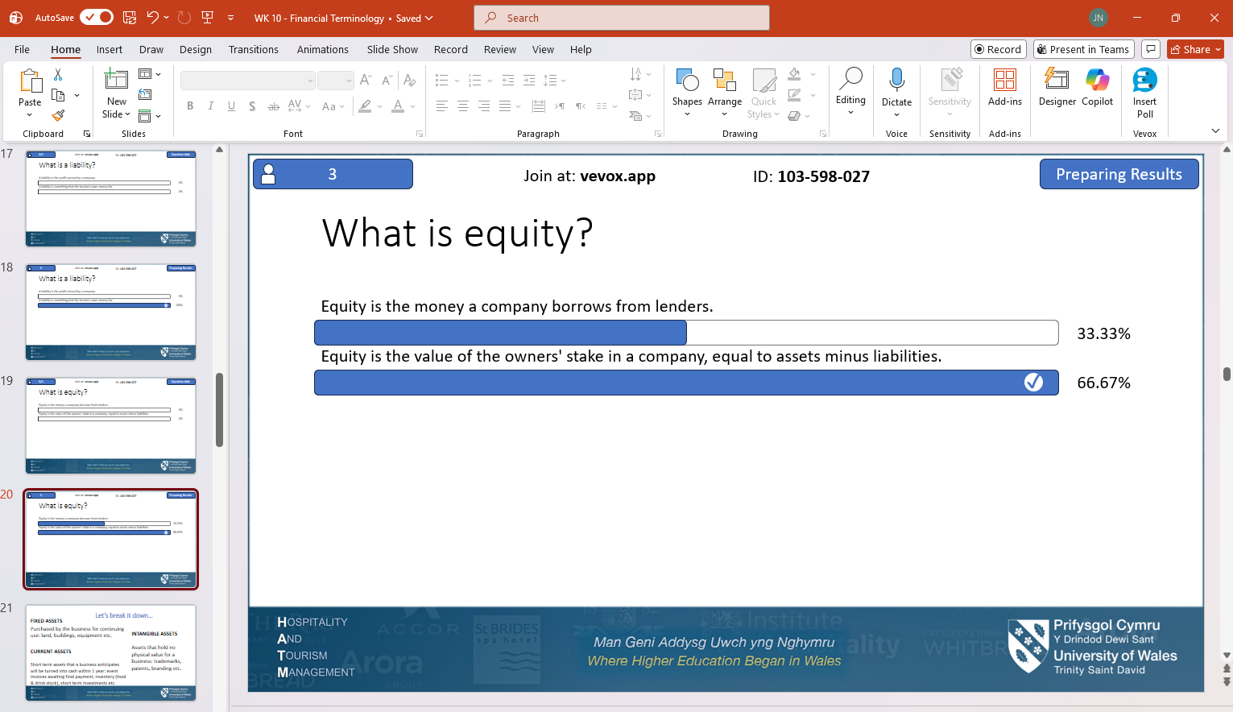
All results and polls are automatically saved and can be revisited via the PowerPoint presentation or through the Vevox account. Another great feature is that the poll can be reopened at any time, meaning it can be used in future classes, or revisited again as part of a recap session to further identify learning outcomes. Other potential adaptations include increased answer options in the Multichoice questions or the inclusion of a leaderboard or other gamification element to increase competitiveness.
This experience has enabled a clearer understanding of how Vevox polls can enhance learning, whilst identifying potential avenues for development and adaptation to different learning styles and needs. These results satisfy the planning and aim as outlined in the lesson plan below.

Lesson Plan



Topic: Financial Terminology |  | Class: Level 4 BA (Hons) International Gastronomy Management – BMGM4000 Effective Management
Date: 18/12/2025 | Length of lesson: 3.5 hours |  | Number of students: 7
Resources required:
Full hybrid setup – working screens for Microsoft Teams, PowerPoint Presentation and appropriate audio (microphone & speakers).
One device per student attending in person (either laptop or mobile).
Two devices for distance students (laptop to join class and mobile for Vevox).
Aim of Lesson
To introduce learners to the concept of financial terminology, with specific links to hospitality to demonstrate their financial functions and how an effective manager can contribute to the processes.
Learning Outcomes – The Learners Should Be Able To:
Identify and recall different financial terms and provide basic definitions.
Recognise how an effective hospitality manager can enhance the financial position and improve market positioning.
Discuss the links between financial positioning and market positioning.
Previous student knowledge required for the session:
No prior knowledge required as this is an introductory class. A basic understanding of financial terms would benefit but is not a necessity as this class is designed for Level 4 students with the anticipation that they have not studied this topic previously.
Anticipated difficulties (if applicable):
Confidence levels of learners: as this is an introductory class there is potential that some will find the content overwhelming and difficult to grasp. I will address this with positive reinforcement and by addressing at the beginning that learning financial terminology can be challenging to validate their concerns. Whilst the digital tool could impact on confidence levels due to concerns of navigating a new platform, the anonymity of answering will hopefully encourage participation.
Preferred learning style: the digital tool may not be suited to all learners. Some students, particularly those that are more mature could potentially resist the use of answering via a digital platform. There is also the potential that some learners prefer verbal interaction and would therefore not appreciate the distance of the digital tool. I will acknowledge that this style of formative assessment may not suit all learners but encourage their participation. I will explain that digital tools are becoming more commonplace in many environments and so this platform could be relevant in their future careers, meaning this activity is beneficial in multiple ways.
Differentiating between financial terms: some of the financial terminology that will be discussed is quite complicated and may present challenges for students when attempting to recall and define different terms. I will address this by clearly communicating that the content is challenging and that it will be revisited throughout their studies. This class is deliberately introductory, and so students shouldn’t feel disheartened if they cannot recall all the terms discussed. I will endeavour to use relatable examples and create a safe and welcoming classroom atmosphere that will encourage students to ask questions.
Professional Standards (where are these being met within the session)
- Demonstrate commitment to learners, their learning, safety and well-being – through digital Word clouds that encourage honest participation which will help to determine appropriate progression. Also, the dedication to create a welcoming atmosphere and safe learning environment through positive reinforcement and clear acknowledgement of challenges.
- Demonstrate dignity, courtesy and respect towards others – through a clear commitment to ensure equal access to all class content irrelevant of whether the student is distance or in-person. I will ensure this through clear communication and careful camera positioning to ensure visibility to all and by helping students individually if required.
- Ensuring appropriate assessment strategies are in place to support learner progress - through the careful design of Vevox polls, I will be able to formatively assess my students. This will assist me with where further attention may be required. The anonymity of this platform will encourage participation, allowing me to capture feedback that may not have otherwise been gained. Although not necessarily possible to identify individual needs, this medium will help to identify broader areas of improvement and will provide a good basis to develop from.
- Facilitating and promoting supportive learning environments where learners are active participants as individual and as members of collaborative groups – by remaining committed to supporting learners’ progression, through multiple instances of formative assessment via the digital platform of Vevox and other discussion points.
- Awareness of how technology can be used to track and support learners – through the utilisation of the digital tool to enhance pedagogical output.

Lesson Detail:

Stage | Focus | Strategy | Time
Introduction:  Recap  Agenda  Development:  Introduction to financial terminology  Break  Recognising your marketplace  Break  Assignment recap  Digital tool discussion and feedback  Plenary/conclusion | Discussion of content covered in previous lesson  Overview of the lesson, including aims and objectives  Why are finances relevant?  What is financial management?  Financial elements  Jargon busting  Test your learning  Income statement and Total Revenue  Market Positioning:  How to identify your position  Market Positioning in Practice  Market Positioning and Effective Management  Recap of assignment requirements  Additional support resources  Assignment Q & A  Discussion to gain student perspective on benefits and drawbacks of using Vevox and to determine their personal thoughts and opinions on the effectiveness of digital tools and preferences in terms of anonymity.  Revisit learning outcomes, determine if they were achieved.  Discussion of key points and Q & A on any content covered. | Informal assessment to determine learning effectiveness. Teacher led questioning and collaborative group discussion.  Teacher led delivery with PowerPoint presentation to support.  Vevox Word cloud to determine current learning levels. Teacher led questioning, honouring anonymity but encouraging student participation.  Teacher led lecture presentation with PowerPoint to support and provide visual aids. Asynchronous material provided to encourage students to research further.  Vevox multiple choice quiz to determine effectiveness of learning. A teacher led discussion of answers to follow.  Teacher led delivery of PowerPoint presentation  Teacher led delivery with PowerPoint presentation to support. Group discussion with teacher led questioning to encourage learners to apply specifics and additional context to learning.  Teacher led delivery with PowerPoint presentation to support. Individual activity where learners are tasked with outlining the market position of their placement establishment or place of work. Group discussion to follow.  Vevox word cloud to gain initial insight and determine current learning levels.  Teacher led questioning and discussion honouring anonymity but encouraging student participation.  Teacher led delivery using PowerPoint presentation, module handbook and links to Harvard Referencing Handbook and UWTSD AI information.  Group discussion, student led with teacher answering any specific questions or concerns.  Group discussion with teacher led questioning.  Teacher led delivery for the revisit of learning outcomes. Collaborative discussion of key points, and student led Q & A with teacher providing answers and assistance. | 5 minutes  5 minutes  10 minutes  50 minutes  20 minutes  40 minutes  10 minutes  20 minutes  20 minutes  15 minutes  15 minutes

Assessment Strategies: when and how are they included within the lesson?
Introduction: Q&A during recap to determine learning from the previous week.
Development: Multiple assessment opportunities through Vevox Word clouds to determine pre-learning comprehension, Multichoice Vevox quiz questions for formative assessment to determine effectiveness of learning and identify areas that may require immediate recap or elaboration. Group discussions and teacher led questioning to enable the teacher to learn outside of observation. An opportunity to provide feedback will be possible through this type of assessment also.
Conclusion: A Q&A and feedback/discussion segment enables summative assessment and will assist the teacher in determining the learning that has occurred and any areas requiring further attention.

Informal reflection (to be completed after the session)

- Time management continues to be an area that requires improvement. A lack of attention in the first half of the lesson saw me running over time and meant that the second half felt rushed in comparison. It was therefore more challenging to identify gaps in learning during the summative assessment at the end.

- Continue to utilise Vevox in classes (where appropriate), particularly the Word cloud function as this promoted rich discussion and notably assisted learner confidence to participate verbally.

- I am pleased with the success of the digital tool. I do not consider myself to be very capable with technology and so I was nervous ahead of this class. However, all learners except for one accessed with ease, and the one that did struggle responded well to my support and assistance. I was proud of my achievements but also proud of my students for being open and willing to participate via a new medium.

- I recognise that the digital tool was a success, but I realise also the importance of prioritising pedagogy as I also saw the value in combining the digital tool with traditional group discussions, activities and lecture presentation delivery also.

Evaluation and Reflection
To reflect on my experience using Vevox I will utilise the Gibbs’ Reflective Cycle (1988). This will enable me to critically evaluate my experiences and incorporate the feedback from learners and my peer.

Description
The subject for this lesson (Financial Terminology) can be challenging for beginners and so I felt it would be an appropriate session to enhance pedagogical delivery with a digital tool. The class was hyflex with some students attending in-person and others online. It was supposed to be 7 students, but only 3 attended, with 2 in-person and 1 dialling in via Microsoft Teams.
Vevox was utilised through Word cloud questioning and Multichoice quiz questions. The Word clouds drove engagement as students shared multiple answers. The energy appeared reduced during the Multichoice questions, suggesting this format was not as popular.
The use of technology helped bridge the gap between learners as they were all utilising the same tool irrelevant of whether they were in the room together or not. This togetherness can be challenging to achieve in a hyflex setting. The digital tool also avoided concerns such as accidental interruptions when answering questions.

Feelings
I was nervous as I lacked confidence in my digital abilities. I was concerned about student reactions and whether they would share my apprehensions. However, I was excited to teach in a different way and hopefully increase student confidence. Concerns regarding teaching performance and student engagement are commonplace (Duckworth, 2013) which reassured me and gave me the drive to continue.
My students were happy to experience Vevox as it was something different and they appreciated the opportunity to answer anonymously. One student had difficulty accessing, but my nerves were further reduced when I successfully assisted. I felt satisfied when discussing responses as all students felt confident to speak up and elaborate on answers. This was a noticeable improvement on previous classes where certain learners remained quiet. I realised this correlates with professional standards, including those that foster inclusivity and effective assessment (Educators Wales, n.d.).

Evaluation
I held a feedback session at the end and sent out further feedback requests via email. I also requested insight from my colleague Daniel who had helped me to navigate the platform. Feedback is crucial as it identifies improvement areas and allows for identification of success that can be replicated (Blair, 2020). I realised I could share my findings with colleagues to help enrich their teaching, which aligns with the professional standard of collaborative working with peers (Educators Wales, n.d.).
All students preferred interacting with Vevox over direct verbal questioning. Feedback included that the platform was easy to use and increased confidence as they could answer anonymously. The youngest student (19 years old) mentioned that he would have preferred a more exciting form of assessment. No other students agreed. This validates the assumption that heightened gamification is more suited to younger learners. Whilst flexibility to include other more competitive and fast paced platforms such as Kahoot could boost wider engagement, it could also damage the likelihood of meeting the overall learning outcomes for all class members (Ashwin, 2020).
Another student had difficulty accessing the poll. I responded quickly through reassurance and assistance whilst encouraging the others to continue. He had no further difficulties and the experience was not disrupted for any other learners. It is acknowledged however, that this response was not considered in advance. Had the class size been increased, or further students experienced difficulties, it would have been more challenging. This demonstrates the importance of effective contingency plans as discussed by Blair (2020) and Beetham and Sharpe (2019).
All students agreed the questions were suitable in terms of subject. There was a mixed reaction regarding difficulty, with some finding it easier than others. It was established that some had prior knowledge. As suggested by Gini et al. (2025) increasing individuality within formative assessments can facilitate a closer alignment to learner needs. However, Eutsler and Long (2024) warn that focusing too heavily on adapting this this can distract from attention on pedagogical requirements putting the outcome in conflict with the intention.
Feedback from Daniel complemented the above findings as he mentioned seeing greater engagement with less confident learners when he utilised Vevox as well. Daniel also suggested buildable questioning to complement different learning levels, advising to include optional additional questions for more advanced learners. Keeping this optional would reduce pressure. This reflects more upon assessment strategy rather than the digital platform itself but is useful as I consider future usage. It demonstrates the flexibility of the tool and the need for ongoing reflection to ensure best practice.

Analysis
Analysing Vevox as a digital formative assessment tool highlighted that it requires careful navigation to ensure practical use complements educational aims. The success in this lesson highlighted my capabilities in teaching with digital tools, however, did demonstrate that ongoing research would benefit further. As outlined, some students felt the questions could have been more challenging, which demonstrates a need for enhancement. In alignment with the professional standard of collaborative working to improve teaching practices (Educators Wales, n.d.) I can identify future focus points to enhance my practice and drive my professional development.
My students found Vevox more successful for Word cloud answering than multiple choice questions which suggests that an alternative platform should be utilised for that style of assessment. However, to satisfy the needs of widening access students it is crucial this is navigated carefully to avoid digital fatigue or overwhelm (Eutsler and Long, 2024).
In terms of anonymity, which was a key focus of this study, it has been discovered that this feature increased engagement. The energy increased when students were engaging with the poll via their devices, and the removal of the fear of answering incorrectly increased their willingness to participate. All Word cloud answers were accurate, suggesting anonymity enabled clearer thinking. Beetham and Sharpe (2019) and Daniela (2020) discuss that digital learning can drive engagement as it provides an opportunity for students to engage with their thoughts and perceptions and provide organic answers without fear of embarrassment. Blair (2020) supports this with the suggestion that the teacher should determine learning success through the focus on “critical thinking rather than on knowledge retention” (p.92). This reinforces the importance of assessment tools such as Word clouds as it allows for students to share perceptions that assist the teacher with determining whether learning outcomes have been achieved.
All students confirmed that they would not have answered so freely (or potentially answered at all) without anonymity. This further demonstrates how digital tools can enhance pedagogy. The students also felt they had retained more information because of their active participation. This is a key point, as learning can be driven through students discovering answers for themselves rather than simply being given them by the teacher (Blair, 2020).

Conclusion
This reflection has demonstrated that the anonymity of Vevox did drive participation and increased learning retention, suggesting it was an effective measure to implement. It demonstrated that digital support could enhance teaching, but that careful considerations must be taken to mitigate risks and ensure pedagogy remains the priority (Beetham and Sharpe, 2019).
My reflections, student and peer feedback, and wider research have supported me to analyse and evaluate the benefits and drawbacks of the chosen digital tool and consider the wider concerns of digital learning. Relating this to appropriate professional standards has given me a wider perspective of digital innovation within teaching practice which will be instrumental in my ongoing professional development.

Action Plan
Target | Specific | Measurable | Achievable | Realistic | Time-bound | Professional Standard
- Explore additional Vevox resources provided by peer. | - Practice using the tool in further depth. | - Set specific time ahead of the next semester to ensure appropriate preparation. | - Utilise the resources and contact peer for support if required.  - Utilise account on Vevox to create different sessions. | - I allocate time on Fridays when I do not teach for these tasks.  - The next semester I will be teaching is September 2026, meaning there is extended time to prepare. | - Ongoing but completed by September 2026. | - Develop and implement effective policies and strategies to support the delivery of effective learning, teaching and assessment.
- Explore other digital platforms. | - Research Kahoot and Nearpod as they offer different experiences to Vevox. | - Allocate time ahead of the next semester to ensure appropriate preparation. | - These platforms are free and easy to access.  - I can test content on my peers. | - I allocate time on Fridays when I do not teach for these tasks.  - The next semester I will be teaching is September 2026, meaning there is extended time to prepare. | - Ongoing but completed by September 2026. | - Develop and implement effective policies and strategies to support the delivery of effective learning, teaching and assessment.
- Explore time management techniques. | - Document timings of digital tool design for clarity.  - Reflect after lessons to identify areas of success and improvement. | - Digital tool design and lesson planning is accounted for in weekly schedule. | - Continue utilising the provided lesson plan template and own reflective diary for structure and accountability. | - This action plan is in preparation for the September 2026 semester and so there is extended time to plan.  - This task is ongoing, but with a week in-between classes there will be opportunity for adaptations if required. | - Ongoing, weekly to also cover the next semester (September 2026). | - Plan and deliver effective learning, teaching and assessment.

Word Count: 4350

Reference List
Alenezi, M. (2023) ‘Digital Learning and Digital Institution in Higher Education’, Education Sciences, 13 (1), pp. 88. Available at: https://doi.org/10.3390/educsci13010088
Almeida, C., Kalinowski, M., Uchoa, A. and Feijo, B. (2023) ‘Negative effects of gamification in education software: Systematic mapping and practitioner perceptions’, Information and Software Technology, 156. Available at: https://doi.org/10.1016/j.infsof.2022.107142
Antonietti, C., Cattaneo, A. and Amenduni, F. (2022) ‘Can teachers’ digital competence influence technology acceptance in vocational education?’ Computers in human behavior, 132. Available at: https://doi.org/10.1016/j.chb.2022.107266
Ashwin, P. (2020) reflective teaching in higher education. 2nd edn. Bloomsbury Academic.
Bearman, M., Dawson, P., Ajjawi, R., Tai, J. and Boud, D. (eds.) (2020) Re-imagining University Assessment in a Digital World, Springer International Publishing. Available at: Re-imagining University Assessment in a Digital World (Accessed 27 February 2026).
Beetham, H. and Sharpe, R. (2019) Rethinking Pedagogy for a Digital Age: Principles and Practices of Design, Routledge. Available at: Rethinking Pedagogy for a Digital Age : Principles and Practices of Design - EBSCO (Accessed 4 February 2026).
Benjamin, L.T. (1988) ‘A history of teaching machines’, American Psychologist, 43 (9), pp. 703–712. Available at: A history of teaching machines. - EBSCO (Accessed 20 February 2026).
Blair, E. (2020) Teaching in higher education, Independent Thinking Press.
Blundell, C., Mukherjee, M. and Nykvist, S. (2022) ‘A scoping review of the application of the SAMR model in research’, Computers and Education Open, 3. Available at: https://doi.org/10.1016/j.caeo.2022.100093
Christopoulos, A. and Mystakidis, S. (2023) Gamification in Education, Encyclopedia, 3, pp.1223-1243. Available at: https://doi.org/10.3390/encyclopedia3040089
Daniela, L. (ed.) (2020) Pedagogies of Digital Learning in Higher Education, Taylor & Francis Group. Available at: ProQuest Ebook Central - Reader (Accessed 4 February 2026).
Duckworth, V. (2013). How to Be a Brilliant FE Teacher: A Practical Guide to Being Effective and Innovative, Taylor & Francis Group. Available at: ProQuest Ebook Central - Reader. (Accessed 23rd February 2026).
Educators Wales. (n.d.) Professional standards for further education and work-based learning leaders in Wales. Available at: Professional standards for further education and work-based learning leaders in Wales | Educators wales (Accessed: 13 February 2026).
Efthymious, L., Epaminonda, E., Ktoridou, D. and Dionysiou, I. (2023) ‘Societal and Ethical Implications of Technology in Education’, 2023 IEEE Global Engineering Education Conference (EDUCON), pp. 1-5, Available at: https://doi.org/10.1109/EDUCON54358.2023.10125268
Eutsler, L. and Long, C.S. (2024) ‘Don’t put the Cart Before the Horse: Self-Study on Using VR in Education’, TechTrends, 68 (1), pp. 136-148. Available at: https://doi.org/10.1007/s11528-023-00897-z
Forbes, D. (2019) ‘An issue of terminology: What is digital learning anyway?’ Waikato journal of education, 23(2). Available at: https://doi.org/10.15663/wje.v23i2.650
Gibbs, G. (1988) Learning by Doing: A guide to teaching and learning methods. Further Education Unit. Oxford Polytechnic.
Gini, F., Bassanelli, S., Bonetti, F., Mogavi, R.H., Bucchiarione, A. and Marconi, A. (2025) ‘The role and scope of gamification in education: Ascientometric literature review’, Acta Psychologica, 259. Available at: https://doi.org/10.1016/j.actpsy.2025.105418
Graham, C.R., Danaa, G., Purevsuren, T., Martinez, A., Cinthia, B.S., Camilotti, B.M. and Batsukh, T. (2023) ‘Digital Learning Transformation in Higher Education: International Cases of University Efforts to Evaluate and Improve Blended Teaching Readiness’, Education Sciences, 13 (11), pp. 1143. Available at: https://doi.org/10.3390/educsci13111143
Guppy, N., Verpoorten, D., Boud, D., Lin, L., Tai, J. and Bartolic, S. (2022) ‘The post-COVID-19 future of digital learning in higher education: Views from educators, students, and other professionals in six countries’, British Journal of Educational Technology, 53 (6), pp.1750-1765. Available at: https://doi.org/10.1111/bjet.13212
Hamer, J. and Smith, J. (2021) Online and blended delivery in Further Education, A literature review into pedagogy, including digital forms of assessment, Department for Education. Available at: online_and_blended_delivery_in_further_education.pdf (Accessed 13 February 2026).
Hamilton, I. and Swanston, B. (2024) Artificial Intelligence in Education: Teachers’ Opinions on AI In the Classroom. Available at: Artificial Intelligence In Education: Teachers’ Opinions On AI In The Classroom – Forbes Advisor (Accessed 20 February 2026).
Jisc. (2019) Digital 2030 - A Strategic Framework for Post-16 Digital Learning in Wales, Available at: digital-2030-a-strategic-framework-for-post-16-digital-learning-in-wales.pdf (Accessed 27 February 2026).
Keengwe, J. (2023) ‘Innovative Digital Practices and Globalization in Higher Education’, USA, IGI Global. Available at: Innovative Digital Practices and Globalization in Higher Education | IGI Global Scientific Publishing (Accessed 4 February 2026).
Marin, V. and Tur G. (2024) ‘Ethical issues in the use of technologies in educational contexts A panoramic review’, Education in the Knowledge Society (EKS), 25. Available at: https://doi.org/10.14201/eks.31301
Ritter, K. (2025) ‘Back to our roots: What we learned from Jerome Bruner’, Journal of Mathematics Teacher Education In Texas, 15 (1), pp.9-14. Available at: Ritter+V15+I1+Aug+25-2 (2).pdf (Accessed 21 February 2026).
Umarova, Z., Iztayev, Z., Kemelbekova, Z., Akhmetova, S., Abdrashova, E., Botayeva, S. and Ashirbekova, Z. (2025) ‘The Impact of the SAMR Model with IT-Enhanced Tools on Student Performance’, International Journal of Information and Education Technology, 15 (4), pp.760-766. Available at: The Impact of the SAMR Model with IT-Enhanced Tools on Student Performance (Accessed 13 February 2026).

