Database Design Manual of Abertawe Arts Centre

Abstract
With the development of information technology, we have entered an era of big data. We always used pen and paper to record data in the past, but now because of the huge amount of data, using computers to record data can help us manage our data system more efficiently. This paper is based on a scenario that the Abertawe Arts Centre wants to rent a venue for a performance group for a certain fee, and sell tickets to customers who want to see the show.
This paper is arranged as follows: Introduction part explain why I chose to use a SQL database, not a NoSQL database and represents the initial database. Section II introduces the Performance Tuning part in order to improve query performance, some indexes, secondary indexes and Transactions are added to the database design. Section III represents a Distributed Database Solution. Section IV is a conclusion part in which I draw a conclusion and suggest where the database could be improved.

Keywords: Database Design, Performance Tuning.

Chapter 1 | Introduction to the initial database I built
Chapter 2 | Indexes and Transactions
Chapter 3 | Distributed Database System
Chapter 4 | Draw a conclusion

Introduction

1.1 Database type selection
Databases can be divided into two types: SQL database, NoSQL database. The SQL database can be also called relational database, it means that a relational model is used to organize the database of data. NoSQL database does not need to create tables, structures and so on previously, each record can have different types and constraints.
The main differences between SQL database and NoSQL database are listed:
- The biggest difference is the way they store the data. SQL database uses tables to store data, data is stored in rows and columns of a data table. Because of this structure, it is easy for users to operate on the data. On the contrary, Non-relational data is not suitable for storing in rows and columns of a data table, but is grouped together in large chunks.
- Different ways of scaling. The amount of data stored in the database increases with the increase of the time that the database is used. Because of the characteristics of the database, SQL database is Vertical scaling and NoSQL database is Horizontal scaling. Vertical scaling needs to use a faster computer, although SQL databases have a lot of room to scale, they will eventually reach the upper limit of vertical scale. In the meanwhile, NoSQL database stores are by nature distributed, you can spread the load by adding more common database servers (nodes) to the resource pool.
- Support for Transaction is different. If our requirements require a lot of transactional operations, SQL database can meet our needs better, NoSQL database also has transaction operation, but it is not as stable as SQL database.
From what has been discussed above, SQL database can better meet the needs of Abertawe Arts Centre. It requires quick queries to ensure efficient customer service, and it does not need So much scalability. Finally, Transactions account for a large proportion of future practical uses, that is why we chose to use SQL database as the first choice.

Initial database design
According to the demands of the Abertawe Arts Centre, we need the databases meet the needs of two groups of people, performing company and customers. There are three sizes of theater offered by Abertawe Arts Centre for the performing companies to choose from. Customers can choose the show they want to see, the date, the number of seats and the place where they want to have.
For the performance company, we need to make sure that the same venue can only be rented to one company at a time, rental fees vary according to different theaters.
For the customer, the customer can choose the performance he wants to see, according to the content of the performance and the customer selected seat class and the number of seats, performance time, and the required amount of money is fixed. We need to ensure that the performances selected by the customers are already arranged, and that the seats selected are available in the theater where the performance will be held and will not go beyond the scope. There are many other requirements, not all of them
After creating the tables, insert data into tables is an essential process. Some of the results are shown below (see Figure1,2,3):
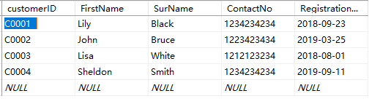
Figure 1 table of customer
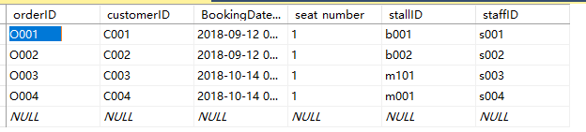
Figure 2 table of order

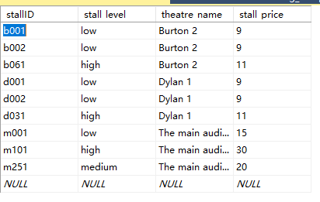
Figure 3 table of stall

Index and Transaction

2.1 Index
In order to achieve the purpose of fast database retrieval, indexes are always been used to database system design. An index is a structure that sorts the values of one or more columns in a database table. An index is used to quickly access specific information in a database table.
There is a good side and a bad side to index creation, good part mainly includes the following three aspects:
- Creating indexes improves the speed of searching through the database;
- Indexes can be used to ensure that each piece of data stored in a database is unique;
- Indexes can be used to reduce grouping and sorting time in queries.
- After the index is established, the optimized hide can be used in the process of information query, which is of great significance to improve the performance of the entire information retrieval system.
In the meanwhile, bad part mainly includes the following three aspects:
- Indexes require database engineers to create and maintain them constantly, and the amount of maintenance increases over time;
- Indexes require storage space.
- When we need to modify the data in the table, such as adding, deleting or modifying it, the index also needs to be maintained dynamically, which brings some trouble to the speed of database maintenance.
We usually try to create indexes on the contents often need to search, primary key, foreign key and so on. Based on the previous experience, I tried to create several indexes.
I created an index on customer table’ primary key, once the staff want to find out whether the customer is a member.
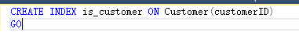
Figure 4 index1

The second index is to speed up the query that a customer wants to check the details of his/her order.
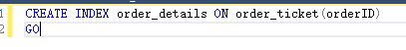
Figure 5 index2

2.2 Transaction
Abertawe Arts Centre wants to use transactions to help them complete the actions that need to be bound. Transactions are units of data operation order and whether or not the database is updated, either all or none of the operations in the transaction are executed. Transactions have four recognized properties: Atomicity, Consistency, Isolation and Durability.
- Atomicity means that all operations in a transaction are indivisible and either all or none of them are executed;
- Consistency means several transactions executed in parallel agree with the result of execution in a particular order;
- Isolation means that several transactions executing at the same time do not affect each other, the result of the parallel execution of the transaction should be consistent with the serial execution;
- Durability means that once a transaction commits, updates to the database are permanent.
Based on the four properties above, I created several transactions which will be shown next. Using the sql statement below can meet the need that company submitted their application but the time is not recorded.
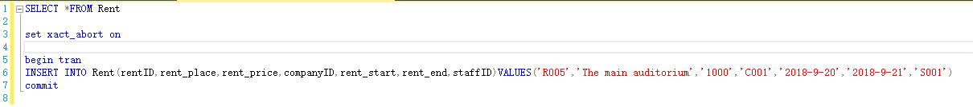
Figure 6 Transaction1

If the data we insert is reasonable, the rent table will be updated.
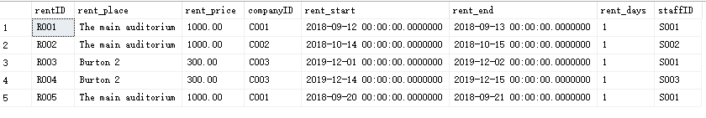
Figure 7 correct result of transaction

The time entered is empty here, the result is the insert failed.
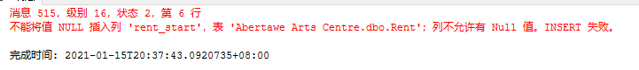
Figure 8 The error message

There is another way of creating a transaction (see figure 9), it can perform the same function
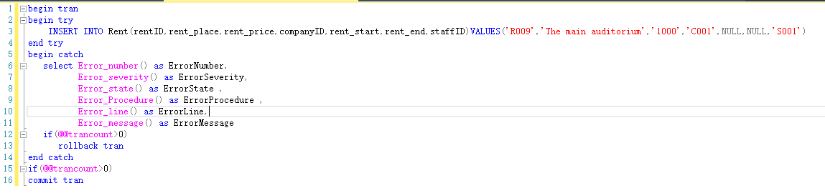
Figure 9 method 2
The second need is that customers can book shows that don't exist, I chose to add a constraint about the date, I only insert into table order_ticket when date exists in table rent.
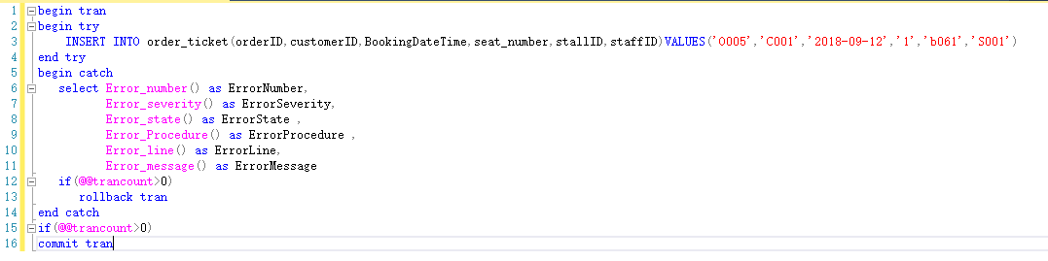
Figure 10 Transaction2
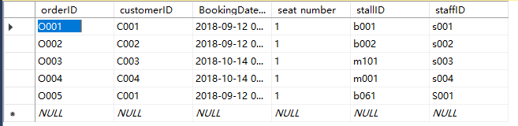
Figure 11 result
When two records are entered, one is valid and the other is illegal, neither record will be updated
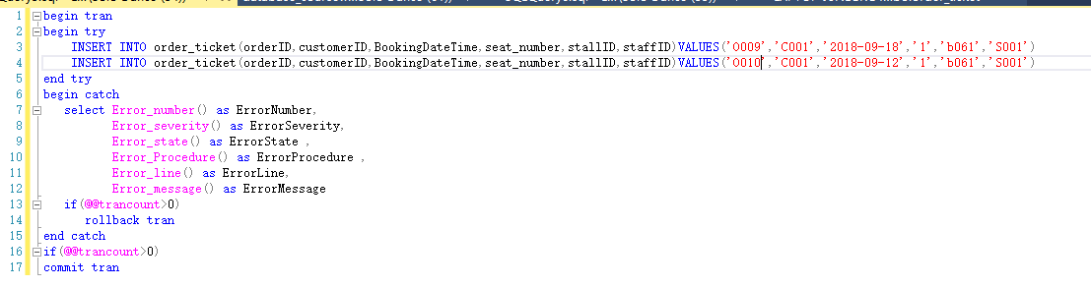
Figure 12 show the results
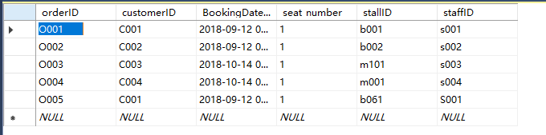
Figure 13 result

Distributed Database Solution

3.1 Theory Introduction
With the increasing maturity of database technology, we have entered the era of big data, the increasing amount of data and the increasing scope of data put great pressure on the centralized database. Centralized databases have several major disadvantages:
- Centralized data processing results in high communication overhead;
- Once the main server failure, the whole will be affected, the reliability is not high;
- Lack of flexibility and scalability.’

Distributed Database System can also be called DDBS, DDBS has a flexible structure and high reliability and good availability. DDBS also has quick response time and high scalability. The main categories of DDBS can be divided into the following two categories:
- Homogeneous Database: All the distributed storage databases are consistent in the operating system, database management system, data structure and so on, so the distributed database is very convenient to manage.
- Heterogeneous Database: Different site of Heterogeneous Database can use different models and different software; this difference may lead to query problems and transaction problems. Besides that, sites can be completely unaware of each other. Different server may use different system, different database management system. They might even use different data model. As a result, communication between sites is relatively difficult and requires translation.

Distributed databases have the following characteristics:
- The data does not reside on a single site, but is stored on multiple sites of Internet,;
- Although data is not stored together, they are logically integrated, shared by all users, and managed by only one database management system;
- Local operations can be done independently within each site;
- They are independent, but they can cooperate with each other.

Distributed database also has the following disadvantages:
- High communication consumption;
- Complicated structure;
- The security and confidentiality of data are more difficult to deal with.

There are four types of fragmentation schemas for the system: horizontal fragmentation, vertical fragmentation, mixed fragmentation, derived fragmentation, I'll go into more details about these four fragmentation schemas:
- Horizontal fragmentation: It means divide a relation into subsets that have no intersection with each other according to certain conditions, and each subset is called a fragment.
- Vertical fragmentation: It means divides a relational table into columns that do not intersect with each other except for the primary key.
- Mixed fragmentation: The combination of Horizontal fragmentation and Vertical fragmentation.
- Derived fragmentation: Shard properties are not properties in the relational table, but some other propertied.

Specific fragmenting rules follow the following three points:
- Completeness condition: All data must be partitioned into a fragment. It is not possible to have globally related data that is not allocated.
- Reconfigurable condition: The split fragment must be available to reconstruct the global relationship before the split.
- Disjoint condition: The segmented data segment is a completely disjoint subset.

3.2 Case analysis
Fragmentation is the process of subdividing a global object into several logical fragments, I mainly use vertical and horizontal fragmentation here. Horizontal fragmentation is equivalent to selecting a subset of instances of a global object, Vertical fragmentation is equivalent to projecting a global object onto its property set.
We can see from the table below that different theaters have different Settings, their grades are different, ticket prices are different, and the total number of seats is different. It can be fragmented using the properties ‘theatre name’ in this table, become different logical pieces. After the fragmentation, the seat will be separated, after combination, they can form the original total table.
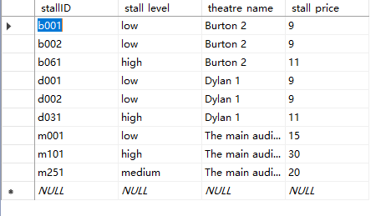
Figure 14 table of stall

I checked table rent, it can be fragmented using the properties ‘rent_place’ in this table. After fragmentation, the whole table will be separated into three tables, the first one only includes the rent order that rent the main auditorium, it will be much easier for a company to check the details of rent when he/she rented the main auditorium. Same as before, the second table only includes the rent order that rent the Burton 2, the third table only includes the rent order that rent the Dylan 1.
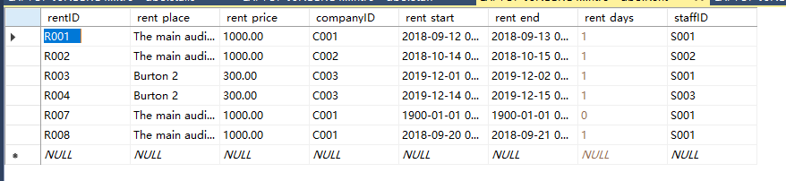
Figure 15 table of rent
In the table of staff, it can be fragmented using the properties ‘position’ in this table, I have four positions in total, they are manager, supervisor, assistant and conductor. After fragmentation, the whole table will be separated into four smaller tables, first table only includes the staff with position called conductor, it will be much easier for the boss to check the details of conductors when he/she want to manage the company. Same as before, the second table only includes staff with position called manager, the third table only includes staff with position called assistant, the fourth table only includes staff with position called supervisor.
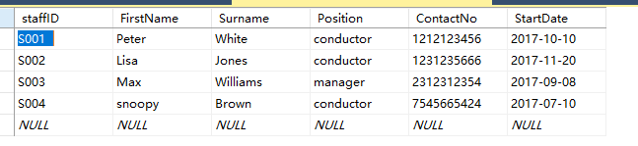
Figure 16 table of staff
In the table of staff, it can be fragmented using the properties ‘Booking Date Time’ in this table, when the manager wants to check the specific date and time of the performance, the total number of queries will be much smaller, the total table reorganized after fragmentation will be consistent with the original table.
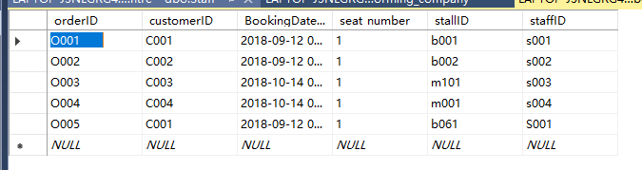
Figure 17 table of order

3.3 Conclusion
The distributed database breaks through the limitation of the centralized database and can provide great convenience for the construction and use of the database under the environment of big data. At the same time, the emergence of this database form to a large extent to solve the problem of low reliability of centralized database, when one of the site failures will not affect other sites, other sites can still operate normally. The problem of high traffic consumption and data transmission security remains to be solved.

4.Conclusion
Through the database course, I learned to use SQL statements create tables, insert data, add indexes, add transactions. In theory, I studied the relational database and non-relational database, what is a distributed database, its advantages and disadvantages, and its characteristics. I strongly believe that through the study of this course, I can meet the need of database knowledge in the future, this knowledge will come in handy.
There is much room for improvement in this database, the attribute content of the table in the database can be improved, such as enriching the gender, salary, length of service and other attributes of employees, which can help managers better manage the employees of the company. The fragments of tables in a distributed database can be more refined and reasonable. If I have the chance in the future, I will optimize this database.

References
[1]https://www.geeksforgeeks.org/distributed-database-system/
[2]https://blog.csdn.net/enmotech/article/details/91685842?ops_request_misc=%25257B%252522request%25255Fid%252522%25253A%252522161070831116780299089555%252522%25252C%252522scm%252522%25253A%25252220140713.130102334..%252522%25257D&request_id=161070831116780299089555&biz_id=0&utm_medium=distribute.pc_search_result.none-task-blog-2~all~top_click~default-1-91685842.first_rank_v2_pc_rank_v29&utm_term=%E5%88%86%E5%B8%83%E5%BC%8F%E6%95%B0%E6%8D%AE%E5%BA%93.
[3] Özsu M T, Valduriez P. Principles of distributed database systems[M]. Englewood Cliffs: Prentice Hall, 1999.
[4] Ozsu M T, Valduriez P. Distributed database systems: where are we now?[J]. Computer, 1991, 24(8): 68-78.
[5] Vagnozzi P. Database indexing method and apparatus: U.S. Patent Application 10/176,566[P]. 2003-7-17.
[6] Manolopoulos Y, Theodoridis Y, Tsotras V. Advanced database indexing[M]. Springer Science & Business Media, 2012.
[7] https://www.guru99.com/what-is-dbms.html.
[8] Bortvedt G K, Gerber R H. Method of commitment in a distributed database transaction: U.S. Patent 5,799,305[P]. 1998-8-25.
[9] Haerder T, Reuter A. Principles of transaction-oriented database recovery[J]. ACM computing surveys (CSUR), 1983, 15(4): 287-317.

