ASSIGNMENT: 2

MODULE: International Meetings Management

Module Code-BMIH6007

STUDENT NAME: Ruksana Begum

STUDENT NUMBER; 2118820

TUTOR: Kathryn Flynn

DUE DATE: 01-01-24

CONTENTS PAGE

SECTION: | TITLE: | PG:
A | Executive Summary, Introduction, Marketing P’S, & The implementation Stage. | 4
B | The Team | 4-5
C | The EMBOK MODEL | 5
D | The Strategic process & Event organisational plan, PROSAL. | 6
E | Target Audience, Logistics | 7
F | Location | 7-8
G | BMA HOUSE LONDON | 8-9
H | SUSTAINABILITY MISSION/VISION | 9
I | Organisational Objectives using SMART | 10
J | Analysing the plan for bid failure | 10-11
K | The Event cycle/concept/schedule & Operation | 11-12
L | SWOT/SITUALTIONAL ANALYSIS | 12-13
M | PESTEL ANALYSIS | 13-14
N | SECURITY & CROWD CONTROL | 14-15
O | CONTINGENCY PLANNING, GUEST ARRIVAL | 15-17
P | LIGHTING & SOUND | 17
Q | Market Factors, Demographic Market, Marketing mix Product, MEDIA | 18-19
R | INFRASTURE PLANNING | 19-20
S | SPONSORSHIP | 21
T | STAKEHOLDERS | 22
U | COMPETITION, TECHONOLOGICAL ADVANCEMENTS | 22-23
V | STAFFING | 24
W | DEMAND SUPPLY, EVENT BUDGET | 26
X | FINANCE CONCLUSION | 27
Y | Finance Expenditure, Income, Recommendations | 28-30
Z.1 | REFERENCES | 31-32
Z.2 | APPENDICIES (1.A- 8) | 33-41

Executive Summary-The project for this event to be running a MICE Event-which is a corporate educational training program on sustainability set out by London Borough Council of Tower Hamlet. An action plan is being developed to ensure that the event runs seamlessly as explained within the presentation.
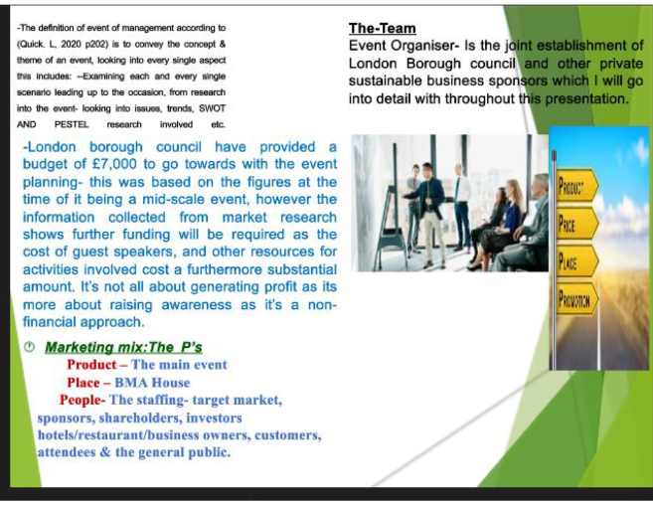
Implementation stage-it’s important to acknowledge on site the delivering of the event. The theme of message being delivered being on track with timescale. Similarly-allowing extra time to set up-and doing a pre rehearsed practise of event to ensure everything goes according to plan/as well as the evaluation stage on how the event went?was it a success?Was there a profit generated?If the main message was addressed etc?
The Team:Event Organiser-Is the joint establishment of London Borough council and other private sustainable business sponsors which I will go into detail with throughout this report. I Ruksana Begum am the main event manager.
-If any profit is made from this it will go back into council to invest into making improved measures on sustainability around this particular borough of London-and if any funds available it may go towards kick starting second part of this event on an international level.
EMBOK Model:
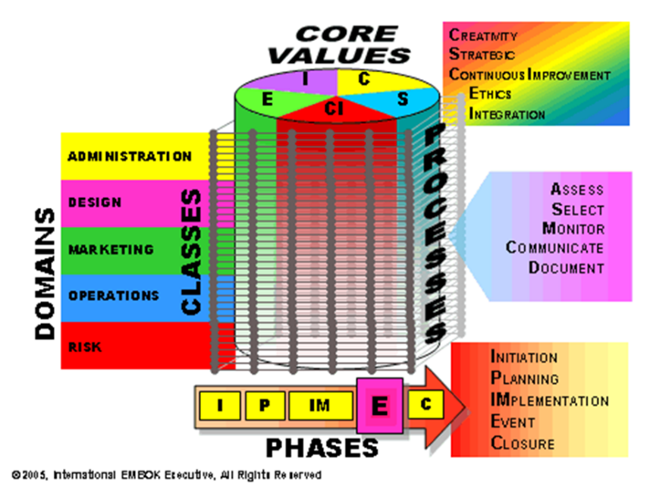
(Embok.Org,2024)
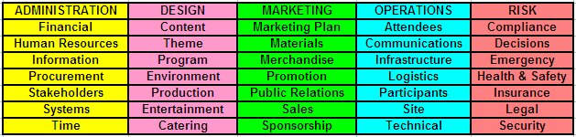
(Embok.Org,2024)
The Embok model will be used throughout the event planning. William Tool put together this resource in1999-there are various colour coded compartments-within elements we will be in particular focusing on the red segment of the model taking an extra emphasis on the risks involved within the planning/implementation of event looking into the health/safety precautions(O’Tool. W, 2008)It’s also important to consider the pink segment of design to help us focus within the creative aspect on the content of the event itself-the theme/production/environment/catering all the important elements that align the theme of sustainability. This report will be referring back to different stages of this Embok model. To help give information/knowledge to the sponsors/stakeholders/for everyone to work together as a team to make this event work(Bladen, C. et al,2012).

The Strategic Process/ Event Organisation Plan
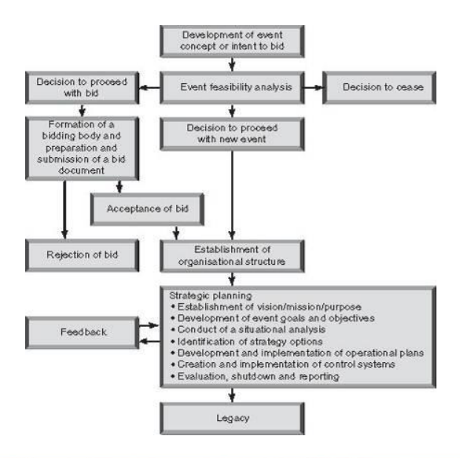 (Grant,2005)
From best practise of theory-we will be following event management strategic planning process for this event(The Bowdin,2012). This will be an effective tool to use as it gives structure of an organised approach to planning/implementing this event. Giving the methods shown within the flowchart-this event can be created to meet the preferences/needs that align within our targets. It helps identify potential bottlenecks within the event process-it may support simplify steps/eliminate repeating steps. This is crucial towards time management to try and get everything in order before the actual event date(Visual Paradigm,2024).This is the theory/event methodology involved we will incorporate both models-this will helps the event work using the information provided.
The Proposal-The proposal for this training programme themed around the importance of sustainability-is to emphasis/critically analyse around this subject. To cover the pink element of content within the Embok model. The sustainability event content has various subjects-REFER TO APPENDIX1A-ON TOPICS/CONTENT ON DIFFERENT SUSTAINABILITY MEASURESTHAT WIL BE COVERED.

Target audience-will be local/national business owners/hotel companies/tourist who are all looking have to a green focused approach-trying to cynically promote sustainability by tapping into the social/cultural aspects of the tourism market-making better choices and practices for the future.
Logistics-organising an event involves logistic considerations to ensure the event runs smoothly from start to finish as shutdown of event is still so important-ensuring safety/protecting the environment/removing debris/managing waste disposal/recycling correctly & a proper clean up ensures areas are safe/maintaining a positive image/complying with regulations/facilitating reflection/improvement. REFER TO APPENDIX 1B ON Logistic Considerations

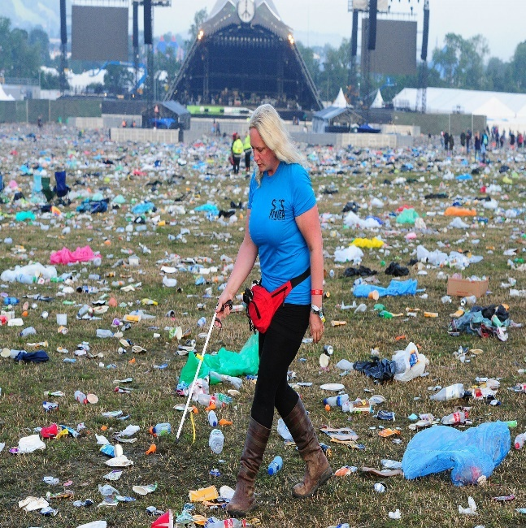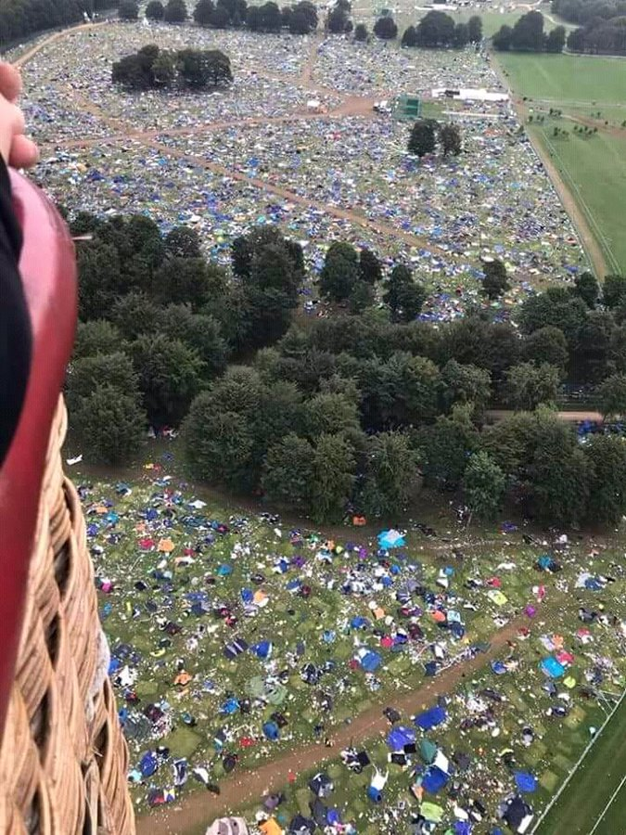

Location-Focusing on the marketing mix of place According to(Fox, D et al,2014 p11).Gathering comprehensive data about the specific location of the event necessitates a significant amount of research as mentioned within the presentation. This process involves delving into various aspects such as geographical features/historical significance/local infrastructure-and any other relevant information-this also aligns with what is required from the pink segment of the Embok Model.

-When it comes to the planning/execution of the event each and every single scenario will need to be taken into consideration e.g. where will it be held?identify factors such as-The financial cost involved in hiring?Is it suited for the target audience/the purpose of the event?Is there enough space?availability of accommodation for long distance attendees?Suitable parking etc. All the research involved was carried before the presentation was conducted it gave us a valuable insight on how to evaluate each aspect-looking into the aims/gain to ensure that the correct decisions are implemented. For instance-choosing the correct location that is suited to accommodate the events requirement/contribute to its overall success(The venue-booker,2024).As explained in the presentation If the event proceeds-the selected location will be the BMA House London(BMA-house.org,2023).As it covers all the criteria needed to achieve what is needed from the event. It also connects with the theme of the event around sustainability. We will explore further into why BMA house has demonstrated its commitment to this by:
-a zero to landfill status in2016.
-Demonstration of a range of environmentally friendly initiatives which include-69%reduction in its carbon footprint saving-5.4million litres of water annually/recycling over46,700 KG of waste since 2019-this meets the criteria of the environmental aspect of the Embok model. REFER TO APPENDIX:2 ON more INFO-on why BMA House has been chosen as the main event location.

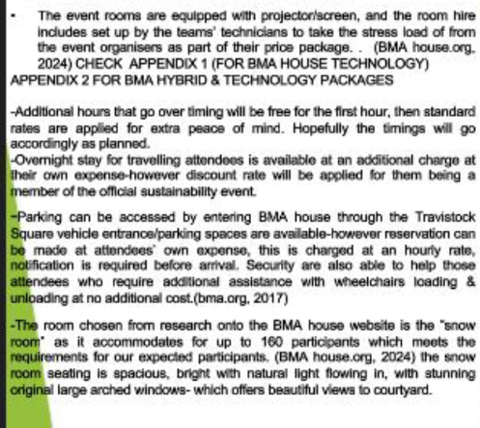
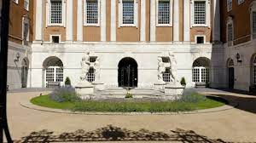

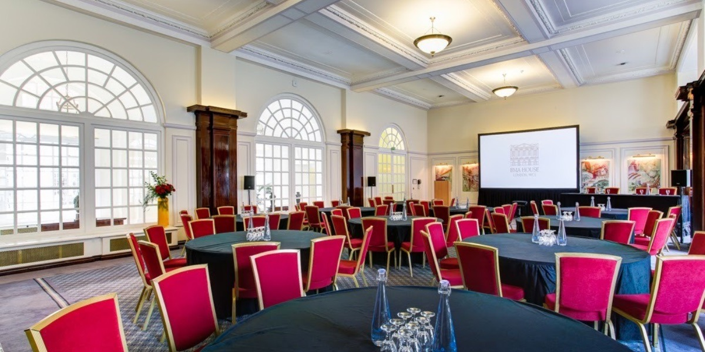
(BMA House.Org,2024)
Sustainability Vision/Mission-Looking into the Vision/Mission of Sustainability as mentioned within the presentation the aim of the project is to reinforce sustainability.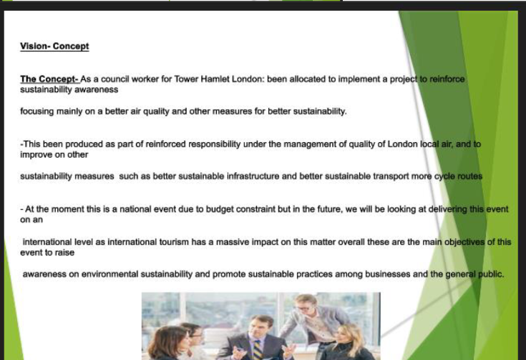
Raising awareness on environmental sustainability and promoting sustainable practices among businesses/the general public. Referring back to best practise of theory-this helps meet the first step of the event management strategic planning process.

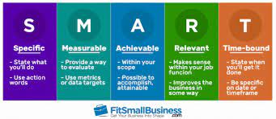
(FitSmall-Business.com,2024)
The Organisation’s Objectives using- (S.M.A.R.T):
- (T):Time Limited-The objectives are clearly defined within the time frame of this event to be achievable. It is feasible given the resources time constraint left to implement the event. Clear direction of time management will help guide the planning and execution of the event successfully for example evaluating the timeliness before the event proceeds from the beginning to end assessing effectiveness of management of staffing as well keeping them updated with briefings of timings of each segment. Referring back to the Embok Model this covers the yellow-compartment of time management.(Launch Space,2024)REFER TO APPENDIX3-FOR OTHER SMARTTARGETS INCLUDINGSPECIFIC/MEASURABLE/ACHIEVABLE/RELEVANT & RANKED.

Analysing the plan- for bid failure-The seal of approval ultimately lies with the head of the-London Borough Council-hopefully the bid will be approved/accepted. However, if it gets disapproved-it will be open to refocus/re-prep again for the next proposal. As the event management team-we feel that there are enough opportunities to proceed-as enough research has been carried out to find correct proposal/location/teams/staffing we feel that there are sufficient sponsors/stakeholders/investors to bring the event forward to-which we will look further into within this report. Analysing the rejection of a bid also covers an important step of the Bowdin’s strategic planning process.
The Event cycle(Bowdin et al,2012) explains that every year a multitude of events take place across the UK-capturing widespread media attention/inundating transpiration networks and hotels energising communication-channels while generating both negative/positive impacts.

There are positives/negatives((Bowdin,2011) states that events can be universal they can generate income/profit/marketing opportunity and promotions/creates a platform-allows hospitality industry to showcase their offerings-building brand awareness/helps attract target audience/potential customers. Also-opportunity to connect with potential clients/partners/suppliers and other industry stakeholders. Negatives include the cost implications/risk of negative reviews/creating traffic congestion within the area/increased risk of anti-social behaviour depending on what type of event it is?/logistic challenges etc, all the positives/negatives mentioned relates in the implementation of our event and this is an important factor to consider.

The Event Concept/ Schedule & Operation-The concept involves in the relevance of creating a sustainable future. As mentioned on presentation-the event will be delivered into segments. We will also at the initial segment of the event provide crucial information to the attendees-to familiarise themselves with emergency procedures/evacuation routes-and important safety information. For this event the attendee total we were hoping to attract is 160attendees in total. As this is the max capacity for the Snow Room. Referring back to the SMART objectives this is keeping the participation level measurable/realistic for us to achieve. We will be using tangible props/decor making the guest experience impactful/memorable(Pro-Global Events, 2024)such as keeping the scenery displayed with images of sustainable measures will be displayed throughout the snow room showcasing what attendees can do to make a difference. The guest will experience/learn segments about sustainability this will be broken up into10 compartments throughout the day between9am–5pm. As shown previously here is the event timetable of what the day will entail as follows:
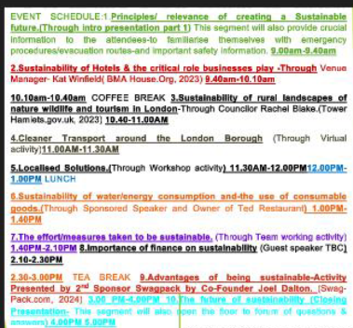
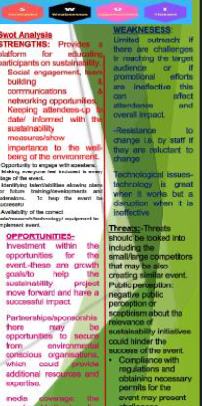
Situational Analysis-this involves gathering/assessing/structuring the data on both the internal/external surroundings of the organisations event(O’Toole, W,2011).Situational analysis can also involve evaluating the events SWOT-ANALYSIS as presented previously. As discussed within the swot/pestel analysis it was highlighted–that it’s important for us to take more emphasis on this matters such as-the disability discrimination act/ not all disabilities are visible there are actions/procedures we will need to follow in order to meet these needs i.e.-inclusive programming/access to quiet spaces for those with sensory sensitivities/or those who suffer with anxiety/overwhelm keeping seating options close to exits if and when they need break/being flexible with breaks; with initial plan-it was down for a mid-morning/1hour lunch and mid-afternoon break-however looking into extra research provided it may be necessary for the final proposal to include further breaks throughout the day extending the event time to close at 5.30PM instead of 5PM. REFER TO APPENDIX4-FOR MORE ON BETTER INCLUSION MEASURES FOR THIS EVENT.

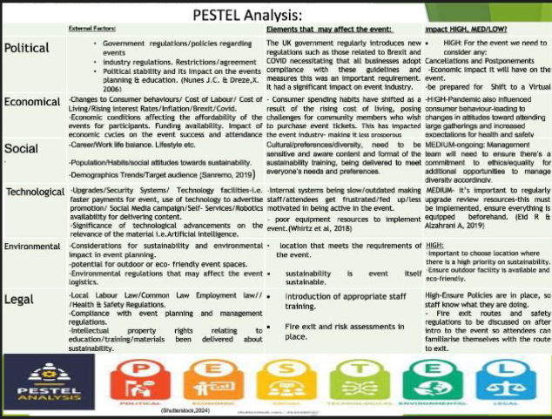
Focusing on the Pestel Analysis social/cultural factors it was highlighted that the management team will need to ensure there’s a commitment to ethics/equality for additional opportunities to manage diversity/inclusion accordingly. Understanding provision for cultural/disability norms. Looking back onto the SWOT analysis the impact on these issues internal strengths/weaknesses include:

-supporting communities by investing in the well-being of the environment/biodiversity this will be done in the training event by doing workshop activities through well-being of the community through sustainable measures of energy/water consumption. REFER TO APPENDIX 5-FOR MORE INFORMATION ON THE EVENTS COMMITMETN TO EDI MEASURES THAT ALIGN WITHIN THE SWOT ANALYSIS.

Security/Crowd control-For this event looking into internal factors, it’s important to consider the layout/flow of guests on arrival/crowd control and how this will be managed-as we do not want the waiting lobby to be jammed-there needs to be an efficient system such as a que formation keeping the flow atmosphere positive and in order. BMA hotel will have their security on hand. This is an important measure as security is an important element. The BMA entrance doors are equipped with metal detectors which is an extra measure-as this is an important part in making sure that the guests are safe. Looking into other major events such as the Arianne-Grande concert it has made it even more critical to have this incorporated-it’s also meets best practise theory of the second step to implement control systems/situational analysis as identified within the process of event organisational plan. BMA HOTEL-have themselves also taken extra measures for all their employees to be trained/respond and access-appropriately towards potentially risky situations(BMA Org,2024). Referring back to the Embok model this follows the Blue/Red segment of operations/attendees/risk and safety(BMA.Org,2024). There was a large segment of the presentation dedicated to safety security as shown below:
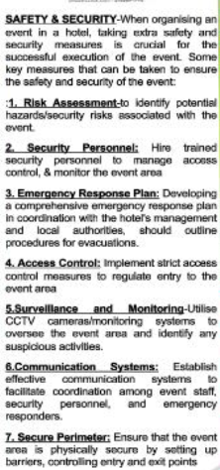
Contingency Planning-This was also incorporated into Contingency plan on the event presentation. The Contingency may need to also consider other aspects that was not given in initial contingency plan such as working toilets/timing being on schedule/working internet and Wi-Fi-running through everything checking and double checking everything ensuring all is efficient.
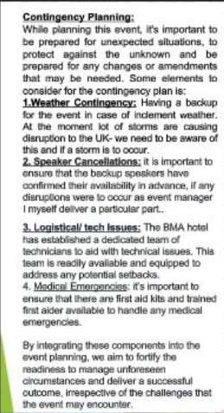

Guest Arrival-The guests will need their tickets on entry and check into the BMA-reception to sign in/followed by a welcome drink at the waiting lobby or courtyard before the doors open for the main event to commence at9AM. Below are examples images of how we intend for the event to proceed in terms of guest arrival/flow:
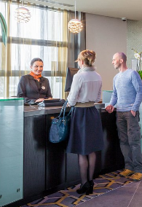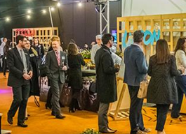
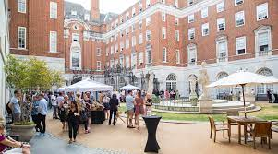
(BMA Org,2024)
Lighting & Sound-As mentioned previously BMA Tech team are at hand for all aspects of technology this includes ensuring that the sound check is in order-all these elements are important as we want to exceed expectations rather than just meet expectations going above/beyond to make this event a transformable experience as stated by(Getz 2012). Also, for the lighting to be effective it needs to align around the principle of sustainability. Making it an eco-friendly even/being mindful of this-for this we have decided to request BMA to switch the lighting to geothermal energy lights this will show attendees the difference of an efficient measure as it only takes2.7 watts LEDs used instead of the standard20-watt lights this reduces energy consumption(Font et al, 2015). Not only will we use this within the snow-room but will be providing this for each attendee to take home.

Market Factors-From research according to(Quinn. B,2013)organisations can carry out market research in order to analyse their markets as previously explained on event presentation.

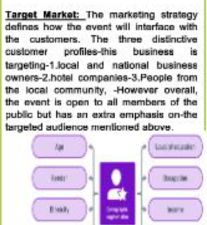

The Demographic Market-For this event we will approach the demographic segmentation by focusing on these particular targets as explained in event presentation.
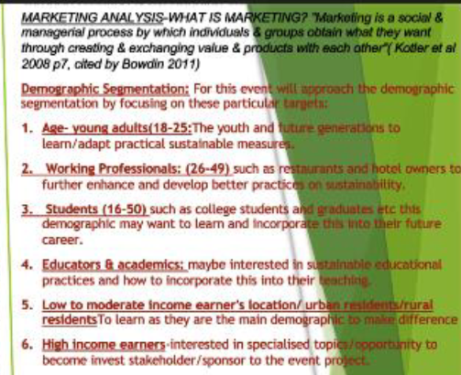
Marketing Mix:Product-To promote the event we have decided to do social media campaign/we will create an app for the event/provide a website for individuals to be able to purchase event tickets/advertising purposes we will also be using other traditional methods of advertising as mentioned on presentation. The social media campaign-can be used to share and continue connecting information on the sustainable event-we have also decided to employ a social media Platform Manager to help manage the content of the event website/social media page(Bark.com2024).
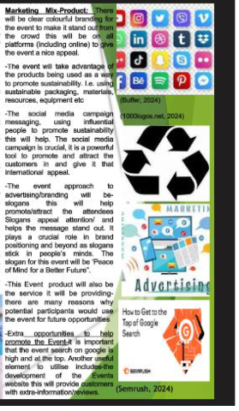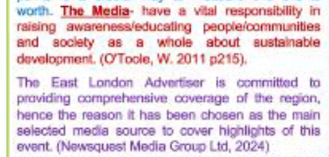
Infrastructure planning-These considerations are crucial such as-keeping the event unique/bespoke/outside space accesses points/hand sanitise stations/as this is an expectation now because of covid. All these considerations have been mentioned within the presentation.
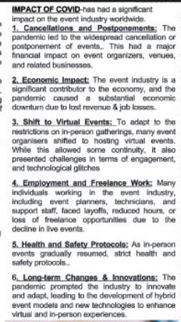

USP(Unique Spelling Point) & Exceptional Experiences-Our event unique selling point-will have the wow factor from the event settings-as some attendees many not have ever attended such as prestigious event or of had the experience/chance to be part of a luxurious hotel experience as BMA. The whole experience may even create an emotion for attendees-making this memorable as well as giving a long lasting impact to take something back on sustainable changes/environmental concepts. Within the ticket price the package includes speakers that renowned within the sustainable hospitality industry they include Owner of TED Restaurants alongside CEO of Swag Pack-who will also be looking to take care of the catering of this event-and swag pack will be working alongside us to take care of the merchandise-products of this event. All of the main details have been given in the initial event presentation as shown below.
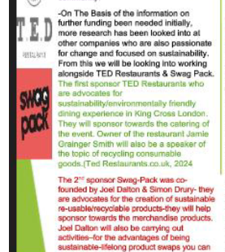

Stakeholders-Major stakeholders will include the host organisation staging the event which in this case is London Borough Council of Tower Hamlet and the host community which for our event BMA-house as discussed within the presentation.
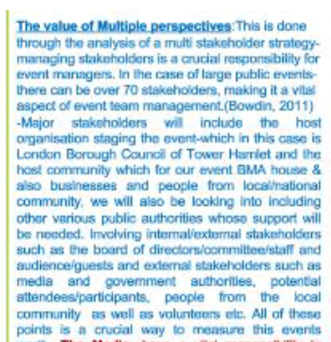

COMPETITON-Our event will be going head to head with other similar events within the area as mentioned within the presentation inserted below;when events are set out around similar timing to each other it can be difficult to win over the speakers/investor’s participants etc. However-we will try to keep our event bespoke/unique especially when it comes to the technological advancements as this will not be overlooked-using technology to enhance the event(Accelevants, 2020).REFER TO APPENDIX-6 FOR MORE INFORMATION ON TECHONOLOGICAL ADVANCEMENTS.
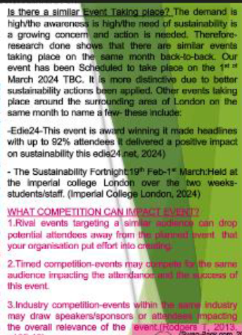
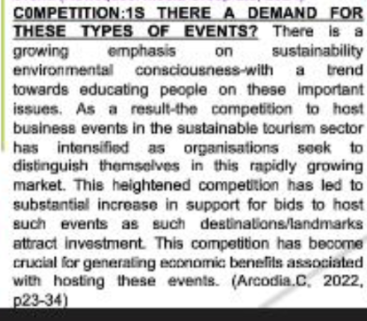
Staffing-This is heavily relied on the running of this event. The staffing should be sufficient/equipped/trained appropriately, and their skill set should be relevant to what is required for this event;we may need to consider-support from volunteers as well-this will also help reduce costs-however it’s still important to give a kind gesture in return-for them to return for future events. In the presentation there were details about the staff costings. It does not matter how large/small the event maybe it’s crucial for staff to understand the rules/regulations/risk management involved within an event process.REFER TO APPENDIX-7 ON MORE ON WHAT MANAGEMENT & STAFFING ARE ABLE TO DO FOR THE OVERALL SUCESSS FOR THIS EVENT.

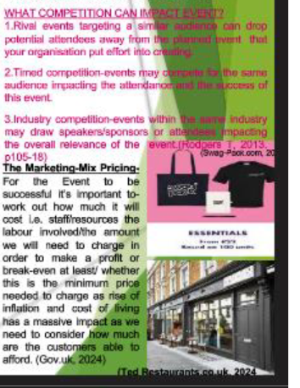
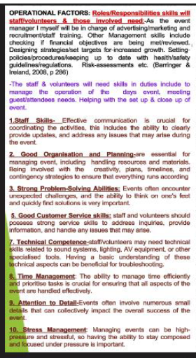
Demand Supply:In the content of event management-the rule of supply can be used to find out to optimal pricing strategy for event merchandise-this is another way to maximise revenue. There are examples given within the presentation on how events can generate income when demand is high.
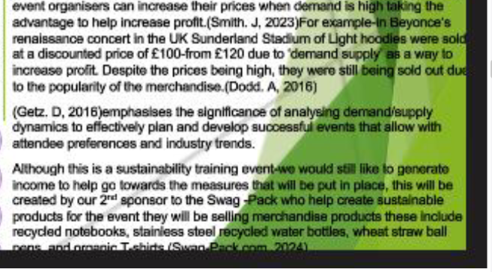
Event Budget-Initially£7,000will be injected from council for booking of event as mentioned within the presentation-The media market expenses are costly, however this is money spent well as it will help provide(ROI)attracting customers in. To help manage the expenses/and not have a loss we have to look at ways to boost revenue streams from various sources-from which the event can generate money from the sales upgraded tea/coffee beverages/selection of freshly baked cakes/biscuits/having a range of these upgraded products- will also be another good way to make money;this will enable the event to break even/or create a profit as the sale of event tickets are not enough to produce a profit.REFER TO-Appendix 8: More information on event finance
-CHECK BELOW FOR FINANCE CHART AS SHOWN WITHIN PRESENTATION.
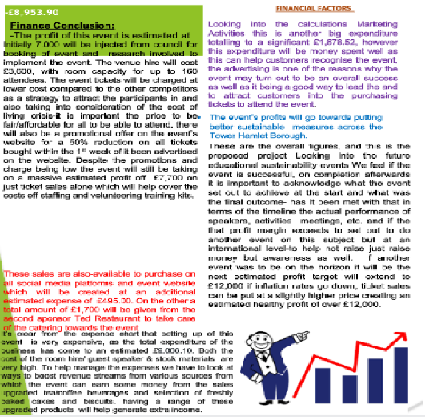

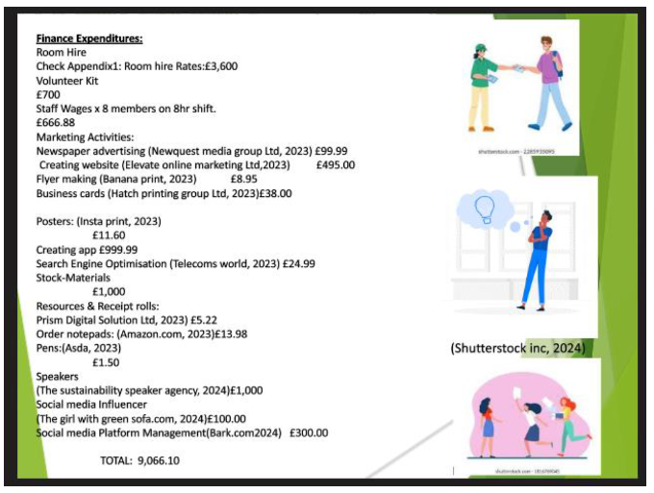
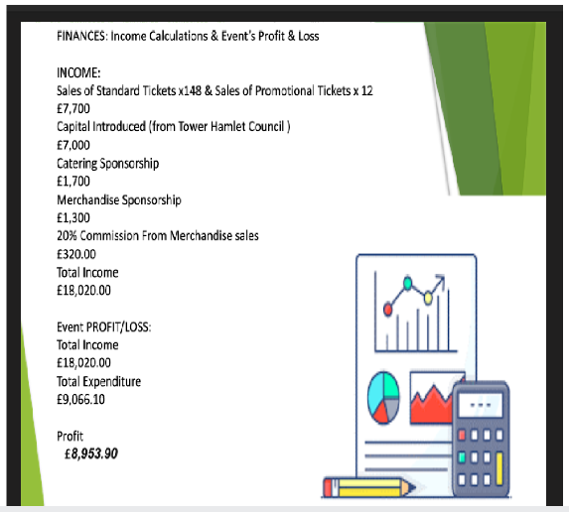

Recommendations:
- Other ways to attract customers in within future events include extended promotional discount period and maybe add more of a range to the cake & beverage service, this will enable the event to have more of a competitive edge over other similar events within the surrounding areas.
- If done again maybe consider extending more attendees capacity, making it more rigorous and impactful
- If another event was to be on the horizon it will be the next estimated profit target will extend to £12,000 if inflation rates go down, ticket sales can be put at a slightly higher price creating an estimated healthy profit of over £12.000 which is a good case scenario.
- Looking into examples of worst case scenarios include the Athens Olympics 2004-the targets were not realistic, a lot of money went in. The event overall was over promised put did not live up to its expectations. The Olympic sport event stadium is now left abandoned/empty as a result and the Greek economy went bust. (Manfred. T, 2014)

(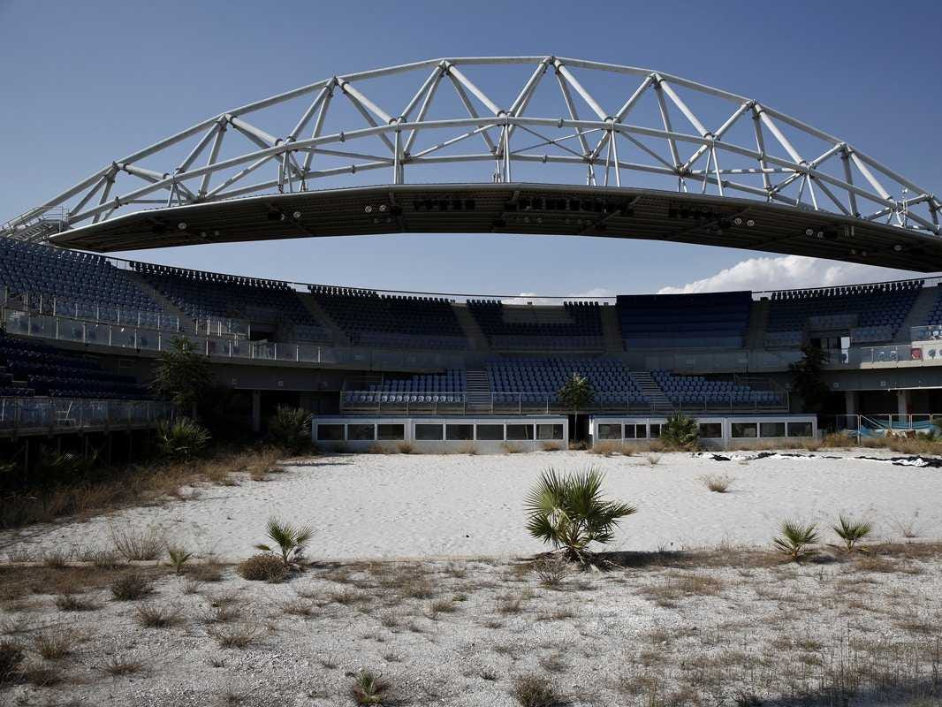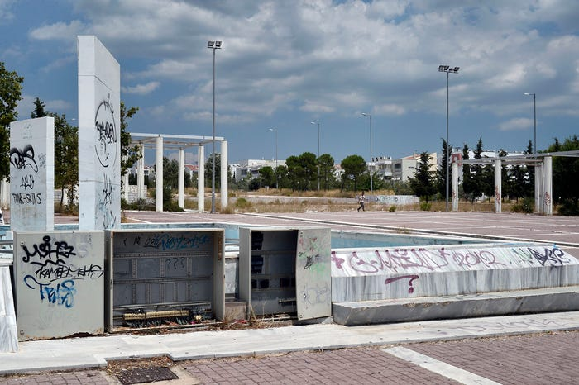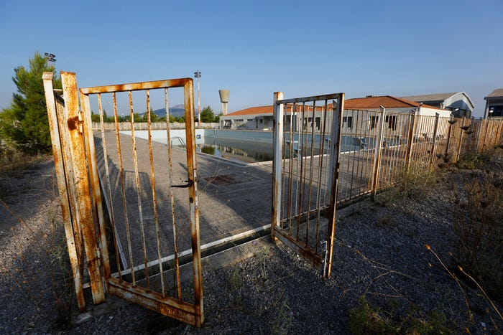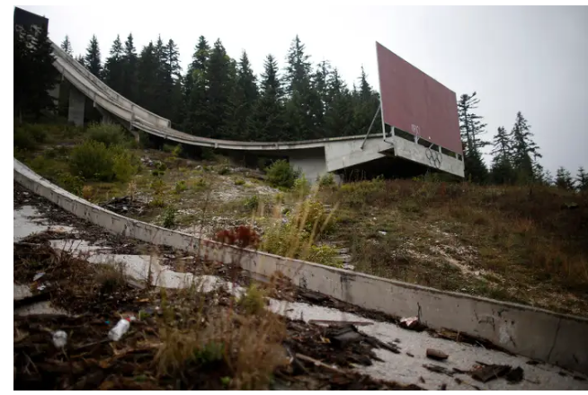
(Manfred. T,2014)

REFERENCES :

Accelevants (2020) TOP8 EVENT TECHONOLGY TRENDS [Video] Available at: https://youtu.be/QGjKt7WWTRw?si=foRv113Qw2BMBtOi

Bark.com (2024) how much does social media marketing cost? 2023 online available at: https://www.bark,com/en/gb/socail-media-marketying/-price-guide/ Accessed 26TH Feb 2024)

Bladen, C. et al, (2012) Event management: and introduction. Abingdon: Routledge Seven

BMA house.org (2024). BMA House London [online] Available at: https://www.bmahouse.org.uk/meet-the-team/(Accessed 17t^{h} FEB 2024)

BMA.Org (2017) Accessibility Guide 2017[online] Available at: https://www.bma.org.uk/media/1547/bma-house-acsessibility- guide-2017.pdf
(Accessed 16th FEB 2024)

Bowdin, G. et al, (2012). Events Management (3rd ED) Netherlands Taylor & Francis

Bowdin, G. et al, (2011.) Events Management (^{2nd} ED) Oxford: Elsevier.

Embok.Org (2024) Welcome to Embok.Org! [Online] Available at: EMBOK - Event Management Body of Knowledge - Afterburner2 — Free, GPL Template (Accessed 27th February 2024)
Font, X., Walmsey, A., & Cogotti S.(2015) Tourism & Water: interactions impacts & challenges. Bristol: Channel View Publications
Fox, D et al. (2014) Doing Events research: from theory to practice. Routledge: Oxford

Francis. C (2023) pictures show disgraceful aftermath of Glastonbury Festival [Online]Available at: Pictures shows disgraceful aftermath of Glastonbury Festival | news.com.au — Australia’s leading news site (Accessed 27th February 2024)
Getz, D. (2012) Event management & Event tourism, 2ND Edition. New York: Cognizant Communication.
Grant, R. (2005) Contemporary Strategy Analysis. Melbolurne, Blackwell
Launch Space (2024) How to create meaningful S.M.A.R.T goals [Online] Available at: How to Create Meaningful SMART Goals - Launch Space (Accessed 27th February 2024)

Manfred. T (2014) What The Abandoned Venues From The Athens Olympics Look Like 10 Years Later [Online] Available at: Abandoned Athens Olympics Venues 10 Years Later (businessinsider.com) Accessed 27th February 2024)

NME (2024) we are the pigs: the people who pick up after you at festivals reveal their horror stories [Online] Available at: The People Who Clear Up After You At Festivals (nme.com) (Accessed 27th February 2024)
O’Toole, W. (2011) Events feasibility and development: from strategy to operations. Elsevier: Oxford
O’Toole, W. (2008) ) Event feasibility and development. Amsterdam:Routledge

Pro-Global Events (2024) The secret to planning a successful corporate event in a hotel. goals [Online] Available at The Secret to Planning a Corporate Event in a Hotel | ProGlobalEvents (Accessed 27th February 2024)
Quick. L, (2020) Managing Events: Real Challenges, Real Outcomes. Sage London
Quinn, B. (2013). Key concepts in event management. United Kingdom SAGE. Publications Ltd. http://www.doi-org.ezoproxy.uwstd.ac.uk/10.4135/9781473914742
Ted Restaurants.co.uk (2024) Welcome to T.E.D- A Taste of seasonal Britain [online] Available at: https://www.tedrestaurants.co.ukAccessed 18th FEB 2024

The venue-booker (2024) Top ten sustainable hotels and conferences venues September 2021 [online] Available at: https://www.thevenuebooker.co.uk/news/sustainable-conference-hotel-uk(Accessed 13th February 2024)

Visual Paradigm (2024) Event Planning Flowchart [Online] Available at: Event planning flowchart | Flowchart Template (visual-paradigm.com) (Accessed 27th February 2024)
APPENDIX 1A:

TOPICS/CONTENT THAT WIL BE COVERED WITHIN THE EVENT:
- Principles/ relevance of creating a Sustainable future.
- Sustainability of Hotels & the critical role businesses play.
- Sustainability of rural landscapes of nature wildlife and tourism.
- Sustainability of water/energy consumption and the use of consumable goods.
- The effort and measures taken to be sustainable.
- Importance of finance on sustainability
- Advantages of being sustainable
- The future of sustainability.

APPENDOIX 1B:

LOGISTIC CONSIDERATIONS: Overview of some key logistics involved in hosting this event:

1.Venue Selection.
Considerations on choosing the appropriate venue, which facilitates for hosting an educational training events, such as meeting rooms, audiovisual equipment, and comfortable seating arrangements.

- Ensuring that the venue has easy access to toilets for attendees, including facilities for individuals with disabilities.

2.Event Set-Up

- Considerations for layout of the event space to accommodate the number of attendees and any specific requirements for the training sessions.

- Set up a cloakroom area if needed for attendees to hang coats and store personal belongings during the event.

3.Indoor/Outdoor Space: Considerations for if indoor and outdoor space is available at the venue for breaks, networking sessions, or additional activities related to the training event.
4.Provision of Drinking Water: if the venue coordinates with hosts to ensure that drinking water is readily available for attendees throughout the event.
5.Invitation and Registration Process
Considerations to develop an invitation list based on our target audience and send out invitations through appropriate channels. Setting up a registration process for attendees to RSVP and confirm their attendance at the event via event website or social media pages.

6. Financial Management

Considerations for creating a budget for the event that includes expenses such as venue rental, catering, equipment rental, and marketing costs etc. Track expenses and revenue related to the event to ensure it stays within budget.

7. VIPs and Media Representatives
- Determining any special requirements for VIP guests and media representatives, such as reserved seating, media coverage, or special accommodations.
- Considerations of coordination with the hotel to ensure that VIPs and media representatives are taken care of during the event.

8. Different Activities

- Planning a schedule of activities for the training event, including presentations, workshops, networking sessions, and breaks.

- Coordinate with speakers, trainers, and vendors to ensure that all activities run smoothly and on schedule.

- Giving importance to these logistical aspects, we can help ensure that the educational training event held within the chosen venue is organised effectively and provides a valuable experience for attendees.

Event organisers should consider these aspects as integral parts of the events planning process to ensure the overall success an impact of their events-In respect to Glastonbury it’s the largest/most iconic music festival-in the world held annually in the UK the aftermath of this concert poses significant challenges for cleanup/closure due to the sheer size of the event and the impact it has on the environment-it generates a large amount of waste including plastic/food waste and-pollution to the land waterways/surrounding areas impacting local ecosystems/wildlife. The cleanup-requires coordinated efforts from organisers/volunteers/contractors as specialised equipment/resources often needed to restore the site to its original condition. All these efforts are essential for mitigating the environmental impact, preserving the site integrity and demonstrating equipment to environmental sustainability (Francis.C,2023). 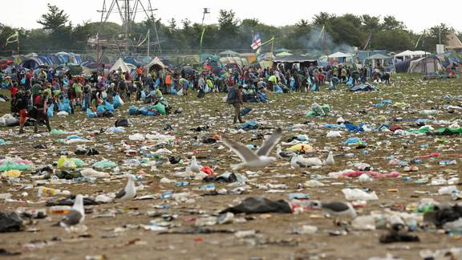

Appendix 2:
More Information on why BMA House has been chosen as the event location:

- Efforts of BMA house has been recognised with several prestigious awards such as the greenest venue by highest space in 2018 and 2019.
- The most sustainable venue by London summer adventure in 2019
- -the silver award for the best CSR of sustainability initiative at the 2019 London venue awards.
- -Furthermore, BMA house provides event planners with a unique inner-city Oasis in the form of its rooftop mindful garden, where access is allowed to the attendees for a further exceptional experience.
BMA HYBRID & TECHNOLOGY PACKAGES (BMA House.Org, 2024)
- 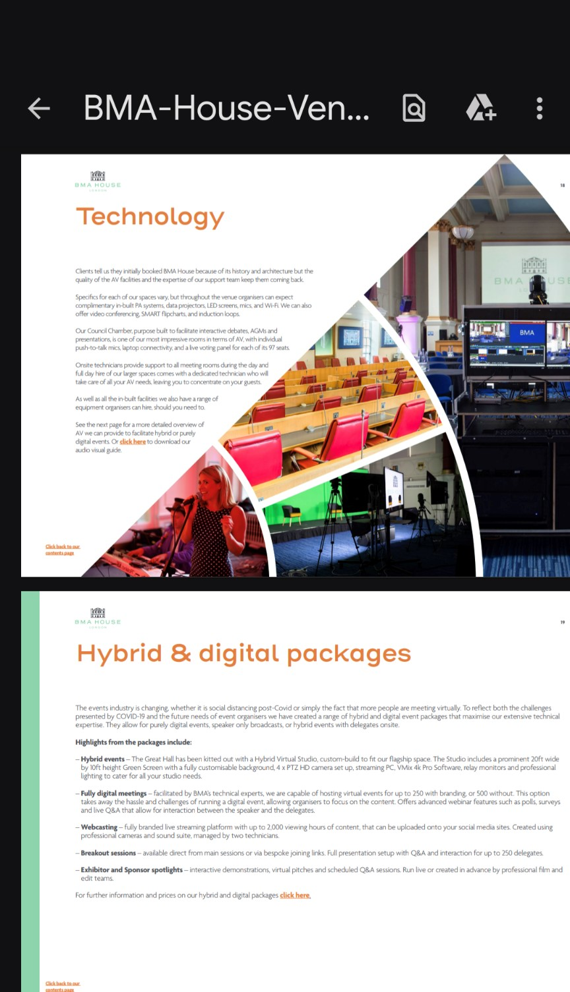

- BMA HOUSE: SNOW ROOM HIRING RATES:
- 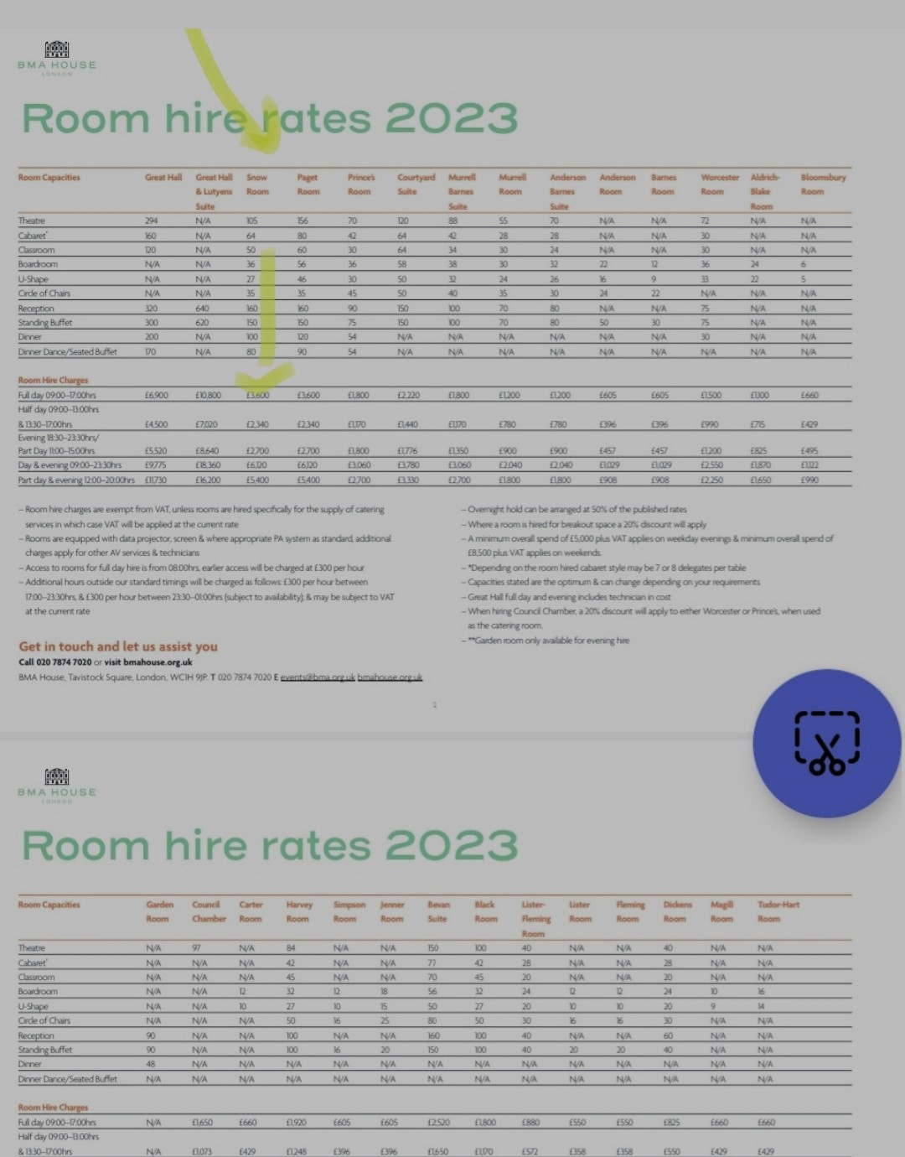
- Room Capacities Great Hall Great Hall Snow Paget Prince’s Courtyard Murrell Murrell Anderson Anderson Barnes Worcester Aldrich- Bloomsbury
- & Lutyens Room Room Room Suite Barnes Room Barnes Room Room Room Blake Room
- Suite Suite Suite Room
- Theatre 294 N/A 105 156 70 120 88 55 70 N/A N/A 72 N/A N/A
- Cabaret
- *
- 160 N/A 64 80 42 64 42 28 28 N/A N/A 30 N/A N/A
- Classroom 120 N/A 50 60 30 64 34 30 24 N/A N/A 30 N/A N/A
- Boardroom N/A N/A 36 56 36 58 38 30 32 22 12 36 24 6
- U-Shape N/A N/A 27 46 30 50 32 24 26 16 9 33 22 5
- Circle of Chairs N/A N/A 35 35 45 50 40 35 30 24 22 N/A N/A N/A
- Reception 320 640 160 160 90 150 100 70 80 N/A N/A 75 N/A N/A
- Standing Buet 300 620 150 150 75 150 100 70 80 50 30 75 N/A N/A
- Dinner 200 N/A 100 120 54 N/A N/A N/A N/A N/A N/A 30 N/A N/A
- Dinner Dance/Seated Buet 170 N/A 80 90 54 N/A N/A N/A N/A N/A N/A N/A N/A N/A

- Room Hire Charges
- Full day 09:00–17:00hrs £6,900 £10,800 £3,600 £3,600 £1,800 £2,220 £1,800 £1,200 £1,200 £605 £605 £1,500 £1,100 £660
- Half day 09:00–13:00hrs
- & 13:30–17:00hrs £4,500 £7,020 £2,340 £2,340 £1,170 £1,440 £1,170 £780 £780 £396 £396 £990 £715 £429
- Evening 18:30–23:30hrs/
- Part Day 11:00–15:00hrs £5,520 £8,640 £2,700 £2,700 £1,800 £1,776 £1,350 £900 £900 £457 £457 £1,200 £825 £495
- Day & evening 09:00–23:30hrs £9,775 £18,360 £6,120 £6,120 £3,060 £3,780 £3,060 £2,040 £2,040 £1,029 £1,029 £2,550 £1,870 £1,122
- Part day & evening 12:00–20:00hrs £11,730 £16,200 £5,400 £5,400 £2,700 £3,330 £2,700 £1.800 £1,800 £908 £908 £2,250 £1,650 £990
- – Room hire charges are exempt from VAT, unless rooms are hired speciﬁcally for the supply of catering
- services in which case VAT will be applied at the current rate
- – Rooms are equipped with data projector, screen & where appropriate PA system as standard, additional
- charges apply for other AV services & technicians
- – Access to rooms for full day hire is from 08:00hrs, earlier access will be charged at £300 per hour
- – Additional hours outside our standard timings will be charged as follows: £300 per hour between
- 17:00–23:30hrs, & £300 per hour between 23:30–01:00hrs (subject to availability); & may be subject to VAT
- at the current rate
- – Overnight hold can be arranged at 50% of the published rates
- – Where a room is hired for breakout space a 20% discount will apply
- – A minimum overall spend of £5,000 plus VAT applies on weekday evenings & minimum overall spend of
- £8,500 plus VAT applies on weekends.
- – *Depending on the room hired cabaret style may be 7 or 8 delegates per table
- – Capacities stated are the optimum & can change depending on your requirements
- – Great Hall full day and evening includes technician in cost
- – When hiring Council Chamber, a 20% discount will apply to either Worcester or Prince’s, when used
- as the catering room.
- – **Garden room only available for evening hire
- 2
- Get in touch and let us assist you
- Call 020 7874 7020 or visit bmahouse.org.uk
- BMA House, Tavistock Square, London, WC1H 9JP. T 020 7874 7020 E events@bma.org.uk bmahouse.org.uk
(BMA House. Org, 2024)

APPENDIX 3:
APPENDIX 3-MORE ON SMART TARGETS INCLUDING:

- (S)Specific-being specific if all tickets are to sell out at the standard rate the profit could be at£8,000-on just ticket sales alone, however on the finance summary the profit has been targeted at£7,700-This is keeping the target realistic aligned with the overall purpose of the event-and it will be the best-case scenario, to make informed decisions based on concrete data available.The worst-case scenario would be if the event idea was copied by a competitor. It’s not just about the finance objectives because the main aim for this event is to raise awareness in particularly to reinforce sustainability awareness focusing mainly on a better air quality and other measures for better sustainability.

- (M):Measurable-For this event the aim at the start was to at least make a break even or have some profit. This is measurable as setting an overly ambitious goal that is not feasible can be demotivating and counterproductive.

- (A):Achievable-Looking into the forecast of this finance summary a profit looks capable to achieve, hopefully this will go back into council to help develop on sustainable measures on susstainability. For this we will need to have the competitive advantage by not increasing the ticket prices so that people are able to afford it, we will also need the correct resources and appropriate staff training to help meet this goal.

- (R):Relevant/Ranked-it’s important to priorities the objectives based on the importance and the impact of the environment. Some of the objectives are more critical and have been given an advanced mission and higher priority for example in promoting sustainable systems for better air quality, this is a key focus of the event objective rather than the other objectives by ranking this objective as a higher mission it ensures that the public are aware of the resources that will be implemented and allocated for this objective to be successful.
APPENDIX-4 MORE INFORMATION ON BETTER INCLUSION MEASURES FOR THIS EVENT INCLUDES:
-Communication: Encourage attendees to disclose any specific needs or accommodations they may require when registering for the event. Ensure that communication channels are open and accessible for individuals to express their needs.

-Assistive Technologies: Provide assistive technologies and aids, such as hearing loops, captioning services, or braille materials, to support attendees with different types of disabilities.

-Staff Support: Train event staff to be aware of and responsive to the needs of individuals with disabilities, including providing assistance, guidance, and support as needed.
APPENDIX 5
FOR MORE INFORMATION ON THE EVENTS COMMITMETN TO EDI MEASURES THAT ALIGN WITHIN THE SWOT ANALYSIS.
-Providing all guests with inclusion awareness on sustainability and how they can get involved in planting trees within the community as this is for everyone to get involved for better air quality.
-Collaborating closely with the event host, who has proactively embraced diversity, equality, and inclusion in its operations, they prioritize initiatives such as the women leadership development program to empower and support women in their professional advancement (Holtgrieve, 2021). The company's core values prioritize people's well-being above all else, demonstrating a deep commitment to fostering a culture that puts people first. BMA's policy statements address a wide range of crucial issues, including promoting global diversity and inclusion, poverty alleviation, disaster relief, nurturing disability well-being, and other aspects of Equality, Diversity & Inclusion (EDI). Through creating an inclusive environment, BMA has made diversity and inclusion a fundamental part of its corporate agenda, leading the local hotel industry in cross-cultural understanding by offering workshops and engagement activities that promote intercultural communication and collaboration(BMA House.Org, 2024)
APPENDIX 6: THE USE OF TECHONOLOGICAL ADVANCEMENTS:

The technological advancements can be used to our event’s favour, i.e. special effects-we are not using this just for the sake of it being used but also to portray an important message. The initial idea on presentation was keeping it be-an in person day event, however more thoughts and considerations have been given to make use of the hybrid event facility as well, giving that BMA House have all the resources available to deliver this/it is less costly for attendees and its making use of the evolutionary technological trends/advancements. Through the virtual reality segment of the event-we will be incorporating a workshop element which will add gamification-the games will be based on sustainability measures were attendees can collect points to win the game-this will help interaction/bring in the fun factor to the event. Making use of all these technological innovation will change the way attendees interact/socialise within the event moving on with times.
APPENDIX 7:What else can management & staff to do to achieve a successful event

- Implement mini briefings before event commences. It’s important to get the staff to develop a good team building skills-for to be able to work alongside each other ultimately to achieve goals for the success of this event. There are challenges as well when it comes to staff as it was explained within the Presentation
.
Appendix 8:More information on Event Finance
- It’s clear from the expense chart-that setting up of this event is very expensive, as the total expenditure-of the business has come to an estimated £9,066.10. Both the cost of the room hire/ guest speaker & stock materials are very high.

- The calculations for the stock materials an extra 5% has been added to the initial total. The stock materials-cost will cover for locally sourced coffee beans/tea pods/milk/sugar/the ingredients needed for the chai-recipe tea as the upgraded for hot drinks on service for the event. Also, the-eggs/flour/all the dairy/vegan free items for cake and biscuits and-all the necessary ingredients needed has been added-these will be purchased on volume wholesale rather individual market sale-as buying in bulk help reduce costs.

