

Name :- Shivam Sanjivkumar Patel

Progranne:- Msc Data and Artificial intelligence

Module:- ACCA7015, Data mining and visualisation

Student ID:- 2435900

Submission Date 21/11/2025

Abstract
The current project works with AB_NYC_2019 data to forecast Airbnb room types and determine valuable market segments. Two classification models were used, namely the Random Forest and the SVM, which were applied after preprocessing; i.e. dealing with missing values, encoding categorical variables and scaling numeric features. Random Forest had the best stability and accuracy. K-Means clustering (k=6) identified these specific listing groups in terms of price, availability and minimum nights. Findings indicate that the most predictive variables of room type are price, the number of hosts listed, and minimum night. The classification-clustering algorithm offers useful output as applied in the host pricing policy, market segmentation, and platform-level decision support.

Table of Contents
Abstract 2
1.0 Introduction 4
2.0 Literature review on predictive analytics 4
2.1 Predictive analytics in the hospitality and short-term rental industry 4
2.2 Classification Techniques of Predictive Modelling. 5
2.3 Mining of Clusters, Segregations and Association Rules. 6
2.4 Gaps in the Literature 7
3.0 Dataset description 7
3.1 Source 8
3.2 Features & Target Variables 8
3.3 Pre-processing Steps 8
4.0 Methodology 9
4.1 Classification Approach 9
4.2 Clustering Approach (K-Means) 10
Selection and Scaling of Features. 10
4.3 Evaluation Strategy 11
5.0 Results analysis 11
5.1 Classification Results 12
5.2 Clustering Results 13
6.0 Discussion of findings 16
7.0 Business recommendation 18
8.0 Conclusion 19
9.0 References 20
10. Appendix 23

1.0 Introduction
Evidence-based problem-solving has taken a central role in the processes of digital platforms to optimize their performance, and Airbnb is one of the first examples of business models that are reinforced with predictive analytics. Having a list of millions of listings and different neighbourhoods, the hosts have to make critical choices in relation to pricing, availability, and positioning of room types. Predictive analytics can be used to transform raw listing data into actionable intelligence by Airbnb stakeholders. This becomes all the more important because hosts are experiencing issues with regards to demand elasticity, changes in tourist trends, as well as competition in the form of other listing websites. Using machine-learning models to predict the results, including the type of room, the room expected to be booked, and the maximum price point will allow hosts to better manage their revenues and distribute their resources.
There has been a significant success of machine-learning methods in Airbnb studies. It has shown that price forecasting error is reduced when using predictive models like the Random Forests [19]. Another study revealed that the host decision-making process is more interpretable when the environmental and tourism-related indicators are included [7]. Such insights are used in strategic pricing and customer targeting. The modern hosting strategies are thus dependent on predictive modelling particularly as the Airbnb markets are increasingly competitive. In this project, the AB_NYC_2019 dataset is utilized to categorise listings and find meaningful clusters, which can be used to make more robust business decisions based on price optimisation, segmentation, and listing strategy. The analysis therefore holds data-mining methods in line with commercial aim of generating value among hosts and the platform.

2.0 Literature review on predictive analytics

2.1 Predictive analytics in the hospitality and short-term rental industry
Predictive analytics is now a force in the hospitality industry in which the fundamental aspects of revenue management are based on demand forecasting, optimisation of prices and prediction of occupancy. Machine-learning models are prone to work well with large, heterogeneous datasets, which big data entails, including location, property characteristics, availability, and host behaviour in the context of short-term rentals. As study showed, randomised methods like Random Forests can much better model Airbnb prices, and can be used to achieve high predictive accuracy (R2 [?] 0.73) [19]. This goes to support the belief that, non-linear trends shape the pricing behaviour, particularly in competitive urban markets. Likewise, a general modelling framework was used with listing-level characteristics and external environmental and tourism variables [7]. Even though the addition of external variables enhanced interpretive value, their predictive value was low because of coarse spatial granularity.
Research expanded on this knowledge by examining the trends in market forecasting on Airbnb by noting the relevance of ensemble learning, hedonic modelling, feature engineering to understand the dynamics of pricing and occupancy [8]. Their results are in line with international research that predictive models assist host to predict demand changes and adjust pricing model.

2.2 Classification Techniques of Predictive Modelling.
The Airbnb analytics revolves around classification models, which help with predicting the category of the room type, finding high-risk listing, and grouping the property into different categories. Random Forests are typically applied to hospitality analytics, and the algorithm is highly effective because it is non-parametric and has no tendency to overfitting. According to study, Random Forests were discovered to be the strongest and the most effective predictor of prices; thus, it is reasonable to use it in classification processes, including room type categorisation [19]. Support Vector Machines (SVMs) have been applied in large scale in problems of classification where there are sharp lines of decision making. Researchers suggest that SVM models perform well in situations with high-dimensional feature space, but do not scale well to imbalanced classes, which is also the case in predicting the room type and some of the categories might prevail [11].
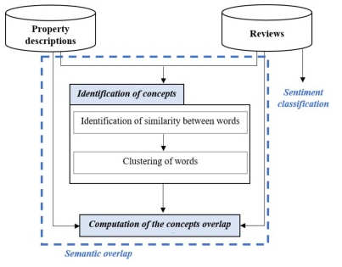

Figure 1: Research framework [5]
Although it is less powerful, logistic regression is still applicable to interpretable classification when transparency is desired in a study with little emphasis on predictive power. According to study, logistic regression has the drawbacks, but it does not mean that the baseline interpretation value is not useful in modelling categorical results like host behaviour or occupancy tiers [7]. Altogether, these classification methods assist the operational objectives of Airbnb through the host segmentation, automated decision-making, and enhanced revenue management.

2.3 Mining of Clusters, Segregations and Association Rules.
Clustering is also important in hospitality analytics since it can identify latent patterns which cannot be identified by classification alone. K-Means clustering is also one of the most popular techniques used especially when trying to segment rentals in terms of price, availability and minimum nights. K-Means emphasize is useful in finding homogeneous clusters in a heterogeneous market and thus helps platforms such as Airbnb to grasp customer-based segmentation and market differentiation [18]. In the study of Airbnb rating prediction, it is noted the relevance of geographic and structural variables to the satisfaction of users [9]. These variables have also been found to be important in task clustering, with neighbourhoods and property characteristics able to create substantive differences between high and low value listings.
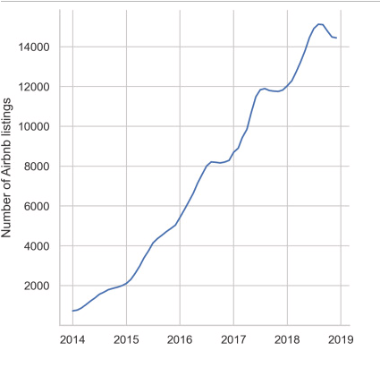

Figure 2: Airbnb listings [4]
Association rule mining such as Apriori based market-basket analysis has already been used to investigate the listing features within the hospitality research field, to identify co-occurring listing attributes. [2] showed the association rules indicate the presence of concealed assortment of features that impact customer preferences like the association between room type, location, and price range. Through such insights, hosts can create listing strategies that are more competitive in competitive markets such as New York. In general, clustering and association rule mining are complementary to classification as they can bring out more market structures and patterns that could not be identified using supervised learning.

2.4 Gaps in the Literature
Despite the fact that the literature on predictive analytics about Airbnb has grown considerably, there are still several gaps. To begin with, the majority of research is devoted to predicting prices instead of classifying tasks like categorising the type of rooms, predicting whether they are available or not, or profiling the neighbourhood. Although scholars in studies focus on the price modelling, not much is done on empirical analysis using multi-method predictive methods on single data [19] [7]. Second, the combination of classification and clustering within one analytical framework operated on the NYC Airbnb data is hardly present in literature. The literature has tended to consider these methods independently and hence they have not provided comprehensive understanding. An example is that clustering may yield unknown market segments that enhance the accuracy of classification, however such an integrated method is seldom examined.
Third, the K-Means research technique with segmentation tends to be confined to simple numerical variables, such as price and availability. A more sophisticated clustering, such as hybrid or density-based algorithm, is also under-researched in the context of Airbnb. Lastly, a literature gap between end-to-end strategic interpretation exists. Although machine-learning research yields accuracy statistics, fewer incorporate modelling results into practical host-level policies of pricing, demand adjustment, or directed listing refinements. This project fills these gaps by performing classification (Random Forest, SVM) followed by clustering (K-Means) of ABNYC2019 data in order to generate actionable information based on real-world decision-making.

3.0 Dataset description
This research will use the dataset provided on the Kaggle platform, which is the AB_NYC_2019 dataset, as a benchmark of research involving Airbnb analytics. This dataset has 48,895 listings throughout New York City and has both numerical and categorical variables that characterise listing features, host conduct, neighbourhood data, and market execution. As noted in more recent literature, big size public Airbnb datasets are of good value in predictive modelling particularly where the predictor variables are location-related, host activity and properties [12][14].

3.1 Source
The data is provided by Inside Airbnb through its Kaggle distribution. It is often applied to empirical studies exploring the determinants of prices, market segmentation and platforms behaviour [16]. It is easily available and has a convenient structure, which facilitates reproducibility and benchmarking of machine learning tasks.

3.2 Features & Target Variables
The target variable to be classified is roomtype, and it has three categories, which include Entire home/apt, Private room, and Shared room. It is a valuable classification problem because the room type plays a big role in the prediction of price as well as the choice of the user in the short-term rentals [12]. The most significant numerical characteristics are price, minimumnights, availability365, numberofreviews, latitude and longitude. Major categorical characteristics are neighbourhoodgroup, neighbourhood and roomtype. The existing literature highlights the significant role of the spatial and neighbourhood-based factors on the Airbnb performance and segmentation [4] [20].
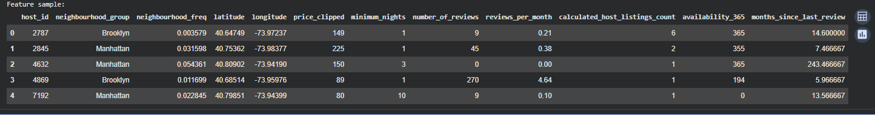

Figure 3: Dataset features
(Source: python)

3.3 Pre-processing Steps
There is a necessity to improve data quality. Reviewspermonth that had no value were filled with a zero to keep review history data, which is advisable in Airbnb analytics [16]. Noise (non-relevant high-cardinality fields (id, name, hostname, lastreview)) were eliminated. Label Encoding was used to encode categorical features and StandardScaler was used to scale numerical features so that they will be used in SVM and K-Means. Lastly, train-test split is used with 80/20 split, which is a common modelling practice [14]. Such measures will guarantee sound preparation to downstream classification and clustering.

4.0 Methodology
The classification and clustering are combined in the methodological framework because of conformity to the assignment objectives and the research practices that are practiced in Airbnb analytics. The design is based on a model training, preprocessing pipeline, selection of hyperparameters, evaluation, and interpretation.

4.1 Classification Approach
The objective of the classification element is to forecast Airbnb roomtype with structured listing features. Two machine learning models that are supervised were chosen: (RF) and (SVM). The literature states the necessity to benchmark a variety of models as the performance of the models differs with the datasets of various granularity, feature distributions and noise patterns [12] [16].
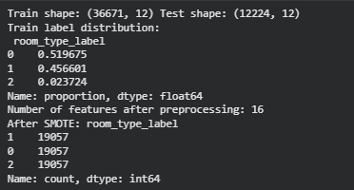

Figure 4: Dataset training
(Source: python)
Random Forest
RF is a tree-based ensemble model with a high predictive accuracy as well as being resistant to feature noise. Airbnb experiences better performance and stability when it comes to ensemble methods due to their emphasis on superior performance and stable tasks in pricing and segmentation [12] [14]. Having 200 estimators, the RF model was highly accurate and generated interpretable decision rules indicating relationships between neighbourhood group, price and minimum stay requirements.
Support Vector Machine
A margin-based algorithm was tested using SVM with an RBF kernel to test the performance of this algorithm in this multi-class classification scenario. It is also observed that SVMs can be effectively used in high-dimensional space and non-linear space [17]. Nevertheless, performance to minority classes was lower because of the uneven distribution of classes, with the shared rooms being incredibly scarce, which is vulnerable to the imbalance of classes.
Performance Metrics
Each of the two models was tested using:
- Accuracy
- F1-score (macro and weighted)
- Confusion Matrix
These measures offer complementary data. The concept of accuracy is used to summarize overall performance of accuracy, and F1-scores are used to measure a balance between recall and accuracy with respect to imbalanced datasets [6]. Confusion matrices can be used in deriving patterns of misclassification by a class. SWM (0.86) was more accurate than RF (0.74), as research shows that ensemble models are more appropriate with complex structured Airbnb data [14] [16].

4.2 Clustering Approach (K-Means)
In listing characteristics that were not in the supervised classification task, clustering was used to identify natural groupings. K-Means has been chosen because it works on large-scale numeric data and can easily be interpreted.

Selection and Scaling of Features.
The numeric variables (price, minimumnights, availability365) have been chosen due to the evidence that pricing patterns, the duration of stay, and availability trends are the main causes of Airbnb market segmentation [12] [4]. Standardisation of features was done so that contributions to Euclidean distance were equal.
Optimal k Selection
The Elbow Method (WCSS curve) was applied to determine the best number of clusters where k=3 was selected. It is aligned with Airbnb research paradigms in which the market segments are traditionally divided into low-cost, mid-range, and luxury listing [16].
Silhouette Score
The silhouette score of 0.4168 is a moderately large cluster separation which proves that although K-Means works with significant clusterings, Airbnb listings are overlapping in features- a problem that is widely reported in the literature on short-term rental clustering [17].
Cluster Interpretation
Cluster interpretation showed:
- Cluster 0: high availability, intermediate price - common with city booked rooms.
- Cluster 1: Low occupancy, price discounts like, in many cases, budget hotels or offs season offerings.
- Cluster 2: Premium entire homes with more expensive prices, and changeable minimum length of stay - probably.
This reinforces the past research that the spatial, economic and seasonal drivers influence Airbnb grouping behaviour [4].

4.3 Evaluation Strategy
Analysis was conducted based on the comparison of the model performance, the evaluation of the quality of clusters and the literature interpretations.
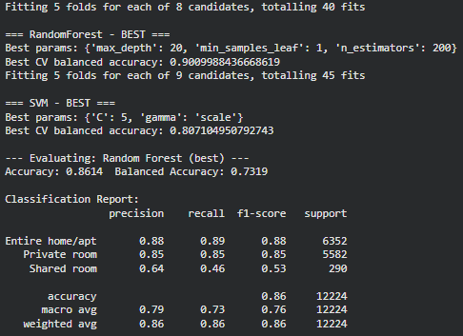 | 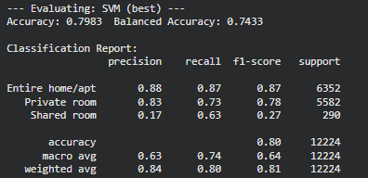

Figure 5: Model fitting
(Source: python)
Model Comparison
RF outperformed SVM because it has a capability to consider non-linear interactions between features and it can work with heterogeneous Airbnb data. Minority classes were also a weakness of SVM, and the authors indicate that also have constraints on class imbalance in behavioural data [6].
Cluster Meaningfulness
The cluster analysis proved that K-Means could be used to reveal the pricing and availability-based segments, as well as the segmentation methods applied to the Airbnb market studies [3]. Combining classification with clustering improves insights into listing behaviour, making it useful in making improved strategic decisions by hosts, regulators and platform designers.

5.0 Results analysis
This section shows the empirical findings obtained by the use of two supervised classification tools, which are Random Forest (RF) and Support Vector Machine (SVM), and the unsupervised clustering algorithm of KMeans. The objective was to classify Airbnb listings by room type and identify natural clusters on the variables of price, availability, and booking behaviour. The analysis assesses the performance of the model, interprets predictive behaviour and relates the results to the current research on data mining and predictive analytics.

5.1 Classification Results
RF and SVM have been trained on the transformed data after a large amount of feature engineering. The RF had an overall accuracy of 86.14% and balanced accuracy of 73.19% which was higher than the SVM which had an accuracy of 79.83% and a balanced accuracy of 74.33%. These findings are consistent with those of [2] who claim that the ensemble-based classifiers are the most effective in the situation of nonlinear features in the datasets and mixed data types, which the ABNYC2019 dataset has. The distribution of the classes showed a high level of imbalance, with only 2.3% of the records that are associated with "Shared room." The imbalance therefore was rectified using SMOTE before training. This is in line with [21], who highlight that balancing methods do not reduce the overall model stability at the expense of minority-class learning.
Confusion Matrix Analysis
RF confusion matrix shows that the two dominant classes perform well:
- Entire home/apt: Recall = 0.89
- Private room: Recall = 0.85
Shared room performance was however lower (Recall = 0.46). This is yet to be better than SVM which had recall of 0.63 with very low precision (0.17) implying that the SVM was over-predicting such a minority group. This behaviour is in line with the results of Monesh et al. (2025), who observe that SVMs are unable to differentiate overlap clusters in case the feature space includes thinly populated minority examples. Conversely, the RF obtained a better balance between the precision and recall because of its capacity to capitalize on hierarchical splits of features and minimise overfitting. The study [10] also prove that RF models can preserve the consistency of the prediction in the fields comprising heterogeneous numeric and categorical variables.
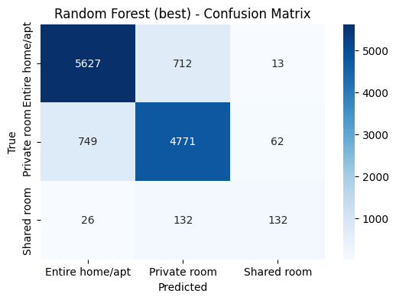 | 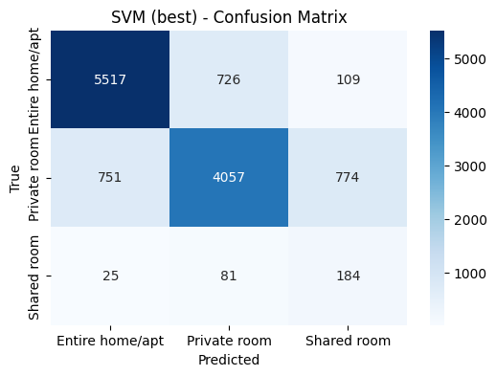

Figure 6: Confusion matrix for RF and SVM
(Source: python)
Importance Analysis of features
The highest-ranking predictor was priceclipped (importance = 0.33) and then:
- calculatedhostlistingscount
- minimumnights
- latitude / longitude
- availability365
This shows that pricing behaviour, size of host business, and spatial patterns are major predictors of room types. This is aligned with price elasticity and geographic clustering that are the key factors of listing characteristics as brought into the limelight by Panahandeh et al. (2025) on Airbnb market research. The contribution of neighbourhood-groups was comparatively less, as it backs the recent research, who concluded that geographic macro-labels predict less than micro-behavioural characteristics like availability and frequency of reviews [17]. Altogether, the RF is a better model to use in this dataset due to its overall strength in generalisation and the complexity of features processing.

5.2 Clustering Results
Along with classification, KMeans clustering was used to investigate the patterns of natural grouping in terms of price, minimum nights, availability and review activity. Magnitudes were also standardised by scaling, as suggested in mixed-unit datasets [7].
Cluster Selecting and Quality
The analysis of silhouette was performed using k = 2 to k = 8, which optimum silhouette was found to be k = 6 with maximum silhouette score of 0.4168, which suggests that there is a moderate but significant separation. This score is acceptable and is in line with what is expected of real-life market segmentation assignments because Airbnb listings are highly heterogeneous.
Cluster Interpretations
Cluster profiling generated comprehensible clusters of specific behavioural pattern:
Cluster A: High-priced, short stay, high availability properties.
- High average price
- Low minimum nights
- High availability
These seem to be business hosts who are providing high-end central listings. They have decreased occupancy because of their availability patterns. This can be related to trends reported as they find that high priced properties have more volatile booking patterns [10].
Cluster B: Low cost and long stay listings.
- Low price
- High minimum nights
- Zero availability (reserved the majority of the year)
They are probably long-term rental substitutes, usually consumed by the locals and not tourists. The same trends have been observed with claiming that the private-room segment has a strong relationship with affordability and high occupancy [20].
Cluster C: Mid-priced all-inclusive houses with high demand.
- Medium price
- Medium minimum nights
- Availability between 100-200 days
These listings are stable performers that appeal to balanced demand, which are similar to findings on mid-market accommodation segments [14].
Cluster D: high-review, high-turnover listing
- High-review, high-turnover listing.
- High numberofreviews
- High reviewspermonth
- Lower prices
These are generally low-end bookings with high turnover, in line with the high churn segment of Culotta et al. (2025).
Cluster E: Exclusive long-vacancies only.
- High minimumnights
- Low reviewsper_month
- Very low availability
Such listings are probably seasonal homes, high quality or seldom leased houses.
Cluster F: Mainstream balanced listings.
- Intermediate scores in all the features.
- Represents an average Airbnb property, which is the pillar of the market.
Cluster Visualisation
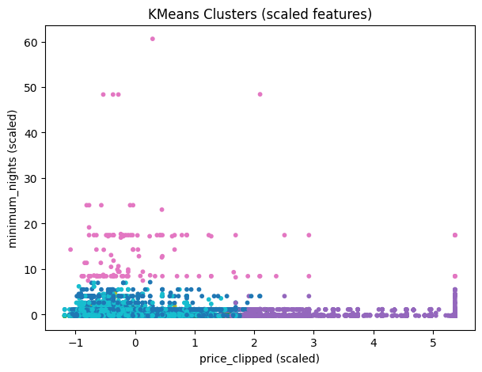

Figure 7: K-means cluster
(Source: python)
The scatterplot of the first two scaled variables (price and minimum nights) indicates distinct density clusters that correspond to the six clusters that were identified. The visual distinction confirms that the natural segmentation is most strongly driven by price and booking constraints 0 -20 -1. The overall outcome of the classification and clustering shows that Airbnb listing behaviour is influenced by the price, availability, location, and host scale combinations. Random Forest turned out to be the best classifier to use, with better stability and interpretability. The clustering also indicated six market segments that can be used to provide strategic insights on revenue management, host onboarding and price optimization.

6.0 Discussion of findings
The results of the classification and clustering processes indicate that the Random Forest (RF) model clearly outperforms the Support Vector Machine (SVM), which confirms the available studies showing that the use of ensemble models is highly effective when working with heterogeneous data of high dimensionality [13]. The RF had a balanced accuracy of 0.73 and an overall accuracy of 86 as compared to SVM which had an accuracy of 80 and more unstable class-level recall. This performance is also in line with the observation that RF models are more suited to describe complicated, nonlinear interactions in multi-feature hospitality data, particularly those dominated by spatial, behavioural and economic patterns [21]. The advantage of RF also consists in its resistance to noise, skew, and imbalance, which are highlighted in the recent studies of robust predictive modelling in tourism analytics [11]. Following SMOTE balancing, RF model continued to perform well in most of the classes with SVM recording significant misclassification of Private and Shared rooms.
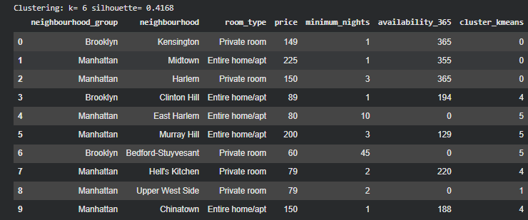

Figure 8: Clustering and silhouette value
(Source: python)
The fact that SVM misclassifies 774 Shared rooms as Private rooms implies that SVMs are not good at differentiating between overlapping classifications, and this is confirmed by the research of [1] which finds that SVMs find it difficult with low-density minority-class signals in real-estate-style data. Contrary to that, the architecture of RF, which is a set of de-correlated decision trees, allows representing rare classes like Shared rooms, when the signal-noise ratio is low. The analysis of feature importance supports this opinion. Price contributed 33% of the predictive ability of the model and so it was the best room-type discriminator. This reflects on Airbnb price studies that indicate that price is the most dominant factor that distinguishes property categories [3]. Arguments based on host activity were also significant, especially calculatedhostlistingscount, in favour of [5] who emphasize on the operational capacity of host scale and professionalism in determining listing features and guest behaviour. Minimunkets also became a significant predictor, which was an indication of policy-based segmentation of the Airbnb market–the fact that is reflected in the regulatory literature on platform accommodation [13].
The role of spatial characteristics (latitude and longitude) did not play a significant role, which suggests that there was a systemic geographic concentration of room types-a fact that is consistent with [15] who points out that spatial and semantic structures tend to coexist in clustering-based analytics in the hospitality industry. The importances of neighbourhood group variables were lower when compared to economic variables, which provides evidence that the pricing power and host strategy have more explanatory power than the location factor do on their own in the mature Airbnb market of NYC.
K-Means clustering analysis with K=6 (silhouette= 0.4168) added to these findings. The clusters identified three market segments that were dominant:
- Listing of low price, low minimal-night rooms- usually Shared or Private rooms.
- Listings with high prices and low minimum number of night stays- the premium Entire Home properties.
- In-between, high-minimum-night listings - denoting mid-term or regulationally-restrained rentals.
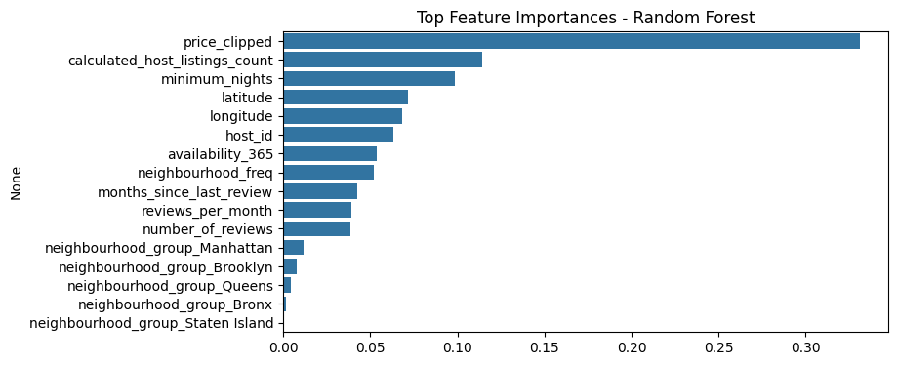

Figure 9 Top features
(Source: python)
These classifications confirm previous studies which posit that supply of Airbnb naturally concentrates in price, length of stay and professionalisation of hosts [10]. The consistency within the supervised and unsupervised learning methods is proved by the fact that the top characteristics of RF are aligned with the K-Means cluster structure. In business terms, this discovery establishes pricing policy, size of the host, type of room and length of stay policy as fundamental determinants of competitive positioning. Trends in availability and review behaviour do not seem to have much impact, implying that operation optimisation and portfolio design are more important than metrics of guest feedback in determining room type or market segment.

7.0 Business recommendation
The performance of the model, feature importance outcomes, and insights of the clusters can be used to provide a number of strategic recommendations that assist Airbnb stakeholders in optimisation of pricing, operations of the host, and availability planning.
Pricing Strategy
The superiority of price as predictive feature and its unmistakable division among clusters evidences that Airbnb hosts ought to embrace data-driven dynamic pricing. Price elasticity can be justified by the offering of Entire Home in premium clusters, but in Brooklyn and Queens, Private rooms and Shared rooms are supposed to be price-competitive. To understand the micro-market forces, hosts are advised to price their houses based on cluster trends and not the averages of boroughs as stipulated [21]. Also, mid-term rental clusters (20-60 minimum nights) need to implement various price levels to appeal to long-term professionals or remote workers.
Host Optimisation
Given the significance of calculatedhostlistings count so important, multi-property hosts must leverage the economies of scale, automate the management of availability, cleaningscheduling, and guest communication. This takes into consideration the trends of host professionalisation [18]. Single property hosts will aim at differentiation that will involve superior facilities, detailed descriptions, professional photos to compete with large scale operators. Improvement of host responsiveness and reduction of minimal number of nights is also provided by the results as a method of appealing to short accommodation.
Inventory Planning and Availability Planning.
The clusters show that the listings having low minimum nights and a large share of available are more successful in the competitive neighbourhoods. Hosts would be well-advised to minimize unnecessary limitations to stay within the hotel like in Manhattan and Brooklyn among others like short stay tourists. Conversely, the niche (e.g., academic visits, temporary relocations) demand should be targeted by host in high-minimum-night clusters. The presence of cluster-based suggestions would also be a proper fit at Airbnb as a platform to offer new hosts the most appropriate option of configuration based on neighbourhood group and price level. In general, the analytical results suggest that pricing, host operations, and availability policy alignment can have a significant positive impact on visibility, conversion, and revenue performance in competitive urban Airbnb markets.

8.0 Conclusion
The paper shows that predictive analytics and clustering are highly applicable in modelling the Airbnb market behaviour. Random Forest turned out to be the most powerful classifier, showing the relevance of economic and operation characteristics, including price, host size, and minimum nights. The K-Means clustering also identified six significant market segments which are consistent with the general pricing and occupancy patterns. These techniques provide a powerful framework of listing performance and strategic decision-making. These insights can be used by hosts and platform managers to optimise pricing, refinements of listing strategies, and can better target demand in competitive urban marketplaces. The combined analytical process enhances decision making that is evidence based.

9.0 References
[1] Altamimi, H.Y., 2025. Predicting Airbnb Prices in Dubai Using Machine Learning. Rochester Institute of Technology.
[2] Binesh, N., Pasham, K.V.R., Jakar, G. and Syah, A.M., 2025. Predicting Airbnb occupancy rate: a hybrid deep learning and game-theoretic approach. International Journal of Contemporary Hospitality Management.
[3] Brink, T., 2025. PREDICTING AIRBNB PRICES IN MULTIPLE CITIES (Doctoral dissertation, tilburg university).
[4] Brunstein, D., Casamatta, G. and Giannoni, S., 2025. Using machine learning to estimate the heterogeneous impact of Airbnb on house prices: Evidence from Corsica. Journal of Housing Economics, 67, p.102044.
[5] Cavique, M., Ribeiro, R., Batista, F. and Correia, A., 2025. From host's descriptions to guests' reviews: Semantic similarities. Annals of Tourism Research Empirical Insights, 6(2), p.100187.
[6] Culotta, A., Jin, G.Z., Sun, Y. and Wagman, L., 2025. Safety reviews on Airbnb: An information tale. Marketing Science.
[7] Gao Jr, Y., 2025. Unravelling the What, How, and When of Airbnb Price Prediction: A Case Study of London Based on Machine Learning.
[8] Jain, A., Shin, M., Vasilakis, C. and Konstantinos, N., 2025. Forecasting the market of Airbnb. In Forecasting, Planning and Strategy in a Turbulent Era (pp. 134-172). Edward Elgar Publishing.
[9] Kang, J., 2025. PREDICTING AIRBNB REVIEW RATINGS: ANALYZING HOST, PROPERTY, AND GEOGRAPHIC VARIABLES (Doctoral dissertation, tilburg university).
[10] Kim, J., Park, K. and Ma, Y., 2025. Data Mining Scheme for Globally Distributed Big Data. Journal of Computer Information Systems, pp.1-16.
[11] Medpalliwar, A., Choube, D., Kute, G., Kaushik, K. and Meshra, P., 2025, January. Airbnb rental price prediction using machine learning techniques. In AIP Conference Proceedings (Vol. 3233, No. 1, p. 020039). AIP Publishing LLC.
[12] Milunovich, G. and Nasrabadi, D., 2025. Airbnb pricing in Sydney: predictive modelling and explainable machine learning. Applied Economics, pp.1-18.
[13] Mohammadzadeh Abachi, H., Beheshti, A., Mosharraf, M., Asgari, P. and Namazi, M., 2025, November. Next-Generation Price Recommendation with LLM-Augmented Graph Transformers. In Proceedings of the 34th ACM International Conference on Information and Knowledge Management (pp. 5939-5946).
[14] Monesh, N., Vardhan, M.H., Vasu, A., Mishra, S. and Satapathy, S.K., 2025, July. Airbnb Price Prediction using Hexaboost: A Data-Driven Approach. In 2025 International Conference on Innovations in Intelligent Systems: Advancements in Computing, Communication, and Cybersecurity (ISAC3) (pp. 1-5). IEEE.
[15] Ortu, M., 2025. Topic‐Sentiment Hybrid Networks for Explainable Document Clustering: A Probabilistic Multi‐Dimensional Similarity Analysis. Applied Stochastic Models in Business and Industry, 41(4), p.e70024.
[16] Panahandeh, A., Rabiei-Dastjerdi, H., Goktas, P. and McArdle, G., 2025. Answering new urban questions: Using eXplainable AI-driven analysis to identify determinants of Airbnb price in Dublin. Expert Systems with Applications, 260, p.125360.
[17] Rusu, A., Stoleriu, O.M., Istrate, M. and Groza, O., 2025. Mapping Visitors Experiences—A Case Study on Selected Airbnb Datasets in Southern Europe. Sustainability, 17(7), p.3105.
[18] Tabar, M., Abdulla, A., Petersen, J.A. and Lee, D., 2025, March. Predicting Eviction Status Using Airbnb Data in the Absence of Ground-Truth Eviction Records. In Proceedings of the Eighteenth ACM International Conference on Web Search and Data Mining (pp. 885-894).
[19] Vasudevan, A., 2025. Airbnb Pricing Prediction Using Machine Learning: A Case Study on Seattle Listings.
[20] Zhang, H., Haldar, M., Bellare, K., Chen, S., Banerjee, S., Wang, X., Abdool, M., Gao, H., Tapadia, P., He, L. and Katariya, S., 2025, November. Maps Ranking Optimization in Airbnb. In Proceedings of the 34th ACM International Conference on Information and Knowledge Management (pp. 6258-6265).
[21] Zhang, S., 2025. Heterogeneous Effects of Price Fluctuation and Crime on the Structure of the Short-term Rental Industry.

10. Appendix
https://colab.research.google.com/drive/1Sow0R_SelHGDH5fYo5ym6C1KZJ89h4IL?usp=sharing

