
Innovation matrix case study
ABCA 5000

Eleanor Black
12/12/2023

Contents

Introduction Page 2
Main Body Page 2,3,4 & 5
Site location history
Sub-Structure
Foundations
Construction materials
Design
Conclusion Page 5
Reference List Page 6
Appendices Page 7,8 & 9

Introduction

University of Wales Trinity Saint David’s (UWTSD) Innovation Matrix is the third building to be built on the SA1 campus, alongside iQ and The Forum. It is proposed to be a central hub for collaborating industry innovation and education by offering businesses partnerships. The proposed development area will total 5,450m² with 3,500 m² being high specification office space. The building aims to be sustainable all throughout construction and into operation by choice of construction materials and sustainable design. The IM building is set to achieve an EPC rating of A, A BREEAM rating of excellent and the “landlord areas” will be net zero in operation. The roof will be covered in 465m² of monocrystalline photovoltaic panels and the building will be heated by air source heat pumps via underfloor heating. The building will also benefit from mechanical ventilation with heat recovery and high levels of insulation throughout to reduce heat loss and carbon emissions (www.uwtsd.ac.uk, n.d)

Site Location History

The new Innovation Matrix is on the SA1 campus, which is former docklands. The area is man-made, built in the 1881 and extended in 1898, to accommodate the rise in coal, copper, tin and iron exportation (www.swanseadocks.co.uk, n.d). Swansea is thought to contain evidence of some of the earliest signs of human occupation in Wales, with evidence going back some 26,000 years (Bowen, 2011). The city centre itself has finds such as arrowheads from the neolithic period found in High Street and a Roman cooking pot found on the North dock in the alluvium (Higgins, 2008)
The earliest OS map of 1879 (figure 1) shows the non-existence of the entire dry docks of Swansea Bay, instead showing the mud flats of Fabian’s Bay. The area was transformed completely with the construction of the Prince of Wales dock, seen in the 2nd edition (1899) of the OS map (figure 2). In the second edition OS map (figure 2), there is evidence of railway tracks, hoists, and various other buildings and structures. Although the majority of these structures have been since demolished throughout the centuries, some evidence of industrial and maritime activity may still remain, with possibility of encountering remnants during intrusive groundworks.

Sub-Structure
Prior to foundations being designed, the ground must be analysed in order to establish foundation suitability. There are two ways to analyse the sub-structure of a certain location. The first is a desktop study. This includes looking at records and aerial photographs, found on sites such as planning portals and google maps. There may also be previous borehole records for other excavations works that have been done.
The second method is a site survey or walkover, this includes taking trial pits throughout the site. This is a cost-effective and simple method of obtaining geotechnical information to determine if a project is feasible or not. Trial pits are usually two metres deep and allos visual inspection of the substrata, establish groundwater levels and to take samples if required. Prince of Wales dock consists of many types of strata and rubble due to it being a brownfield site and the engineer would use this information along with the information found from the desktop study to design the foundations for the IM building.

Geotechnical reports conducted to the North of the IM on the North side of the Prince of Wales dock concluded that the made ground comprised of “brick and concrete fragments, tile fragments, timbers, slag metal and plastic at varying depths (0.83m- 7.40mOD), according to CoDA, 2006. Additionally, the 1855 Local Board of Health Plan labels the SA1 development area as a spoil bank, which provides an indication of what may be underneath in deeper deposits. This will also give an indication of the potential sub-strata for the IM build site as the docks were all built within the same timeframe (1800’s) and can be assumed that the same construction methods and materials were used throughout.
A further, more recent geotechnical survey for plots E7 and E8 have been undertaken on the SA1 development site by TerraFirma. The results concluded that the made ground was of varying thickness and mainly comprised of loose, black, gravelly sand with low cobble content. It also highlighted a nearby contamination area (plot D5b) with contaminants including arsenic, lead and benzopyrene.

14 bore holes were drilled on and around the development site in 1880 to analyse the sub-strata directly beneath where the structure is to be built. Borehole 1 showed mainly sand, with a combination of gravel and small stones. Borehole 14 was a mix of clay types, gravel and sand (mapapps2.bgs.ac.uk, n.d.). Additional, Geotechnical testing should be undertaken of any recent samples to determine natural moisture content, organic matter content, particle size distribution and compressive strength. Geo-environmental tests should be included to analyse any chemicals (cyanide), metals, pH and the solubility of the ground. These factors will enable the site engineer to make suitable choices for the foundations and/or feasibility of the project

Foundations
When considering suitable foundation types there are various requirements that need to be considered first including purpose of the proposed structure, sib-strata, load bearing capacity, site location history and cost feasibility. Once all considerations have been analysed, the site engineer can decide which type of foundation will be most suited to the building.
The IM building is a relatively large structure spanning 5,450m2 with a mix of office and lab space. It will be a steel framed building with UK sourced steel cladding, for sustainability reasons. This makes the building quite heavy, however it is only two storeys so there is less load on the foundations and therefore the soil compared to high rise buildings. The building is also long, meaning that the weight is distributed further making it more stable.
The soil and sub-strata is a critical component of choosing and designing the foundations of a building. If an unsuitable foundation type is chosen this can lead to numerous issues including sinking, cracking of the structure and even collapse. However, if the main focus is on the load of a structure, then costs will increase, affecting feasibility. The purpose of a building also directly affects the foundation choice. For example, an office and factory of the same size will have different foundation need due to the factory housing heavy machinery, putting more pressure on the foundations.

The main three types of foundations are raft, pile and strip. Strip is the cheapest available. It involves removing a strip of earth to a set depth and width, filling the trench with concrete and tamping it level. Strip foundations can only be used on good load-bearing strata and to a depth of no more than 1.5m-2m to be economical.
Raft foundations are often used when the sub-strata is of poor loading bearing capacity. It involves four foundation piers linked with a slab to form a large foundation. The foundation “floats” on the ground to apply pressure evenly over a greater area.
Piled foundations are used for heavy, tall buildings or where the ground is poor load-bearing capabilities. This method is expensive due to the piles needing to be drilled or bored. Pile foundations are deep foundations with slender columns of steel or concrete to support the structure and transfer the load to the desired depth, often where the sub-strata is stronger (Civiltoday, 2019)
For the Innovation Matrix, by taking into consideration the soil type, site history, and design of the building, that the most suitable foundation type would be pile foundation. This allows the contractors to dig to a chosen depth to reach better ground in order to sustain the weight of the structure, whilst minimizing risk of cracking, collapse, etc.
There are different types of pile foundations, each suitable for a variety of uses. They are classified by their design function (end-bearing, friction or combination), construction method (driven) or replacement (bored).
End-bearing piles transfer the majority of the load onto the bottom tip of the pile, into a layer of firm sub-strata whilst receiving lateral restraint from the soil. Friction piles use shear stresses by transmitting the load to surrounding soil by friction lowering the pressure.
Driven piles are driven, drilled or jacked into the ground, displacing the sub-strata and densifying it in order for it to cope with the loads needed. Bored piles, instead, remove the soil to form a hole, which is filled in-situ. Bored piles have minimal vibration so are popular in urban areas. Bored piles would be a good choice for the IM building due to the other university buildings still being occupied at the time of construction and the short distance from the construction zone, potentially leading to complications from the vibrations of the other pile types (www.designingbuildings.co.uk, n.d)

Construction Materials

The Innovation Matrix has been designed with sustainability at the forefront. The steel frame is considered sustainable as it is 93% recycled and 99% recyclable, making it a circular material, meaning that instead of going to landfill, decommissioned buildings can be demolished and put back into the supply chain again and again. Steel is also incredibly strong and durable, it can cope with a lot of stress, making it a perfect choice for the IM building. Also, steel can cope with other issues such as pest infestations or rot, that materials like timber will suffer from. The costs effectiveness from the steel frame structure is also a benefit as, although it will be more expensive to source in the first place, there will be less to repair in the long run due to its durability. It is also thought that insurance companies charge less for steel framed buildings such as the IM due to its ability to withstand a range of conditions (Kit Buildings Direct, 2022).
Additionally, the steel cladding roof system that the IM building will be clad in is made in the UK for lower carbon emissions and certified to BES 6001 responsible sourcing standard. Furthermore, both the wall cladding, and roof system cladding have been fire tested to EN 13812 and EN ISO 1716 with a rating of A1, meaning that it is non-combustible (Tata Steel in Europe, n.d).A student accommodation building a short distance away (SA1 8PH) is built to a similar design, with a steel frame and steel cladding.

The building will have a high amount of double glazing, with an average u-value of 1.2w/m²K. This means that only 1.2 watts will be transmitted per square meter for every degree of temperature difference between the inside of the building and outside. A lower u-value means that there is less heat transfer and a more insulated building. 1.2w/m²K is on the lower end for double glazing, which helps with the green strategy approach. The roof of the IM building will be covered with 465m² bifacial dual glass monocrystalline PV modules with a power range of 475w to 505w and a maximum efficiency of 21%. The PV system will offset the electricity usage of the building, reducing both electricity, and heating costs, lowering the carbon footprint for the building.
The building will ventilate naturally in the summer months, via clerestory windows which reduces thermal gains in the summer, which has been stress tested in thermal models to ensure it is future proofed for global warming projections (Matrics Arloesi Canllaw Partneriaeth Partnership Guide Innovation Matrix, n.d.)

Design

The building aesthetically needed to tie in with the current university buildings, which are directly next to the IM building. The iQ and Forum building are both finished with brick with a fair amount of glazing. Having quality glazing on the IM building helps incorporate the structure within the SA1 development zone. The development will be complete with various trees and shrubs being planted around the building with a rain garden and bioretention soil to aid with drainage.
The aged steel cladding that will be used pays homage to the history of the site, with a “warehouse” appearance with the modernity of the glazing. It also ties in nicely with the engineering laboratory next door to the iQ building, meaning that it doesn’t look out of place with the brickwork of the other university buildings.
The building dimensions can be viewed in figure 3,4 and 5 on the elevation views. These are also available on Swansea planning portal under the reference code 2022/0954/RES.

Conclusion

Overall, looking at the site location history, it would be wise for extensive groundwork investigations to be conducted due to the fact that Swansea lies on the Carboniferous coal measures with the mining of the coal greatly influencing the development of the region. The sub-strata of the area are mostly un-surveyed and is likely to contain peat deposits and alluvium, along with maritime and industrial remnants. These investigations should be considered when deciding on foundation type, although pile foundations have been heavily used in the SA1 development zone, which the Innovation Matrix lies.
The structure aims to have sustainability at the forefront with its steel frame and cladding, PV panels, and use of natural ventilation, among other design features, making it a BREEAM excellent building in terms of its green strategy.

Reference List

Bowen, F. (2011). A report for Waterstone Estates Ltd Archaeological desk-based assessment. [online] Available at: https://coflein.gov.uk/media/314/712/665374.pdf.
‌
Civiltoday (2019). What is Pile Foundation? Types of Pile Foundation - Civil Engineering. [online] Civiltoday.com. Available at: https://civiltoday.com/geotechnical-engineering/foundation-engineering/deep-foundation/176-pile-foundation-definition-types.

Kit Buildings Direct. (2022). Steel Frame Office Building: Is It a Good Option? [online] Available at: https://www.kitbuildingsdirect.co.uk/blog/are-steel-frame-office-buildings-a-good-option/.

mapapps2.bgs.ac.uk. (n.d.). GeoIndex - British Geological Survey. [online] Available at: https://mapapps2.bgs.ac.uk/geoindex/home.html?layer=BGSBoreholes&_ga=2.36769312.1465440843.1704736911-2023813094.1704736911 [Accessed 8 Jan. 2024].

Matrics Arloesi Canllaw Partneriaeth Partnership Guide Innovation Matrix. (n.d.). Available at: https://www.uwtsd.ac.uk/media/uwtsd-website/content-assets/documents/campuses/UWTSD-Innovation-matrix-brochure.pdf [Accessed 8 Jan. 2024].

Tata Steel in Europe. (n.d.). Colorcoat Prisma®. [online] Available at: https://www.tatasteeleurope.com/construction/products/coil-flat-sheet/prefinished-steel-cladding/colorcoat-prisma [Accessed 8 Jan. 2024].

www.designingbuildings.co.uk. (n.d.). Pile foundations. [online] Available at: https://www.designingbuildings.co.uk/wiki/Pile_foundations#What_are_the_types_of_pile_foundations.3F [Accessed 8 Jan. 2024].

www.swanseadocks.co.uk. (n.d.). Swansea and Port Talbot Docks Website. [online] Available at: http://www.swanseadocks.co.uk/docksnewsite/history.html.

www.uwtsd.ac.uk. (n.d.). Innovation Matrix | University of Wales Trinity Saint David. [online] Available at: https://www.uwtsd.ac.uk/matrix/.
‌

Appendix

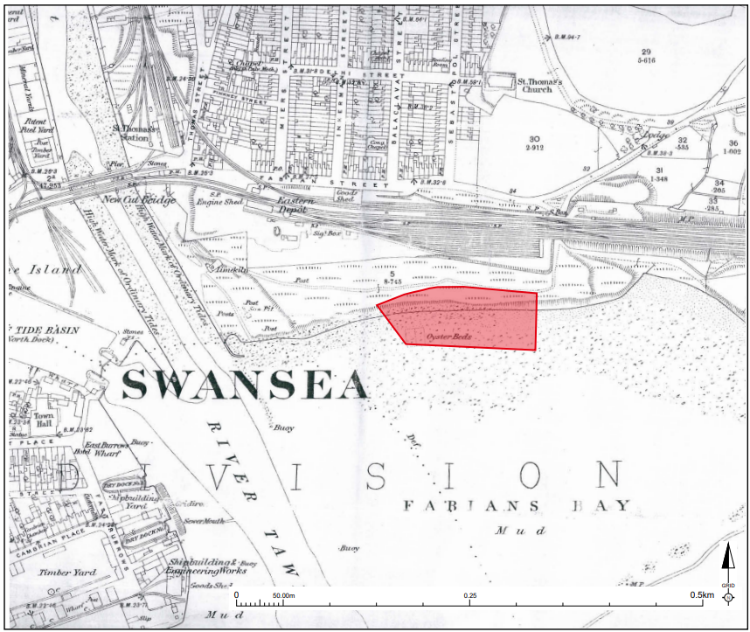

Figure 1; first edition (1879) OS map. Red box signifying other development areas in the SA1 development zone.

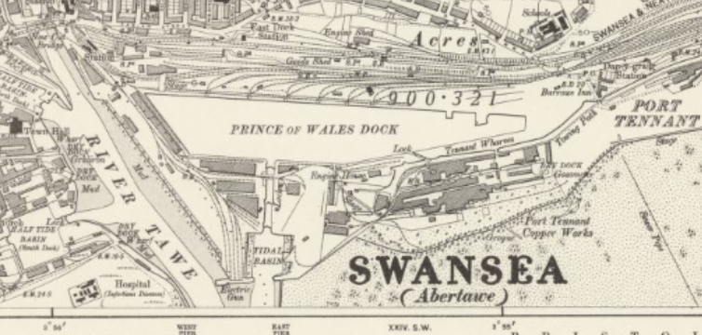

Figure 2; seconds edition (1899) OS Map.

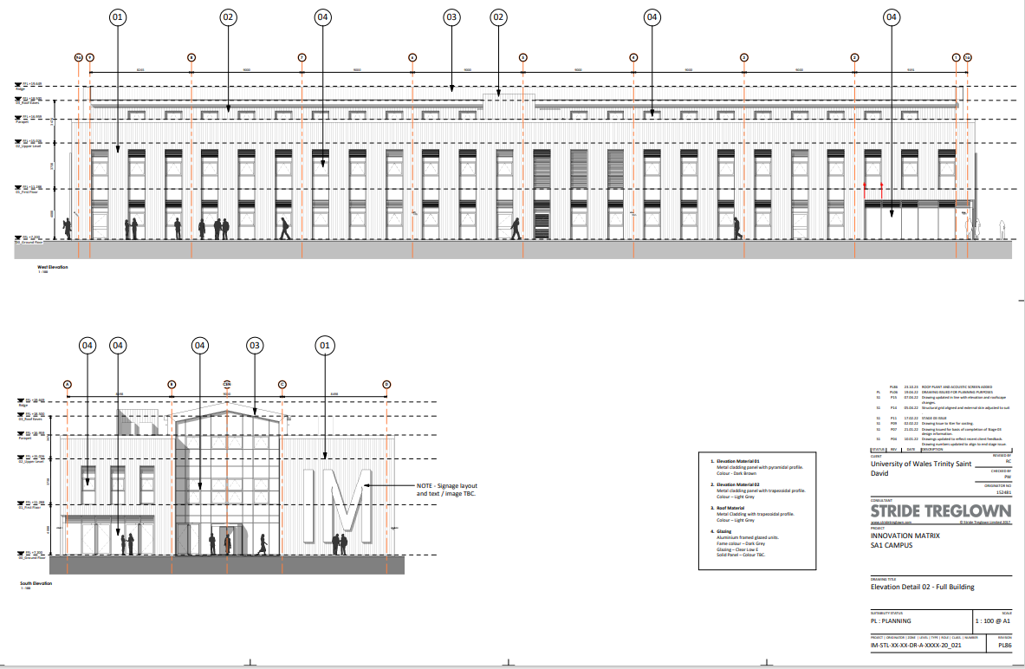

Figure 3; Elevation of the Innovation Matrix, complete with measurements. Can be viewed online at https://property.swansea.gov.uk/online-applications/applicationDetails.do?activeTab=documents&keyVal=S3CC28EVI0J00

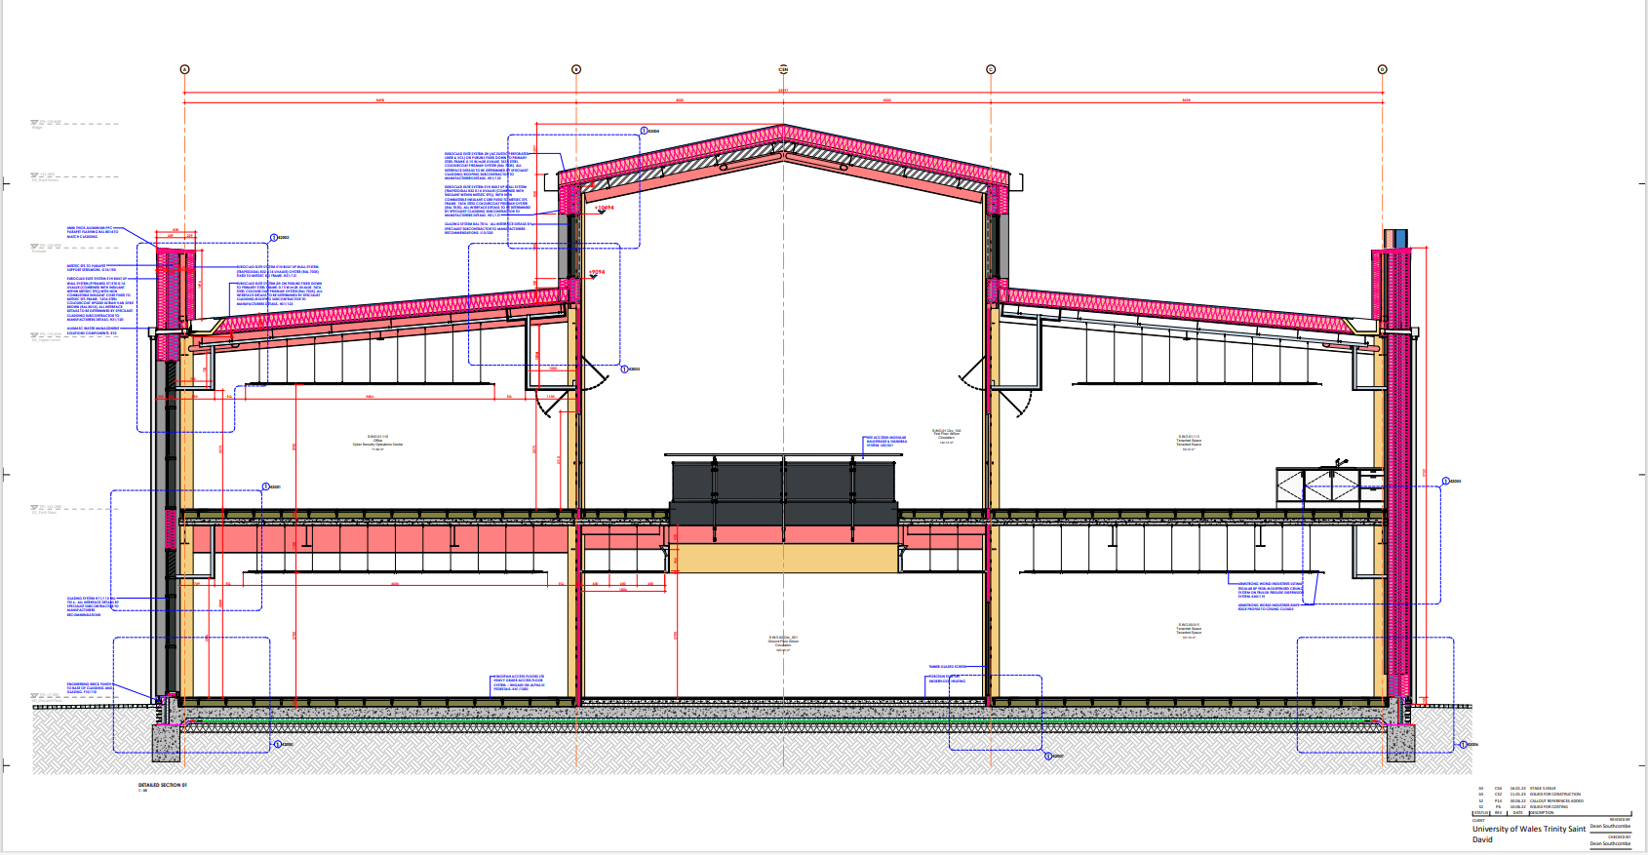

Figure 4; Detail of the IM, complete with measurements. Can be viewed online at https://property.swansea.gov.uk/online-applications/applicationDetails.do?activeTab=documents&keyVal=RS83QNEVL1900

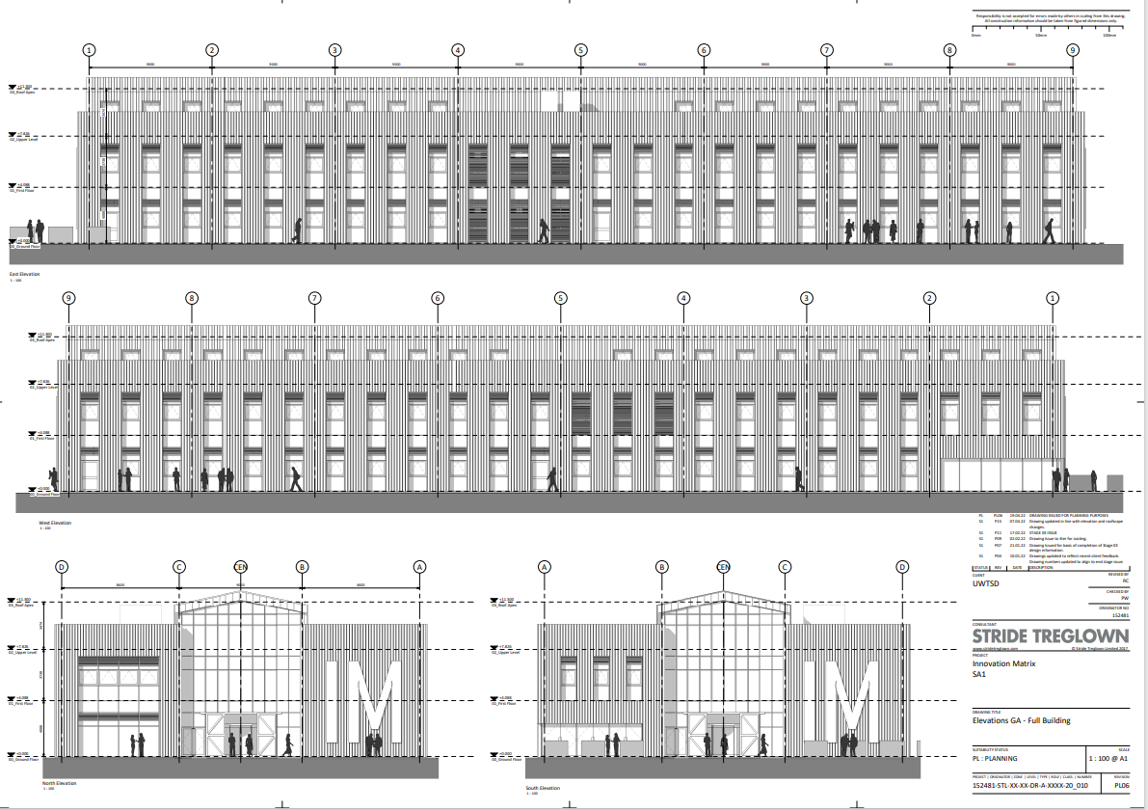

Figure 5; Elevation detail of IM, complete with measurements. Can be viewed online via Swansea planning portal

