Name:Andreea Camelia Liuta
Id number:2131348
Lecturer: Jemma Smith

International Meetings Management for the Hotel Industry

Table of Contents
Slide 1 – Introduction 4
Slide 2 – Situational Analysis – Market factors 5
Slide 3 – Situational Analysis – Operational factors 6
Slide 4 – Situational Analysis – Financial factors 7
Slide 5 – Situational Analysis – Financial factors 8
Slide 6 – SWOT Analysis 9
Slide 7 – PESTLE Analysis 10
Slide 8 – PESTLE Analysis 11
Slide 9 – Risk Analysis 12
Slide 10 – Conclusion 13
References 14

Slide 1 – Introduction
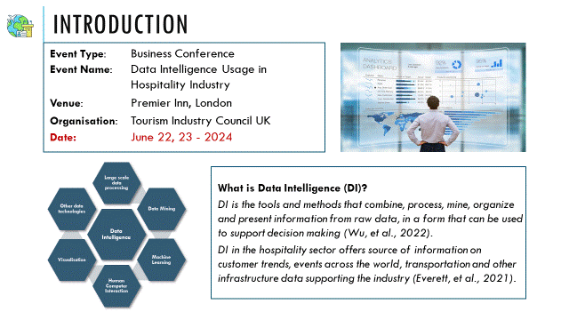
Speaker Notes
The proposed event is a business conference on Data Intelligence Usage in the Hospitality Industry. The event is to be conducted in London and the expected size is about 100 members from the hospitality industry. The attendees will also be organisations and associations of the hospitality industry who help in partnering and collaborating with other businesses associated with the industry and who will benefit from applying data intelligence tools for their business. The presentation will address the feasibility of conducting an event of this size based on situational analysis of the market, operational and financial factors in addition to the study on the internal and environmental factors that may influence the event. The internal factors are the Strengths / Weakness / Opportunities and Threats (SWOT) for the event and the environmental factors the Political, Economic, Socio-Cultural, Technological, Legal and Environmental (PESTLE) factors that influence the event.

Slide 2 – Situational Analysis – Market factors

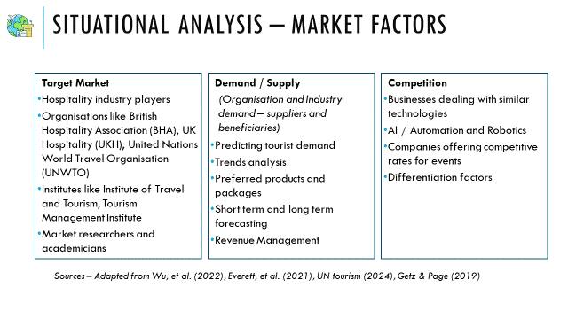Speaker Notes
The market factors concern the target market, collaborators and the competition that may affect the turnout for the event. The target market is essentially all the major players in the hospitality industry, who gain benefit from the technology. In addition to business owners in the hospitality sector, associations that work with similar businesses and help in partnership and collaboration of various supporting fields in the sector and institutes, researchers and academicians are the target market for the event.
The demand and supply is from all partnering businesses that can predict tourist demand, trends and effectively forecast for better and efficient delivery of services. Competition is from similar businesses that deal with data intelligence or different formats such as Artificial Intelligence (AI), robotics, automation and various other innovations that impact the way hospitality services are delivered.

Slide 3 – Situational Analysis – Operational factors
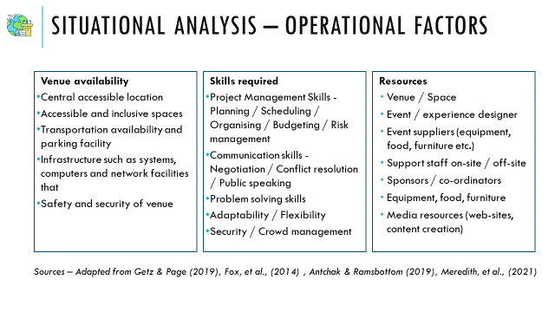
Speaker Notes
Events are operated under an environment of high uncertainty, as the event management team needs to offer a unique experience under dynamic conditions where expectations may keep changing. Risks are an inherent part of an event organisation plan and it is essential to be aware of all the possibilities that may impact a successful management of an event. Hence the skills needed for event management can be wide and generic such as project management or specific such as specialists in technology, catering, negotiation etc. In addition to technical and management skills, soft skills such as communication and negotiation is also valued, as the role of event managers is predominantly public or customer facing and situations may be needed to be handled with tact and diplomacy.
Event managers need to make a variety of decisions related to choosing venue, designing the event experience and selecting resources and vendor partners for conducting the event. Availability of venues with most of the facilities can reduce the effort involved in selecting the vendors. Business meeting spaces offered by Premier Inn have a select options with facilities for parking, refreshments and basic infrastructure for holding business meetings.

Slide 4 – Situational Analysis – Financial factors
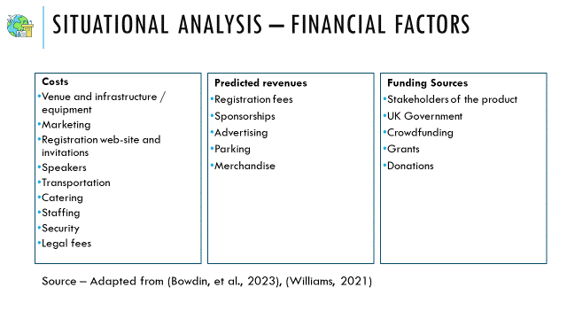
Speaker Notes
Financial management depends on the type of event – profit driven, association conferences, community events etc. However, financial planning and cash flow management is an important factor in event planning as there is a lot of uncertainty and risks involved in any type of event. Significant expenditure occurs in the initial stage of the event and mismanagement can lead to risks in successfully conducting the event.
The proposed event is a business conference wherein the goal is to demonstrate the usability of data intelligence to transform the industry and benefit all players in the market. The event is funded by various organisers to promote the product to industry players.

Slide 5 – Situational Analysis – Financial factors
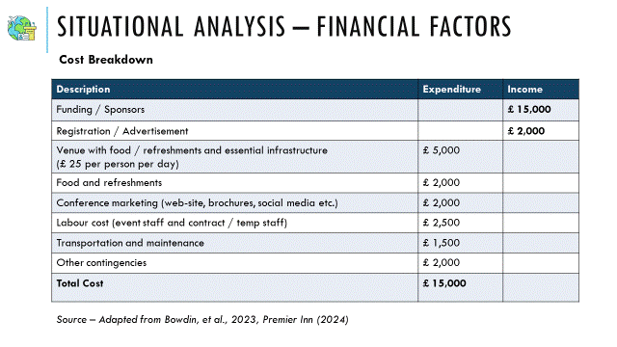
Speaker Notes
The cost breakdown is a realistic estimate based on the pricings at Premier meetings. The line items are grouped based on broad categories and the estimate is made on the expenses that are likely to take up a major percentage of the budget. Premier meetings, similar to most venues, provide most of the infrastructure and equipment for the meeting. The event venue offers staff to co-ordinate between the facility officials and the event co-ordinators, however, event management team is expected to organise any additional staff with unique skillsets required for the meeting. A contingency cost is also included to deal with any unexpected expenses during the event. The main sources of revenue for the event are the funding from various sources and the sponsors. The other source of income are the registration and the advertisements which will contribute to the profit of the event.

Slide 6 – SWOT Analysis
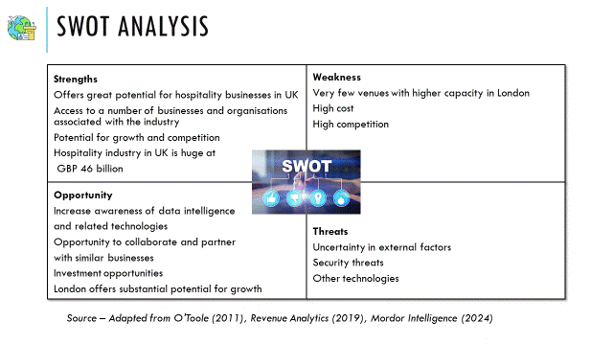
Speaker Notes
The strength and weakness of the SWOT analysis is an assessment of the internal factors and the opportunity and threat the external factors that affects the competitive position of the particular organisation or phenomenon. The SWOT analysis on the proposed event reveals the factors that make the event appealing to the attendees, the weakness that negatively impact its appeal, the opportunity that the event can give to the attendees and the threats that can deter them from participating.
Data intelligence has a lot of applications in the hospitality industry such as revenue management, customer relationship management, sales optimisation, data analytics etc. An event promoting the usage of data intelligence in hospitality offers an opportunity to discuss the various challenges and benefits in implementing the technology. The event being held in London gives an additional advantage for many businesses at both national and international level to participate and contribute. However, there are very few alternatives for venues with facilities to handle a huge turnout, forcing the event to rely on the limited options available. The analysis reveals that a well-chosen venue with an attractive agenda can assure success of the event.

Slide 7 – PESTLE Analysis
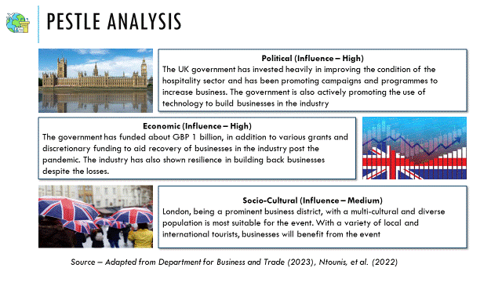
Speaker Notes
The environmental factors play an important role in the management of the event. The political and economic factors have a high influence in the success of the event. The UK government has invested heavily in the hospitality sector and has contributed through various grants and funding to businesses to recover from the loss of the pandemic. The political and economic environment for the hospitality and event industry has been particularly volatile and performance in the sector has been dismal. The government recognises hospitality sector as one of the contributors to the economy and has committed to the revival of the industry. In the revival plan, the government has encouraged the use of technology and its various applications to ensure that the industry has regained its competitive edge. Hence the political and economic influence plays a major role in the success of the event and the agenda of promoting data intelligence usage to improve the industry performance.
Socio-cultural influence on the event is medium as the event is a business conference and involves diverse businesses that are concerned with the use of technology to improve their revenue. However, London, with its unique culture, offers a convenient and suitable location for a business conference.

Slide 8 – PESTLE Analysis
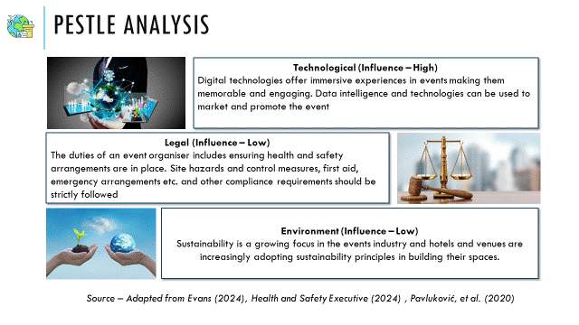
Speaker Notes
Technological influence on the event performance is high, as data intelligence can be applied to the proposed event to promote the proposed technology itself. The use of technology can be leveraged to offer immersive experiences that can assure a memorable event for the attendees. Activities that encourage active engagement between the attendees and event hosts, workshops and ideation are stimulating intellectual experiences that can contribute to the success of the event. Legal influences and environmental influences will have minimal impact on the event itself, as the organisers are at minimum, expected to comply with the regulations that have been set by the government or the event venue business owner. The choice of event venue will factor in essential technical infrastructure, sustainable event space and a location that assures health and safety arrangements on-site.

Slide 9 – Risk Analysis
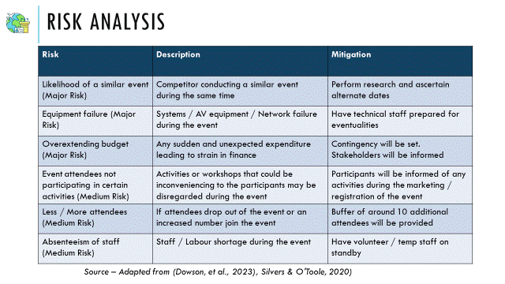
Speaker notes
The feasibility studies offer a valuable input to risk management in any project. While risks are inevitable in the event industry, it is essential to assess if the risks are most likely to occur during the proposed event in the feasibility studies. The risk assessment table offers a broad category of risks that highlights specific elements that have been uncovered during the research for the situational analysis, that need mitigating measures. The UK health and safety executive recommends a step by step risk assessment process for identifying and mitigating hazards. These standard risks can be addressed by the venue business owner.
However, there are specific risks, such as likelihood of another business conducting a similar event during the same time that can affect the success of the proposed event, over-extending budget, equipment failure etc., that need to be addressed by the event organiser. Event attendees may exceed or fall below the expected count. They may be unwilling to participate in certain activities. The event organiser must be prepared with counter measures under these circumstances.

Slide 10 – Conclusion
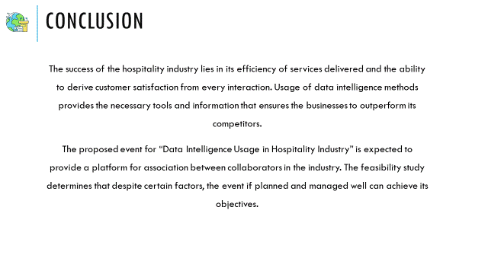
Speaker Notes
Hospitality industry caters to a wide audience comprising national and international businesses. Technology has been a driving force of change and transformation across all industries. Data intelligence not only improves the hospitality services to customers, but also facilitates better collaboration among all the partners and vendors in the industry. The proposed event to host a business conference on data intelligence usage in the industry is expected to highlight these advantages to the stakeholders in the business. The feasibility study shows that with appropriate risk mitigation measures in place, and appropriate planning and management, the event can be held successfully.

References
Antchak, V. & Ramsbottom, O., 2019. The Fundamentals of Event Design. 2019 ed. New York: Taylor & Francis.
Bowdin, G. A. J. et al., 2023. Events Management. 2023 ed. New York: Taylor & Francis.
Department for Business and Trade, 2023. Hospitality Strategy: Reopening, Recovery, Resilience, London: OGL Crown Copyright.
Dowson, R., Albert, B. & Lomax, D., 2023. Event Planning and Management - Principles, Planning and Practice. 3rd ed. London: Kogan Page.
Evans, N., 2024. Strategic Management for Tourism, Hospitality and Events. 2024 ed. New York: Taylor & Francis.
Everett, S. et al., 2021. The Tourism, Hospitality and Events Student′s Guide to Study and Employability. 2021 ed. London: SAGE Publications.
Fox, D., Gouthro, M. B., Morakabati, Y. & Brackstone, J., 2014. Doing Events Research: From Theory to Practice. 2014 ed. New York: Taylor & Francis.
Getz, D. & Page, S. J., 2019. Event Studies: Theory, Research and Policy for Planned Events. 4th ed. New York: Taylor & Francis.
Health and Safety Executive, 2024. Managing an event. [Online]
Available at: https://www.hse.gov.uk/event-safety/managing-an-event.htm
[Accessed 1 5 2024].
Hire Space, 2024. Conference Venues in London. [Online]
Available at: https://hirespace.com/GB/London/Conference-Venues
[Accessed 30 4 2024].
Meredith, J., Shafer, S. & Mantel, S., 2021. Project Management: A Managerial Approach. 11th ed. New York: Wiley.
Mordor Intelligence, 2024. Hospitality Industry in UK Size & Share Analysis - Growth Trends & Forecasts (2024 - 2029) Source: https://www.mordorintelligence.com/industry-reports/hospitality-industry-in-the-united-kingdom. [Online]
Available at: https://www.mordorintelligence.com/industry-reports/hospitality-industry-in-the-united-kingdom
[Accessed 1 5 2024].
Ntounis, N. et al., 2022. Tourism and Hospitality industry resilience during the Covid-19 pandemic: Evidence from England. Current Issues in Tourism, 25(1), pp. 46-59.
O'Toole, W., 2011. Events feasibility and development. 2011 ed. Oxford: Elsevier.
Pavluković, V., Vujičić, M., Kennell, J. & Cimbaljević, M., 2020. Sustainability in the Meetings Industry. Serbia, SITCON 2020 - TOURISM AND SUSTAINABLE DEVELOPMENT – CHALLENGES, OPPORTUNITIES, AND CONTRADICTIONS.
Premier Inn, 2024. Pricing. [Online]
Available at: https://www.premiermeetings.co.uk/pricing
[Accessed 30 4 2024].
Revenue Analytics, 2019. Analytics, Data Intelligence, and Automation Key to Revenue Management Investment for Hospitality Industry, Revenue Analytics' 2019 Report Finds. [Online]
Available at: https://www.prweb.com/releases/Analytics_Data_Intelligence_and_Automation_Key_to_Revenue_Management_Investment_for_Hospitality_Industry_Revenue_Analytics_2019_Report_Finds/prweb16421190.htm
[Accessed 1 5 2024].
Silvers, J. R. & O'Toole, W., 2020. Risk Management for Events. 2020 ed. New York: Taylor & Francis.
UN tourism, 2024. Data, intelligence and trends. [Online]
Available at: https://www.unwto.org/archive/competitiveness-market-intelligence
[Accessed 27 4 2024].
Williams, N. L., 2021. Managing Event Projects. In: N. Ferdinand & P. J. Kitchin, eds. Events Management: An International Approach. London: SAGE, p. 3.
Wu, B., Hu, Y. & Gu, X., 2022. Achieving Greater Educational Impact through Data Intelligence. 2022 ed. Singapore: World Scientific Publishing Co. Ltd., Pte.

