

Wales Institute for Science and Art
University of Wales Trinity Saint David

ACDB 5015: Advanced Physics of OME

Design of Shaped Charges

Gareth James
Student Number: 2217522

Abstract
Shaped Charges are capable of producing high velocity projectiles as result of harnessing the explosive effects of the Munroe Effect. Their capability to penetrate a number of target materials has seen their application within a wide range of industries.
Two designs were created in Abaqus (produced by D’Assault Systèmes) in 2D to explore the jet formation and velocities achieved during this process. An additional 3D model (based on one of the 2D models) was used to explore the jet formation process also.
This report relates to the modelling process and the results obtained for these design simulations whilst examining the relationship between cone angle, jet formation and the associated velocities achieved. This included an overview of the effectiveness of the Lagrangian method employed and other that could be used as an alternative, in the evaluation of the simulations and results which contribute to successful modelling and analysis.

Contents
1. Introduction 1
2. Shaped Charge Structure 2
2.1. Shape charge detonation and Jet Formation 3
3. Method: 6
3.1. 2D Simulation: 6
3.2. 3D Simulation 9
3.3. Materials: 10
4. Results: 12
4.1.1. 60 Degree Conical Liner 13
4.1.2. 90° Conical Liner 18
4.1.3. 3 24
5. Discussion 28
6. Conclusion 31
7. References 32

Table of Figures
Figure 1 - Structure of a Shaped Charge [1] 4
Figure 2 - Shaped Charge and Jet Formation [14] 5
Figure 3 - Shaped Charge with Truncated Conical Liner [24] 7
Figure 4 - Design 1 - Shaped Charge with 60° Conical Liner 8
Figure 5 - Design 2 - Shaped Charge with 90° Conical Liner 9
Figure 6 - Mesh and Assembly for Design 2 9
Figure 7 - Design 1 (Left) and Design 2 (Right) - 10
Figure 8 - 3D Model - 90 Degree Conical Liner Mesh 11
Figure 9 - Mesh Geometry for 3D Model of Shaped Charge with 90° Liner 12
Figure 10 - 2D Model 60 Liner - Time-Steps 0, 30, 60 and 100 15
Figure 11 - 2D Model 60 Liner - Time-Steps 120, 160, 200 and 230 16
Figure 12 - 2D Model for 60 Liner - Jet formation images taken at 0, 100 and 200 time steps 17
Figure 13 - Velocity Graph relating to Jet Tip at Time-Step 200. 18
Figure 14 - Jet Formation from 60 Liner at Time-Step 200 19
Figure 15 - 2D Model 90 Liner - Time-Steps 0, 30, 60 and 100 20
Figure 16 - 2D Model 90 Liner - Time-Steps 120, 160, 200 and 230 21
Figure 17 - 2D Model for 90 Liner - Jet formation images taken at 0, 100 and 200 time steps 22
Figure 18 - Velocity Graph relating to Jet Tip of 90 Liner at Time-Step 200. 23
Figure 19 - Jet Formation from 90 Liner at Time-Step 200 24
Figure 20 - Jet Velocity Comparison between 60 and 90 liners 25
Figure 21 - 3D Model of 90 Liner - Time Steps 0/30/60/100 26
Figure 22 - 3D Model of 90 Liner - Time Steps 90/120 27
Figure 23 - Velocity Graph relating to Jet Tip of 90 Liner at Time-Step 120. 28
Figure 24 – 3D Model - 90 Liner Jet Formation at Time-Step 120 29
Figure 25 - Blast Wave Propagation through HE Fill of the 3D model 31

Introduction
The following study relates to the construction and modelling of a Shaped Charge and explores the relationship between Jet formation and velocity. This was executed in Abaqus, produced by D’Assault Systèmes using a Lagrangian solver, within the Explicit Dynamics analyser.
A shaped Charge refers to a device which utilises an explosive load to collapse and focus a liner, resulting in a high velocity jet being formed. The jet produced has the capability to penetrate deep into hard materials such as concrete and metal. The shaped charge has a cavity at the opposite end of the point of detonation. This charge, if left in its unlined state is referred to as a hollow-charge or an unlined-cavity charge (in the USA and UK) [1] [2]. According to Walters the terminology Hollow Charge is attributed to A. Marshall (1920) and Shaped Charge was an American term developed during the Second World War.
The effects of hollow charges and their development are typically attributed to Munroe with his exploration of this in the late 1880s and 1890s in the United States. His observations related to the detonation of a block of guncotton which had left an imprint on a steel plate. This imprint had been left as a result of the letters being stamped into the surface of the block and placed with the indented side in contact with the plate itself. It was observed that the cavities had focused the explosive detonation and increased the penetrative properties of the blast, resulting in letters being imprinted on the surface [3]. Research was not limited to the US, and between 1911-1914 Neumann continued to explore this concept with cylindrical charges, both lined and un-lined. This period of research lead to this phenomena being named the Munroe Effect (in the UK and USA) or the Neumann Effect (or von Foerster) in Europe.
The first lined shaped charge was constructed by Munroe in 1894, and consisted of a tin can enclosed in dynamite, with the open end of the can facing a steel target. This formed the basis for Neumann’s experiments with cylindrical hollow-charges in the early 1910s. By the 1940s this design had been refined and utilised in military applications during the Second World War. Some examples of these can be seen in the German Panzerfaust, Japanese Sakura bomb, and the British Projector Infantry Anti-Tank (PIAT) [1]. Following the end of the conflict, the designs were taken further and utilised in more effective High Explosive Anti-Tank (HEAT) munitions in cavalry and artillery units [4].
As a result of the devastating penetrative capabilities shaped charges are often used to neutralise hardened or protected targets, including concrete structures (such as runways, defensive positions and command bunkers), armour plating. Outside of military applications shaped charges have been used in mining, quarrying, and rock drilling alongside milling in the petroleum and gas industries; explosive demolitions and cutting through metal reinforced concrete structures in the construction industry; and tunnel construction [5] [6] [7] [8].
Shaped Charges have been extensively researched over time, with particular interest with regards to area of jet formation. Where X-ray imagery has been used to capture jet formation in 1974, physical research can be costly, with consideration to the time and resources required to capture data of interest. Modelling and simulation software provides a more cost-effective approach, providing a reduction in costs in both time and resources [9].

Shaped Charge Structure
The construction of a simple shaped charge consists of three main elements which include a liner, an explosive material, and a case or chamber containing a high explosive [10]. An example of the structure of a shaped charge can be seen in Figure 1.
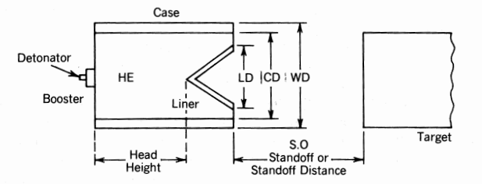
Figure 1 - Structure of a Shaped Charge [1]

Shape charge detonation and Jet Formation

The performance of a shaped charge is a culmination of the device as a whole system and the relationships between the components which make it. The key areas which affect performance and penetration include the explosive (which include the dimensions, diameter and length), the liner (including material, thickness, head height, and cone angle), and stand-off distance (which allows the jet to fully form) [11] [12] [13] .
When a shaped charge is initiated the detonation shockwave propagates through the explosive from the point of detonation (PD). As it progresses through the material the detonative wave contacts the apex of the liner and propels this away from the PD, starting the process of inverting the liner.
As the shockwave continues through the explosive material it collapses the liner geometry at hypersonic speeds. As the Apex is forced in the direction of the blast propagation, the liner is pushed along the axis away from the POD.
The detonation wave continues to pass through the explosive, compressing the liner geometry towards the axis and away from the POD. The combination of these forces turns the liner into and elongated jet of metal and is capable of reaching velocities between 3-10 km/s [14] and as high as 12km/s [10]. As a result of the forces generated and pressure the liner is exposed to the liner material behaves as that of a liquid, however it does not melt and retains the characteristics and behaviours as that of a solid [11] [15].
In order of the jet to form effectively, there must be space to do so. The space required for this to take place is referred to as a stand-off distance. It is the nature of the jet formed and the stand-off distance that results in the devastating ability to penetrate a vast number of targets to depth [4].
The jet formation process can be seen in Figure 2

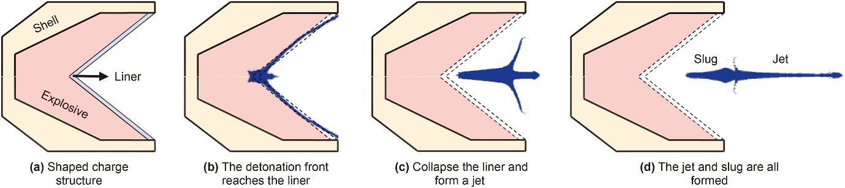
Figure 2 - Shaped Charge and Jet Formation [14]

    - Explosive
The explosive material provides the driving force behind the formation and velocity of the jet itself. Where early shaped charges were made from TNT, experimentation and research indicated that by changing the explosive there were improvements to the performance of shaped charge devices, with the jet being capable of penetration across different target materials. In changing the high explosive to a more efficient compound, higher velocities and greater penetrative capabilities were achieved. Substitutes have included Comp. B, Octol and LX-14 [1]. The explosive component of the SC has been associated with the velocity of the jet and is a key consideration when designing a SC.

    - Liner
The SC Liner is a key consideration when designing and SC and should be considered essential in the formation of the jet. There are a number of factors to be considered in relation to the liner, each of which contributes towards the performance and effects desired at the target.
Pure metals have become the preferred choice for charge liners. Tungsten, Steel, Molybdenum, Nickel and Copper remain popular options for charge liners [16], likely as a result of their ductility and density. Research conducted by the Germans in the 1930s supported the choice of copper as the ideal liner material, which is now widely used in the majority of shaped charges [1]. Due to the need for consistent performance the majority of SC produced the majority of SC are made from copper and tantalum as a result of their intrinsic properties relating to density and malleability, which are essential properties required to form the jet. By altering the liner material the penetrative properties of the jet may be affected [17].
    - Stand-Off
This also extends to the stand-off distance required for the liner to form the jet.
Standoff (SO) can be described as the distance between the target and the SC. SO affects the jet ability to penetrate a target, as a result an SO that is too small will not allow the jet to form an optimum shape for this purpose, and an SO that is too great may result in jet bifurcation or break up, resulting in poorer performance. The optimum SO distance for jet formation has been debated, but typically ranges between 2 to 6 charge diameters but can be greater depending on the thickness of the liner, geometry and cone angle [9] [18] [19].
There are a number of factors pertaining to the construction of a shaped charge which contribute to both jet formation and penetrative capabilities. These factors include the liner angle, liner thickness and geometry, stand-off distance and explosive.

    - Cone Angle and Geometry
Where conical liner angles have been determined to be more effective between 35-50°, it has also been suggested that smaller angles can result in greater perforation capabilities (depending on liner and target material), as a result of increased jet tip velocity [14]. The relationship between liner thickness and cone angle has been extensively researched (within a community of shared interest) with a range of observations relating to the relationship between wall thickness and cone angle.
The jet may not form if the liner wall that is too thin, as it will not withstand the pressures generated by the explosive material. Equally, a liner wall that is too thick will not form an ideal jet accompanied with a decrease in both velocity and penetration [9]. The ideal wall thickness has been identified as proportionately related to the charge diameter and can range between 1% to 6% of this [19].
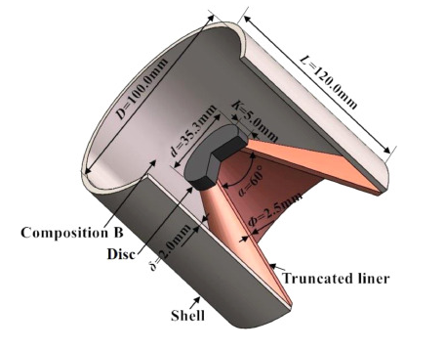
Examples of geometry include trumpet shaped, tulip, and conical liners. Each with own variations in cone angle, along with variations in liner thickness, both tapered and un tapered [17]. Other variations have included the truncation of the cone liner and changes to the cone apex itself [20].
Figure 3 - Shaped Charge with Truncated Conical Liner [24]

Where the performance of a shaped charge is dependent on a combination of factors, 2 designs were created in Dassault Systèmes Abaqus package to explore the problem.
To explore how the cone angle can affect the jet formed by an SC it was determined that the angles of 60° and 90° would be used for the liners. Composition B was selected for the HE fill, as there were several examples of this being used in literature, with available and complete data sets for the values required.

Method:

2D Simulation:
Modelling the designs for the shaped charges took place in the Abaqus software package produced by Dassault Systèmes. An example of a shaped charge design was taken from literature, and an Axisymmetric model was replicated.
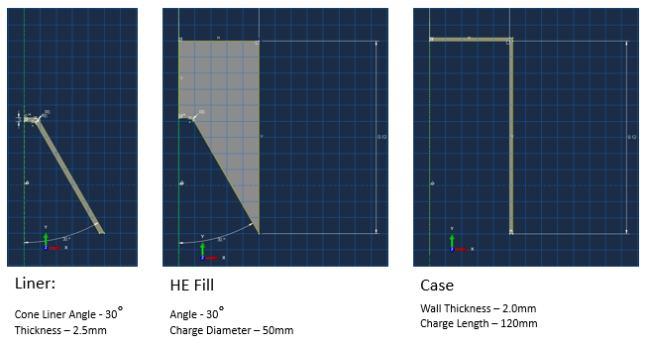
The case, high explosive [HE] fill, and liner were created as separate parts, starting with the case and liner, with the HE fill being the last component so that all surfaces were coincidental, thus providing a fill with no voids in the material. Once each part was complete, they were used to create the Assembly. The process was replicated for both SCs. The design and construction can be seen for the 60° SC design can be seen in Figure 4 below
Figure 4 - Design 1 - Shaped Charge with 60° Conical Liner
.

The parts were saved and labelled according to the component, which enabled them to be identified during the assembly process. Where this process was identical for both designs, alterations were made to the cone liner angle and used to build the rest of the design around it.

The designs for the 90° Conical Liner can be seen in Figure 5, with the mesh and assembly visible in Figure 6. A comparison between the two designs can be seen in Figure 7.
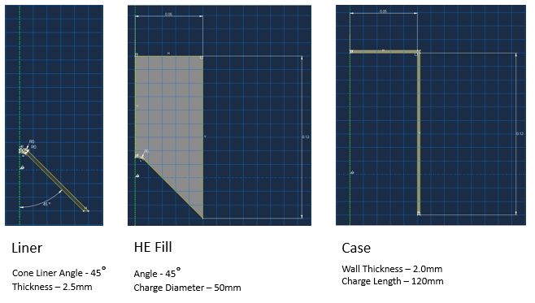
Figure 5 - Design 2 - Shaped Charge with 90° Conical Liner

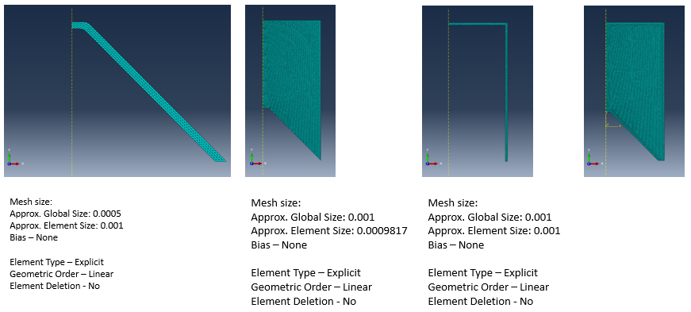
Figure 6 - Mesh and Assembly for Design 2

To allocate material properties, each part was selected as a section and assigned the material accordingly. Material data for the copper (Cu) liner and steel casing were also identified and allocated to the relevant sections. This was done by opening the materials manager and manually inputting the data. These can be viewed in section 2.3 Materials.
For the 2D model the Load Module was opened and the central axis was selected.
Once these steps were completed the model was meshed by selecting Mesh in the module dropdown bar and selecting each part. The mesh was added to each of the parts separately and using a global mesh size of 0.001 was used. A comparison between the assembly and mesh can be seen below in Figure 7.
The simulation was run by opening Job in the module drop down bar and selecting the create button.
Results were accessed by selecting the results tab in the Module drop down bar. Where the model was created as a cross-section, a rotational view was created by opening ODB options and selecting the Sweep Extrude function. To provide a more detailed view of the conical liner the Sweep Elements tool was opened and then increased to 12 sections. This provided a 180 revolved sweep of the SC throughout the process around the axis of symmetry, effectively generating a representative cross section through the centre of the SC and its components.
Results can be viewed in the Results section of this report.

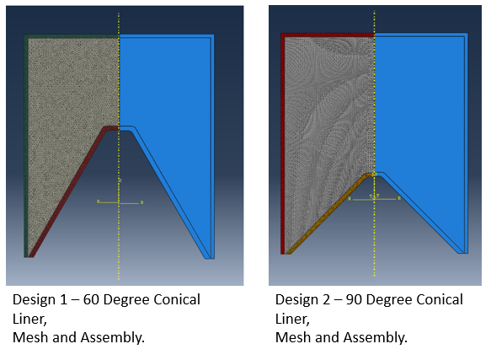
Figure 7 - Design 1 (Left) and Design 2 (Right) -

3D Simulation

The 3D model was produced by selecting the 3d option in the Modelling Space instead of using the Axisymmetric option. The designs for the component parts had been saved as part of the project files and were used as reference in order to generate the 3D model.

The Mesh process was executed in the same manner as the 2D model but using a tetrahedral (TET) mesh. To run the simulation the mesh for the liner was modified with a bias towards the outermost edges. The Approximate Global Size (AGS) was set to 0.002, with a minimum size (MS) set to 0.0004. This resulted in a functional 3D liner which can be seen below in Figure 8.

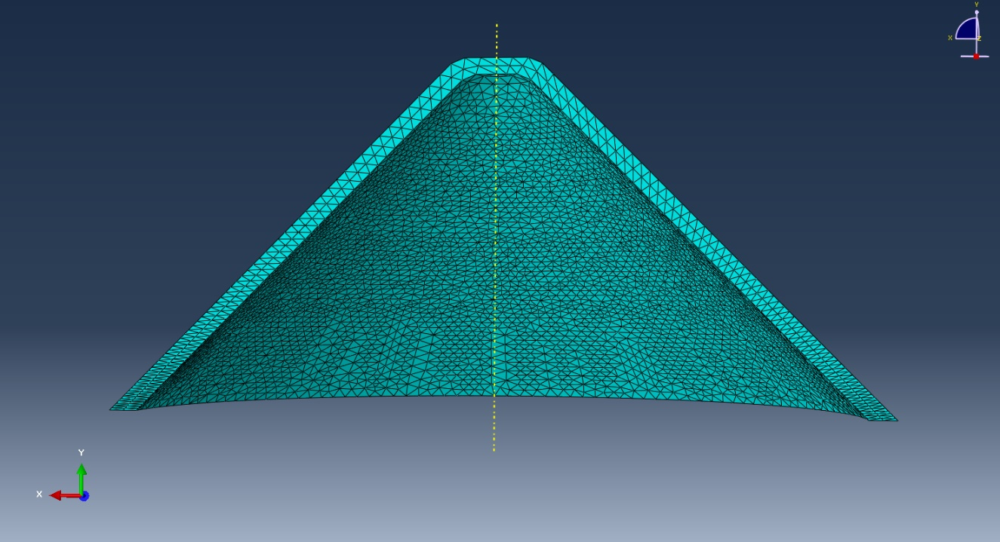
Figure 8 - 3D Model - 90 Degree Conical Liner Mesh
For the HE Fill the mesh parameters were set as 0.006 for AGS and 0.004 for the MS. There was no bias assigned to any of the edges, as the focus of the model related to the jet formation and velocity. As with the 2D model, the HE Fill was assigned the properties for Comp B.

The Case mesh was set to 0.005 for both the AGS and MS respectively, with no bias assigned to the edges. The properties for Steel were assigned to the section, as with the 2D model.

The assembly was constructed following the same process as with the 2D model before running the simulation. The mesh for these components can be seen in Figure 9.

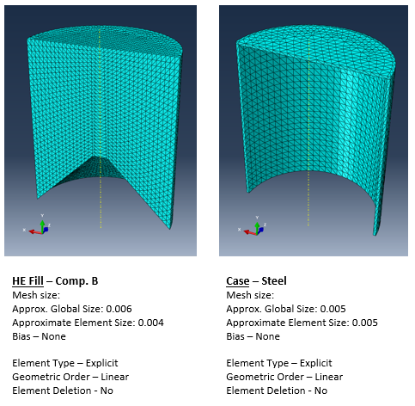
Figure 9 - Mesh Geometry for 3D Model of Shaped Charge with 90° Liner
Details for the Mesh parameters can be identified below each component

Materials:
Copper has been widely used for liners in shaped charge construction [11] [15] [21], and as such was selected as the material for the Liner. The Johnson-Cook parameters (JC) and Mie Gruneisen Equation of State (EoS) for this can be seen in Table 1.
Composition B (Comp. B) was chosen for the fill, as this had been identified in several journal articles [15] [16] [22] [23]. Comp B which is commonly used in the defence industry due to its consistent performance in a number of environments and platforms. This is based on a mix of RDX (Royal Demolition Explosive or 1,3,5 trinitro-1,3,5-triazine – which is also known as Hexogen or Cyclonite) and Trinitrotoluene (TNT) [15] at a ratio of 60/40. Material Data for Comp B can be seen in Table 2.
Steel was identified as a common component material in SC designs and has been used for both liner and case in numerous designs [4] [24]. For the 3D model Steel 4340 was allocated to the casing material; the material data can be found in Table 3.

Table 1 - Material Data for Copper (Cu) Liner [21]
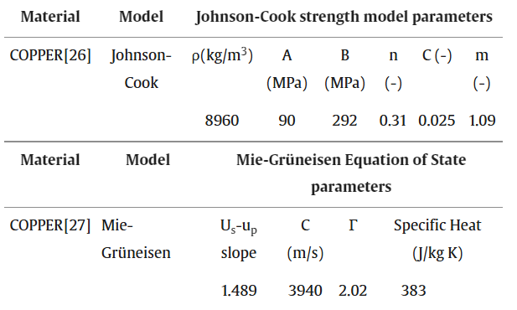

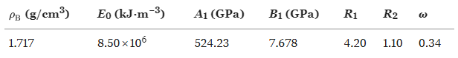
Table 2 - Material Data for Composition B [16] – Jones Wilkins Lee (JWL) Perameters

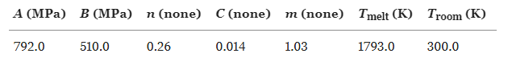
Table 3 - Material Data for Steel Case (Steel 4340) [24] – JWL and Johnson Cook (JC) Parameters

Results:
  - 2D Models for Shaped Charge with 60° and 90° Conical Liner:
The results of the 2D Models can be found in the respective sections below. Images were taken from the same time step in order to allow direct comparison of the jet formation and velocities associated with the jet tip. The images were taken at the 0, 30, 60, 100, 120, 160, 200 and 230 time step for both the 60° and 90° conical liners.
The images in this section relate to V Magnitude and show the velocity of different parts of the liner. As previously stated, the velocity of the jet tip is what provides the penetrative capabilities of shaped charge. In taking images at the same time-step jet formation and velocity can be compared directly between the two designs.
To obtain the images changes were made to the display settings by entering Common Plot Options, selecting Visible Edges and selecting the No Edges option.

60° Degree Conical Liner
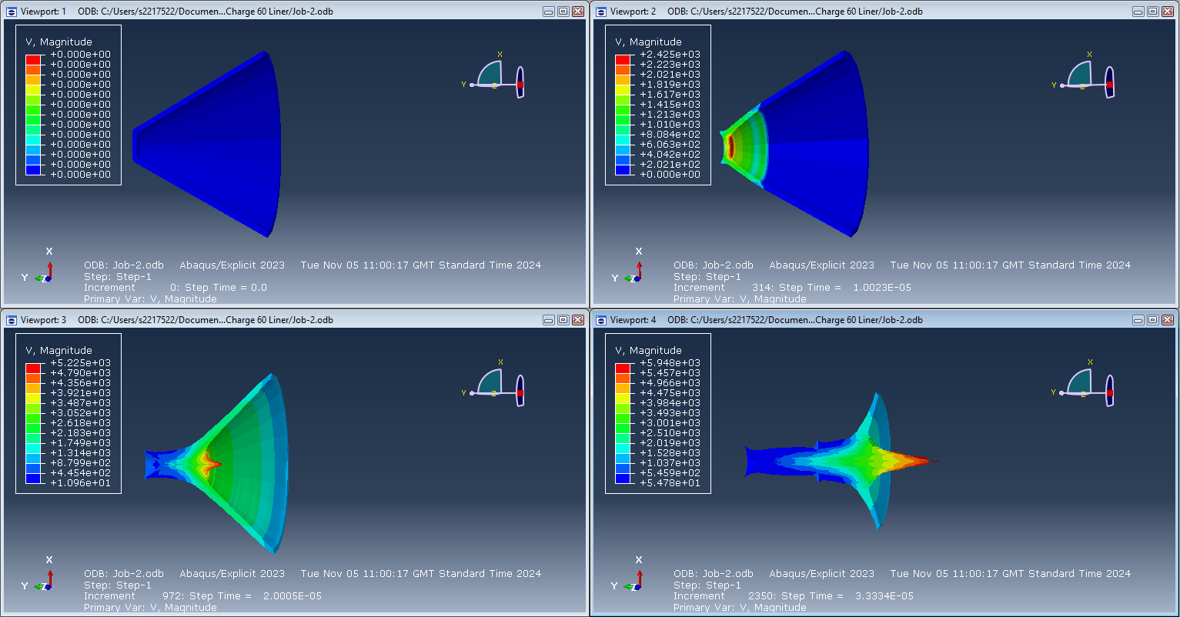
Figure 10 - 2D Model 60° Liner - Time-Steps 0, 30, 60 and 100

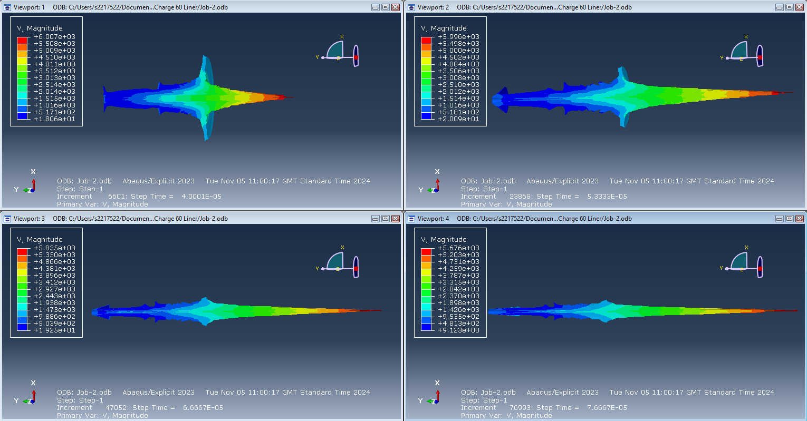
Figure 11 - 2D Model 60° Liner - Time-Steps 120, 160, 200 and 230
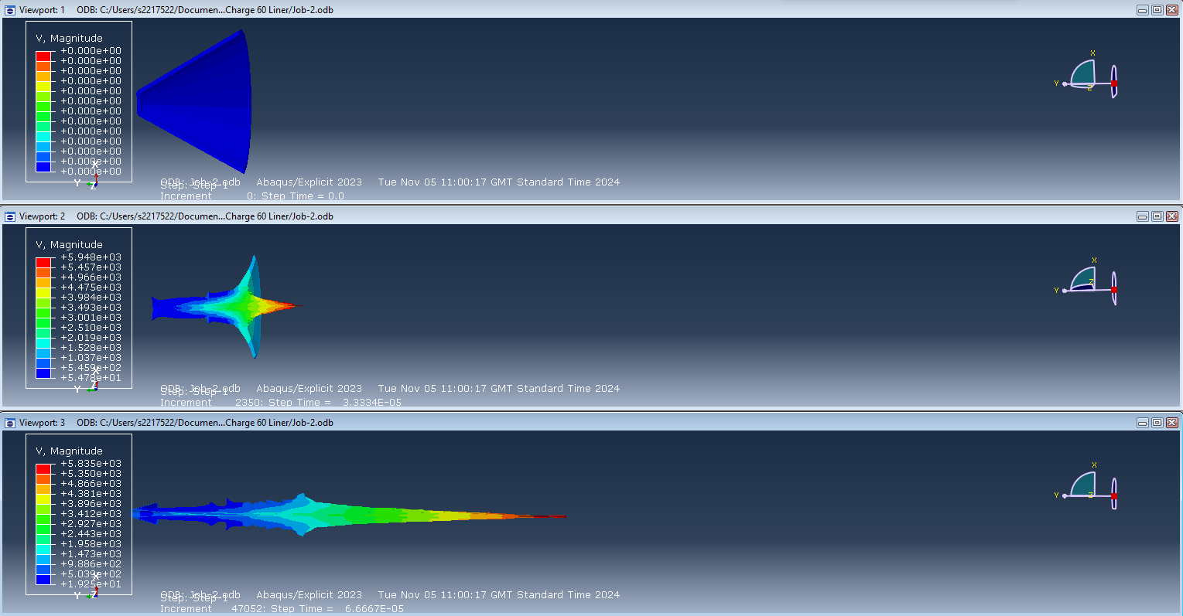
Figure 12 - 2D Model for 60° Liner - Jet formation images taken at 0, 100 and 200 time steps

Figure 13 - Velocity Graph relating to Jet Tip at Time-Step 200.

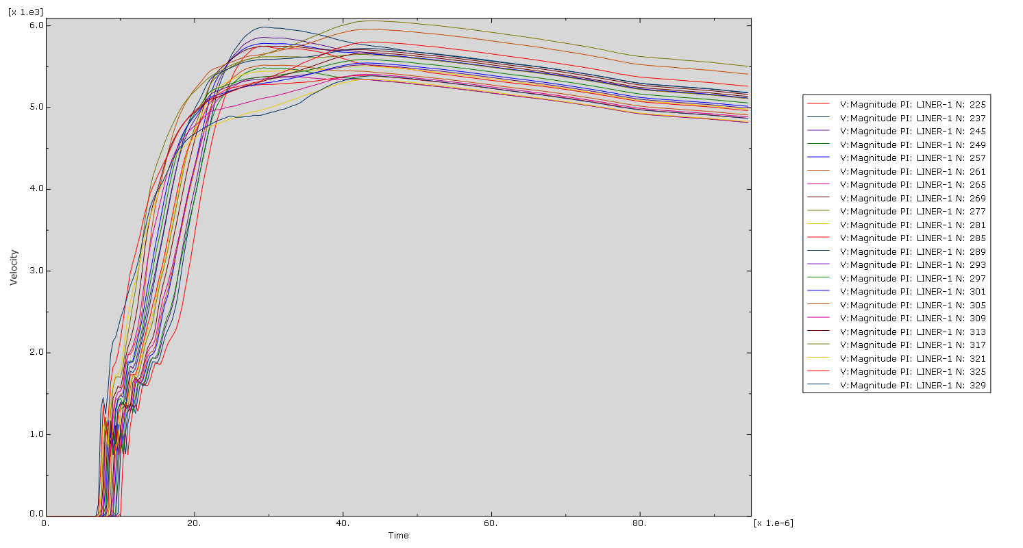
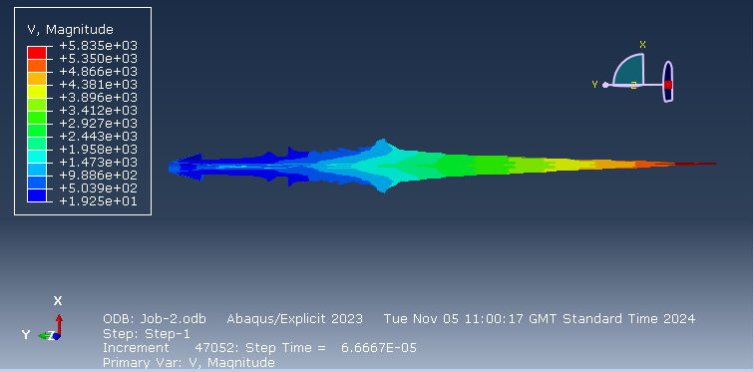
Figure 14 - Jet Formation from 60° Liner at Time-Step 200

90° Conical Liner
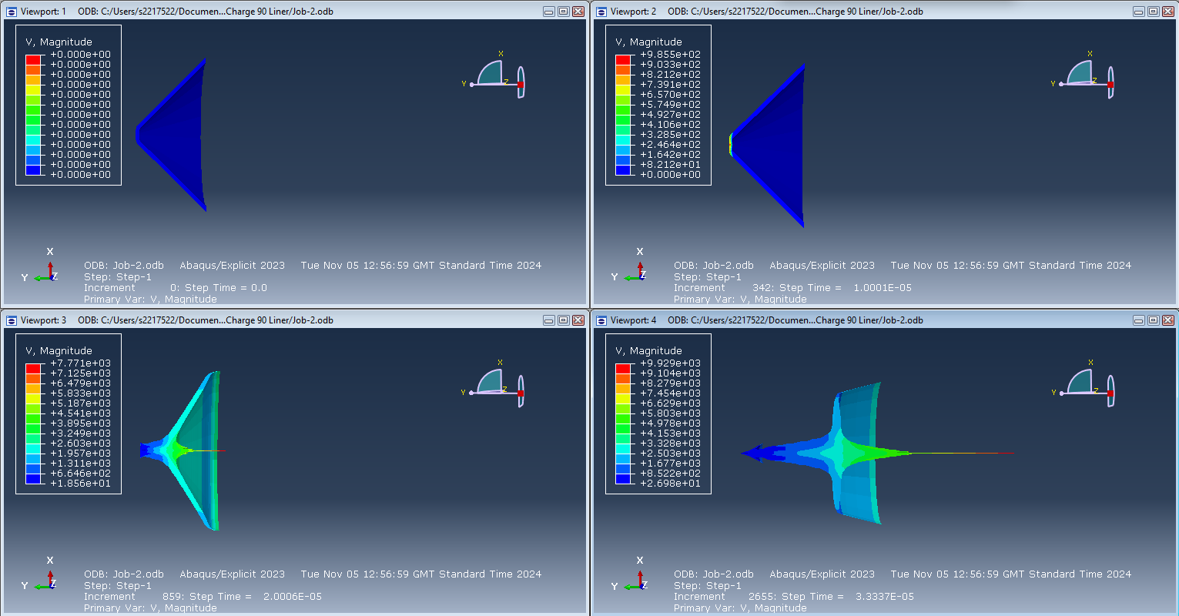
Figure 15 - 2D Model 90° Liner - Time-Steps 0, 30, 60 and 100

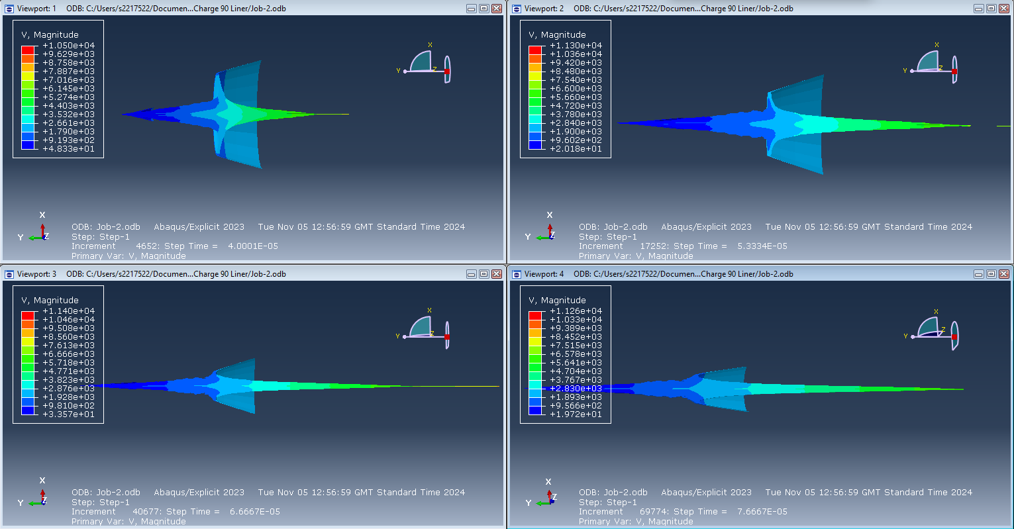
Figure 16 - 2D Model 90° Liner - Time-Steps 120, 160, 200 and 230
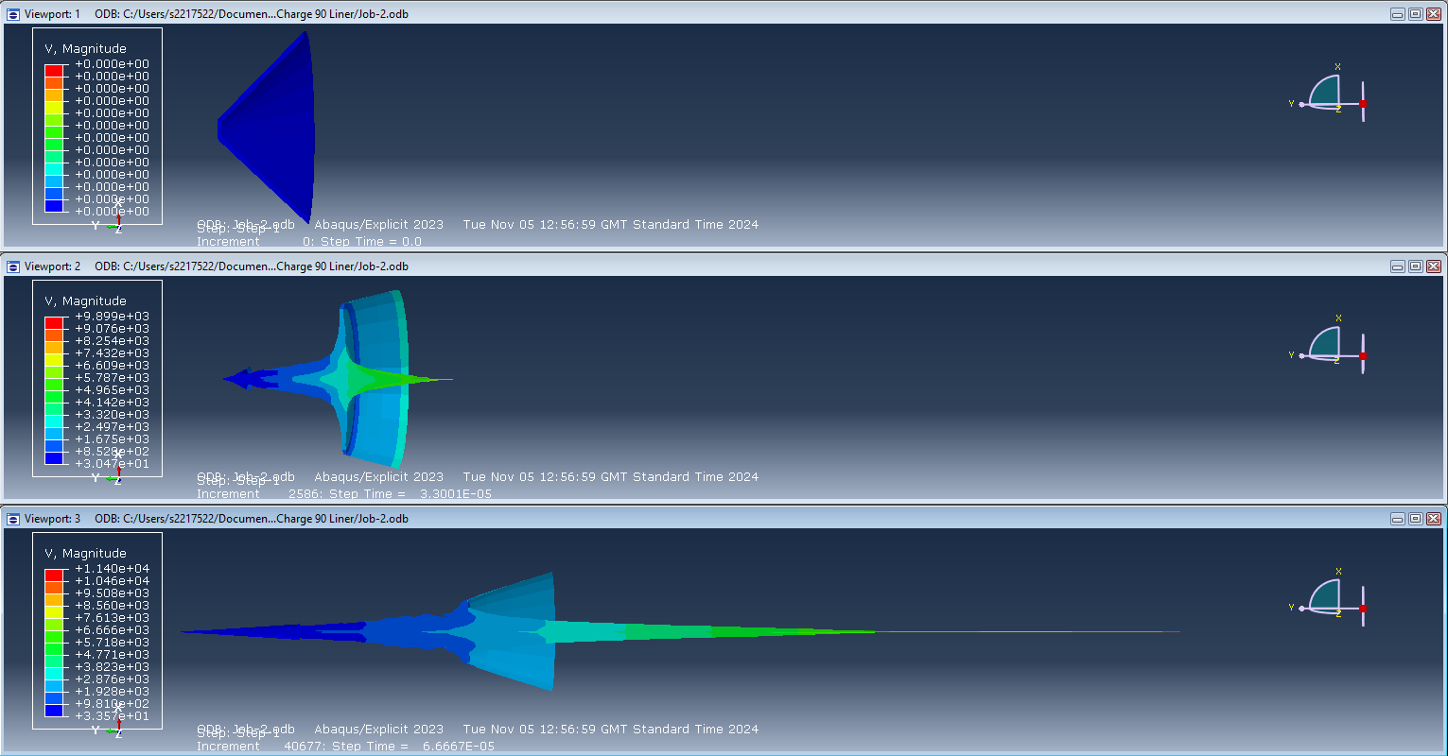
Figure 17 - 2D Model for 90° Liner - Jet formation images taken at 0, 100 and 200 time steps
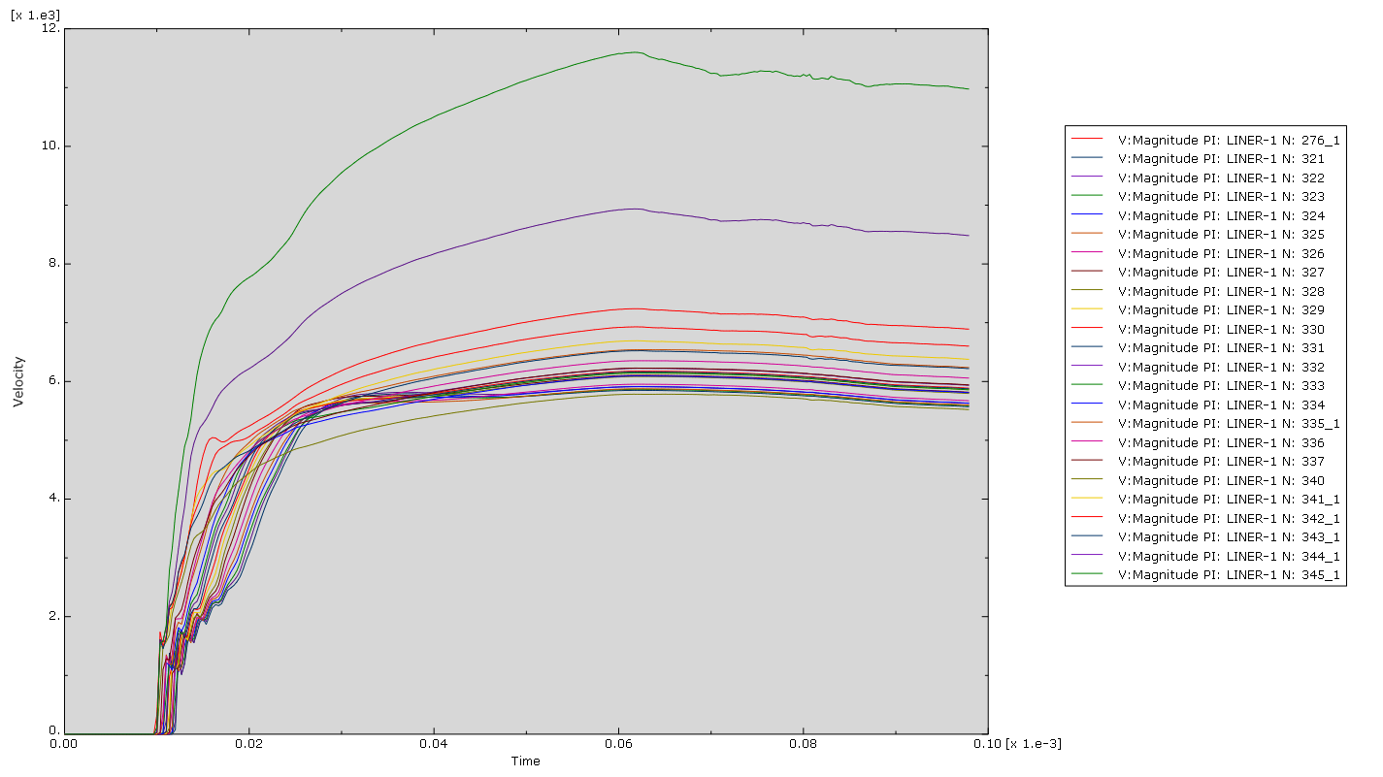
Figure 18 - Velocity Graph relating to Jet Tip of 90° Liner at Time-Step 200.
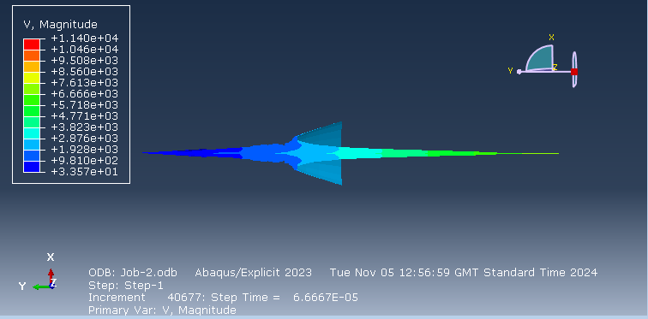
Figure 19 - Jet Formation from 90° Liner at Time-Step 200

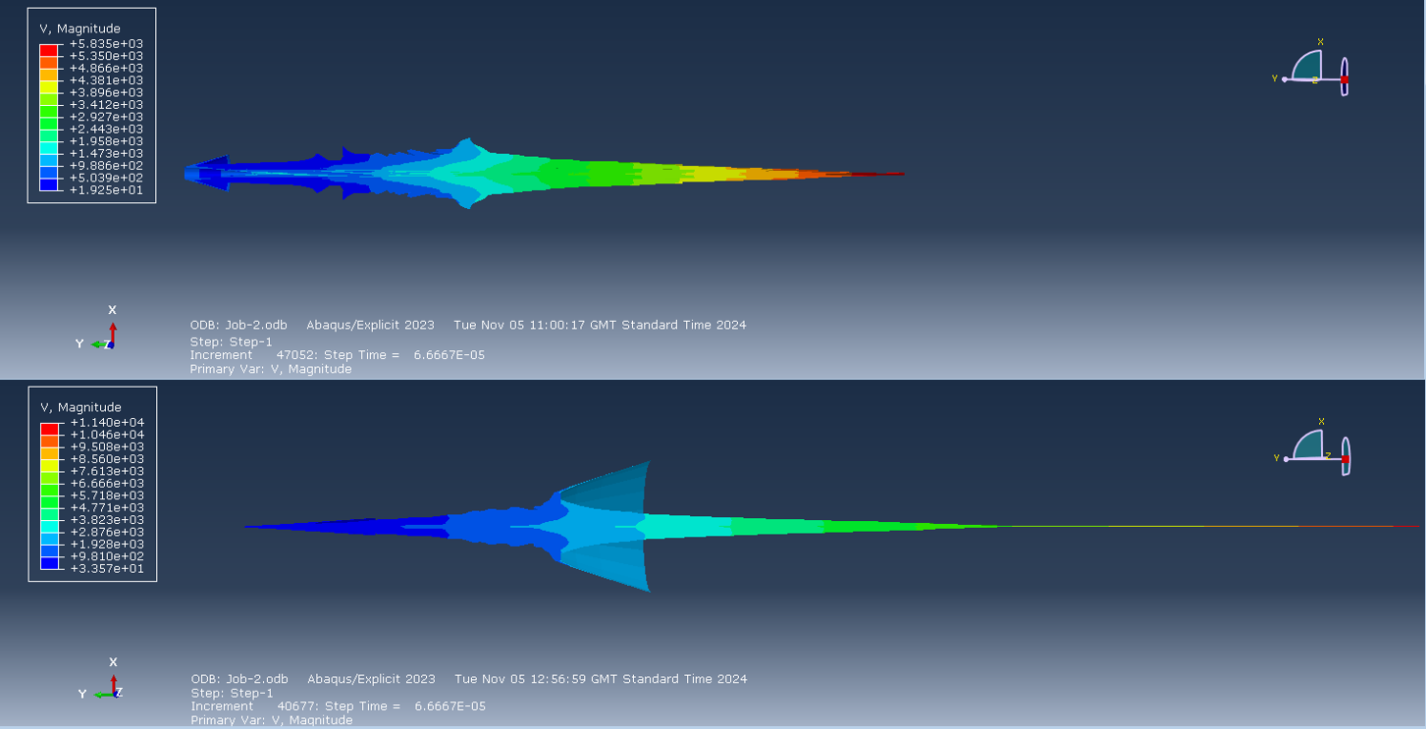
Figure 20 - Jet Velocity Comparison between 60° and 90° liners

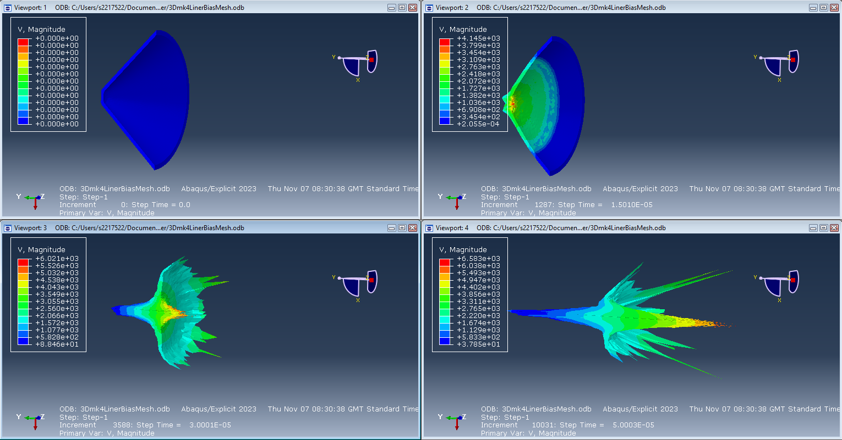
    - 3D Model of Shaped Charge with 90° Conical Liner
Figure 21 - 3D Model of 90° Liner - Time Steps 0/30/60/100

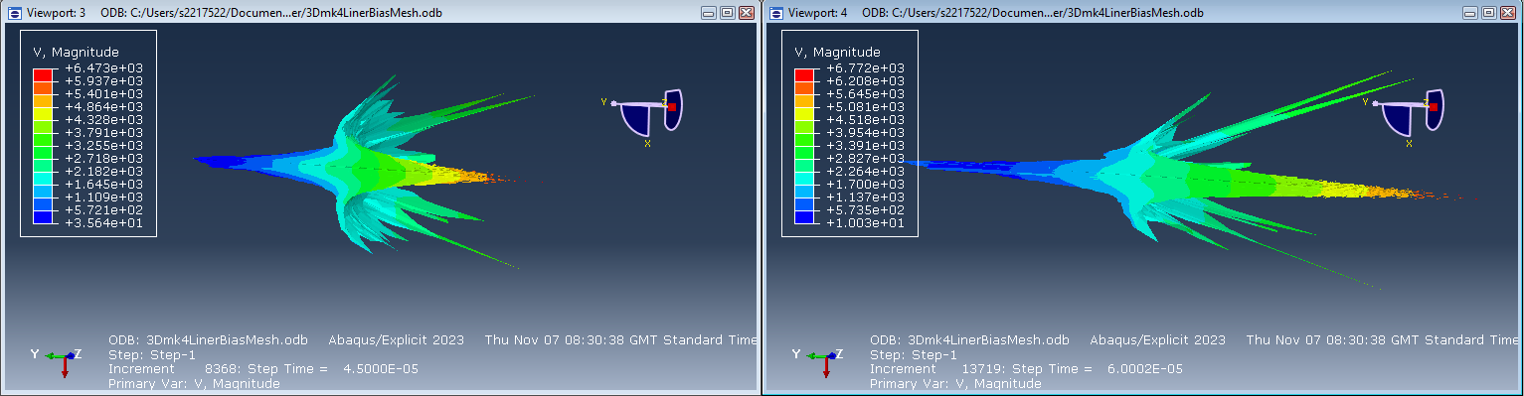
Figure 22 - 3D Model of 90° Liner - Time Steps 90/120

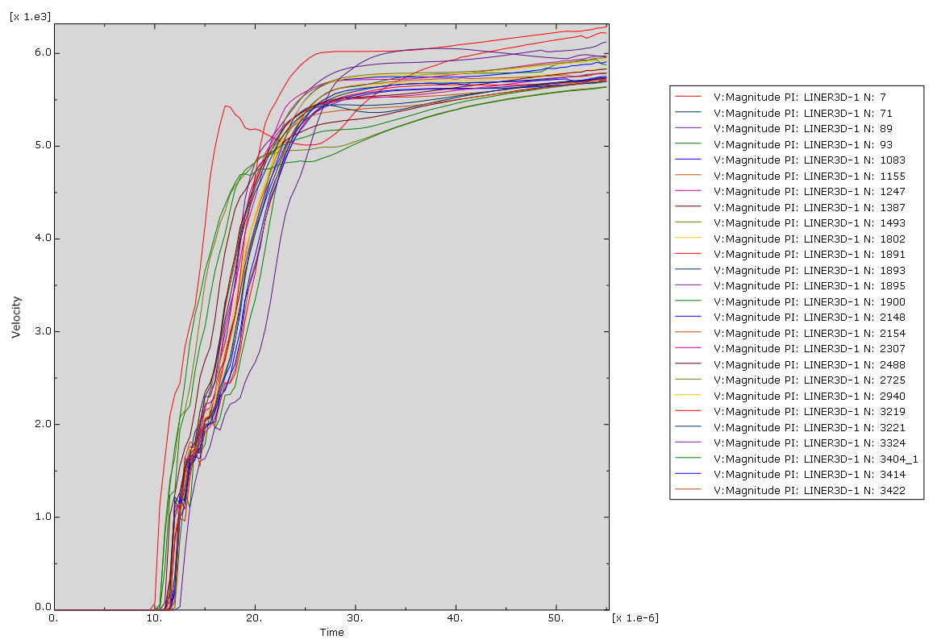
Figure 23 - Velocity Graph relating to Jet Tip of 90° Liner at Time-Step 120.

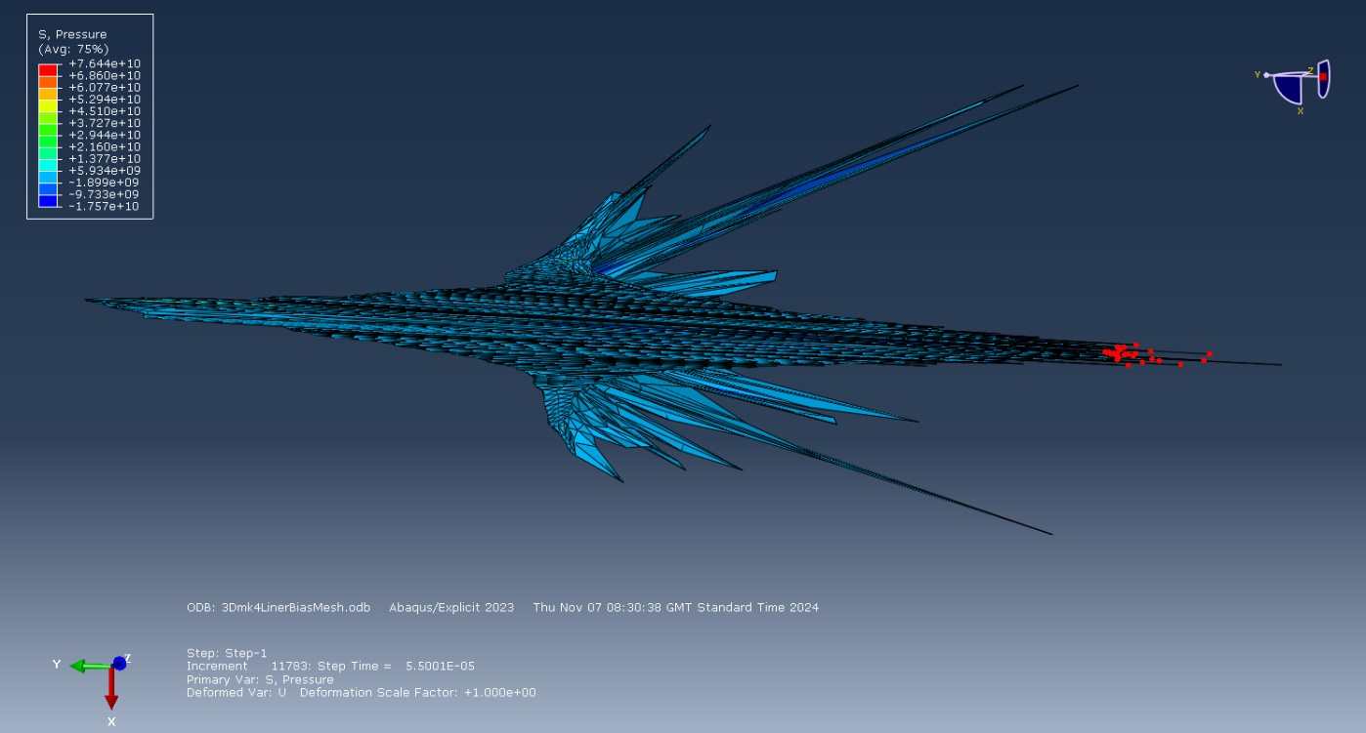
Figure 24 – 3D Model - 90° Liner Jet Formation at Time-Step 120

Discussion
Due to the complex nature of how the jet is formed during the detonation of a shaped charge, a high-performance software package was required to run the simulation. Utilising Abaqus to examine Jet formation in both 2D Axisymmetric and 3D models provided an opportunity to explore the field of SC performance with reasonable results.
From the 2D Axisymmetric Model results it was possible to compare the difference in velocities of the jet tip. This was done through node analysis of a selection of nodes in the Jet tip of the 2D models, and can be seen in Figure 13 and Figure 18, with a direct comparison of the jet formations of the 60° and 90° liners in Figure 20. The velocities achieved by the 60° and 90° liners were 5835 m/s and 11400 m/s respectively. Where the 90° liner produced results of far greater velocities that the 60° liner, it was selected as the base for the 3D model whereby the jet formation and velocity could be further examined.
One of the key differences between the 60° and 90° liner was the shape of the Jet itself. Where the 60° produced a typical jet shape, with a clearly identifiable slug, the 90° liner produced a long lance-like structure with a needle-like tip. Where the velocity of the jet tip has been linked to enhanced performance of an SC, exploring the relationship between jet shape and velocity would provide insight to this.
3D Model –
The initial mesh generated was based on the same specifications as the functional 2D model. When the mesh was generated, it was more than the 250,000 node limit of the licensed software, and therefore had to be modified. As the focus of this study related to the formation of the jet, it was determined that a coarse mesh would be suitable for the HE Fill and Case, with a finer mesh for the liner. Reducing the node count enabled the model to run to some success, however by reducing this the model accuracy would also be reduced.
A key difference between the 2D and 3D simulations was the increase in time taken to run the model. Where 2D simulations were comparatively faster than the 3D model, there was a considerable increase in time taken to process the data and calculations by the software. This was anticipated due to the increased number of nodes associated with the 3D model, however exceeded user expectations. Should the software license been capable of running a higher node count to produce a more detailed model, additional considerations would also be given to the processing capabilities of the computer and the time-scales associated with it.
With a model that was able to be run within the limitations of the programme, there were further issues encountered. The main limitations included multiple abortions early in the detonation process and extreme deformation of components as a result of mesh parameters. Following adjustments to the mesh the simulation was able to run long enough to show early stages of jet formation, however, did not run far enough to establish a consistent and fully formed jet as seen in the 2D model. The jet produced can be viewed in Figure 24 and some similarities seen between this and the jet produced at step 100 in Figure 17, which suggests that should the model have run to completion a more detailed examination could have been conducted.
At Step 123 the 3D model aborted and failed to continue running. Numerous attempts were made to identify the issue however these were futile. During this process it was observed that the mesh may have contributed to the success of the model running as far as it did. Through examination it was identified that the pattern created during the mesh generation step may have supported the model to run with some success. When isolated and observed the pressure/blast wave propagation matched the mesh generated throughout the detonation process. This can be seen in Figure 25.
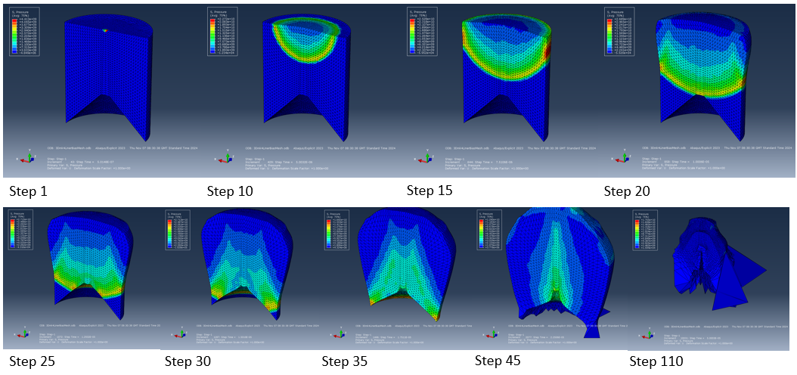
Figure 25 - Blast Wave Propagation through HE Fill of the 3D model

For both the 2D and 3D models produced in Abaqus, these were calculated using a Lagrangian method. Where this is capable of analysing vast amounts of data in a short time frame it has shown that it is capable of providing a comparatively accurate representation of the mechanics of the formation of an SC Jet (particularly in the 2D models). Where the Lagrangian approach is used, both elements and nodes of the mesh remain attached to the material. Where it is designed to deform in a representative manner as that of the material, one of the limitations of this method is that it is liable to suffer from mesh distortion as a result of large deformations [25], resulting in model failure. An example of this can be seen in Figure 25.
An alternative to a pure Lagrangian approach could be running the simulation using Eulerian modelling. With regards to the mesh, this will remain fixed in space and allow the material to move through the mesh where deformation occurs. However, this has been suggested by Mir (et. al) that the mesh boundary nodes and intrinsic material boundary nodes may not be coincident, and therefore would be difficult to model free boundary and interface conditions of both the model and materials.
Arbitrary Lagrangian-Eulerian (ALE) formulation allows for the combined use of the Lagrangian and Eulerian methods. ALE allows the boundary nodes to be coincident with material boundaries while adjusting interior nodes to reduce mesh distortion, which may provide a solution to the distortion experienced in the 3D model. The benefits of this approach include the ability to maintain a high-quality mesh under severe material deformation and can be used in modelling problems in explicit dynamics [26].
Where Abaqus is capable of running these alternative solvers, a Combined Eulerian Lagrangian (CEL) could also be utilised. Where CEL differs from ALE is that it enables both Lagrangian and Eulerian meshes to be used whilst avoiding problems with the mesh elements of the model. Another benefit of considering this approach is an ability to increase the number of nodes that can be used, paired with a decrease in time taken to set up the simulation. Comparatively the cost of using CEL is a slight increase in CPU processing time, as opposed to that of ALE [27].
Other Options for analysing the formation of the jet include Smooth Particle Hydrodynamics (SPH). SPH is a particle-based method in which smoothed field variables are calculated by particle interpolation and is different to the Lagrangian approach [10] [28]. This accuracy is due the physical representation of the centre of the elements generated by the model, they present as round (or spherical) particles, and depending on the scale used may oversimplify visual representations of jet formation and present jet bifurcation where it does not occur. There are benefits to using SPH as it provides insight to high plastic strain rates relating to ballistic impact, and is capable of handling high deformation rates as it does not rely on the use of mesh [29] [28].
To validate the performance of the effect of liner angle further modelling could be conducted in relation to target penetration depth. Where simulations have been used to inform results with some degree of accuracy. From the results generated, there is evidence to show that 2D and 3D generative modelling can be used to provide an approximation of how SC devices are expected to perform [8] [9] [20].

Conclusion
From this study the detonation process and resultant jet formed by the liner provided an insight to the relationship between liner angle and velocity, with clear differences between the velocities of a 60° and 90° liner. Where Abaqus performed well with regards to the 2D simulations and was able to provide a simple generative representation of how the SC Jet would form, there were issues encountered with the 3D iteration of a simple design.
To progress the 3D modelling further would take time to refine the mesh in order to produce a model without errors, however there may be further problems encountered due to the solver type used. This could be achieved with further experience and knowledge of the software package.
It is likely that the issues faced were a result of using an exclusively Lagrangian solver, and that using ALE or CEL solvers may eliminate mesh-related problems and produce a model capable of running a complete simulation. The benefits of adopting this approach would include further understanding and exploration of the behaviour of the liner material, as these approaches are capable of processing high velocity fluid dynamics associated with the formation of the SC Jet.
A combination of modelling approaches could also be used to support the investigation further, whereby providing a broader view of the mechanics of the detonation process and how the jet is formed. The use of SPH could provide insight into how target materials are expected to react under high velocity impact, and therefore should also be considered as a supplement to other modelling techniques also.
The study itself has provided an insight to how cone liner angle affects jet velocity and was informative in providing a visual representation of the process of jet formation. The tools available within the Abaqus package also provided an opportunity to explore the various elements contributing to SC Jet formation.
Using Abaqus to produce 2D and 3D models provides a clear benefit in understanding the expected performance of SC Jet formation. The tools available within the package and images generated demonstrate the effectiveness of the programme as a tool in exploring the formation of an SC Jet and the velocities associated with it.

References

[1] | W. P. Walters and J. A. Zukas, Fundamentals fo Shaped Charges, New York: John Wiley & Sons, Inc., 1989.
[2] | W. Walters, “A Brief History of Shaped Charges,” 24th International Symposium on Ballistics, vol. 1, pp. 3-10, 22-26 September 2008.
[3] | J. Akhavan, The Chemistry of Explosives, London: Royal Society of Chemistry, 2022.
[4] | T. Baykara, V. Gunay and A. Demirural, “Structural Evolution and Microstructural Features of the Hydrodynamically Penetrating Copper Jet of a Shaped Charge,” Journal of Materials Engineering and Performance, vol. 30, pp. 1862-1871, 2021.
[5] | C. Kong, Y. Li, Y. Jin, J. Xia, Q. Wang and Y. Liao, “Analysis of the influence of charge liner on the penetration effect of shaped charge jet assisted window sidetracking,” Geoenergy Science and Enginerring, vol. 243, 2024.
[6] | S. Xiu, B. Wu, H. Zhang, S. Qi, J. Wang and H. Bian, “Study on crack propagation mechanism and charge structure optimization of tunnel shaped charge hydraulic blasting,” Case Studies in Construction Materials, vol. 21, 2024.
[7] | Q. Chen and K. Liu, “A high-resolution Eulerian method for numerical simulation of shaped charge jet including solid–fluid coexistence and interaction,” Computers and Fluids, vol. 56, pp. 92-101, 2012.
[8] | B. Burch, “Determining and mitigating the effects of firing a linear shaped charge under water,” Missouri University of Science and Technology, 2014.
[9] | Y. Gu , J. Wang, H. Li, K. Tang and L. Liu, “Formation characteristics and penetration performance of an underwater shaped charge jet,” Ocean Engineering, vol. 258, no. August, p. 111695, 2022.
[10] | P. Dehestani, A. R. Fathi and M. Daniali, “Numerical study of the stand-off distance and liner thickness effect on the penetration depth efficiency of shaped charge process,” Proceedings of the Instituation of Mechanical Engineers, Part C: Journal of Mechanical Engineering Science, vol. 233, no. 3, pp. 977-986, 2019.
[11] | P. Dehestani, A. R. Fathi and H. R. M. Daniali, “Numerical study of the stand-off distance and liner thickness effect on the penetration depth efficiency of shaped charge process,” Proceedings of the Institution of Mechanical Engineers, Part C: Journal of Mechanical Engineering Science, vol. 233, no. 3, pp. 977-986, 2019.
[12] | D. S. Stewart, N. Glumac, F. M. Najjar and M. J. Szuck, “Hydrodynamics Computation of Jet Formation and Penetration for MicroShaped Charges,” Procedia Engineering: The 12th Hypervelocity Impact Symposium, vol. 58, pp. 39-47, 2013.
[13] | Z. Zhifan, W. Longkan and V. V. Silberschmidt, “Damage response of steel plate to underwater explosion: Effect of shaped charge liner,” International Journal of Impact Engineering, vol. 103, pp. 38-49, 2017.
[14] | K. Jiang, S.-C. Deng and H.-B. Li, “Theoretical calculation and analysis of the velocity of shaped charge jet with modified collapse velocity model,” Petroleum Science, 2024.
[15] | P. Żochowski and R. Warchoł, “Experimental and numerical study on the influence of shaped charge liner cavity filing on jet penetration characteristics in steel targets,” Defence Technology, vol. 23, pp. 60-74, 2023.
[16] | X. Wen-Long, C. Wang, J.-m. Yuan and T. Deng, “Bore-center annular shaped charges with different liner materials penetrating into steel targets,” Defence Technology, vol. 15, no. 5, pp. 796-801, 2019.
[17] | S. Saran, O. Ayisit and M. S. Yahvuz, “Experimental Investigations on Aluminum Shaped Charge Liners,” Procedia Engineering, vol. 58, pp. 479-486, 2013.
[18] | Z.-X. Zhang, “Chapter 25 - Special Blasting Techniques,” in Rock Fracture and Blasting Theory and Applications, Svalbard, Butterworth Heinemann, 2016, pp. 483-491.
[19] | O. A. Klamer, “Technical Memorandum 1383: Shaped Charge Scaling,” Picatinny Arsenal, Dover, New Jersey, 1964.
[20] | C. Wang, D. Chen and W. Xu, “The jet formation and penetration capability of hypervelocity shaped charges,” International Journal of Impact Engineering, vol. 132, no. October, p. 103337, 2019.
[21] | H. Bornstein, V. Kuznetsov, J.-P. Lu, S. Stojko and J. Freundt, “Characterisation and validation of the JWL equation of state parameters for PE4,” International Journal of Impact Engineering, vol. 164, no. June, p. 104190, 2022.
[22] | J.-Y. Chen, D.-L. Feng, S.-X. Deng, C. Peng and F.-S. Lien, “GPU-accelerated smoothed particle hydrodynamics modeling of jet formation and penetration capability of shaped charges,” Journal of Fluids and Structures, vol. 99, no. November, p. 103171, 2020.
[23] | W. Guo, S. K. Li, F. C. Wang and M. Wang, “Dynamic recrystallization of tungsten in a shaped charge liner,” Scripta Materialia, vol. 60, no. 5, pp. 329-332, 2009.
[24] | W. Xu, C. Wang and D. Chen, “The jet formation and penetration capability of hypervelocity shaped charges,” International Journal of Impact Engineering, vol. 132, no. October, p. 103337, 2019.
[25] | A. Mir, X. Luo , I. Llavori, A. Roy, D. L. Zlatanovic, S. N. Joshi and S. Goel, “Challenges and issues in continuum modelling of tribology, wear, cutting and other processes involving high-strain rate plastic deformation of metals,” Behavior of Biomedical Materials, vol. 130, no. June, p. 105185, 2022.
[26] | D'Assult Systemes Simulia, “ALE adaptive meshing: overview,” D'Assault Systemes, - - 2009. [Online]. Available: https://classes.engineering.wustl.edu/2009/spring/mase5513/abaqus/docs/v6.6/books/usb/default.htm?startat=pt04ch12s02abo12.html. [Accessed 28 12 2024].
[27] | A. Aridhi, T. Perard, F. Valiorgue, C. Courbon, J. Rech, A. Brosse, M. Girinon, B. Truffart and H. Karaouni, “Comparison of theCEL and ALE approaches for the simulation of orthogonal cutting of 15-5PH and 42CrMo4 materials,” Proceedings of the Institution of Mechanical Engineers, Part B: Journal of Engineering Manufacture, vol. 237, no. 11, pp. 1726-1736, 2022.
[28] | Y. Gocmen, H. Vural, C. Erdogan and T. Yalcinkaya, “Numerical analysis of ballistic impact through FE and SPH methods,” Procedia Structural Integrity, vol. 42, pp. 1736-1743, 2022.
[29] | A. Chattrairat, E. Kandare, S. Aimmanee, P. Tran and R. Das, “Understanding post-impact biomechanics of ballistic cranial injury by smoothed particle hydrodynamics numerical modelling,” Computational Particle Mechanics, pp. https://doi.org/10.1007/s40571-024-00783-2, 2024.
[30] | H. Wu, F. Hu and Q. Fang, “A comparative study for the impact performance of shaped charge JET on UHPC targets,” Defence Technology, vol. 15, no. 4, pp. 506-518, 2019.

