Module Title: Sustainable Hospitality and Tourism Management
Module Code: BMIH5006
Assignment Type: Report

Student Name: Alice Catalina Gheorghe
Student ID: 2128521

Table of Contents
Introduction 3
Marriott Overview 4
Evaluation of Greenwashing at Marriott 5
Marriott's Self-Evaluation Practices 6
Use of Green Technology at Marriott 8
Comparison with Industry Standards 11
Critical Evaluation of Sustainable Tourism and Greenwashing at Marriott 13
Conclusion 15
Reference list 16

Introduction
Sustainability in the tourism and hospitality industry has become a pivotal aspect of the contemporary business landscape shaping and transforming corporate responsibility and public emancipation. This study examines Marriott International, a major player in the global hotel market, evaluating its dedication to sustainability, its green certifications, and the possible dangers of greenwashing. As consumers are becoming more environmentally conscious, and sustainable consumption of natural resources, emphasis on green hotel initiatives becomes imperative and paramount. This research aims to explore how Marriott's multidimensional approach to sustainability which includes self-evaluation procedures, incorporation of green technologies, and adherence to industry standards, intersects business ethics and environmental stewardship.

Marriott Overview
Marriott International was founded by Willard Marriott in 1927 in Washington, D.C. The hotel chain is considered the largest hotel network with its operations in diverse services and product offerings. The company has 31 brands, 8000 properties, and a global presence in 139 countries. It manages, franchises, and issues licenses for accommodation, which includes timeshare, hotel, and apartment properties (Marriott International, 2023). Marriott International has become a major force in the hospitality sector, enticing travellers from all over the globe through its exceptional amenities and personalized service. With its wide range of hotel brands and robust presence in both local and foreign markets, the firm remains the industry leader. Marriott's impact may also be seen in its dedication to sustainability, as demonstrated by programs like "Serve 360: Doing Good in Every Direction".

Evaluation of Greenwashing at Marriott
Marriott International, a well-known hotel brand, has been accused of "greenwashing." The expression "greenwashing" depicts the act of organizations putting forth overstated or bogus proclamations about their attempts to advance ecological manageability. Marriott's "Make a Green Choice" drive, welcoming guests to forego tidying up their rooms while visiting, has drawn analysis (He and Very, 2020). This program's critics ensure that it is a great representation of greenwashing as, regardless of its appearing to be natural neighbourliness, it probably won't make a significant commitment to supportability. Supporters note how it saves energy and water, yet critics — like the Sierra Club — draw attention to how costly it is for representatives with fewer hours worked. This raises doubt about the profound quality of adjusting the interests of people and the climate.
These allegations raise "whitewashing," with critics asserting that Marriott has utilized procedures to limit the meaning of criminal examinations and safeguard its image (Dailykos, 2024). The improper handling of a sexual assault case, charges of environmental greenwashing, minimizing safety and security concerns, and inadequate management of negative evaluations are just a few examples. The allegations of whitewashing have more extensive implications for the cordiality area in general as well as concerning Marriott's standing. Clients, labourers, and financial backers are only a couple of the partners that are presently calling for corporate obligation and responsibility (Abdou et al. 2020). The Marriott brand, as well as the business on the loose, has experienced an absence of trust and dependability because of the absence of transparency in dealing with charges of unfortunate behaviour and criminal demonstrations.

Marriott's Self-Evaluation Practices
Marriott uses self-evaluation techniques to track its progress toward sustainability objectives. Although there may be advantages to this strategy, questions remain regarding transparency and possible greenwashing, especially when it comes to environmental claims (Bernard and Nicolau, 2022). Marriott International, a prominent player in the global hospitality sector, has included self-evaluation techniques in its administrative and strategic arranging procedures.
In support of self-evaluation practice, Marriott identifies several contextual factors such as cost-effectiveness, strategic planning, ethical standards, and internal control and flexibility. Self-evaluation has much lower financial and time expenses than independent audits. Marriott International's strategic planning emphasizes social responsibility, innovation, diversity, ethical behaviour, and a thorough approach to execution, assessment, and control. Marriott establishes assessment standards, customizing them to particular goals and situations to provide more rapid adaptation and modification (Serve360.marriott, 2024). Cross-departmental engagement in self-assessments can promote a sense of accountability and ownership for reaching sustainability objectives. Marriott is dedicated to upholding the highest moral standards. Through self-evaluation, the business may determine how well it adheres to these criteria and make the required corrections. It aids in the company's evaluation of its advantages, disadvantages, opportunities, and dangers as well as the development of growth and sustainability plans.

Figure 1: Self-evaluation framework of Marriott
(Source: Self-created)
In comparison to any other methodological practices, self-evaluation practice also constitutes several contextual drawbacks and limitations. Self-evaluation is prone to subjectivity and may not consistently represent one's actual performance (UNIDO, 2024). The absence of a thorough outer check raises concerns about information precision and potential greenwashing, where detailed information probably would not reflect reality. Relying too much on self-evaluation may put Marriott at risk for violations or poor efficiency. Furthermore, the self-evaluation practice at Marriott demonstrates beneficial aspects of insightfulness, employee engagement, and cost-efficiency. It can provide staff members with a clearer picture of their performance and potential growth areas.

Use of Green Technology at Marriott
Marriott International has made significant advancements and transformations in the aspect of implementing green technology in its sustainability practices and environment-friendly approaches. The brand's green technology ranges to a diverse and comprehensive domain.
Energy Efficiency: Marriott has put resources into energy-proficient advancements to lessen the energy utilization of its properties (Moret, 2020). This incorporates the execution of Driven lighting frameworks, which consume less energy than conventional lighting, bringing about lower energy charges and diminished fossil fuel by-products. Heating, ventilation, and air conditioning (HVAC) systems are optimized with the use of smart building technologies and energy management systems, guaranteeing that energy is used effectively depending on occupancy and environmental circumstances.
Sustainable design: Marriott's dedication to sustainable construction methods is demonstrated by its leadership in creating LEED hotel prototypes and providing developers with incentives through the LEED Volume Build Programme (Janjusevic, 2022). The firm is known for its innovative efforts in ecologically aware buildings, as seen by the over 140 LEED-certified hotels.
Net-Zero Emissions Commitment: Marriott has formally joined the Race to Zero, under the Business Ambition for 1.5 standards, demonstrating its commitment to becoming a leader in the worldwide movement towards net-zero emissions (Landau, 2020). Working together with groups like Global Citizen highlights our shared commitment to open and effective climate action.
Green Hotel Global Dashboard: Marriott deserves praise for taking a positive step towards accountability and openness with the launch of the Green Hotel Global dashboard (Graziano, 2021). The dashboard keeps track of each property's environmental effects, practices, and regulations, making it possible to assess progress year over year and pinpoint areas that require improvement.
Marriott is committed to achieving net-zero greenhouse gas emissions by 2050, and this dedication is reflected in its green technology efforts. The business lessens its environmental impact via the use of sustainable design principles, energy-efficient technology, and renewable energy (Zhang et al. 2020). However, successful execution and ongoing oversight are necessary for these activities to be sustained. Marriott lessens its ecological impact by utilizing energy-efficient technology like smart thermostats and renewable energy sources. Furthermore, the business's emphasis on waste minimization and the restoration of natural capital shows its adherence to the circular economy's tenets.
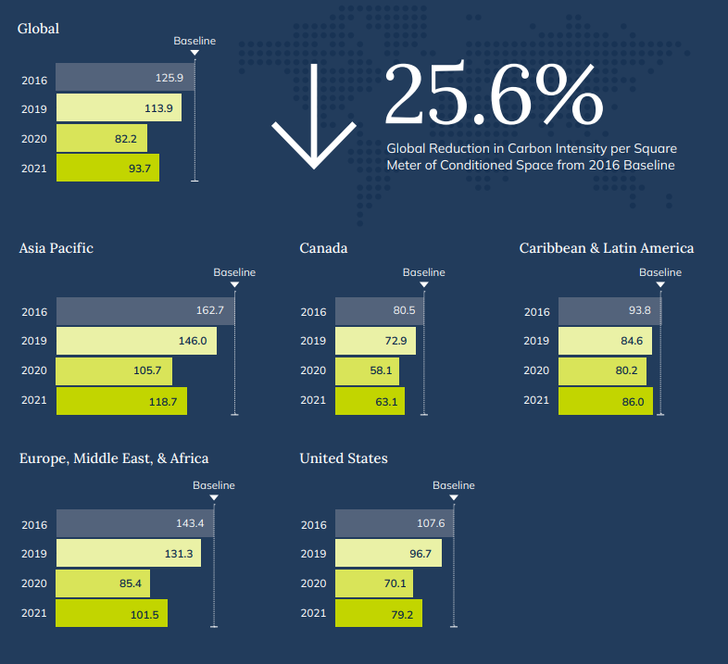
Figure 2: Global and Regional Environmental Performance
(Source: Marriott, 2024)
Considering the detailed exploration of the green technologies’ integration, Marriott can negate the alternative sustainable technologies for enhancing its commitment towards environmental responsibility and broader global efforts for the hospitality sustainability approaches. Marriott should increase the amount of on-site green energy sources that are used to power hotel offices, such as solar-powered chargers, wind turbines, or geothermal systems (Bernard and Nicolau, 2022). Implementing energy capacity plans can also increase the sustainability of power sources' reliability. The company should enhance spectacular structure advancements to mechanize and improve lighting, environment control, and energy consumption. It can make use of artificial intelligence (AI) computations and Internet of Things (IoT) devices to create more energy-efficient and responsive board frameworks.

Comparison with Industry Standards
Marriott's green efforts demonstrate a strong commitment to sustainability and are in line with the rapidly developing industry standards (Erdem, A. and Barakazı, 2023). The company's initiatives encompass governance, social responsibility, and environmental protection, demonstrating a holistic commitment to ESG standards.

Aspect | Marriott’s Green Initiatives | UK Standards
Carbon Intensity Reduction | Decreased by 32% from the baseline of 2016, surpassing the target of 30% | By 2050, the UK is required by law to attain "Net Zero" carbon emissions. Suppliers must submit Carbon Reduction Plans (CRPs) detailing their present carbon footprint and their emission reduction promise.
Renewable Energy Goals | Dedication to evaluating and implementing renewable substitutes | The goal of the UK government is to lead the world in renewable wind energy. By 2030, offshore wind is expected to provide more than enough electricity to power every house in the nation (UN, 2024).
Sustainability Certifications | 32% of properties that meet recognized requirements for certification | In the UK, there are more than 400 sustainability standards and certifications, proving a dedication to ethical, social, environmental, and food safety measures.
Extreme Weather Preparedness | Impact acknowledged, but specific tactics might be improved | To shield citizens from the negative health consequences of inclement weather and foster community resilience, the UK Health Security Agency has introduced the Adverse Weather and Health Plan (AWHP).
Diversity in Leadership | Women make up 44% of worldwide CEOs, while persons of color make up 20.5%. | The value of diversity in leadership is emphasized by the UK. Often, diverse businesses perform better than industry standards.
Transparency on Initiatives | Thorough reporting of objectives and progress | The government of the United Kingdom has acknowledged the necessity of augmenting the openness of judgments supported by algorithms and has pledged to create a benchmark for algorithmic transparency (Scholz et al. 2020).

Critical Evaluation of Sustainable Tourism and Greenwashing at Marriott
Marriott International's commitment towards sustainable tourism malpractice demonstrates commendation and strategic benefits and potential limitations. In the context of positive aspects, Marriott has exhibited significant strides in decreasing carbon emissions, surpassing its goals, and engaging in the certification program. With programs like "Serve 360: Doing Good in Every Direction," Marriott International has made tremendous progress toward sustainable tourism. The company's dedication to having a beneficial and long-lasting influence wherever it conducts business is guided by this program (Bardukova, 2023). Several initiatives like the Global Green Council and Green Hotel Global dashboard define the hotel's commitment to environmental responsibility. This responsibility reaches out past inward tasks, with endeavours to engage accomplices, draw in clients, and address more extensive natural difficulties. Potential greenwashing, in which the business's sustainability initiatives may be overstated or portrayed inaccurately, is a disadvantage (Clark, 2023). Despite its noteworthy accomplishments, Marriott's level of commitment is called into doubt given the absence of a measurable financial effect study on the company's carbon footprint reduction. Giving carbon emissions a price might help stakeholders better grasp the financial effects of environmental initiatives.
Marriott International’s sustainable tourism practices can be compared with the contextual successful organizations such as Intercontinental Hotels Group, AccorHotel, and Hilton Worldwide. Businesses with broad objectives, such as Accor's PLANET 21 program and Hilton's Travel with Purpose initiative, have adopted strong sustainability practices (Sanvitale, 2020). These initiatives frequently include precise measurements, open communication, and an understandable economic assessment of the results of sustainability initiatives. Marriott International can get a better approach and inspiration from the successful examples of organizations that effectively enhance sustainability practices. The necessity of continual expansion and improvement within Marriott's sustainable development plan is shown by this comparative study.

Conclusion
Marriott International with its sustainable business practices and environmentally friendly tourism approaches is considered as the key player in the hospitality sector. The accusations of "greenwashing" make people think about corporate transparency and pressure Marriott to provide more evidence to support its claims. Self-evaluation techniques are insightful, but they should be used with caution to avoid subjectivity. Although Marriott's use of green technology complies with industry norms, constant development is still necessary. Whereas the comparative study of the contextual tourism industry organizations demonstrates the industry standards and robust measurement practices with the uncovering of authentic environment sustainable practices.

Reference list
Abdou, A.H., Hassan, T.H. and El Dief, M.M., (2020). A description of green hotel practices and their role in achieving sustainable development. Sustainability, 12(22), p.9624.
Bardukova, L., (2023). Navigating the Hospitality Horizon: Current Trends and Strategies for Customer Attraction and Retention in the Hotel Industry. Economics and computer science, (2), pp.88-103.
Bernard, S. and Nicolau, J.L., (2022). Environmental certification and hotel market value. International Journal of Hospitality Management, 101, p.103129.
Bernard, S. and Nicolau, J.L., (2022). Environmental certification and hotel market value. International Journal of Hospitality Management, 101, p.103129.
Clark, M., Kang, B. and Calhoun, J.R., (2023). Green meets social media: young travelers’ perceptions of hotel environmental sustainability. Journal of Hospitality and Tourism Insights, 6(1), pp.36-51.
Dailykos, (2024) Marriott’s “green choice” isn’t so green, and it’s hurting workers. (n.d.). Daily Kos. Available at: https://www.dailykos.com/stories/2020/1/20/1911782/-Marriott-s-green-choice-isn-t-so-green-and-it-s-hurting-workers [Accessed on: 24.01.2024]
Erdem, A. and Barakazı, M., (2023). Innovative Technology Applications in Hotel Businesses. In Digital Transformation of the Hotel Industry: Theories, Practices, and Global Challenges (pp. 17-36). Cham: Springer International Publishing.
Graziano, H., (2021). Responsibility and Sustainability in International Hotel Chains. In Tourism in the Mediterranean Sea: An Italian Perspective (pp. 143-166). Emerald Publishing Limited.
He, S. and Very, I., 2020. On Climate Crisis: Are We Doing Too Little, Too Late?. Boston Hospitality Review.
Janjusevic, L., (2022). Sustainable Tourism Development, Evidence-Based Approach. Economic and Social Development: Book of Proceedings, pp.121-133.
Landau, T., (2020). Action and progress on sustainability challenges: case examples from Marriott, Booking and Soneva. Worldwide Hospitality and Tourism Themes, 12(5), pp.563-573.
Marriott International, (2023). About Marriott International | Corporate Information. [online] Marriott.com. Available at: https://www.marriott.com/marriott/aboutmarriott.mi.
Moret, N.J., (2020). The sustainable business model of a hotel–the case of the W Barcelona.
Sanvitale, A.L., (2020). Corporate Social Responsibility in the Hotel Industry: A Study of Marriott International and Odyssey Hotel Group.
Sarode, M.A., (2022). Start-Up Hotels And Environment Sustainability-Benefits And Strategy. Journal of Positive School Psychology, pp.12041-12044.
Scholz, P., Linderová, I. and Konečná, K., (2020). Green Management Tools as a Way to Sustainable Behaviour in the Hotel Industry: Case Study from Czechia. Sustainability, 12(23), p.10027.
Serve360.marriot, (2024) Home - csr-marriott. (Online). Available at: https://serve360.marriott.com/ [Accessed on: 24.01.2024]
UN, (2024). Greenwashing – the deceptive tactics behind environmental claims | United Nations. Available at: https://www.un.org/en/climatechange/science/climate-issues/greenwashing [Accessed on: 24.01.2024]
UNIDO, (2024) Green Industry initiative | UNIDO. (n.d.). Available at: https://www.unido.org/our-focus-cross-cutting-services-green-industry/green-industry-initiative [Accessed on: 24.01.2024]
Zhang, L., Wu, J., Liu, H. and Zhang, X., (2020). The value of going green in the hotel industry: evidence from Beijing. Real Estate Economics, 48(1), pp.174-199.

