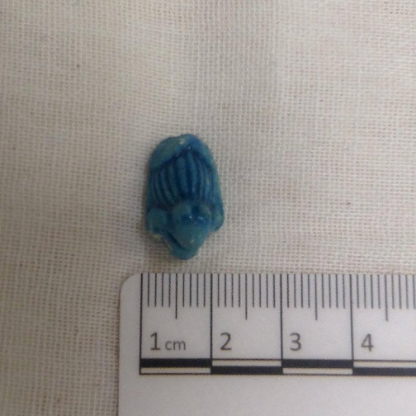
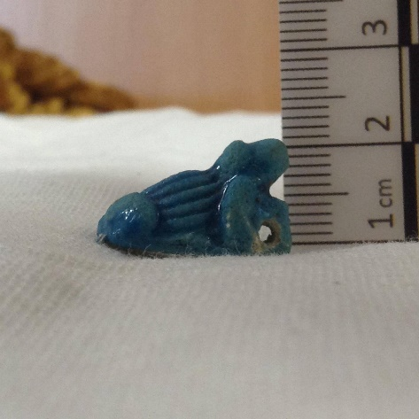
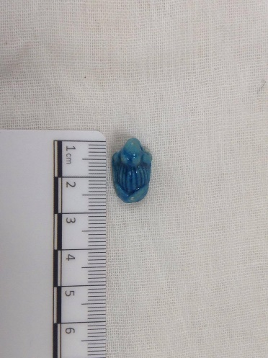
Figure 1 L. Kelly. Frog Amulet with measurement apparatus [Photograph] Electronic. (2019)
Object number: CCM 1725.004 (Southey)
Object type: Scaraboid amulet (Frog)
Material: Faience
Period: Unknown
Provenance: Egypt
Dimensions: 1.8cm in length, 0.9 cm height, 1.2cm width
Object analysis by Abigail McKeeman
Colour and material
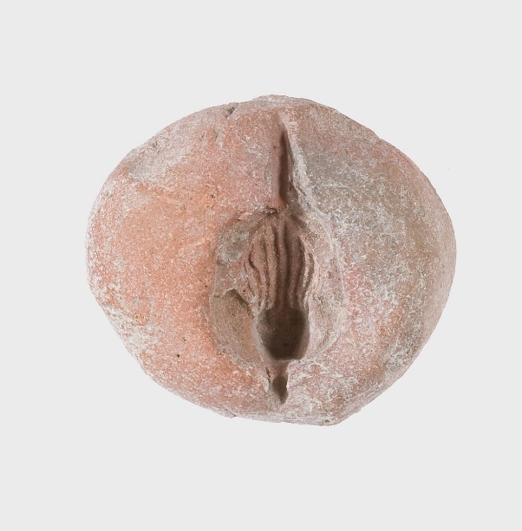
This object is from the Major Harry Hartley Southey collection in the Cyfartha Castle Museum, it has uncertain origin apart from being an Egyptian object and unknown date. He collected many objects while on campaign throughout the Mediterranean and Middle East including Egypt until 1917 when he was killed in the Battle of Gaza. Following his death his family donated his collection to the museum.
Figure 1. Electronic: Metropolitan Museum. Frog Mould,ca. 1390-1353 B.C [Photograph]. Electornic (2019)
We know that he was based in Cairo and made friends with the curator of an Egyptian museum who helped him procure artefacts from tombs, so it is likely that they came from this area. The scaraboid frog amulet is 1.8cm in length, 0.9cm height and 1.2 cm width (each at tallest, widest point), showing that this object is minuscule. It has a supporting pillar beneath the head which has a hole through it so it could have been a bead. Taking into consideration its size the likelihood of it being a bead is further strengthened.
This object is made of faience and blue in colour. Faience is mixture of materials that form a paste which is put into a mould (see figure 1) and then fired. In Ancient Egypt colour was perceived differently than we do now. An example of this is that the four basic colours were “white, black, red and green, which is translated in Egypt language as hedji, kem, deshr, and wadj respectively” with blue being an artificial colour possibly with little or no distinction with the colour green (Reiblien, 2011). The colour blue was created by “heating a mixture of copper salts, calcium and sand mixed with flux” (Nasr, 2003, p.8) rather than being naturally sourced like green malachite. It is also possible that this is a substitute for more precious material such as turquoise or lapis lazuli as argued by Riggs (2014), because Riggs says that faience is also referred to with the same words as these more precious materials. In terms of this object, this could mean that it is a substitute for lapis lazuli or turquoise to allude to wealth, and therefore not necessarily a high-status object. Consequently, this means one cannot assume what status this object is due to the material it is made of.
What does this object represent?
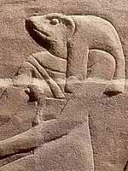
The object may be a symbol of the goddess Heqet, she is often depicted as a frog or a woman with a frog’s head (see figure 2), and we know of other amulet examples that are linked to Heqet. She is the goddess of childbirth and fertility as well as being associated with rebirth in the afterlife. Heqet is associated with afterlife in various ways namely the pyramid texts, which are a set of hieroglyphic inscriptions that contain information about the Egyptian beliefs of the afterlife (ref). Heqet is mentioned in the pharaohs quest to join the eternal stars (in utterance 539, line 1312 C) and therefore showing that she plays a role in bringing the pharaoh to the afterlife. Heqet is also meant to be the wife of Khnum (alternatively Heh) and would breathe life into a person after they had been created on the potter’s wheel, so therefore is intimately associated with both birth and death in Egypt. The purpose of this object is unclear as it could have been an amulet to ensure Heqet’s protection in the afterlife, so they could be reborn, but equally, it could be a symbol worn by a pregnant woman for protection during childbirth.
Figure 2: Seawright. Heqet [Photograph]. Electronic (2012)
Frogs are an enduring symbol throughout Egyptian history as Grey (2012) says they are present from the predynastic times right through to Roman Egypt. In addition, throughout this time they are associated with resurrection, even by Coptic Christians who created frog lamps (generally decorated with frogs rather than shaped like them). This strengthens the view that this is a funerary object and an important one because it retains its relevance throughout 4000 years of history. So, this scaraboid amulet is part of a long history of funerary traditions that Egyptian people believed would help them attain a place in the afterlife.
What is the object?
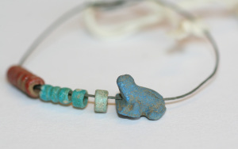
So, what could this object be? It could potentially be a bead as previously mentioned due to the hole beneath the head and the size, it is a known form of amulet as there is a number of examples in the Manchester Museum (see figure 4). These beads were worn on both bracelets and on necklaces, however since there is only the frog amulet surviving and no other associated artefacts, we cannot say for certain if it was intended to be worn in either of those ways or worn at all. Another idea is that this could be an amulet designed to be placed with a deceased person to help ensure rebirth in the afterlife along with the various rituals that were performed. It was possibly placed on the deceased as we do have examples of other amulets such as heart scarabs that helped the deceased pass successfully into the afterlife. Nevertheless, one must be careful how much we theorise about this object as we do not know where exactly it was found and in what context (Southey did not record this).
Figure 4: Grey. Ancient Egyptian Frogs [Photograph]. Electornic (2012)

Bibliography

Gray, A. 2012, Oct 31,-last update, Ancient Egyptian Frogs. Available: https://frogblogmanchester.com/2012/10/31/ancient-world-frogs/ [2019, 31/03/].

Nasr, M. 2003, Valley of the Kings, Tiba, Egypt.

Reiblein, A. 2011, "Colour in Ancient Egypt", Ancient Egypt Magazine, vol. 11, no. 5, pp. 32-40.

Riggs, C. 2014, Ancient Egyptian art and architecture : a very short introduction, Oxford : Oxford University Press.

Seawright, C. 2012, Nov 29,-last update, Heqet, Frog headed goddess of childbirth. Available: http://www.thekeep.org/~kunoichi/kunoichi/themestream/heqet.html#.XKEH2JhKhPZ [2019, 31/03/].

