Employability skills Portfolio



Name : Tibka Mesfin Kebede Student
Student Number :2115101

content page

Task 1 Academic Blog …………………………………………………………………………………………

Task 2 programme engagement hours ………………..…………………………………………..

Task 3 Academic interview …………….…………………………………….…………………….………

Task 4 poster ………………………………………………………………………………………………………

References……………………………………………………………………………………………………………

Communication

Communication is sending information or a message from one person to another (The care certificate 2022). It includes the exchange of information and the expression of feelings, which can lead to understanding (social care Limited 2018). Communication is one of the critical skills for students; It is essential since it helps deliver ideas and knowledge about any particular subject. It also helps them become creative, interactive and engage well with people around them and speak up confidently (The care certificate 2022).
Moreover, it becomes fundamental for students, as it allows them to expand their network, work effectively in groups, ask questions, share opinions and express themselves (Stanford university 2022). With such skills, students can crack any interview, rock a presentation, understand people and have good conversations. For instant taking the communication skills module has helped me speak concisely and boldly, which benefited me with the various school activities such as role-play and presentations.



Adaptability

Adaptability is a personal or learned characteristic that enables you to manage or adapt to changes in life which is a crucial part of problem-solving and collaboration (Gumer and Nonan 2016). For students, the start of university is a period of tremendous transition. It entails negotiating a massively different learning environment, a considerable rise in personal responsibility, a change in social networks, and it frequently occurs in combination with other significant life events (Collie, Holliman, and Martin 2016). Having adaptability skill enables you to take on new roles or responsibilities with minimal adjustment time and respond quickly to changing strategies or ideas (ref). Thus being adaptable has eased my transition to university life by enabling me to exercise control over the new environment and resources thereby aiding me avoid dynamics that can lead to failure like anxiety, uncertainty and procrastination. Adaptability is not only critical for students in university but also for when embarking on career paths after graduation (University of Leeds 2022).

Critical Thinking

As a guide to belief and action, Critical thinking is the intellectually disciplined process of actively and skilfully conceptualising, applying, analysing, synthesising, and evaluating information gleaned from or generated by observation, experience, reflection, and reasoning (The foundation of critical thinking 2019). Having such skills means that no matter the path or profession you pursue, the craft will always be relevant and beneficial to success (The university of people 2021). Students at the university level must critically evaluate the materials and information they use in their work. When reading other people's work, they must ask the right questions; their writing must demonstrate that they can assess multiple arguments and viewpoints and utilise evidence to help them build their own opinions, views, theories, and ideas. Questioning and learning with an open mind are vital components of critical thinking. (University of Leeds 2022). After gathering more information about critical reflection on the study skills module, I contributed my essay basis on clinical psychology.

“The whole is greater than the sum of its parts” Aristotle

Teamwork can entail collaborating to attain a standard process that allows regular people to achieve remarkable results (Alter school of business and economical 2022 ). Such skills can be highly beneficial in the workplace. It will enable individuals with different skills and strengths to pool their knowledge and resources together and complete a task (Global Resource centre 2022). On the other hand, the absence of teamwork pieces of knowledge and methods can lead to occupational failure, dissatisfaction, low morale and poor productivity. Employees who work in an organisation that does not have a strong concept of teamwork usually fail to deliver the expected results and to achieve the goals and visions of that organisation (University of Manchester 2022 ). I enjoy working as a team because different team members contribute different opinions; therefore, teams member can produce creative and effective outcomes.



Time Management

I believe I have a good handle on time management. Someday are better than others, but on average, I complete all my work and get at least six or seven hours of sleep. For me time management is primarily about getting the job done while making time for what I enjoy doing. Managing and planning how to split your time between various activities is time management(Thomack 2012). When you get it right, you'll find yourself working smarter rather than harder to get more done in less time, even when time is short and pressures are high(National Health Service 2021). Time management is vital for the students to prioritise all their work tasks and achieve their goals faster. When you better manage your time, you'll be able to take on new opportunities and grow your mark (Albers school of business and economics 2019 ).


Dependability

Dependability is the quality of being trusted and likely to do what people expect from you (Cambridge dictionary 2022). Being a dependent person benefits the employer and the employee as it helps in growth and development both in professional and personal terms. Furthermore, a dependable person is rewarded with promotion (Deekshe 2020). Students show they are reliable in many ways; for example, they have excellent university attendance, never miss turning in assignments, They work hard to meet all their responsibility. They fear disappointing anyone, especially themselves. (Advantage press 2012). Therefore, in my current job, colleagues routinely express their satisfaction that they can count on me to show up for work, do what I say I will, and fill in when necessary. I am a great team player who will gladly cover tasks for a coworker if requested. In my present employment, I also have perfect attendance.

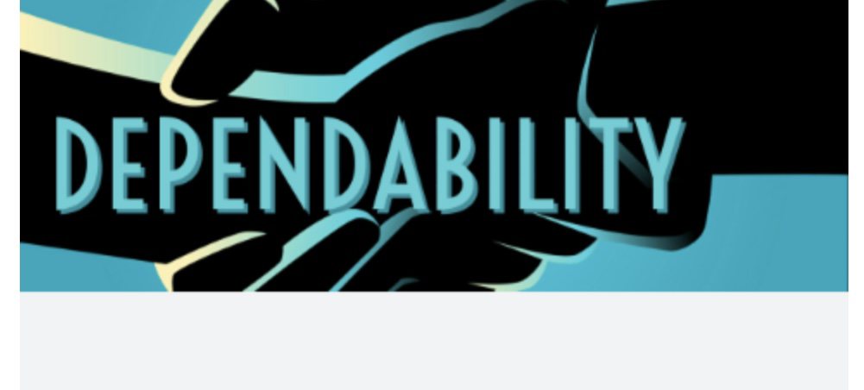

Date | Engagement hours | Module
29 September | 10:00-13:00  3hr | Study skill in care  (BMHP4016)
4 October | 10:00-13:00  3hr | Study skill in care  (BMHP4016)
6 October | 14:00-17:00  3hr | Introduction to Health social care (BMHP3002)
11 October | 10:00-13:00  3hr | Study skill in care  (BMHP4016)
13 October | 14:00-17:00  3hr | Introduction to Health social care (BMHP3002)
18 October | 10:00-13:00  3hr | Study skill in care  (BMHP4016)
20 October | 14:00-17:00  3hr | Introduction to Health social care (BMHP3002)
25 October | 10:00-13:00  3hr | Study skill in care  (BMHP4016)
27 October | 14:00-17:00  3hr | Introduction to Health social care (BMHP3002)
1 November | 10:00-13:00  3hr | Study skill in care  (BMHP4016)
3 November | 14:00-17:00  3hr | Introduction to Health social care (BMHP3002)
8 November | 10:00-13:00  3hr | Study skill in care  (BMHP4016)
10 November | 14:00-17:00  3hr | Introduction to Health social care (BMHP3002)
15 November | 10:00-13:00  3hr | Study skill in care  (BMHP4016)
17 November | 14:00-17:00  3hr | Introduction to Health social care (BMHP3002)
22 November | 10:00-13:00  3hr | Study skill in care  (BMHP4016)
24 November | 14:00-17:00  3hr | Introduction to Health social care (BMHP3002)
29 November | 10:00-13:00  3hr | Study skill in care  (BMHP4016)
1 December | 10:00-12:00  2hr | Effective communication in Heath and social care  (BMHP3001)
6 December | 10:00-14:00  4hr | Employability skill and Reflection  (BMHP4015)
8 December | 10:00-12:00  2hr | Effective communication in Heath and social care(BMHP3001  (BMHP3001)
10 January | 10:00-14:00  4hr | Employability skill and Reflection  (BMHP4015)
12 January | 10:00-12:00  2hr | Effective communication in Heath and social care  (BMHP3001)
17 January | 10:00-14:00  4hr | Employability skill and Reflection  (BMHP4015)
20 January | 10:00-12:00  2hr | Effective communication in Heath and social care  (BMHP3001)
24 January | 10:00-14:00  4hr | Employability skill in care Reflection  (BMHP4015)
31 January | 10:00-12:00  2hr | Effective communication in Heath and social care  (BMHP3001)
2 February | 10:00-12:00  2hr | Effective communication in Heath and social care  (BMHP3001)
7 February | 10:00-14:00  4hr | Employability skill in care Reflection  (BMHP4015
9 February | 10:00-12:00  2hr | Effective communication in Heath and social care  (BMHP3001)
 | 15 hr | Coffee meting with fellow class mate
 | 30 hr | What App group chat
Total hours = 134

Academical Interview

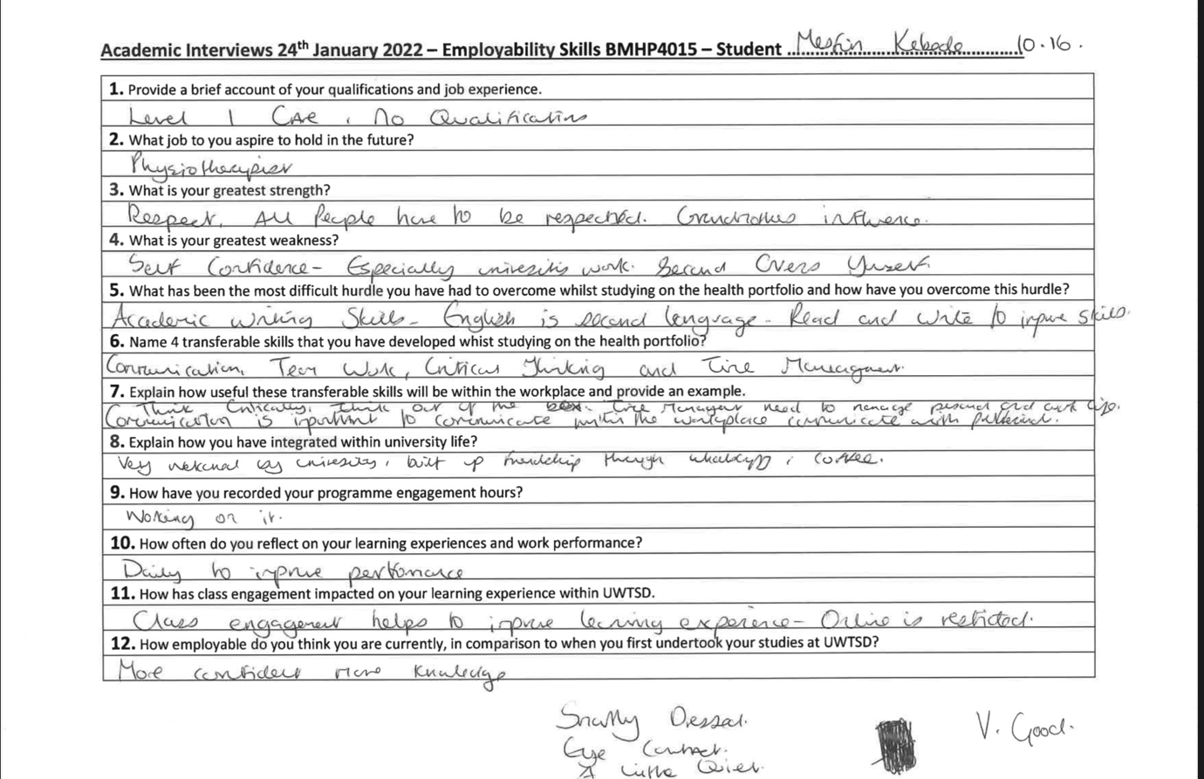

Poster

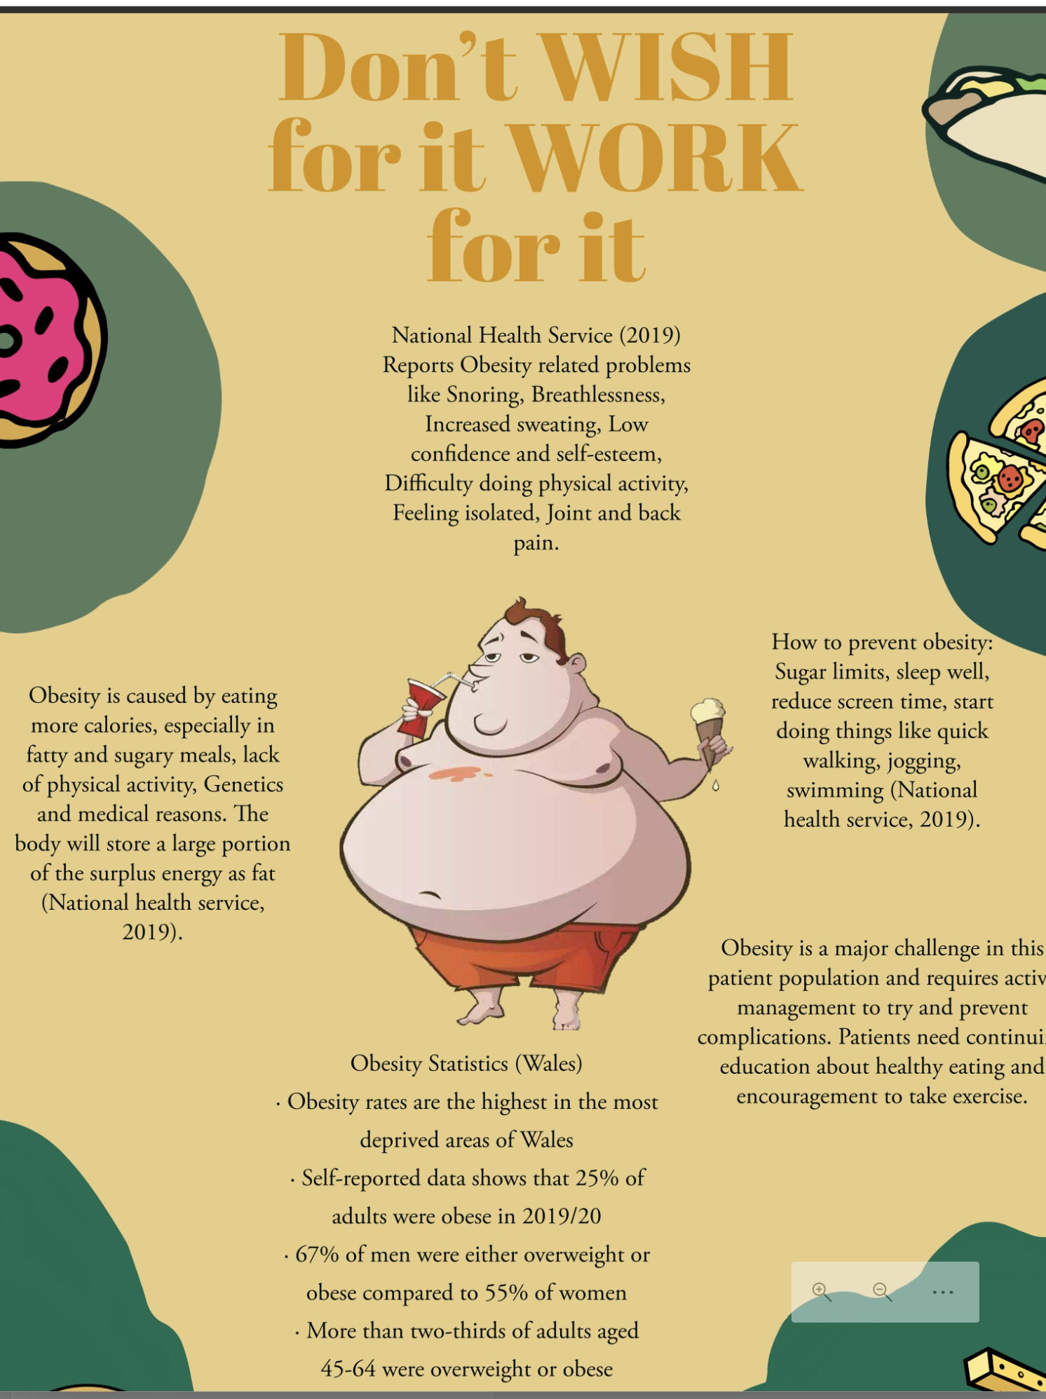
Reference

A.,Gumer and P., enonan (2016) collage and career competency : adaptability. .Available at http://www.researchcollaboration.org/uploads/TeacherGuide-Adaptability.pdf Accessed 22 January

Advantage press (2021)Character and leadership . Available at https://www.nhsd.net/Downloads/PE%20Packet%2002.pdf Accessed 22 January

Albers school of business and economical (2020) Benefit of time management in the workplace Available at https://www.seattleu.edu/business/online/albers/blog/benefits-time-management-workplace Accessed 22 January

B,. Thomack (2012) Time mangement for today workplace demands .Available at http://m2.wyanokecdn.com/5e51dfd20834a127f0064e04c18f712e.pdf Accessed 17January

Cambridge dictionary (2022) Dependability . Available at https://dictionary.cambridge.org/dictionary/english/dependability Accessed 2 January

Deekshe (2020) Can you say dependability is a skill? Available at https://thinkerspoint.in/soft-skills/dependability-in-workplace/ Accessed 20 January

Global resource centre (2022) why is teamwork in health care important ? Available at https://www.hrhresourcecenter.org/HRH_Info_Teamwork.html Accessed 14 January

Haw, C. and Rowell, A. (2011), "Obesity and its complications: a survey of inpatients at a secure psychiatric hospital", The British Journal of Forensic Practice, Vol. 13 No. 4, pp. 270-277. Available at: https://www.emerald.com/insight/content/doi/10.1108/14636641111190033/full/html?fullSc=1&fullSc=1&mbSc=1&fullSc=1&fullSc=1 (Accessed 12 January 2022).
House of Commons Library (2021) Obesity Statistics. [Online] Available at: https://dera.ioe.ac.uk/37120/1/SN03336.pdf [Accessed at 10th of January 2022].
National Health Service (2019) Obesity. [Online] Available at: https://www.nhs.uk/conditions/obesity/ [Accessed 10 January 2022].
National Health Service (2019) Obesity. [Online] Available at: https://www.nhs.uk/conditions/obesity/ [Accessed 12 January 2022].
National health service (2021) Easy time management tips. Available at https://www.nhs.uk/mental-health/self-help/tips-and-support/time-management-tips/

Social care Limited (2018) ways people communicate.Available at : https://activesocialcare.com/handbook/communication/ways-that-people-communicate

Stanford University(2022) oral communication skills are important for students .Available at : https://collegepuzzle.stanford.edu/oral-communication-skills-are-important-for-students/

The care certificate (2022)Communication .Available at: https://www.skillsforcare.org.uk/resources/documents/Developing-your-workforce/Care-Certificate/Care-Certificate-Standards/Standard-6.pdf Accessed 22 January

The foundation of critical thinking(2019) Defining critical thinking . Available at https://www.criticalthinking.org/pages/defining-critical-thinking/766 Accessed 2 January

The university of people (2021)why is critical thinking important . .Available at https://www.uopeople.edu/blog/why-is-critical-thinking-important/ Accessed 14 January

Training journal (2020) The importance of adaptability in the work place. .Available at https://www.trainingjournal.com/articles/features/importance-adaptability-skills-workplace

University of Leeds (2022) Employability skills . Available at. https://careerweb.leeds.ac.uk/info/4/make_yourself_employable/202/employability_skills/13 Accessed 24 January

University of Strathclyde (2022) team and collaboration skills . Available at https://www.strath.ac.uk/professionalservices/careers/skills/peopleskills/teamworkcollaborationskills/ Accessed 20 January

University of Manchester2022() teamwork . Available at https://www.careers.manchester.ac.uk/findjobs/skills/teamwork/

