
2522158 Victoria Butler-Richards
Task 1 – Reading Task Template
Upload your photo of your A3 in-class notes here:
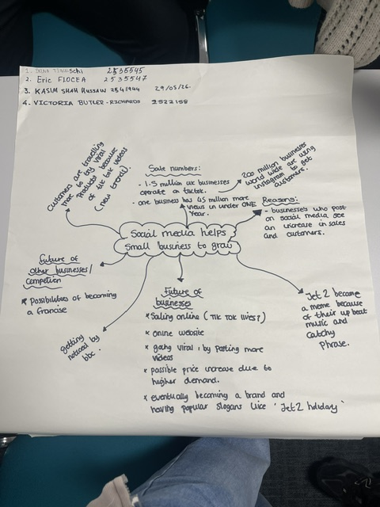

1. Answer these questions using the sentence starters below
a. What is the main idea of the text?
The main idea is that it is showing how small business have used social media to gain more customers, In recent years, online social media platforms such as TikTok and Instagram have emerged as significant drivers of small business growth. These platforms provide accessible and cost-effective opportunities for businesses to reach broad audiences, enhance brand visibility, and engage directly with consumers. As the influence of digital media has expanded, an increasing number of small enterprises have integrated social media into their core marketing strategies. This trend has proven effective, as the use of short-form video content, targeted advertising tools, and interactive features has enabled small businesses to attract new customers and strengthen their overall market presence.
b. What are two key points?
One key point is how social media has helped small businesses grow.
Another key point is how important marketing your business is.
c. What part of the text did you find most important? Why?
A key aspect of operating a successful business is the ability to actively promote it and attract new customers. However, effective business management also requires thoughtful decision-making about which strategies are most beneficial for long-term growth and profitability. Business owners must evaluate which approaches align with their goals, resources, and target audience in order to maximize their potential for financial success.
d. Was anything unclear or difficult to understand?
Not really however it was interesting to learn how much social media can help a business.
e. How did your group help you understand the text better?
My group helped me by helping me understand how different business would go about posting on social media.
3. One sentence reflection
Question: What did you find challenging about this task?
At this stage, I am not finding any particular aspect of the task difficult. The instructions are clear, and I feel confident in my understanding of what is required. Although I am not experiencing challenges, I am continuing to pay attention to the details of the assignment to ensure that my work remains accurate, well-structured, and aligned with the expectations.

