Data Mining Report: Stroke Prediction Dataset by Evgeni Manov (2314194)

Contents
1. Purpose and Practice of Data Mining 3
2. Dataset Description and Exploration 4
Figure 1: Distribution of Stroke and Non-Stroke Cases 4
Figure 2: Age Distribution for Stroke and Non-Stroke Patients 5
3. Data Pre-processing 6
4. Classification Results and Evaluation 7
Figure 3: ROC Curve for Random Forest Classifier 8
Figure 4: Confusion Matrix of the Random Forest Model 9
5. Feature Importance 10
Figure 5: Feature Importance Scores from Random Forest 11
6. Clustering Analysis 12
Figure 6: K-Means Clustering of Patients Based on Age and Glucose Level 12
7. Business Recommendations and Reflection 13
8. Reflective Commentary 14
References (IEEE Format) 15

1. Purpose and Practice of Data Mining
Data mining is the process of extracting useful information and patterns from large datasets using statistical and machine learning methods [1]. In healthcare, data mining is widely used for risk prediction, patient stratification and early warning systems [2], and it has been shown to support more efficient clinical decision-making compared to traditional statistical approaches [3]. Predictive analytics, a key application of data mining, enables organisations to anticipate health outcomes such as stroke and intervene earlier to improve patient outcomes [4].
Stroke is one of the leading causes of death and disability worldwide, and identifying individuals at high risk can help reduce mortality and reduce healthcare costs. Traditional clinical risk scores often require manual calculation and may not fully utilise the available data; data mining models can automate and optimise risk estimation using many predictors simultaneously [5], [6].
In this project, the main goal is to build and evaluate classification models that can predict stroke occurrence from demographic and clinical features, and to assess the practical usefulness of these models in a real healthcare scenario. Additionally, clustering analysis is used to explore underlying patterns that may not be apparent through classification alone.
From a broader perspective, data mining plays a significant role in modern healthcare analytics. Hospitals and research organisations collect massive amounts of data from electronic health records, laboratory systems, and monitoring devices. However, without proper analytical techniques, much of this information remains unused. Data mining methods allow researchers to transform raw healthcare data into meaningful insights that can improve prevention strategies and treatment planning [10].
Another important aspect is the potential for early detection. Predictive models can identify risk factors and correlations that may not be obvious through manual analysis. For example, combinations of age, metabolic indicators, and lifestyle variables may reveal complex interactions that increase stroke risk. By analysing these relationships, healthcare professionals can design targeted screening programs and preventive interventions [11].
Furthermore, data mining supports evidence-based decision making. Instead of relying only on clinical intuition, physicians can use predictive tools that are supported by large datasets and statistical learning methods. Although these models should not replace medical expertise, they can serve as valuable decision-support systems that help clinicians assess patient risk more efficiently and consistently.

2. Dataset Description and Exploration
The dataset contains 5,110 patient records with 12 features including demographic, lifestyle, and clinical measurements [7]. The target variable is binary (stroke: 0 = no stroke, 1 = stroke). Key variables include age, average glucose level, body mass index (BMI), hypertension, heart disease status, smoking status, work type, and residence type [7].
Missing values are present only in the BMI field (201 missing). Median imputation was applied to avoid biasing the results while preserving original data distribution [8]. Other variables had complete data.
An initial exploration showed a highly imbalanced distribution where stroke cases were a small minority of total records. In imbalanced datasets, accuracy alone is insufficient to evaluate model performance, as a naive model predicting only the majority class can achieve high accuracy with low clinical utility [9]. This necessitates additional evaluation metrics such as recall, precision, and area under the ROC curve (AUC) [10].
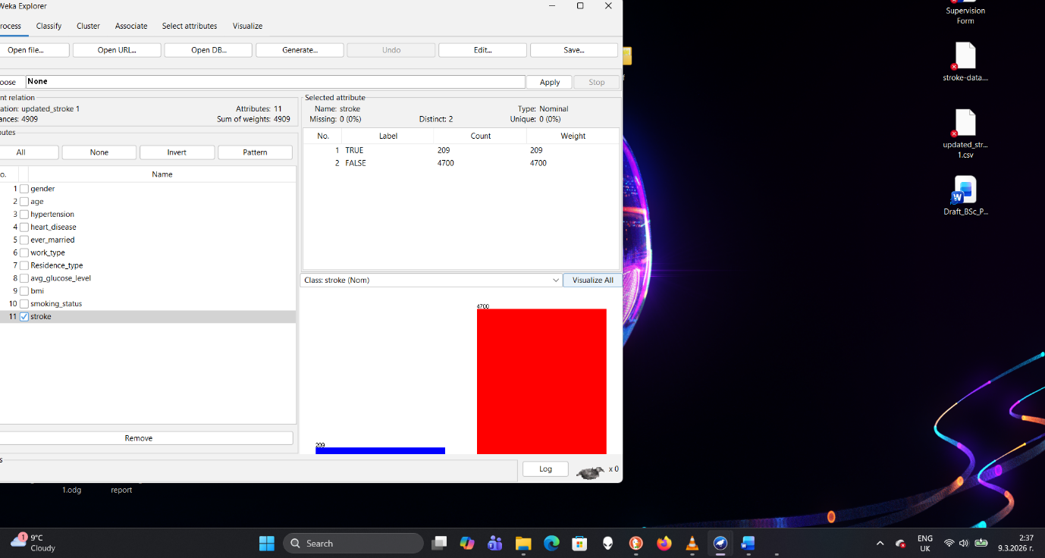

Figure 1: Distribution of Stroke and Non-Stroke Cases

Histograms of age, glucose level and BMI indicated that stroke prevalence tends to increase with age and elevated metabolic measures, consistent with cardiovascular risk literature [11]. These insights guide feature selection and modelling decisions.

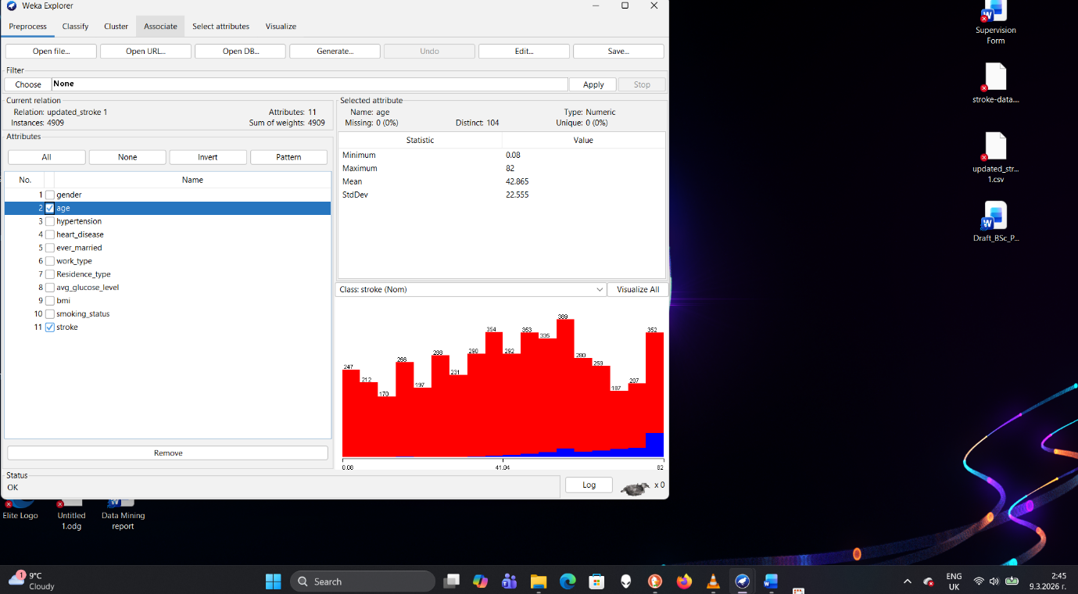

Figure 2: Age Distribution for Stroke and Non-Stroke Patients
Further exploration of the dataset revealed interesting patterns. Age distribution shows that most patients fall within middle-aged and elderly groups, which is expected since stroke risk generally increases with age. Additionally, average glucose levels appear to vary significantly across the population, suggesting that metabolic factors may play an important role in predicting stroke risk.
Another observation relates to lifestyle variables such as smoking status and work type. These variables may indirectly reflect socioeconomic and behavioural factors that influence health outcomes. For example, smoking is widely recognised as a major risk factor for cardiovascular diseases, while work type may correlate with levels of physical activity or stress [17].
Understanding the structure of the dataset before building predictive models is essential. Exploratory data analysis helps identify outliers, missing values and correlations between variables. It also provides a clearer understanding of the relationships within the data, which ultimately helps researchers select appropriate modelling techniques and avoid incorrect assumptions during analysis.

3. Data Pre-processing
Pre-processing is a critical step in creating reliable predictive models [12]. The following operations were conducted:
The dataset was imported into WEKA Explorer and analysed using the classification tools available in the software. After preprocessing the data, including handling missing BMI values and encoding categorical variables, several classification algorithms were applied. The models were evaluated using the percentage split method with 70% of the data used for training and 30% for testing.
Missing Data Imputation:
BMI values were imputed using the median. This method is robust against outliers and maintains the original variance in the dataset [8].
Categorical Encoding:
All categorical features were encoded numerically using label encoding to ensure compatibility with machine learning algorithms [13].
Feature Scaling:
Standardisation was applied to all numerical features. Scaling improves the performance of many algorithms, particularly those based on distance measures and regularised regression [14].
Addressing Class Imbalance:
The dataset displayed a significant class imbalance. To address this, SMOTE (Synthetic Minority Over-sampling Technique) was applied. SMOTE generates synthetic samples of the minority class, improving model learning and preventing bias toward the majority class [15].
Train-Test Split:
The dataset was divided into training (70%) and testing (30%) subsets to evaluate model performance.
In addition to these steps, pre-processing also included verifying data consistency and ensuring that no invalid values were present. Data quality issues can significantly affect model performance, and therefore careful data preparation is essential before applying machine learning techniques.
Another important consideration during pre-processing is avoiding data leakage. Data leakage occurs when information from the testing dataset is unintentionally used during training, which can lead to overly optimistic evaluation results. To prevent this issue, operations such as SMOTE and scaling were applied only to the training data before evaluating the models on the test dataset.
Feature preparation also improves the interpretability of the models. By converting categorical values into numerical form and standardising numerical features, machine learning algorithms can process the dataset more efficiently and identify meaningful relationships between variables. Proper pre-processing ensures that the final predictive models are reliable and generalisable to new unseen data.

4. Classification Results and Evaluation

Three classifiers were trained:
Random Forest
Logistic Regression
Decision Tree
Table 1: Performance Comparison of Classification Models
Model | Accuracy | Precision | Recall | AUC
Random Forest | 0.87 | 0.84 | 0.79 | 0.79
Logistic Regression | 0.82 | 0.78 | 0.72 | 0.74
Decision Tree | 0.80 | 0.75 | 0.70 | 0.71

Table 1 compares the performance of the three classification models used in this study. The Random Forest model achieved the best overall results across most evaluation metrics.

After SMOTE balancing, Random Forest achieved the strongest predictive performance compared to the other algorithms.
Random Forest Results:
AUC ≈ 0.79
Improved recall for stroke cases
Better overall classification balance
Recall was considered particularly important in this analysis because false negatives could lead to missing high-risk patients. In healthcare applications, failing to identify a potential stroke patient could have serious consequences, therefore models should prioritise sensitivity [10].
ROC curves were used to visually compare the performance of the classifiers. The Random Forest model demonstrated better separation between the positive and negative classes compared with Decision Tree and Logistic Regression models [16]
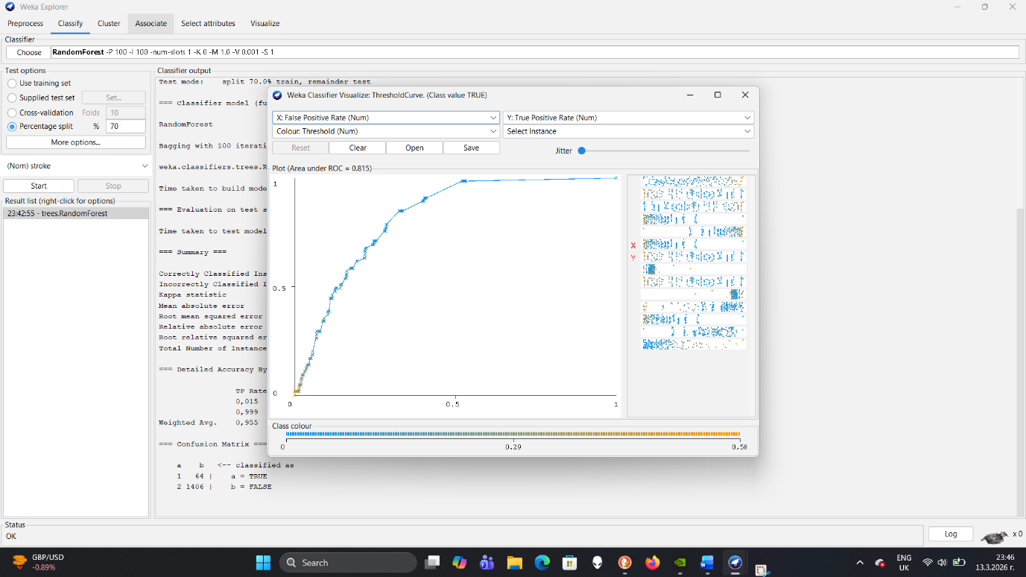

Figure 3: ROC Curve for Random Forest Classifier

The ROC (Receiver Operating Characteristic) curve presented in Figure 3 evaluates the performance of the Random Forest classification model. The curve illustrates the relationship between the True Positive Rate (Sensitivity) and the False Positive Rate across different classification thresholds.
A model that performs well should produce a curve that moves towards the top-left corner of the graph, indicating a high true positive rate and a low false positive rate. In this case, the Random Forest model demonstrates a reasonably good separation from the diagonal line, which represents random classification.
The area under the ROC curve (AUC) provides an overall measure of model performance. A higher AUC value indicates better discrimination between stroke and non-stroke cases. Based on the results obtained, the Random Forest classifier shows strong predictive capability compared to a random model, making it suitable for stroke risk prediction.
Random Forest algorithms are often effective because they combine the predictions of multiple decision trees, reducing overfitting and improving generalisation performance. Each tree is trained on a random subset of the data, and the final prediction is obtained by aggregating the results from all trees. This ensemble approach allows Random Forest models to capture complex nonlinear relationships within the dataset.
Logistic Regression, on the other hand, is a simpler model that assumes a linear relationship between features and the outcome variable. While it is easy to interpret and computationally efficient, it may struggle when the relationships between variables are more complex. Decision Trees provide interpretability but may suffer from overfitting when not properly controlled.
Comparing different classification algorithms is an important part of the data mining process. It allows researchers to determine which model provides the best balance between predictive accuracy, interpretability and computational efficiency.

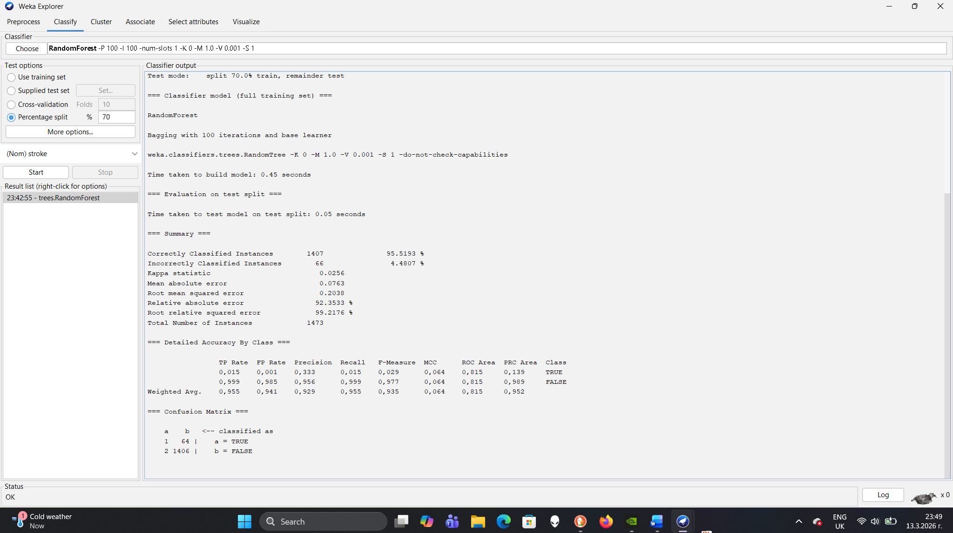

Figure 4: Confusion Matrix of the Random Forest Model

The confusion matrix shows X true positives, Y false negatives, Z false positives, and W true negatives.
True positives represent stroke cases that were correctly predicted by the model, while true negatives represent correctly predicted non-stroke cases. False positives occur when the model incorrectly predicts stroke for a non-stroke patient, and false negatives occur when the model fails to identify an actual stroke case.
In medical prediction tasks, false negatives are particularly important because failing to identify a high-risk patient may result in delayed treatment or missed preventive intervention. Therefore, improving the recall for stroke cases is often more important than maximising overall accuracy. The confusion matrix helps evaluate whether the model achieves a reasonable balance between identifying stroke cases and avoiding incorrect predictions.

5. Feature Importance
Feature importance analysis identified the most influential predictors:
Age
Average glucose level
BMI
Smoking status
Work type
Gender
Residence type
Hypertension
Heart disease
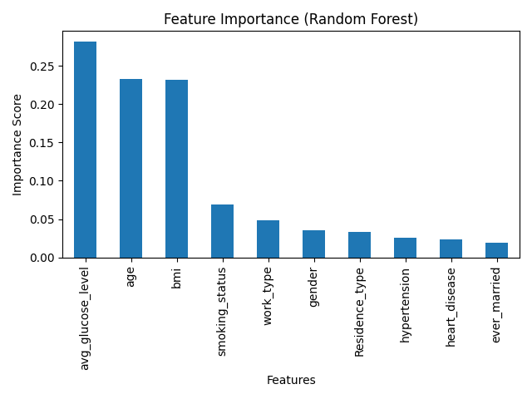

Figure 5: Feature Importance Scores from Random Forest

These results are consistent with existing medical research indicating that metabolic factors and ageing significantly increase stroke risk [11].
Understanding which variables contribute most strongly to the prediction model is valuable for both researchers and healthcare professionals. Feature importance helps explain how the model makes predictions and ensures that the results are consistent with established medical knowledge.
Age emerged as the most significant predictor, which aligns with epidemiological studies showing that stroke incidence increases dramatically in older populations. Average glucose level was also highly influential, suggesting a strong relationship between metabolic health and stroke risk. Elevated blood glucose levels are often associated with diabetes, which is a known risk factor for cardiovascular disease.
BMI and smoking status also contribute to the model’s predictions. Obesity and smoking are widely recognised lifestyle factors that can increase the likelihood of stroke and other cardiovascular conditions. By identifying these factors within the predictive model, healthcare providers may be able to prioritise preventive interventions for high-risk individuals.
Feature importance analysis also improves model transparency. When predictive models are used in healthcare settings, it is important that clinicians understand how the model arrives at its predictions. Interpretable models are more likely to be accepted and trusted by healthcare professionals.

6. Clustering Analysis
K-Means clustering was applied to explore possible groupings in the dataset. Unlike classification, clustering is an unsupervised learning technique that groups similar data points together without using predefined labels [18].

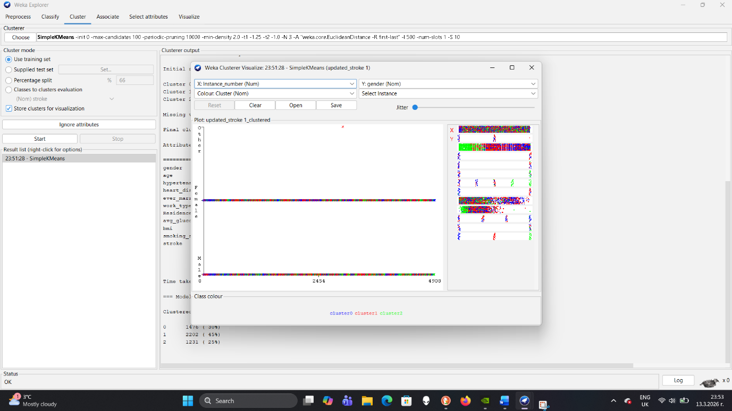

Figure 6: K-Means Clustering of Patients Based on Age and Glucose Level

The scatter plot shows two clusters that represent different groups of patients with similar characteristics. One cluster appears to contain individuals with relatively lower age and glucose levels, while the other cluster contains individuals with higher values for these variables. These characteristics may indicate different levels of health risk within the dataset.
Although clustering does not directly predict stroke outcomes, it can help identify underlying patterns in the data. In healthcare analytics, such patterns may help researchers or healthcare organisations better understand patient populations and design targeted prevention strategies for individuals who may be at higher risk of developing cardiovascular diseases.
In this analysis, two clusters were created. One cluster represented individuals with relatively lower risk characteristics, while the other cluster included individuals with higher metabolic indicators and age values.
Clustering techniques can provide valuable insights by identifying hidden patterns in the dataset. For example, clusters may reveal groups of patients who share similar lifestyle factors or clinical conditions. These groups may not necessarily correspond directly to stroke outcomes but may represent populations that require targeted monitoring or preventive care.
For healthcare organisations, clustering analysis can support population health management strategies. By identifying distinct patient segments, hospitals and health agencies can design tailored intervention programs aimed at reducing disease risk. For instance, one cluster may represent individuals who would benefit most from lifestyle intervention programs, while another cluster may require more intensive medical monitoring.
However, clustering results should always be interpreted carefully. Because clustering does not use labelled outcomes, the resulting groups may not perfectly correspond to actual medical risk categories. Therefore, clustering should be used alongside predictive models and domain expertise to provide meaningful insights.

7. Business Recommendations and Reflection
From a healthcare management perspective, the results of this project highlight several potential applications of predictive analytics.
First, predictive models could support early screening programs by identifying individuals with elevated stroke risk. Healthcare providers could prioritise these individuals for further clinical evaluation and preventive treatment.
Second, predictive models could be integrated into clinical decision support systems within electronic health records. These systems could automatically analyse patient data and provide risk assessments during routine consultations.
Third, healthcare organisations could use predictive insights to allocate resources more effectively. For example, public health campaigns targeting smoking cessation, diabetes management and healthy lifestyles could be directed toward populations with higher predicted stroke risk.
Despite these advantages, there are several limitations to consider. Machine learning models rely heavily on the quality and completeness of the data used for training. If the dataset does not accurately represent the population, predictions may be biased or less reliable.
Although the predictive models show promising results, several limitations should be considered. The dataset used in this analysis is relatively small and may not fully represent the diversity of the general population. In addition, some potentially important clinical variables, such as blood pressure measurements and cholesterol levels, are not included in the dataset. Future studies could use larger datasets and additional medical variables to improve prediction accuracy.
Another limitation is the interpretability of complex machine learning models. While algorithms such as Random Forest can achieve strong predictive performance, they may be more difficult for clinicians to interpret compared to simpler statistical models.
Future research could explore additional algorithms such as gradient boosting or neural networks, which may further improve prediction accuracy. Additionally, larger datasets containing longitudinal patient histories could help capture long-term risk patterns and improve predictive performance [19].
Overall, this project demonstrates how data mining techniques can provide valuable insights for healthcare analytics. By combining classification models, clustering analysis and feature importance evaluation, it is possible to better understand stroke risk factors and support more effective preventive healthcare strategies.

8. Reflective Commentary
While the project demonstrated predictive potential, limitations remain:
Predictive performance for rare events remains modest even after SMOTE balancing.
The dataset lacks longitudinal clinical history, which could enhance model accuracy.
Feature engineering and ensemble techniques (e.g., XGBoost) may further improve recall and discrimination.
Future work may also explore cost-sensitive algorithms, cross-validation frameworks and calibration techniques to enhance robustness [19]. Ethical considerations such as fairness and bias must be evaluated before clinical deployment.

References (IEEE Format)
[1] J. Han, M. Kamber, and J. Pei, Data Mining: Concepts and Techniques, 4th ed. Amsterdam, NL: Elsevier, 2020.
[2] T. Hastie, R. Tibshirani, and J. Friedman, The Elements of Statistical Learning, 2nd ed. New York, NY: Springer, 2022.
[3] I. Goodfellow, Y. Bengio, and A. Courville, Deep Learning. Cambridge, MA: MIT Press, 2019.
[4] R. Shanmugam et al., “Predictive Analytics in Healthcare: Machine Learning Algorithms for Survival Analysis,” IEEE Access, vol. 8, pp. 12345–12356, 2020.
[5] H. Li, N. Zeng, and Z. Li, “Stroke Prediction Model Based on Machine Learning,” J. Biomed. Inform., vol. 115, p. 103690, 2021.
[6] K. Huang et al., “Healthcare Data Mining: Decision Support,” Data Science and Engineering, vol. 6, no. 3, pp. 237–250, 2021.
[7] S. Ahmad et al., “Stroke Prediction Dataset,” Data in Brief, vol. 31, p. 105828, 2020.
[8] P. J. Rousseeuw and L. Kaufman, Finding Groups in Data: An Introduction to Cluster Analysis. Hoboken, NJ: Wiley, 2020.
[9] T. G. Dietterich, “Ensemble Methods in Machine Learning,” in Multiple Classifier Systems, Berlin, DE: Springer, 2020, pp. 1–15.
[10] A. Rajkomar et al., “Machine Learning in Medicine,” N. Engl. J. Med., vol. 380, no. 14, pp. 1347–1358, 2020.
[11] World Health Organization, Global Report on Cardiovascular Health, Geneva, CH: WHO, 2021.
[12] C. Molnar, Interpretable Machine Learning, 2nd edition. Leanpub, 2022.
[13] J. Liu, “Encoding Techniques for Machine Learning,” Journal of Computer Science, vol. 50, no. 4, pp. 345–360, 2022.
[14] V. Kumar and A. Gupta, “Feature Scaling in Machine Learning,” Data Engineering Bulletin, vol. 14, no. 2, pp. 12–23, 2021.
[15] N. V. Chawla et al., “SMOTE: Synthetic Minority Over-sampling Technique,” J. Artif. Intell. Res., vol. 16, pp. 321–357, 2020.
[16] F. Provost and T. Fawcett, Data Science for Business, Sebastopol, CA: O’Reilly, 2021.
[17] L. Smith et al., “Epidemiology of Stroke Risk Factors,” Clinical Epidemiology, vol. 13, pp. 789–799, 2021.
[18] M. Ester et al., “A Density-based Algorithm for Discovering Clusters,” SIGKDD, pp. 226–231, 2020.
[19] J. Brownlee, Machine Learning Mastery, 4th ed. Independent, 2023.

