

MODULE: POPULATION HEALTH AND DIGITAL HEALTH PROMOTION

ASSIGNMENT TITLE: COMPONENT 1
TASK 1- BLOG
TASK 2- POSTER

MODULE CODE: LCHS7007

STUDENT NAME: RICHARD OJI

STUDENT NUMBER: 2013435

LECTURER: Dr PING WU

Table of Content

Blog 1: The Impact of Digital Health Technologies in Tackling Obesity in the UK…………………………………....3-4

Blog 2: Combatting Mental Health Issues in Adolescents with "Mind Care"….…………………………...…………….….5-6

Poster: Health Promotion Intervention…...……….….…….7-8

References……………………………………….………….......8-9

Blog 1: The Impact of Digital Health Technologies in Tackling Obesity in the UK
A recent article by the BBC warns that obesity is a pressing public health issue in the UK, with its prevalence steadily rising over the past decades (Roxby 2024). According to the NHS, 28% of adults in England were classified as obese in 2019, with a further 36% overweight (NHS England Digital 2022). The concern extends to children, where one in five 10 to 11-year-olds are obese. Obesity is associated with numerous health complications, including type 2 diabetes, cardiovascular diseases, and certain cancers, posing a significant burden on the healthcare system and society (Lin and Li 2021). 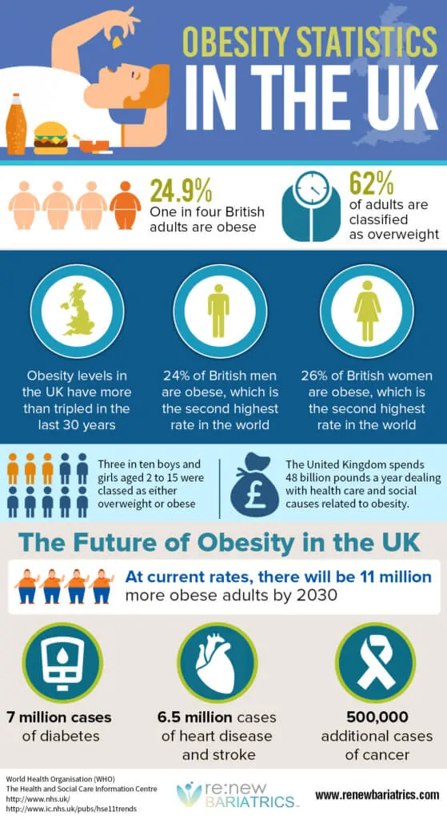 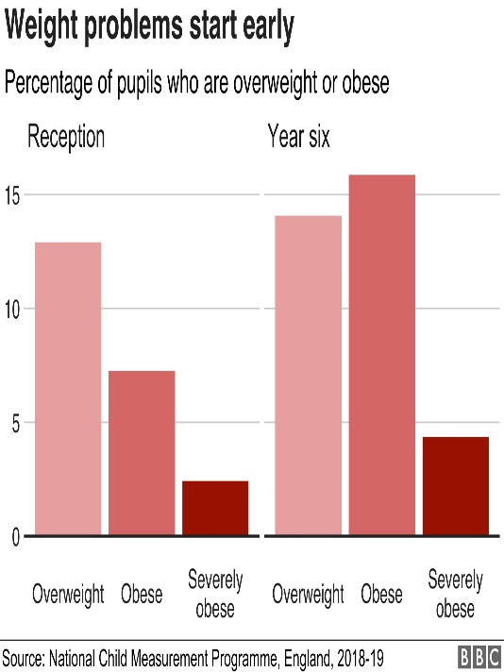
(Renew Bariatries,2017). (BBC News,2020).
To combat this growing epidemic, digital health technologies have emerged as vital tools in health promotion. One such technology is the NHS's "Better Health" app (NHS 2024). This application is designed to support individuals in making healthier lifestyle choices by providing personalised advice, tracking physical activity, offering dietary recommendations, and setting realistic goals. The app utilises behavioural change theories, such as the Health Belief Model and the Theory of Planned Behaviour, to motivate users towards sustainable health improvements.
The effectiveness of the "Better Health" app in promoting health is supported by various studies. Digital interventions, including apps, significantly improve physical activity levels and dietary habits among users (Martínez-Olcina et al. 2022). Additionally, a 2020 study by Public Health England (2021) found that users of the "Better Health" app shows that, active life style helps reduce excessive weight, with a higher intake of fruits and vegetables.
However, while the "Better Health" app demonstrates significant potential, it is not without limitations. One major advantage is its accessibility, providing health promotion resources to a broad audience at minimal cost (Public Health England 2021). The app also offers personalised feedback, which can enhance user engagement and adherence to health behaviours. Furthermore, it facilitates continuous monitoring and support, essential for long-term lifestyle changes.
On the downside, the reliance on digital technology may exclude certain populations, such as older adults or those with limited access to smartphones and the internet, exacerbating health inequalities (Philip et al. 2022). Additionally, the effectiveness of such apps heavily depends on user motivation and engagement. Many users may download the app but fail to sustain its use, limiting its long-term impact (Philip et al. 2022).
Addressing these shortfalls requires a multifaceted approach. Ensuring digital literacy and access to technology across all demographics is crucial (Martínez-Olcina et al. 2022). This can be achieved through community-based programmes and partnerships with local organisations to provide training and resources. Additionally, integrating the app with healthcare providers can enhance its effectiveness by offering personalised support and follow-up (Philip et al. 2022). Encouraging feedback mechanisms within the app can also help maintain user engagement by adapting to individual needs and preferences.

Blog 2: Combatting Mental Health Issues in Adolescents with "Mind Care"
Mental health issues among adolescents have become a significant public health concern in the UK (BBC News 2024). According to the NHS, one in eight children and young people aged 5 to 19 had at least one mental disorder in 2017 (Baker and Kirk-Wade 2024). The COVID-19 pandemic has exacerbated this issue, with a 2021 report from the Office for National Statistics (2021) indicating a sharp rise in anxiety, depression, and self-harm among teenagers. These mental health challenges can lead to long-term consequences, including poor academic performance, substance abuse, and increased risk of suicide.
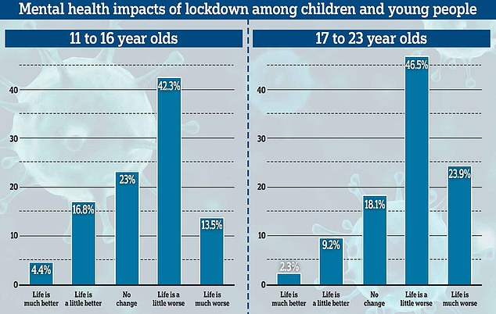
(Mail Online, 2021).
To address this pressing issue, I have designed "Mind Care," a digital health application tailored to promote mental well-being among adolescents. "Mind Care" integrates elements of cognitive-behavioural therapy (CBT), mindfulness practices, and social support networks to provide comprehensive mental health support. The app features interactive CBT modules, guided meditation sessions, mood tracking, and a peer support forum, all designed to be engaging and user-friendly for young people.
"Mind Care" aims to enhance mental health promotion through several key functionalities. The interactive CBT modules help users identify and challenge negative thought patterns, fostering resilience and positive thinking. Guided meditation and mindfulness sessions offer relaxation techniques to manage stress and anxiety. The mood tracking feature allows users to monitor their emotional well-being, identifying triggers and patterns over time. Additionally, the peer support forum provides a safe space for users to share experiences, seek advice, and offer support to one another, fostering a sense of community and reducing feelings of isolation.

(Yalsa Blog,2016).
The impact of "Mind Care" in promoting mental health can be significant. Studies have shown that digital CBT can be as effective as face-to-face therapy in treating anxiety and depression. A 2024 random controlled trail exploring the effectiveness of three different digital interventions in JAMA Psychiatry found that digital interventions for mental health can reduce symptoms of depression and anxiety in young people (Horwitz et al. 2024). The app’s accessibility ensures that mental health support is available anytime and anywhere, which is crucial for adolescents who may be reluctant or unable to seek traditional therapy.
However, "Mind Care" also has its limitations. One major advantage is its accessibility, as it can reach a wide audience with minimal cost. It offers personalised and interactive content, which can enhance engagement and adherence. The anonymity of the peer support forum can encourage users to share openly, which might not be possible in face-to-face interactions.
On the downside, the digital nature of the app may exclude those without access to smartphones or the internet, potentially widening health disparities. There is also the challenge of ensuring sustained engagement, as users might initially use the app but gradually lose interest. Moreover, while the app provides valuable support, it is not a substitute for professional mental health care, and there is a risk that severe cases might not receive the necessary intervention.
To address these shortfalls, ensuring digital equity is crucial. Partnering with schools and community organisations can help provide access to the necessary technology and digital literacy education. Enhancing the app’s engagement features, such as gamification and regular updates, can help maintain user interest (Horwitz et al. 2024). Integrating "Mind Care" with existing mental health services can provide a more comprehensive support system, ensuring that users with severe mental health issues receive professional help.

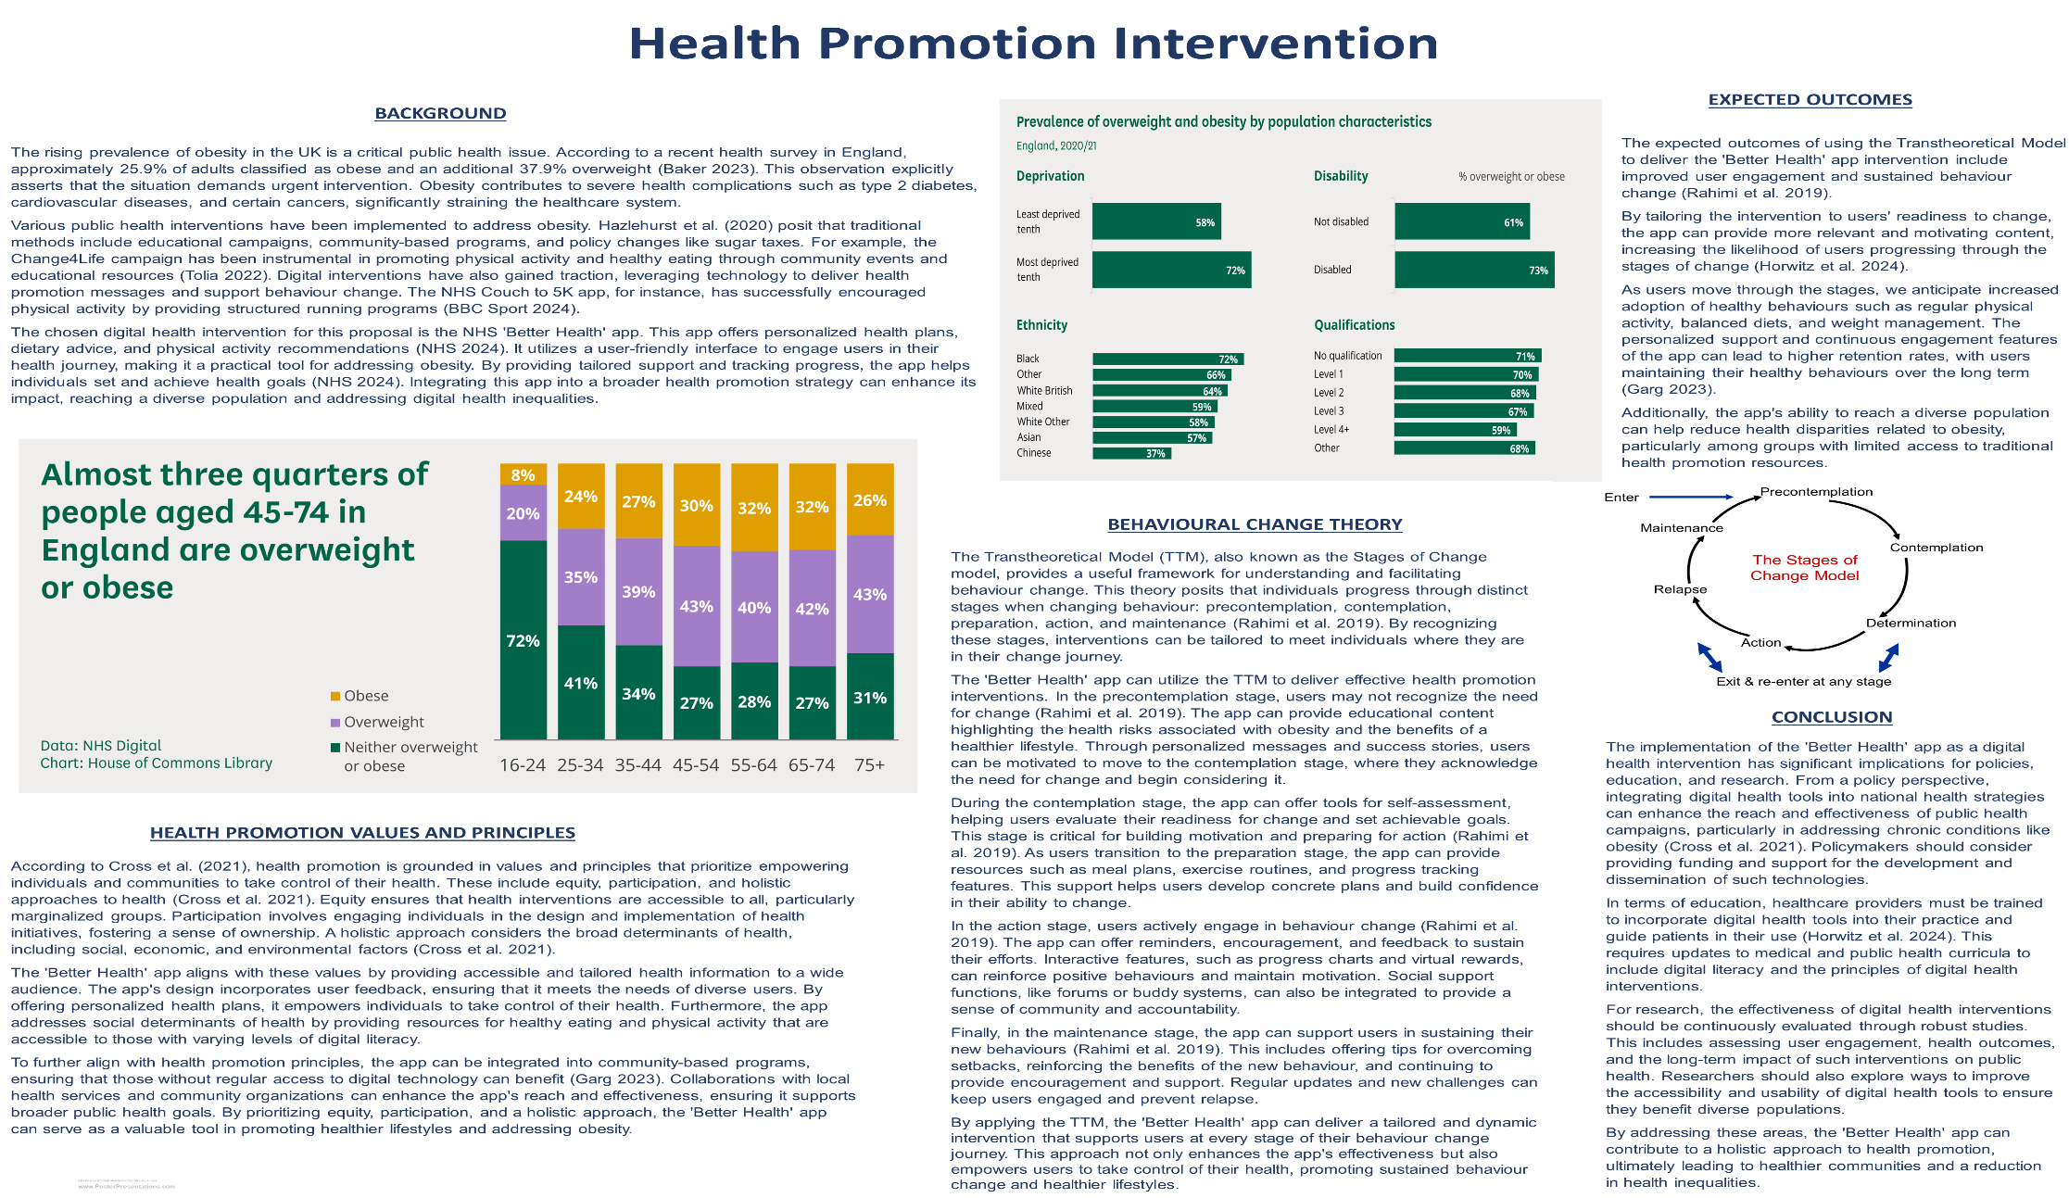
Poster

References
Andrews, Luke. “Six in Ten Older Teenagers Could Have an Eating Disorder, NHS Says.” Mail Online, 30 Sept. 2021, www.dailymail.co.uk/news/article-10044931/One-SIX-children-mental-health-problem-major-NHS-study-finds.html. Accessed 7 Aug. 2024.
Baker, C., (2023). Obesity statistics [online]. UK Parliament. [Viewed 23 July 2024]. Available from: https://commonslibrary.parliament.uk/research-briefings/sn03336/#:~:text=The%20Health%20Survey%20for%20England,is%20classified%20as%20'overweight'.
Baker, C. and Kirk-Wade, E., (2024). Mental health statistics: prevalence, services and funding in England [online]. UK Parliament. [Viewed 23 July 2024]. Available from: https://commonslibrary.parliament.uk/research-briefings/sn06988/
BBC News, (2024). More people in early 20s out of work from ill health than early 40s - study [online]. BBC Home. [Viewed 23 July 2024]. Available from: https://www.bbc.com/news/health-68399392
BBC Sport, (2024). NHS Couch to 5K: free fitness app surpasses seven million downloads and launches new feature [online]. BBC Sport. [Viewed 23 July 2024]. Available from: https://www.bbc.com/sport/68836703
Cross, R., Foster, S., O'Neil, I., Rowlands, S., Warwick-Booth, L. and Woodall, J., (2021). Health promotion: global principles and practice. 2nd ed. Wallingford: CABI Digital Library.
Garg, B. S., ed., (2023). Health promotion - principles and approaches [online]. IntechOpen. [Viewed 23 July 2024]. Available from: doi: 10.5772/intechopen.107637.
Hazlehurst, J. M., Logue, J., Parretti, H. M., Abbott, S., Brown, A., Pournaras, D. J. and Tahrani, A. A., (2020). Developing integrated clinical pathways for the management of clinically severe adult obesity: a critique of NHS England policy. Current Obesity Reports [online]. 9(4), 530–543. [Viewed 23 July 2024]. Available from: doi: 10.1007/s13679-020-00416-8
Horwitz, A. G., Mills, E. D., Sen, S. and Bohnert, A. S. B., (2024). Comparative effectiveness of three digital interventions for adults seeking psychiatric services. JAMA Network Open [online]. 7(7), article no: e2422115. [Viewed 23 July 2024]. Available from: doi: 10.1001/jamanetworkopen.2024.22115
Lin, X. and Li, H., (2021). Obesity: epidemiology, pathophysiology, and therapeutics. Frontiers in Endocrinology [online]. 12. [Viewed 23 July 2024]. Available from: doi: 10.3389/fendo.2021.706978
Martínez-Olcina, M., Cuestas-Calero, B. J., Miralles-Amorós, L., Vicente-Martínez, M. and Sánchez-Sánchez, J., (2022). Effectiveness of app-based intervention to improve health status of sedentary middle-aged males and females. International Journal of Environmental Research and Public Health [online]. 19(10), 5857. [Viewed 23 July 2024]. Available from: doi: 10.3390/ijerph19105857
Mental health [online], (2021). Office for National Statistics. [Viewed 23 July 2024]. Available from: https://www.ons.gov.uk/peoplepopulationandcommunity/healthandsocialcare/mentalhealth
NHS, (2024). Lose weight - better health [online]. nhs.uk. [Viewed 23 July 2024]. Available from: https://www.nhs.uk/better-health/lose-weight/
NHS England Digital, (2022). Overweight and obesity in adults [online]. NHS England Digital. [Viewed 23 July 2024]. Available from: https://digital.nhs.uk/data-and-information/publications/statistical/health-survey-for-england/2021/overweight-and-obesity-in-adults
Philip, B., Abdelrazek, M., Barnett, S., Bonti, A. and Grundy, J., (2022). Towards better mHealth apps. In: MOBILESoft '22: IEEE/ACM 9th international conference on mobile software engineering and systems, Pittsburgh Pennsylvania [online]. New York, NY, USA: ACM. [Viewed 23 July 2024]. Available from: doi: 10.1145/3524613.3527804
Public Health England, (2021). NHS weight loss plan: better health campaign evaluation [online]. London: gov.uk. [Viewed 22 July 2024]. Available from: https://assets.publishing.service.gov.uk/media/61265801e90e070541075822/Evaluation_of_the_NHS_App_PHE_Report_25Aug2020.pdf
Rahimi, A., Hashemzadeh, M., Zare-Farashbandi, F., Alavi-Naeini, A. and Daei, A., (2019). Transtheoretical model of health behavioral change: a systematic review. Iranian Journal of Nursing and Midwifery Research [online]. 24(2), 83. [Viewed 23 July 2024]. Available from: doi: 10.4103/ijnmr.ijnmr_94_17
Renew Bariatric. “United Kingdom Obesity Statistics, Figures in 2017 - Renew Bariatrics.” Renew Bariatrics, 26 Nov. 2017, renewbariatrics.com/uk-obesity-statistics/. Accessed 7 Aug. 2024.
Roxby, P., (2024). Millions more middle-aged are obese, study suggests [online]. BBC. [Viewed 23 July 2024]. Available from: https://www.bbc.com/news/health-69009787
Tolia, V., (2022). Change4life campaign, UK. In: The palgrave encyclopedia of social marketing [online]. Cham: Springer International Publishing. pp. 1–6. [Viewed 23 July 2024]. Available from: doi: 10.1007/978-3-030-14449-4_167-1
Takahashi, Deborah. “The Calm before the Storm: How Teens and Libraries Can Fight Mental Illness.” YALSA Blog, 29 May 2016, yalsa.ala.org/blog/2016/05/29/the-calm-before-the-storm-how-teens-and-libraries-can-fight-mental-illness/. Accessed 7 Aug. 2024.
Triggle, Nick. “How Bad Is Our Obesity Problem?” BBC News, 25 July 2020, www.bbc.co.uk/news/health-53514170. Accessed 7 Aug. 2024.

