Contents
1. Abstract 2
2. Aim 2
3. Introduction 2
4. Modeling assumptions 2
5. Model setup 2
5.1. Projectile 2
5.2. Target 3
5.3. Whole model setup 3
6. Models 3
6.1. 550m/s run 3
6.2. 800m/s run 3
6.3. 1050m/s run 3
7. Future Work 3
8. Conclusions 4
9. References 4
10. Abstract 5
ABSTRACT 1 5
ABSTRACT 2 6
ABSTRACT 3 6
ABSTRACT 4 7
ABSTRACT 5 7
ABSTRACT 6 8
ABSTRACT 7 9
ABSTRACT 8 9
ABSTRACT 9 9
ABSTRACT 10 10
ABSTRACT 11 10
ABSTRACT 12 10
ABSTRACT 13 11
ABSTRACT 14 11
ABSTRACT 15 11
ABSTRACT 16 12
ABSTRACT 17 12

1. Abstract
A model of an APFSDS round going through a target at varying speeds in order to understand the effect of speed on penetration. As speed increases penetration increases but also the difficulty of slowing down the projectile increases

2. Aim
The aim of these models is to investigate the effects of speed on the penetration power of an APFSDS round. In the process of doing this an additional aim of learning to use the basics of ABAQUS and general numerical modeling. This was done by making a model from scratch of an abstracted APFSDS round, about to hit a target perpendicular to its surface at a set speed that can be changed to analyze the penetration of the rounds.

3. Introduction
The modeling software for this project was ABAQUS. This is a modeling software often used for projectile analysis and allows the user to setup a layout, apply material properties to each object in the layout, mesh each object, apply initial conditions, and then run the scenario and see a representation of how the scenario would play out in real life. The most important aspect of this is the material modeling, this was done through the Johnson-Cooke material model. This model is a very good basic damage model for high-speed projectiles so is ideal as a way of analyzing the penetration of projectiles while learning numerical modeling an ABAQUS.

4. Modeling assumptions
In this model air is not included, this assumes that air resistance will not have an effect on the model as a whole. This is a fair assumption as the projectile was placed very close to the target so air resistance would not have enough time to have an effect. It is also assumed that air resistance has already had its effect on the speed of the projectile before the model. The target and the projectile are assumed to be made of a constant material with no variations.

5. Model setup

5.1. Projectile
The projectile is a total of 95cm long and 6cm in diameter. The tip of the projectile is 2cm in diameter and the tip smoothly tapers from the 6cm diameter to the 2cm diameter over 8cm of the projectile's length [1]. The projectile also is made completely of a non-specific tungsten alloy [2] [3]. The model dimensions are shown in ABSTRACT 1. The meshing of the projectile was more dense at the tip than along the side as this reduces model complexity while also giving a more dense
point of contact shown in ABSTRACT 2 ABSTRACT 3 and ABSTRACT 4.

5.2. Target
The target is a 1mx1mx0.1m [4] cuboid which has been split into 9 sections as shown in ABSTRACT 5 and is made from a non-specific steel alloy [5] [6]and is meshed as shown in ABSTRACT 6 with a denser mesh in the center.

5.3. Whole model setup
The entire model is arranged so that the projectile is 2cm away from the target and is moving towards it, tip first at a set speed, towards the more densely meshed center of the target. This setup is shown in ABSTRACT 7 and ABSTRACT 8.

6. Models

6.1. 550m/s run
At 550m/s the projectile can penetrate the target but stays inside of it. The tip of the projectile protrudes from the back face of the target, but it goes no further. This is shown in ABSTRACT 9 when the projectile comes to 0 velocity. The part of the projectile in the target gets very squished as it enters to form as funnel like shape. The ABBSTARCT 10 and ABSTRACT 11 show that the failing of the plate is caused by tensile stresses while the hole in the block is formed by compressive stress.

6.2. 800m/s run
At 800m/s [7] the projectile fully penetrates the block and passes completely through it. The speed after going through the target is about 675m/s losing a total of 225m/s of speed shown by ABSTRACT 12. This would seem to imply that it takes 225m/s to pass through the target but as shown is 550m/s it takes more than that. This projectile also gets much less squished and mostly stays the same shape as shown in ABSTRACT 13 and ABSTRACT 14. Again, penetration is caused by tensile stress and expanding the hole to the size of the projectile is done under compressive forces.

6.3. 1050m/s run
At 1050m/s again the projectile fully penetrates the target. The target exits the plate at 960m/s which is only 90m/s slower than it started which seems to show that if a projectile is moving faster the less it will be slowed down by penetration this is shown in ABSTRACT 15. As the projectile is penetrating the tip gains a bend and this pushes it off course which causes a warp in the projectile, this is shown in ABSTRACT 16 and ABSTRACT 17. As before, penetration is caused by tensile stress and expanding the hole to the size of the projectile is done under compressive forces.

7. Future Work
There are some obvious future steps to take from here. Due to a limited time frame the quality and fidelity of the model is quite poor so improving mesh density and number of time steps a more accurate model can be produced. After that a model of the plate being at different angles to the direction of travel of the projectile would allow the investigation of angling armor to penetration depth and also how angling can change the speed decrease at different penetration speeds.

8. Conclusions
It is clear that as speed increases the penetration becomes easier but also with faster speeds more momentum is carried so taking away speeds is harder to do. This task has also allowed me to learn how ABAQUS operates and how to properly use it

9. References

[1] | Swiss Govenment, "Long rod penetrators," Swiss Govenment, [Online]. Available: http://longrods.ch/round.php. [Accessed 15 05 2023].
[2] | AZO Materials, "Tungsten," AZO Materials, [Online]. Available: https://www.azom.com/properties.aspx?ArticleID=614. [Accessed 15 05 2023].
[3] | K. R. S. Yadav, "The mechanical properties of tungsten-based composites at very high strain rates," sciencedirect, vol. 203, no. 1-2, pp. 140-153, 1995.
[4] | W. O. W. Lanz, "PENETRATION LIMITS OF CONVENTIONAL LARGE CALIBER ANTI TANK GUNS/KINETIC ENERGY PROJECTILES," Swiss Federal Armament Works, 1992.
[5] | Dassult Systems, "Simulation of the ballistic perforation of aluminum plates with Abaqus/Explicit," Dassult Systems.
[6] | AZOMaterials, "Stainless Steel - Grade 304 (UNS S30400)," AZOMaterials, [Online]. Available: https://www.azom.com/properties.aspx?ArticleID=965. [Accessed 15 05 2023].
[7] | P. L. B. L. L Westerling, "Tungsten long-rod penetration into confined cylinders of boron carbide at and above ordnance velocities," sciencedirect, vol. 25, no. 17, pp. 703-714, 2001.

10. Abstract

ABSTRACT 1
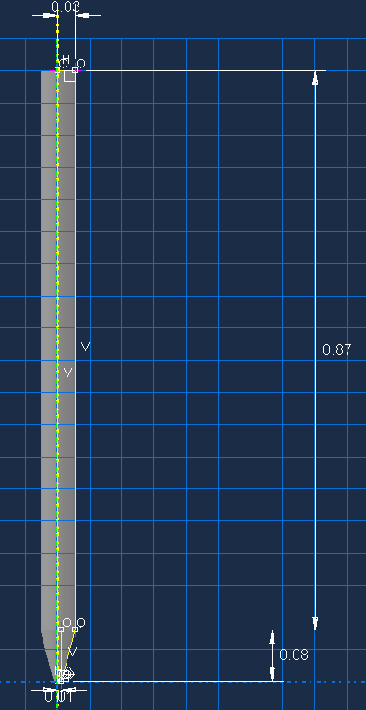

ABSTRACT 2


ABSTRACT 3
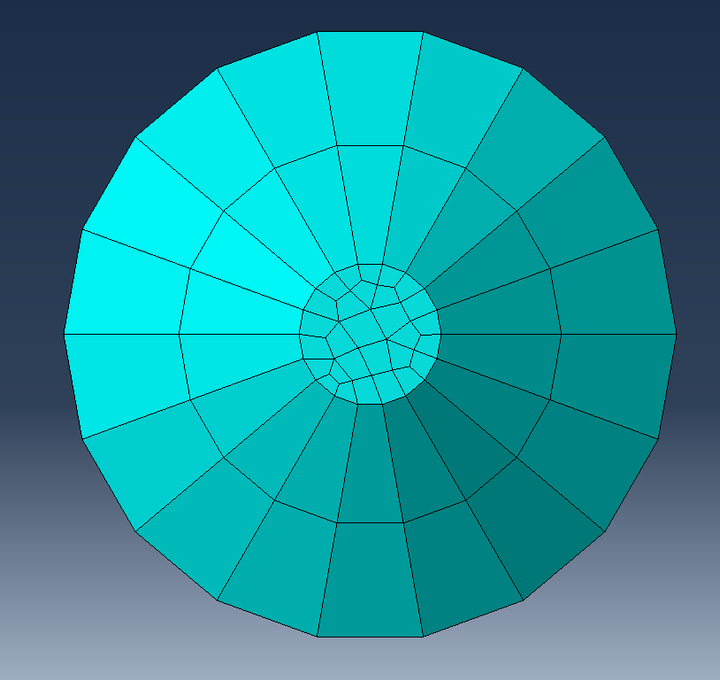

ABSTRACT 4
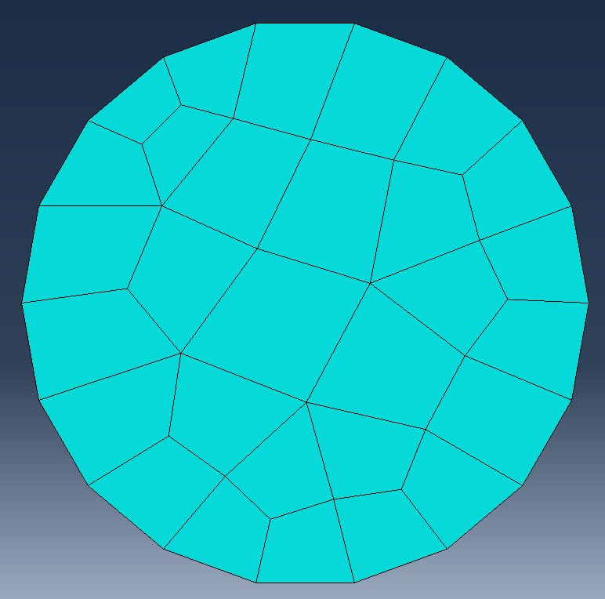

ABSTRACT 5
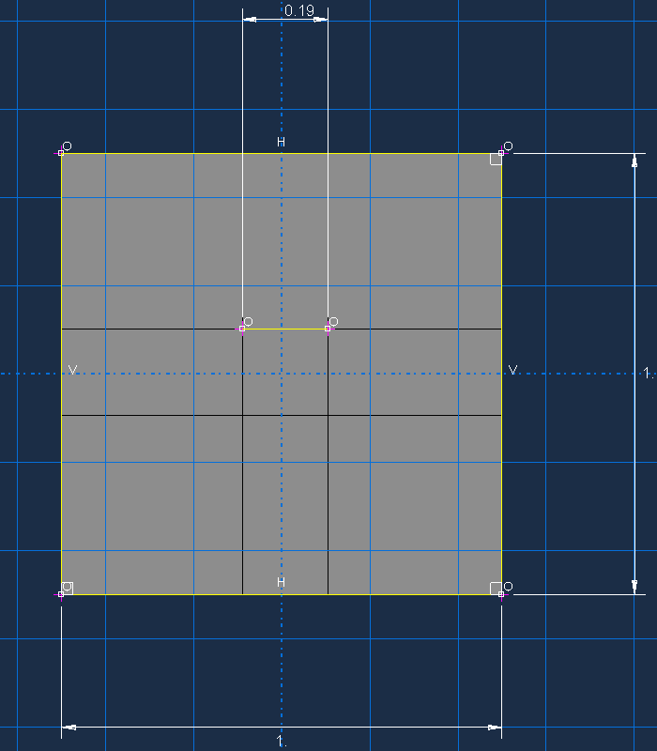

ABSTRACT 6
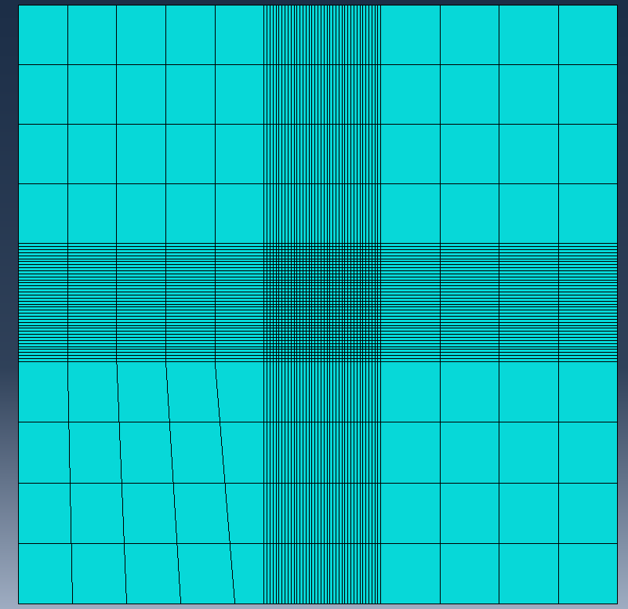

ABSTRACT 7
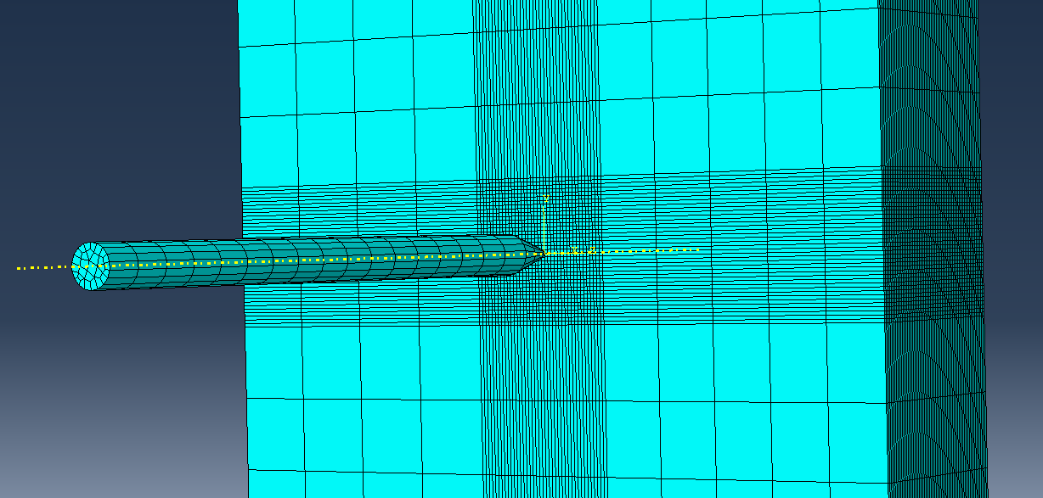

ABSTRACT 8
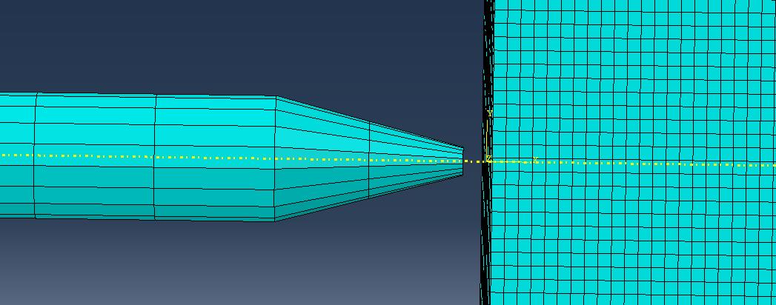

ABSTRACT 9
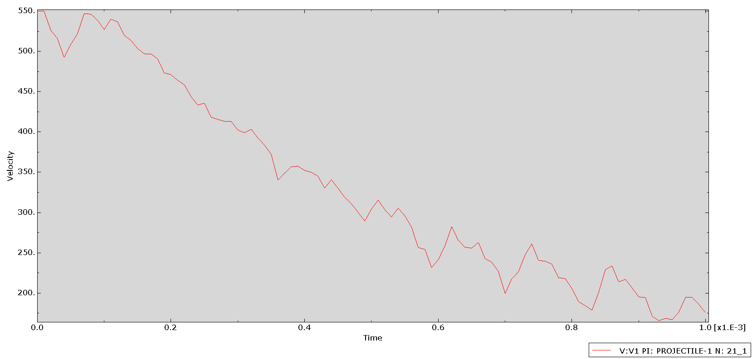

ABSTRACT 10
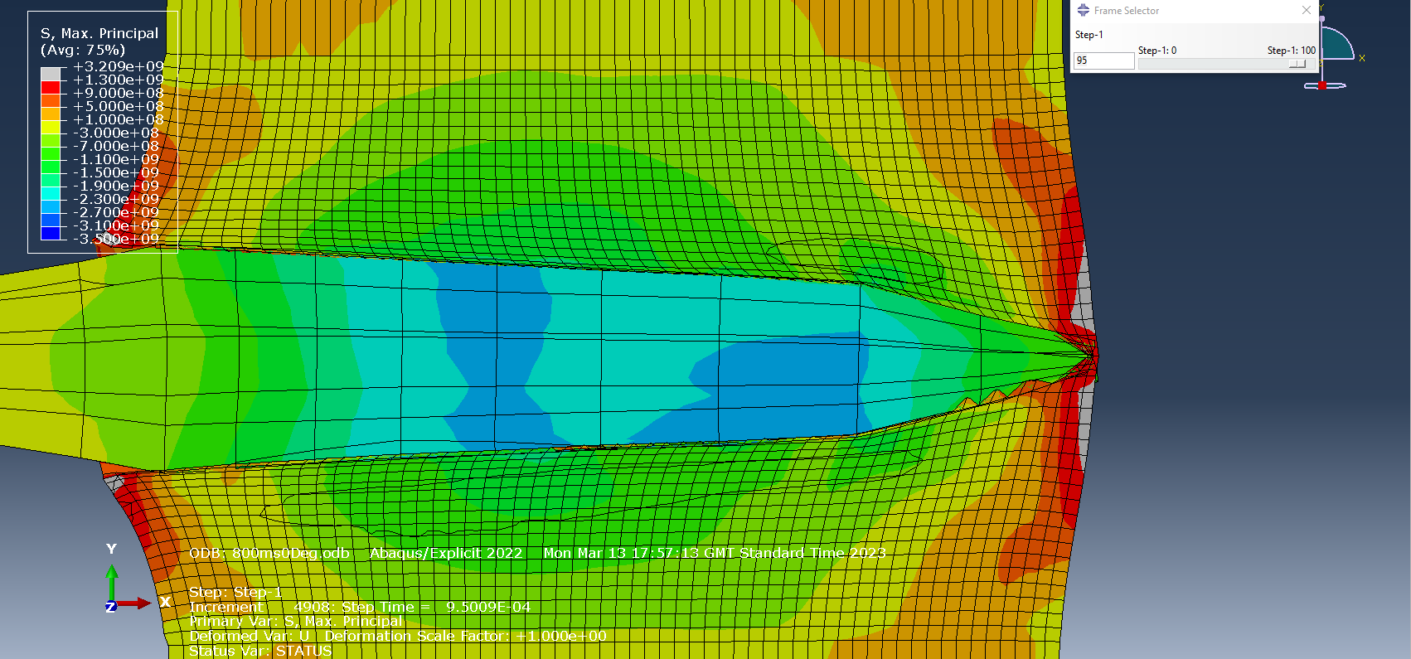

ABSTRACT 11
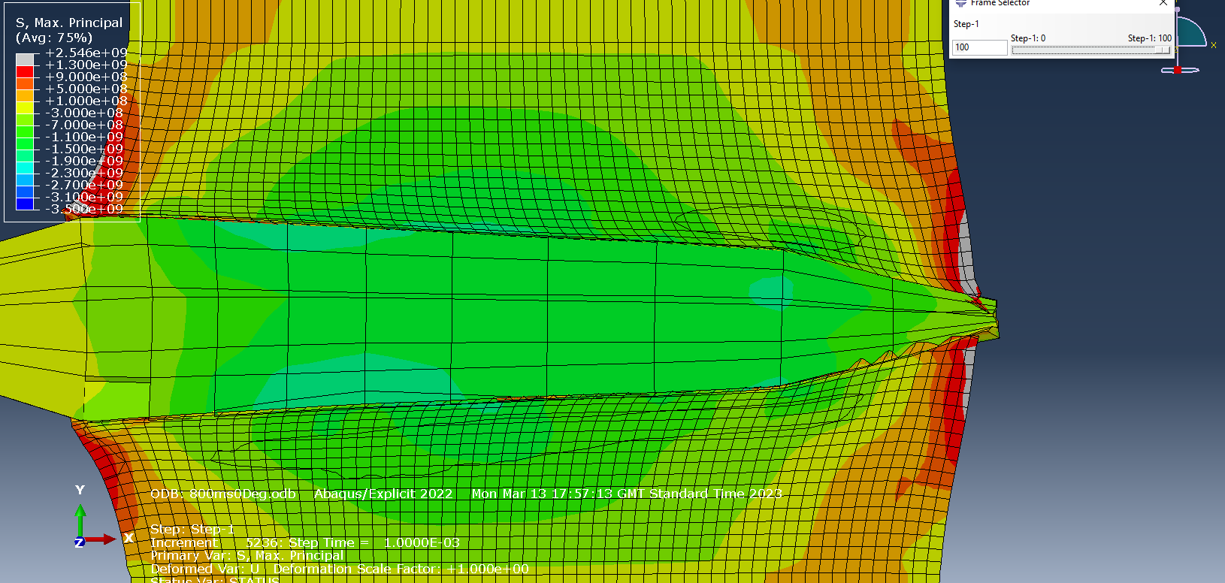

ABSTRACT 12
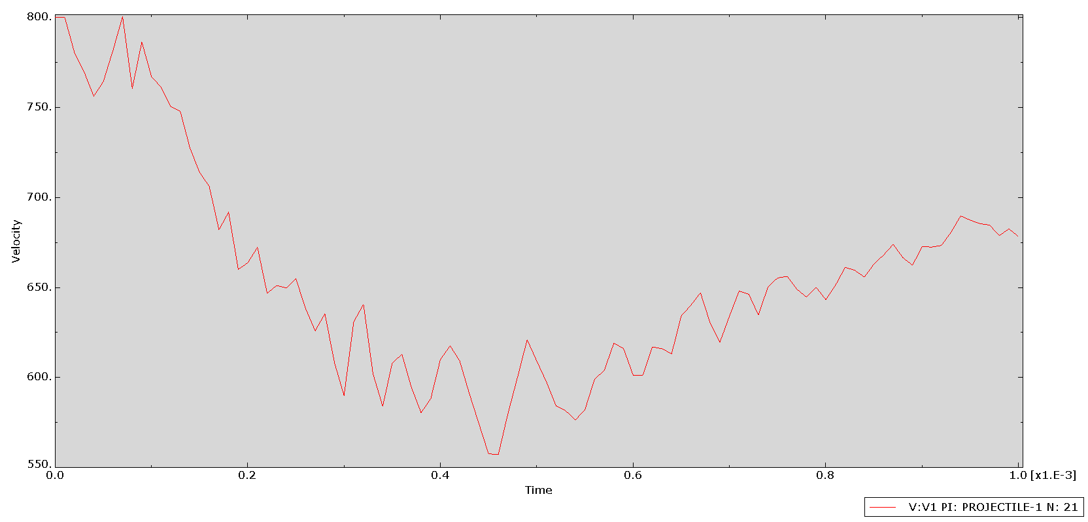

ABSTRACT 13
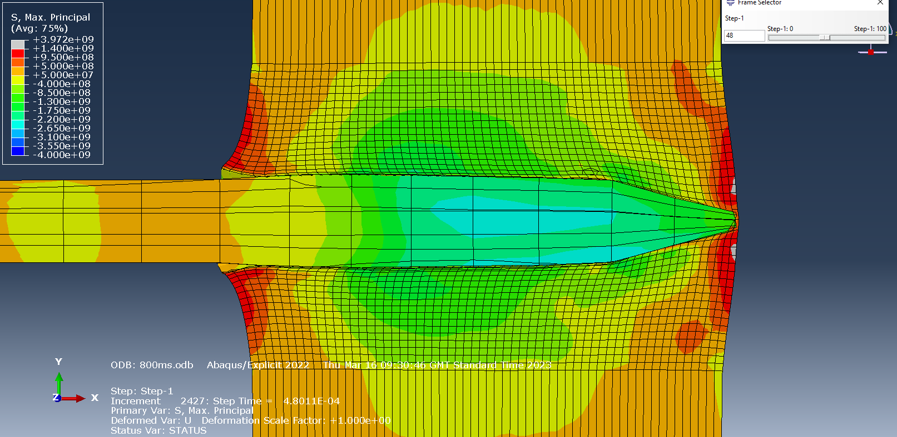

ABSTRACT 14
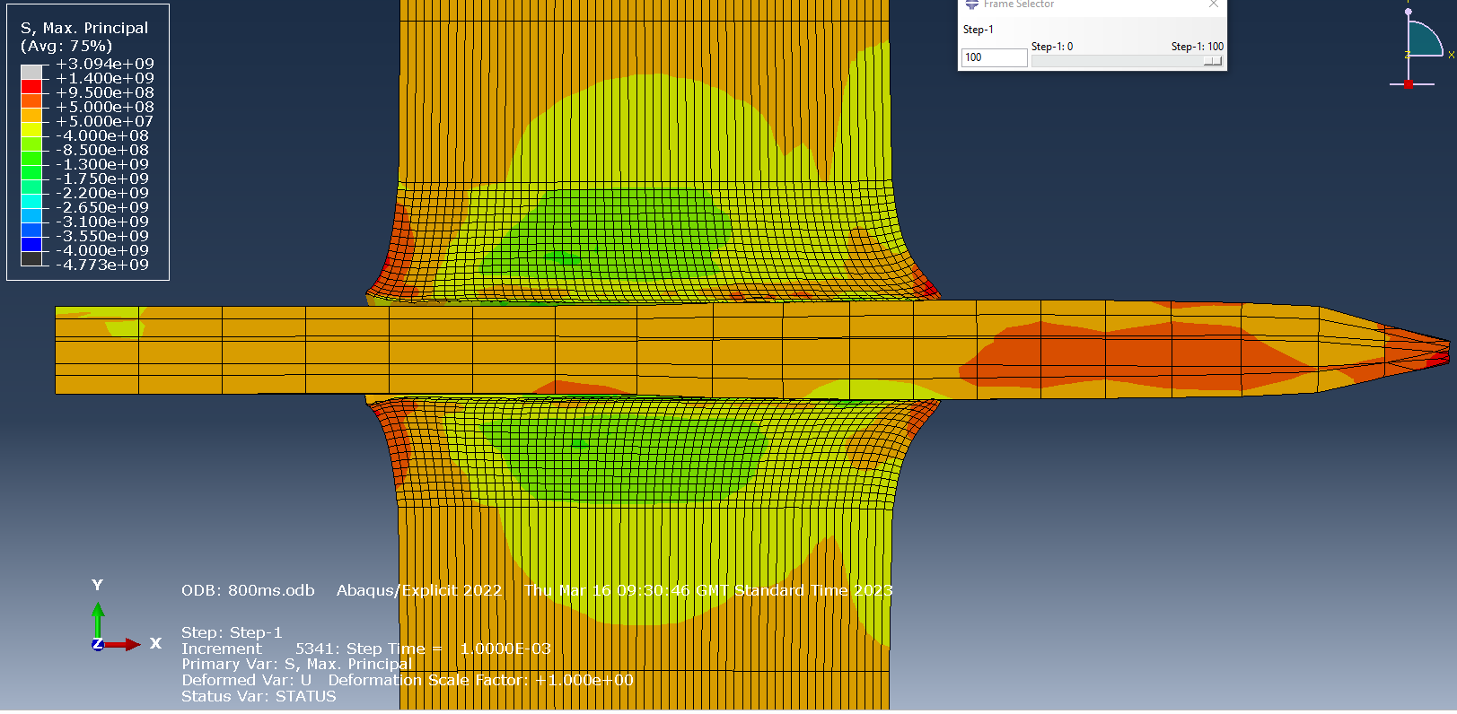

ABSTRACT 15
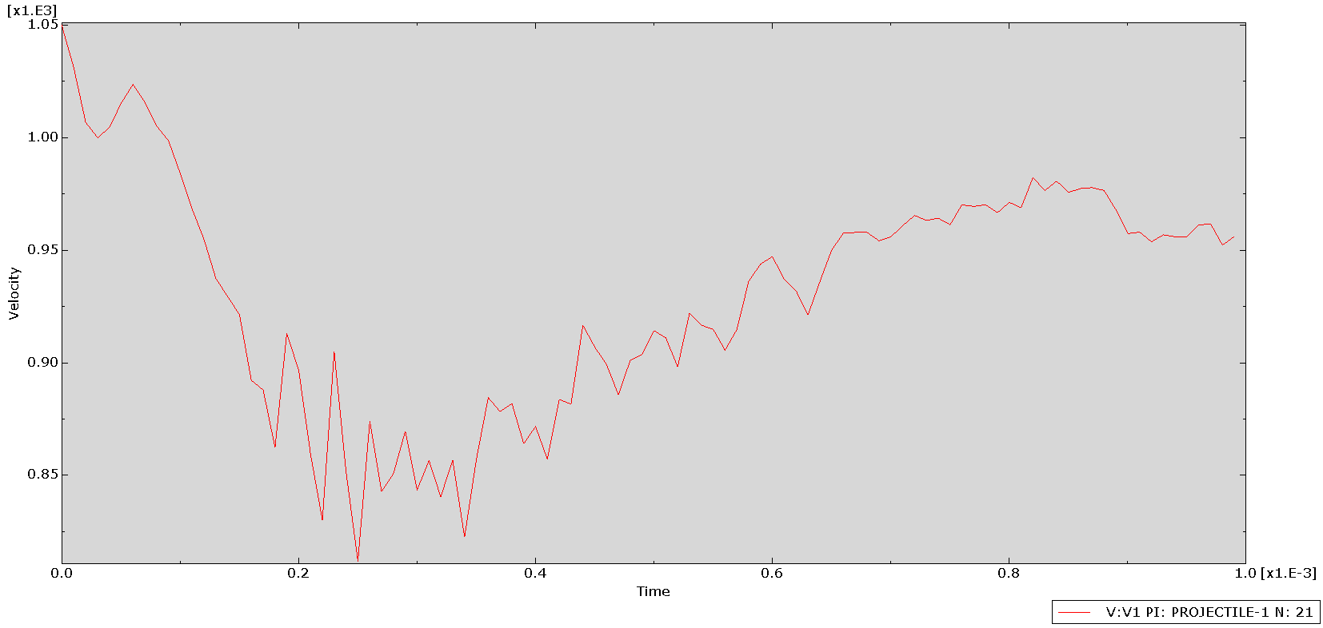

ABSTRACT 16
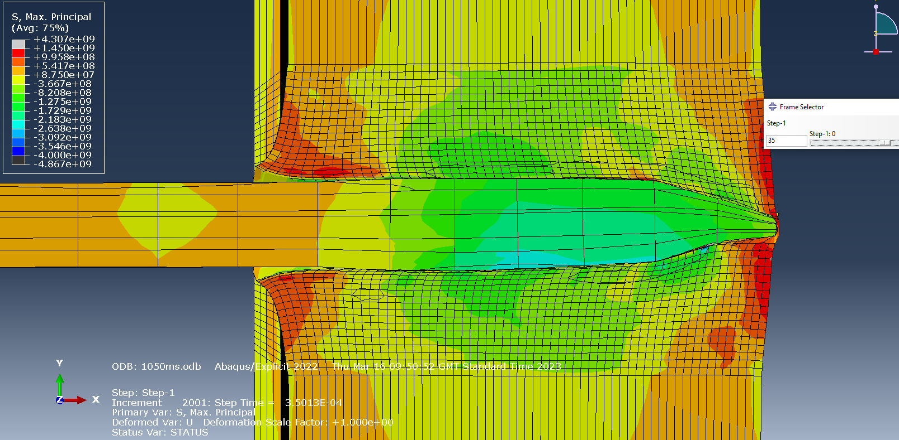

ABSTRACT 17


