BMSW4002 EFFECTIVE TEAM WORKING & COMMUNICATION
Student Names: Group 10, Team 2
Frank Sunshine Shina (Leader): 1914609
Stefania Andrea Bumbacea: 1916791
Daniel Brindusescu: 1908591
Alexandra Elena Tocu: 1906078
Alexandra Musca: 1914421
Lecturer’s Name :EjiroEsohwode

Table of Contents (slides)
- Introduction.................................................................................3
- Benefits of Team Working........................................................4,5,6,7
- Stages of team development..............................................8,9,10,11,12 • Team Roles.................................................................13,14,15,16,17,18
- Managing
Conflicts.............................................................19,20,21,22,23,24,
- Successful Team development....................................25,26,27,28,29,30
- References-------------------------------------------------------------31

Introduction
- We are a group of five representing Safety First Consulting Ltd, and we are here today to demonstrate and discuss how successful team working can help your organisation. The purpose is to analyse the pros and cons of different theories, and take you through steps and considerations needed to be made in order to achieve Effective Team working.
- My name is Frank Shina, the team leader and I will be talking about
Benefits of Team working, my colleague, Alexandra Tocu will discuss
Stages of Team development, Alexandra Musca will talk about Team roles, Daniel Brindusescu will explain Managing conflicts, and Stefania Bumbacea will present Successful Team development.

Benefits of Team Working
- Team resolve problems much quicker as they work in collaboration, share ideas, come up with suggestions and supports each other.
- Situational Leadership facilitates efficiency and increases productivity.
- Team work is essential to a company’s success because it takes less time to finish tasks is less time compared to when working independently
- How Belbin’s 9 Team Roles concept enables successful team building.
- Managing stages of development is essential in the formation of a team according to Bruce Tuckman’s theory.

How to improve Team Performance
- Improved communication enables the team to discuss their problems and find a means of resolving them as interactions between workers is much more effective and free-flowing.
- Team work makes you happier as the team are able to allocate tasks and support each other. In most organisations where they work in teams, managers establish goals, performance standards and milestones, but allow team members to determine how to meet the requirements.
- Reward and recognition increases productivity as it improves the morale of the team and motivates them to work harder. For example, a team that knows that they will receive an award or incentives like pay rise or promotion tends to put more efforts compared to a team that are less motivated.

SWOT Analysis of Team working
- Lack of commitment; Team working can be very effective, however, research shows that there are some problems such as, loss of productivity as majority of work is being done by a few members while underperforming ones simply hide behind the team.
- Poor communication; There is bound to be fish market syndrome where everyone is talking and no one is listening.
- Interpersonal conflicts within the team can have a negatively impact on the group’s harmony and efficiency. Power struggles and conflicts often occur when members are competing for positions, especially during the Storming and Norming stages. They break up and unable to progress to the next stage Performing.
- Poor Leadership; In some cases, leaders are not able to get the team to work together as not all workers are suited to work in a team. Some achieve results by working more efficiently on their own as they may not be able to make the best use of their skill set in being part of a group.

Conclusion
• In conclusion, as illustrated in my SWOT Analysis, while Team working brings about flexibility, efficiency, empowerment and increases productivity, there are some disadvantages such as, potential conflicts, lack of commitment, poor communication and bad leadership. However, the benefits of working as a team clearly outweighs the disadvantages, and that is why I want to recommend Effective Team working to your organisation. This was referenced in both Bruce Tuckman’s 1965 theory, and Whelan 2014’s.

Stages of Team Development
- I n 1965, Bruce Tuckman said that the development of the teams will occur in a number of stages :
- Forming
- Storming
- Norming
- Performing
- Adjouring

Forming stage
- Most team members are positive and polite.
- Members are sharing experiences, interests and backgrounds.
- The team will not be very productive yet.

Storming stage
- Team members contributes in different ways realising the tasks
- Some problems are likely to emerge. Morgan,2017
- Most teams experience conflicts

Norming Stage
- Members and the leader need to consider now how to manage a damaging conflict. Morgan,2017
- All members start to contribute and work as a unit
- As new tasks emerge, members may still meet a few conflicts, but will be easier to manage, if they already dealt with conflicts before.

Performing stage
- Team reaches the performing stage when hard work leads.
- Every team member is now on the same page and they gets the task completed.
- Most groups struggle to reach this stage.

Adjourning (Finish or completion)
- Teams are often built for a special task, then they usually disband after finishing the task.
- Team members who developed close working relationships with others, may find this stage difficult.
- (courses.lumenlearning.com)
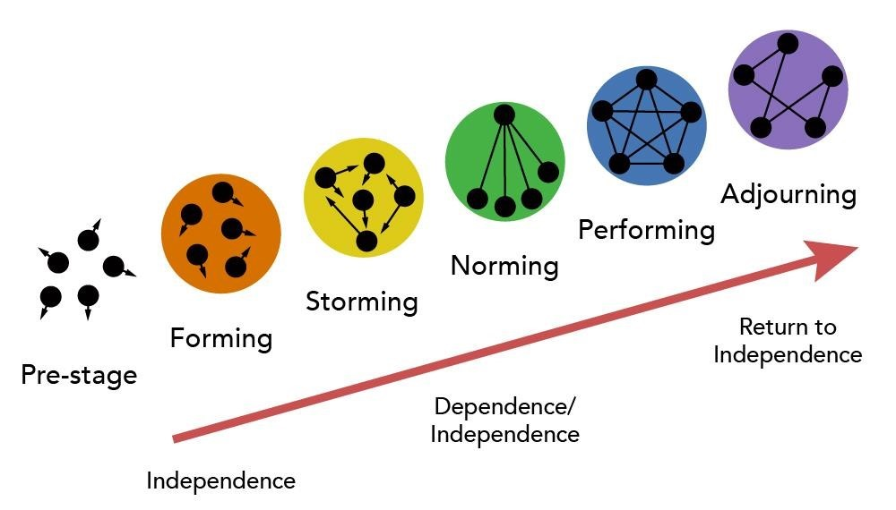
(
courses.lumenlearning.com
)

Limitations
- However, in 2004 ,Wheelan criticise Tuckman’s idea, saying that it takes about six months for a team to get to the performing phase and not all groups make it to this stage as they get stuck at ones of earlier stages.
- Tuckman did not talk about the largest groups, but only about small groups.
- References :
- Morgan, P. M. (2017), The business student’s guide to study and employability, Sage, London

Team roles (Belbin) /Leadership role (Hersey &Blanchard)
Team roles are crucial for every organization as they help in clearing every member's work, what they have to perform. It is necessary to be aware about every member role so that segmentation of work is done properly.
A team is defined as group of people coming together for achieving common desired goals. (Romero, 2019). In a team, there each individual play different role depending upon their skills & responsibilities. According to Belbin, there are various types of team roles which are further discussed below-
Team Role cont...
- Action oriented- completer- These kind of members in team are to called as perfectionists as because they pre-pared themselves for occurring situations or unexpected events. They are not dependent on anyone and like to finish their work on given deadline. Finishers also have a problem with delegation; they would rather be overwhelmed than share their work with others.
- People oriented- Coordinator- They are the role player of team who are responsible for managing and handling team effectively. Moreover, also help team members and guides them about their work when and how to do it.
- Action oriented role-shaper- This specifies, those people play this role who are enthusiastic and dynamic in nature. Such type of people are always ready to face challenges with positive mind. Shapers are also considered top be known as extrovert who fearlessly talk to everyone.
- Action oriented -implementer- Individual who are actually responsible for turning ideas into real practice & course of action comes under this category. They are well organized, rigid. Also, they always are ready
(Driskell, 2017).
- Team worker- These are one who cares about team &assures that team remains together and united as for longer period of time or till completion of project. They maintain a supportive relationship with every member and allows everyone to take participate decision-making equally (Oke, 2016) .
- Resource investigator- They are known for their strong networks, negotiation skills, at workplace and in market. They act a s secret agent in organisation who acquire the necessary credentials by any how.
- Evaluator- Such type of people are calm and look into things as well as other situations with proper considerations. Also, they make decisions only when they are sure about the factors. They do not want any problems or issues in their work.
- Specialists- These are one who have specialized in some specific field or area. They are expert in that field and are limited to there specialization only.
- Plants- Then comes the plants, who are being known for their innovative approach. Externally they get appraisal from everyone (Romero, 2019).

Conclusion
• Team roles are essential to be recognized so that work is divided accordingly. So, organization need to clear every employee role within in a team so that problem or errors do not occur in near future.
Furthermore, this also help in achieving goals & objectives.

Managing Conflicts
- This presentation is based on a study report regarding managing conflicts in a company, occurring between the employees, stuff and management.
- By using the Thomas-Kilmann Conflict Mode Instrument and the Six Steps Method to manage a conflict, this presentation is highlighting the critical aspects and essential factors related to management conflicts and their causes within an organisation.

Managing conflict, causes
- Reasons for conflict are generated by three types of factors as it follows: communications factors, structural factors and personal factors:
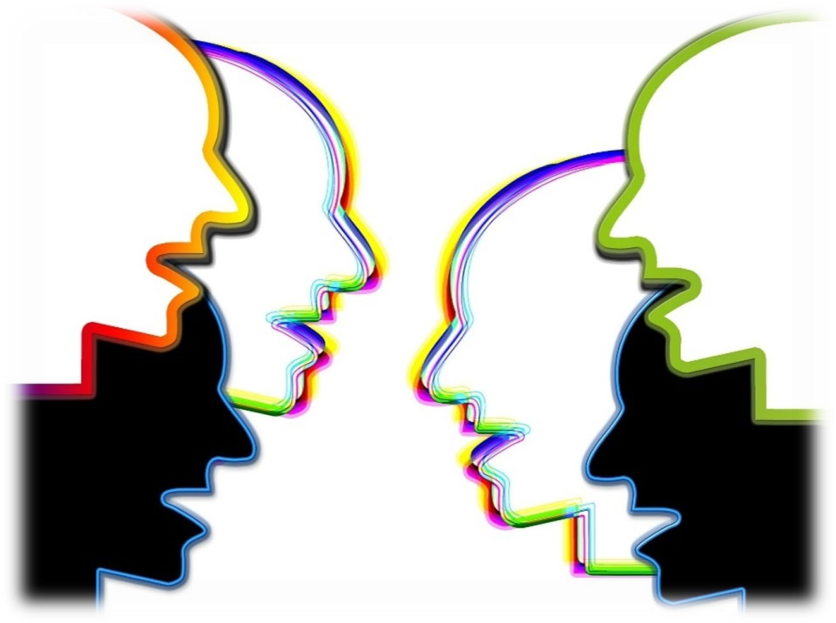
- Inadequate training
- Unproductive work environment
- Bullying and harassment

Steps to manage conflict
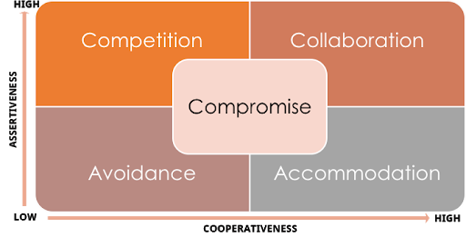
Conflict between the employees in an organisation can be addressed using:
- Competition
- Collaboration
- Compromise
- Avoidance
- Accommodation

Steps to manage conflict
•
Discussion to clarify the
disagreement
1
•
Establish common goal for each
parties
2
•
Identify the barriers standing in the
way to reach common goals
4
•
Find the best ways to solve the
dissention
5
•
Ways to meet common goals
3
•
Acknowledging the agreed solution
and determining each party
responsibilities
6

Conclusion
• This presentation concludes that, there are many issues and problems that may appear in an organisation; that, can causes conflicts leading to disruption of the company activity. Consequently periodical training of company staff in the matter of Leadership, Problem Solving and other related subjects is the best solution to settle disputes that may naturally occur.

References
- Thomas, K, W., and Kilmann, R. H, The Thomas-Kilmann Conflict Mode Instrument (Mountain View, CA: CPP, Inc., 1974).
- Kiitam, A., McLay, A. and Pilli, T., 2016. Managing conflict in organisational change. International Journal of Agile Systems and Management, 9(2), pp.114-134.
- Langa, C., 2018, June. Managing conflict situations within the school system organisation. In 2018 10th International Conference on Electronics, Computers and Artificial Intelligence (ECAI) (pp. 1-4). IEEE.
- Potterton, D., 2018. Managing conflict through workplace civility. Industrial Management, 1, pp.21-24.
- Tjosvold, D., Wan, P. and Tang, M.M., 2016. Building trust and constructive conflict management in organizations (pp. 53-74). Springer, Cham.
- Tokakis, V., Polychroniou, P. and Boustras, G., 2018. Managing conflict in the public sector during crises: the impact on crisis management team effectiveness. International journal of emergency

Successful Team Development
- Each company needs to have an organizational culture that encourages teamwork. It requires collaboration, communication, trust and respect, but mainly, the presence of a leader with an attitude that represents balance in the team.
- The leader will be able to identify the development potential of team members, encourage and help them develop new skills, as well as provide constructive feedback on an ongoing basis.
- Thus, employees will be able to evolve professionally, maintaining that sense of belonging to the organization. The work environment is also an essential factor in increasing the productivity of team members.
- A modern, pleasant, welcoming space and a positive atmosphere will make a difference.

The 4 Pillars to Build a Successful Team
✓Common Goal and sense of direction. Team should normally have a shared purpose and understand the expected result, their role and how their team’s output will contribute to corporate goals.
- Development of Skills-Reasonable & efficient operating procedures. They need to put a system in place to plan, hold meetings, identify and solve problems, make decisions, give and assess the progress and perform duties.
✓Synergetic Harmony-Active reinforcement systems. Usually in the larger company, a team needs to have a process of holding members accountable and reward positive results and behaviours.
- Keeping the Accent on the Positive-Talented members. When setting up a team, it is important to have someone with a clear vision of what they want to accomplish and identify what is required to get the job done.

Communion vs. Competition
- In most cases, common setback to the efficient operation of the team is the conflicts between workers. However, team members are advised to work together as a strong unit.
- On the other hand, if tasks and roles are not well defined, there is bound to be a sense of rivalry among them. Furthermore, some companies often encourage competition to achieve better results, creating apathy and frustrations between members of the team.
- The solution? Developing a concept and strategic way of thinking that involves a balanced mix of competition and togetherness.
How can a leader encourage team spirit?
Through common goals;
- By making everyone feel that they a belong to the group and the company;
- By allocating tasks clearly, organising social and professional activities, meetings, workshops, team-buildings and team volunteering action.
- By acknowledging each member of the team as a unique individual, with different experiences, skills and views, and promote creativity innovation and creativity.
- By having outstanding communications skills that can illuminate each member to discover the best of their potential.

The 4 Pillars of a Team Building
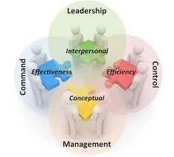

Conclusion
• To develop a team successfully, maintaining a well-structured team and achieve a lasting results, a leader must demonstrate emotional intelligence, compassion and empathy, and lead by example to prove that he is also part of the team while maintaining his objectivity.

References
- Jones, Dr. Alex, The Tuckman’s Model Implementation, Effect, and Analysis & the New
Development of Jones LSI Model on a Small Group (2019). Journal of Management, 6(4),
2019, pp. 23-28. , Available at SSRN: https://ssrn.com/abstract=3525281
- Driskell, J. E., Salas, E., &Driskell, T. (2018). Foundations of teamwork and collaboration.
- Volkov, A. &Volkov, M. (2015), Teamwork benefits in tertiary education.
- Casper, W. C. (2017). Teaching beyond the Topic Teaching Teamwork Skills in Higher Education.
- Potterton, D., 2018. Managing conflict through workplace civility. Industrial Management, 1, pp.21-24.
- Langa, C., 2018, June. Managing conflict situations within the school system organisation. In 2018 10th International Conference on Electronics, Computers and Artificial Intelligence (ECAI) (pp. 1-4). IEEE.
- Reyes, Denise L., et al. "Team Development: The Power of Debriefing." People & Strategy, vol. 41, no. 2, Spring 2018, p. 46+. Accessed 17 Aug. 2020.
- Romero, 2019. Social networks under stress: Specialized team roles and their communication structure.ACM Transactions on the Web (TWEB),13(1), pp.1-24.
- Oke, 2016. Importance of team roles composition to success of construction projects. International Journal of Construction Project Management,8(2), p.141.
- Morgan, P. M. (2017), The business student’s guide to study and employability, Sage, London

