

Major Project Questions

Student: Xinxin He

Assessor: Rob Goodson & Kelvin Lake

Question 1

In Equation 1, why is A_{T} the product of π and the diameter; is this not the circumference of a circular shape?

Question 1 Response (maximum 200 words)

is the cross-section area of the flow, this formula here is wrong, I have forgotten why I wrote this. In the calculation of these two annular orifices, is the product of thickness of flow and the circumference of the annular orifice. Sorry for my mistake.
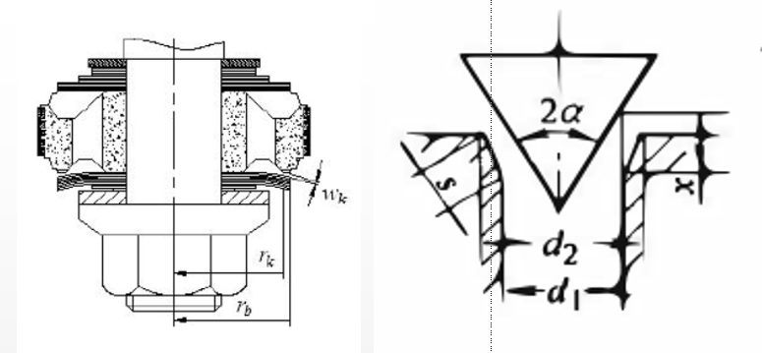

Question 2

What experimental errors would you have seen during your testing? Discuss these.

Question 2 Response (maximum 200 words)

The data obtained in the experiments include the sizes of all major components of the mono-tube damper, the damping force obtained by the sensors pasted on the devices, and location of the piston at every moment. There may be some error of the measurement of the size of the components. The damping force and location detected different sensors may have some error, but these error is inevitable and cannot be controlled because these is influenced by the sensors and electrical devices. Compared to the influence of these error, other data such as the distance between the needle valve and the valve seat, the threshold of the pressure difference to bend the shim stack are more influential to the accuracy of the damping force, but these data can only be estimated according to experience and try and error.

Question 3

Clearly you have used the software available to you at the University. Was this the best software to use? Are there alternatives that you would have liked to have used? Why?

Question 3 Response (maximum 200 words)

I used Matlab to calculate the mathematical model of this process. I think it the best software for me to use because I am familiar with this software. I would have liked to use the Simulink of Matlab at first, but the output of this module need to be managed further to get the relationship of damping force and velocity of the piston rod, so I choose to programme directly.
Another software that may suitable to analyze this process is CFD (Computational Fluid Dynamics), which is an expert software to analyze fluid dynamics and can show the result by 3D model, but since I have not used it before, and did not know exactly whether it can model the process as complex as the damper, so I choose the Matlab.

Question 4

You mention the possible use of a feedback control system in the simulation. Would it not be possible to include a ‘limit’ in the analyses that could be determined from experiments?

Question 4 Response (maximum 200 words)

This is a method to reduce the oscillation of the damping force, by letting the shim deformation equal a constant when it is calculated to be bigger than this constant, and the result of this method is shown in the following figure. In this method, the constant can only be determined according to the shim deformation simulated in the Solidworks, because the shim deformation cannot be measured during the experiment.

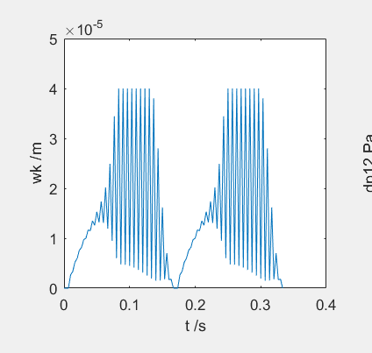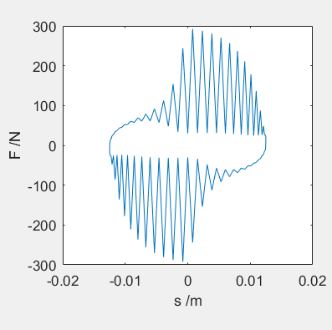

Question 5

How important do you think is the influence that in your simulation model the relationship between pressure difference and shim deformation is linear?

Question 5 Response (maximum 200 words)

The shim deformation in one step will influence the pressure difference in the next step. If the relationship between pressure difference is nonlinear shown in the following figure, the amplitude of the oscillation of pressure difference will be smaller, between under the same pressure difference p1, the shim deformation will smaller than that in the linear relationship, so the pressure difference in the next step will higher. According to this reason, whether the relationship between the pressure difference and shim deformation will only influence the amplitude of the oscillation of damping force.



