Ensure you have a suitable environment open, and that you have a working instance of Jupyter Notebook.

- Open Anaconda Navigator and ensure you are in the environment that you set up. Click ‘Launch’ on the Jupyter Notebook tab.


- Once the Jupyter Notebook tab opens in a browser window, choose ‘New’ and in the dropdown menu choose ‘Python 3 (ipykernel)’.
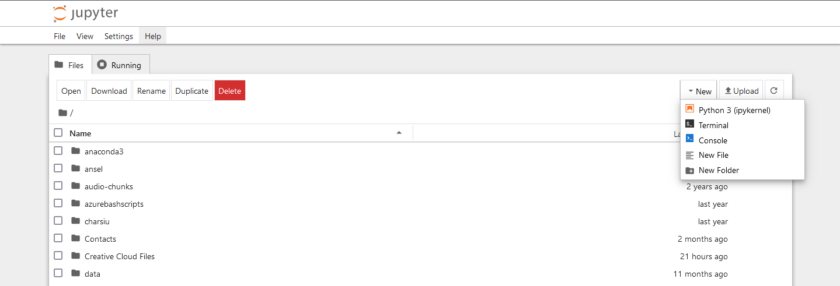

- Once a notebook window is opened, you can start coding. Ensure ALL CODE is typed from the GREYED CELL in the images.
Firstly import the packages you will need. For this tutorial you will need:
  - os for the directory system.
  - Version from packaging - to assert versions.
  - Tensorflow
  - Keras from Tensorflow
  - Numpy

Numpy and Tensorflow (see next step) will be imported using an alias (a variable to use in stead of the full name). This will be quite common with several packages. Importing packages will always be the first step. Once you have coded a cell in Notebook, you will need to click the ‘run’ button to run that cell (looks like a play button, see below).

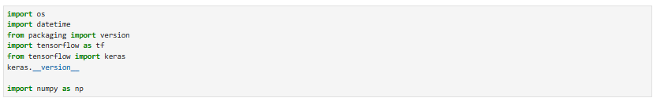

- As a note, remember you can name your notebook to be saved for later reference.

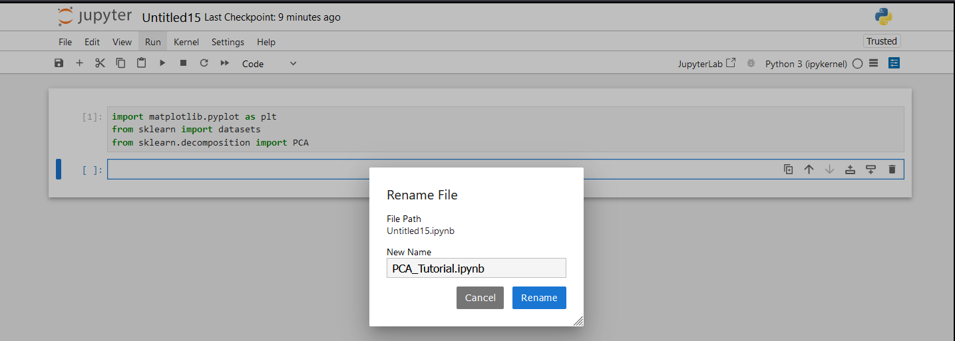

- Check the version of Tensorflow. We will also assert that it is TF2 as it is offers more flexibility. Run the cell.
- Load the MNIST Digits dataset directly from Keras. This can be downloaded from Moodle if you do not have it. Save it to a variable of your choice (mnist_digits in the example). Set the training set / lables and test set / labels (as variables) and load the dataset into these. Run the cell.

- Check the shape of the data. Run the cell.
What is the shape of the data?
What do the numbers mean?
How many images are there?
What size are the images?

- We can also check the dtype. Run the cell.
What does this show you?
- Let’s plot one of the images to see what it looks like. You can change the index to look at any of the handwritten digits (change the 0 in X_train_full[0] to whatever index number you want. Try a few! Run the cell.
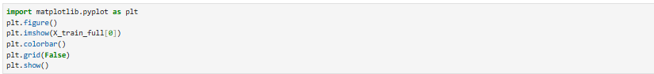
What do you notice about the image?

- This is an optional step in the case of the digits (for obvious reasons) but we can set class names so it is easier to interpret. Print the names and the actual labels out. Again, we can set the index to any number for a different result. Run the cell.
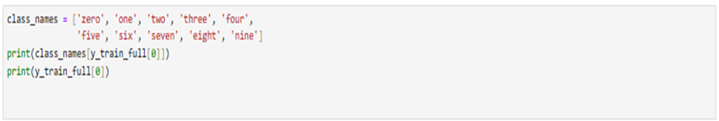
- We can also plot a range of images with their labels so we can check everything is in order. Run the cell.

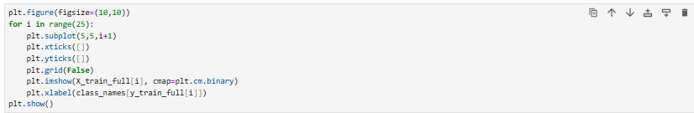

- It is now time to normalise the dataset. Dividing each image by 255 normalises the pixel values between zero and one. At this point it is also good to split the training set into train and validation. The first 5000 images will be validation in this case. Run the cell.
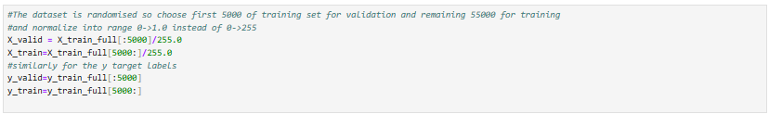
- Now we are ready to create a model. We will set the model as Sequential(). This will be stored in a variable (model). We can then add the layers needed in our model using the variable and adding the layers we choose to add. The first is a Flatten() layer as we need a flat array of numbers in a fully connected layer, the shape is the size of the image (28 x 28 pixels). The rest are Dense() layers with the number of neurons being 300 in the first, 100 in the second and a ReLu activation function. The final layer is an Output layer, set to 10 neurons (nodes) for the number of classes with the softmax activation function as discussed in the lecture, giving a max probability for the classification. Run the cell.
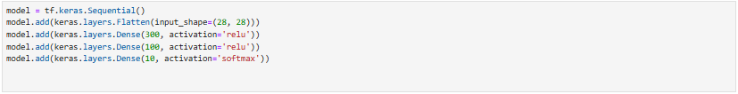
- Check the model summary. Run the cell.
What information does this give you?
What do you notice?
Why is the output shape of the first layer the number it is?
How many parameters are there per layer and overall?

- We now compile the model. Run the cell.
- We can now fit the data to train the neural network. The first part of the cell is to log the data for the Tensorboard to display. We also include callbacks for the Tensorboard. Create a variable to fit the model training to. History is chosen but any name can be used. To this we are fitting the features and labels from the training and validation dataset so that the neural network can validate its accuracy as it proceeds. We also set the iterations of training, called epochs, and for this run we will iterate over 20 epochs, meaning 20 passes to improve accuracy. Run this cell.
What happens at this point?
What happens to the accuracy and the losses?

- Now we can plot the accuracy and loss across the epochs for both training and validation. Run the cell.
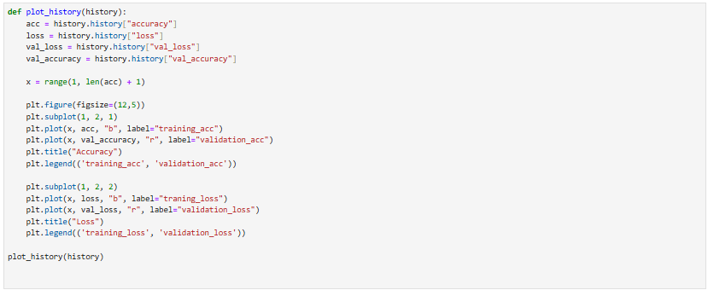

How does this look?
What do you notice about all four curves?
What do you notice about the pair of curves in each graph?

- Now we need a new notebook. We need to repeat the process up to Step 15.

- Now we can set our method for logging the results using os. Run the cell.
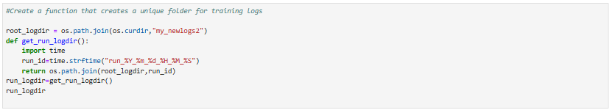
- We now create our tensor callbacks, set our early stopping callback and fit the model again. This time set epochs to 100. Run the cell.
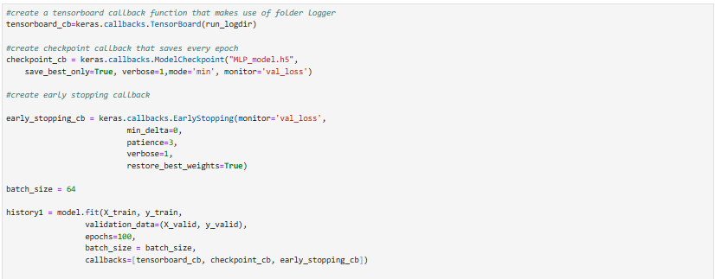

How happens here?
What is different from the first notebook?

- Now let’s plot the same curves again. Run the cell.

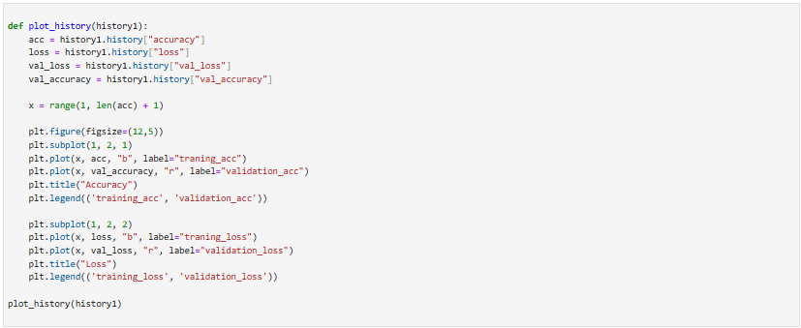

What does this show?

What is different to the previous run?

