
Applied Computing
Wales Institute of Science and Art (WISA)

Digital Forensics (ACCA7031)

Investigative Process - Imaging

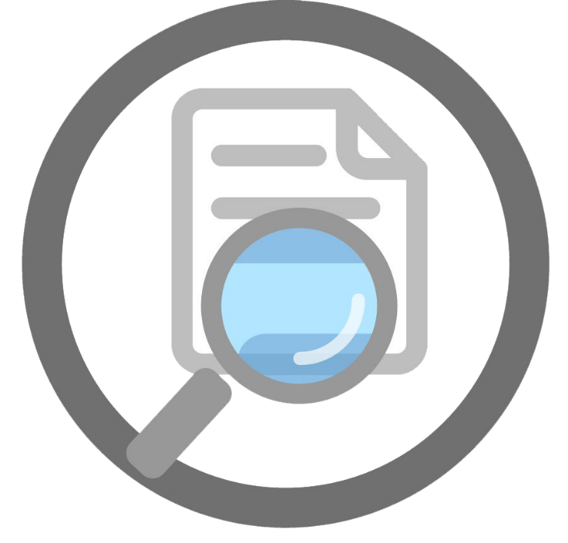
This Photo by Unknown Author is licensed under CC BY-NC

Lab Activities are based on
TryHackMe, EC Council – CHFI, and other Industry Digital Forensic Curriculum

Objectives
In continuation to our lectures, this hands-on Activity helps in providing you an overview of digital forensic investigation process.
ETHICAL STATEMENT
As discussed during our lectures, it is very important to adhere to Personal Ethics, Professional Ethics, Computer Ethics and Business Ethics.
We, the participants and stakeholders in the digital forensics laboratory, recognize the significance of ethical conduct when using digital forensics tools and processes for academic purposes. Our commitment to ethical standards is grounded in the principles of integrity, privacy, and responsible handling of digital data.
The tools and techniques you are exposed to’ in this lab is to work only on a virtual machine environment and the purpose is entirely to demonstrate various digital forensic activities. Experimentation with these tools, techniques, and resources is at the discretion of the instructor and institution. If you as a student consider using these tools for educational purposes on an outside environment, you should contact your lecturer prior to any experimentation.
Note: Unauthorized access to data, computer, and network systems is a crime in many jurisdictions and often is accompanied by severe consequences, regardless of the perpetrator’s motivations. It is the learner’s responsibility, as the user of this material, to be cognizant of and compliant with computer use laws.
Task 1: Image Acquisition – Deep Dive
Task 2: Working on Acquired Images

Task 1: Image Acquistion – Deep Dive
Pre-requisite: Previous Handson Activities
Required Images:
- Folder with Files (EO1/RAW)
- Folder with Files (DD)

Checkpoint: Based on the discussions about the image formats during the lectures and discussions with your classmates/ team, you must now be very clear on what’s the purpose and scope of these different formats. If you are not clear, please discuss again with your Team and Lecturer.
Deep dive to look at the image acquired to understand the file system. Always, a file system stores the data in a logical way in any media. The Operating Systems uses the logical methods to retrieve the data when required. A lot of algorithms involved in this process. However, as a Forensic Analyst, understanding the file system will help you to corelate the manner in which the data is arranged, leveraging an option to identify the meta data.
  - What are the possible tool options to identify and analyse the file system of the image you acquired? Research, discuss with your Classmates/ Team and identify tools.
  - We will be using The Sleuth Kit. Go to the website and look at the available documentation. Did you come across Autopsy? Have an overview of this tool. We might be using in our future activities.
  - Download the Sleuth Kit for your Operating System and save it.
  - Check the details of DD (RAW) File. You have to make sure you give the correct path of the file. Set your path to the bin folder of Sleuth Kit.
  - Check the details of E01 File. You have to make sure you give the correct path of the file. Set your path to the bin folder of Sleuth Kit.
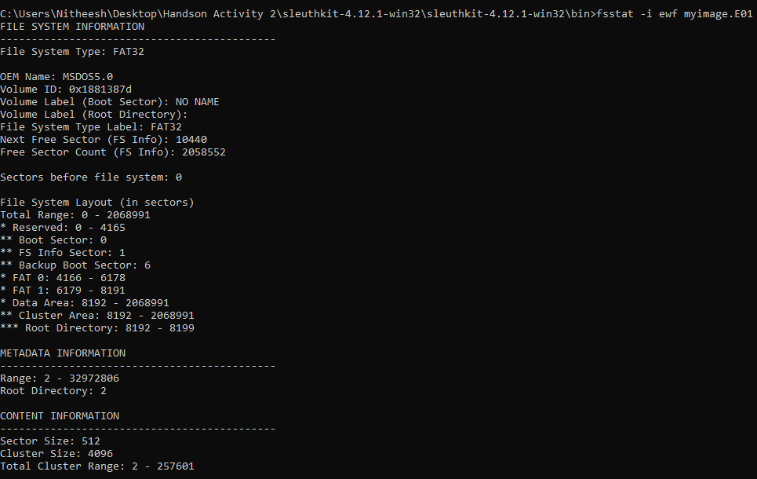
  - Discuss with your team/ classmates: “From the outputs after analysing DD File and E01 File, what details could you analyse as a Forensic Analyst?”. (Hint: Analyse Metdata, Directory Structure, File System, File Signature, etc)
  - Try analysing other file formats. Do a research on tools and procedures to analyse the file system of other formats listed below.
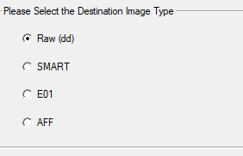

Task 2: Working on Acquired Images
An image you are working on is likely the evidence that need to be analysed and presented to the court of law. Assuming that you have understood the purpose of imaging the evidence and ensuring its integrity during our earlier activities, we proceed ahead in analysing the acquried image.
Required Images:
- task4.E01
- task4_02.E01
- task4_03.E01
- task4_04.E01
- task4_05.E01
- task4_06.E01
- task4_07.E01
- task4_08.E01
- task05_01.E01
- task05_02.E01
Keep in mind:
- Always verify the file’s integrity
- Pay attention to very discrete information.
- Key Factors: Hidden Files, Malwares, etc
Warning: For this activity, we might be using image files from external sources. The image files are available to download from your Lecturer. The download may contain malicious files. Don’t attempt to do anything other than instructed (even in a virtual network)
- Do a research and discuss with your classmates/ team about available tools to mount the acquired images. Note: You must have your own RAW File and E01 file. In addition to those two files, download another file from the link above. Read the warning before downloading.
- For demonstration, OSFMount is used here. You shall use any other mount tools as you pick during the discussion.
  - Install OSFMount. It is a Free Tool from Pass Mark Software.
  - Mount the images and analyse the details:
  - Mount E01 Image and analyse the details
  - Mount DD Image and analyse the details
  - Mount task4.E01 image from the download link and analyse the details. (It contains Malicious Files in it)
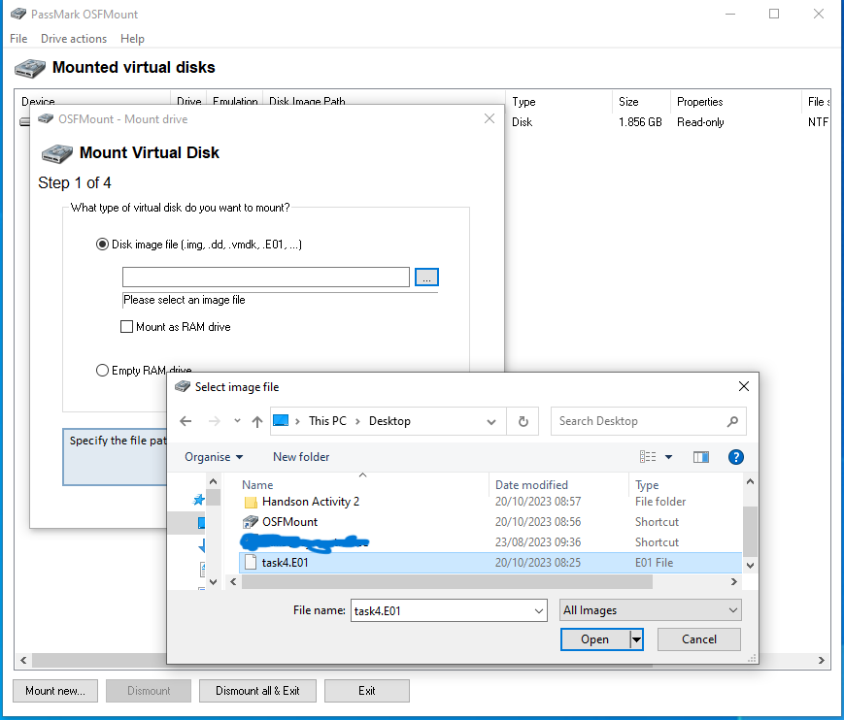
  - Scan the drive to check:
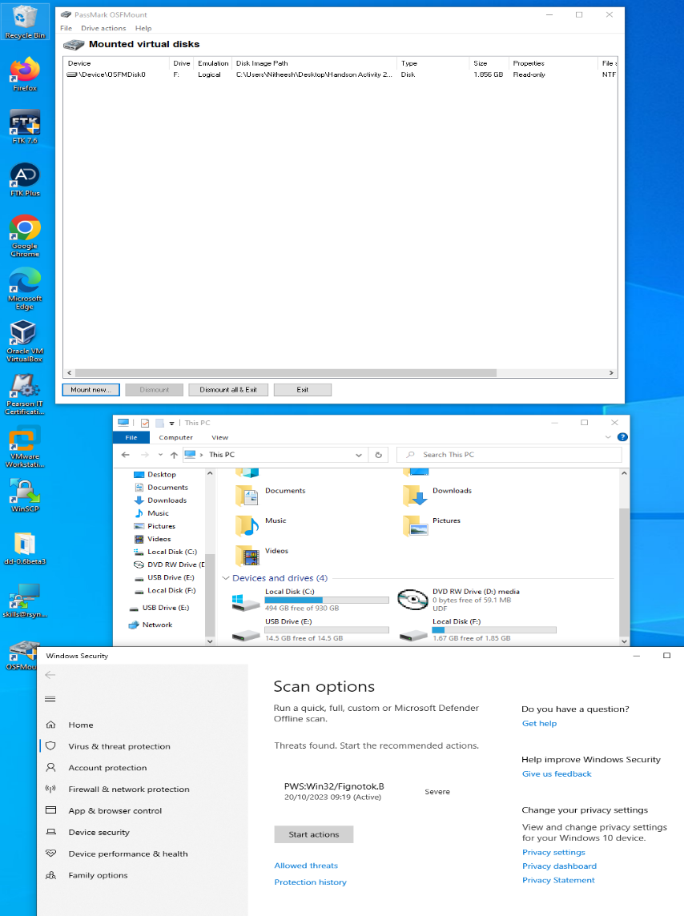
  - Discuss this situation:
    - What if you acquire an image, mount it and see some malicious files in it? What actions would you take?
    - What was the threat identified in the task4.E01 image? Could you deep dive and identify the location of the threat and find more information on the threat?
  - Mount task4_02.E01 image from the download link and enumerate the autorun locations.
    - Did you identify any malware (including virus, trojans, etc)
    - Check if you need to remove any unwanted programs
    - Check for autorun entries, that could eventually slow down the boot process and affect overall system performance. Identify and disable unnecessary autoruns. (For Autorun entries, download Sysinternals Suite and run it.)
    - Check for any security risks. Identify and mitigate risks associated with autoruns. Analyse using “Analyse Offline System”
    - Understand your system behavior – look at how softwares and services are configured on startup.

  - Similarly, Mount task4_03.E01, task4_04.E01 and task4_05.E01 images from the download link and enumerate the autorun locations.
    - Identify any malware (including virus, trojans, etc)
    - Check if you need to remove any unwanted programs
    - Check for autorun entries, that could eventually slow down the boot process and affect overall system performance. Identify and disable unnecessary autoruns.
    - Check for any security risks. Identify and mitigate risks associated with autoruns. Analyse using “Analyse Offline System”
    - Understand your system behavior – look at how softwares and services are configured on startup.

  - Mount task4_06.E01 image from the download link and enumerate the autorun locations.
    - Identify any malware (including virus, trojans, etc)
    - Check for autorun entries, that could eventually slow down the boot process and affect overall system performance. Identify and disable unnecessary autoruns.
    - Check for any security risks. Identify and mitigate risks associated with autoruns. Analyse using “Analyse Offline System”
    - Look at HKEY_Current_User\SOFTWARE\Microsoft\CurrentVersion\Run. What is your observation?
    - How many browser helper objects exists on the computer?
    - Understand your system behavior – look at how softwares and services are configured on startup.
  - Working on Forensic Images
    - Open Forensic Toolkit. Login using Cisco and Password. Go to File New User
    - Login using your credentials.
    - Create a New Case. Refer to the screenshot below. Open a Case.

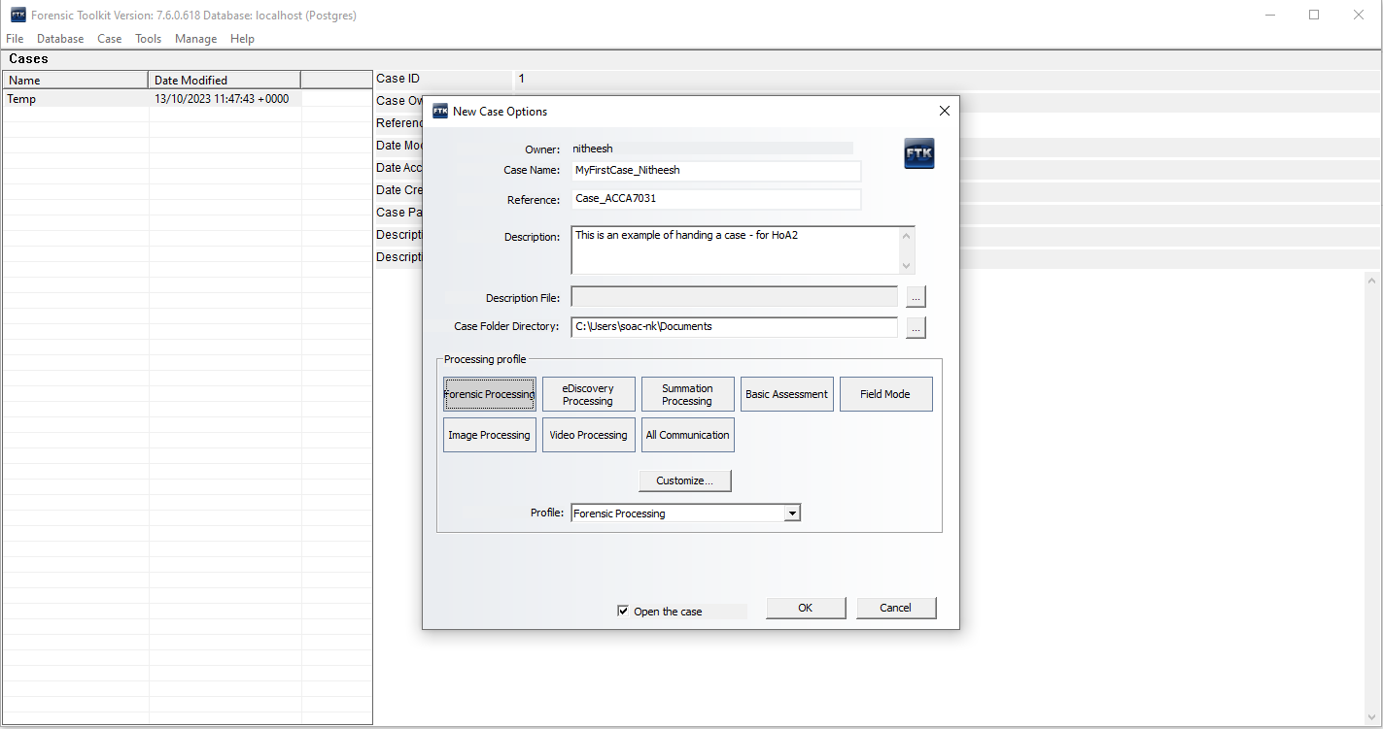
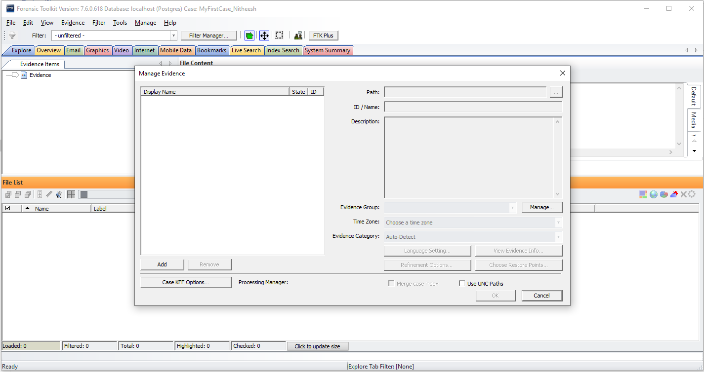

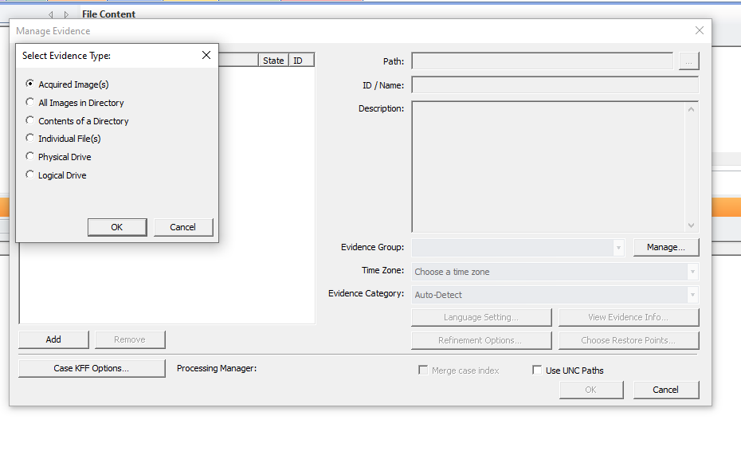
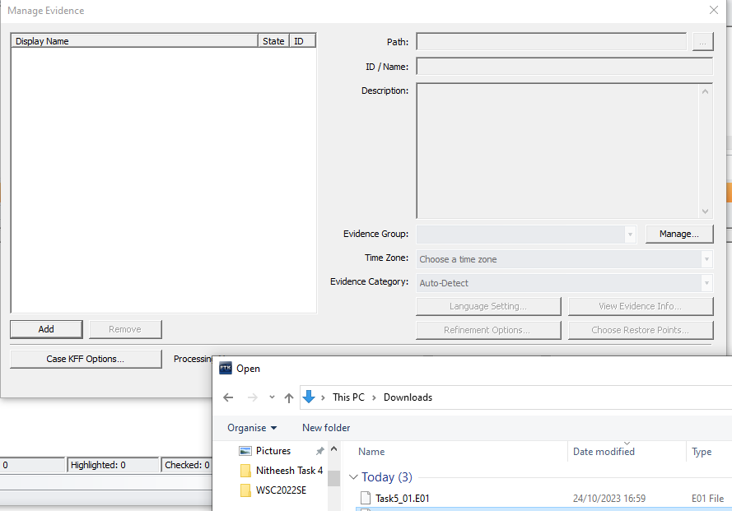
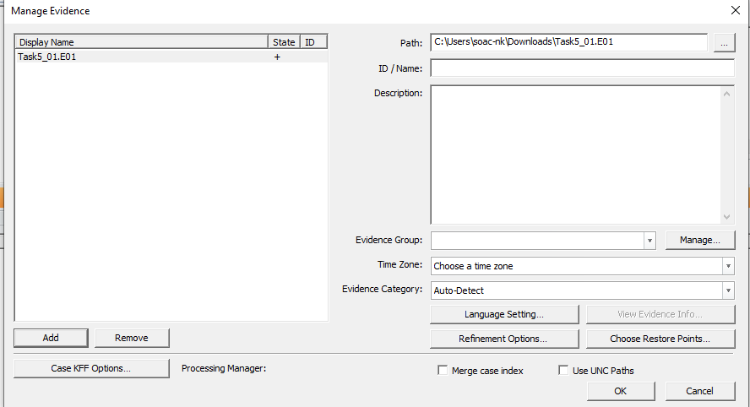

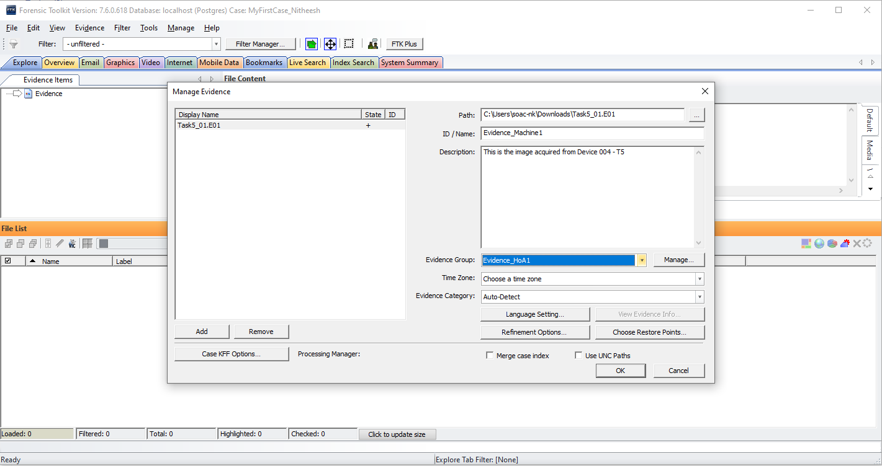

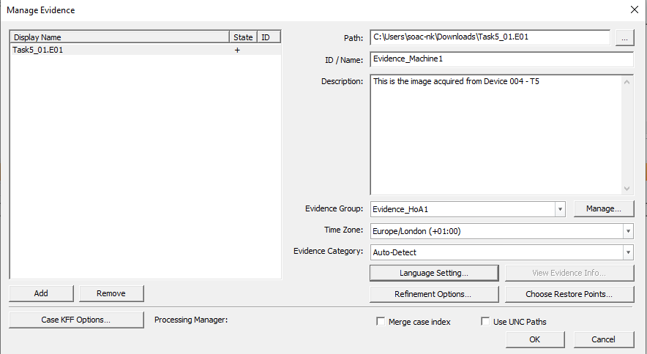
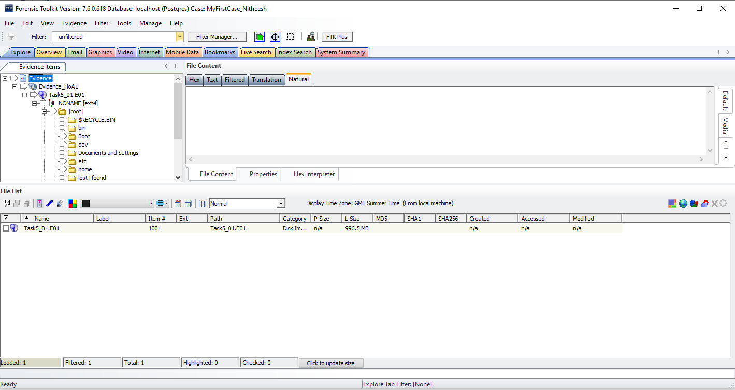

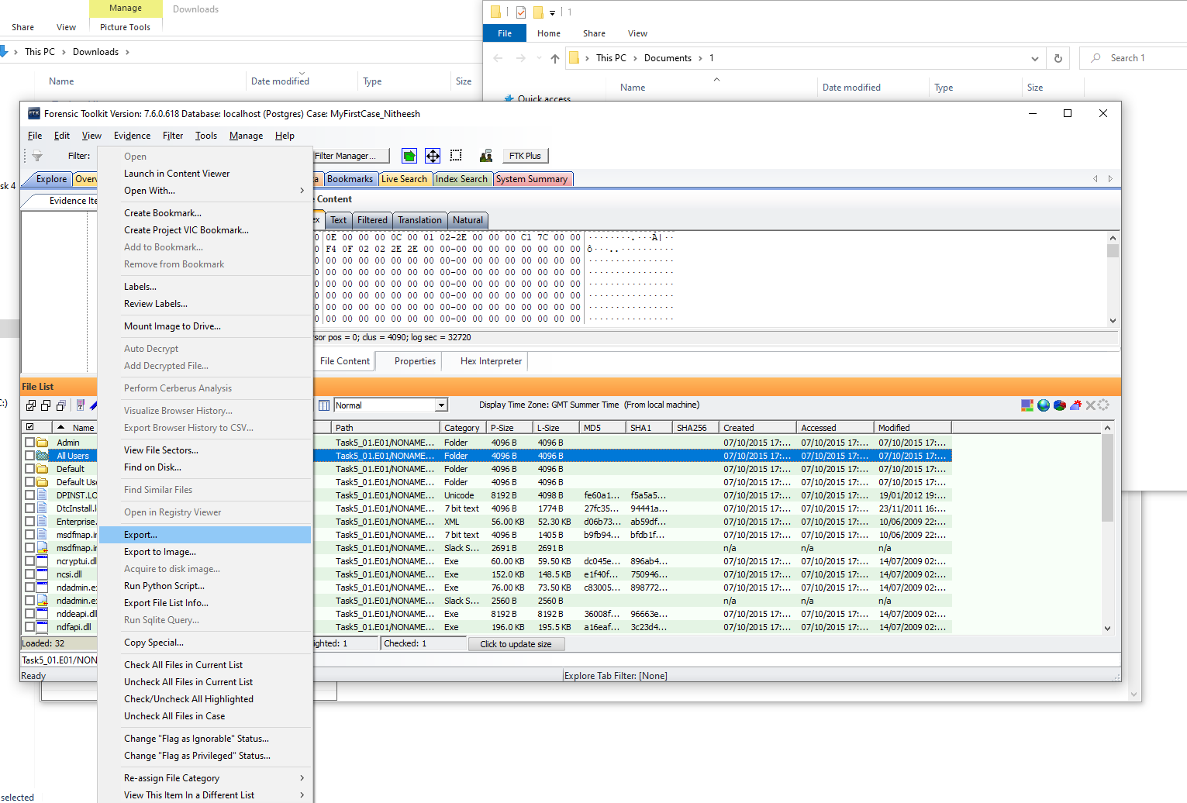

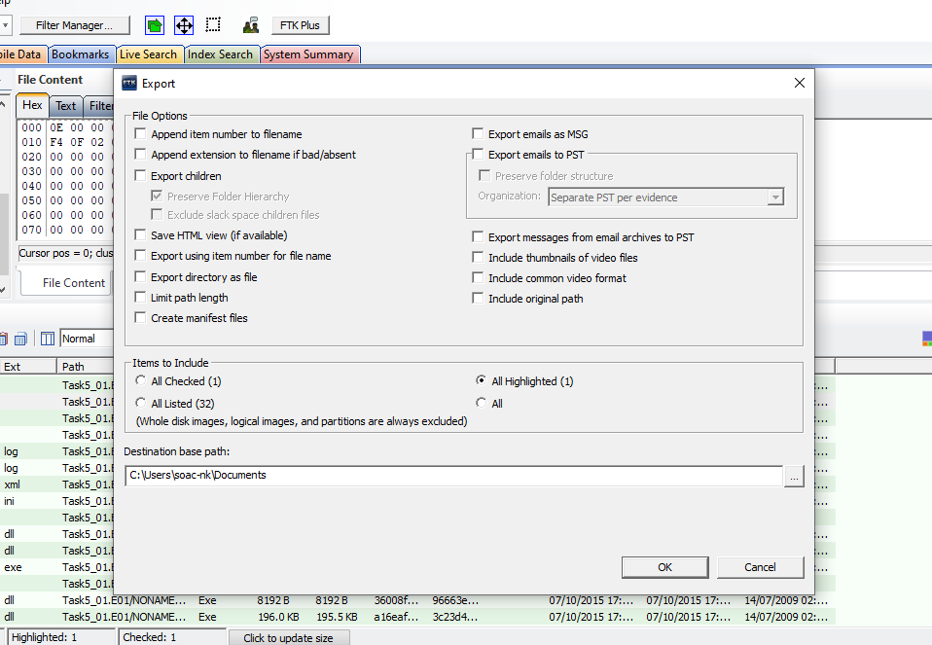
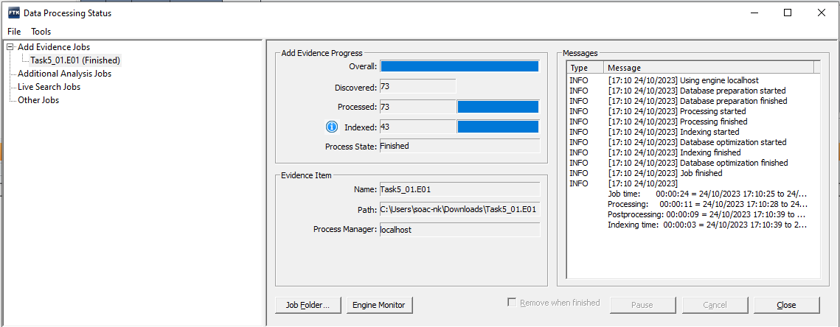

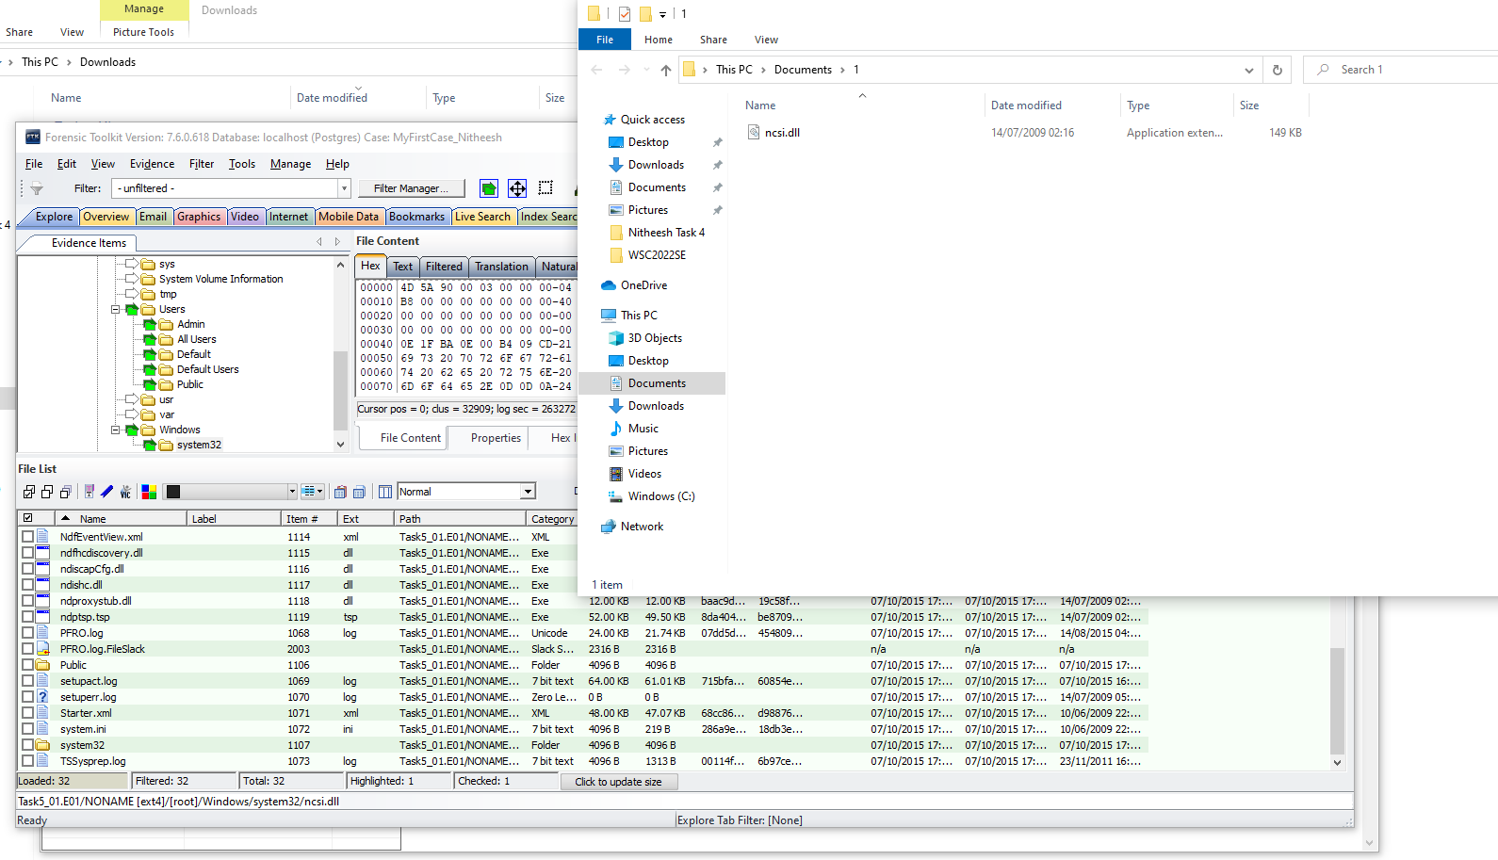
  - Analyse the Image file and try to recover evidences.
    - Download task05_02.E01and create new case. Analyse the evidence.
    - Use other tools to analyse the evidence (task05_01.E01 and task05_02.E01) to find/ gather further more information.
    - Document the steps with screenshots, pros and cons of each tools and additional evidences gathered. (You shall try Autopsy, EnCase etc)
  - From the task05_02.E01 image,
    - Did you manage to recover Microsoft word document? If yes, how many documents?
    - Did you manage to recover exe files? If yes, how many files? And what are the details?
    - Did you manage to recover spreadsheets? If yes, how many documents?
    - Any details you could gather from the collected/ gathered evidences?

Acquired Images:
Folder with Files (EO1/RAW)
Folder with Files (DD)
Overall Reflection
- Understanding on the concepts discussed in the lecture and its relation to the activity done.
- Understanding about various tools used and various frameworks available for DF Investigations.
- Rate yourself: Understanding of Preparation – DF Investigation
-------------------------------------------End of Activity--------------------------------------------

