

Certificate of Higher Education in Skills for the Workplace

Task 2
Professional career development report

Student name: Peter Kristof
Student ID: 2113479

Module name: Professional Career Development
Module code: (BMSW4005_LON)
Lecturer name: Bianca Sanfilippo
Word count: 3003
Submission date: 05/09/2022

Table of Contents
Introduction 3
Recruitment and Selection 3
Description 4
Feelings 5
Evaluation 5
Analysis 5
Conclusion 6
Action Plan 6
Skills and knowledge which contribute toward working effectively 6
Skills 7
Planning and Organizing 7
Delegation 7
Excellent Communication 7
Time Management 8
Leadership 8
Problem-solving 8
Stress tolerance 8
IT skills 8
Team working 9
Knowledge 9
Human rights 1998 9
Health and Safety at work 10
Data Protection 10
Equality act 2010 11
Company Policies 12
Personal strengths and areas for further development 12
Swot Analysis 12
My employment goals and my personal career action plan/development plan 14
My short - medium – long term targets for the development of my professional career plan (using SMART targets) 15
Conclusion 17
References: 17
Appendix 19
Job application form 19
Your details 19
Education and training 19
Certificate of Higher Education in Skills for the Workplace 20
A-Level or equivalent in engineering 20
A-Level or equivalent in mechanic 20
EAL level 2 NVQ certificate in warehousing and storage 20
Employment history 20
Right to work in the UK 23
References 23
Declaration 24
Questions I asked is interviewer: 24

Introduction

This report will be about role play for a job interview I performed in class and my professional development. What is a job interview? The interview is a process where the employer meets the applicant for the job and asks questions to determine if he is the right person for the position (Cambridge Dictionary, 2022). It is very important to be prepared for this process as all jobs require an interview and most people face this process multiple times during their carrier.

Recruitment and Selection
In this personal reflection on the role play will use Gibbs’s reflective cycle model. It was developed by Graham Gibbs in 1988. This model helps people learn from their experiences, especially their mistakes. I choose this model because it suits the best to my writing style. It is divided into six stages:
- Description
- In this stage we detailly describe the situation.
- Feeling
- This stage talk about feelings and thoughts during the experience
- Evaluation
- Looking back objectively and thinking about what did go well and what did not go well
- Analysis
- Making sense of what happened
- Conclusion
- What could you do differently or what skills do you need to develop to handle the situation better
- Action Plan
- What would you do in a similar situation in the future,
(Gibbs' Reflective Cycle, 2020)

(Gibbs' Reflective Cycle, 2020)

Description
In week seven I paired with another student, and we presented the role play for a job interview in front of our lecturer and other students. Originally we were planning to do it one week later but we had to move it because my role play partner was unable to attend on the planned date. In the roleplay, each one of us acts as an interviewer and interviewee for a position we would like to apply for in the future. First I played the role of an interviewee for the Logistic Operation Manager. I was asked multiple questions and tried to answer them to the best of my knowledge. After that, we swapped and was playing the role of the interviewer. I was interviewing my partner for a cyber security role. I asked him five questions he answered and then I thanked him for coming to the interview.

Feelings
I was a bit frustrated as my partner did not notify me about doing the role play until the start of the class. I was a little more nervous as an interviewee but stayed calmer as an interviewer. After a role play, I felt relieved and satisfied with having it done. My partner did not seem to be stressed, he was relaxed during the role play and happy after it. I think other students and the lecturer enjoyed role play. Now I am a bit worried if the role-play was good enough to give us a good grade.

Evaluation
As an interviewee, I answered all the questions but one of my answers was not clear to the interviewer. I had to repeat myself and explain it again for him to understand. It could be because my pronunciation or answer was not clear enough. It would also help me to have questions before the role-play day, so I could prepare better. When acting as the interviewer I tried to keep eye contact and a friendly face to keep the interviewee calm. My partner struggles a bit with one question and it took him some time to answer it. I forgot to mention what position is the interview for and did not tell the interviewee when or how I will contact him about the outcome of the interview.

Analysis
My partner did well, he had enough time to prepare as I sent him the questions two weeks before role play but I did not. If I would get questions in advance the interview would be done on higher standards and without unnecessary frustration. I was still able to do the role play thanks to experiencing interviews as an interviewee and interviewer in the past, but it could be done much better. I was not dressed for the interview and am not fully satisfied with my performance. I should always be ready to reply to any question I may be asked in an interview. Even if I get into an unexpected situation, I should stay calmer and act more professionally. I should also be able to talk about myself, my achievements and my skills when asked.

Conclusion
I learned that preparation is a key to success. If I and my role play partner would be well prepared, we would stay confident and perform better. I need to learn to stay calm in stressful situations and act professionally under the pressure. I should also communicate more with the person I am working with on a task. If I would message him a few days before class I would know we need to do role play on that day. We live far from each other, but we could also do trial interviews using digital technologies. I could also watch some videos about the interviews to be better prepared for the possible questions and to know what I should focus on when answering them.

Action Plan
In the future, I will communicate more with people I work with on given tasks to stay informed about any issues we may face. I will exchange ideas, suggestions and action plans with my team. Before my next interview, I will prepare myself for common questions potential employers may ask me and try to answer them at home in front of the mirror. I will also learn some stress relief techniques that may help me in similar situations. I will be more prepared and that should give me an advantage over other applicants.

Skills and knowledge which contribute toward working effectively

I would like to become a Logistic Operation Manager, to work effectively in this position I need to be aware of the position’s responsibilities. According to Operations Manager Job Description | Indeed (2022), Operations Managers have a lot of different responsibilities. Most important are managing the team of people, performing human resources duties, promoting high morale, ensuring safety rules are followed, creating the forecast, managing the annual budget, and ensuring compliance with law and regulations. To be able to fulfil all responsibilities I am required to have certain skills and knowledge.

Skills
According to Smiljanić (2020) the skills needed to be successful as Operation Manager are planning and organizing, delegation, excellent communication, time management, leadership, problem-solving, stress tolerance, IT skills and team working.

Planning and Organizing
As an operations manager, I will have a lot of different tasks to complete which is why planning and organizing are crucial for this position. I will need to track workload and plan to ensure I and my team can finish all the tasks in a sensitive timeline. To be able to do that I will need to stay organized. I will also plan the forecast and the budget for a year and then organize expenses to meet the budget.

Delegation
I will not be able to complete everything by myself, which is why I will have to master the art of delegation. When working on a project I will need to work with my team and decide who is the best person for each task. I will have to learn the strengths and weaknesses of each team member to ensure they are confident in the task assigned. Thanks to delegating tasks to others I will be able to focus on high-priority tasks. The delegation also builds trust between the team and their manager.

Excellent Communication
I will have to communicate effectively whether I engage with my team members, other managers, or clients. I will meet different personalities so I will have to use written, verbal, and nonverbal communication right to ensure I get messages across to others in the desired form. Communication skills will be most needed when performing human resources responsibilities such as disciplinary or dismissal meetings. Team and individual performance reviews are another responsibility that will require good communication skills.

Time Management
As an Operations Manager, I will be faced with many deadlines that I will have to adhere to, which is why this skill is essential. Missing some of the deadlines could lead to losing customers and damage the future of the business. Managers who master this skill can deliver work on time, provide better customer service, and tend to procrastinate less.

Leadership
Operation managers are working with different teams of people who have different knowledge, technical skills, and personalities, so they need to know how to lead a group of individuals to achieve a common goal. They need to be able to support, motivate and guide people to complete any given task.

Problem-solving
As operation manager, I will face several challenges and obstacles so I will have to know how to identify the problem and provide solutions. Every organization has room for growth and improvement so using correct problem-solving techniques will help me to continuously improve procedures to maximize productivity and company income.

Stress tolerance
Operations managers find themselves in a tense environment very often due to workload, which is why they need to be able to work under pressure and stay calm regardless of the situation. They need to keep in mind they represent the organization so their outburst could have a lot of unwanted consequences. There are several things I could do to reduce stress level when things get tough, such as different relaxation techniques.

IT skills
We live in the digital age, so digital literacy is essential for any management position. Operations managers communicate with team members, other managers, customers, and the senior management team using digital technologies which is why they need to have good IT skills.

Team working
Operations managers can not underestimate the importance of teamwork. They are leaders of the team and work with other teams within the business to achieve a common goal.

Knowledge
To work effectively as Operation Manager, I need to know four main legislations and company policy.
The legislations I need to know are Human rights 1998, Health and Safety at work, Data Protection, and Equality act 2010.

Human rights 1998
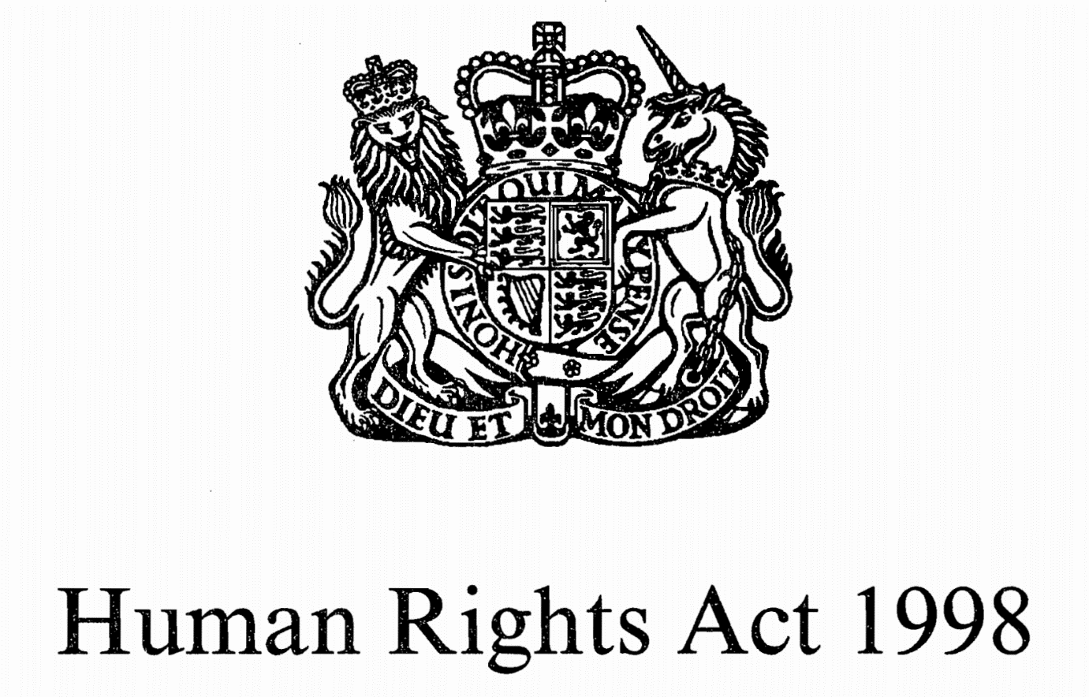
Human Rights Act (1998) is a law that set up rights and freedoms that everyone in the United Kingdom is entitled to. This legislation covers many human rights, such as the right to life, right to freedom from slavery, right to liberty and security, right to a fair trial, right to no punishment without law, right to respect for private and family life, right to freedom of expression, right to education, right to freedom of religion and many more. (Casserley, 2022)
The operations manager needs to be aware of Human Rights Act to ensure all employees have those rights at the workplace.

Health and Safety at work
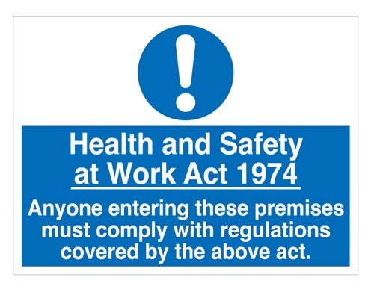
Health and Safety at Work Act (1974) is legislation that covers employer and employee responsibility at work. These responsibilities are ensuring that everyone at work is safe and that the working environment is not affecting the health of employees. (Practitioner, 2017)
The operations manager is the person that enforces Health and Safety at Work by providing proper training and needed personal protective equipment to employees. He should also ensure all the Health and Safety rules are followed.

Data Protection

Data Protection Act (1998) is protecting personal data and information that is in possession of any business, organization or government. It also covers how is this used or shared. (What Is Data Protection | How Does It Affect Your Company?, 2013)
Operations Managers have access to many confidential data of the employees and customers which is why they need to be aware of the Data Protection Act. If any confidential data would leak the company would be facing huge consequences such as an enormous fine or potential loss of customers or even loss of employees’ trust.

Equality act 2010
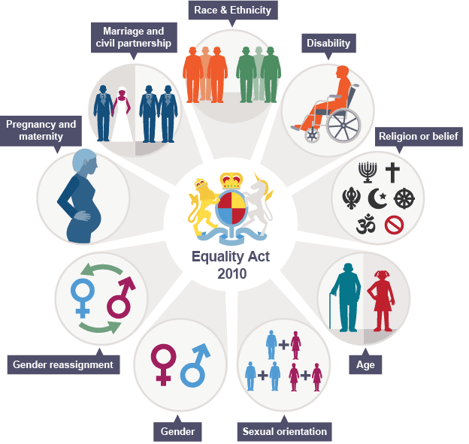
Source : https ://legalresearch.blogs.bris.ac.uk/tag/equality-act-2010/
Equality Act (2010) protects everyone in the United Kingdom from discrimination, harassment and victimisation. It protects nine characteristics:
age, disability, gender reassignment, marriage and civil partnership, pregnancy and maternity, race, religion or belief, sex, and sexual orientation. (Your rights under the Equality Act 2010 | Equality and Human Rights Commission, 2020)
Operation managers need to ensure no one in the company is discriminated against, harassed, or victimised based on these nine characteristics.

Company Policies
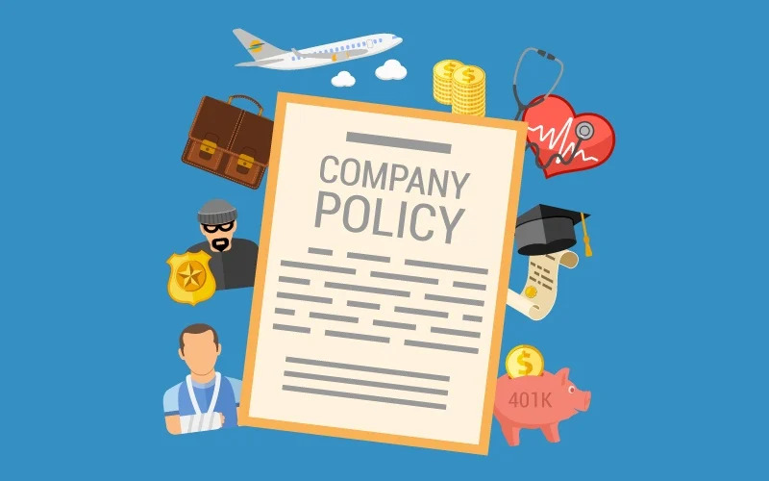
Company Policies establish the rules of conduct outlining the responsibilities of employee and employer. It applies to all employees within an organization regardless of position. Company Policies are unique for each company. (What is Company Policy? | peopleHum, 2022)
Operations managers often lead disciplinary or even dismissal meetings which is why they need to have full knowledge of company policy. Also, they are often the first point of contact if any employee has questions about company policies.

Personal strengths and areas for further development
We all have some strengths and some weaknesses, we also have some opportunities and face some threats. I will use SWOT analysis to break down mine.

Swot Analysis

SWOT ANALYSIS
STRENGTHS  - Experience  - Leadership skill  - Problem-solving and decision-making skills  - Good at planning and organizing  - Time management  - Stress tolerance  - Delegation  - IT skills | WEAKNESSES  - Communication skills  - Knowledge of legislations and company policies
OPPORTUNITIES  - Company that supports my professional development  - Exceptional operation knowledge | THREATS  - Busy period of my life- work, study, building house  - Laziness

My biggest strength is my experience in the supply chain and logistics industry. Other strengths relevant to the position I would like to apply are skills I possess such as leadership skills, problem-solving and decision-making skills, time management skills, and IT skills. I am also very good at planning and organizing, delegating tasks, and I am stress tolerant.
My weaknesses are communication skills and knowledge of legislations I require to have if I want to succeed as an operations manager. I have some knowledge of company policy at this point but I feel like more knowledge and understanding is required.
The opportunity I value most is the company I work for as it is supporting me in my personal and professional development. I am also recognized by the team as a person with exceptional knowledge of operations procedures.
The only two threats I face now is the busy period of my life as I work, study and build the house at the same time and the laziness I sometimes experience.

My employment goals and my personal career action plan/development plan

My professional career pathway is:
Logistic Operations Manager

What are my current strengths?
- Experience
- Leadership skills
- Delegation skills
- Knowledge of operations processes
- IT skills
- Time management skill
- Stress tolerance
What are my achievements and areas of success since the beginning of the module/programme?
- I have been promoted to Operations Supervisor
- I have passed all four modules
In what areas do I need to develop?
- I need to focus on improving my communication skills
- I need to study legislations and company policy
- BC degree in Business and Management

Why is it important to improve in these areas?
- to be successful at my current position and position I would like to apply in the future
- to give me more opportunities within the company

Who will help me? What resources will I need?
- Further study (University, Lecturers)
- Self-educating (study company policies and legislations)

What are the constraints/ barriers to achieving this key and how I will manage these– eg time, resources,
- Time - work on time management to reduce unproductive activities,
- create a daily planner that will help me to stay focused on planned tasks and overcome laziness

What further action do I need to take now?
Actions to be taken – things to do, people to see.
- Apply for level 5 and 6 Business and Management course
- Start studying legislations and company policies

Time scale – by when
- 30th September

My short - medium – long term targets for the development of my professional career plan (using SMART targets)

Short-term plan (3 -6 months)
Specific | - Finish level four course,  - apply for level five and six BC study  - read company policies  - study legislations
Measurable | - get a level four certificate  - application form  - knowledge gain
Achievable | - last two assessment  - student finance  - policies provided by HR  - legislation can be found online
Realistic | - write reports for both modules  - find a course I want to join  - read company policies for thirty minutes during the work  - study two hours a day
Time-Bound | - by 15th September  - by 30th September  - by 31st October  - by 31st October
Medium-term plan (1-2 years)
Specific | - finish study
Measurable | - BC degree
Achievable | - Student Finance
Realistic | - Study two hours a day
Time-Bound | - October 2024
Long-term plan (2-5 years)
Specific | - Operations Manager
Achievable | - Promotion
Realistic | - keep good conduct record  - attendance record  - professionalism at work
Time-Bound | - November 2024

Conclusion

While writing this report I realized my plan to become an Operations manager is achievable if I keep pushing myself and follow my career development plan. Of course, there are some areas for development but if I keep updating SWOT analyses, I will see what I need to focus on to become the best version of myself. Reflecting on situations that did not go well or as good as I expected will help me to learn from the mistakes I made and thanks to that I will be able to avoid the same mistakes in the future. All three combined will guarantee success in my life. Nobody is perfect so there will always be areas for development, but I believe I am ready to face any challenge I may come into my path in the future thanks to the skills and techniques I learned in this module.

References:

Dictionary.cambridge.org. 2022. job interview. [online] Available at: <https://dictionary.cambridge.org/us/dictionary/english/job-interview> [Accessed 10 August 2022].
The University of Edinburgh. 2020. Gibbs' Reflective Cycle. [online] Available at: <https://www.ed.ac.uk/reflection/reflectors-toolkit/reflecting-on-experience/gibbs-reflective-cycle> [Accessed 13 August 2022].
Uk.indeed.com. 2022. Operations Manager Job Description | Indeed. [online] Available at: <https://uk.indeed.com/hire/job-description/operations-manager?gclid=Cj0KCQjwl92XBhC7ARIsAHLl9anh0BRtZKCaVkaQMiHfI-_vorkkkHzs1eISKZCEZM38n0uzkv3LKdwaAmQ8EALw_wcB&aceid=> [Accessed 13 August 2022].
Smiljanić, D., 2020. The Skills You Need to Succeed in Operations Management - Binfire. [online] Binfire. Available at: <https://www.binfire.com/blog/skills-needed-in-operations-management/> [Accessed 15 August 2022].
Casserley, C., 2022. Human Rights Act 1998 | United Kingdom. [online] Encyclopedia Britannica. Available at: <https://www.britannica.com/topic/Human-Rights-Act-1998> [Accessed 20 August 2022].
Practitioner, S., 2017. Health and Safety at Work Act 1974 explained. [online] SHP - Health and Safety News, Legislation, PPE, CPD and Resources. Available at: <https://www.shponline.co.uk/legislation-and-guidance/health-and-safety-at-work-1974/> [Accessed 20 August 2022].
Secure Data MGT. 2013. What Is Data Protection | How Does It Affect Your Company?. [online] Available at: <https://www.securedatamgt.com/blog/data-protection-affect-your-company/> [Accessed 20 August 2022].
Equalityhumanrights.com. 2020. Your rights under the Equality Act 2010 | Equality and Human Rights Commission. [online] Available at: <https://www.equalityhumanrights.com/en/advice-and-guidance/your-rights-under-equality-act-2010> [Accessed 20 August 2022].
peoplehum. 2022. What is Company Policy? | peopleHum. [online] Available at: <https://www.peoplehum.com/glossary/company-policy> [Accessed 20 August 2022].

Appendix

Job application form

Application for Operations Manager

Your details

Name: Peter Kristof

Education and training
Please give details:
University of Wales Trinity Saint David - London
October 2021 to September 2022

Secondary technical school – Presov, Slovakia
September 2016 to June 2018

Secondary technical school – Presov, Slovakia
September 2003 to June 2006

Qualifications
Please give details:

Certificate of Higher Education in Skills for the Workplace

A-Level or equivalent in engineering

A-Level or equivalent in mechanic

EAL level 2 NVQ certificate in warehousing and storage

Employment history

Your current or most recent employer

Name of employer: UPS SCS

Job title: Operations Supervisor

Length of time with employer: 1 year

Reason for leaving: still working on this position, but looking for new challenges

Duties:

- Daily Monitor of inbound and outbound order flows, ensure cut-off times are adhered to, and that all orders which need to depart have been shipped
- Enforcing Health and Safety Policies and adhering to Company Policies and Procedures, timely reporting of accidents, injuries, and other incidents
- Workforce Planning, arranging staff rota and work shift patterns, using system data to build forecasts
- Ensure inventory cycle counting routine is maintained
- Ensure UPS assets and Equipment are deployed effectively and maintained to appropriate standards
- Present customer performance review calls and face-to-face meetings
- Prepare Forecast for warehouse costs ensure these are maintained, and report variances
- Responsible for filling absence forms, return to work and recruitment interviews
- Carry out performance reviews with team members every six months

Previous employers
Please tell us about other jobs you have done and about the skills you used or learned in those jobs.

Operations Team leader- UPS

- Daily transport and distributions operations
- organise, plan, manage and prioritise workload to suit operational requirements.
- Manage the team of 40 staff
- Allocate loading bays for vehicles in accordance with operational deadlines and booking slots.
- Ensure shift members receive, locate, store, pick, load, and despatch goods as per customer operating requirements.
- Assist warehouse supervisors/ managers in investigating any incidents/accidents that occur to reduce their frequency.
- Assist in induction and training of new starters and ensure all warehouse staff are aware of specific customer requirements and procedures.
- Comply with Health and Safety legislation, promoting high standards and acting immediately on hazards and unsafe practices in conjunction with other staff.
In this position I learned:

- organise, plan, manage workload
- to work under pressure
- company procedures and policies
- work under pressure

Operations coordinator- TESCO distribution

- responsible for meeting our targets by working accurately and safely
- making day-to-day operational decisions required in my area
- Complete handover reports for the next shifts
- Report to the team manager any Health and Safety concerns
- Manage a team of up to 70 staff within the Warehouse
- tracking operational figures and running reports
- Issue work to colleagues.

In this position I learned:
- to manage people in my department
- to always ensure work is being done safely and within deadlines
- work in a fast-paced environment
- to work within a large team to achieve common goals
Tesco Distribution- Assembler, FLT driver, Loader/Unloader, Marshaller

- picking/packing
- operating Reach truck/forklift truck, PPT
- loading/unloading/marshalling

In this position I learned:

- to operate various mechanical handling equipment
- to work safely following Health and Safety rules

Supporting statement

Please tell us why you applied for this job and why you think you are the best person for the job.
I applied for this job as I seek advancement and new challenges. I’m a hard-working person with twelve years of experience in the logistics and supply chain industry. I have experienced different positions within the industry and that gives me a better understanding and overview of the overall process. I’m fast learning, self-educating person always thinking of ways to improve and innovate to simplify processes and achieve better performance and lower cost. Development is a core of my drive and I believe in this position I will be able to learn and progress while being beneficial to the company.

Right to work in the UK
Do you need a work permit to work in the UK? Yes

References
Please give the names and contact details of 2 people who we can ask to give you a reference. We may ask them before an employment offer is made. We will not ask your current employer until we get your permission.

John Galambosi- 07731137857
Darren Skofield- 07743354578

Declaration
I confirm that to the best of my knowledge the information I have provided on this form is correct and I accept that providing deliberately false information could result in my dismissal.

Name: Peter Kristof

Signature:

Date: 17/07/2022

Questions I asked as an interviewer:
Tell me about yourself.
What makes you the best candidate for this position?
What would you do if a person in your team is underperforming?
How do you deal with the conflicts at the workplace?
What are your strengths and what are your weaknesses?
How would you motivate other team members?
Have you got any questions?

