BMIH5007 Financial Management for the Hotel Industry

Student Name: Denisa Bildan
Student ID: 1913826

Executive summary
Every business must create financial plans, such as budgets, and the success of a firm or organisation also depends on the production of budgets. This report discusses the importance of budgeting alongside budgeting methods and sustainability by budgeting control. Setting and sticking to a budget is essential for adequately allocating and using available resources. The organisation's objectives can be achieved with the help of a sound financial planning strategy. Incremental, activity-based, value proposition and zero-based budgeting are the four most common or typical approaches for developing a financial plan. Businesses should employ the method that gives them the best returns. Money from customers is considered sustainable if it is greater than or equal to expenses. One of the most crucial things a business can do is adopt a budget that can be sustained very long because it is a guaranteed way to help the business succeed in the long run.
Table of Contents
Executive summary 2
Introduction 4
Analysis of Grand hotel budget planner 4
Importance of Budgeting 5
Different Budgeting Techniques 6
Incremental budgeting 6
Activity-based budgeting 7
Value proposition budgeting 7
Zero-Based Budgeting 7
The Way Budgeting Controls Support Sustainability 8
Conclusion 8
Reference 9
Appendix: 10

Introduction
In any business organisation, stakeholders involved in budgeting must closely connect. Costing and budgeting are inseparable. The economic factors and concerns of a business expand its boundaries. In other words, many companies or businesses are not using the recommended budgeting procedure, which typically combines some financial considerations automatically. For any business or organisation, budgeting is a necessary process, and the fate of the business also depends on the effective budgeting process (Guilding, 2014). Currently, budgeting approaches or systems can differ, and businesses follow the budgeting process that suits them most. Projects' ability to prove their worth and relevance is increasingly a factor in receiving funding. Using budgeting tools to increase organisational efficiency and fulfil the business's operational needs can be done instead of relying on previous data, which can be referred to as 'Zero-based budgeting.' To match businesses' globalisation and adapt to the changing time, businesses or organisations are adopting a Zero-based budgeting strategy (Horner, 2020). This report is focused on Zero-based budgeting, and this budgeting strategy's importance alongside different paths to prepare this budgeting is demonstrated. Besides that, for the long-term sustainability of a business, the importance of that budgeting process is also discussed in that report.

Analysis of Grand hotel budget planner
Revenue for The Grand Hotel was highest in April and June, as seen in the last part of this budget. The higher number of business account payouts during those months was the primary cause. The lowest revenue was generated in July since that was when the smallest quantity of cash was deposited into business accounts. The company received 1915100 pounds in cash and other cash equivalents during the fiscal year under review. Interestingly, while the cash sales stayed steady month after month, the interest income fluctuated widely. Total expenditures followed the budget, amounting to 138,3680 GBP. The payments peaked in December and dropped to their lowest point in the first week. There were many payments made in December. To maximise profits, the hotel minimised its building insurance premiums while increasing staff pay. Much of the hotel's budget went into various payments industry transactions. Costs for meals, drinks, a minibar, transportation, and room rates stood out very high. The most significant monthly net cash inflow occurred in the first month, with the lowest occurring in the seventh. The 638,220 GBP supports the hotel's bullish outlook in net cash flow generated over the period in question. The monthly net cash flow has increased consistently over the past year. It is reassuring evidence that the hotel will keep bringing in money in future years. With no hitches, management put the budget into action. The hotel was able to maximise profits while minimising expenditures. Finally, this ensured that the hotel had turned a profit.

Importance of Budgeting
"Budgeting" is the process of making and sticking to a plan to reduce spending and increase income within a given time frame (Atrill and Mclaney, 2007). In this process, a business or organisation decides its inflow and outflow of money and creates a blueprint. It is a crucial skill for any business funder, manager, or administrator as it can help a business organisation spend its money precisely and flawlessly, ensuring the highest utilisation of its resources. The importance of budgeting is given below:
- Resources availabilities are ensured: One of the prime purposes of budgeting is to ensure an organisation has enough cash or funds to attain its objectives (Becker et al., 2016). By using budgeting, a business can identify its spending sectors and wisely spend it to save money that can be used later.
- Internally goal-setting and progress reporting are supported: Budgeting estimates how much money needs to be spent to achieve its goals. For achieving financial or business goals, effective budgeting plays a crucial role. Without an activity-based spending plan, this is a fantastic procedure also. A business's financial sections should be dictated by the financial goals as the goal and spending are interlinked (Horner, 2020). A business's staff or members can learn about accomplishments and plans for the future with the aid of budgeting. Budgeting helps achieve objectives and provides insight into an organisation's proper performance.
- Prioritizations of project benefits; For developing a budget, a business has to prioritise its projects based on their importance and returns. The manager has to identify the returns of each project and if the projects match the organisational values and their impact on financial objectives (Gross, 2020). The value proposition budgeting strategy could prove helpful in prioritising work and significant projects by determining and defending each item's value.
- Achieving opportunities: For any business organisation, it is essential to have detailed financial records as a business's internal and external stakeholders might require a detailed report about transactions. Any investor needs to get a financial performance history which helps him decide if he should invest or not. The capacity to manage business finances, resources allocation, and implement adjustments as necessary can be demonstrated through documentation showing planned and actual spending from past periods (Seal, 2015). Investors might want to look at the current budget to predict or understand a business's future planning or performance.
- Adaptable strategy offerings: A business's expenses and incomes generating forecasts are illustrated by budgeting. Various uncontrollable factors can affect this process of budgeting (Batt et al., 2021), as the coronavirus pandemic is one of the uncontrollable forces that forced businesses to invalidate their previous budgeting. Because of travel restrictions and lockdowns caused unforeseen consequences that are economical. Executives made swift but astute budget adjustments despite significant losses and security concerns. Executives are making changes to budgeting procedures to make it easier to switch gears. According to McKinsey, zero-based budgeting is becoming more common as businesses try to determine how much capital they require to remain operational.

Different Budgeting Techniques

Incremental budgeting
This type of budgeting is prepared by using previous budgets or the level of performance of starting point, and minor incremental adjustments are made. This is often accomplished by spending the allocated cash from the previous year after adjusting for inflation. Standard practice in incremental budgeting calls for factoring in inflation as a means of rebalancing. Some organisations or businesses examine items of budget line elements differently (Tucker, 2019). In this budgeting, spending is not analysed and adjusted for the next month, which is different from Zero-based budgeting. However, income and spending are reviewed in that budgeting system. Minor adjustments to the budget are often disregarded because of their seeming lack of importance. However, preceding periods' budget modifications must be considered carefully (Jens Hutzschenreuter, 2009). Nevertheless, the spending is not justified and analysed in that budgeting system which is the main difference between the Zero-based budgeting system.

Activity-based budgeting
In this budgeting system, the costs or spending of a business or organisation are recorded alongside analysing by which the organisation can improve its efficiency. A financial plan can be prepared by analysing cost results (Cooper and Slagmulder, 2019). While it may include additional computations, activity-based budgeting is a more comprehensive approach to financial planning than traditional budgeting. In this context, budgeting means more than just keeping track of expenses and making necessary adjustments for things like inflation. As an alternative, it aims to reduce expenses and improve efficiency. For example, if a business organisation wants to achieve £1000 in sales, the business has to calculate the expenses linked with the selling process's steps.

Value proposition budgeting
A planner who creates value proposition budgeting needs to think about the following aspects:
- Where does this money spend in the budget, and what is it used for?
- Can it be said that this item benefits the consumer, the worker, or the stakeholder?
- Is it worth spending money on that item? If not, is there any other explanation for such a high price tag?
To ensure that all planned expenditures help the business, it is essential to approach budgeting with a value proposition perspective(Atrill and Mclaney, 2007). Zero-based budgeting and value proposition budgeting are utilised to reduce unnecessary expenditures.

Zero Based Budgeting
With a zero-based budgeting technique, every money spent must be explained. Zero-based budgeting refers to the method of assessing a business's outlays and intake by starting with "zero." The costs are broken down into distinct groups and assessed based on historical results and future projections (Pyhrr, 2019). With this help, the management can allocate funds according to the requirements instead of past levels. In 1970 this method was first developed by Peter Phrr. Justifications for managers' operations need to be explained with this zero-based budgeting system. Otherwise, the management will not accept or grant the budget. Managers deserve recognition for the work they do. Wasteful money and time would be cut with a zero-based budget. The zero-based budgeting method provides a better likelihood of using available resources than other budgeting approaches, such as the progressive method.

The Way Budgeting Controls Support Sustainability
When the amount collected from customers exceeds or is equal to the amount spent, the budget is said to be sustainable. Either past figures or forecasts of future income and expenses could be factored in. Only by delegating budgetary authority to individual managers can the budget be managed efficiently. Managers checked spending against budget estimates to ensure money was being spent wisely (Bui and De Villiers, 2017). The long-term expenditure plan is then revised to conform to the revised forecast. Corporations operate independently from the government and are organised primarily to generate financial gain. There is no way to stay in business without turning a profit. The ability to foresee potential outcomes significantly impacts the quality of decisions. A scenario's result can be influenced by including assumptions and forecasts like these. If a scenario includes financial information, then a budget has been made. Making a budget is like constructing a financial simulator for a business (Atrill and Mclaney, 2007). The company's financial and other resources can be maximised through budgeting, too. Company and regional budgets display a wide variety of spending patterns. Several industries, such as manufacturing, distribution, aviation, construction, and hospitality, have vastly different approaches to budgeting. In light of this, stringent budgeting may aid a company's efforts toward sustainability if its management is serious about this issue.

Conclusion
Budgeting is a prime factor for any business; thus, the business must conduct or create a sound budget. Any business or organisation can sustain itself in the long run. Zero-based budgeting system is also used widely. Budget makers need to know various importance of the budgeting systems to ensure sound budgeting.

Reference
Atrill, P. and Mclaney, E., 2007. Management Accounting for Decision Makers. Harlow, Essex Pearson Education.
Batt, C.E., Rikhardsson, P. and Karlsson, T., 2021. Exploring the impact of organisational context on budgeting. Corporate Ownership and Control, 18(4), pp.134-151.
Becker, S.D., Mahlendorf, M.D., Schäffer, U. and Thaten, M., 2016. Budgeting in times of economic crisis. Contemporary Accounting Research, 33(4), pp.1489-1517.
Bui, B. and De Villiers, C., 2017. Management control systems to support sustainability and integrated reporting. Sustainability accounting and integrated reporting, pp.121-148.
Cooper, R. and Slagmulder, R., 2019. Activity-based budgeting--part 1. Strategic Finance, 82(3), pp.85-85.
Gross, M.J., 2020. The Importance of Budgeting. Social Administration: Managing finances, personnel, and information in human services, 1, p.11.
Building, C., 2014. Accounting Essentials for Hospitality Managers. London; New York: Routledge.
Horner, D., 2020. Accounting for Non-Accountants. 1st ed. Kogan Page Publishers.
Jens Hutzschenreuter, 2009. Management Control in Small and Medium-Sized Enterprises. Springer Science & Business Media.
Pyhrr, P.A., 2019. Zero‐Based Budgeting. Handbook of budgeting, pp.677-696.
Seal, W., 2015. Management Accounting. Maidenhead: Mcgraw-Hill Education.
Tucker, H.J., 2019. Incremental budgeting: Myth or model? Western Political Quarterly, 35(3), pp.327-338.

Appendix:
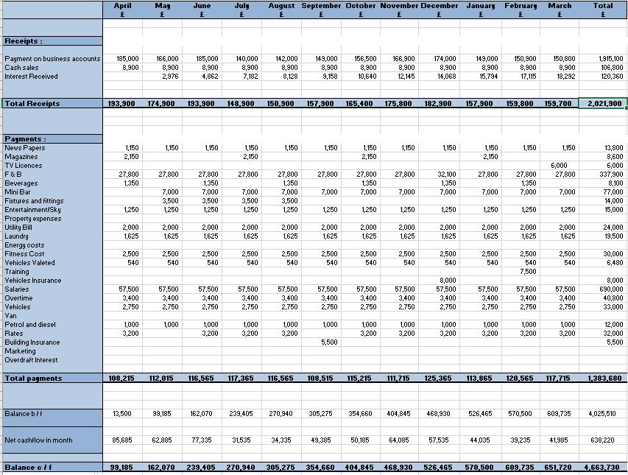
Figure 1: Grand Hotel Budget
Source: (Author’s Construct)

