When in Beijing or Dubai
Rhodri Stranaghan
19th November 2018

Terms of Reference
A report submitted as a requirement of the International Tourism Management Intercultural Communications Course M5X02108 at the University of Wales Trinity Saint David, Swansea.

Table of contents
Introduction
The United Arab Emirates and China are two Asian countries, who see things differently to ‘westerners’ so this must be considered prior to a business meeting between an American and people from either of these countries, to prevent any unsuccessful negotiations and breakdowns of communications and ensure that the trip can be deemed a success. The briefing paper will introduce the reader to Hofstede’s Six Dimensions of Culture theory, as well as Halls high and low context cultures theory to inform and prepare an American who is Head of Marketing of TBG Tours Ltd ready for their upcoming business trip, looking at the cultural differences and business codes of both countries as well as make recommendations on how to react to certain things such as gifts, gestures and invitations. Various methods will be used in addition to the theories aforementioned, extensive research of key theorists with a main focus on Hofstede, online journal articles, newspaper articles and books as well as lecturers notes and slides will be used to complete the briefing paper.
Results;
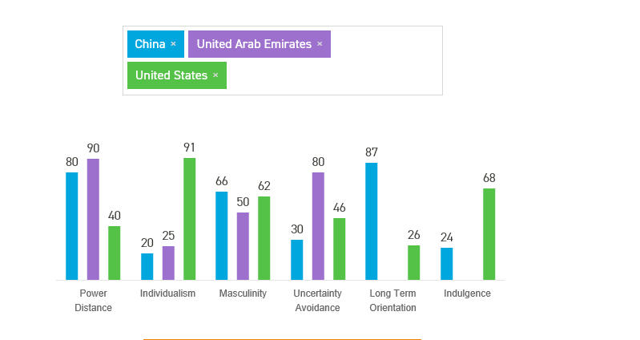
R1 (Hofstede 2018)
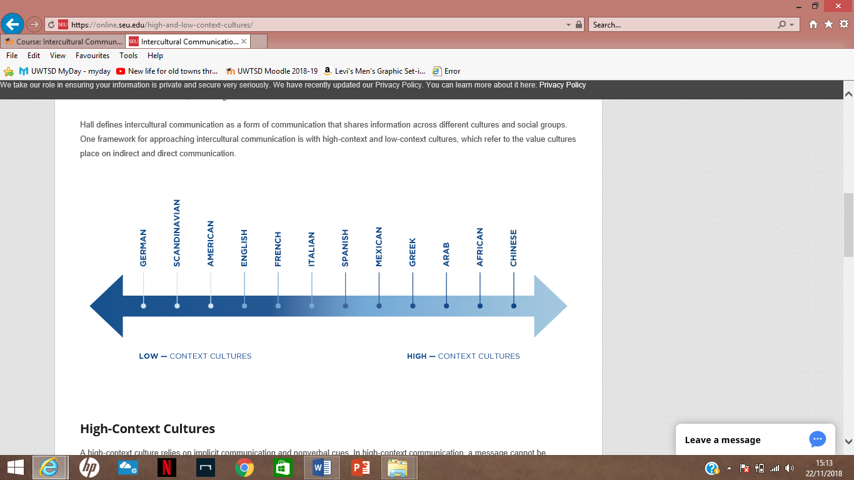
R2

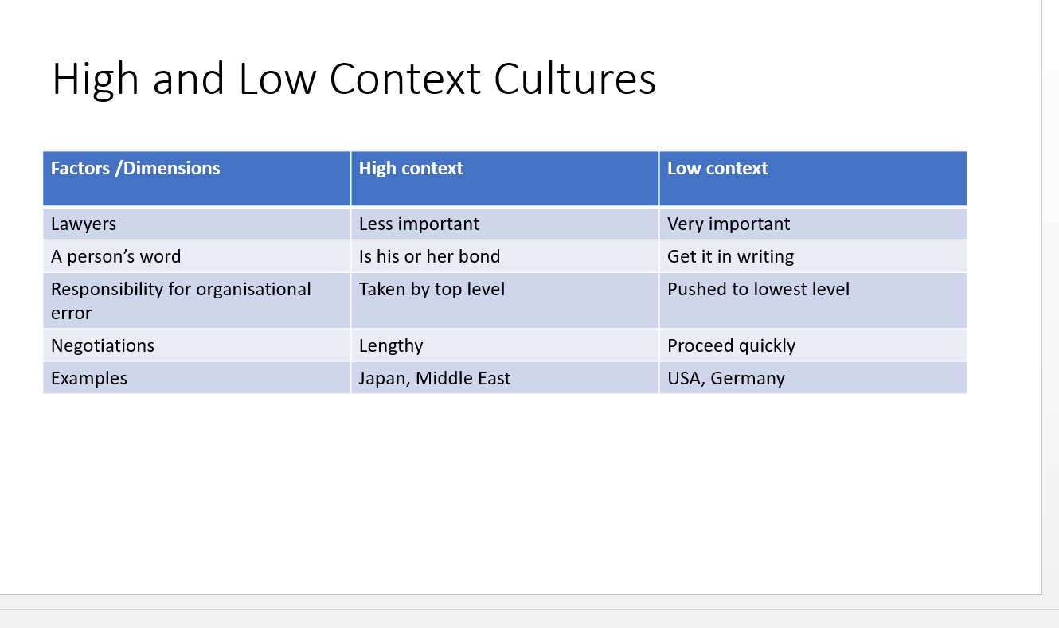
Figure 3;
(Jawad, C 2018)
Figure 4;
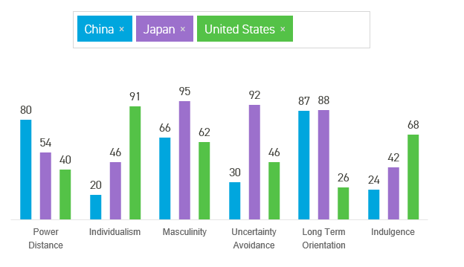
(Hofstede 2018)

Main Body/Discussion
Important Considerations Prior to the trip-
Culture Custom-
Having an understanding of the difference in culture, also known as cultural awareness is very important before going on these trips, to ensure that there is nothing in which can be deemed fine in America however considered insulting in either China or the United Arab Emirates.
Countries such as China who’s dealings are more orientated towards good faith as the priority in business will perhaps not align so well with the western way of closing a deal, as the Chinese might be less concerned with the nuance of contract language or with identifying and spelling out the consequences of all eventualities in a written agreement (Kim & Sharpe 2017). It is vital for American businessmen to have an understanding of the numerous social, cultural, and economic differences they will face when they attempt to do business in foreign countries. (Hall 1959)

China-

Cultural differences in China-
The dimensions of culture were devised by Hofstede and gives a good insight in to the cultures of different places.
Power Distance is the extent of power equality in society. As can be seen in (Figure 1), the power distance results between China and the USA are very dissimilar, and at 80 China are at the top of the scale, this shows us that they as a society believe that inequalities amongst people are acceptable. Superiors there will not challenge the power distance, and workers are influenced by authority and sanctions, and people should not set their sights higher than their level already. (Hofstede & Hofstede).
Individualism versus Collectivism
In Individualist cultures people are characteristically meant to to look after themselves and their closest family members. Collectivist cultures in contrast are where people are integrated into strong groups from a younger age where everyone looks after one another, there can often be a divide in an organisations between in groups but their loyalties are important. As figure 2 shows, China are low on individualism, which again differs to America who score 91. The difference must be recognised as the Chinese will be wary of any businessmen from the United States potentially being only in to for themselves.
Hofstede found that wealthy countries had higher individualism scores and poorer countries had higher collectivism score. (Jawad 2018)
Femininity versus Masculinity
Masculinity as explained by Hofstede & Hofstede (2005) relates to being driven and more competitive in nature, and that all effort is placed on being the best (Moran, 2014). The results for (figure 1) show that both China and the United States are considered quite masculine with 66 and 62 respectively. However the results aren’t as high as and so there will be a competitive edge in business which should be noted. Femininity on the other hand, consists of having both men and women are supposed to be modest, tender, and concerned with the quality of life. (Hofstede 2001)

Uncertainty Avoidance-
Uncertainty Avoidance can be expressed through stress, wanting things to be set in stone and clear amongst other things. As can be seen in (Figure 4), China with 36 are quite low on uncertainty avoidance meaning they are less liable to anxiety in the work place and have little job stress, this is in contrast to Japan who are high and score 92, whilst United States are also like China score quite low with 46. This shows China and America are quite similar in having less stress dependent on work which means less worry will go in to negotiations on one’s personal wellbeing other than getting the job done. There is high tolerance for doubt in structures and procedures in low uncertainty organisations and countries. (Ohlsson & Odelj 2006). High uncertainty orientated countries tend to have a high need for security as well as a strong belief in experts & their knowledge and would rather work for bigger organisations where they feel safer. (Jawad 2018).

Long Term Orientation
As shown in (Figure 1) Hofstede’s long term orientation predominantly focuses on long term achievement in goals, relationship building and persistency to get things done. As expected, China rank very high on the scale for Long Term Orientation with 87 whilst America score 26.
Having a short term orientation as opposed to long term means that the goals are shorter. As well as this, short term orientation stands for a society of traits and virtues related to the past and the present, like national pride, respect for culture and traditions as well as fulfilling social obligations. (Hofstede 2015)
Indulgence
China are quite low when it comes to indulgence in comparison with America which can be seen in (Figure 1). In indulgent cultures such as America the expectation is that, for one example customer service staff visibly exhibit their ‘happiness’ with smiles and friendly behaviour. In more restrained cultures such as China and Russia, this would be considered inappropriate an unnatural (MacLachlan 2013).
Business Code and Conduct- China
Introduction – Meetings in China are often arranged in advance, however it is not uncommon to not be given conformation about a meeting until. It is normal to wait anxiously until the last minute for confirmation. Chinese businessmen often prefer waiting until a few days before or even the day of the meeting to confirm the time and place. Upon greeting, it is also important for the host to initiate it, and a gentle handshake is deemed acceptable. It is also important to make a point of learning a few words and phrases in Chinese, as the host will appreciate the effort. (Penzner 2006). Chinese people tend to dislike touching and see pointing as rude as well as a firm handshake, which in some cultures is deemed as normal. (Moran, 2014).
Gifts and Business Cards – As Penzner (2006) states, gifts, should be avoided on a personal level and should be from business to business, and anything with certain colours like blue and black should be exempt. It is also important that all businesses cards given out are reciprocated and in English on one side and Mandarin on the other, and in gold.
Negotiations –
As (Graham & Lam 2003) state, during a formal negotiations setting, only native Chinese speakers can read the facial expressions and body languages of the Chinese negotiators, so it might be of interest to hire an interpreter. However this could potentially show weakness in oneself to be able to negotiate without assistance.
Communication
One theory in which conveys communication in culture well is Hall’s high / low context cultures theory. China is on the high end of the scale which can be seen (Figure 2), along with American being on the opposite end. (Figure 3) exemplifies how certain factors of communication in business contrast between high and low context cultures. For example, lawyers are more important in low context cultures, a person’s word needs to be put in writing and negotiations need to be done as quickly as possible.

United Arab Emirates
In the Arab world, once a man's word is given in a particular kind of way, it is just as binding, if not more so, than most of our written contracts. The written contract, therefore, violates the Moslem's sensitivities and reflects on his honour. (Hall, 1959)
Power Distance
Power Distance in the United Arab Emirates is exceedingly high at 90 as figure 1 shows, and so a hierarchical outlook is accepted, and people should definitely obey their superiors. A power struggle could arise with an American who may feel they are being treated as second best.
Individualism versus Collectivism-
The United Arab Emirates can be deemed a collectivist society scoring just 25, similar to China, whilst America are on the other end of the scale. Loyalty comes before everything and subsequently overrides societal rules and regulations (Hofstede & Hofstede). However, (Khelifa 2010) states that Islamic and Emirati people are now picking up some ‘western’ values such as independence and freedom which indicates a big change in the culture of the country.
Masculinity versus Femininity -
This is somewhere which differs from societies perception as the United Arab Emirates scores low on masculinity with a score of 50 (Figure 1) whilst the United States are slightly higher with 62. The United Arab Emirates can be considered neither masculine nor feminine (Hofstede). This is not likely to impact the deal as both countries in this aspect are similar.

Uncertainty Avoidance-
The United Arab Emirates score 80 on Hofstede’s uncertainty avoidance dimension. Countries with higher scores indicate risk aversion cultures, while lower scores indicate risk taking cultures (Hancıoğlu et al 2014). They prefer to avoid uncertainty, so for a meeting with an Emirati it must be noted that they prefer to know exactly what’s happening and where, all the little details.
Criticisms of Hofstede
There are various criticisms of Hofstede’s work and his dimensions. During the time of the survey Europe had not long before been disturbed by World War II, this means that the Uncertainty avoidance was high. In addition, some researchers have questioned Hofstede’s research as being outdated. (Shaiq 2011).
Despite some criticisms of his research, Hofstede’s model has proven to be robust and has been the basis for many subsequent cross-cultural studies. (Willeymns 2008)

United Arab Emirates Business Code of Conduct
Introductions-
Business meetings in Dubai are similar to western ways, this is due to the amount of expatriates there, although the language spoken there is Arabic to the locals, many speak English and so learning a few phrases in Arabic will not harm the negotiations. The business attire in Dubai is quite formal. For women, they should dress modestly and should keep arms and legs covered. It is not necessary to wear traditional Muslim clothing, however, local businessmen may choose to wear may wear a dishdasha if they see fit.

Gifts and business cards-
Similar to the Chinese business etiquette, gifts are not a necessity and if giving a gift ensure, it must be a small token with personal significance.
Communication-
Halls high and low context cultures theory shows Arabian people quite high on the scale.
Conclusion

Appendicies

Bibliography
Kim, J & Sharpe, Z. (2017). Culture, Contracts, and Performance. Dispute Resolution Journal. 72 (1), p8.
Hall, E. T (1959). The Silent Language. 3rd ed. New York: Doubleday. P88-92.
https://online.seu.edu/high-and-low-context-cultures/
Jawad, C 2018, Seminar 4: Intercultural Communications: Hofstede 2 lecture slide notes, International Travel & Tourism Management, M5X02108, University of Wales Trinity Saint David, delivered 18th October 2018.
https://www.hofstede-insights.com/
Moran, T.R. & Abramson, N. R. & Moran, S.V. (2014) Managing Cultural Differences. 9th Ed
Maclachlan, M. (2013). Indulgence vs. Restraint – the 6th Dimension. Available: https://www.communicaid.com/cross-cultural-training/blog/indulgence-vs-restraint-6th-dimension/. Last accessed 25th Nov 2018.ition. London and New York: Routledge.

Hofstede, G (2001). Culture Consequences. Thousand Oaks, CA: Sage. p297.
https://www.hofstede-insights.com/product/compare-countries/
Ohlsson, C & Ondelj, S. (2006). What happens with company culture when high and low masculine cultures merge. Kristianstad University . 1 (1), 26.
Hofstede, G (2015) ‘Long versus short term orientation in 10 minutes’. (PowerPoint Presentation https://geerthofstede.com). Available at- https://www.google.co.uk/url?sa=t&rct=j&q=&esrc=s&source=web&cd=14&ved=2ahUKEwiTpaHMovDeAhXMLMAKHbSuAnsQFjANegQIBxAC&url=https%3A%2F%2Fgeerthofstede.com%2Fwp-content%2Fuploads%2F2016%2F08%2FLong-Short-Term-Orientation-in-10-minutes-2015-09-05.pptx&usg=AOvVaw1dpL-iLa6cP6KZcRwBMN3Y Accessed 25th Nov 2018.
Penzner, B. (2006). The Art of Chinese Business Etiquette: Ancient traditions form the basis of strategy. AFP Exchange. 26 (4), p61-63.
Graham, J.L. and Lam, N.M., 2003. The Chinese negotiation. Harvard business review, 81(10), pp.82-91.
Khelifa, M. (2010). Trading Culture: Have Western-Educated Emirati Females Gone Western?. OIDA Journal of Sutainable Development. 1 (3), p19-29.
Willemyns, M. (2008). The rapid transformation of emirati managers' values in the United Arab emirates. Proceedings of the Academy. 1 (1), 4.
Hancıoğlu, Y & Dogan, B. U. & Yildinm, S.S. (2014). Relationship between Uncertainty Avoidance Culture, Entrepreneurial Activity and Economic Development. Procedia- Social and Behavioral Sciences. 150 (4), p 908-916.
Shaiq, H.M.A & Khalid, H.M.S. (2011). Why not everybody loves Hofstede? What are the alternatives? European Journal of Business and Management. 3 (6), p- 103-104.

