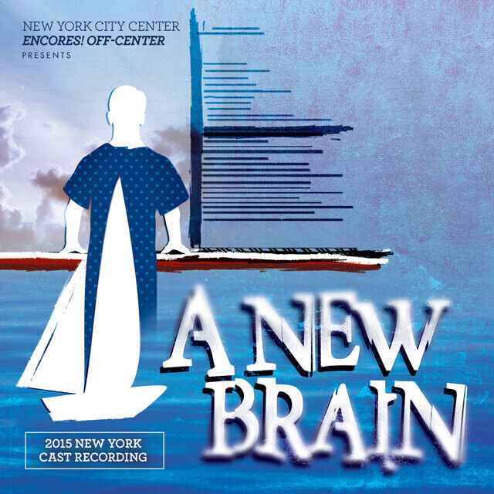
Process Journal 3

Tom Waters
Student Number: 2004105
Module: Production 1

Tech Rehearsals
Tech rehearsals, the final stage, where we work with the set, costumes, lights and sound. The performance was taking place on a raised platform, so for health and safety reasons we spent time blocking any movement, in particular when using our large prop, a hospital bed. Additionally, we had access to the full thrust of platforms so we were able to rework anything that needed it. Previous changes meant we were now all working on the same level, so we focused on sightlines. Sight lines in theatre are very important especially when working in the style pf thrust. “Essentially, sight lines refer to what your audience sees on-stage. If you haven’t thought about sight lines, chances are view from particular seats will be blocked by other theatregoers, the set or technical equipment” (Speciality Theatre, 2013) Due to theatre being a visual experience it is important that we spent a lot of time altering any positions to enable the sight lines to be better received by the audience.
The remainder of tech rehearsals focused vastly on lighting and running each number allowing time for the lighting designer to experiment. This also gave us as a cast a chance to get used to the space and experimenting with quick changes, handling props and exits and entrances. Personally, the process of blocking the lights was very long and involved a lot of waiting around, however I did appreciate it’s importance as every number in the show had much going on and most scenes relied heavily on a specific area being lit for the performance to be effective. I spent the time productively, ensuring I was secure in my lines and choreography. I was also glad I had this time to plan my quick changes and entrances before the dress run.

Dress Run
Personally, I found the dress run to be very important to the process. I feel even though we had rehearsed so much over the past few weeks and worked out all the props and costumes etc. during tech. I found that this was really the first time where we as a whole team could see what we ha produced and whether the show worked as a whole with all the new factors and elements.
I performed well during the dress run with no struggles or mistakes throughout. I became more connected to the character and the relationship between myself and Gordon on stage was one of the best it has been in my opinion. I feel everyone really stepped up and no one really crumbled under the pressure so I was extremely proud of myself and the rest of the team. During the tech rehearsals I was given the slight note to revisit the music tracks for one of my songs due to me not quite getting the melody as it is sung very quickly. Perfecting this ensured I felt very prepared and excited for the performances to be watched by the audience.
Notes taken by Luke and Tori, heavily involved sightlines for myself as I had to face Gordon on the bed for much of the time and I also had to rework some numbers and blocking so that I could be seen on both sides rather than one side only seeing my back for an entire number.
Before the dress run, we were each given a point of focus by Luke. Luke explained that new thoughts and stimulants could affect our performance so we used these points of focus throughout the dress run to see if it had an impact on the character and their relationships with one another. To propose to Gordon, my focus, made my whole connection with Gordon so truthful and the need to be with him was much more present for me. As a whole I just felt the love I had for Gordon felt purer and I was excited to hear from the team watching that they really felt and related to the connection we had with one another. I found this whole technique really interesting as I feel I am so used to working only with Given Circumstances which “are the situational and environmental circumstances affecting the life of the character that are thrust upon, or given to, the character by the script.” (Tannenbaum, Acting Magazine) Therefore, it was nice to not only have these given circumstances but also given something new to think about that we would not have got from the script.

Performances
Overall, I am so happy with how the final performances went. I feel the first show there was a slight decrease in energy levels in a few of us due to nerves and tiredness however I made sure to perform as best as I possible and really experiment with the character. Additionally, it was really nice to have the interaction with audience as if a joke was made in the show, we were used to not having a response and we found there were certain points that the audience also found funny which we weren’t expecting so I found it very refreshing.
In my opinion, each show kept getting better and better, and even with a smaller audience on the matinee performance we all still treated the performance as if we had a full house. The choreographer Tori gave me some advice, that even though we know this show the audience does not, so each performance is going to consist of people seeing it for the first time so every time we perform it needs to have that same energy and drive. This is something I really found helpful and it really gave me a push to give the small audience the same treatment. I feel it is something that will drive me in performances in the future.
For each show Luke continued with the theme of giving us a new point of focus so we were not just trying to recreate our last performance but each one would be based on new impulses and emotions that would change the relationships and their importance throughout the shows. The points of focus I received in my shows were, I had been sleeping with someone else for a few months, I no longer wanted to live in New York and my previous boyfriend passed away from a brain injury. Using these focuses made each performance different for me, especially during the emotional stropped back songs where in my head I found myself asking many questions and feeling confused as not having the answers. This really a brought out a truthfulness to my performance that I had not yet discovered. I strongly believe that points of focus have a drastic impact on the mind-set of a character and the actor portraying them so I will be using the technique in any future shows and performances. I was very wary about trying it to begin with, however after seeing the effects it had on me and my performance it clearly works and is something I will keep in my toolkit for my future.
Overall, I feel I really brought the character of Roger to life and my real understanding of the character and his life story really allowed me to preform in such a natural truthful manner. The connections I made with my fellow actors on stage were so beautiful and present, I couldn’t have asked for a better journey to have in this show. All the notes and long rehearsals really paid off and I found myself being able to not worry too much about singing the right note or doing the correct steps but be confident and really enjoy it and have fun with an amazing group of people who came together to produce a really special piece of theatre backed by an amazing team.

Bibliography

Importance of sight lines- A must know. (2013) Speciality Theatre
Available at: https://specialtytheatre.com/what-are-sight-lines-and-why-do-they-matter/
(Accessed on: 29th May 2022)

Tannenbaum. T, What are the Given Circumstances? Acting Magazine
Available at: https://actingmagazine.com/2019/01/what-are-the-given-circumstances/#:~:text=The%20%E2%80%9Cgiven%20circumstances%E2%80%9D%2C%20in,the%20character%20by%20the%20script.
(Accessed on: 29th May 2022)

