DS 1 Template – 2620189 - Marsha Forde

My Screenshots/Photos
- Please add 4–6 screenshots or photos of your digital life.
- You can use your phone or laptop.
- For each screenshot, write one or two sentences explaining what it shows.

Screenshot/Photo 1
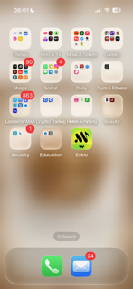
This is my home screen. I have to come through this screen to get to all my apps and folders. From here I can navigate my way through my mobile apps that I use daily. I have organised my home screen into categories, so it is easier and faster for me to find specific applications.

My Waze App
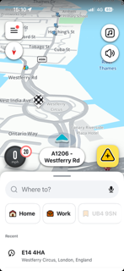
This is an application called WAZEs. I use this for travel directions by following the map. Here it shows my use of the app to navigate my way to university. I use this application on a daily basis helping me to travel with directions to places I do not know how to get to. I also use it for the driving features like traffic update and red light and speed camera Google maps because i think this app is better and have more features.

My Fashion Nova App

This is a screenshot of an app that I use to purchase clothes or scroll through looking for clothing to buy. This app helps me to navigate through its pages selecting, saving and purchasing items.

My Social App - Snapchat
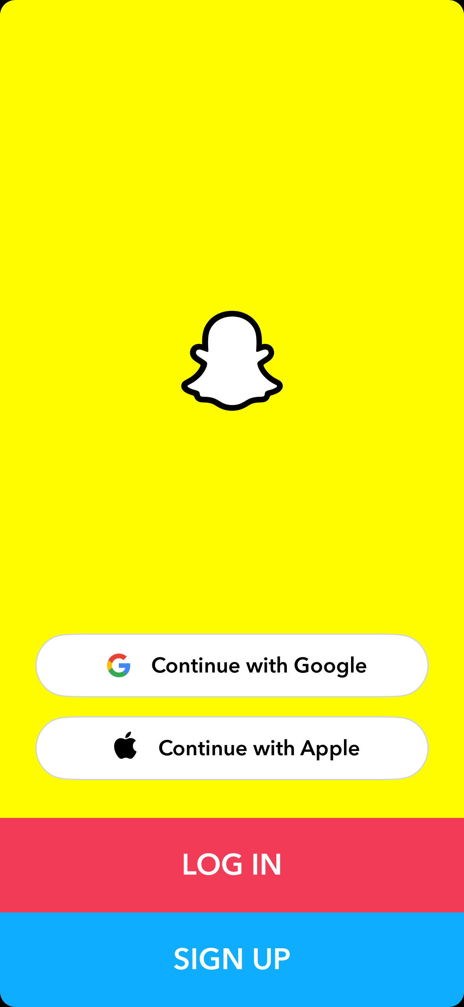
This is me accessing a social media app called SnapChat. I use this on a daily basis to stay in contact with friends. I can see posts from people I follow daily for a 24hr period. I also like using this apps features such as the filters. I don't post on the platform to the public. I like its privacy features to only communicate with friends.

My Metro Mobile Banking App
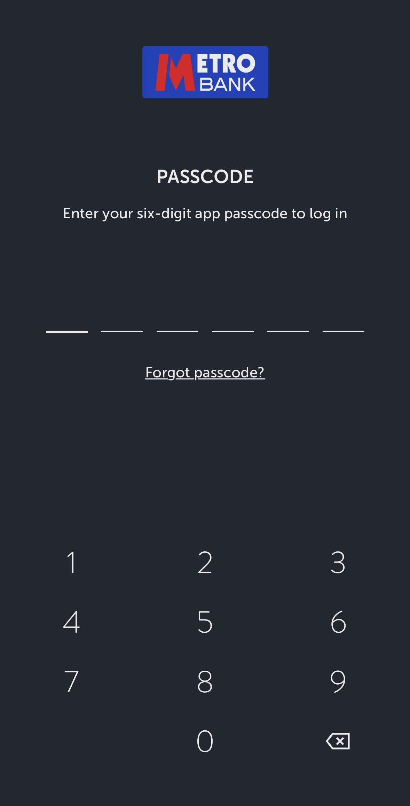
This is a screenshot of my banking home screen. I use this on a daily basis. This app helps me manage my money. It helps me manage transactions, move money around and monitor my finances.

My Just Eat Food App
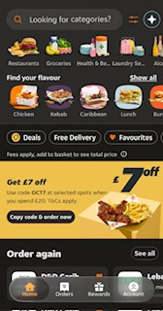
This is a screenshot of a food app that I use to order take away food or order groceries. I prefer this app compared to other like Uber Eats. I prefer it because I seem to get more value for money. I receive discount codes for my favourite places to eat and it also gives me a loyalty stamp card which gives me money off.

My Short Reflection
- Write 5–8 simple sentences about your digital life.
- You can use the sentence starters below if helpful.
I use a wide range of digital tools, on a daily basis, in my everyday life. I use it socially and personally. Socially it helps me to stay connected with friends and family. It helps me access personal things like my banking and emails. It is also helping me to learn and complete my university tasks and work via apps like Microsoft Office. It’s helping me become more feel confident in using the university technology to research information, create documents, and stay organised. An area I would like to improve is my communication and digital skills so I can work more efficiently and confidently. These skills are very important because they will help me progress and succeed in my learning and studies. It will help me prepare for any future employment opportunities and better equip me to work effectively. I didn’t realise until doing this task just home much I use digital tools every day in my life.

Sentence starters
- I use digital tools to …
- I feel confident when I …
- I want to improve …
- I often use these tools: …
- I sometimes feel nervous about …
- I hope this module will help me …
- Digital skills are important for me because …
You can write more if you want.

Submission Checklist
Before you submit, please check:
​​​ ☐ I added 4–6 screenshots
☐ I wrote short sentences for each screenshot
☐ I wrote my short reflection
☐ My work is my own
☐ My file opens correctly
​​☐ My file opens correctly

