  A project portfolio | Project Management  Rio-Raquel Ramsey (2416415)  Module:LCLM5003

Part A: Project Proposal Poster

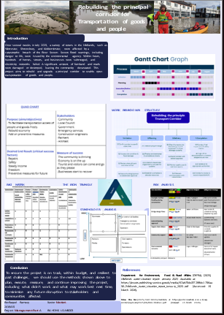

Part B: Reflection from the Feedback received from the tutor and peers.

Introduction
This is a reflection report based on my experience from the beginning, during, and end of the design, assembly, and presentation of a poster on rebuilding the principal corridor for the transportation of goods and people. This reflection will be written in the style of (Gibbs, 1988), a six-stage reflective cycle. Using this reflection matrix helped me develop deeper self-awareness by evaluating thoughts, feelings, actions and end results. Taking on board the feedback I received from both the lecturer and my class.

Description
My class and I were tasked with a three-part assignment. Part A required us to create a project poster proposal based on a scenario involving flooding in the Midlands, we were given three options to choose from:
- Reopening the Highway
- Rebuilding the Principal Corridor for the Transportation of Goods and People
- Reconstruction of the local infrastructure damaged

I chose option 2 because it felt the most relatable and manageable for me. The assignment required us to include tools such as a RACI Matrix (Clift, 2024), a Risk Analysis Matrix (Thomson Reuters, 2024) and a Gantt Chart. In week six, we had to present our posters to the class and tutor. The feedback I received was that I presented well, my poster was very good, and that by mentioning animals as stakeholders and explaining my thought process, I was able to think outside the box.

Feelings
At the beginning of the project I felt overwhelmed by the amount of information and the complexity of the task, As I started organising the poster and piecing the information together, I began to start feeling confident. Leading up to the presentation, I felt anxious because public speaking makes me nervous. However, once I finished presenting, I felt so relieved. I found designing the Charts and matrices quite challenging and time-consuming, but as the poster came together, my confidence rose as well
Evaluation
There were several positive aspects of the experience. As the poster developed, so did my confidence, and to my surprise, the presentation went better than I expected. I received a strong score, which showed that my efforts paid off. I also found that understanding each model helped me speak clearly and confidently during the presentation. The main challenge for me was fitting all the required information onto the poster whilst keeping it clear and readable. The technical elements, such as the Gantt Chart (Laprad, 2026).
Analysis
Feeling overwhelmed initially stemmed from being unfamiliar with the tools required for the project. Working through each model improved my understanding, which in turn helped to reduce the anxiety I felt. The time I spent working on the charts and matrices strengthened my knowledge, which helped me deliver a strong presentation. The difficulties I faced with the poster highlight the importance of planning the layout and managing key information. Positive feedback and presentation outcomes show that preparation and familiarity can reduce nerves and improve performance.
Conclusion
To conclude, this experience was valuable, although initially I felt overwhelmed and anxious. I learned that breaking down and processing the task can lead to improved confidence and performance. I also learned that preparation is crucial for reducing anxiety. If I find myself in the same situation again, I will plan the poster layout to avoid spacing and clarity issues at the end.

Action Plan
In future projects, I will:
- Start by mapping out the poster layout before creating the content.
- Allocate more time to learning and practising project management tools to reduce stress later down the line.
- Practice my presentation earlier to build confidence and reduce anxiety.
- Use feedback from this assignment to refine my approach to clarify, organisation and time management.

Part C: Project Management Plan
Project Management Plan

Introduction
In 2025, communities within the Midlands, such as Worcester, Shrewsbury, and Kidderminster, were all devastated by major disruption caused by a breach of the River Severn. Hundreds of homes, businesses and streets were affected, and farmland was submerged, leading to electricity network failures. Communities were left devastated by the damage. This project plan outlines how the Principle transport corridor will be safely and efficiently reopened.

Project Description

The aim of this project is to rebuild, upgrade, and reopen a resilient principal corridor for the transportation of goods and people, as the original was destroyed by the flooding. This is essential for businesses and communities to have open access to and from their communities. But also, to access goods to support their businesses and communities, and to restore crucial transport links.

Project Objectives
The objectives of the project are to rebuild, upgrade, restore, and reopen the principal corridor within 6 months and within budget. It will not only restore transport links but also improve access in and out of communities. The overall outcome will boost communities, making the corridor safe, resilient to future flooding and fully functioning. Which in turn will reduce future disruption. Whilst under construction, we will also aim to minimise disruption and cost.

Work Breakdown Structure
figure 1. shows 4 main stages broken down as the project evolves, the first stage is Initiation.
- Initiation
1.1 Confirm project scope
1.2 Access site conditions and flood damage
1.3 Review of what will work and what will fail
1.4 Secure funding/sponsor, and stakeholder approval

- Planning
  - Establish project design
  - Finalise environmental and compliance checks
  - Establish stakeholder engagement
  - Establish a schedule and allocate resources

- Delivery
3.1Clear and prepare the site, stabilise the ground and implement multiple drainage systems
3.2 Build corridor with added upgrades
3.3 Monitor quality cost and real time reports
3.4 Maintain communication with stakeholders

- Completion
  - Conduct final Inspections and safety checks
  - Sign off on documentation and confirm obligations
  - Handover to appropriate authorities
  - Conduct a review and record impact assessment

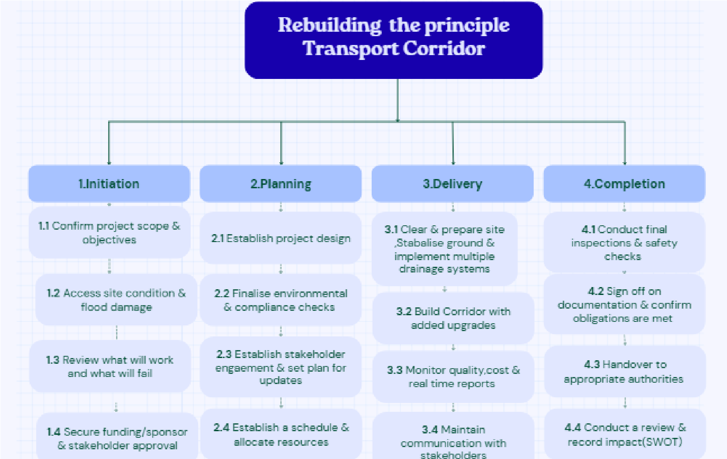

Figure 1. Work Breakdown flow chart
Quad Chart

Gantt Chart
Stakeholders’ involvement
Allocation of resources
Risk Analysis

Conclusion
Reference

