Ieuan Rees Year 3 PCDA
University ID- 2124740
Literature review
As part of my dissertation in year 3 I will be speaking about the need for a degree in policing.
In this literature review I will look to see what research has already been published in relation to this topic and I will look to see how this will support or not support my research.

I m y dissertation I aim to research whether there is a need for a degree for a degree in Policing, currently England and Wales have three different professional entry routes for entering the police. These routes are commonly known as Police Constable Degree Programme (PCDA) where officers join the police without having a degree and do a three year probation, Degree Holder Entry Programme (DHEP) where officers join having a degree regardless of what the degree is in and they do a two year probation and finally there is the degree in professional policing where officers would have studied this degree in university then join the police after having complete the degree in their own time.
I will look to highlight the issues surrounding these different entry routes.
In an article publish by C. Watkinson-Miley, C. Cox and M. Deshpande (2021) they look specifically a study involving 30 student officers completing the PCDA programme who are all have various lengths of service ranging from 3- 12 months.
The article outlines how three different groups of PCDA students have taken part in a study that involved 4x1 hour focus sessions surrounding the PCDA where students were asked a number of questions.
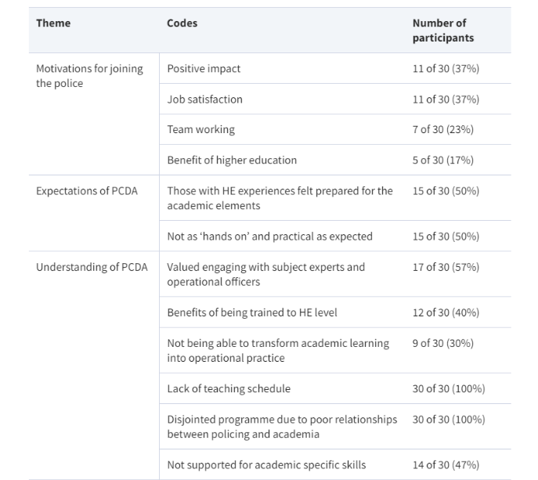
Below is a table from the article published by C. Watkinson-Miley, C. Cox and M. Deshpande (2021)

From looking at the above table some of the statistics would suggest that people taking part in the PCDA programme are not satisfied with it and the statistics are suggesting an overall negative impact on the students.
This aspect of the article written by C. Watkinson-Miley, C. Cox and M. Deshpande (2021) briefly highlights some key areas around the PCDA programme, the article also goes on further to say how many people have only joined due to it being the only option available to them.
What the article doesn’t highlight is the physical and mental health impact that the degree programme has on student officers which is what I will aim to highlight in my own research by speaking with officers who have complete the degree.

In a further article published by R. Honess and S. Clarke (2023) the article against speaks about the degree entry programme and the degree programme and looks at whether a level of higher education within the police is needed.
The article speaks about how the College of Policing have a plan to professionalise policing with the degree programmes and how that will give the public more confident in policing. There is however no research within the article to suggest that the public are even aware that officers need to complete a degree.
The research I will conduct will aim to provide clarity of this by constructing a survey that is aimed at the general public to see what it is they know about the policing degree.
The article also suggests that the university work that officers must complete in their own time is not work that it is merely essential learning to become a police officer.
There is no evidence in the article to suggest that this is the case, my research will involve speaking with student officers and former student officers and gauging their opinions on if there is any relevant connection between the university work and the duties they do on a daily basis.

There is research out there surrounding the university degree and opinions surrounding whether it is necessary however it does appear that further research is needed which is what I plan on conducting.
There is little information on what the general public know about the degree programme and given that the College of Policing insist that this makes policing more professional the general public’s opinion should be vital as if this is the reason for doing the degree programme then one would assume they are aware it exists.
The research I will conduct will be first hand from current officers and this will then be able to be compared with any existing research.
Word count- 717
Bibliography
C. Watkinson-Miley, C. Cox, and M. Deshpande, (2021) ‘A New Generation of Police Officers: Experiences of Student Officers Undertaking the Police Constable Degree Apprenticeship in One UK Police Force’, Policing: A Journal of Policy and Practice, 16(1st ed.), pp. 122-134. Available at: https://academic.oup.com/policing/article/16/1/122/6421685?login=true (Accessed 1 May 2024).
R. Honess, and S. Clarke, (2023) ‘ʻItʼs Not “Uni” Work, itʼs Essential Learning to be a Police Officerʼ: Examining the Higher Education Elements of Police Education Qualifications Framework Programmes’, Policing: A Journal of Policy and Practice, 17(4th ed.), pp. 0-23. Available at: https://academic.oup.com/policing/article/doi/10.1093/police/paad023/7162643?login=true (Accessed 1 May 2024).

