
E-PORTFOLIO ASSESSMENT
By Muhammad Shahid

March 6, 2026

Programme: CertHE Computing Skills for Workplace
Module: Learning in the Digital Era
Module code: ACCA4025
Lecturer: Mohammed Ben Farah,
Student ID 2530120

Table of Contents
My E-portfolio Statement 2
Task 1 – Written Summary. 3
Summary. 4
Screenshot. 4
Task 2 – Mind Map & Academic poster. Mind-map screenshot. 6
Click the link to view the mind map online 6
Poster 6
Poster to link. 7
Task 3 – Automatic Referencing. E-portfolio screenshot 7
Task 4 – Screenshot of e-Portfolio creation and review. 7
E-Portfolio Creation and Review 8
Conclusion 11

My E-portfolio Statement
I used Google Sites to create my e-portfolio. I chose this platform because it is straightforward to use and allows me to organise my work clearly into separate pages for each task [1]. Google Sites also makes sharing easy, as my portfolio can be accessed through a single link without requiring the viewer to sign in, which is useful for tutor marking [1]. In addition, it integrates well with Google Drive, making it convenient to upload and manage my work in one place [2].

- Portfolio for home page.

https://sites.google.com/view/muhammads-portfolio/home
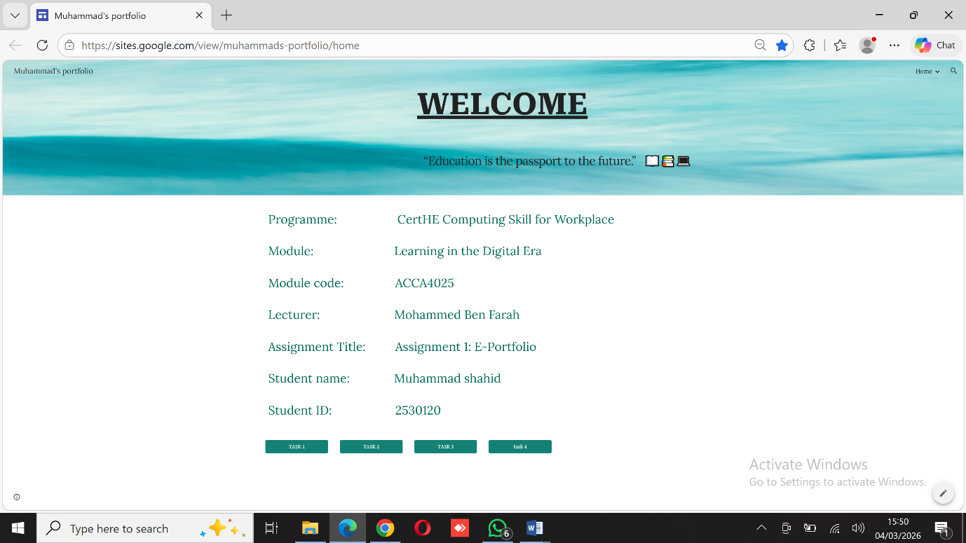
2. And a screenshot for the home page of the portfolio

Task 1 – Written Summary.

Summary.
During my studies, I have learned that business success depends on more than technical knowledge. I have developed important skills such as communication, which has improved through writing assignments, giving presentations, and working in groups. These skills help me share ideas clearly and work well with others. I have also improved my critical thinking by analysing information and considering different viewpoints when completing academic tasks. In addition, I have developed digital skills by using online learning tools and collaboration platforms. Being adaptable and open to learning has also helped prepare me for future employment and professional development.

Screenshot.
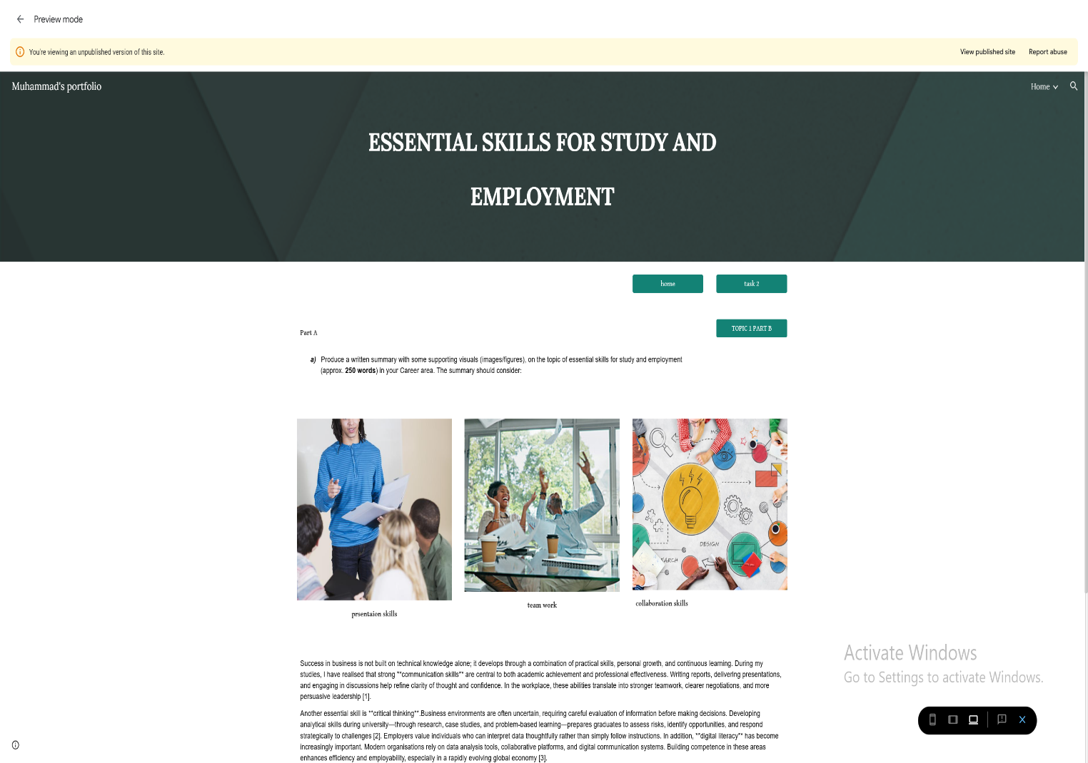

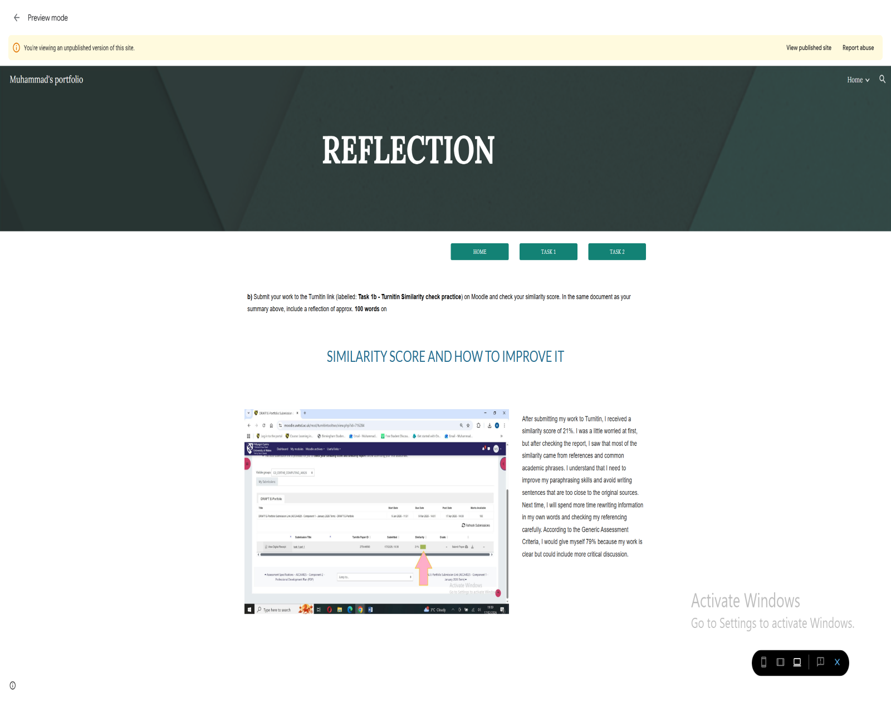

Task 2 – Mind Map & Academic poster.
Mind-map screenshot.
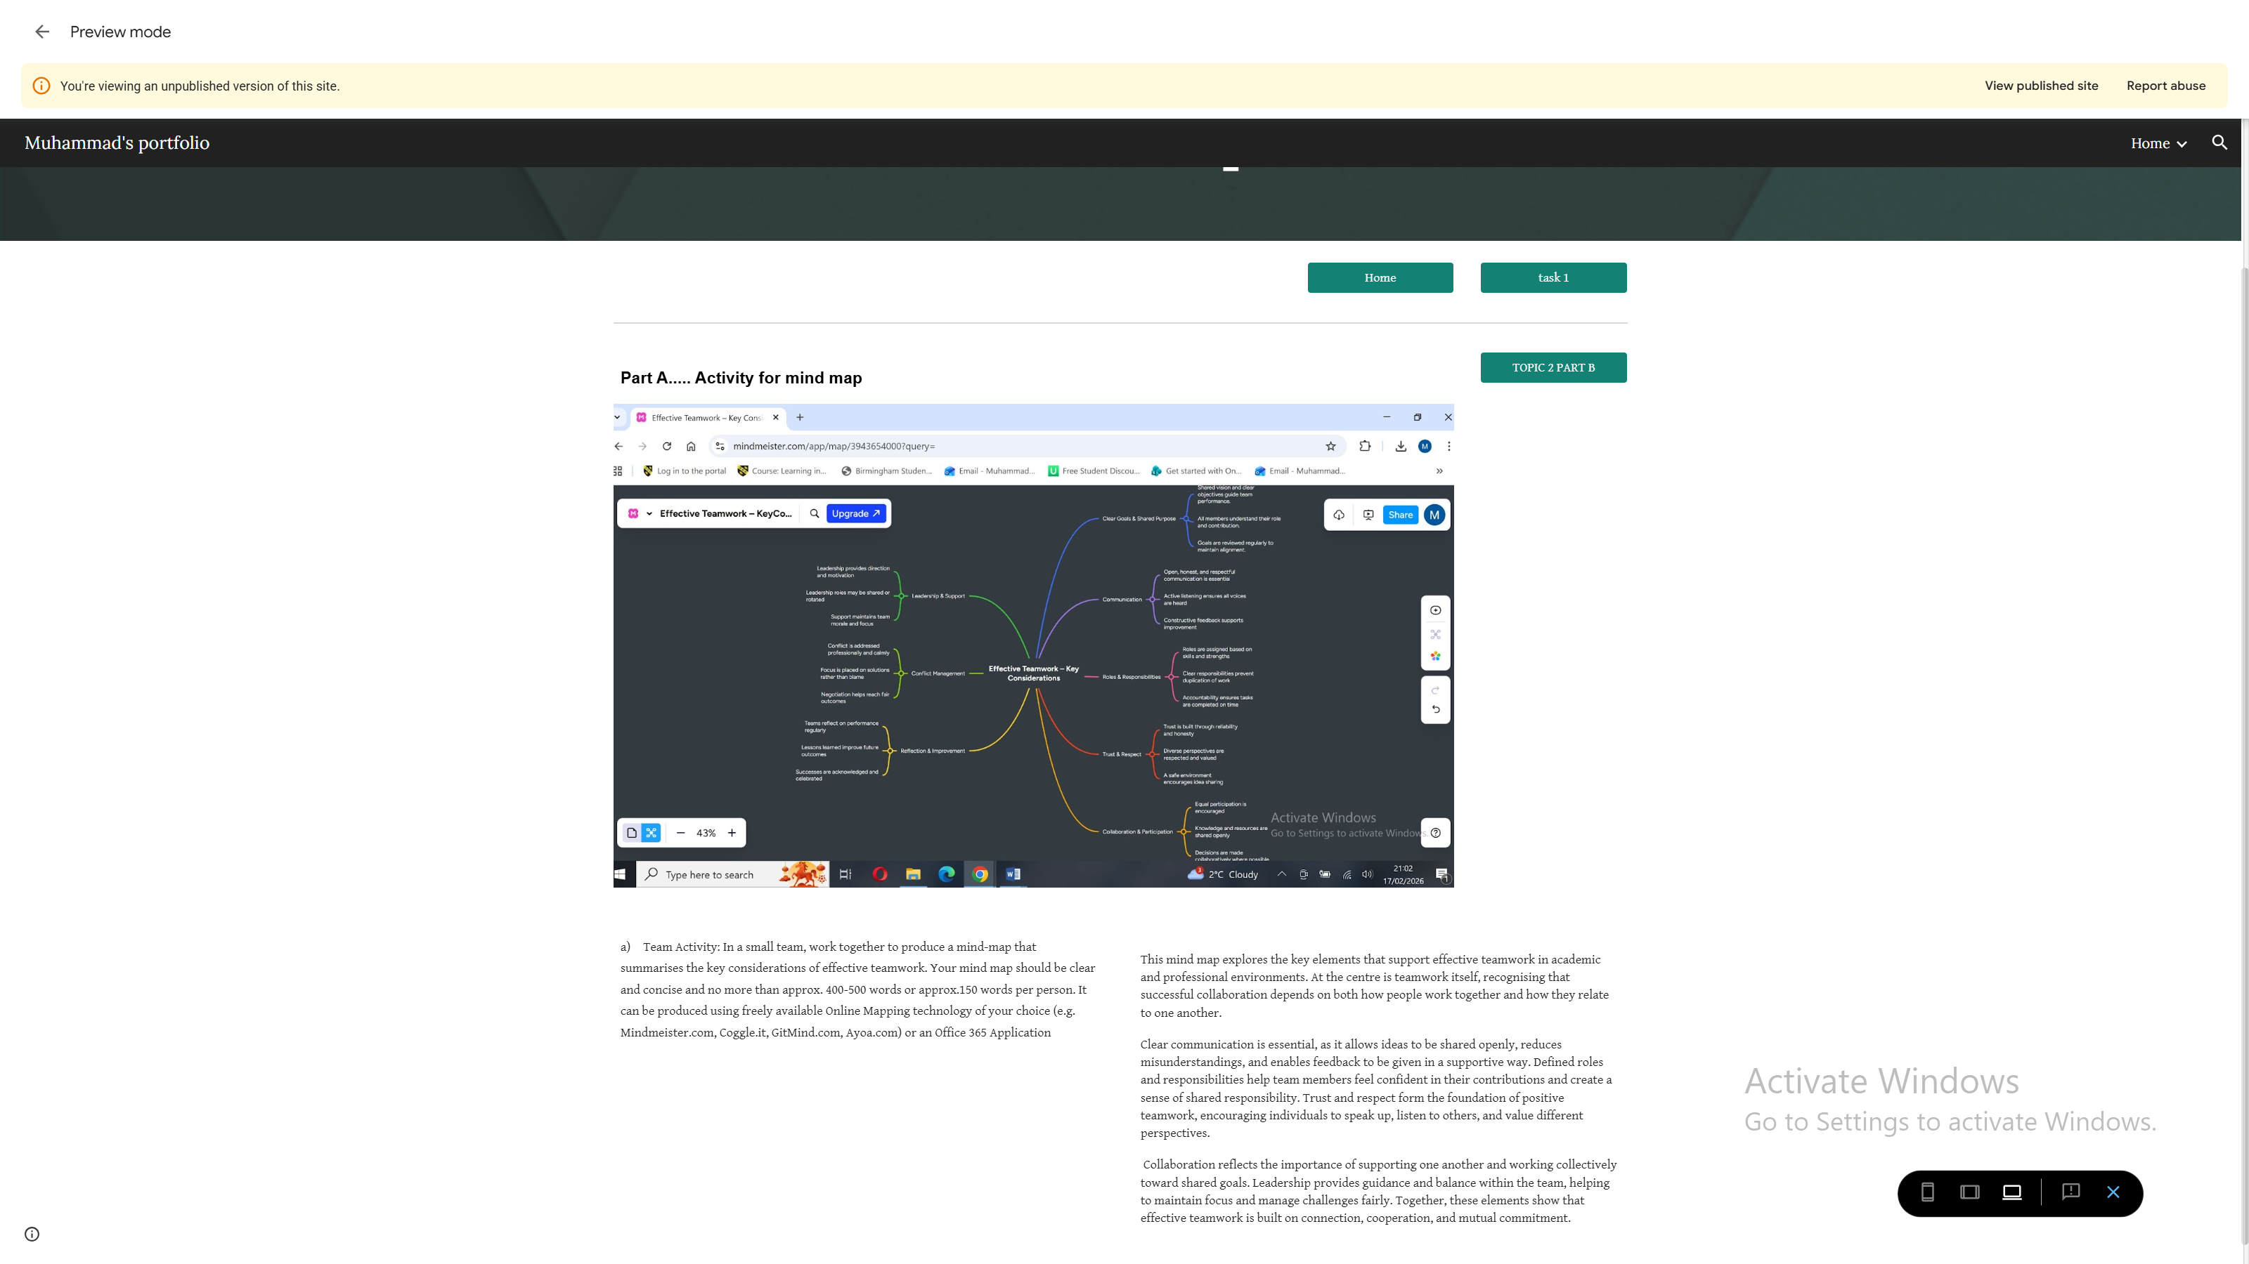

Click the link to view the mind map online
https://mm.tt/map/3943654000?t=ShutlFWh6m

Poster screenshot.
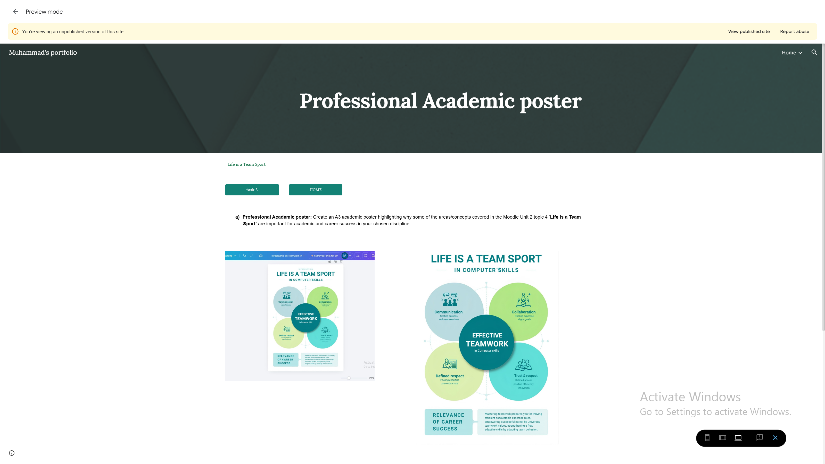

Poster to link.
https://www.canva.com/design/DAHB4JTC7qs/Z4VdnypcrdSmg4QQbSXCAA/edit?utm_content=DAHB4JTC7qs&utm_campaign=designshare&utm_medium=link2&utm_source=sharebutton

Task 3 – Automatic Referencing.
E-portfolio screenshot
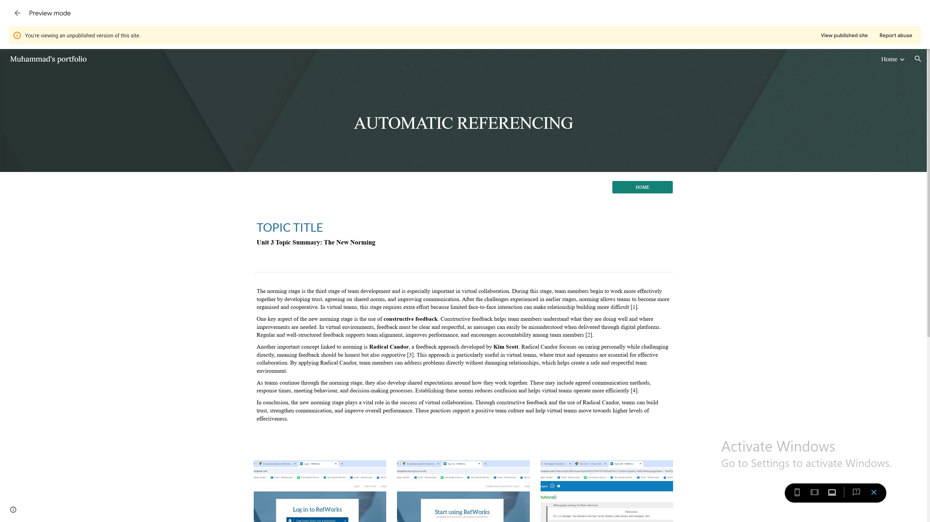

Task 4 – Screenshot of e-Portfolio creation and review.
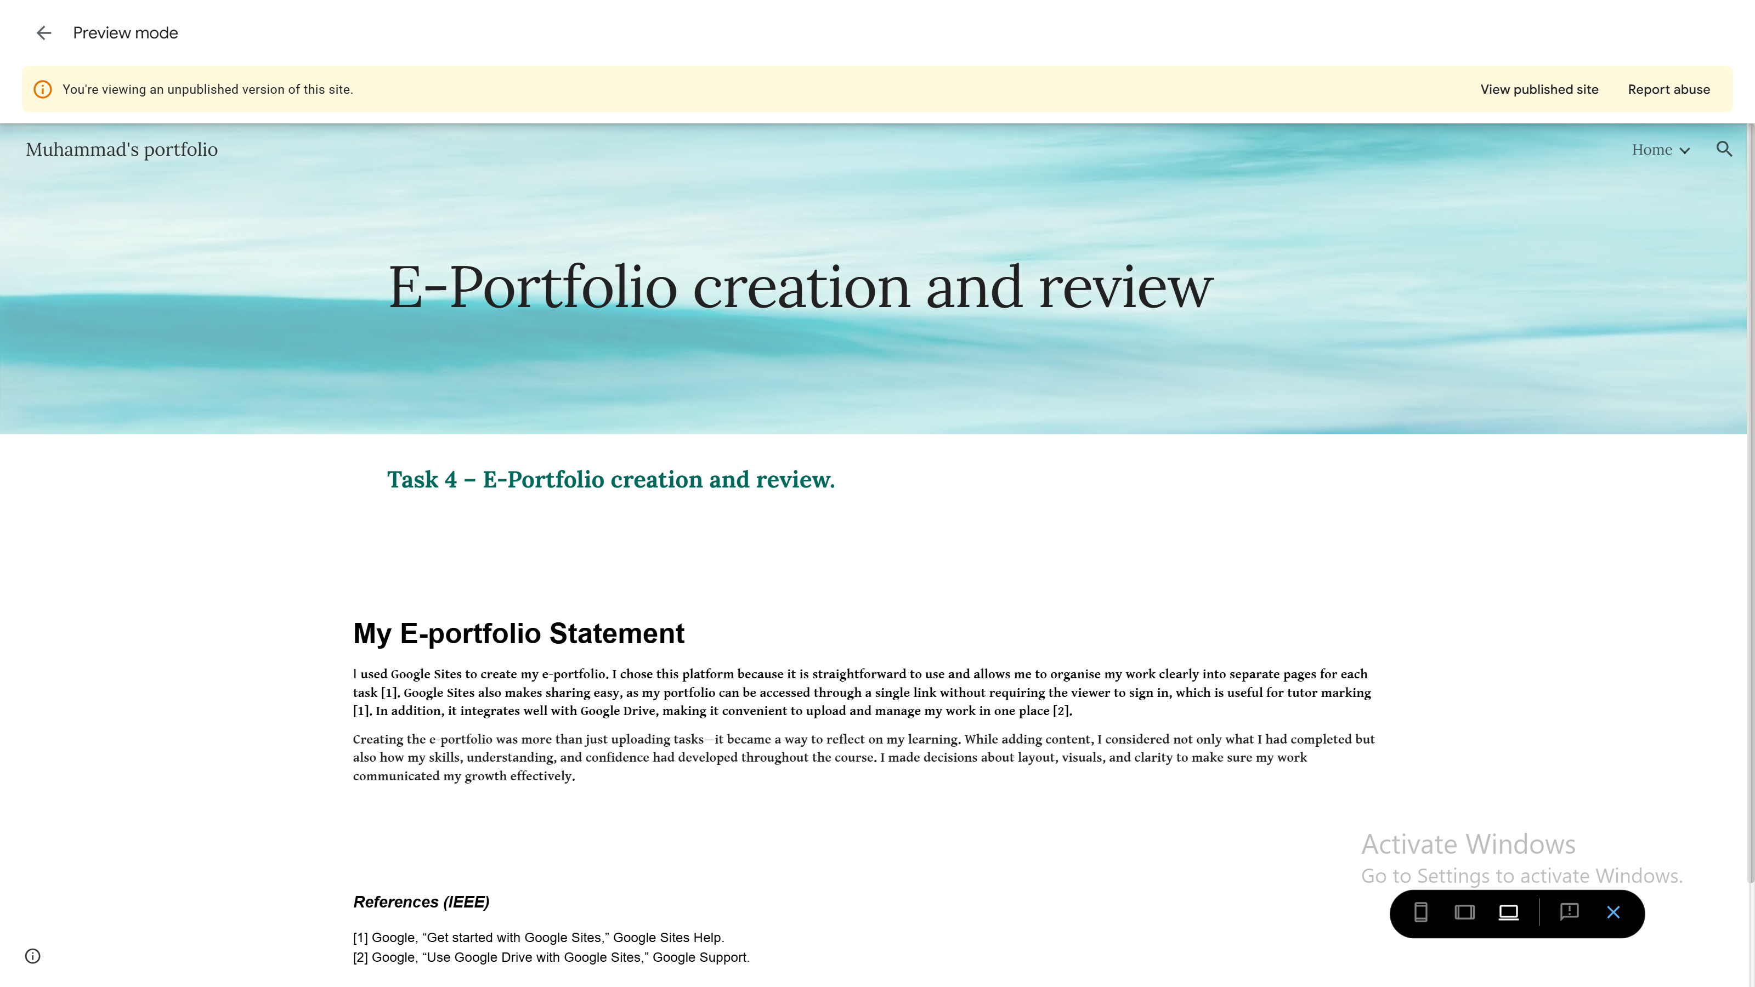

E-Portfolio Creation and Review

For my e-portfolio, I chose to use Google Sites because it allowed me to organise my work in a way that felt both professional and personal. I was able to structure my portfolio logically, creating clear sections for each task, and including screenshots and hyperlinks so that everything is easy to access. I spent time thinking about how a tutor would navigate my work, ensuring that every link worked and each page was easy to understand.

Creating the e-portfolio was more than just uploading tasks—it became a way to reflect on my learning. While adding content, I considered not only what I had completed but also how my skills, understanding, and confidence had developed throughout the course. I made decisions about layout, visuals, and clarity to make sure my work communicated my growth effectively.

After completing the portfolio, I reviewed every section, testing links, checking screenshots, and adjusting any areas that felt unclear or incomplete. This process helped me develop digital organisation skills and gave me insight into how presenting work thoughtfully can highlight both achievement and personal development. It reinforced the importance of reflecting on learning as a key part of professional growth.
* All screenshots of the e-portfolio.
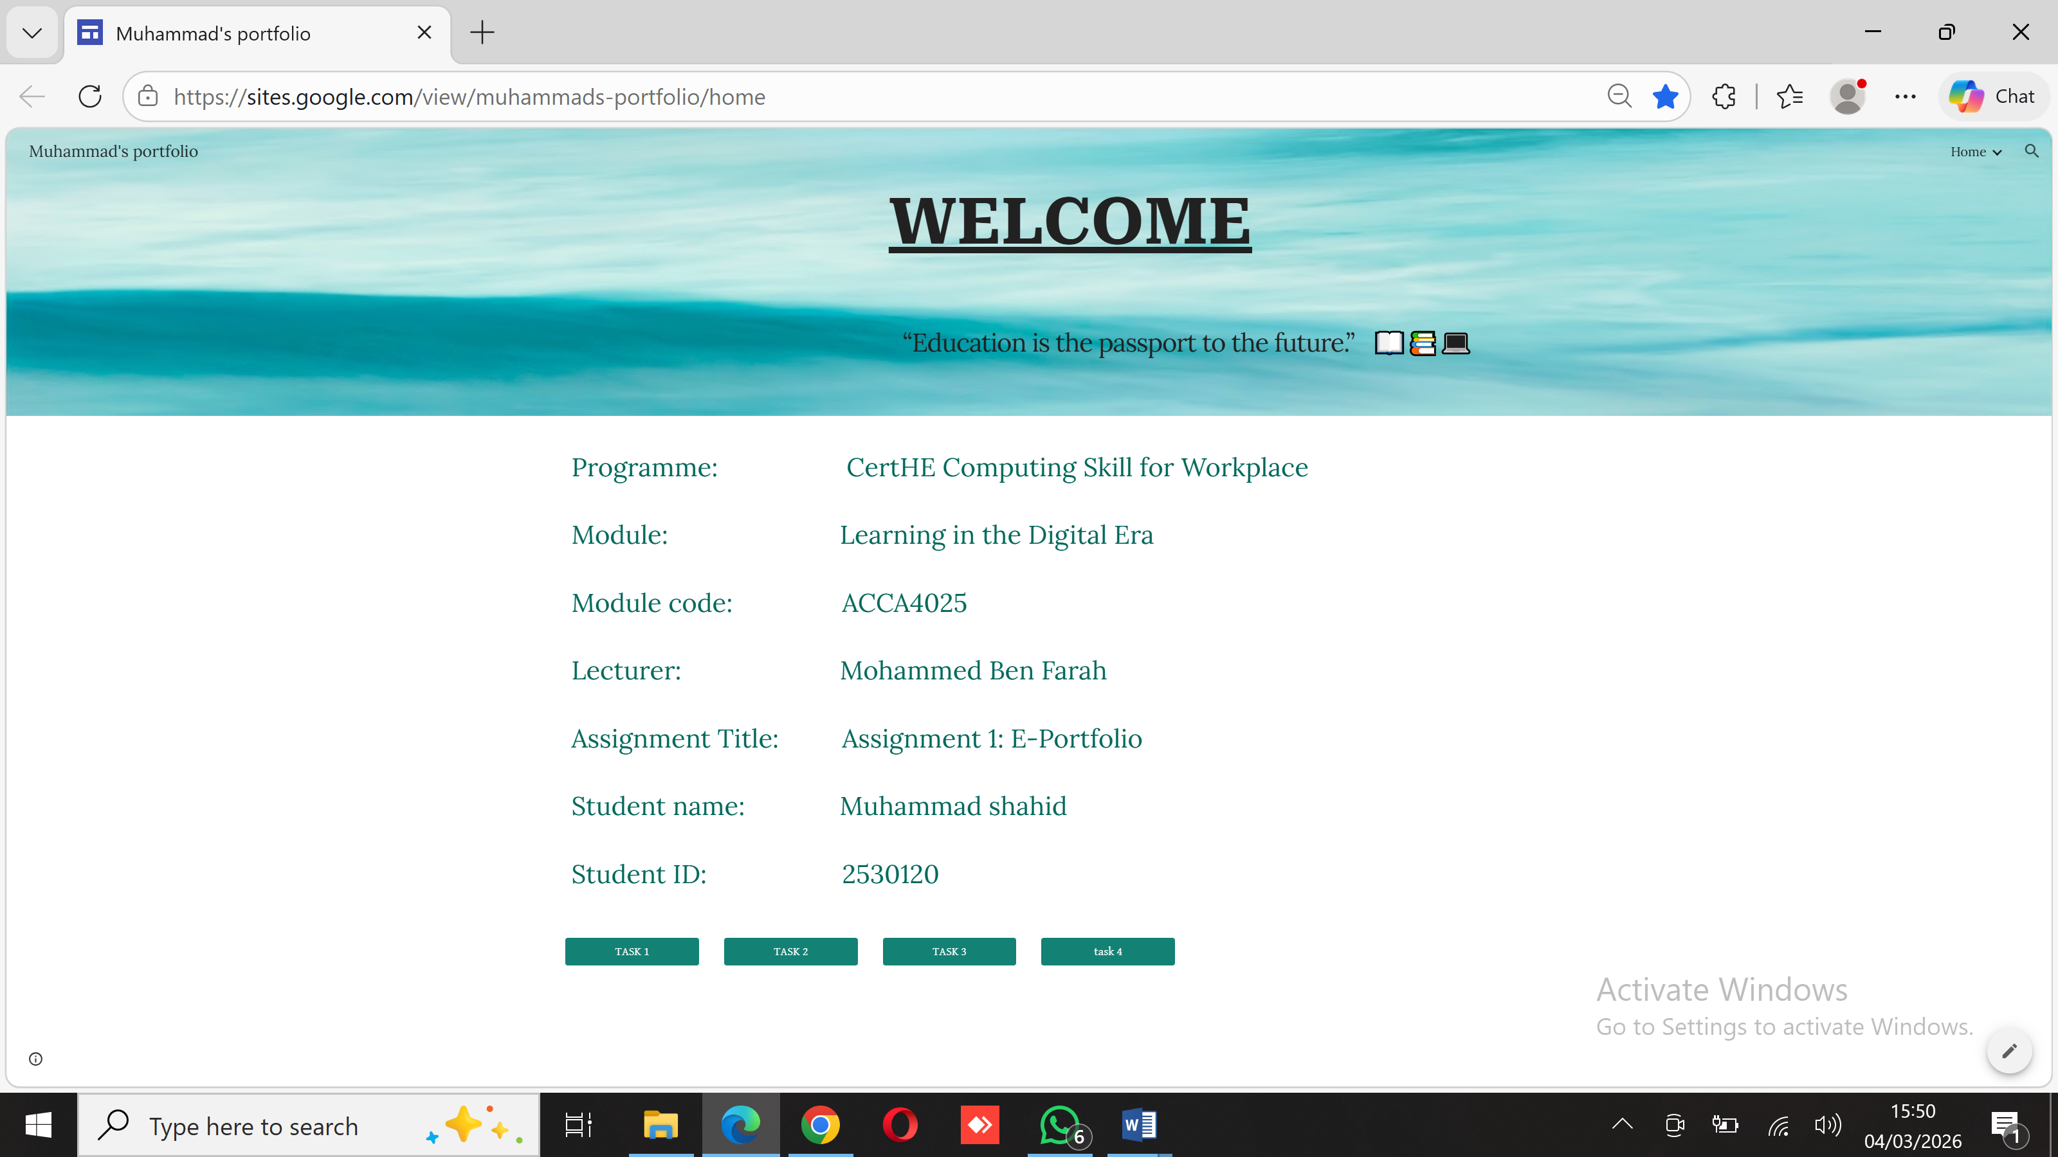

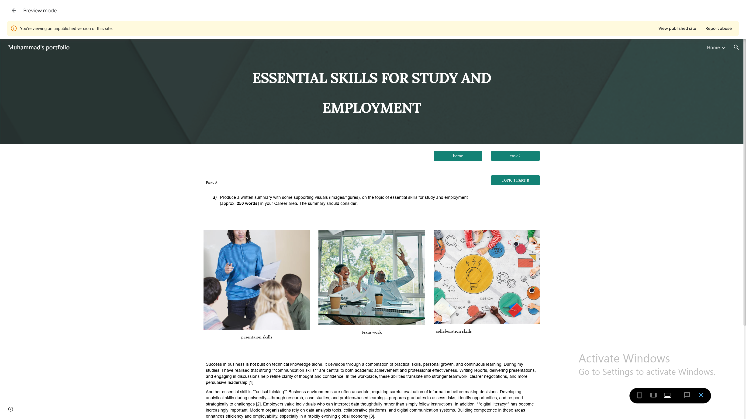

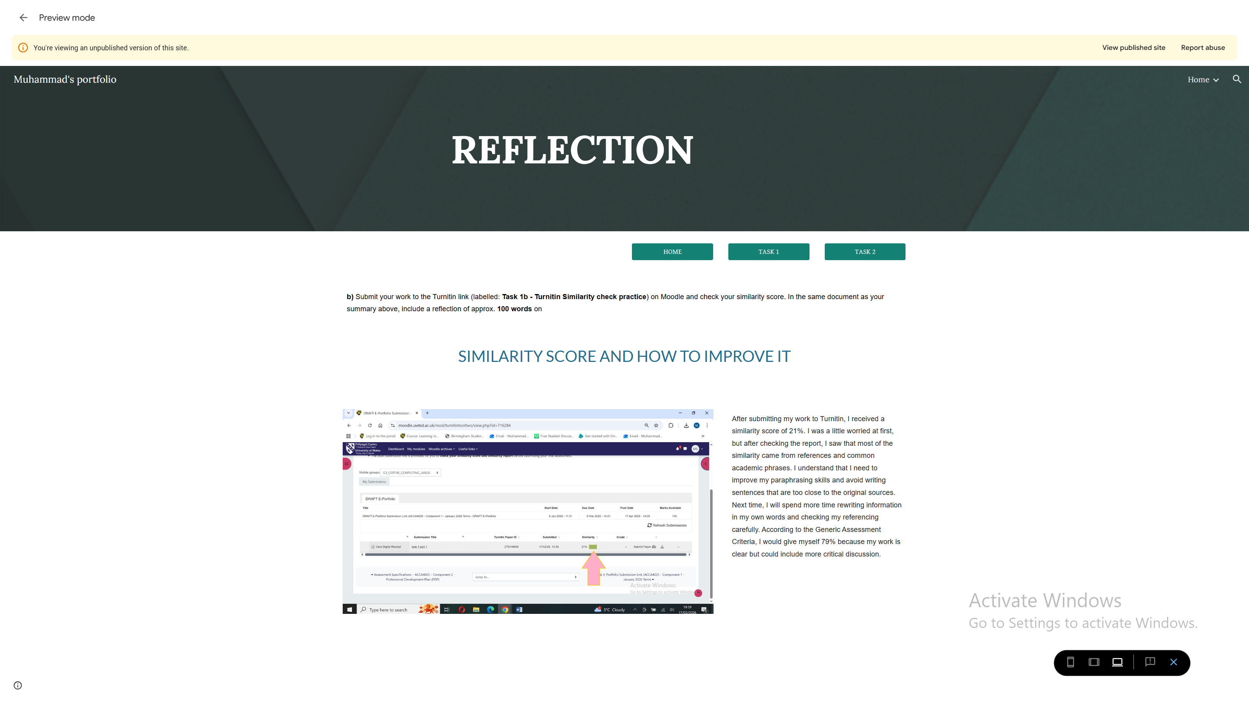
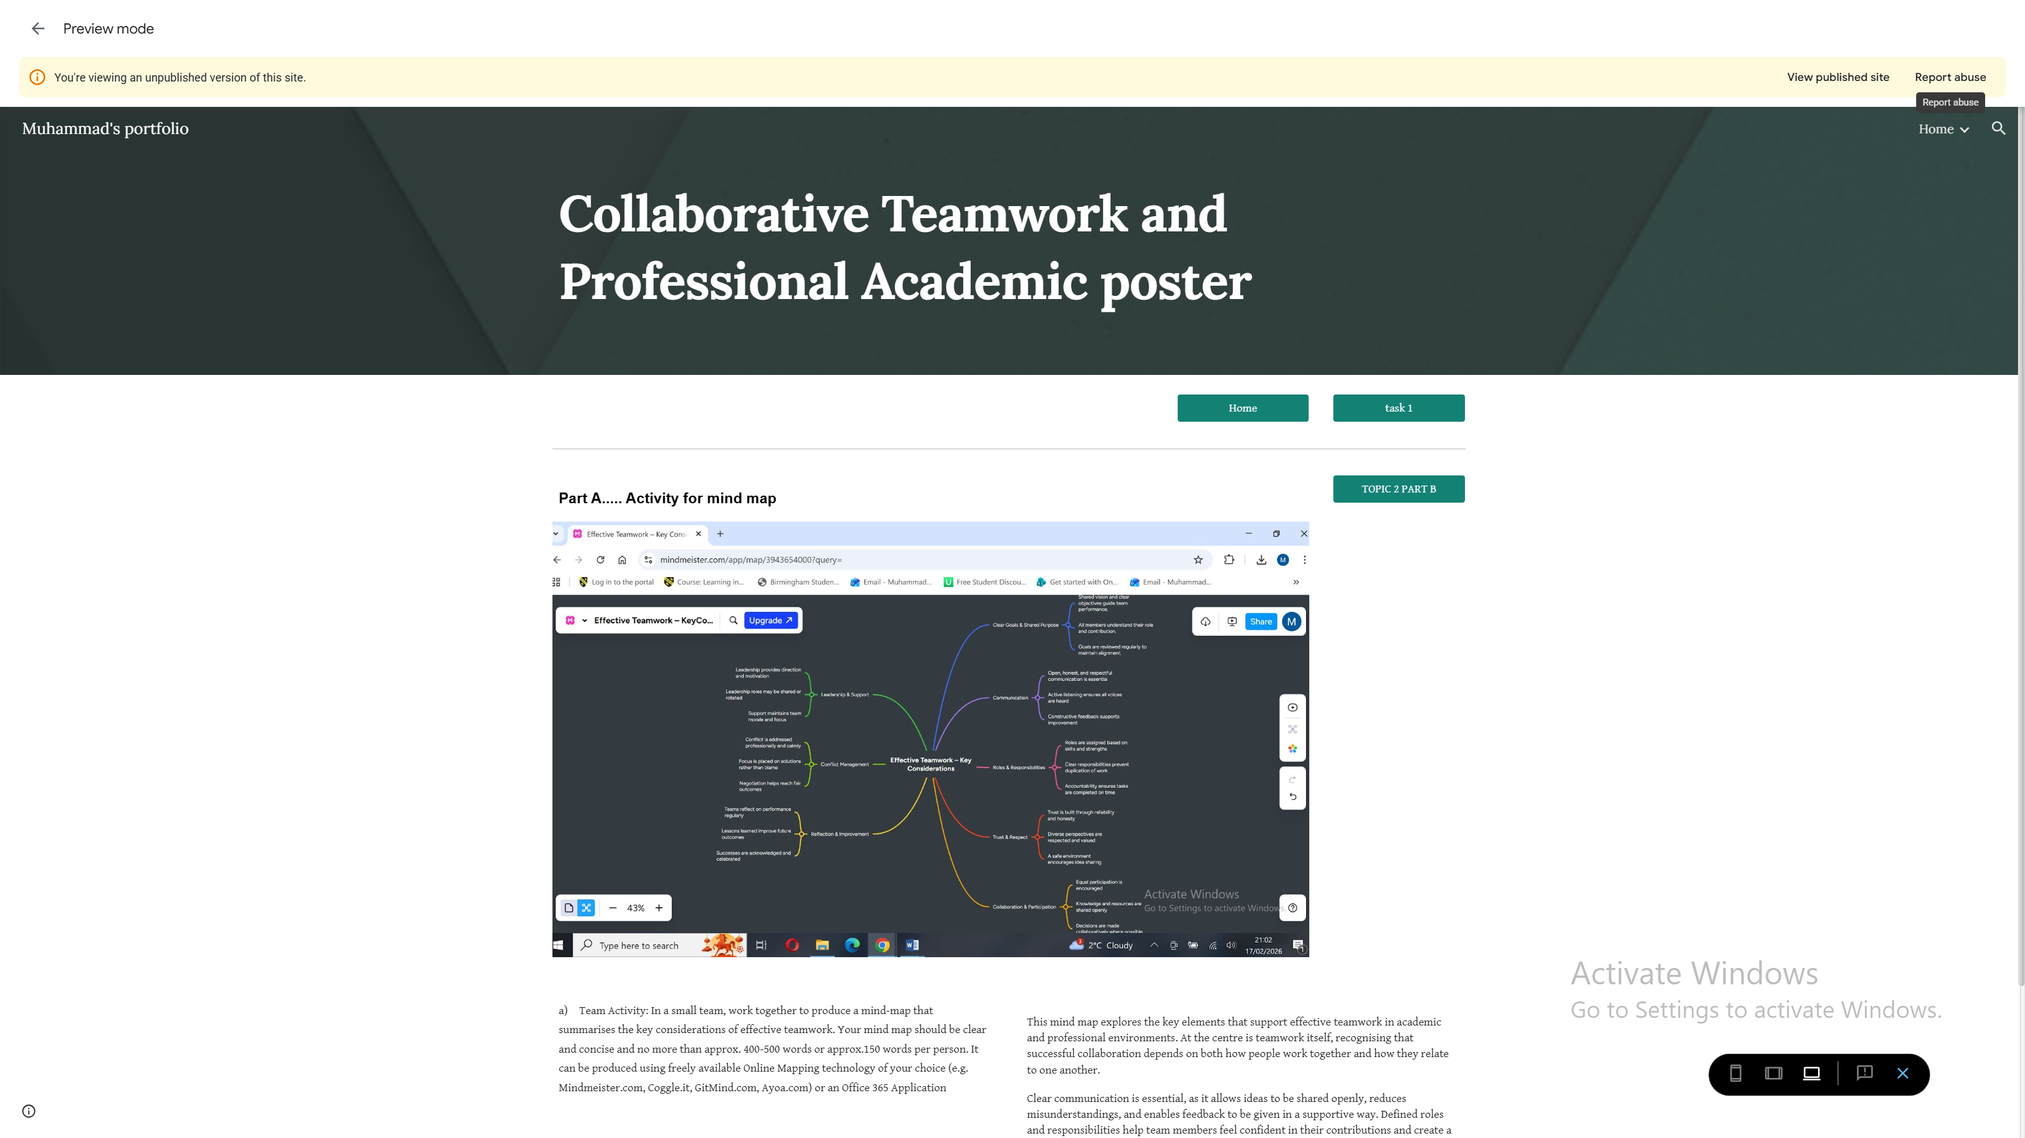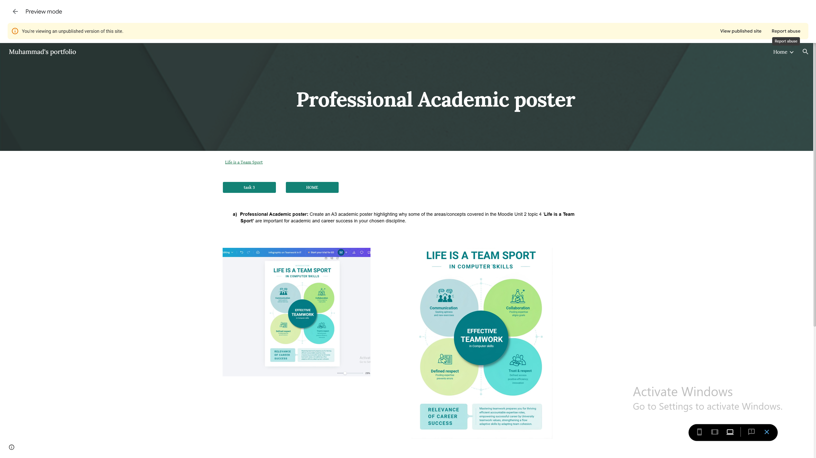
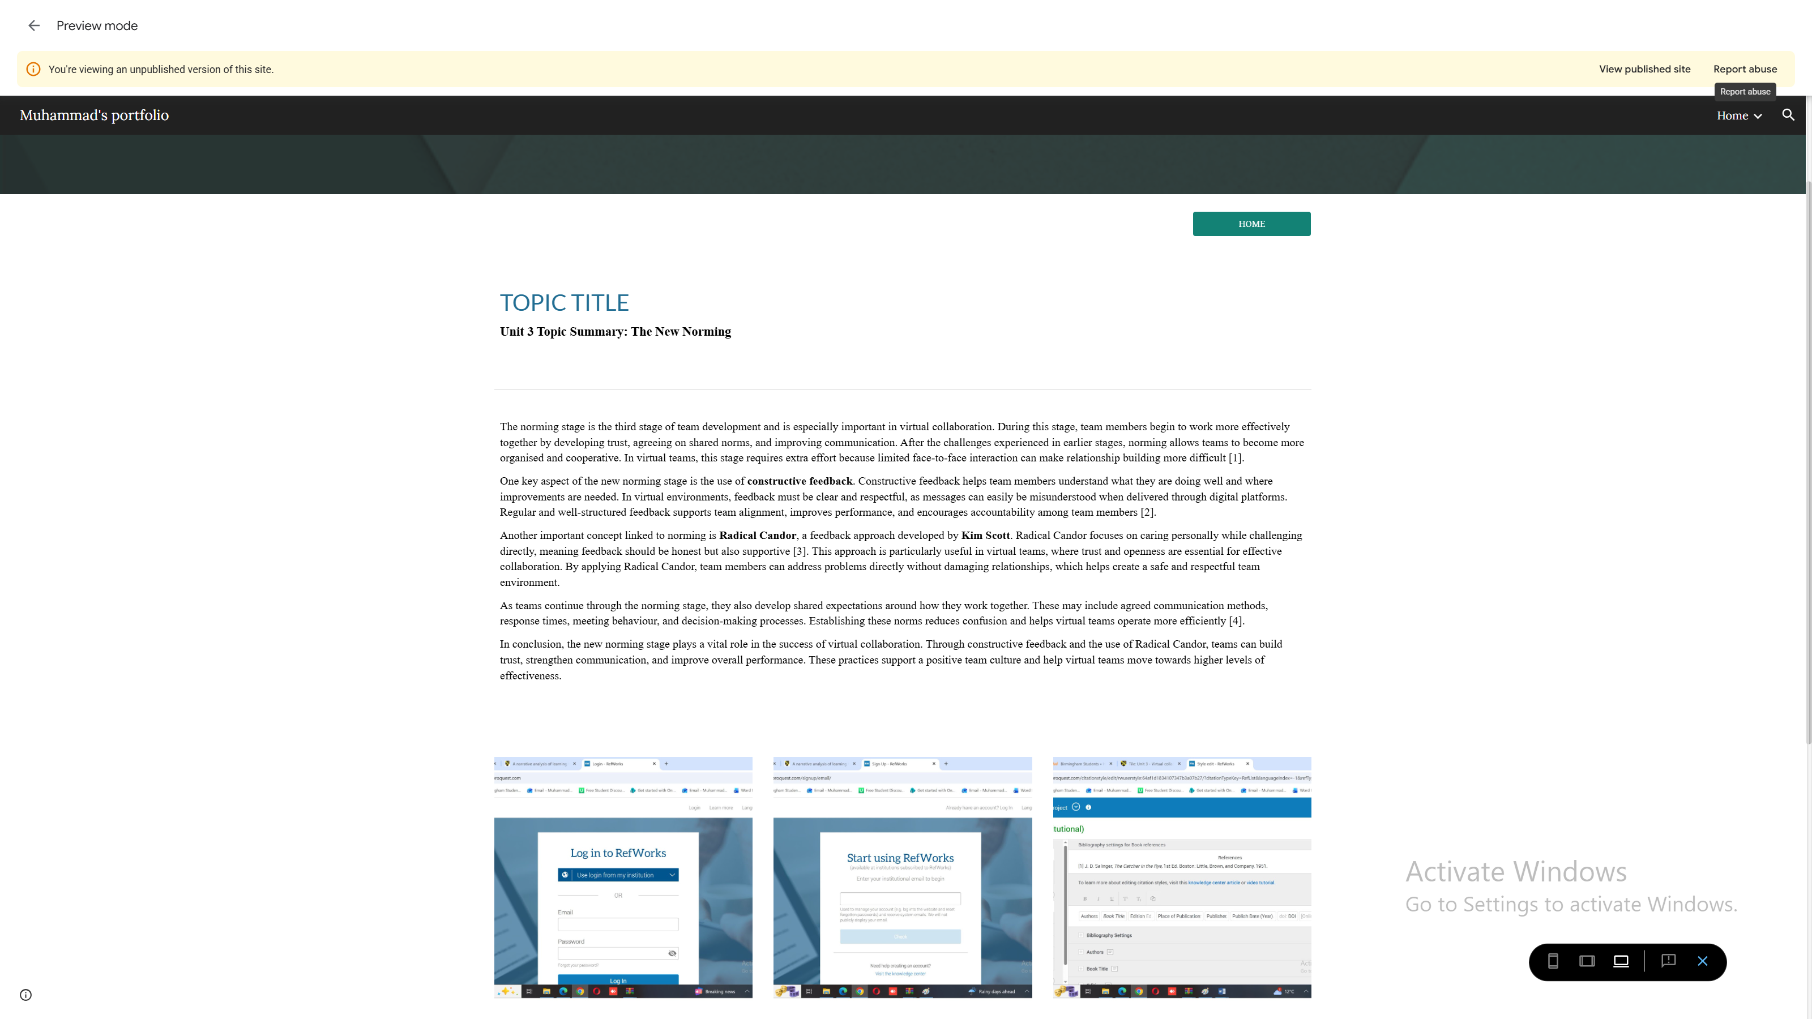

Conclusion
Creating this e-portfolio has been a valuable process for reflecting on my learning, developing key skills, and highlighting my work in a professional format. Throughout the course, I have strengthened my communication, critical thinking, and digital literacy skills, and the portfolio allowed me to present these in a clear and organised way. By including screenshots, hyperlinks, and structured sections for each task, I ensured that my work is accessible, complete, and easy for tutors to navigate.
The process of building and reviewing my e-portfolio also encouraged me to think critically about my own progress. I considered how each task demonstrated my growth, reflected on challenges I overcame, and identified areas for further improvement. Using Google Sites helped me develop my digital and organisational abilities while giving me the freedom to design a portfolio that represents both my academic achievements and personal development.
Overall, this e-portfolio has not only documented my coursework but also highlighted the skills and attributes I have gained throughout my studies. It has strengthened my confidence, prepared me for future professional opportunities, and shown the value of reflecting on learning as part of ongoing gGrowth.

