

Student Name : | Denise Cardoso
Student Number : | 2030455
Module Number : | BMHP5003
Module Teacher : | Olusegun Awolaran
Lecture Name : | Introduction of Physiology
Date of submission :  Report n : 2 | 28 April 2023

Table of Contents
1.Introduction 3
2. Anatomy and Physiology of patient with Diabetes type 2 4
3. Life Style questionnaire Patient A – Diabetes type 2 : 6
4. Health and Social Care Practice 7
5. Recommendations : 8
6. Conclusion 9
7. Reference 10

1.Introduction

Diabetes type 2 is a chronic disease characterized by the body's resistance to insulin and increased blood sugar levels. O developing the disease due to several years of unhealthy lifestyle habits, especially excessive consumption of carbohydrates in the diet and sedentary lifestyle. There are 2 types of Diabetes, type 1 diabetes and type 2 diabetes which is considered the most serious which we will talk about in this report (NHS, 2020).
According to “Diabetes.co.uk” in United Kingdom there are 4.9 million people with Diabetes where 90% suffer from Type 2 Diabetes, 10% Type 1 Diabetes. The risk factors for this type of Diabetes come from family history, age, life style, ethnicity or in the case of obesity ( Diabetes.co.uk, 2023).

This report focuses on choosing a health condition “Type 2 Diabetes”, describing routine health and lifestyle measures including information on anatomy and physiology. I will also include health and social care recommendations and practices that I would give to patients with type 2 diabetes. I will highlight UK-based planning examples to explain how information and measurements about how the body functions can inform care planning for individuals or communities .

2. Anatomy and Physiology of patient with Diabetes type 2
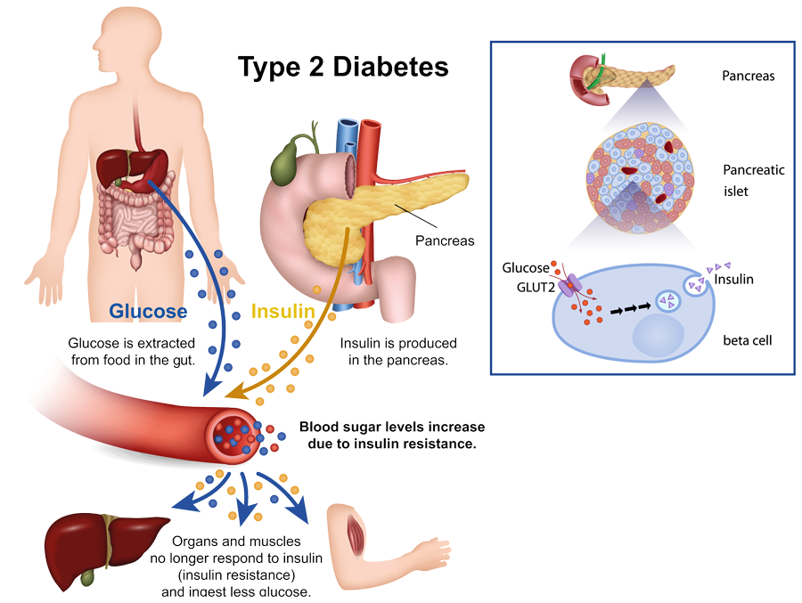

( Hanefeld, 2020)
Based on the table provided by diabetes.co.uk the diagnosis of the blood glucose levels:
Plasma glucose test | Normal | Pre diabetes | Diabetes
Random | < 200 mg/dl | ---------- | > 200 mg/dl
Fasting | < 100 mg/dl | 100 to 125 mg/dl | > 126 mg/dl
2 hour post-prandial | < 140 mg/dl | 140 to 199 mg/dl | > 200 mg/dl

Testing the sugar level in milligrams per decilitre in the blood is important for its control and monitoring. The random glucose test is used to diagnose type 1 diabetes. The fasting test is used to diagnose type 2 diabetes (Diabetes.co.uk, 2023).

Type 2 diabetes is associated with insulin insufficiency. The pancreas in turn is the organ producing enzymes and proteins formed by 2 endocrine and exocrine glands. The endocrine pancreas secretes hormones that regulate blood glucose levels. The exocrine pancreas produces enzymes that digest food.
The food we eat provides glucose, which is the main source of energy. The pancreas, through the production of insulin, facilitates the entry of glucose into the cells and the production of energy. What happens in type 2 diabetes is the lack of cellular response to insulin, called insulin resistance (Animated Diabetes Patient, 2014).

This progressive development of insulin resistance as the body's cells become more insulin resistant and this has a few factors. For example, patient A ate a donut and a chocolate mousse blood glucose will increase the pancreas will produce insulin in proportion to the large amount of glucose absorbed. But the insulin response process by the cells of the body where the insulin will react and interact with a specific receptor on the cells that will trigger the translocation mechanism of the gluteus 4 of its cell vesicles and it could be another gluteus as well (Mandal and Sally ,2019). They will be translocated and fused in the cell membrane causing glucose to be absorbed into the body's cells consequently reducing blood sugar levels. In Type 2 Diabetes, that mechanism that helps in the glucose absorption process will be impaired, the cells will not respond to insulin. They will be increasingly resistant to insulin, causing the amount of glucose absorbed by the cell to be very small, consequently causing an increase in blood glucose, this progressive condition leads to type 2 diabetes (Diabetes UK ,2018).

Type 2 diabetes is incurable, but there can still be a diabetes remission due to weight loss. Remission happens when there is a drop in blood sugar levels below the diabetes level. According to a study, it is believed that the fat located in the liver and pancreas interferes with the functionality of these organs, leading to type 2 diabetes. Weight loss comes from a low-calorie, low-carbohydrate diet or bariatric surgery. (Ryan and McDermott, 2022).
Patient A suffers from obesity, he has complained about having to get up many times at night to pee. And complains that the vision is blurry. He feels very tired and his foot is in pain and swollen, not being able to carry out many tasks.
According to the lifestyle questionnaire carried out to patient A, we can see that she has an inadequate diet and a sedentary lifestyle, in addition to having a family history of type 2 diabetes and, on top of that, being obese and a smoker, considering these factors directly interfere with glucose homeostasis (Diabetes UK, 2020).
Symptoms of Diabetes type 2:
- Constant thirst
- Frequent hunger
- Constant urge to urinate, especially at night
- Delayed wound healing process
- Tingling in the feet
- Blurred Vision (NHS,2020)
- Frequent infections
- Tired

Complications diabetes type 2, the incorrect treatment of diabetes brings consequences such as:
-Diabetic Renopathy, characterized by damage to the retina of the eye.
-Diabetic foot
-Heart attack and Stroke ( Diabetes UK)
-Infections, excess sugar in the blood causes a lot of damage to the immune system
- Diabetic neuropathy
- Kidney disease
- Gum disease

3. Life Style questionnaire Patient A – Diabetes type 2 :

Patient A- Male
1- 47years old;
2- Black African;
3- He smokes 20 years, 2 packs of cigarettes per day;
4- He does not drink alcohol;
5- Family story: His mother had diabetes;
6- Medical Record: Obesity;
7- He has been unemployed for 3 years;
8- He did not practice any physical activities;
9- Irregular meal;
10- Preference for fast food and sweets
11- Recently diagnosed with diabetes type 2
12- Atopic skin
13- In the video below we have the report of patient in the UK who were recently diagnosed with type 2 diabetes and how it is apprehended to deal with this condition :
1a) Understanding Type 2 Diabetes - YouTube (Diabetes UK , 2020).

4. Health and Social Care Practice

One of the main precautions when diagnosing type 2 diabetes is monitoring blood glucose levels and blood pressure. The right and healthy proportion of food, the process of chewing, digestion, emotional support, practice of exercises are the keys to controlling type 2 diabetes.
The diagnosis of diabetes in a patient is not well accepted where the acceptance process is in an unstable emotional context. However, there is an emotional support site, there is an assistance guide and social support, we have caregivers who will provide support (Matt, 2023).
The first care for a patient with type 2 diabetes is to monitor blood sugar values. As a caregiver, you will encourage the patient to change their lifestyle, encouraging the patient to drink liquids to stay hydrated and sugar-free juices. It will provide support for food re-education as well as emotional support. The care service will also provide guidance in terms of serving the fruit, considering that it pays attention to the amount of sugar in some fruits as well as measuring the proportion per hour so that the patient does not have many hours without food or that he or she eats the wrong way .Some activities that help to lower blood glucose levels will also be stimulated. As a caregiver, she will advise the patient to encourage, reduce salt, provide meals in a minimum of every 3 hours, encourage the patient to chew slowly and well reducing heavy meals at night disrupt digestion and raise blood glucose. (Matt, 2023).
The practice of regular physical exercises instructed by the doctor is important because it reduces the values ​​of glucose in the blood and for weight (Mayo clinic Staff, 2022).
One of the ways to control type 2 diabetes is associated with weight loss with a healthy diet. The NHS and Diabetes UK has a national program for the prevention of diabetes, you healthier, where the patient has access to personalized support, helping to achieve goals, improve eating habits and encourage the practice of physical exercises. Diabetes UK provides patient access to a hotline and a trained consultant, an online forum, events, information on a group of places where you can get help. (NHS 75 England).

5. Recommendations :

- To avoid complications in type 2 diabetes, it is necessary to maintain good blood glucose control by following the medical indications and guidelines correctly and a healthy diet is essential.
- To improve the role of fibres, it is of great importance to consume of water and avoid eating foods high in sugar. Increased fibre consumption, which slows down the absorption of carbohydrates, helping to control blood sugar (Gray and Threlkeld, 2019).
- The NHS and Diabetes UK provide a wide range of information, services, advice and incentive, monitoring, control and treatment programs for people suffering from Diabetes (NHS, 2020).
- Tabaco and alcohol should be avoid
- Should consume vegetables daily from 3 to 5 servings at lunch and dinner. It is very important that she consumes 3 servings of fruit daily, not exaggerating the amounts, as they contain fructose, a form of carbohydrate that helps to increase blood glucose. The fruit must be consumed at different times and 'it is necessary to have
attention to the consumption of fruit juices (NIH, 2016)
- Consume little amount of salt. Make meals in a minimum space of 3 in 3 hours and try not to have heavy meals at night that can disrupt digestion and raise blood glucose.
- We recommend the patient to do physical exercises
- Blood Glucose monitoring (NIH, 2016)
- Surgery to reduce the weight
- Take control of your stress
- Stay hydrated
- Get support to lose weight

6. Conclusion

Diabetes type 2 is a highly prevalent disease with very serious complications. Therefore, it is important to educate and inform the patient, ensuring that he cooperate actively and understand the risks of not changing your life habits. Must be them demonstrated that sometimes it is not necessary any type of medication and the simple change of lifestyle and a correct diet can be enough. When they are not, it is equally important to make it clear that taking the medication does not invalidate the need to maintain a healthy lifestyle.

7. Reference

- Animated Diabetes Patient, (2014) Understanding Type 2 Diabetes [YouTube]. Available at: https://www.youtube.com/watch?v=JAjZv41iUJU&t=93s (Accessed: 15 April
2023) ;
- Diabetes.co.uk, (2023) Blood Sugar Level Ranges [Online]. Available at: https://www.diabetes.co.uk/diabetes_care/blood-sugar-level-ranges.html ( Accessed: 25 April 2023);
- Diabetes UK, complications of diabetes [Online]. Available at: https://www.diabetes.org.uk/guide-to-diabetes/complications (Accessed: 25 April 2023 );
- Diabetes UK, ( 2018) What Is Type 2 Diabetes? | 2 Minute Guide | Diabetes UK[YouTube]. Available at: 16 April 2023) ;
- Diabetes UK (2020) Newly diagnosed with Type 2 | Learning Zone | Diabetes UK [Online]. Available at: https://www.youtube.com/watch?v=JSqF71sR3wA (Accessed: 07 April 2023);
- Diabetes Statistic [Online]. Available at : https://www.diabetes.org.uk/professionals/position-statements-reports/statistics (Accessed: 07 April 2023) ;
- Diabetes.co.uk, (2019) Diabetes and Smoking[ Online]. Available at: https://www.diabetes.co.uk/diabetes-and-smoking.html (Accessed: 7 April 2023) ;
- Diabetes.co.uk,(2023) Diabetes Prevalence [Online]. Available at : https://www.diabetes.co.uk/diabetes-prevalence.html (Accessed: 7 April 2023);
- Gray, A. and Threlkeld J. R. (2019) Nutritional Recommendations for Individuals with Diabetes [Online]. Available at: https://www.ncbi.nlm.nih.gov/books/NBK279012/ ( Accessed: 26 April 2023 );
- Mandal, A. and Sally, R B.sc. (2019) Diabetes Mellitus Type 2 Pathophysiology [Online]. Available at: https://www.news-medical.net/health/Diabetes-Mellitus-Type-2-Pathophysiology.aspx (Accessed: 24 April 2023);
- Matt, V.(2023) 17 Diabetes Mellitus Nursing Care Plans [Online]. Available at: https://nurseslabs.com/diabetes-mellitus-nursing-care-plans/ ( Accessed: 24 April 2023 );
- Mayo Clinic Staff (2022) Diabetes management: How lifestyle, daily routine affect blood sugar [Online]. Available at: https://www.mayoclinic.org/diseases-conditions/diabetes/in-depth/diabetes-management/art-20047963 ( Accessed: 23 April 2023);
- NHS, (2020) Symptoms [Online]. Available at: https://www.nhs.uk/conditions/type-2-diabetes/symptoms/ (Accessed: 23 April 2023);
- NHS, (2020) What is type 2 diabetes? [Online]. Available at: https://www.nhs.uk/conditions/type-2-diabetes/ (Accessed: 7 April 2023);
- NHS (2020) Finding help and support Type 2 diabetes [Online]. Available at: https://www.nhs.uk/conditions/type-2-diabetes/finding-help-and-support/ ( Accessed: 28 April 2023 );
- NHS75 England, NHS Diabetes Prevention Programme (NHS DPP) [Online]. Available at : https://www.england.nhs.uk/diabetes/diabetes-prevention/ (Accessed: 24 April 2023);
- NIH NIDDK, (2016) Diabetes Diet, Eating, & Physical Activity [ Online ]. Available at: https://www.niddk.nih.gov/health-information/diabetes/overview/diet-eating-physical-activity#whatFood (Accessed: 24 April 2023 );
- NIH NIDDK,(2016) Managing Diabetes [Online].Available at: https://www.niddk.nih.gov/health-information/diabetes/overview/managing-diabetes (Accessed: 25 April 2023);
- Prof Hanefeld, M. (2020) Timely insulin therapy to treat type 2 diabetes [Online]. Available at: https://researchoutreach.org/articles/timely-insulin-therapy-treat-type-2-diabetes/ (Accessed: 25 April 2023);
- Ryan, E. and McDermott ,J. (2022) Type 2 Diabetes Remission: What is it and How Can it be Done? [Online]. Available at: https://diatribe.org/type-2-diabetes-remission-what-it-and-how-can-it-be-done ( Accessed: 24 April 2023) ;

