

BSc (Hons) Professional Police Practice

LEVEL 5 - 40 Credits

Workbook title: Competency Based Workbook 3 (PCDA)

(SOUTH WALES POLICE, GWENT POLICE AND UWTSD)

Learner name: Benjamin Sherwood

Learner’s University Registration Number:
2023949

FACULTY OF BUSINESS AND MANAGEMENT
PUBLIC SERVICE PROGRAMME

Module title: Professional Police Practice 2 (PCDA) BMPP5000D

Workbook Guidance

Please read these notes carefully; they provide essential information.

What is the workbook for?

The purpose of this workbook is to enable learners to demonstrate and provide evidence of how they meet the learning outcomes set by the College of Policing, for the BSc programme. Essentially, you are being asked to outline your experiential learning based upon your theoretical understanding in a range of operational situations.

- Wellbeing and Resilience
- Decision-making and Discretion
- Vulnerability and Risk
- Public Protection
- Maintaining Professional Standards
- Leadership and Team-working
- Policing the roads
- Information and intelligence
- Conducting Investigations

You may wish to use the same incidents as you’ve outlined in the Occupational Competence Portfolio.

How should the workbook be presented?

Blank electronic copies can be found on Moodle of this workbook. You must submit this document electronically therefore it is important that you save your work regularly and upload the final typed version through Turnitin on Moodle.

Word count policy can be found in chapter 7 of the Academic Quality under section 7.7 (this applies to presenting work above and under the specified word count).
(https://www.uwtsd.ac.uk/media/uwtsd-website/content-assets/documents/academic-office/aqh-chapters/chapters---en/Chapter_07_Assessment_Taught_Programmes_Pages_72-79-UPDATED-05-11-2019.pdf)

Reflective practice is a core aspect for your workbooks and although there is a variety of useful resources on Moodle, there is one particular book, that is specifically based on reflective practice in policing, here is a link to one chapter from Selina Copley’s Reflective Practice for Policing Students:
https://moodle.uwtsd.ac.uk/pluginfile.php/298870/mod_resource/content/1/Reflective%20Practice%20for%20Policing%20Students%20-%20Selina%20Copley%20Chapter5.pdf

How is the workbook assessed?

Advice and support about the completion of this workbook will be provided by university staff as part of your initial training day. Your tutor constable and in-force training staff will not be involved in assessing or marking your workbook after it has been submitted.

Dates of workbook submission will be made available during the initial training day and posted on Moodle.

Once submitted your workbook will be assessed and marked independently.

Confidentiality

It is important that no individual can be identified either directly or indirectly from the information in the workbook. Therefore, you must:

- adhere to guidance in the Student Handbook about unfair practice and plagiarism.
- not identify individuals including witnesses, victims or offenders by name.
- not write information that enables any individual to be identified indirectly through the description you provide. This includes references to names, colleagues, places (including hospitals, schools, town, villages, streets) specific incidents which were high profile and could be identified due to past publicity, other professionals or any other personal information including medical or other conditions.
- take personal responsibility for adhering to confidentiality rules.
- not include any dates of any incidents or anything that specifically identifies an actual incident.

Please be aware that any content that is deemed to be inappropriate, disrespectful, or abusive will not be tolerated. Following review of any content of this nature the information will be shared with the employer of the student responsible.

Should any health and wellbeing concerns be raised because of disclosures made by the student within this workbook, the employer of the student will be informed.

NOTE

Your workbook will be submitted electronically via Turnitin on Moodle. Guidance on this is in the Student Handbook.

Remember that the workbook is YOUR responsibility you must not rely on the assessor or anyone else to pick up any confidentiality breaches as this is your work and you must accept full responsibility for confidentiality. Meeting all the confidentiality requirements is very important.

Dyslexia and other special circumstances

If you have any condition that you feel may affect your ability to deal with any part of the programme, please see the Student Handbook for further guidance. The University has a Student Services Unit that may be able to help but it is the learner’s individual responsibility to contact them.

Guidance:

- Your workbook must contain the items specified in the table below (clearly identified and in the order given);
- You should use this particular document to insert your text / answer within each section of this workbook;
- You should upload your completed document as a saved pdf file of this workbook; if this is not possible then a Worddoc file is acceptable. Do not send a scanned file from a photocopier, an apple.dot file or a Microsoft publisher file as Turnitin will not be able to assess them, despite you being able to upload them.

Contents

Workbook | Area of Professional Practice | Word count
Task 1 | Wellbeing and Resilience | 1250
Task 2 | Decision-making and Discretion  Vulnerability and Risk  Public Protection | 1750
Task 3 | Maintaining Professional Standards  Leadership and Team-working | 1750
Task 4 | Policing the roads  Information and intelligence  Conducting investigations | 1750
Task 5 | Individual Learning Plan | 1500 equivalent
 | Total | 8000
 | Bibliography

Task 1

Relevant areas of the National Policing Curriculum:
Wellbeing and Resilience

Having achieved Independent Patrol Status, reflect on the impact of organisation culture within policing on your wellbeing and resilience (organisation change, retaining personal values in a wider organisational culture).

Consider the risks of conforming to organisational culture.

Illustrate your strategies for maintaining wellbeing and resilience.

1250 words (+/- 10%: include your actual word count at the end of each section)

ANSWER:

This essay will provide a reflection on the impact of organisation culture within policing on my wellbeing and resilience. This will explore the effect of moving teams having achieved Independent Patrol Status.

Having spent three months under tutorship was my first real test in operational policing. I thoroughly enjoyed the experience and gained the initial knowledge and understanding required to go independent. I felt that the past three months had provided me with the skillset to deal with incidents on my own and make decisions without the support of my tutor. The moment of achieving Independent Patrol Status provided a sense of relief and accomplishment. This is because it was the next step to becoming confirmed in rank and was my first exposure to response policing. I also felt a mixture of excitement and apprehension towards the experiences that awaited me as I would be dealing with incidents independently.

Additionally, shortly after becoming independent I faced another challenge of changing teams. This created additional pressures as I would need to form relationships with new team and adapt to a new sergeant’s leadership style. I did not know what expectations my new team would have of me and whether they would be as supportive and approachable as my old team.

Organisation culture represents the attitude and behaviour within an organisation. It is illustrated by Edgar Schien’s Iceberg Model which illustrates 3 levels;
- Artifacts and behaviours
- Values and beliefs
- Basic assumptions
These are split between visible structures and processes upon how organisation says it will get do things and the invisible theories in use which is really the way things get done. Schien’s model signifies that by analysing the three levels organisations can achieve a better understanding of the different aspect of organisational culture. (Open University, 2022)

Organisation culture within the police is ever changing and over the decades been subject to large amounts of public scrutiny from the Macpherson report which labelled the police as institutionally racist to the fight against misogyny highlighted after the kidnap, rape and murder of Sarah Everard in 2021. Police culture has again been under scrutiny with the two Metropolitan Police officers being jailed for crime scene images involving Biba Henry and Nicole Smallman undermining the trust that the public has in the police. (BBC News, 2021)
This issue of trust has been investigated in the Operation Hotton Report by the IOPC, (2022) which correlated the concerns about misogyny within the police and lack of public confidence in policing. The report made 15 recommendations stressing the importance for the Met Police Service to achieve trust and confidence of its officers before tackling the lack of with the communities it polices.

My perception of police culture is the importance placed upon equality and diversity and being victim focused. From that comes a focus to ensure that you treat individuals as they wish to be treated. There is a big focus on teamwork and unity. Working together to complete tasks and all pitching in at the end of the shift to try and finish on time. The iNews, (2021) comments on a report conducted by the Police Federation of England and Wales (PFEW) stating, “six in 10 officers said their workload had been too high, leading to stress and mental health problems”.
This research by the PFEW was also referenced by the charity Mind, (2019) that,
“the survey found that almost 8 in 10 of officers say they have felt feelings of stress and anxiety within the previous 12 months and of those, 94% said these difficulties were caused or made worse by their job.” Nearly 8 in 10 police officers recently felt stressed, finds Police Federation - Mind
This continued pressure from police culture can seriously effect wellbeing and stresses the importance of resilience. Different from my previous employment with requirement to do the job in hand and this takes precedent over breaks and finishing time. There is always the possibility of being retained or cancelled to work on a rest day. The impact this has on wellness can at times be quite detrimental and requires a proactive approach to wellness.

During my first twelve months of policing on response I have developed many strategies for maintaining wellbeing and building resilience to the stresses of the job. The challenges created by the job that effect these are shift work which directly impacts my ability to maintain a healthy lifestyle such as getting a good night sleep, healthy eating, and regular exercise. These practices have a positive effect on my wellbeing in and outside of work.
Time management has been essential for maintaining my wellness and incorporating the use of technology by using an application on my phone which records my sleep, my exercise and has reminders to drink water and eat.
Preparation, with meal prepping ensures that I have access to healthy non-processed food through my shift. This includes snacks such as fruit and granola bars to be able to eat on the go which this job often requires.

Having been operationally independent for over six months, I feel my confidence has grown and gained a breadth of knowledge and understanding required to perform in my role. I have integrated well with my new team and shown resilience in adapting to challenges of being a response officer. I recognise that as I continue my career, I will most probably experience challenges that negatively impact my wellbeing with work pressures such as workload and working hours. However, by implementing the strategies outlined above I will have the knowledge and tools necessary to overcome these demands.
(931 words)

Task 2

Relevant areas of the National Policing Curriculum:
Decision-making and Discretion, Vulnerability and Risk, Public Protection.

You must choose an incident, for example a domestic related incident, and reflect on how you made decisions in complex and unpredictable circumstances using dynamic risk assessment.

Give a brief description of the problem including social and legislative contexts and any relevant cultural, ethnicity and language issues.

Evaluate decisions made during the incident and your use (or otherwise) of the National Decision Model. Explain the rationale behind your decisions and your considerations when recording details of the incident. Consider your ethical approach to the decision. Outline the consequences of your decision making.

1750 words (+/- 10%: include your actual word count at the end of each section)

ANSWER:

This essay will evaluate a policing incident which I attended involving a domestic between a male and a female. It will reflect on how I made decisions whilst in complex and unpredictable circumstances using dynamic risk assessment throughout.

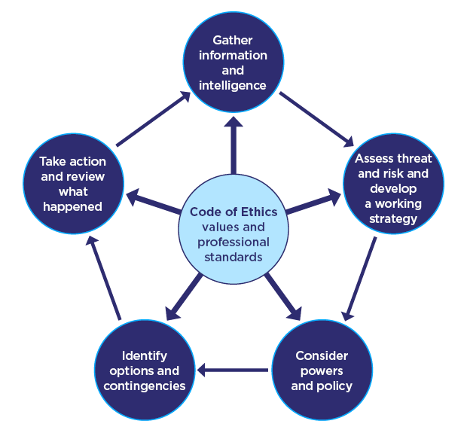

Fig. 1 The National Decision Model (College of Policing, 2014)

I will begin by describing the incident and the processes I used to make decisions. The National Decision Model (NDM) which I used throughout the incident influenced the decisions I made. The NDM is a cyclical process that enables officers to dynamically assess the threat and risk posed when deciding what action to take. Dynamic risk is constantly evolving and therefore requires re-evaluation as more information becomes available. The NDM also provides the ability to review the actions taken and the rationale behind your decision making,

I will consider the decisions I choose while using the NDM and reflect on what worked and what I would differently next time. I will explore the significance of safeguarding vulnerable individuals and the important role police have gathering information to supply partner agencies to effectively reduce the risk posed.
I will analyse the ethical approach of my decision making and proportional use of force in this incident and the justification in why I believed it to be reasonable under the circumstances. Lastly, I will look at the consideration of discretion and why in this situation it was not appropriate to effectively safeguard vulnerable individuals.

The incident was reported as an ‘Abandoned 999’ call. Police had received a short call whereby a female voice could be heard asking for help and for police to attend. In the background, raised voices could be heard and someone was crying before the call ended. The operator was unable to gather any more details, but the number was associated to a female linked on Niche. I asked the control room to check for any warning markers linked to the female. Utilising the first stage of the NDM, gathering information and intelligence is vitally important as these feed into the threat assessment. A poor effort at this stage will give a skewed threat assessment and could potentially put yourself and your colleagues at risk. The check came back with a warning marker for the female as a high-risk domestic abuse victim against her ex-partner and a critical marker linked to her address. Without confirmation of the other individuals involved it remained unknown exactly what was happening, and this would have to established upon arrival. As the incident was given a grade one priority, given the potential high threat and the unknown risk I made my way as quickly as possible.

A colleague and I arrived outside the address linked to the female. Approaching the address, you could hear people shouting at each other and someone crying. At this stage, we were unable to make out what was being said nor confirm how many people were involved. I started banging on the door whilst my colleague tried to gain access to the rear of the property to see if he could identify another way inside. I considered using my powers of entry under Section 17(1)(E) of PACE (PNLD, 2022) which enables officers to enter the property to save life or limb. It can be used in emergency situations when there is a belief that there is an immediate risk of serious or life-threatening harm. In this moment the door opened, and a female stood in the doorway holding a small child who was crying. The female looked very upset and had swelling and redness to the left side of her face. It wasn’t clear how she had sustained the injuries, but I have checked on the female and the child to assess whether they needed emergency medical treatment. It was at this moment that we discovered that the female first language was in fact Russian, and she only spoke limited English. Guiding the female and her child inside, my colleague took them in to the bedroom whilst I conducted a search of the house to locate any other persons present.

Entering the living room, I could see clear signs of a disturbance with a broken coffee table as well as smashed plates and glass covering the floor. Towards the end of the room was a male pacing back and forth. The male appeared distracted as he did not notice me at first and continued to pace back and forth muttering to himself. I noticed there was a small cut to his hand and a heavy smell of alcohol which appeared to be coming from the male. Impact factors at this stage were the size and build of the male, the potential intoxication of alcohol or unknown substance, the use of smashed glass from the floor as a potential weapon. This was in addition to the fact that I was currently unable to see my colleague who was with the female and child in the other room.

College of Policing notes a number of ‘impact factors’ that amplify situations of potential conflict resulting in a higher risk. These include factors like weapons, alcohol, prior knowledge and size/build of those involved. If any of these are evident it is important that officers, consider these as part of their dynamic risk assessment together with any other information about potential threats faced. (College of Policing, 2020)

Assessing the threat and risk of harm, we had safeguarded the female and child, but I was considering the potential harm to myself and the probability of it happening as I was dealing with this male independently. Considering my body language and tone of voice when communicating with the male as not to seem threatening as ultimately, I wanted to calm the situation and gather more information to establish what had happened.

I thought about Betari’s Box theory, and the way that people can get trapped in a continuous cycle based upon how their attitudes and behaviours influence each other’s responses. The concept states, “my attitude affects my behaviour which will affect your attitude which in turn affects your behaviour”. I considered my non-verbal communication by maintaining an open stance and allowed the male time to speak. This allowed me to control the situation as having an agitated, aggressive male only posed a greater risk of harm towards myself and others in the address. (College of Policing, 2020)

I have then been informed by my colleague that the victim has disclosed via language line that her partner has assaulted her causing the injury to her face. Referring to the NDM, with regards to identifying options and contingencies by considering the different ways in which a particular decision can be made, or situation resolved with the least risk of harm.

It was now time to act by implementing the option chosen. The presence of my colleague made the male irater and become more agitated. My colleague has then told the male that he is under arrest and the male has reacted aggressively by squaring his body towards us and I could see him tensing up. The male then made this threatening gesture of punching his fist into his hand whilst making a verbal threat towards us that he no intentions of going with us if we came any closer, he would fight.

I have considered my powers at this point with regards to use of force under section 117 of PACE states, “the officer may use reasonable force, if necessary, in the exercise of the power.” (Police and Criminal Evidence Act, 1984)
(1251 words)

Task 3

Relevant areas of the National Policing Curriculum:
Maintaining Professional Standards, Leadership and Team-working

Evaluate theories of team dynamics as a means of developing team cohesion (reasons why some teams cannot function, theories and models relating to team dynamics, ways to improve team cohesion).

Consider why inter-personal conflict can occur within a team and outline what strategies can be adopted to enhance individual and team performance.

Consider how team dynamics within the police service can result in failing to comply with professional standards requirements (Code of Ethics, policies, procedures, protocols or legislation).

1750 words (+/- 10%: include your actual word count at the end of each section)

ANSWER:

This essay will evaluate theories of team dynamics as a means of developing team cohesion and how they can be applied to policing. I will examine this application by focusing on Tuckman’s Stages of Team Development as well as Lencioni’s Five Dysfunctions of a Team.
I will also be considering why inter-personal conflicts can occur within a team and outline strategies that can be implemented. Finally, I will examine how team dynamics within the police service can result in failings in professional standards requirements.

People in a team must work together for the team to become effective. Tuckman developed a model which explores how to build an effective team consisting of five progressive stages. Tuckman discovered that most teams follow a five-stage development to lead to becoming a high performing unit. The Five stages are illustrated below;

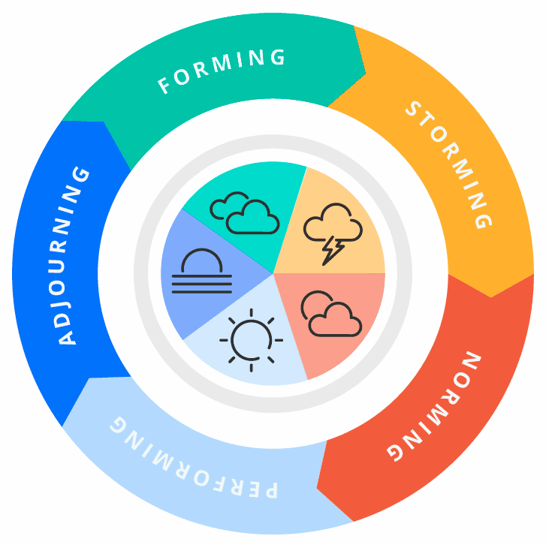
Fig. 1 Tuckman’s Model - (Teamhood, 2019-2022)

Applying the model above to my own personal experience of becoming a police officer and starting training with the police. This process would last six months over which time the team would develop and evolve through each stage presented by Tuckman resulting in a team that worked well together.

Forming
In the first box, this is the initiation stage with most of the support coming from the trainer as all new members of the team have little or no previous experience. They will naturally have lots of questions and the trainer will need to guide them in aligning their purpose. The roles at this stage are undefined and everyone reserves formalities treating each other as strangers. I found this phase challenging as there was so much new information to take in and I was slower with the processes and decision making.

Storming
At this stage, I began to gain confidence as well as other members of the team also started to communicate their feelings. I was improving my knowledge and performance but was not yet where I wanted to be. Open debate was encouraged in our early weeks of training, and this allowed for team members to confront each other challenging their ideas and opinions. There was some resistance by some of the team to challenge the trainer with them openly expressing their frustration with the expectations of the class. It was evident that we still considered ourselves individuals rather than as part of a team. In this stage, it is more imperative that the trainer guides the team so that they continue towards their goals and do not become distracted.

Norming
After 3 months, the inter-team relationships became clear and as I started to understand my role within the team as it became clearer. Members of the team realised that they could work together and accept each other’s viewpoints. This resulted in an increased level of motivation and a more of a continuous effort to resolve issues. I would participate more in team discussions and compare myself with others. The team also started to engage in social activities such as going food after lessons which increased team effectiveness.

Performing
By the end of our six months training the class was working well as a team with everyone feeling like confident decision makers. The team was flexible and functional with a focus on completing tasks together. I found myself making decisions that would benefit the team especially supporting my classmates through online revision sessions. If there was any disagreement this was resolved positively and did impact on the team. At this point, the trainer would have little involvement with all individuals feeling more capable to make their own decisions without relying on guidance.

Fifth Stage: Adjourning
In 1977, Tuckman and Mary Ann Jensen discovered that through additional research that there was a fifth stage to be included in the model called the ‘Adjourning’. After the team completes a review of its achievements and tries to accommodate those who leave the team, progressing to new roles while identifying suitable members to fill the vacancies. In my example, the whole team disbanded as it finished training and left to join already establish response teams and start the ‘forming’ stage again.

There are a variety of models which help teams perform effectively including the DISC model and the GRPI model. Another model for understanding team dynamics is Lencioni. In his book, ‘The Five Dysfunctions of a Team’ he identifies five dysfunctions which impact the effectiveness of teams. Lecioni notes that all teams can be dysfunctional and should try to overcome each level in turn working from the bottom up.

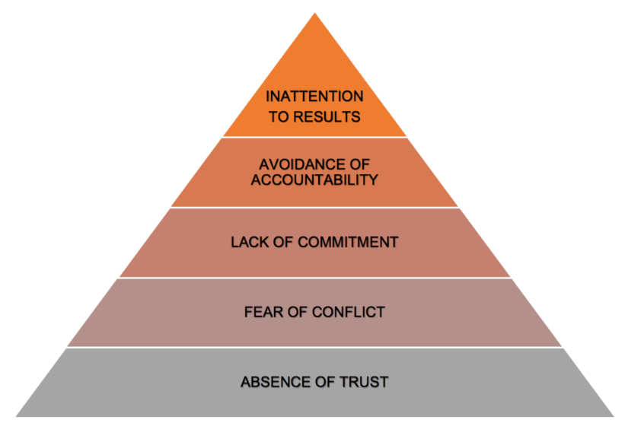

Fig. 2 Lencioni Model - (BC Campus, 2020)

After I achieved Independent Patrol Status I was moved to a new team. Over a short period of a few months, the majority of the existing members progressed on to new roles which meant they were replaced with a combination of newly trained individuals and transferees from other UK police forces. This meant that the team initially fell victim to Lencioni’s first stage ‘Absence of trust’. Members of the team were reluctant to admit their mistakes due to the lack of trust with one another. By hiding their vulnerabilities, the team struggled to develop or perform effectively. But as time progressed, the team began to find their trust in each other asking for help when needed. The team has now moved onto the ‘fear of conflict’ stage where there are currently some disagreements formulating around key issues such as workload and allocation. Team leaders are actively trying to stimulate debate for team members to discuss their opinions and have difficult conversations to avoid it coming back later.

It is vitally important that police officer work together effectively in their teams to avoid conflict. Inter-personal relationships will develop over time with some relationships being stronger and closer than others. It is expected that individual personalities will occasionally clash and to avoid have a negative impact on the overall team’s performance ensuring a professional and positive working environment is essential. Difference in opinion due to a person’s background and beliefs can permit conflict within a team. Allowing for an open discussion to address these alternative viewpoints can lead to positive change and resolve any conflict. Intervention at the earliest opportunity to resolve such conflict is essential if optimum team functionality is to be maintained. This responsibility for early action when addressing conflict should fall on the those involved as well as the line manager. If the conflict goes unresolved this could affect performance output and hinder a team’s progression to the performing stage of Tuckman’s model.

The CUDSA model is one approach to resolving conflict.

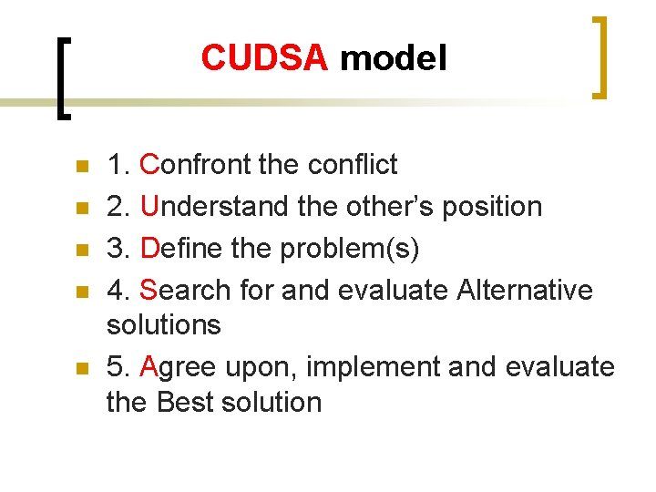
Fig. 3 CUDSA Model (Slidedoc, 2015)

The CUDSA model can be used to handle some conflicts in an informal manner. The NHS use CUDSA as part of their conflict resolution training where a conflict requires resolving in a systematic fashion. The manual states that “it is the most appropriate model for formal conflict management.” (NHS, 2020)

The Police have a clear responsibility to uphold the principle of policing by consent. Trust and confidence by the public in the police is essential to that consent. If misconduct or complaints are not dealt with openly and robustly then that trust, and confidence is undermined. The Professional Standards Department (PSD) plays a vital role in maintaining that balance. However, failures in team dynamics if not identified can lead to misconduct and a requirement for professional standards to get involved.

Using Lecioni’s ‘Five Dysfunctions of a Team’ it demonstrates how the police service can result in failing sin professional standard requirements. Lack of trust exists when individuals on the team do not ask for help and are not prepared to admit their mistakes. This can lead to individuals covering up their mistakes rather than seeking advice to correct them. Negatively impacting victims and the potential outcomes of investigations leading to police misconduct enquiries and ultimately a distrust in the police. Another aspect of Lecioni’s dysfunctions is the ‘Avoidance of accountability’ as this can create an atmosphere whereby officers are reluctant to report or call out their colleagues for inappropriate behaviour. This is evident in the ‘Operation Hotton Report’ by the IOPC which uncovered “an underlying culture allowed conduct issues to permeate, and behavioural problems went unchallenged”. The report identified two recommendations for challenging and reporting improper conduct to review the adequacy of current training and guidance around available routes to report wrongdoing and to understand the reasons why an officer has failed to report or challenge inappropriate conduct. The IOPC makes these recommendations to eradicate potential environments whereby inappropriate behaviour may go unchallenged and result in failings in professional standard requirements. (IOPC, 2022)

Should a breach in the code of ethics occur (Home Office, 2014) stipulate that the breach may not always need formal action for misconduct under the regulations. Line managers, Supervisors and Professional Standards Departments have the responsibility bestowed upon them to exercise their professional judgement when dealing with minor behavioural misconduct. This must be done in accordance with any legislation that is placed upon them. The Code of Ethics is there to provide overarching guidance on how behaviour that does meet the expectation of policing principles or standards should be dealt with.
(1522 words)

Task 4
Relevant areas of the National Policing Curriculum:
Policing the roads, information and intelligence and conducting investigations.

Explain how information and intelligence can be used in the disruption of the more prevalent criminal activity (e.g. drug smuggling, human trafficking, child sexual exploitation, counterfeit goods, organised crime groups and ‘county lines’) by effective policing of the roads.

Outline how ANPR can be used as investigative resource when disrupting criminal activity.

1750 words (+/- 10%: include your actual word count at the end of each section)

ANSWER:

This essay will explain how information and intelligence can be used by police in the disruption of criminal activity by effective policing of the roads. This will provide an understanding in how intelligence is gathered, processed, and utilised.

The National Intelligence Model (NIM) is a standardised framework to place intelligence at the forefront in disrupting and reducing crime. Intelligence is information concerning incidents, events or people which is subjected to a system of processing. The information is recorded, graded and evaluated to make it usable intelligence.

The NPCC has introduced a national strategy for policing the roads for 2022 -2025 focusing on four main objectives.
- Preventing harm and saving lives
- Tackling crime
- Driving Technology and innovation
- Changing minds

These can all be negatively impacted by serious and organised crime groups operating within the UK road network. An emphasis on the use of ANPR and intelligence becomes essential to tackle crime and target those who pose a dangerous threat to our communities.

It will also outline how ANPR can be used as investigative resource when disrupting criminal activity.

Locations of ANPR are not disclosed as this information would likely aid criminals and reduce the effectiveness of APNR to roads policing.

Vehicle drives past an ANPR camera, the camera reads the registration number and instantly checks this against a database containing a list of vehicles of interest to police. All vehicles passing an APNR camera are recorded even those that are not on the list so that they may be accessed at later date for investigative purposes.

Locations of ANPR are not disclosed as this information would likely aid criminals and reduce the effectiveness of APNR to roads policing.

Vehicle drives past an ANPR camera, the camera reads the registration number and instantly checks this against a database containing a list of vehicles of interest to police. All vehicles passing an APNR camera are recorded even those that are not on the list so that they may be accessed at later date for investigative purposes.
(337 words)

Task 5
Individual Learning Plan

The second learning outcome identified in the accompanying module descriptor (BMPP 5000D) asks that you create an individual learning plan to meet your identified needs through reflection upon your continuing practice. This shows confidence in your ability to manage your own learning in response to evolving circumstances in the workplace.

This task differs from the PDPs that you have completed in your previous workbooks in that this learning plan allows you to assess what level you believe you are in key knowledge, skills and experience against where you believe you (and the force) consider you should be – now and in the coming 6 to 12 months of your placement. This should then be used to target future development need.

1500 words equivalent. Please note that this is not the actual number of words used in completing the table, the count reflects the thought and research behind it.

It will count towards the overall equivalent word count of 8000 words expected from this module.

ANSWER:

Knowledge, Skills and Experience Assessment

 | REQUIRED |  |  | RATING |  |  | DEVELOPMENT NEED
KNOWLEDGE  Sexual Offence First Responder (SOFR) | Low  1-4 | Med  5-7  7 | High  8-10 | Low  1-4  4 | Med  5-7 | High  8-10 | My knowledge of sexual offences is limited to what was obtained in training. I have since going operational attending a few sexual offence reports with a SOFR trained officer. I have observed them and gained a little more knowledge about sexual offfences and what needs to be actioned by the initial attending officer. I have completed training packages on the College of Policing as well as booked on to SOFR course which I believe will help further my understanding of sexual offences as well as how to deal with a victim of a sexual offence.
SKILLS  Taser usage | Low  1-4 | Med  5-7 | High  8-10  8 | Low  1-4 | Med  5-7  5 | High  8-10 | I have recently completed and passed my Taser X2 course. This has provided me with the skills necessary to discharge and effective use of a taser. Although, I have been trained I have yet to use my taser operationally so it is vitally important that I maintain the high standards taught to me on the course. I will continue uphold these standards and be prepared for when the situation that is appropriate and reasonable to use the taser. This will also maintain the skills necessary to hopefully pass the refresher course which must be conducted annually.
EXPERIENCE  Dealing with Traffic offences | Low  1-4 | Med  5-7 | High  8-10  8 | Low  1-4  3 | Med  5-7 | High  8-10 | I have only dealt with a handful of traffic offences. These were mostly in my tutorship and since obtaining IPS I have had very limited experience. I have dealt with an RTC and conducted a roadside breath test but that is it. Due to changes in policy I will no longer undertake a traffic attachment. So I contacted RPU to make arrangements to complete a shift with a traffic officer. This I hope will provide me with the experience necessary to feel more confident in dealing with traffic offences.

Bibliography
The bibliography should only include sources referenced within the workbook using the Harvard referencing system. Information about referencing in written assignments and how to avoid plagiarism can be found on Moodle. It is important that you are aware of the importance of ensuring that the work submitted is your original work.

BBC News, 2021. Bibaa Henry and Nicole Smallman: Met PCs jailed for crime scene images. [Online]
Available at: https://www.bbc.co.uk/news/uk-england-london-59474472
[Accessed July 2021].
BC Campus, 2020. 4.2 Five Models for Understanding Team Dynamics. [Online]
Available at: https://pressbooks.bccampus.ca/technicalwriting/chapter/understandingteamdynamics/
[Accessed July 2022].
College of Policing, 2014. National Decision Model. [Online]
Available at: https://www.college.police.uk/app/national-decision-model/national-decision-model
[Accessed July 2022].
College of Policing, 2020. Conflict Management Skills. [Online]
Available at: https://www.college.police.uk/guidance/conflict-management/conflict-management-skills
[Accessed July 2022].
Home Office, 2014. Police Officer Misconduct, Unsatisfactory Performance and Attendance Management Procedures, London: UK Gov.
iNews, 2021. Police officers facing mental health crisis as three-quarters faced difficulties in last year, report finds. [Online]
Available at: https://inews.co.uk/news/uk/more-than-three-quarters-police-officers-struggled-with-mental-health-last-year-report-finds-1119989
[Accessed July 2022].
IOPC, 2022. Operation Hotton: Learning Report, London: Independent Office for Police Conduct.
Mind, 2019. Nearly 8 in 10 police officers recently felt stressed, finds Police Federation. [Online]
Available at: https://www.mind.org.uk/news-campaigns/news/nearly-8-in-10-police-officers-recently-felt-stressed-finds-police-federation/
[Accessed July 2022].
NHS, 2020. Conflict Resolution Training NHS Workbook. s.l.:IKON Training Ltd.
Open University, 2022. 7 Developing an effective team culture. [Online]
Available at: https://www.open.edu/openlearn/money-business/leadership-management/step-leadership/content-section-8
[Accessed July 2022].
PNLD, 2022. Legal Q&A. [Online]
Available at: https://www.pnld.co.uk/article/?id=8e92899b-f5b3-ec11-983f-6045bd103e61
[Accessed July 2022].
Police and Criminal Evidence Act, 1984. Power of a constable to use reasonable force. s.l.:UK Public General Acts.
Slidedoc, 2015. Working in a Team by Dr Fadel Naim. [Online]
Available at: https://slidetodoc.com/working-in-team-by-dr-fadel-naim-consultant/
[Accessed July 2022].
Teamhood, 2019-2022. Team Development Cycle – from Forming to Performing. [Online]
Available at: https://teamhood.com/team-performance-resources/team-development-cycle/
[Accessed August 2022].

