MOdule name: Software development LECTURER: SUNETH Fernando
Student Name: Asan Rafail
Student number 2112905 | Date: 27 Apr. 22
software development- assesment 1

Table of Contents
What is variable and why are they important in writing programs? 2
What an if/else statement is? 2
Why are loops needed in programming and when you might use a for and while loop? 3
What exactly is Loop? 3
What is the meaning of For Loop? 3
What exactly is a While Loop? 3
Exercise 1 4
Example 1 4
Example 2 4
Exercise 2 5
Example 1 6
Example 2 6
Exercise 3 7
Exercise 4 9
Pairs 9
References: 11

What is variable and why are they important in writing programs?

A Python variable is a memory region set aside for storing values. A variable in a Python programme, in other words, provides data to the computer for processing. In Python, each value has a datatype. Numbers, Lists, Tuples, Strings, Dictionary, and more data types exist in Python.

What an if/else statement is?

[1] The if-else condition is used to execute both the true and false parts of a condition. The if block code is run if the condition is true, and the else block code is executed if the condition is false.

Figure 1
Operation of If/else
statement
flowchart

text expression
false

true
body of if
body of else

Figure 2 Input Example of If/else statement code
# Program checks if the number is positive or negative
# And displays an appropriate message
num = 3

# Try these two variations as well.
# num = -5
# num = 0

if num >= 0:
print("Positive or Zero")
else:
print("Negative number")
Figure 3 Output of Figure 2 Input
Positive or Zero

Why are loops needed in programming and when you might use a for and while loop?

What exactly is Loop?
[2] Loops can repeat a section of code until it meets a certain criteria. Their use in programming is quite prevalent. Unlike other programming languages that contain For Loops, While Loops, Dowhile Loops, and so on, Python does not have these features.

What is the meaning of For Loop?
[2] To iterate through members in a series, the for loop is used. It's frequently used when you have a piece of code that must be repeated "n" times.

Example For loop
1 #
2 #Example file for working with loops
3 #
4 x=0
5 #define a while loop
6 # while(x <4):
7 # print x
8 # x = x+1
9 #Define a for loop
10 for x in range(2,7):
11 print(x)
Output
2
3
4
5
6

With the number declared in the range, the For Loop iterates.
As an example,
Loop for x in the range (2,7)
When this code is run, a number between 2 and 7 will be printed (2,3,4,5,6). The number 7 is not included in the range of this code.

Not only may For Loops be used for numbers, but they can also be used for a variety of other things.

What exactly is a While Loop?
[2] While Loop is a programming construct that is used to repeat a piece of code. It executes the code block several times until a given condition is fulfilled, rather than just once.

Example for While loop
1 #
2 #Example file for working with loops
3 #
4 x=0
5 #define a while loop
6 while(x <4):
7 print(x)
8 x = x+1
Output
0
1
2
3
Variable x is set to 0 on line 4 of the code.
Line 7 of the code: The while loop checks for condition x4. x is currently set to 0. The situation is correct. While Loop is active, the flow of control enters.
Line 8 of the code: The value of x is printed.
Line 9 of the code: x is increased by one. The control flow returns to line 7. x now has a value of one, which is less than four. When the condition is true, the while loop is repeated once again. This continues until x equals 4, at which point the while condition is false.

Exercise 1
Show how variables can contain different types of values by declaring three variables that will contain a name, a measure of height and a person’s age. Prompt the user to input these values and display them on the screen. The variables should be appropriately typed for the data required.

Example 1
Input:
print ("Welcome to Exercise 1 programme solution")
name = str(input("Please enter your name: "))
age = int(input("Please enter your age: "))
height = float(input("Please enter your height: "))
print("Thanks, you entered:", name, str(" - "), age, str("years old"), str(" - "), height, str(" cm tall"))
Output:
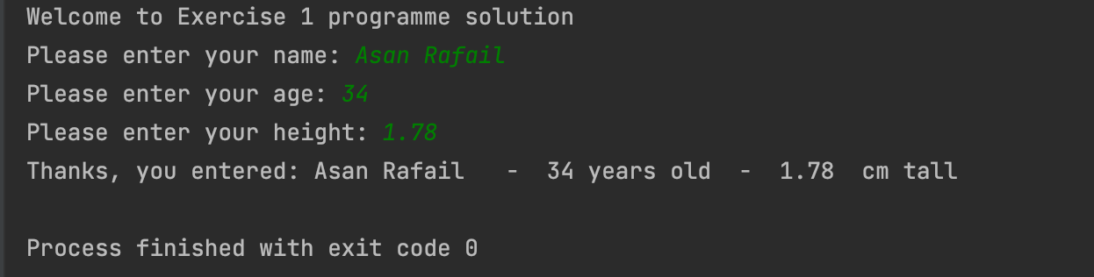

Example 2
Input:
print("Welcome to Exercise 1.1 programme solution")
name = str(input("Please enter your name:"))
age = int(input("Please enter your age: "))
height_in_metres = float(input("Please enter your height in metres:"))
max_height = 3.0
if height_in_metres >= 3.0:
print("Unless you are a giant, that seems a bit high! Please enter a new value")
height_in_metres = float(input("enter height in metres:"))
print("Thanks, you entered:",name, " - ",age, " years old - ",height_in_metres, "cm tall")
Output:
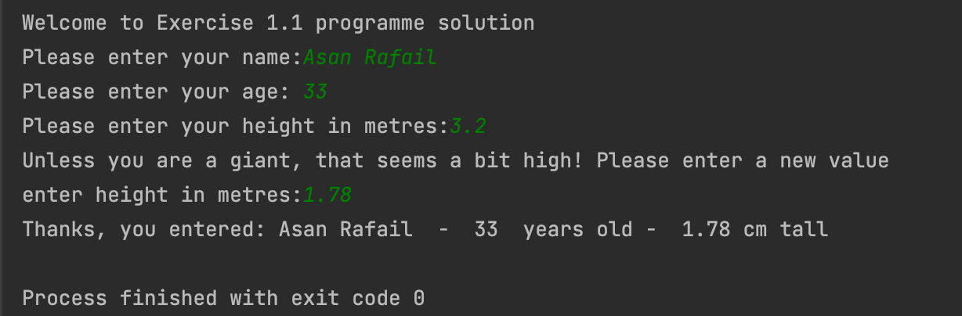

Exercise 2
Allow user to enter dimensions of shapes shown below (in cm), then calculate the area of the blue shaded part. Note: The square and rectangular areas are empty.

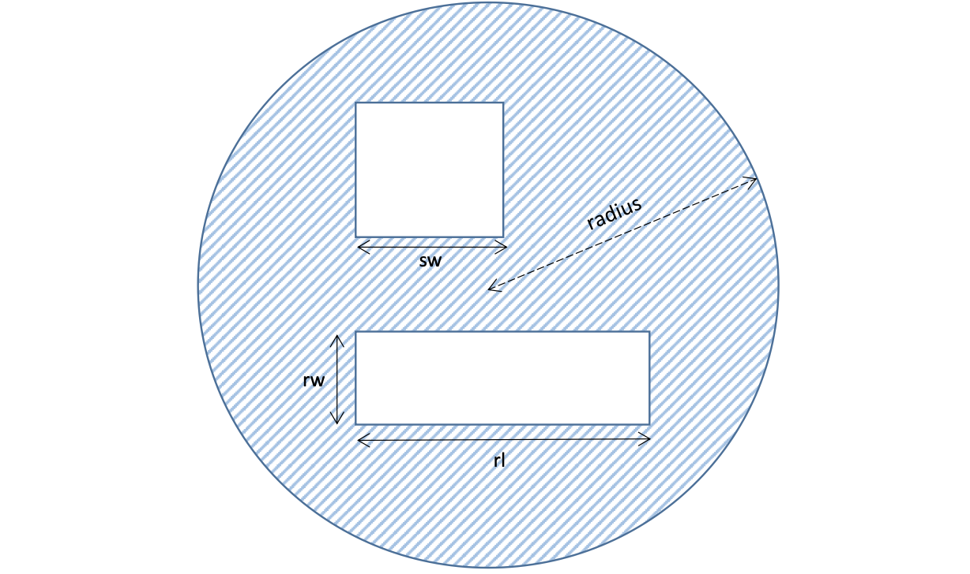

Example 1
Input:
print("Welcome to Exercise 2 programme solution")
from math import pi
r = float(input("Please enter radius of the circle: "))
r = pi * r ** 2
b = float(input("Please enter side of square: "))
c = float(input("Please enter width of rectangle: "))
d = float(input("Please enter length of rectangle: "))
square=b*b
rectangle=c*d
shaded_area = r - (square+rectangle)
print("The shaded area is: ", shaded_area, str("cm"))
Output:
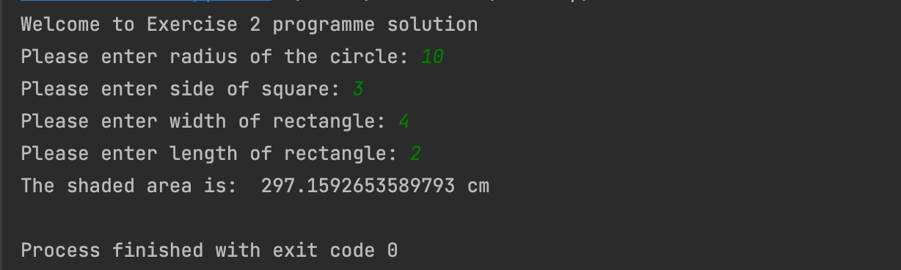

Example 2
Input:
print("Welcome to Exercise 2.2 programme solution")
from math import pi
r = float(input("Please enter radius of the circle: "))
r = pi * r ** 2
b = float(input("Please enter side of square: "))
c = float(input("Please enter width of rectangle: "))
if c>=10:
print("That seems a little big, please try again")
c = float(input("Please enter width of rectangle: "))
d = float(input("Please enter length of rectangle: "))
square=b*b
rectangle=c*d
shaded_area = r - (square+rectangle)
print("The shaded area is: ", shaded_area, str("cm"))

Output:
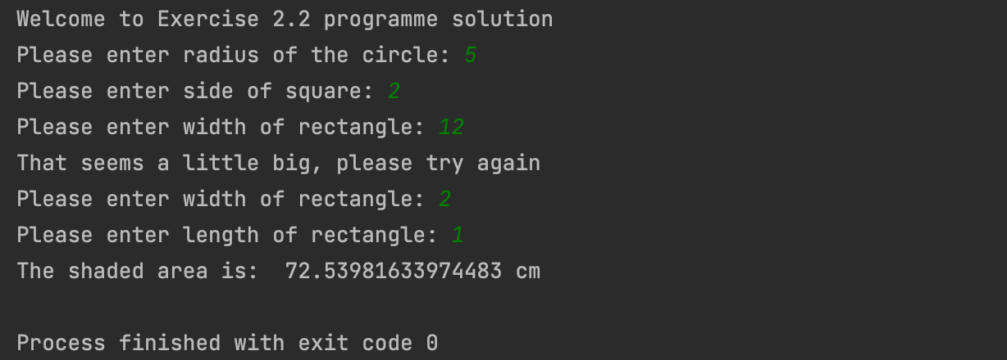

Exercise 3
Write a program that allows the user to enter car mileage (per day) for a week. When the mileage has been entered, calculate the total mileage. Finally, calculate the total cost of petrol for the week, at the rate of £1.35/litre and 11.2 miles to the litre. Use a list/array and loop(s) where appropriate.

Input:
def is_digit(string):
if string.isdigit():
return True
else:
try:
float(string)
return True
except ValueError:
return False
def insertMiles():
miles = input()
if is_digit(miles):
miles = float(miles)
else :
print("Please try again")
miles = insertMiles()
if miles < 0:
print("Please try again...")
miles = insertMiles()
return miles
if "main" == "main":
rate = 1.35
consumption = 11.2
WeekDays = ["Monday:", "Tuesday:", "Wednesday:", "Thursday:", "Friday:", "Saturday:", "Sunday:"]
totalMileage = 0
for day in WeekDays:
print("Enter miles for {0}".format(day))
totalMileage += insertMiles()
rez = (totalMileage / consumption) * rate
# I was displaying the message
print("The total mileage was: {0}".format(round(totalMileage,1)))
print("Cost of petrol: {0}".format(round(rez,2)))

Output 1:
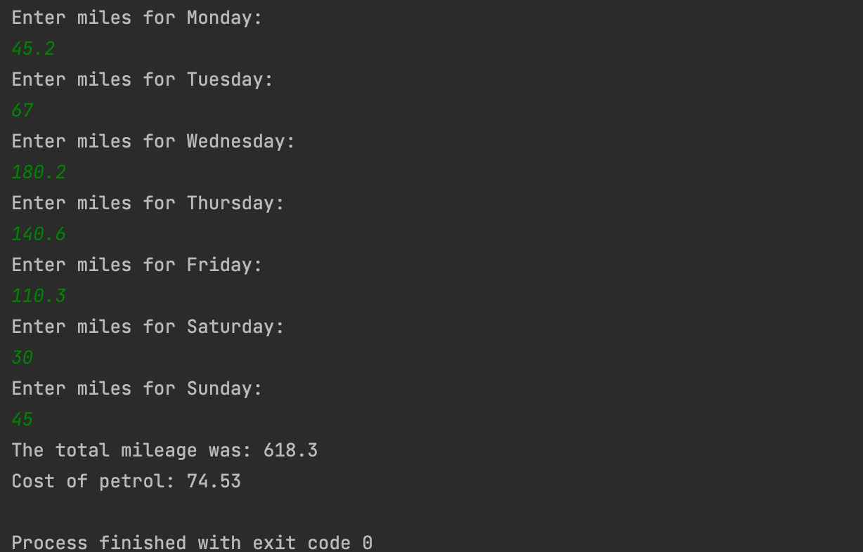

Output 2:
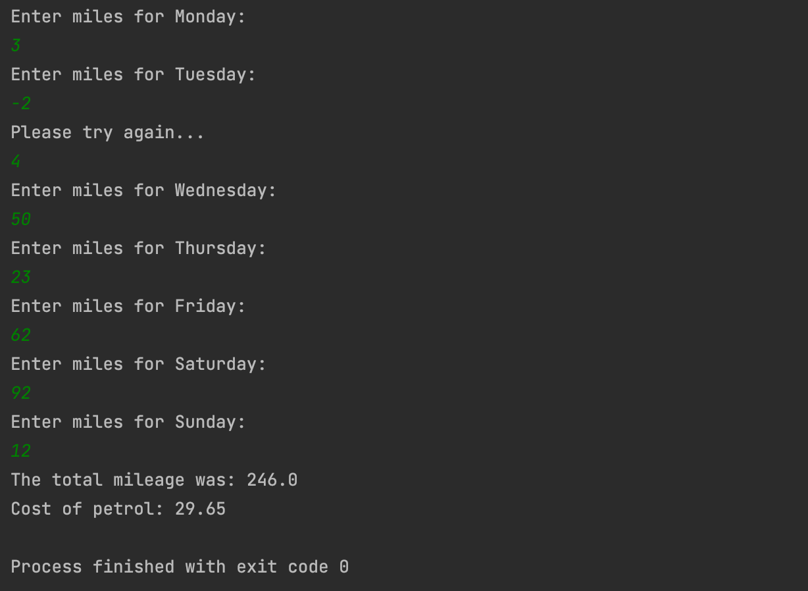

Exercise 4

Pairs
Input:
def showGameArea(GameArea):
indexArea = ""
infoArea = ""
index = 0
for item in GameArea:
indexArea += str(index) + "\t"
index += 1
infoArea += item + "\t"
print(indexArea)
print(infoArea)
def getGuess(nr,GameArea,firstGuess = -1):
print("Please enter guess {0}".format(nr))
guess = input();
if guess.isdigit():
guess = int(guess)
else :
print("You must enter the number... Try again")
guess = getGuess(nr, GameArea, firstGuess)
if guess < 0 and guess > GameArea.length:
print("This position is not available... try again")
guess = getGuess(nr, GameArea, firstGuess)
if GameArea[guess] == 'X':
print("This position has already been... try again")
guess = getGuess(nr, GameArea, firstGuess)
if firstGuess == guess:
print("You cannot enter 2 identical digits... try again")
guess = getGuess(nr, GameArea, firstGuess)
return guess
def CheckPairs(nr1, nr2, GameList):
if GameList[nr1] == GameList[nr2]:
return True
print("Not a match. Position {0} was {1} and position {2} was {3}".format(nr1, GameList[nr1], nr2, GameList[nr2]))
return False
def ChangeGameArea(nr1, nr2, GameArea):
GameArea[nr1] = 'X'
GameArea[nr2] = "X"
def name == "main":
pairs = 5
turns = 1
Objects = ["dog", "cat", "mouse", "phone", "money"]
GameList = [Objects[0], Objects[0], Objects[1], Objects[1], Objects[2], Objects[2], Objects[3], Objects[3], Objects[4], Objects[4]]
GameArea = ['?', '?', '?', '?', '?', '?', '?', '?', '?', '?']
GameFlags = True
print("Welcome to the pairs game! There are {0} pairs to find".format(pairs))
while GameFlags:
print("You've had {0} turn(s) so far".format(turns))
showGameArea(GameArea)
guess1 = getGuess(1 ,GameArea)
guess2 = getGuess(2, GameArea, guess1)
if CheckPairs(guess1,guess2,GameList):
ChangeGameArea(guess1,guess2,GameArea)
pairs -= 1
if pairs == 0:
GameFlags = False
print("Well done, you got them all. You did it in {0} turns".format(turns))
turns += 1
Output:
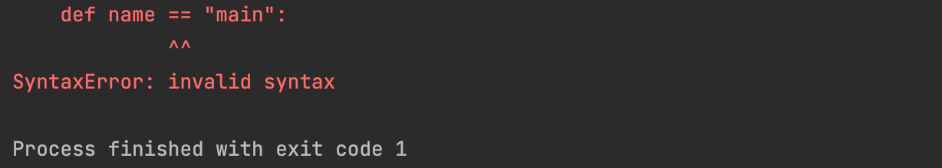
My programme wasn’t executable. I applied the logic behind it with the best of my knowledge but still I couldn’t make it work.

References:
[1] A. Biswal, “Understanding Python If-Else Statement,” Simplilearn.com, Feb. 07, 2022. https://www.simplilearn.com/tutorials/python-tutorial/python-if-else-statement (accessed Apr. 11, 2022).
[2] S. Campbell, “Python For & While Loops: Enumerate, Break, Continue Statement,” www.guru99.com, Mar. 12, 2022. https://www.guru99.com/python-loops-while-for-break-continue-enumerate.html (accessed Apr. 11, 2022).

