ECAD5008 Caitlin Bayliss-Clark
Student number:2200631

BA Primary Education with QTS

A written assignment critically evaluating how Assessment for Learning can be utilised in a series of learning opportunities to aid progression across chosen areas of learning and experience. (3973 Words)

Assessment for Learning can be utilised in a series of learning opportunities to aid progression in a variety of areas of learning and experience (AoLE). I will explore this throughout my research in order to determine how it is utilised in addition to the benefits and consequences that follow it. This is important in determining the best AfL strategy for the individual child and to be aware of where the child is currently in regard to their progression holistically and their future steps. I will do this by designing three lesson plans in line with the Athrofa guidelines, implementing AfL strategies that I believe would be beneficial for that particular lesson and assess if there were a better alternative that would aid the child more. These lesson plans will be aimed at a year three class which will be aged seven to eight and whom will be at various stages of progression. The lessons I have created will be at the beginning (see lesson plans A), the halfway point (See lesson plan B) and coming up towards the end (See lesson plan C) of their learning in the selected AoLE’s. They will be used to assess at what point of their progression they are currently in and what needs to be done to help them progress even further and close the gap within their learning.
It is argued by Paul Black and Dylan Wiliam (1998) that there is not enough focus on feedback but too much focus on marks and grades. Clear and effective use and quality of feedback allows teachers to effectively pass on comprehensive feedback to learners so that the learners can better understand the steps needed to improve. The learner and the teacher are able to communicate with each other to better learn where the learner currently is, where they want to get to and what’s the best way to get there.
The 3 AoLE’s I have chosen to focus on are Mathematics, Languages, Literacy and Communications (LLC), and Humanities. The new Curriculum for Wales argues argues that Mathematics plays a vital role in day-to-day life. It is important that mathematical skills are developed, and progression recorded to help learners focus in on these skills to help them navigate real life events. It is stated that Mathematics “can help the learners become healthy, confident individuals, ready to lead fulfilling lives as valued members of society” (Curriculum for Wales, 2019). LLC allows learners to develop their own sense of identity and learn to communicate clearly and efficiently. It helps learners develop a greater understanding of everything around them including the world and other people. Developing LLC skills can improve access to new opportunities allowing children to meet new people and continue to develop these skills (Curriculum for Wales, 2019). The humanities area of learning contains aspects of history, religion, social studies, geography, values and ethics. This can allow for the introduction of further studies of humanities like psychology and sociology further on their education. This area helps them learn about their human rights and how worldwide aspects like religion can influence the world. This area also allows them to explore their own personal views and identify their own beliefs and values. By understanding their own beliefs, the learners are likely to have a better understanding of other people's beliefs and will become more respectful of that (Curriculum for Wales, 2019).

There are six AoLE’s altogether and within these areas are twenty-seven ‘What Matters Statements’ split between the six AoLE’s which have been built into the new Curriculum for Wales. Within these what matters statements are a variety of progression steps. The newly implemented focus on the ‘What Matters Statements’ and the progression steps allow for a more focused and strategic assessment for learning, allowing for increased validity surrounding AfL (Donaldson, 2015). There are three main principles of AfL in order to develop the child’s learner, consisting of “supporting individual learners on an ongoing, day-to-day basis”, “identifying, capturing and reflecting on individual learner progress over time” and “understanding group progress in order to reflect on practice.” (Curriculum for Wales, 2020). There are four areas of AfL (Assessment for Learning).
One area of AfL is Sharing criteria with learners which allows the students to understand better what is being expected of them and their quality of work. If the learner's success criteria are explained in clear and simple terms that they can understand from the very beginning and continually reiterated throughout their learning, they will be able to achieve more as they understand and are reminded of the expectations that are set out for them. Monty (1997) argues that not enough emphasis is placed on where the learners were at with their previous teachers, if more focus is put on this then a more accurate and learner appropriate success criteria can be developed. This would result in higher levels of achievement and higher levels of learner confidence. By removing the idea of competition and comparison to other learners, instead focusing on what each child needs to work on from analysing their formal assessments, the learners are more likely to accept what is being told to them and be aiming for success (Monty, 1997). A specific and learner focused success criteria allows for this to be attainable. Within my lesson plans designed for this assignment, I have set out a very clear success criteria, made specifically to the learners needs based on seeing what content the learners had covered in their previous year of school and observing where they are currently at (See Lesson Plans A, B and C). In my lessons I will have the success criteria written up clearly on the board. I will ask the learners beforehand what they think I’m expecting from them and then set out my expectations. The learners will be reminded of the success criteria throughout as I mark as they work. I will remind them of and refer them to the success criteria.
Another area of AfL is Quality of Questions; the Assessment for learning and the National Literacy and Numeracy Framework (2013) argue that open questions allow us to better our understanding of what our students know and what we can do for them. This encourages a more in-depth explanation of what they know compared to being asked closed questions with a basic yes or no answer. Monty (1997) argues that whilst this is a good method of understanding the learning that’s taken place, the actual quality of questions asked still needs to be greatly improved. For example, the thinking time provided by teachers is less than 3 seconds. Wasik (2018) studied a variety of studies that showed most teachers in the studies waited one to one and a half seconds before expecting the learners to answer. This does not allow learners enough time to come up with and provide a comprehensive answer. Improvements need to be made on the response time provided as well as the actual questions. It is argued that a longer wait time allows the learners to come up with better and more elaborate responses, as well as coming up with follow up questions if they don’t understand (Wasik, 2018). Another point of argument would be as Monty (1997) believes; the learners will simply wait for another student who frequently answers questions to put their hand up in response. Open ended questions allow the learners to provide a better response based off of what they have learnt and opens the question up to whole class discussion, whereas using a nominal questioning strategy allows for satisficing theory. Satisficing theory (Simon, 1947) is based off the idea that when faced with multiple choice questions, such as yes and no questions, or questions that are particularly difficult to comprehend, the learners will choose the easiest possible answer or the answer they think the teacher wants to hear.
Another AfL strategy is the Use and Quality of feedback. This is known to provide learners with clearer instructions on how to better their work (Carless, D 2017). It is argued that students benefit greatly from AfL strategies like feedback when it is not judgemental, and the students are actively involved in their learning development (Stiggins, R. J. 2002). This is supported by Monty Neil (1997) who argues that if less focus is placed on marks and grades, but more focus put on direct feedback, we can take away the negative impact that comes with AfL and boost the learner's confidence. However, he also argues that when positive reinforcement is applied in the classroom setting such as gold stars, many students end up being reluctant to try anything challenging and develop a fear of failure as their peers would be receiving rewards and they won’t. This fear and embarrassment of failure can prevent the child from challenging themselves and developing their learning further. Within my lesson plans, I have implemented feedback techniques that provide both positive and negative feedback. I have found from my personal experience and discussions with other teachers that learners have responded very well to ‘Two Stars and a Wish’. It allows me to give the learner some positive feedback on their work and identify one aspect of their work which I think they should work on the most. I have found that the learners do not become overwhelmed when they are given one target to work on (See lesson plan A). It also allows the learners to see clearly what they should work on to develop their work even further. This feedback can be provided orally or in a written format, depending on the child’s reading ability and comprehension skills. This is supported by Webb and Jones (2009) as they argue Two Stars and a Wish allow teachers to take their time and come up with suitable feedback and allows the teacher to follow up with as much or as little verbal feedback as they see fit. Webb and Jones (2009) also argue that this method did not allow for any contradictions or confusion within the feedback provided. Monty (1997) also argues that evidence of what needs to be improved on and their achievements must be provided so learners can see exactly what it is that they’re working with.
This leads to another AfL strategy which is Peer and Self-assessment. Stiggins (2002) argues that allowing children to peer and self-assess their learning lets the children feel in control of their learning and helps them build confidence, allowing continual development with a high level of self-esteem. This high level of confidence suggests that learners will be less likely to be discouraged from learning. Children are then able to see their own progress through self-assessment and see far they have come in terms of their learning. Webb and Jones (2009) argue that peer assessment has vital links to sharing criteria as it allows the learners to re-assess the success criteria and learn from other learner’s work. Zariski (1996) argues in support of this suggesting that peer-assessment allows learners to have more ownership of their work and to see their failures as opportunities instead. It is also suggested by Laverick (2007) that peer assessment is beneficial to metacognition: the “knowledge and understanding of your own thinking” (Cambridge Dictionary). It allows them to develop the awareness of learning and what works best for them as the learner. However, Lindblom’s (2006) study suggests that some learners found it more difficult to self-assess than peer assess as they struggled to remain impartial about their own work. This is supported by the Cambridge International Education Teaching and Learning Team who argue that all the above-mentioned areas can help support the development of a child’s learning provided that their used effectively.

For my first lesson plan I have chosen to focus on the Humanities Area of Learning and Experience (AoLE). The What Matters Statement I have chosen for this lesson is “Enquiry, exploration and investigation inspire curiosity about the world, its past, present and Future.” (Curriculum for Wales, 2019). I chose this statement because for this is the beginning of their learning for the chosen topic. Following this statement, I chose to focus on progression step 2.2 (See Lesson Plan A- Meaningful Links to Curriculum). I chose this progression step as I believe it is attainable to all the learners in the class, however, whilst many may excel at this progression step it allows me to see which individuals need further encouragement with participating with others as well as developing their independence. This learning episode also links the Languages, Literacy and Communications AoLE. More specifically, the What Matters Statement “Understanding languages is the key to understanding the world around us” (Curriculum for Wales, 2019), focusing on progression step 2.3 and progression step 2.4 (See Lesson Plan A- Meaningful Links Across the Curriculum). Despite this crossover, my focus is humanities, so the learning intention of the lesson is to ask and answer questions about what has just been learnt. I have chosen to introduce the lesson with a PowerPoint with the main points about the topic. I will ask the learners a variety of questions throughout the introduction portion of my lesson (See Lesson plan A-Intro). As I have previously mentioned, the Assessment for learning and the National Literacy and Numeracy Framework (2013) suggests that questioning allows us as practitioners to have a clearer understanding of the information the learners are taking in and what they don’t understand. This way I can adjust my method of teaching to better suit the learners, my explanation and reading of the PowerPoint can be adapted so it’s simpler for them to understand if that’s the case. After an in-depth class discussion about the topic, the learners will discuss and write down in their mixed ability groups questions that they could ask or would like to ask the two main people in our topic. I chose to do this task in mixed ability groups as I felt that many learners would benefit from a whole class discussion, it allows them to hear other perspectives and ideas that they may not have thought of themselves. This is supported by Hallam and Ireson’s (2006) study which argues that in mixed ability teaching, the higher ability learners were facilitating and supporting the lower ability learners. This task will take approximately ten minutes. Following this we will then move on to a Hot-Seating task where two learners will sit in the ‘Hot-Seat’ and answer using their imagination and current knowledge to answer the questions that the learners came up with in their groups. The expectation is that the questions will be what the learners would like to know or questions beginning with ‘How did you feel when…?’, ‘Why did you…?’. We will then sum up our learning at the end of our lesson using a KWL chart. As a class, the learners will feedback to me what they now know about the topic (k) and what they would like to know next (W). We will leave the what I have learnt (L) column empty until our follow up topic on the lesson. We will use the W column as a foundation for our next lesson so I can develop a lesson based on what the children would like to know about the topic. I chose to do a KWL chart in this manner as I feel as though it is a good way for me to find out what the children would like to learn so that they’re engagement levels are increased further in the following lesson. Cook (2023) argues that KWL charts allows the learners to feel more in control of their learning and excites them. This will be my main method of AfL for the lesson, seeing what the children can recap from the lesson and take note of what they would like to learn. This will give me a better understanding of the information that they have absorbed from the lesson and allow me to know what I need to do in order to help learners progress effectively.
For my second lesson plan, I will be primarily focussing on Languages, Literacy and Communications (LLC) with crossovers to science and technology. The What Matters Statements I have chosen to focus on are “Expressing ourselves through languages is key to communication” (Curriculum for Wales, 219) and “Understanding languages is key to understanding the world around us.” (Curriculum for Wales, 2019). I made the decision to focus on these statements for this lesson as this lesson plan is taking the role of a follow up from a previous learning experience on instructional words or sequence adverbs. Within these statements I chose to narrow in on progression steps 2.19 and 2.10 (See lesson plan B-Meaningful links to Curriculum). I chose these progression steps as they show what it is I am looking for within the lesson and what I aim to get across to the children. The learning intention is to be able to write instructions in a clear sequence. This task is intended to be appropriate to all the learners in the class as I will put the class into their learning groups, lower, middle and higher. The lower ability group will be able to write simpler sentences whilst the middle and higher groups can compose more complex and extended sentences. The introduction of the lesson will take place as a whole class activity to activate prior knowledge and recap the previous learning that had taken place (See lesson plan B). It has been argued that activating prior knowledge has shown to have unequivocally positive effects (Kostons and Van Der Werf, 2015). I will use open questions to help guide the lesson in the correct direction, this will also open up the lesson for full class contribution in which I can implement AfL strategies such as observing participation and engagement levels and conduct verbal feedback with questions such as ‘How did you find this task?’. Another method of AfL that I will implement would be thumbs up/ thumbs down to see if everyone understands and if anyone is unsure of what we’re discussing or about to set off to do. Whilst on the main task of writing up their instructions on a discussed topic such as ‘How to make a Jam Sandwich’, each learning group will be provided with a displayed success criteria for them to follow to help them understand and be reminded of what is being expected of them. This can be glued into their workbooks as the success criteria will differ for each group because each group will be at different levels of ability. I will walk around the groups, observing individuals and if I notice a common misconception, I will call for a ‘pit-stop’ and we will discuss what went wrong and how we can correct this misconception. The Estyn report (2022) is in support of ‘pit-stops’, the report tells us that teacher feedback has concluded that pit stops do not interrupt the structure of the lesson.
For my third lesson plan, I have chosen to focus on mathematics with crossovers to LLC. I have chosen to focus on the What Matters Statement “The number system is used to represent and compare relationships between numbers and quantities.” (Curriculum for Wales,2019). Within this statement, I chose to focus on progression steps 2.10 and 2.11 (See lesson plan C). I made the decision to focus on these steps as it allows me to recap with the learners what they know about their times tables. The learning intention is for them to read and answer mathematical questions. The learners would have learnt their two- and five-times tables through song, so to activate their prior knowledge we will sing these songs as a class. I will observe those who are not participating and therefore encourage participation and engagement. We will also introduce the three- and four-times tables to recap for those who already know it and those who need further introduction to it. The learners will then be split into their ability groups and given a pirate themed task. They will have to read the multiplication question on the card and match it up to the correct answer on the treasure chest card. These multiplication questions will vary for each ability group. The lower ability will focus on their two- and five-times tables whilst the middle and higher ability groups will focus on three- and four-times tables. The lower ability will have the class TA to sit with them and work with them directly whilst I walk around the class and check how everyone is getting on. I will put ‘pit-stops’ in place if I see any common misconceptions that need correcting and just to check how everyone is feeling about the task. The lesson will end with a game as their plenary. This will consolidate the learning that’s just taken place and allow them to receive the benefits of working as a whole class. The learners will play ‘Hot potato’, they will pass around a teddy in a circle and answer the timetable they have been asked as quickly as they can. If they get it wrong, they must sit down until the next person gets their question right. This allows for them to see that it’s okay to get answer wrong and they won’t miss out on any learning. The chosen timetable will be one that they are all somewhat familiar with to continue to develop and enhance their skills. It is argued that mental maths increases the learner’s confidence levels as well as activity in the learner’s prefrontal cortex, allowing them to exercise this can help with decision making and communication (Keith McNulty,2022).
Throughout planning the learning episodes below, AfL has been my primary focus. Some of the strategies that I have implemented into the learning episodes are strategies that I have implemented in my own classes. Even though I have implemented the AfL strategies I think would best benefit this class, there’s no guarantee that they may all work. What I have personally tried in the past with my previous classes may not work with a different class. I may have to adapt them or even dismiss a strategy entirely; this is completely dependent on the needs of the child and how best I can support them holistically. There is a possibility that whilst all the above AfL have their benefits. They also have their limitations, the children may not respond to particular strategies, ‘pit stops’ may interrupt the flow of the lesson or there may be children who need more advanced forms of AfL and support. For this, I would recommend visual aids for the learners to help communicate how they’re feeling about the progress or what they think they need more support with. A one-to-one teacher would also be greatly beneficial for students who need a considerate amount of extra support. The one-to-one can relay any observations they’ve made to myself, and we can work together to put extra strategies in place that they will respond to. This would be greatly beneficial to those with any additional learning needs ranging from autism to a speech impediment. It allows those who lack the communication skills needed, to be able to communicate with us as practitioners as well as develop different ways and skills to communicate. Assessment for learning can be utilised in a variety of different ways as shown by the lesson plans previously discussed. As I have also looked at, there are a variety of different forms of AfL that may be better suited to some learners than others. Whilst some learners may benefit greatly from a clear success criterion, some may find that quality of feedback is more favourable to their needs. Understanding AfL is vital in order to be able to know where your learners are currently at, where they need to be and how we, as practitioners, can get them there.

Appendix:
Lesson plan A:
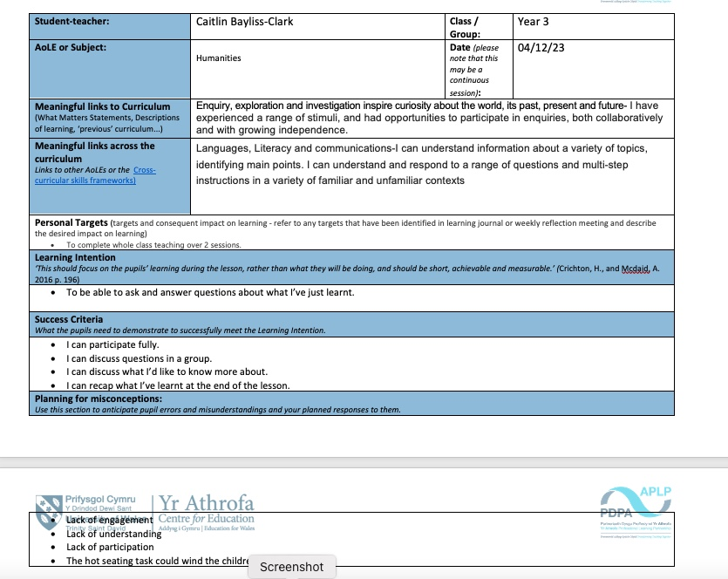

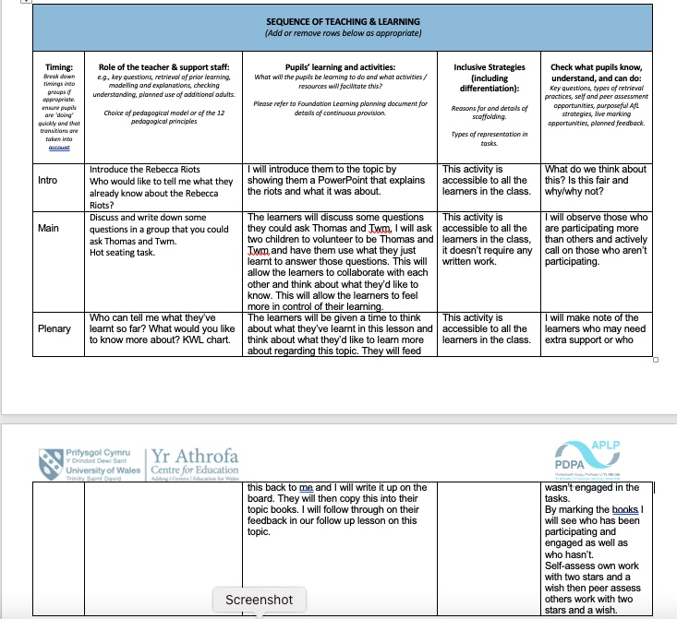

Lesson plan B:
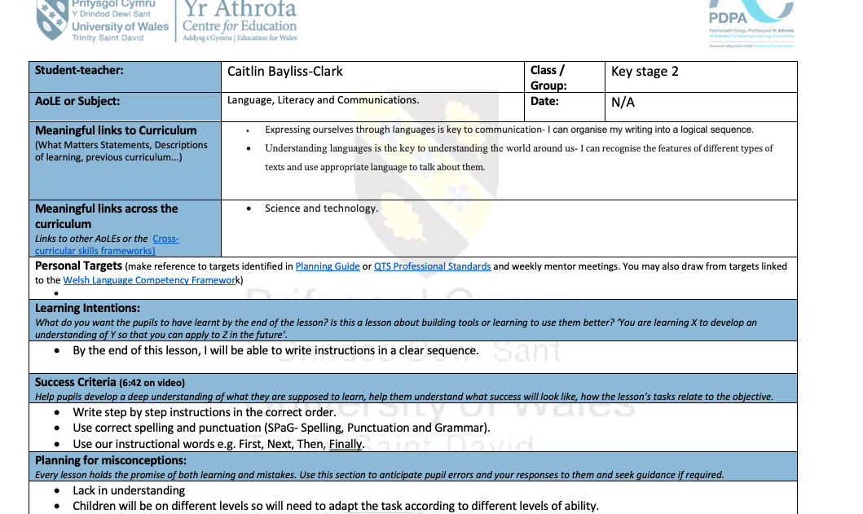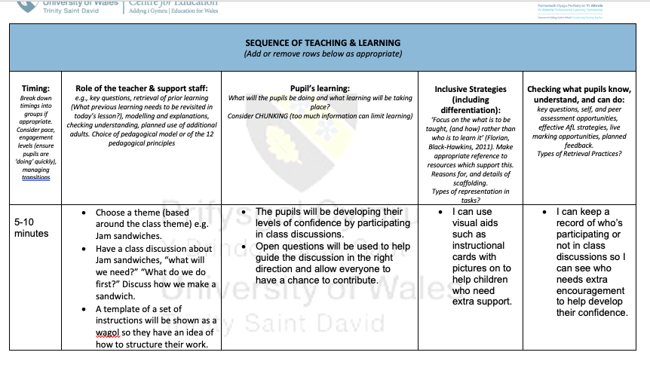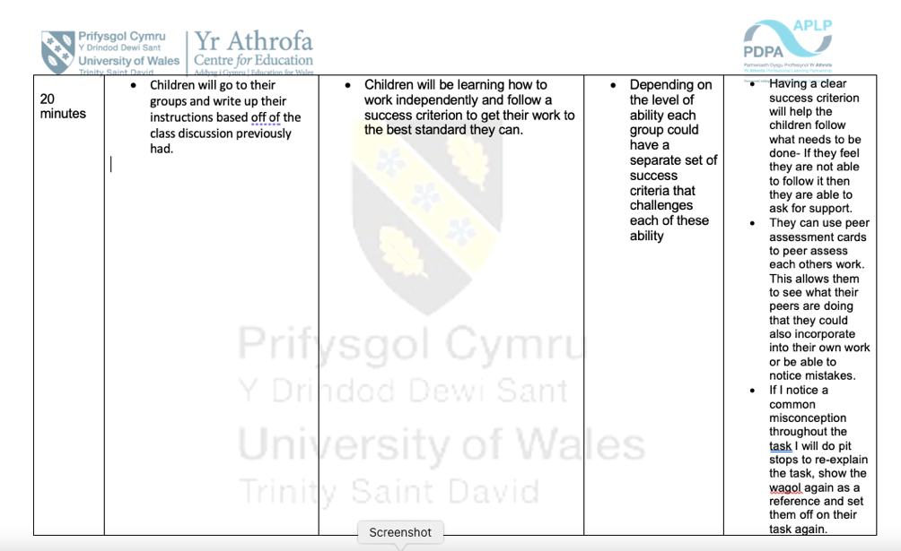

Lesson Plan C:
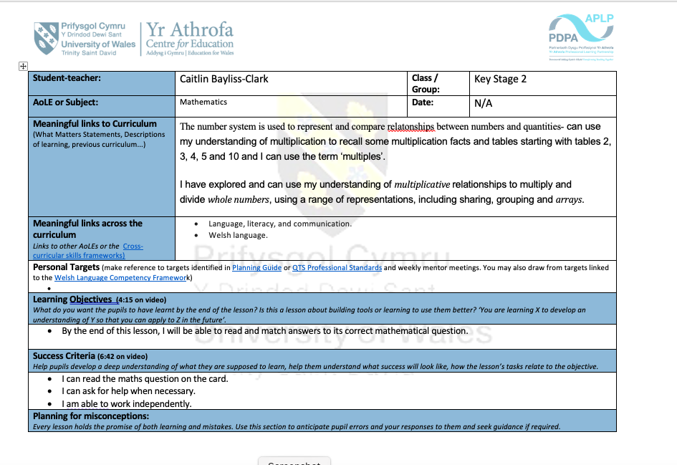
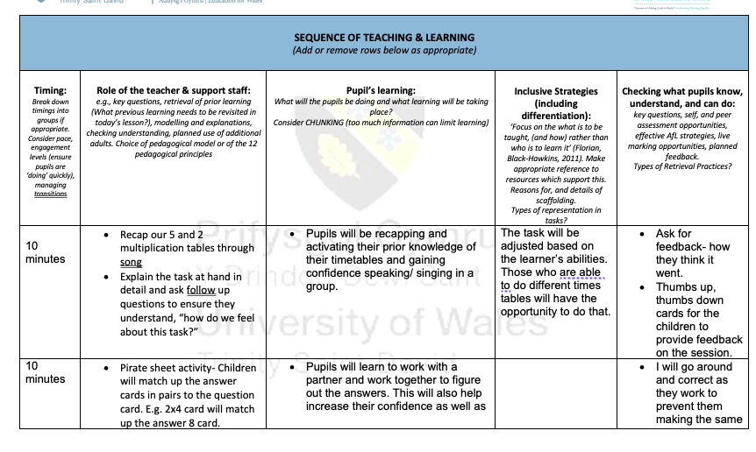
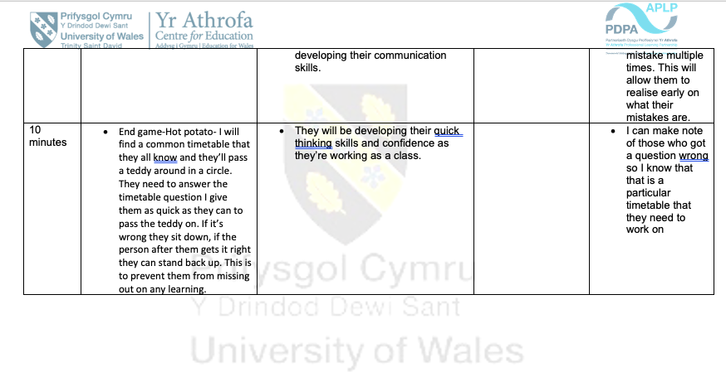

References:
Black, P and Wiliam, D (1998) Inside the Black Box: Raising Standards Through Classroom
Assessment

Carless, D, (2017) Scaling up assessment for learning: Progress and prospects. Scaling up assessment for learning in higher education, pp.3-17.
Cambridge Dictionary Available at: https://dictionary.cambridge.org/dictionary/english/metacognition (Accessed:11/12/2023)
Curriculum For Wales (2020)
Area of Learning and Experiences
Available at: https://hwb.gov.wales/curriculum-for-wales/mathematics-and-numeracy/
(Accessed on: 08/11/2023)

Curriculum for Wales (2022) Supporting Learner Progression: assessment guidance Available at: https://hwb.gov.wales/curriculum-for-wales/humanities/statements-of-what-matters/
(Accessed:18/12/2023)

Cambridge International Education Teaching and Learning Team (date not provided)
Getting Started with Assessment for Learning
Available at: https://cambridgecommunity.org.uk/professionaldevelopment/gswafl/index.html
(Accessed on: 21/10/2023)

Cook, J (2023). KWL Chart Graphic Organiser- Definition, Benefits & Uses
Available at: https://study.com/academy/lesson/kwl-chart-example-graphic-organizer-and-classroomapplications.html#:~:text=A%20KWL%20chart%20is%20primarily,lesson%20after%20it%20is%20completed.
Accessed: 16/12/2023
Donaldson, G (2015) Successful future: Independent Review of Curriculum and Assessment Arrangements in Wales.
D. Monty Neill (1997) "Transforming Student Assessment," Phi Delta Kappan, pp. 35-36.
Hallam, S, Ireson, J. (2006) Secondary school pupils' preferences for different types of structured grouping practices. British Educational Research Journal,32(4),583-599.

Kostons, D. and Van Der Werf, G. (2015), The effects of activating prior topic and metacognitive knowledge on text comprehension scores. Br J Educ Psychol, 85: 264-275. https://doi.org/10.1111/bjep.12069
Lindblom, S., Pihlajamaki, S. and Kotkas, T. 2006. Self, peer and teacher assessment of student essays. Active Learning in Higher Education, 7 (1): 51

McNulty, K (2022). Is Your Mental Math Good Enough?
Available at: https://keith-mcnulty.medium.com/is-your-mental-math-good-enough-323fc58e4110#:~:text=Strong%20mental%20arithmetic%20also%20provides,like%20your%20phone%20or%20calculator.
Accessed: 20/12/2023
Simon, H. A. (1997_1947). Administrative Behavior: A Study of Decision-Making Processes in Administrative Organizations (4th ed.). New York: Free Press.
Stiggins, R. J. (2002). Assessment crisis: The absence of assessment for learning
Wasik, B. A, and Hindman, A, H. (2018) Why Wait? The Importance of Wait Time in Developing Young Students’ Language and Vocabulary Skills.
Welsh Government (2013) Assessment for learning and the National Literacy and Numeracy Framework November Guidance document no: 120/2013
Webb, M and Jones, J. (2009) Exploring tensions in developing assessment for learning, Assessment in Education: Principles, Policy & Practice, 16:2, 165-184, DOI: 10.1080/09695940903075925
Zariski, A. (1996) Student peer assessment in tertiary education: Promise, perils and practice. In Teaching and learning within and across disciplines. Proceedings of the 5th Annual Teaching Learning Forum.

