Kamil Sloboda 1712240

ScrewFix during COVID19 Pandemic


Contents

Introduction 2
1. Project Management 2
2. Project Life Cycle 3
2.1 Project Initiation 3
2.2 Project Planning 6
2.3 Project Execution 12
Recommendations 14
Reference list: 15

Introduction
At the beginning of 2020 businesses located in the United Kingdom did not expect what will happen in the next several months. Huge impact of COVID-19 on the world's economy brought an unclear future for existing companies. Lockdown has created a wide range of challenging tasks for businesses of all sizes. Companies which did not qualify as an essential have been forced to stay closed during the pandemic, on the other hand open businesses had to settle down again and adapt to the new economic landscape (Murphey, 2020).
Most hardware stores have been declared as essential shops because they provide equipment and materials that help to keep warm houses with electricity. One of these deemed shops is Screwfix - multichannel British retailer of trade accessories, tools and hardware products designed for professionals and DIY fans. During pandemic Screwfix stores were open only for people to pick up essential products through Click & Collect service meaning that customers could not look around the stores. The company also provided delivery service by accepting orders on their website (Langton, 2020).

These uncertain times have led to creation of new projects to adapt to the new economic landscape and rules brought by COVID-19 pandemic. Project is a great opportunity for organizations to achieve objectives more efficiently and helps to make changes in organized manner as well as to reduce probability of failure (MyMG, 2020). Screwfix and other companies had to prepare a new project which will help them to survive during the pandemic.
The project and the project management are two different terms where the project could be considered as an achievement of a particular objective, which involves a series of tasks and activities which consume resources. Project has to be done in specific measurements and it has start and end dates. The project management could be defined as the process of controlling and observing the achievement of the project aims (Munns, 1996).

1. Project Management
Project management is the application of skills processes, knowledge, methods, and experience to achieve specific project goals according to the project criteria within agreed specifications (APM, 1992).
To lead a project successfully, a project manager has to have numerous skills of initiating, planning, executing, monitoring and closing. To achieve these specific measurements, project managers mostly use several techniques and tools to help them coordinate activities during a project life cycle (Patanakul, 2010).

2. Project Life Cycle
The project life cycle shows and describes all stages that the project goes through during its activity from start to finish. When it is well defined it brings structure to the project (Cohen, 2018). Screwfix project life cycle will consist four different stages:
- Project Initiation
- Project Planning Phase
- Project Execution
- Project Closure

2.1 Project Initiation
Project Initiation is the first phase of the project life cycle where the reason or opportunity for the project is identified and a project is being developed to take advantage of that opportunity (Ray, 2018).
Useful instrument to describe project initiation is a simple and effective tool called quad chart. It explains what the project is all about and is usually used to offer a solution to a problem or to introduce a new product (Chegg, 2020).

SCREWFIX as an essential retailer of trade goods during COVID-19 pandemic
Purpose  - To deliver essential products to customers  - To provide them an essential equipment in a safe environment  - To allow essential workers to make the job completed | Stakeholders  - Essential businesses (Drivers) (Primary)  - Screwfix contractors and goods providers (Drivers, Primary)  - Screwfix employees (Managers, co-workers, supporters) (Secondary)
Desired end results  - Delivered essential products to customers (Unmeasurable)  - Provided essential equipment with safety regulations (Unmeasurable)  - Allowed essential workers to make the job completed (Unmeasurable) | Measures of success  - Satisfied customers due to opportunity to accomplish their essential tasks (Quantitative)  - Safe and comfortable processes during the sales operations (Qualitative)  - Profitability of the organization (Quantitative)

Screwfix has been deemed as an essential business and at the first part of the project life cycle its purpose is to provide essential products to its customers (Grahns, 2020). As the government decides to make strict rules about shopping, Screwfix has to adapt new regulations based on safety measurements. Thanks to active actions in sales, the company will be able to deliver essential goods not only for private buyers but also for essential companies as well as for self-employed workers who provide important and necessary works for people who need them immediately. The project is designed for essential businesses to allow them to carry on crucial significance jobs and to people who are in an emergency which has been created as a result of unexpected factors (GOV, 2020). Also, thanks to activities where Screwfix provides their goods, suppliers will be able to keep sales of their products, therefore keep their income constantly growing. Screwfix employees, from managers to basic workers are all involved in the project and their aim is to deliver the best possible service in these uncertain times (Screwfix, 2020). The company will achieve success when essential products will be delivered to their customers with attention to safety regulations announced by the government and necessary works will be made thanks to its active processes of sales.
The success of the organization will be shown in customer’s experience through delivered products and high-quality protection against Coronavirus for both Screwfix colleagues and its customers. As well as these factors, organization profitability is another important factor which has an impact on the overall success of the project.

Another useful tool which helps to determine which people are valuable to involve them in the project is stakeholder analysis. A stakeholder analysis is a process of identifying all the internal people and teams before the project begins. Thanks to it there is a possibility to enlist helpful company employees and to achieve alignment between all stakeholders. It is also important to predict future conflicts in the organization and to reduce their impact during the project (ProductPlan, 2020).

Priority | Stakeholder | Stakeholder’s perspective | Action
High | Essential businesses and private customers | Many companies need essential tools and equipment to work with | Through providing essential equipment and tools, Screwfix involves its customers in daily shopping
Medium | Screwfix suppliers | Goods providers are responsible for Screwfix stock in stores | Continuously contact with logistic department will keep contractors involved in the project
Medium | Screwfix employees | Thanks to them shops can be open | Safe regulations to make safe environment for employees to keep them involved in the project
Medium | CEO Joe Mewet | The whole project has to be accepted by CEO | All essential steps must be provided to CEO

Screwfix stakeholder analysis shows that internal and external units are involved in the project of providing goods to customers during COVID-19 pandemic. Essential businesses which deliver necessary works to people who need it are important stakeholders for the company project. Without these businesses and private customers, the whole project will not be able to achieve success. Screwfix as a multichannel retailer shop creates its income on its sales therefore through providing essential tools and equipment for its customers the organization will be able to involve stakeholders even in daily shopping and to make a profit. To achieve that it is important to keep the stock of its products up to date through creating a strong and trustful net with Screwfix suppliers. Goods providers will be able to stand across the lockdown. To sell products it is necessary to have staff which is involved in Click & Collect sales. All employees are important starting from shop floor workers ending at IT engineers which are responsible for all transactions made by online purchases. To help them survive in these uncertain times Screwfix has to guarantee a safe workplace environment with rules and regulations made by the government. The project must be approved by Screwfix’s CEO Joe Mewet who is responsible for all processes and projects in the organization.

2.2 Project Planning
After the first phase of the project life cycle is reviewed it is time for the second phase called project planning phase. This stage is at the heart of the life cycle and provides information where everyone involved is already located and describes how to achieve the project goals. The planning phase has been made when the project plans are created, the project requirements and deliverables are defined, and the project schedule is generated. The plans created during this phase are helpful in managing time, costs, changes, quality, risk and related issues. The plans also offer an opportunity to look at staff control and external suppliers to ensure that the project will be delivered on time within schedule and budget (Watt, 2018).
Risk analysis is an important tool to overview possible threats and barriers in the project life cycle. It is the process of assessing the likelihood of an adverse event occurring within the corporate, government, or environmental sector (Hayes ,2019). Screwfix faces several threats during COVID-19 pandemic.
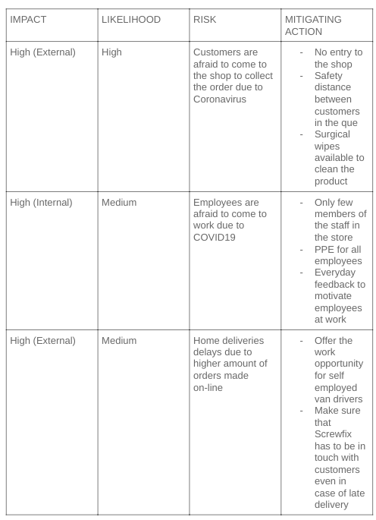

The high impact of a few factors are possible threats for the Screwfix project during pandemic. Customers are afraid to visit local stores because they would like to avoid contact with other people. Coronavirus spreads between people rapidly and to stop its spreading it is necessary to follow safety regulations. At Screwfix safety is a priority and to keep customers safe the company needs to make changes. The stores will be open only for Click & Collect orders. Catalogues and products need to be removed from the shop floor. To place an order the customer will need to visit the website or by downloading the Screwfix app and placing an order there. During the collection of goods, customers will be able to use contactless collection points and to minimise social contact, Screwfix will operate a lane system with a limited number of customers in the queue. While waiting for an order the employee will need to ask for a two-meter distance from other customers. Dedicated signs will indicate correct and proper movement around the store (Screwfix, 2020).
Another high risk comes from employees who are afraid to come to work due to COVID-19 pandemic. To protect co-workers Screwfix has to provide hand sanitisers station inside the store. Also, PPE needs to be available for all colleagues. To achieve better protection, plastic screens will be installed to avoid closer contact between people in stores. Contact between managers, team leaders and basic workers must be provided on the highest possible standard. Everyday feedback and speech about its importance in the project will help to motivate employees to work. Feedback represents resources that inform individuals in the work environment about how well they have attained both their own and the organization’s goals and targets (Marthouret, 2016). Questionnaires about safety procedures and its impact on employees also will lead to improvement.
Click & Collect orders are not the only way to provide goods to customers. Home deliveries are also an important part of the project and there is a possibility of delays due to the large amount of orders made on-line. To stay close in the relationship between customer and organization it is important to develop excellent communication in case of late delivery. Building a good relationship is more cost effective than finding new customers. That is why many companies' goal is to build long-lasting relationships (Pietruszewska, 2020).

The project triangle expresses triple influence of time, quality, cost or scope that should be managed in project delivery. Each point of the triangle is connected to two other points and it is moving when it has a lower or higher impact on the existing situation (Microsoft, 2019).

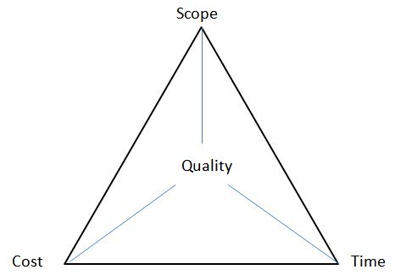

In Screwfix scenario the risk laid down in deliveries which could be delayed due to large amounts of orders made on-line. Delays might have an impact on extra costs which company could possibly incur during the project. When a customer did not receive the product in expected time, there is a possibility that an order made by the customer could be cancelled which will lead to generating unexpected costs based on bringing back products to stores and extra fees to the sales platform for the service which has been given. High demand on home delivery service needs more time to organize all orders and to prepare them for shipping. Recruiting drivers for Screwfix could possibly shorten the delivery time but also will generate extra costs in this respect.

Another tool for projects is work breakdown structure (WBS) which integrates costs, scope and schedule baselines ensuring that plans of the project are in correct alignment. Breaking work tasks into smaller ones is a frequent technique used to make work more approachable and manageable. A deliverable based WBS demonstrates the relationship between project deliverables and the scope which occurs in the project (WBS, 2020).
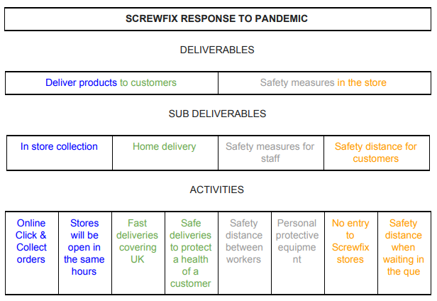
During the pandemic Screwfix goal is to deliver products to its customers and to do it in a healthy and safe manner. This is an example of a top-down approach which mostly generates more accurate and complete WBS. In this case work breakdown structure is derived by decomposition of overall project into subprojects and lower level tasks (PM, 2018). To accomplish and achieve project objectives Screwfix need to follow guidance included in the WBS table. There are two different ways of delivering Screwfix products to organization customers. In store collection and home delivery. Customers will be able to pick up the product from the shop only by using Click & Collect orders and browsing in the shop will be prohibited. Most of the shops will operate in the same hours although several stores will open under reduced hours to minimize the risk of spreading the virus. Home deliveries will work as previously but due to existing pandemic there is a risk that orders could be delayed. When delivering products to customers, Screwfix postal service needs to remember about safety measurements to protect the lives of customers and its own. As well as safety measurements are important during deliveries, they are also important in the stores. Screwfix needs to protect colleagues and its customers in the same proportion. Keeping safety distance between employees, building plastic screens, providing personal protective equipment and hand sanitisers around the store will be helpful to reduce the risk of COVID-19 spreading. Customers will not be able to browse products in stores and Screwfix marshall will need to supervise people to see if they stick to the rules of two-meter distance (Screwfix, 2020). All the tasks are main objectives which Screwfix will carry on during the lockdown.
Another tool that illustrates a project schedule is a Gantt chart. This harmonogram is a type of bar chart where terminal elements and summary elements of the project are shown in the graphs with start and finish dates (Kumar, 2005).

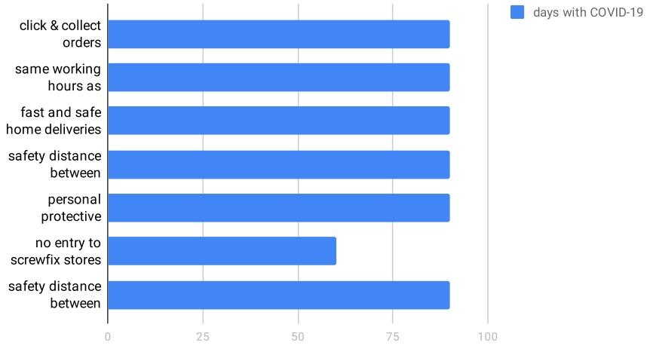

Screwfix is planning to follow the guidelines during the whole pandemic period. Most of the tasks will be implemented every day to ensure that safety rules are not broken to provide the highest possible level of protection for both colleagues and Screwfix customers.

Another tool is a network diagram which is a graphical representation of tasks, workflow, and responsibilities for a project. It frequently looks like a chart with a series of arrows and boxes and it is used to construct the schedule and work sequence for the project, as well as overview its progress through each stage (Wrike, 2020).
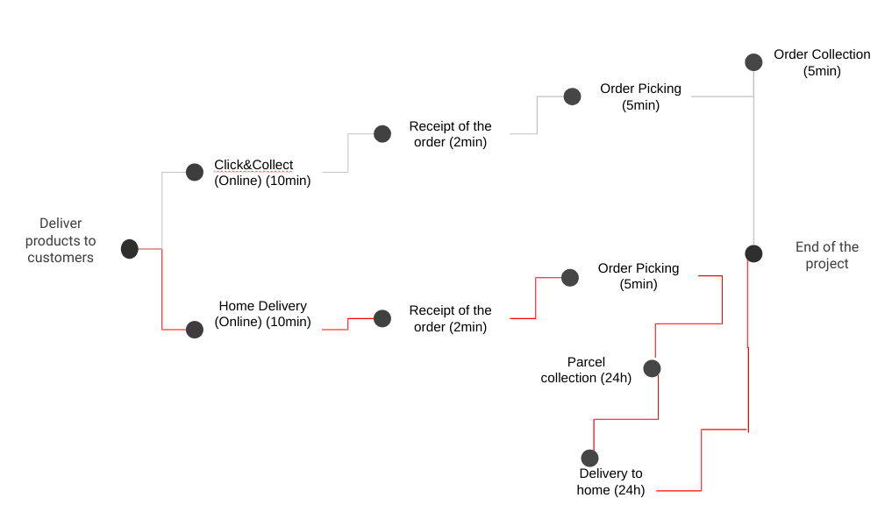

The main objective of delivering goods to customers shows that the quickest route to do that is through Click & Collect orders. Customers will need to wait significantly longer for the product if they decide to order it online with home delivery service.

2.3 Project Execution
When the second phase of the project life cycle is completed, the next following stage is a project execution phase. In this phase systematic assessment of an ongoing or completed project determines the importance and level of achievement of project aims, efficiency, development effectiveness, impact and sustainability (ILO, 2017). A mid-term evaluation serves two immediate purposes like decision making and summarizing project from the experience. Some projects in the organizations are taken into consideration only when the project is profitable and although it is a crucial factor in Screwfix, also other factors are important in the overall assessment of the project.
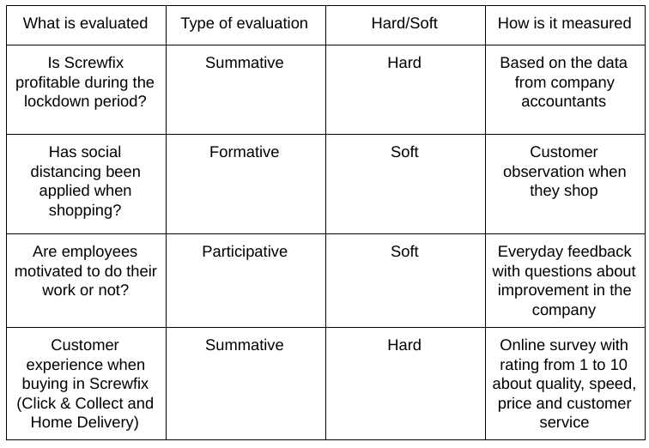
One of the most important questions in organizations is about profits and income of the company when the project has been applied. Thanks to government regulations Screwfix has been granted as an essential business. The full report of annual financial records will be available in 2021 and to that date the only possible thesis is that the company sells products and has an advantage over its competition, which was not considered as a essential businesses and had to stay closed during the pandemic.
Screwfix as a main objective decided to keep colleagues and customers safe to protect them from existing viruses. As a motivational method to keep workers motivated to act, Screwfix is using Herzberg theory. Two factors of motivation and hygiene shows managers, co-workers and all colleagues are engaged in the project. As a motivational factor worker are ensured that they are doing a responsible job with the possibility to earn 100% of their salary instead of 80% government benefit. Daily feedback and open mindedness are crucial to improve the situation in the stores. On the other hand, hygiene factors such as inappropriate work conditions are reduced to minimum to ensure that protection is delivered on the highest possible level and building a good team environment helps to prevent unnecessary conflicts in the organization.
Screwfix also offers online surveys for its customers each time they place an order. As a prize they are able to join a weekly ruffle with £100 worth vouchers to spend in Screwfix. Thanks to that method the company gathers the data to overview the current projects in the organization. As a result of the project it is visible that people's attitudes are changing.

Recommendations
Screwfix operates in a safe manner during the pandemic of COVID-19. The company puts the safety of its customers and colleagues at first place. The project is still ongoing although it is possible to draw some conclusions from existing projects. To overview what went wrong and what went well it is practical to use the tool called delta evaluation. Screwfix is going through the project fine although there is always possibility to improve something. For example, when customers are waiting outside the store to collect their order, they could be possible more satisfied when they will have protection on wet and rainy days. By building small roofs on the lane where customers are queuing will improve customer experience. Supermarkets like Sainsbury are offering umbrellas for its customers when they need to wait to enter the shop. Another recommendation for Screwfix could be installing post lockers in the front of the shop to allow customers to pick up the order even at night. People who are working at the same hours as the store is open cannot pick up the order individually. In case that they need the product as soon as they finish their job, they will be able to collect it in the post locker.
According to David Kolb “Learning is the process whereby knowledge is created through the transformation of experience” (Mcleod, 2017). The project life cycle shows that each project is supposed to be planned in the correct way to achieve success. Frequently people without experience are starting new projects and they fail because they did not prepare a detailed analysis of the business environment and other factors. Thanks to that tool even the failure can be turned into success although the most important thing is to draw conclusions after each project is completed. As Winston Churchill said, “Success consists of going from failure to failure without loss of enthusiasm” (Churchill, 1932).

Reference list:
- Chegg (2020) What Is A Quad Chart? Available at: www.chegg.com [Accessed on: 01.07.2020].
- Churchill, W. (1932) Success consists of going from failure to failure without loss of enthusiasm. Available at: www.brainyquote.com [Accessed on: 01.07.2020].
- Cohen, E. (2018) What is the Project Life Cycle and How to Use It Better? Available at: www.workamajig.com [Accessed on: 01.07.2020].
- Grahns, A. (2020) Is Screwfix open today? Coronavirus lockdown opening hours and advice. Available at: www.bbc.co.uk [Accessed on: 01.07.2020].
- Hayes, A. (2019) Risk analysis. Available at: www.investopedia.com [Accessed on: 01.07.2020].
- HSE, (2020) Social distancing, keeping businesses open and in-work activities during the coronavirus outbreak. Available at: www.hse.gov.uk [Accessed on: 01.07.2020].
- Kumar, P. (2005) Effective Use of Gantt Chart for Managing Large Scale Projects Cost Engineering. Morgantown, WV: American Association of Cost Engineers
- Langton, K. (2020) Screwfix click and collect opening hours: Is Screwfix open for click and collect today? Available at: /www.express.co.uk [Accessed on: 01.07.2020].
- Marthouret, E. (2016) The effect of quick feedback on employee motivation and performance. Available at: www.diva-portal.org [Accessed on: 01.07.2020].
- Microsoft (2019) The project triangle. Available at: https://support.microsoft.com/ [Accessed on: 01.07.2020].
- Munns, A. (1996) The role of project management in achieving project success. Available at: www.moodle.uwtsd.ac.uk [Accessed on: 01.07.2020].
- Murphey, D. (2020) Unusual opportunities for businesses during lockdown. Available at: www.businesswest.co.uk [Accessed on: 01.07.2020].
- MyMG (2020) What is a Project? Available at: www.mymanagementguide.com [Accessed on: 01.07.2020].
- Patankul, P. (2010) An empirical study on the use of project management tools and techniques across project life cycle and their impact on project success. Available at: www.moodle.uwtsd.ac.uk [Accessed on: 01.07.2020].
- Pietruszewska, M. (2020) 7 Ways to Build Strong Relationships With Customers Available at: www.tidio.com [Accessed on: 01.07.2020].
- PM (2018) Work Breakdown Structure. Available at: www.project-management.com [Accessed on: 01.07.2020]
- Product Plan (2020) Stakeholder Analysis. Available at: www.productplan.com [Accessed on: 01.07.2020].
- Ray, S. (2018) Project Initiation: How to Start Your Project Off Right. Available at: www.projectmanager.com [Accessed on: 01.07.2020].
- Screwfix (2020) Click & Collect. Available at: www.screwfix.com [Accessed on: 01.07.2020].
- Watt, A. (2018) Project Management. Available at: https://opentextbc.ca/ [Accessed on: 01.07.2020].
- WBS (2020) What is a Work Breakdown Structure? Available at: www.workbreakdownstructure.com [Accessed on: 01.07.2020].
- Wrike (2020) What is a network diagram in project management? Available at: www.wrike.com [Accessed on: 01.07.2020].

